REVISION NOTICE TABLE
DATE | DESCRIPTION OF REVISION

PROCESSING NOTES
Cruise: 2013-43
Agency: PBS, Salmon and Freshwater Ecosystems, Nanaimo, BC
Location: Strait of Georgia
Project: Salmon Marine Interactions
Chief Scientist: Neville S., Sweeting R., Morris J.
Platform: W.E. Ricker
Date: 26 June 2013 – 21 July 2013

Processed by: Germaine Gatien
Date of Processing: 3 September 2013 – 24 April 2014

Number of original hex files: 98 Number of CTD casts processed: 98

INSTRUMENT SUMMARY
A SeaBird Model SBE 911+ CTD (#0506) was mounted with an SBE43 Dissolved Oxygen sensor (#1438), a WetLabs ECO-FL Fluorometer #2215 and an SBE pH sensor #0852. The deck unit was #0424.

SUMMARY OF QUALITY AND CONCERNS
The log book was in good order with a personnel list, an equipment list, a record of sampling done and notes about problems encountered.

Processing was delayed because the salinity samples were missing. They were never found which was particularly unfortunate because it is obvious there is a problem with one temperature sensor. From the results of cruise 2013-10 it is thought that the secondary temperature sensor was faulty, but until post-cruise calibrations of the temperature sensors are available, it is not certain whether the primary salinity data require recalibration. No recalibration was applied in original processing, but the sensors have gone to the factory and salinity will be recalibrated later if the factory report indicates it is necessary.

The NMEA positions were not added. No reason was given for this in the log, so it is assumed this was an error in setting up the configuration file. Depths were entered in the headers, but there was a format error so that they were not recognized by the routine that converts files to IOS header format. Latitude, longitude and depths were added to the headers based on log book entries.

There was no dissolved oxygen calibration sampling during this cruise. The results of four cruises which used the same DO sensor between February and May 2013 and had DO calibration sampling produced similar corrections with slopes increasing slowly. So the SBE Dissolved Oxygen sensor was corrected using the results of cruise 2013-12.

The ratio of the ECO sensor fluorescence to extracted chlorophyll looks similar to those seen in other cruises, with the ratio being high for low CHL and approaching 1 as CHL rises.

The SBE pH data should be used with caution; no field calibration data were available at the time of processing. Calibration is required for each cast to get absolute values, although general trends within a cast are likely real.

A spreadsheet was prepared combining bottle analysis results with CTD data from 10m gathered during the downcast and from the upcast. The downcast is likely the better choice to be used in conjunction with the bottle data.

PROCESSING SUMMARY

Seasave
This step was completed at sea; the raw data files have extension HEX.

Preliminary Steps
The Log Book was obtained. Problems noted include large differences between T and S late in the cruise, a few cases of the CTD touching bottom and a few spikes in pH.

The cruise summary sheet was completed.
The histories of the dissolved oxygen, conductivity and pressure sensors were obtained.

The configuration file did not change through the cruise. All entries were correct except that the pressure offset has been adjusted from -1.5 to -0.1 since early 2012 since values seemed too low. The file was saved as 2013-43-ctd.xmlcon.

There were post-cruise calibrations available for the two conductivity sensors and the pressure. The primary conductivity had shown no drift since the previous calibration and the secondary drift was slight. The pressure slope and offset had changed slightly, so a new configuration file was prepared with the post-cruise calibration used for pressure, 2013-43-ctd-post.xmlcon. Tests showed that using the post-cruise pressure calibration resulted in pressures that were higher by 0.13db at the surface and 0.12db at 250db. This shows that the adjustments made to earlier cruises may have been slightly too large but within the accuracy expected of this sensor. The post-cruise pressure calibration will be used for this cruise.

There was no DO sampling from this cruise.
Bottle data were provided in 2 spreadsheets: nutrient and extracted CHL. While salinity samples were taken according to the log book, none could be found at IOS. They are presumed to have been lost. The data from the two spreadsheets were combined and upcast CTD data from 10m will be added later. The combined file was saved as 2013-43-bottles_plus_CTD_data.xlsx.

Conversion of Raw Data
All data were converted using file 2013-43-ctd-post.xmlcon.
As noted in the log the data for events #155 and 162 were not saved.

There is some confusion about which dissolved oxygen sensor was in use. The log and configuration file indicate that it was #1438, but this sensor was also said to be on the Vector at the same time. It was eventually discovered that sensor #1438 was NOT on the Vector, so it will be assumed that the configuration file and log for this cruise are correct. There is no oxygen calibration sampling for this cruise. An inter-calibration with 2013-13 could be made later since some casts are fairly close to each other. But the area of closest overlap is one subject to high temporal and spatial gradients, so this is not likely to be a convincing quality check.

Plots were made for a few casts. The CTD stops at between 14 and 15.5db during the upcast. The Niskin bottle is usually mounted about 5m above the CTD, so CTD data will be extracted from 10db for inclusion in the file with bottle samples. With no salinity data available it will not be possible to determine how reasonable this estimate is.

Checks were made of all the channels:
- The temperature channels differ by 0.09Cº on all casts examined. When last used they differed by 0.04Cº at the beginning of the cruise and by >0.1Cº by the end.
- Conductivity differences are low on downcasts, noisier on upcasts.
- Fluorescence looks noisy with dark values ~0.2ug/L.
- Dissolved Oxygen looks normal.

WILDEDIT
Program WILDEDIT was used to remove spikes from the pressure, temperature and conductivity channels only.
Parameters used were: Pass 1 Std Dev = 2 Pass 2 Std Dev = 5 Points per block = 50

ALIGNCTD
Various advancements were tested to make DO and temperature traces have the same offset between downcast and upcast data. Overall an advance of 4.5s looks best. This setting was used on other cruises using this sensor.
ALIGNCTD was used to advance the DO signal relative to temperature by 4.5s.

CELLTM
Tests were run on 4 casts using a variety of settings. The results are hard to interpret because the upcast data are very noisy. But overall the best choice was (α=0.03, 1/β=7) for both channels.
CELLTM was run using (0.03, 7) for both the primary and secondary conductivity for all casts.

DERIVE
Program DERIVE was run twice:
on all casts to calculate primary and secondary salinity, dissolved oxygen concentration and descent rate; the tau correction was applied.

Conversion to IOS Headers
The IOSSHELL routine was used to convert SEA-Bird 911+ CNV files to IOS Headers.
CLEAN was run to add event numbers and to replace pad values in the Pressure channel using linear interpolation based on scan number.

Checking Headers
NMEA position and time data were not added to these files – no reason was given in the log, so it is assumed that this was an error in setting up the configuration file.

Most depth entries were missing because of a format error that meant the conversion to IOS Header format missed the information. The entry should look like:
** Depth(m): 235
But most entries had
** Depth(m): 235m

A spreadsheet was prepared with the depths from the log book as well the latitude and longitude. The spreadsheet was opened in Ultraedit and edited to add the hemisphere indicators N and W.
Merge CSV file to Header was used to add the header information from the spreadsheet to the CLN files. To test that the information was entered correctly a track plot was produced and there were no obvious errors.

A header check was run and this did point to latitude error which was fixed.

There are some negative pressure and fluorescence values at the end of event #165, but nothing that will affect the downcast files. This could indicate that the pressure is reading a little low, though at least some of the values look more like spikes. The peak fluorescence value is 65ug/L which seems high but the shape suggests this is real, not a spike and not an off-scale value.

A cross-reference list was produced and checked against log records. Two errors in positions were found and corrected. The time for the first CTD cast, event #3, does not agree with the log book. Checking the list of events, the log entries make more sense. There is a note where each day ends, assisting in this assessment. The time was changed in the file.

The surface report indicates that the average surface pressure was 2.7db. The shallowest data recorded were from 0.8db at the end of a cast, with salinity values low enough to be fairly near the surface. The pressure may be a little low since the post-cruise calibration was used, but it is reasonable.

SHIFT
Fluorescence
In other recent uses of ECO Fluorometers it has been found necessary to advance the fluorescence by +12 records (0.5s) relative to pressure. A few casts were examined and the data are so noisy that it was difficult to test, especially since the CTD stopped at 15m during the upcast and gradients are very low below that. As far as can be judged in low gradient areas, a small advance improves the data somewhat.
SHIFT was run on the fluorescence channel to advance by 12 records.

Conductivity
Tests were run on both conductivity channels for 3 casts. For the primary conductivity the best setting was -0.6 records. For the secondary the best setting varied slightly from feature to feature and cast to cast, but either -1.2 or -1.4 looked best, so -1.3 looks like a good choice.
All casts were put through SHIFT using -0.6 records for the primary and -1.3 records for the secondary conductivity.

Dissolved Oxygen
The SBE DO data have already been aligned, but a few casts were examined to see if further adjustments are required. The results are confusing with cases where the DO traces are closer than temperature traces and other cases where the opposite is true. Given the slow response of these sensors it is impossible to get a really good comparison. The shift already applied is likely the best we can do.
SHIFT will not be run on this channel.

DELETE
The shifted files were put through REVERSE.
DELETE was run twice, first on the SHFC1 files and next on the REV files.

The following DELETE parameters were used:
Surface Record Removal: Last Press Min Maximum Surface Pressure (relative): 10.00
Surface Pressure Tolerance: 1.0 Pressure filtered over 15 points
Swells deleted. Warning message if pressure difference of 2.00
Drop rates < 0.30m/s (calculated over 11 points) will be deleted.
Drop rate applies in the range: 10db to 10db less than the maximum pressure
Sample interval = 0.042 seconds. (taken from header)
COMMENTS ON WARNINGS: The only warnings for each set of files pertained to the upcast, so are of no concern.

COMPARISON WITH BOTTLES
The DELREV files were bin-averaged and then thinned to 10db. The data were exported to a spreadsheet and that data was added to file 2013-43-bottles_plus_CTD_data.xlsx. The primary temperature and salinity were selected since these sensors were closer to bottles during 2013-10.
The DEL files were bin-averaged and thinned to 10db and those data were also added to the above file.

The only bottle data that can be compared to CTD data are the extracted chlorophyll samples. This indicates that the fluorescence is reasonably close to the chlorophyll.
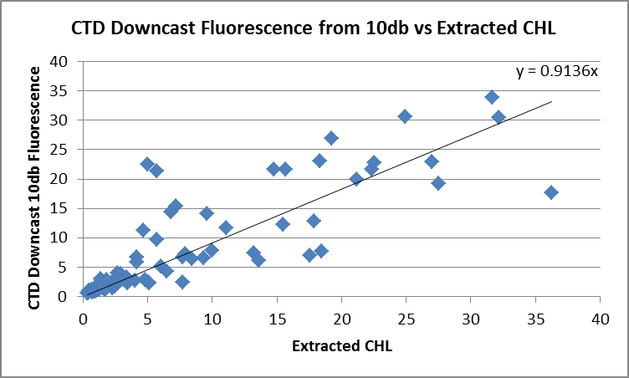

The ratio of CTD fluorescence to extracted chlorophyll reads about 50% higher than CHL when CHL is very low. For most samples fluorescence is between 50% and 150% of the CHL values. There are stations for which the ECO values are much higher, but those are casts where the fluorescence gradient is high near 10m. The depth from which the samples come varies, but all CTD data are from 10m, so a slight depth mismatch will lead to a large error where the gradients are high. A plot of the ratio of Fluorescence/CHL versus CHL has the same general shape that is usually found.

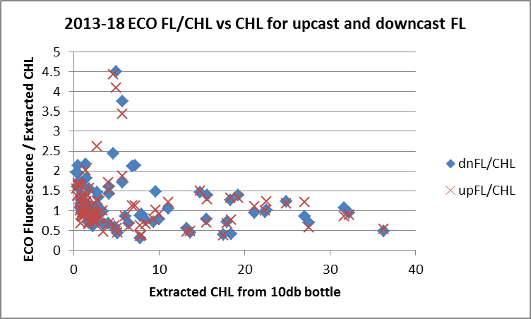

There is little difference between the comparisons with upcast and downcast fluorescence. The temperature and salinity vary much more with upcast temperature lower and salinity higher. During 2013-10 the bottles were closest to the downcast values but that does not necessarily mean the downcast was better, but it is likely that the downcast should be better because for the upcast the CTD is just starting up from being stopped and likely to carry some deeper water with it. So the downcast CTD data are probably the best ones to use in conjunction with the bottle data. This is supported by comparisons during 2013-10 when upcast salinity was much higher than bottles while downcast salinity was close to bottles.

DETAILED EDITING
Based on results from 2013-10 the primary temperature and salinity data were selected for editing and eventual archiving.
All DEL files were copied to *.EDT.
CTDEDIT was used to clean the primary temperature and salinity data.
Cast #156 required no editing.
All other casts required some editing – mostly removal of records corrupted by shed wakes or spikes near the top or bottom of the cast.
All edited files were copied to *.EDT

Other Comparisons
Previous experience with these sensors –
- The primary T and C sensors have been used many times since they were last calibrated. Calibration sampling was not often available and at other times was not trusted. In early 2012 there was a good comparison that found salinity very close to bottles; it was low by about 0.002 in the most recent comparison. During 2013-10 the average difference between the downcast CTD salinity and bottles was <0.001 for casts with well-mixed surface waters. Using the same casts, the upcast CTD salinity was higher than bottles by an average of 0.01. The secondary has been found to be low by <0.002 in 2 recent cruises. Differences between sensor pairs were low during cruises when both these sensor pairs were in use until 2013 when there were large differences between temperature sensors but conductivity sensors were close. Based on comparisons with salinity bottles it was believed that the secondary temperature was performing badly.
- The pressure sensor has been used 13 times since it was last recalibrated. In April 2012 the offset applied was reduced from -1.38 to -0.1db. This was found appropriate for the 7 cruises since then.
- The dissolved oxygen sensor has been used for 6 previous cruises since its last factory service. There was calibration sampling for 4 of these cruises. The slope of corrections has increased gradually. The results of 2013-12 are probably most suited for use for these data because the bottle comparison was better and the region is similar to the one sampled during this cruise.

Historic ranges – Data were plotted with the 3-standard deviation plots of temperature and salinity ranges where local climatology was available. For many casts there was no local climatology available, or the climatology was based mostly on casts at standard sites which are not the ones occupied during this cruise. There were some excursions very close to the surface with salinity below the minimum and temperature above the maximum, but these casts in the northern Strait of Georgia and the Gulf Islands area were very close to shore where 3-standard deviations is not appropriate. Casts in Puget Sound looked out of line but this area is probably not well represented in the climatology. The casts from well offshore all fell well within the historic ranges. There was one small excursion towards high salinity for a few metres during one near-shore cast on the west coast. The 4 casts in Queen Charlotte Strait had low salinity below 150db. The 3-standard deviation range is considered too severe a criterion in this area of active mixing. These excursions are not systematic and do not suggest calibration problems.

Post-cruise calibration – The primary conductivity was reported to have 0 drift per month in January 2014 while the secondary had drifted by about 0.0001 per month. There was no post-cruise calibration available for the temperature sensors, one of which is presumed to have drifted significantly.
Pressure was recalibrated in January 2014. There was no report on drift, but conversion of a test cast using the new parameters showed pressures higher by 0.13db at the surface and 0.12db at 250db.
The SBE DO sensor was recalibrated in January 2014. There was no report on problems, and the drift was approximately 5%.

Initial Recalibration
Salinity will not be recalibrated. The calibration samples were lost. Post-cruise calibrations indicate that there was no drift in the primary and a small drift in the secondary conductivity. There are no post-cruise calibrations available for temperature but there are large differences between the two temperature and salinity channels, so at least one temperature sensor must have drifted significantly. During 2013-10 the secondary temperature sensor malfunctioned, so it is assumed that is the one with a problem.
Until post-cruise calibrations of the temperature sensors are available, it is not certain whether the primary salinity data require recalibration. No recalibration will be applied at this stage, but the sensors have gone to the factory and salinity will be recalibrated later if the factory report indicates it is necessary.

The results of 2013-12 seem best suited for recalibration of the dissolved oxygen data because the bottle comparison was better and the region is similar to the one sampled during this cruise.
Tile 2013-43-recal1.ccf was prepared to apply the correction:
Oxygen:Dissolved:SBE Corrected = 1.0706 * Oxygen:Dissolved:SBE +0.0418

Fluorescence Processing
The ED1 files were put through a median filter, size 11, applied to the fluorescence channel only.

BIN AVERAGE of CTD files
The following Bin Average values were applied to the filtered files (output AVG):
Bin channel = pressure Averaging interval = 1.000 Minimum bin value = .000
Average value will be used. Interpolated values are NOT used for empty bins.
After averaging, page plots were examined on screen and look reasonable; there are a few unstable features, but they are in areas where they may be real and no instrumental cause was found.

Profile plots were made to check all channels. There are a few spikes in pH that look odd, but the spikes do not seem to come from temperature spikes and will be left to researchers to assess. These spikes were noted in the log.
T-S plots were examined; there were some unstable features, but they come from areas where active mixing is likely.

FINAL CTD files steps (REMOVE and HEADEDIT)
The following channels were removed from all casts: Scan_Number, Temperature:Secondary, Salinity:T1:C1, Conductivity:Primary, Conductivity:Secondary, Oxygen:Voltage:SBE, Status:Pump, Descent_Rate and Flag.

A second CTD dissolved oxygen channel was derived with units umol/kg.

Dissolved Oxygen saturation was calculated and surface values were plotted. The values varied from about 68% to 150% though the shallowest depths available also varied. The lowest values were in areas of active mixing such as the Strait of Juan de Fuca, Johnstone Strait and Queen Charlotte Strait. The highest values were mostly in Puget Sound, Barkley Sound and some inlets and are generally associated with high fluorescence values. Given the season and the fact that all casts were fairly close to shore, the variability looks normal and the values do not suggest calibration problems.

HEADER EDIT was used to fix formats and channel names and to add the following comments:
Data Processing Notes:
----------------------
Fluorescence data are nominal and unedited except that some records were
removed in editing temperature and salinity.

The salinity calibration samples were lost. There are large differences between
the 2 salinity and temperature channels. Post-cruise conductivity sensor
calibrations showed no significant drift in those sensors, but there was
no post-cruise information available for the temperature sensors at the time
of initial processing. The secondary temperature sensor malfunctioned during
an earlier cruise, so the primary temperature and salinity were selected for
archiving. Salinity was not recalibrated, but recalibration will be applied
later if the factory report on the primary temperature sensor indicates it
is necessary.

There was no calibration sampling for dissolved oxygen, but the results
of a comparison with titirated samples during cruise 2013-16 was
used to recalibrate the Dissolve Oxygen concentration.

WARNING: The pH:SBE:Nominal data should be used with caution; no field
calibration data were available at the time of processing.
Calibration is required for each cast to get absolute values, although
general trends within a cast are likely real.

For details on the processing see processing report: 2013-43-proc.doc.

Producing final files
The Standards Check routine was run and no problems were found. The final files were named CTD.
A cross-reference listing was produced for CTD files.
HEADER CHECK was run and no problems were found.
A cruise track was plotted and no errors found.
The sensor history was updated for the CTD sensors.

Particulars:
Tripped at 9m: 146,169,172,193,208,235,247,250,253, 292, 295, 298,307,310,316,322

3. Some pauses during cast
31. Very low salinity surface layer
47. Salinity spike on downcast ~110
56-63. pH buffer solution left off between 56 and 63
69. Messenger didn’t trip Niskin on 1st attempt – stopped archiving data, sent CTD back down to 15m to get bottle at 10m.
94. Fluorometer not cleaned; stopped briefly at 209m on downcast
146. Peculiar pH spike ~130m on upcast.
155 & 162. Files not saved
166. Differences between sensors: -0.089(T) and 0.078(S)
See log book for many records of differences between sensors
259. Sounder problems – depth readings stopped ~57m. Very likely touched bottom. CTD appears to be ok.
265. Depth rose from 178m to 158m during cast. pH spike at ~105m on downcast.
280. Error in station name – should be T08 – fixed at sea.
283. Sounder glitch – read 850m when there was only 96m of water. CTD stopped at 100m strong current – CTD touched bottom. No obvious signs of damage. Error in station name – should be T07 – think fixed at sea.

Institute of Ocean Sciences

CRUISE SUMMARY
CTD
CTD# | Make | Model | Serial# | Used with Rosette? | CTD Calibration Sheet Competed?
1 | SEABIRD | 911+ | 0506 | No | Yes

Calibration Information CTD #506
Sensor |  | Pre-Cruise |  | Post Cruise
Name | S/N | Date | Location | Date | Location
Temperature | 2106 | 13Apr11 | Factory
Conductivity | 1764 | 29Mar11 | Factory
Secondary Temp. | 2663 | 31Mar11 | Factory
Secondary Cond. | 2424 | 29Mar11 | Factory
SBE 43 DO sensor | 1438 | 29Mar2011 | Factory
WetLabs Eco Fluorometer | 2215 | 19June2013 | IOS
SBE pH | 0851 | 29May 2912 | Factory
Pressure Sensor | 69698 | 15Apr2011 | Factory

