REVISION NOTICE TABLE
DATE | DESCRIPTION OF REVISION
1 April 2025 | Updated channel names & formats in TOB & loop files. GG

PROCESSING NOTES
Cruise: 2013-005
Agency: OSD
Location: North Pacific / Bering Sea / Chukchi Sea
Project: Canada’s Three Oceans / Distributed Biological Observatory
Party Chief: Vagle S.
Platform: Sir Wilfrid Laurier
Date: July 4, 2013 - July 24, 2013

Processed by: Germaine Gatien
Date of Processing: 29 October 2014 – 4 July 2018
Number of original HEX files: 50
Number of CTD files: 50 Number of bottle casts: 37

INSTRUMENT SUMMARY
A SeaBird Model SBE 911+ CTD (#0941) was used for this cruise. It was mounted in a custom-built compact 24-bottle rosette sampler and attached were a Wetlabs CSTAR transmissometer (#CST-1050-DR), an SBE 43 DO sensor (#1117), a SeaPoint Fluorometer (#2745), a Biospherical QSP-200L4S PAR sensor (#70123) and an altimeter (#40853).
24 OceanTest Equipment 10L bottles were used mounted on the rosette.

A thermosalinograph (SeaBird 21 S/N 3274) was mounted with a fluorometer (SCF3275) and a remote temperature sensor #0271.

The data logging computer was a Dell Optiplex 755 (WGBCIOS101655.)
The data acquisition program was Seasave 7.22.5.
The deck unit was a Seabird model 11, serial # 11P53201-0800; it included a NMEA board to automatically add GPS positions into the header of the data files.
The salinometer used at IOS was a Guildline model 8400B Autosal, serial # 68572. Bottles were analyzed on 12 and 13 December 2013.

SUMMARY OF QUALITY AND CONCERNS
The Daily Science Log Book and rosette log sheets as well as spreadsheets detailing sampling were provided.

The file names were non-standard and the event numbers used correspond to those on the rosette log sheets, but not to those in the Daily Science Log Book.

The CTD was lowered to about 10m for a soak after which it was returned to about 4m. After a brief stop (usually 10 or 15 seconds) the full cast was run. That wait was likely too short to allow the water disturbed by the rising rosette to settle. A 30s minimum wait after a stop is recommended before firing bottles and a similar wait at the top is likely needed in order to get CTD data that is not disturbed by the upcast. Acquisition started before the soak which makes processing more difficult as the initial drop section must be removed to enable DELETE to make the best choice of data, and requires that each cast be handled separately in order to not lose good data. This can be avoided by either waiting to start acquisition until the end of the soak or as far as practical start the full cast at a set time after acquisition starts such as 5 minutes.

There was insufficient information about the dissolved oxygen sensor to enable recalibration since there was no calibration sampling and the sensor was found to be damaged at the time of the post-cruise calibration. The values do not show a sign of severe damage, but are likely low due to calibration drift. Dissolved oxygen values are given with less precision than usual.

A new pressure offset was determined at sea and used in processing. No further recalibration was found necessary.

Salinity samples were analyzed 4.5 to 5 months after the end of the cruise. The comparison with the CTD suggests some influence from poor flushing of Niskin bottles and/or evaporation of samples, but the effects are not severe. A post-cruise calibration indicates that the two conductivity sensors drifted minimally while secondary temperature drifted enough to lead to salinity being slightly high, ~0.0005psu. The primary channels were selected for archiving and no recalibration was applied to salinity.

A SeaPoint fluorometer was mounted on the CTD for this cruise. In the usual pattern seen for these instruments it reads lower than the extracted chlorophyll except when CHL values are below about 2ug/L.

The thermosalinograph data comparisons with CTD data suggest that the intake temperature is reading high and the TSG salinity is reading low. Comparisons with loop salinity and CTD rosette samples also suggest the TSG salinity is low, but delay in analysis can lead to increasing salinity in samples. A post-cruise calibration in late 2015 shows insignificant drift in the intake temperature, and if conductivity drift was linear with time, the salinity would be low by no more than 0.003psu. No recalibration was applied.

When the log indicates that the ship was in ice, the thermosalinograph salinity tended to read much lower than the CTD salinity.

PROCESSING SUMMARY

Seasave
This step was completed at sea; the raw data files have extension HEX.
Files had non-standard names with cruise number followed by a 2-digit event number and a station name.
The station name section was removed from the names and the event numbers were changed to 4-digit format.

The event numbers match the rosette log, but not the Daily Science Log book. They are in order of CTD casts, while the log book includes all in-water science activities such as nets, grabs, XCTD, UCTD and float launches. Since the chemistry data also use the consecutive CTD casts in their numbering, it is safest to stick to those event numbers. For a guide to how the 2 different set of event numbers relate, see file “2013-05-event-number-guide.csv” in the documents folder for this cruise.

Preliminary Steps
The Daily Science Log Book and rosette log sheets were obtained. A cruise report was available.
The rosette sheet event numbers will be used.

The CTD was lowered to about 10m for a soak after which it was returned to about 4m. After a brief stop (usually 10 or 15 seconds) the full cast was run. There are two problems with this protocol:
- The stops were likely too short to allow the water disturbed by the rising rosette to settle. A 30s minimum wait after a stop is recommended before firing bottles and a similar wait at the top is likely needed in order to get CTD data that is not disturbed by the upcast.
- Acquisition started before the soak which makes processing more difficult as the initial drop section must be removed to enable DELETE to make the best choice of data, and requires that each cast be handled separately in order to not lose good data.

Spreadsheet 2013-05_SWL_Chem and Logs.xlsx contains a sampling log with details on bottles fired and results of analyses.

The cruise summary sheet was completed.
There was no history available for the pressure sensor, conductivity and DO sensors and this was likely the only cruise on which they were used between calibrations.

The calibration constants were checked for all instruments. Most sensors had been recalibrated in late 2012 and there were post-cruise calibrations from late 2013 for the temperature, conductivity and dissolved oxygen sensors. There was an error in either the serial number of the parameters for the PAR sensor. It was confirmed by the CTD technician that the serial number was correct, so the parameters are wrong. The correct ones were entered in file 2013-05-ctd.xmlcon.
The pressure offset differed from that in the last factory recalibration, but was deliberately changed at sea, so the adjusted setting will be used.

There was no deep sampling, so no hysteresis tests were done.

BOTTLE FILE PREPARATION
The ROS files were converted in the same way as the full files except that bottle number and bottle position channels were included and oxygen concentration and salinity were derived.
The files were then converted to IOS Header files with BOT extensions.
A preliminary header check turned up no problems. There was no off-scale fluorescence.

Temperature and salinity were plotted for all BOT files. There were spikes in the both salinity channels which were cleaned. There were other areas with a lot of noisy data, but these appear to be real variations during the stop, not of instrumental source. They were not edited. CTDEDIT was used to remove such spikes from casts #8, 14, 16, 17, 22, 23, 24, 25, 33 and 34. The edited files were copied to BOT.

The BOT files were averaged on bottle number and those files were used to prepare an ADDSAMP file.
That file was edited to add sample numbers. A few changes had to be made to the ADDSAMP file:
- Cast 36 was intended to be a rosette cast, but something obviously went wrong as there are 3 bottles at the bottom. Cast 37 has 5 bottles that correspond to the rosette sheet. Cast #36 will not be processed further.
- Cast #39 had 4 bottles fired at the surface but only 1 was assigned a sample number. The 3 extra lines were removed from the ADDSAMP file.
- Cast #46 had 6 bottles fired but only 4 sample numbers assigned and only 4 sampled. From this point onwards the sample numbers are in irregular order.
- Cast #47 had 5 bottles fired but only 4 were given sample numbers and only 4 sampled.

The ADDSAMP file was used to add sample numbers to the BOT files, creating SAM files. Those were bin-averaged on bottle number to create SAMAVG files. (A second version wtih standard deviations was produced and set aside for any future need.)

Next, text file 2013-05-bot-hdr.txt was prepared to add an explanation of quality flags and some general comments from analysts.

Spreadsheet “2013-05_SWL_Chem and Logs*.xls” contained final analysis data. The file was simplified and saved as “2013-05-chemistry.csv” in preparation for combining with the CTD data from the rosette files.
The comments from various channels were combined into a single comment column.
The Bottle Integrity Column was renamed Flag: Niskin_Bottle and the flags 2 were change to 3 and 1 to 2, to be in line with the flag definitions used for other channels.
Comments were entered for the Niskin bottles that had been flagged.

A 6-line header was added to ensure proper channel names, formats and pad values were entered and comments added to the header.

- There are some flags that seem inappropriate. For some Phosphate samples one of the duplicates was off-scale but was included in the average in the general file. I used the 1st value and entered flag 2 with a comment that the duplicate was rejected. Ex. Sample 16.
- In some other cases both Phosphate values were off-scale and given a 4 flag. I changed the flag to 5 padded the value. Ex. Sample 19.
- Samples 109-111 have an average in the general file. In this case I wonder if the 2nd sample should have been chosen since it is closer to the Grebmeier result. A flag 4 is probably right either way.
- Flag 6 was added to the IOS nutrient files except where one duplicate was rejected.

The 6-line header was converted to MRG1 files.

File 2013-05-bottle data.csv was then converted to individual MRG1 files. Those were put through CLEAN and SORT (on bottle #) and then merged with the SAM files with output MRG.

The altimeter readings and bottom depths from the headers of the CLN files were exported to a spreadsheet.

To see if the altimetry and/or bottom depth entriesa re reasonable a check value was calculated:
Check = Water Depth – Altimetry – Max Depth Sampled
Where the value was >4 plots were examined to ensure that the altimetry algorithm had worked well and it looked fine in all cases. So then the bottom depth entries were checked and it was found that the entry in the headers often differed from that in the rosette log and Daily Science log book which also sometimes differed from each other. Two entries were missing from the headers. Overall the entries in the Daily Science Log book looked best.
For 7 casts the water depth was changed to match the Daily Science Log book: 1, 2, 8, 11, 20, 21, 35.
The station name was added to cast #1. These changes were made to the SAM files and the merge with the bottle data was repeated.

These files were put through CLEAN to remove SeaBird headers and comments from the secondary file.

Compare
Salinity
Compare was run with pressure as reference channel. There was a lot of scatter in the plot of differences between salinity from bottles and from CTD versus pressure. This is not a surprise in such shallow sampling. Focusing on median values is likely more reliable than averages given the scatter. The standard deviations in the CTD data during bottles stops are relatively high, as expected where gradients are higher. If the Niskin bottles are not completely flushed at the stop level, then we would expect bottom bottles to contain some water from higher levels, thus have somewhat lower salinity than ambient waters. For bottles fired above the bottom level the bottle contents are likely to have some higher salinity water than ambient waters.

The differences were examined in a few different ways:

 | Median Differences
Cases included | Sal0-SalBot | Sal1-SalBot | Sal1-Sal0
ALL | -0.0023 | -0.0015 | 0.0008
Press>40db* | -0.0016 | -0.0011 | 0.0005
Press>40 bottom bottles* | -0.0008 | -0.0001 | 0.0007
Press>40 non-bottom bottles* | -0.0030 | -0.0026 | 0.0004
Shallow, well-mixed below 5db* | -0.0019 | -0.0013 | 0.0006
* excluding a few cases with differences >0.01psu

When all bottles are included the average differences from bottles are very high, with both salinity channels low by roughly 0.02psu. This is likely due chiefly incomplete flushing of Niskin bottles in the presence of high vertical salinity gradients so that the bottles contain higher salinity than ambient conditions. This is worst near the surface. The median differences are much lower.

When the data above 40db are excluded plus a few outliers based on differences, the median differences are slightly lower. Niskin bottles likely entrain some water with them and shed wakes likely also pass through the bottles when the rosette stops. This will have opposite effects on salinity values for bottles fired at the bottom and those fired during the upcast. The bottom bottles are likely to contain water with salinity lower than ambient waters while upcast bottles will have higher salinity. So comparisons of CTD salinity with bottom bottles would lead to the conclusion that the CTD is reading higher than it really is while during the upcast the opposite would happen. There are 31 bottles in the 40db+ fit that were fired at the bottom and 13 upcast bottles.

The primary salinity is low by between 0.008 and 0.003psu based on those two groups, while the secondary is low by between 0.0001 and 0.0026psu. The samples were analyzed 4.5 to 5 months after collection. The standard deviation in the precision study was Sp=0.005psu which is a little high. This may be due to some evaporation of samples, though that problem is likely not severe. Nonetheless, it may account in part for the CTD salinity looking a little lower compared to bottles than is suggested by the post-cruise calibration.

Some of the shallow casts were well mixed vertically. When the 5m samples were excluded from those casts plus standard deviation in the CTD data >0.01, the median difference was -0.0019 for the primary and -0.0013 for the secondary. This comes from areas where complete flushing is not critical and the values lie within the range based on the deeper comparison. The trend lines show smaller differences with increasing depth, with both the primary and secondary CTD salinity being within 0.001psu of bottles at 50db. This appears to be the most reliable comparison.

The median difference in the 2 CTD salinity channels is fairly consistent in all the fits and is never large. This suggests that most of the calibration drift in the secondary conductivity noted in the post-cruise calibration occurred after this cruise (see section 15).

A plot of differences versus file pair number is difficult to interpret because of the varying depths and gradients sampled.

For full details for the COMPARE run see file 2013-09-sal-comp1.xls.

Extracted Chlorophyll versus CTD Fluorescence
In the usual pattern the CTD fluorescence tends to read much higher than extracted chlorophyll when the latter values are very low. As CHL values rise, the fluorescence drops to values closer to CHL and for CHL > 2ug/L most fluorescence values were lower than CHL. See file 2013-05-fl-chl.comp.xls.

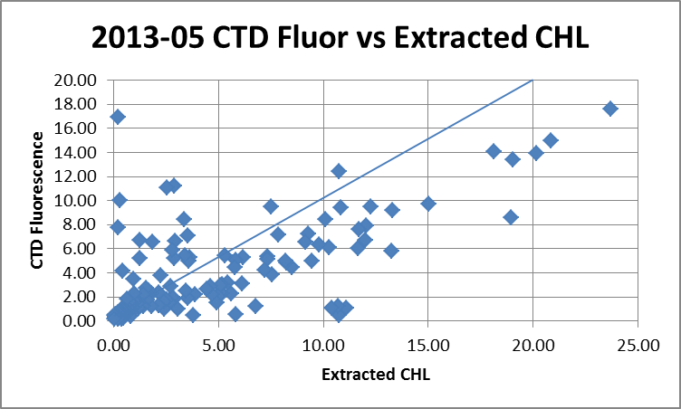

Conversion of Full files from Raw Data
The file names were changed to standard format before conversion.
All files were converted using 2013-05-ctd.xmlcon. The hysteresis correction was not selected since all casts were shallow; the Tau correction will be used.
The altimetry corrections applied to the ROS files were applied at this stage to the CNV files. There may be a few more that need attention later. The station name was added to file #1 as well.

All channels were plotted for a few casts to check for problems in the conversion. All casts were shallow so variability is high throughout and upcasts are quite different from downcasts in the top 30m or so. The temperature channels track reasonably well in the better-mixed areas. The conductivity channels track reasonably well overall, but there is a lot of noise, especially in upcasts. Transmissivity, altimetry, PAR, Spar and Fluorescence traces look normal. The dissolved oxygen has the usual offset, but the high temperature gradients in a shallow cast will challenge the instrument, and we can expect a problem aligning the data, especially since there are frequent stops for all casts so the upcast cannot be expected to match the downcast. Descent rates are mostly high and sometimes very high.

WILDEDIT
Program WILDEDIT was run to remove spikes from the pressure, conductivity & temperature only.
Parameters used were: Pass 1 Std Dev = 2 Pass 2 Std Dev = 5 Points per block = 50
The parameter “Keep data within this distance of the mean” was set to 0 so all spikes would be removed.

ALIGN DO
There are so many stops for bottles and while the range of DO values is small, there is a lot of variability in temperature and dissolved oxygen, so the usual tests are not helpful in deciding how to align the data, except to indicate that some shift is needed. The value used for 2010-05 was applied since this was the same sensor as used then. The same sensor was also used for 2011-18 when a lower shift was used but the sensor was found to need repairs after that cruise.
ALIGNCTD was used to advance the DO Voltage by 5s relative to the pressure.
Tests messy but +2.5s appears to improve things

CELLTM
As for ALIGNCTD tests are not helpful for these shallow casts with so many stops and high variability, so settings were used that are always found reasonable, and often the best choice.
CELLTM was run using (α = 0.0245, β=9.5) for both the primary and secondary conductivity.

DERIVE
Program DERIVE was run on all casts to calculate primary and secondary salinity and dissolved oxygen concentration (using the Tau correction).

Tests
Normally a second run of DERIVE is done to study the differences between channels for a few test casts, but these casts are so shallow that little can be learned from that. However, tests were run at this point to compare the pre-cruise calibrations with the post-cruise, with particular attention to the dissolved oxygen. In the course of that study it is easy to do a check of channel differences as well. The data were put through Loop Edit and then bin-averaged to 1m bins. Cast #50 was chosen as being the deepest and coming from the end of the cruise may show how much drift occurred during the cruise.
See spreadsheet 2013-05-0050-comparisons.xlsx for details.

First, the differences between channels were considered.
- The temperature channels were extremely close when the pre-cruise calibrations were used.
- The temperature channels were extremely close when the post-cruise calibrations were used.
- The salinity channels were close when the pre-cruise calibrations were used with the secondary higher than the primary by a median value of 0.001psu. There was a high standard deviation in the differences.
- The salinity channels were close when the post-cruise calibrations were used with the secondary higher than the primary by a median value of 0.0012psu. There was a high standard deviation in the differences.
So there was likely some drift in the secondary conductivity channel but not as much as reported in December 2012 (see section 15). There was another cruise between this one and December 2012; it is likely that most of the drift occurred after 2013-05.

The differences between the values using pre-cruise and post-cruise calibrations are as follows:
- Temperature:Primary varied by ≤0.0001C°.
- Temperature:Secondary was higher using the post-cruise calibration by 0.0005 to 0.0006C°.
- Salinity:T0:C0 was higher by from 0.0006 to 0.0010psu using the pre-cruise calibration.
- Salinity:T1:C1 was lower by from 0.0085 to 0.0113psu using the pre-cruise calibration.
- Oxygen:Dissolved:SBE was lower by 0.742 to 1.080mL/L using the pre-cruise calibration.

These results are in line with the calibration report (see section 15). Taken together with the study of channel differences, this suggests that most of the calibration drift in temperature and salinity sensors occurred after this cruise.

For the dissolved oxygen sensor the report was vague: “Drift since last calibration is +/- 0.05 ml/l over range 1 to 7ml/l (from 1 Nov 2012 to 11 Dec 2013).” We do not have DO values in that range. Even for the values closest to 7mL/L the differences are much larger than 0.05mL/L. This may be related to low temperatures associated with these data or there may have been damage to the sensor at some point.

If the differences are plotted against the pre-cruise DO values and a trendline is forced through the origin, the correction found is DO (post) = 1.1051 * DO (pre). This is not a reliable fit; any others suggested by the distribution would lead to either a much higher slope or a very large offset.

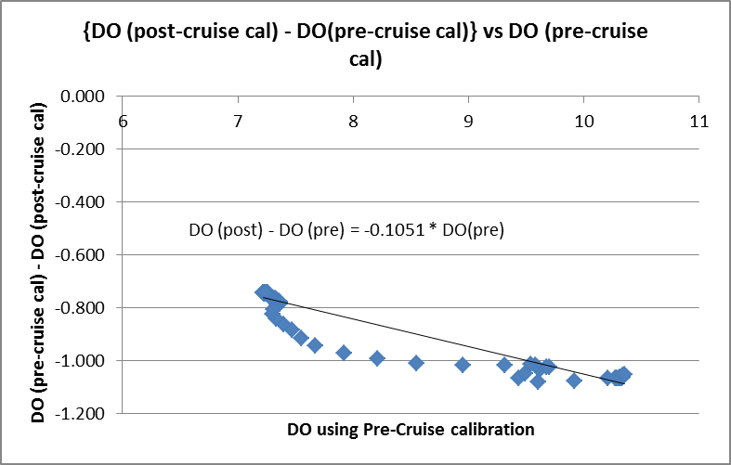

Looking at individual values, the errors vary from ~10% to 12%. Such a large drift suggests some damage to the sensor. This is confirmed by the service report in which are found the remarks “slow dry tau response found” and “the resolution was lower than expected”. The lid and membrane assembly were replaced at that time. While this confirms there was damage, there is no evidence of when it occurred.

One last comparison was made, looking at casts from the same sites in July 2012. The 2012 data was put in the archive with just a single decimal place due to the lack of information to enable recalibration. When data from near 3m, 10m, 40m and 50m were compared at 3 sites that were visited both years, there were significant differences, with 2013 values lower overall, but since the temperature and salinity are very different as well, so this doesn’t help.

Conversion to IOS Headers
The IOSSHELL routine was used to convert SEA-Bird 911+ CNV files to IOS Headers.
CLEAN was run to add event numbers and to replace pad values in the pressure channel with interpolated values based on record number.

Checking Headers
The header check was run.
- There was a negative pressure value during event #5. This occurred as a spike at the end of the cast when the pumps were off and conductivity also spiked low. The CTD likely came out of the water very briefly. The pressure was between 0.0 and 0.3 during the 45s at the end of the cast. So this suggests that the pressure is quite accurate.
- Fluorescence went off scale during at least one cast reaching a value of 50ug/L; this occurred as a spike during the soak period so should be removed with normal processing steps. There were no other casts with off-scale fluorescence.

Surface check was run and shows an average surface pressure for the cruise was 0.4db, a reasonable value given the method of deployment.

The pressure values look to be accurate – they were checked at sea and the offset applied in conversion used that information.

The cross-reference check was compared with the log book and 2 errors in station names were found and corrected. They were both cases of the entry not being updated from the previous site. No other errors were found.

The altimeter readings and bottom depths from the headers of the CLN files were exported to a spreadsheet. As described in section 4 the check value was calculated and where it was >3m the entry was investigated. As with the rosette files, changing the water depth to match the log book entry produced a better result for all except the last two casts. The last 3 casts were in ice, so it is possible that there were problems with the sounder or the ship had to move to complete the cast. The altimetry looks fine so that was not changed and the water depth may be appropriate for some of the cast, so no change was made to that.

The 10m-soak data need to be removed so that DELETE will select the most appropriate data.
A graphical examination of the files was used to make an estimate of the first record # to be included and CLIP was used to remove all records before that. Plots were made after CLIP and some settings were fine-tuned until enough data are removed to ensure that DELETE will select the appropriate data.

The cruise tracks (with event #s and station names) were plotted and added to the end of this report. No problems were found.

Shift
The casts are too shallow, have too many stops for bottles and data too variable to allow meaningful testing of alignment for conductivity and fluorescence. The same sensors were used for 2010-05, 2011-18 and 2012-09 so the settings used in alignment for those cruises were applied for this cruise. Plots were examined before and after and the alignment was improved by these steps.

Fluorescence
SHIFT was run on all casts to advance the SeaPoint fluorescence channel by +24 records.

Conductivity
SHIFT was run applying an advance of -0.4 records to the primary conductivity and -0.6 records to the secondary conductivity.

Dissolved Oxygen
The Dissolved Oxygen voltage channel was aligned earlier. There is no obvious further adjustment that would improve the comparison between downcast and upcast traces.

DELETE
The following DELETE parameters were used:
Surface Record Removal: Last Press Min
Maximum Surface Pressure (relative): 10.00
Surface Pressure Tolerance: 1.0 Pressure filtered over 15 points
Swells deleted. Warning message if pressure difference of 2.00
Drop rates < 0.30m/s (calculated over 11 points) will be deleted.
Drop rate applies in the range: 10db to 10db less than the maximum pressure
Sample interval = 0.042 seconds. (taken from header)
COMMENTS ON WARNINGS: The were no warnings.

Other Comparisons
Previous experience with these sensors – This was the first known use of the temperature, conductivity and dissolved oxygen sensors after the previous factory calibration; they were used for one other cruise before going to the factory for a post-cruise calibration. The pressure sensor was calibrated in late 2009, but checks made at sea in 2013 were used to update the offset parameter.

Post-Cruise Calibration -
Summary of pre and post cruise sensor calibration’s performed at Sea-Bird Electronics Inc.
Primary Temperature (sn 5048)
Drift since last calibration is -0.00042 C/yr (from 2 Nov 2012 to 7 Dec 2013)
Secondary Temperature (sn 5073)
Drift since last calibration is -0.00005 C/yr (from 2 Nov 2012 to 7 Dec 2013)
Primary Conductivity (sn 3579)
Drift since last calibration is -0.00010 psu/month (from 2 Nov 2012 to 10 Dec 2013)
Secondary Conductivity (sn 3581)
Drift since last calibration is -0.00080 psu/month (from 2 Nov 2012 to 10 Dec 2013)
Oxygen SBE43 sn 1117
Drift since last calibration is +/- 0.05 ml/l over range 1 to 7ml/l (from 1 Nov 2012 to 11 Dec 2013)

Historic ranges – There was no local climatology available. The casts were very shallow and mostly near-shore so a climatology of this area would be of limited value due to high variability.

Repeat Casts –
There were no repeat casts.

DETAILED EDITING
The post-cruise calibration showed insignificant drift in the primary salinity and large drift in the secondary channel, but comparisons with bottle salinity and tracking differences between the two salinity channels showed that any large calibration drift must have happened after this cruise. There is also no really obvious choice based on spikes in the data. The primary channels were chosen for editing and eventual archiving.

The data are quite noisy with many small unstable features near the surface, so a return was made to the shift step to see if varying the alignment made a significant difference; some settings work better at one level while another is better elsewhere. But the value used previously looks like the best choice overall.

CTDEDIT was used to remove large spikes, smaller spikes that appear to be due to instrumental problems and likely to affect the bin-averaged values and records corrupted by shed wakes including some surface records and records from near the bottom. All cast required some editing.

The CTD was lowered to about 10db and returned to the surface. After a short stop it was then run through the full cast. The stop was often less than 15s. If it is safe to wait longer before running the downcast, it is recommended that the wait be increased to at least 30s. That may improve the quality of data in the top 5m where there were often unstable features that were difficult to edit as it was not clear which data to remove and which to leave. Ship effects may also be a factor in this noise.

Plots were made to see if further editing was required. Many unstable features remain but most are fine-scale. A few were re-examined in CTDEDIT to see if further editing would be useful and in a 3cases extra editing was applied.

Initial Recalibration
Pressure, temperature and salinity do not need recalibration and there is insufficient information to enable recalibration of Dissolved Oxygen.
No recalibration was applied.

Special Fluorometer Processing
A median filter, fixed size=11, was applied to the fluorescence channel in the COR1 files to reduce spikiness. A few casts were examined before and after this step and showed that the filter was effective.

BIN AVERAGE of CTD files
The following Bin Average values were applied to the FIL files (output AVG):
Bin channel = pressure Averaging interval = 0.5 Minimum bin value = .000
Average value will be used. Interpolated values are NOT used for empty bins.
After averaging, page plots were examined on screen. Many unstable features remain as described in section 16. Very heavy editing would be needed to remove them and often the unstable feature is due to a very small reversal in salinity. No further editing was applied.

Bin Average was run a second time to include standard deviations for all channels. Those files have extensions AVGSTD.

Final CTD File Steps (REMOVE and HEADEDIT)
REMOVE was run on the AVG files to remove the following channels (Output *.REM):
Scan_Number, Temperature:Secondary, Salinity:T1:C1, Conductivity:Secondary, Oxygen:Voltage:SBE, Altimeter, Status:Pump, Descent_Rate and Flag
REMOVE was run on the AVGSTD files to remove (Output: *.REMSTD):
Scan_Number, Scan_Number:STD, Status:Pump:STD, Flag and Flag:STD

A second SBE DO channel (with umol/kg units) was added to both the REM and REMSTD.
REORDER was run to get the two DO channels together.

HEADER EDIT was used to fix formats (reducing DO format to 6.1 because no reliable calibration info is available and channel names and to add the following comments:

Data Processing Notes:
----------------------
The event numbers used correspond to those on the rosette log sheets, but not to those
in the Daily Science Log Book. See document "2013-05-event-number-guide.csv" to relate
the two sets of event numbers.

Transmissivity, Fluorescence:SeaPoint, PAR and PAR:Reference are nominal and unedited
except that some records were removed in editing temperature and salinity.

There was no calibration sampling for dissolved oxygen, and damage to the sensor was
noted in December 2012. It is not know when the damage occurred; it may have been
after this cruise. Calibration drift in this type of sensor generally leadss to values
that are low, but we cannot predict by how much. Values are nominal and are reported
with 1 less significant figure than usual.

Salinity drift was not significant.

For further processing details see the processing report 2013-005_Processing_Report.doc.

The Standards Check routine was run and the only report was about the dissolved oxygen formats being non-standard, but that was done deliberately.
The Header Check was run and one station name was found to be wrong; that was corrected.
The cross-reference list was produced and no problems were noted.
The final files were named CTD.

Profile plots were made and look ok.
The track plot looks ok.
The sensor history files were updated.

Dissolved Oxygen Study
As a final check of dissolved oxygen data, % saturation was calculated and plotted. The near-surface values ranged from 88% to 125% with the highest values in the Chukchi Sea. These values are reasonable, but by about 5% than in the same area in 2012; calibration sampling was also unavailable for that cruise.

Final Bottle Files
The MRGCLN2 files were put through SORT to order on increasing pressure.

REMOVE was run on the MRGSORT files to remove the following channels (Output *.MRGREM):
Scan_Number, Temperature:Primary, Salinity:T0:C0, Conductivity:Secondary, Oxygen:Voltage:SBE, Altimeter, Status:Pump, Descent_Rateand Flag.

A second SBE DO channel was added with different units and REORDER to get the 2 SBE DO channels together.

HEADER EDIT was run to fix formats and units, fix a few headers, change the channel name Bottle_Number to Bottle:Firing_Sequence and the name Bottle:Position to Bottle_Number, to fix the platform name and to add a comment about quality flags and analysis methods and a few notes about the CTD data.

A header check was run on the final files until all problems were found and addressed.

For a final check the CHE bottle data were exported to a spreadsheet and compared with the rosette log sheets and no errors were found. Many samples were indicated to be duplicates on the rosette sheet, but in most cases analysts used the second sample only for a precision study and did not average duplicates.

Standards check was run on all files. There were warnings concerned deliberate changes in formats from the standard ones. There were also slightly negative values for Nitrate_plus_Nitrite in casts #35 and 37.which were replaced with a zero values.
A cross-reference list turned up errors in station name format; those were fixed.
The track plot was produced on screen and no errors were found.

The cruise plot was added to the end of this report.

Thermosalinograph Data
Date were provided in 3 hex files.
The TSG files have non-standard format that include the wrong cruise number and a space in the name that causes problems. The file names were adjusted and then the files were converted to ensure the data are really from 2013-05 and they are.

Document “2013 TSG and Underway Log.xls” contains details on loop sampling and a few comments about other issues.

a.) Checking calibrations
The calibrations were checked and no errors were found.
One XMLCON file was saved as 2013-005-tsg.con.

b.) The files were converted to CNV files using the configuration file 2013-005-tsg.con.
Initial plots showed a lot of single-point spikes in the salinity and conductivity traces, but not in temperature.
Conversion was done again including pressure but not salinity, so that salinity could be derived after taking steps to reduce the spikiness of the conductivity.

Tests were done to see if WILDEDIT improved the data. Many settings tested removed even tiny spikes that may well be real, but good results were found with the following:
Parameters used were: Pass 1 Std Dev = 2 Pass 2 Std Dev = 10 Points per block = 100
(Running WILDEDIT directly on salinity also worked well but applying it to the conductivity made more sense and also worked well.)
DERIVE was then run to derive salinity.

The files were then converted to IOS HEADER format.
A check was made of fluorescence and the minimum values measured were 0.037, 0.061 and 0.098ug/L for the 3 files. This shows that the Vblank value is reasonable. The maximum fluorescence was 15.12ug/L.

CLEAN was run to add End times and Longitude and Latitude minima and maxima to the headers.
ADD TIME CHANNEL was used to add Time and Date channels based on the Julian time.

Time-series plots were produced. A few problems were noted:
File 2. – The temperature starts to rise at about 0400 on July 14 and continued for about 1.5 hours. It is noted in the loop document that the pump was turned off intentionally to reduce spray on the port breezeway.
File 5 – There was another section where it appears that the pump was off, but there is no note about this one.
File 9 – There is a section with very little change, but no rise in temperature so the flow is probably ok. The log does not indicate any activity during that time but there is little change in position, so there likely was a stop.

The track plot shows one bad position for 2 scans in file #2 (scans 36708 and 36709). There was no change in position between the scans bracketing the problem, so the same values were entered for the two null values. This was done to the CLN file and ATC was rerun so the values in the headers were updated.

c.) Editing
All files were opened in CTDEDIT to remove bad data.
File #1- Removed salinity, temperature, fluorescence from section with pump off and cleaned salinity lightly.
File #2 – Removed salinity, temperature, fluorescence from 2-hour section when the pump appears to have been turned off and cleaned salinity lightly.
File #3 – Salinity cleaned lightly.

d.) Bin-averaging
The files were bin-averaged over 6 scans.

e.) Checking Time Channel
The CTD data were thinned to reduce the files to a single point from the downcast at or within 0.5db of 5db.

All files were opened in EXCEL and reduced to the times of CTD files. There were 48 matches.

To check for problems in the TSG clock or bad matches of TSG and CTD data, the differences between latitudes and longitudes were found. The average and median differences in latitude and longitude were all <0.0001° The largest difference in latitude was 0.00024°, but there was a fairly large difference in one longitude at 0.00171°. That case was checked and it was found that only 40s before the start time of the CTD cast, the TSG did record a position that would match. So there appears to have been slightly larger drift than for other casts. The drift through the CTD cast is also a little high.

This comparison shows that both the times and positions are reliable for both systems.
This spreadsheet will also be used in step (f) to compare temperature, salinity and fluorescence from the CTD and TSG.

f.) Comparison of T, S and Fl from Loop and Rosette samples and TSG and CTD data
- T1 vs T2 The intake thermistor was connected throughout the cruise. The differences between the two TSG temperatures were between 0.16 and 0.53Cº with a median of 0.26Cº, but if the cases are excluded in areas where log notes indicate the presence of ice, the largest difference is 0.34Cº while the median is just slightly lower at 0.25 º. As expected, the heating in the loop is greatest where intake temperatures are lowest.
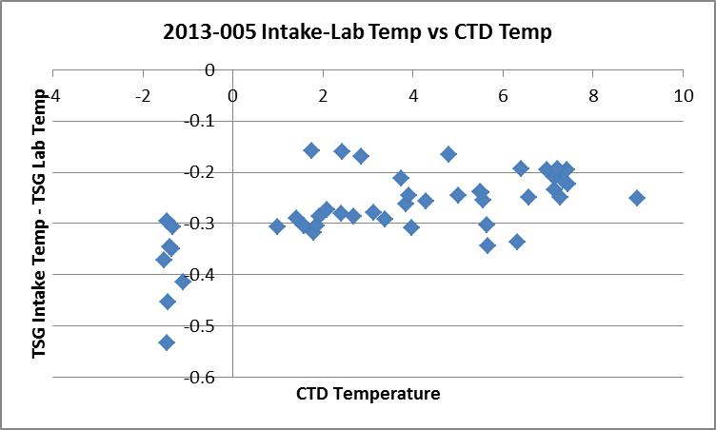

- TSG vs CTD The spreadsheet comparing CTD and TSG files was examined to find the differences between the salinity, fluorescence and temperature channels for the CTD and the TSG.
The TSG salinity is lower than the CTD salinity by an average of 1.6psu, a median of 0.018 and a standard deviation of 3.53. The range of differences is very large. The large differences come from a time when there are many notes in the log about being in ice. When only casts from before the first mention of ice are included the TSG is low by an average of 0.019 and a median of 0.006psu; the standard deviation is 0.07psu.
When all data were included the TSG intake temperature was higher than the CTD by average of 0.146Cº; the median difference was 0.164Cº and the standard deviation was 0.8Cº. When only casts are included that came before the first log note about being in ice, the TSG is found to be high by an average and median of 0.135Cº.
The ratio of TSG fluorescence to CTD fluorescence ranges from 0.15 to 1.7 with a median of 0.88.and standard deviation of 0.27ug/L. When areas where there was ice are excluded there is little difference in the average and median, but the range is smaller: 0.5 to 1.4. The 3two low points at about 4 to 5ug/L on the graph below come from casts where ice was noted in the log.
(See 2010-05-ctd5-tsg-comp.xls.)
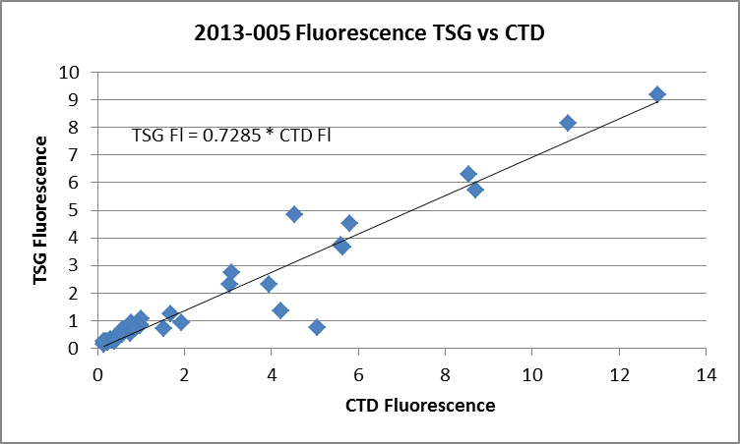

- Loop Bottle - TSG Comparisons A spreadsheet was prepared by combining all loop sample data with TSG salinity. TSG data were extracted by matching times. In 2 cases there were very large differences that proved to be due to errors in the dates for the loop samples. The TSG log provided the correct data and those matches were much better. The TSG is lower than the bottle salinity in all cases. The median difference was -0.035psu with a standard deviation of 0.033psu and a range of -0.005 to -0.104psu. The samples were not analyzed until a year after collection so would expect some evaporation of samples which could explain being low by 0.03psu, though it seems unlikely to be low by 0.1psu. (See 2013-05-tsg-loop-comp.xls.)

- 5m rosette samples – To do a few more checks against CHL, the 5m rosette values were extracted and combined with the TSG fluorescence and salinity. The times were matched but it was based on the start times for the casts, so there will be significant errors due to the difference in time. (See file 2013-05-TSG-Rosette-comp.xlsx.)
The TSG fluorescence has a median value of ~0.95 times the rosette bottle values based on 30 bottles, but the range was from 0.04 to 4.0. Excluding the data collected in areas where ice was noted reduces the range greatly, and slightly reduces the median ration to 0.9. As usual the ratio of TSG Fluorescence to Extracted CHL is high for low CHL and settles to about 0.5 once CHL reaches about 5ug/L.
The ratio is ~0.9 when CHL is about 0.3ug/L and ~0.20 when CHL is about 1ug/L. The median value is higher than in the loop bottle comparison, but that is likely because there are fewer high CHL values in the rosette comparison. Given the many sources of error the results of the two comparisons are reasonably consistent.
The TSG salinity is lower than the bottles by an average of 0.8psu but by a median of only 0.01 when all bottles are included. When those from the area with ice reports are excluded the median difference is the same but the average is much lower at -0.03psu.

- Calibration History
The TSG primary temperature and conductivity were recalibrated in November 2012. There was a post-cruise calibration in November 2015. At that time the temperature was said to have drifted by +0.00044 C°/year and the salinity to have drifted by -0.0005psu/month. If the drift was linear with time the temperature would have been high by 0.0002C° at the time of this cruise and the salinity low by 0.003psu. The drift in the external temperature sensor was +0.00001Cº per year.

Conclusions
1. The TSG clock appears to have worked well.
2. The temperature in the loop increases by about 0.34Cº, but there is a large range, which is to be expected when intake temperatures vary greatly.
3. The TSG intake temperature reads higher than the CTD by about 0.14Cº.
4. The TSG Salinity appears to be reading lower than the CTD by about 0.006psu when not in ice. It is lower than loop samples by a median of 0.035psu and none of those samples appear to have been taken when in ice. However, the loop samples waited over a year to be analyzed so evaporation may have raised those values. The TSG salinity is lower than the 5m rosette salinity by about 0.01 in the areas with no ice reported; the rosette samples may come from slightly deeper waters due to incomplete flushing of Niskin bottles so values may be higher than in situ waters. The post-cruise calibration report suggests that the TSG salinity may be low by 0.003, but only if we assume linear drift. The comparison with the CTD and the post-calibration estimate are reasonably close; both suggest a small error, at most.
5. The fluorescence from the TSG is about 90% of that from the CTD and about 90% of the CHL samples from the 5m rosette.
6. The presence of ice has a very big influence on TSG salinity, a small one on temperature and is variable with regards to TSG Fluorescence, keeping values lower than those from the CTD for a few casts, but not others.
7. Given that the TSG salinity appears to be lower than that from the CTD and the temperature higher, it is possible that the water entering the loop may have been drawn from slightly higher than 5m. We don’t have much CTD data above 3.5m, so we can’t judge this well. The differences in temperature are quite large while those in salinity are mostly small except in the areas of ice cover. That may be because salinity is better mixed near the surface than temperature. It is also possible that there is some slight heating of the water at the intake. The post-cruise drift estimate was near-zero for the intake temperature sensor.

g.) Recalibration
No recalibration is justified given all the uncertainties in the comparisons.

i.) Preparing Final Files
REMOVE was used to remove the following channels from all casts: Scan Number, Temperature:Difference, Conductivity:Primary, Flag and Position:New.
REORDER was run to change the order of channels.

The START and END positions in the headers are incorrect for file 2013-005-0005.REO; the bad values found earlier were replaced but the header was not updated. So CLEAN was run on the ATC file to obtained the update. That information was then replaced in other files for this cast.

HEADER EDIT was used to add a comment, change the DATA TYPE to THERMOSALINOGRAPH and add the depth of sampling to the header. Those files were saved as TOB files.
The TSG sensor history was updated.
As a final check plots were made of the cruise track and it looks fine.
The cruise plot was added to the end of this report.

Producing final files
A cross-reference listing was produced for CTD and CHE files.
The sensor history was updated.

Particulars

1. Bottles 6, 7 and 9 nozzles clogged with something – maybe old paper tissue.
2. Bottle 5 top valve loose but spigot ok.
3. Bottle 4 slow drip.
4. Bottles 13 and 18 – something stuck in spigots
39. Bottles 14-16 – no sampling and no sample numbers assigned.
46. Bottle 2 and 3 – no sample numbers assigned. Bottles 4, 5, 6 have sample #s 282, 283, 284.
47. Bottle 2 has no sample number. Bottles 3, 4, 5 have sample #s 286, 287, 288.

Institute of Ocean Sciences

CRUISE SUMMARY
CTDs
CTD# | Make | Model | Serial# | Used with Rosette? | CTD Calibration Sheet Competed?
1 | SEABIRD | 911+ | 0941 | Yes | Yes

Calibration Information CTD #506
Sensor |  | Pre-Cruise |  | Post Cruise
Name | S/N | Date | Location | Date | Location
Temperature | 5048 | 2Nov2012 | Factory | 9Dec2013
Conductivity | 3579 | 2Nov2012 | Factory | 10Dec2013 | Factory
Secondary Temp. | 5073 | 2Nov2012 | Factory | 7Dec2013
Secondary Cond. | 3581 | 2Nov2012 | Factory | 10Dec2013 | Factory
Transmissometer | 1050DR | 24June2013 |  | 12June2014
SBE 43 DO sensor | 1117 | 2Nov2012 | Factory | 11Dec2013 | Factory
SeaPoint Fluorometer | 2745
PAR | 70123 | 13Mar2007
Surface PAR | 20281 | 13Mar2007
Pressure Sensor | 941 | 07Dec2009 | Factory
Altimeter | 40853

