REVISION NOTICE TABLE
DATE | DESCRIPTION OF REVISION
13 June 2017 | Convert CTD files from UNIX to DOS text format. Roy Hourston.
10May 2018 | Added vessel name Seaveyor 1 to CTD file headers

PROCESSING NOTES
Cruise: 2012-36
Agency: IOS, IOS, Ocean Sciences Division, Sidney, B.C.
Party Chief: Tuele D. Location: Kyuquot Sound
Project: Kyoquot Circulation Platform: Surveyor 1
Date: 7 June 2012 – 9 June 2012

Processed by: Germaine Gatien
Date of Processing: 15 June 2012 - 26 June 2012
Number of original CTD files: 37 Number of CTD casts processed: 32

INSTRUMENT SUMMARY
A SeaBird Model SBE-25 CTD (s/n 0334) was used.

SUMMARY OF QUALITY AND CONCERNS
The pressure sensor has drifted by about 2.5db since December 2010.

The log included information from another cruise which is confusing. The practice of entering several cruises in a single log is based on the desire to avoid wasted paper for short cruises. Perhaps a special format log could be produced in house for such short, small-boat cruises with water-proof paper and just a few pages. The log entries were in good order with no mention of any problems.

The CTD was soaked at the surface for about 2 minutes which was adequate for equilibration.

The times in the log are in UTC while the computer times in the raw files are in PST with a 1-day error in date. The times in the headers of the archived files are in UTC with the correct date.

There were 2 salinity samples. The comparisons are insufficient to assess accuracy with confidence, but the CTD salinity data were within 0.004 of the bottles.

The transmissivity calibration entered in the configuration file produced unbelievably high values (>90%/m), so a post-cruise calibration was done and the new parameters were used to recalibrate the data. The values are still rather high, but possible given high freshwater input to this region in spring.

PROCESSING SUMMARY

1. Seasave - This step was completed at sea; the raw data is in a single HEX file. The file names were non-standard.

2. Preliminary Steps
The Daily Log was obtained. Because there is information about 2 different cruises in the log book; the equipment list is not accurate for this cruise. There was a note about which CTD was used, but none of the other information about ship name, project name and added sensors were available. It is understood that it looks like a waste of paper to use separate books for cruises with few casts. Special logs for such short, small-boat cruises might be a help with waterproof paper and very few pages. Perhaps this might be fabricated in-house.

There were notes about problems with the CTD clock which was believed to be 1 day late and 1 hour early, so that 06/08/2012 15:41:02 PDT should be 06/07/2012 16:41:02 PDT. Subtracting 23 hours will fix this, but then 7 hours should be added to get UTC; so a net correction of -16 hours is appropriate.

There were 2 salinity bottle samples collected from a Niskin bottle placed 1m above the CTD during event #11.

The cruise summary sheet was completed.

The configuration file used at sea was checked and no errors were found; though the transmissivity calibration was not available to check. The file was saved as 2012-36-ctd.xmlcon.

3. Conversion of Raw Data
All initial attempt to convert the files using 2012-36-ctd.xmlcon failed because the temperature and conductivity sensor numbers were entered as -9 rather than 5013 and 3531 in the hex files; those serial numbers were replaced with -9 in the configuration files which was then saved as 2012-36-ctd2.xmlcon.
One cast could not be converted but it obviously contains no data.

Some of the file names contain the station name, but those appear to be copies of others that contain the event numbers. Most file names have a format like 02-31002.hex, which appear to be from events #2 to 29. There are 5 files with names K029.hex to K033.hex. This means there are 2 files which appear to be from event #29 but they are not identical; a plot shows that the first one is missing some data from the end and the 2nd (K029.hex) is complete.

Plots of temperature, conductivity and transmissivity look fine, but the pressure looks off. On the most recent use of this equipment pressure was recalibrated by adding 2.5db. Plots of conductivity show that the surface is between -2.2 and -2.7db. Using the value of 2.5db looks reasonable. Configuration file 2012-26-ctd2.con was adjusted by adding the offset and the data were reconverted.
Plots of the second run show better results.

The 2 casts from event #11 are contained in a single file and will have to be separated later.
File names were changed to standard formats and the CNV files that were copies were deleted.

4. WILDEDIT
This step is usually skipped and since there is no evidence of spikes it was not run.

5. WFILTER
WFILTER was run using cosine filter, size 5 on the pressure, temperature and conductivity channels. Plots were made before and after this step. Most reversals disappear from the pressure after this step but the trace is not overly smooth. When salinity was derived on filtered files it was much smoother than the unfiltered version, but temperature and salinity still have some reversals as expected.

6. CELLTM
SeaBird recommend the use of (α, 1/β) = (0.04, 8) for CELLTM for the SBE 25. A variety of settings were tested – all improved the data with the best choice varying from feature to feature, but the recommended setting was at least as good as any other and definitely better than not using CELLTM.
CELLTM was run on all casts using (α, 1/β) = (0.04, 8)

7. DERIVE
Program DERIVE was run to calculate salinity.
File 2012-36-0011.cnv was put through SECTION to create a file with the 2nd lowering of the CTD. The output file was renamed 2011-36-9011.CNV.

8. Conversion to IOS Headers
The IOSSHELL routine was used to convert the CNV files to IOS Headers.
CLEAN was run to add event numbers based on the file names.

9. Checking Headers
A spreadsheet was prepared containing file name, latitude, longitude, station name and water depth with the information taken from the log book. The file was saved as 2012-36-header.csv.

IOS SHELL program “MERGE:CSV file to headers” was used to add information from the csv file to the IOS files with output MRH.

A cross-reference listing was produced and checked against the log entries and no errors were found in positions. The times are wrong with the date always 1 day later than it should be. The times are roughly 1 hour too early, but the differences vary from 45 minutes to 60 minutes. The computer is trusted more than the log book since there were several people involved in the latter including the vessel operator.

ADD TIME CHANNEL was used to subtract 16 hours. (-24 hours for error in day +8 hours from PST to UTC)

A track plot was run and looks fine.

HEADER CHECK was run. The only potential problem was negative pressures, but these are all at the end of the upcast and the associated transmissivity was 0.

The surface check shows an average of 1.1db.

Profiles were examined for all casts and problems were found in casts 4 and 44 where the upcast and downcasts are very different. In both cases the transmissivity shows that the CTD touched bottom and the upcast data were likely affected by that. For cast #33 which was deeper than #4 the problem clears before the CTD gets back to the surface.

10. Salinity bottles
There were 2 salinity samples, taken about 1m above the CTD during casts #11 and 23. They were analyzed within 2 weeks of collection. The salinity near the bottom was fairly quiet. The event #11 sample was compared with the 2nd lowering of the CTD since that was deeper than the first and corresponds to when the bottle was fired. The CTD was lower than the bottles by 0.004 and <0.001. This is as close as one could expect to come given the local gradients.

Event # | Station | Salinity:Bottle | Bottom Pressure | CTD Salinity 1m above bottom downcast | CTD downcast - bottle
11 | VI13 | 32.8905 | 114.2 | 32.8866 | -0.0039
23 | KC3 | 32.9655 | 130.4 | 32.9650 | -0.0005

11. SHIFT
Conductivity
Tests were run using values from -3 to +3 but there was no observable change, presumably because salinity is so well mixed for these casts. SHIFT was not run.

12. DELETE
DELETE was run on all casts using the following parameters:
Surface Record Removal: Last Press Min. Surface Swell Pressure Tolerance: 1.0
Swells deleted. Warning message if pressure difference of 2.00
Drop rates < 0.2m/s (calculated over 5 points) was deleted from 10db to 10db above the maximum pressure.
COMMENTS ON WARNINGS: There were no warnings.

Casts #11 and #9011 were compared and are remarkably close given they are shallow, with differences in both temperature and salinity on the order of 0.002 along lines of constant density.

13.DETAILED EDITING
All files needed a little editing. CTDEDIT was used to remove records near the top and bottom of many casts and a few records corrupted by shed wakes. It was also used to clean salinity where unstable features looked likely to be caused by misalignment of T and C.

From this point onwards for event #11 the 2nd drop will be selected for processing since that was when the bottle was actually fired. So file 2011-36-9011.del was chosen for editing and saved as 2011-36-0011.ED1.

Notes of editing details were made in the headers.
T-S plots were examined and no further editing was found necessary.

- Inter-comparisons
Sensor History – This CTD was used during 2012-26 when there were 3 salinity bottles in fairly shallow water with salinity fairly noisy. The CTD was considered to be within 0.01 of the bottles, but the results varied from the CTD being high by 0.002 to being low by 0.06. The pressure was found to be reading low by about 2.5db.
Comparison of repeat casts –The only repeat cast was the 2 lowerings during cast #11. As described in section 12 the repeatability was excellent.
Historic Ranges – There is no local climatology available for this area.
Post-cruise calibrations – None available.

- Bin Average and REMOVE
The files were bin averaged using 1db bins.

REMOVE was run to remove Scan_Number, Conductivity:Primary, Descent Rate and Flag channels.

No recalibration will be applied to pressure since it was adjusted at the conversion stage and the salinity comparison looks good. However, the transmissivity looks too high, with a maximum of 90%/m. That was based on a calibration done in February 2011, but the measured values are not available for review, just m and b, and the results are unbelievable. The CTD technician did a post-cruise calibration, from which new values were calculated for m and b. A correction to the transmissivity using the 2011 parameters was determined as follows

Correction to Transmissometer 498DR
 | m | b
Used in original conversion | 24.573 | -1.2778
From June 25 calibration | 22.0198 | -1.2265

Trans (corrected) = (Trans (Original) + 1.2778) * (22.0198/24.5730) - 1.2265
= 0.8961 * Trans (Original) +1.145033 - 1.2265
= 0.8961 * Trans (Original) – 0.0815
Using that correction the original maximum of ~90%/m will become ~80.6%/m. That is much more believable.

CALIBRATE was run to apply a correction with scale factor 0.8961 and offset -0.0815. Plots were made of the results and the transmissivity still seems a little high, but not unbelievable. A few small negative numbers were created in the process, so CLEAN was run to replace those with pad values and to reset the header limits.

- HEADER EDIT and final checks
Header Edit was used to fix headers, fix formats and channel names and to add the following note to the headers:
Data Processing Notes:
----------------------
Transmissivity data are nominal and unedited, except that some
records were removed in editing temperature and salinity.
The parameters used in the original conversion of transmissivity
produced unbelievably high values, so a post-cruise calibration was
done and a correction applied..

There were only 2 salinity calibration samples; the CTD was
within +/-0.004 of those bottles.

For details on the processing see processing report: 2012-36-proc.doc.

A cross-reference listing was produced.
A header check was run on the CTD files and no further errors were found.
The sensor history was updated.

Particulars
11. Calibration bottle did not trip, so there was a second drop to do that.
23. Calibration bottle

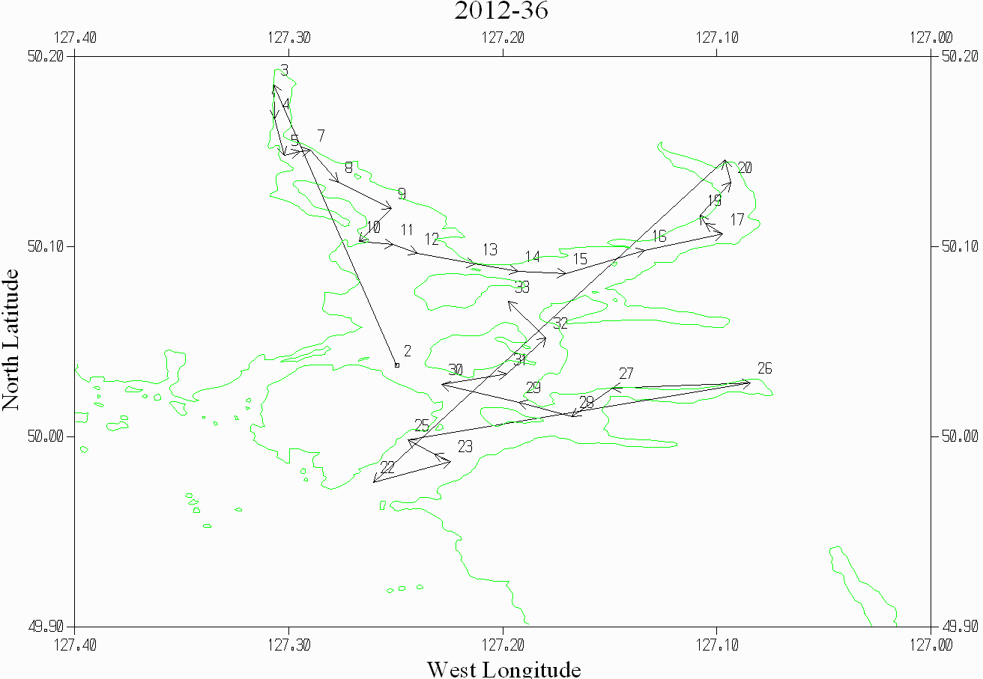

CRUISE SUMMARY

Cruise ID#: 2012-36
Dates: Start: 7 June 2012 End: 9 June 2012
Location: Kyuquot
Party Chief: Tuele D.
CTD# | Make | Model | Serial# | Used with Rosette? | CTD Calibration Sheet Competed?
1 | SEABIRD | 25 | 0334 | No | Yes

CTD CALIBRATION INFORMATION
Make/Model/Serial#: SEABIRD/SBE25/0334 Cruise ID#: 2012-36

Calibration Information
Sensor |  | Pre-Cruise |  | Post Cruise
Name | S/N | Date | Location | Date | Location
Temperature | 5013 | 30Dec2010 | Factory
Conductivity | 3531 | 29Dec2010 | Factory
Transmissometer | 498DR | 10Feb2011
Pressure | 0464 | 17Jan2011 | Factory

