REVISION NOTICE TABLE
DATE | DESCRIPTION OF REVISION
1 April 2025 | Updated channel names & formats in TOB files. GG
25 Feb 2025 | Corrected channel name for channel Nitrate_plus_nitrite:ISUS in CTD and CHE files. G.G.
20-Jul-2011 | Changed instrument serial number in the thermosalinograph files from 2487 to 2488.

PROCESSING NOTES
Cruise: 2010-28
Agency: OSD
Location: WCVI / Strait of Georgia
Project: La Perouse / Effingham Inlet/Aquaculture/SoG
Party Chief: Spear D.
Platform: John P. Tully
Date: April 28, 2010 – May 5, 2010

Processed by: Germaine Gatien
Date of Processing: 7 March 2011 – 17 March 2011
Number of original CTD casts: 38 Number of CTD casts processed: 37
Number of bottle casts: 26 Number of bottle casts processed: 26
Number of original TSG files: 1 Number of TSG files processed: 1

INSTRUMENT SUMMARY
A SeaBird Model SBE 911+ CTD (#0506) was used during this cruise. It was mounted in a rosette and attached were a Wetlabs CSTAR transmissometer (#1005DR), a SBE 43 DO sensor (#1176) on the primary pump), a Seapoint Fluorometer (#2345) with a 10X cable (on the primary pump) and an altimeter (#1024). There was an ISUS mounted for the first 3 casts only. Casts were run with deck unit 0424. All casts were run on the LARS mid-ship station. Seasave version 7.18c was used. The salinometer used was a model 8400B Autosal, serial # 69086.

A thermosalinograph (SeaBird 21 S/N 2248) was mounted with a Wetlab/Wetstar fluorometer (WS3S-713P), remote temperature sensor #2416 and a flow meter.

SUMMARY OF QUALITY AND CONCERNS

The CTD and rosette logs were generally in good order. There were extensive notes about equipment problems; there were issues with wire, pumps, bottles and data spikes. In one case where 2 bottles were fired at the surface, the rosette log entry for the 2nd bottle was erased. Though no samples were taken, it was fired, so the entry should have been left in place. Drawing a line through an entry is better than erasing it, since it often turns out that the original entry was correct. It at least draws the attention of analysts or data processors to a potential problem.

The precision of the SBE dissolved oxygen channel is considered to be, roughly:
• ±0.6ml/l from 0-100db
• ±0.2ml/l from 100-500db
• ±0.08ml/l from 400-600db
The sensor did not fully equilibrate in the hypoxic layers in Effingham Inlet. If reliable DO sensor data are required in hypoxic waters then a stop near the top of the layer lasting about 4 to 5 minutes would be required. A long stop at the bottom would ensure a good bottle comparison and good upcast data, but would not improve the downcast.

The Oxygen:Dissolved:SBE data for cast #39 were noisy. Where data were obviously bad they were replaced with pad values. There are other areas that look spiky, but it is not clear which data are good and which bad, so no editing was applied to those data.

After this cruise it was discovered that transmissometer #1005DR was giving values that were much too low. Based on many cruises that sampled deep water, a correction factor was derived. These data are still considered nominal since the correction is based on expected values, not calibration checks. The data for this cruise were corrected by multiplying all values by 2.382. For details see document “Transmissometer 1005DR Corrections.DOC” in the Cruise Data\Document folder in the archive.

Data from an ISUS nitrate sensor were processed for 2 downcasts and one bottle file. There were voltages in cast #1 that were <0.4 while the minimum voltage from the bottle file (#6) has a minimum of 0.4 volts. This may explain why there are some negative values in the Nitrate_plus_nitrite:ISUS channel in cast #1. The fit is not as reliable as we would achieve with more sampling. The negative values were replaced with pad values.

No CTD file was produced for cast #6 since it was a repeat of cast #5 and the data quality was low. This is likely due to the very low descent rate.

There was a problem with the thermosalinograph that is probably due to the NMEA device being connected to the deck unit rather than a PC; the same problem occurred through part of cruise 2010-12. Intermittent lines were missing 1 to 4 digits and are missing from the converted file; since time is calculated based on record number the times were wrong. Reorganizing line lengths enabled conversion of all records, and hence fixes the time channel, but there is corruption of other channels, including the intake temperature and fluorescence channels. Extreme values were removed from those channels and then a graphical editor was used to remove more points that look unreliable. There likely remain other corrupted points that did not stand out as outliers. The lab temperature and salinity channels do not appear to have been affected. The intake temperature and fluorescence channels should be considered of lower quality than usual. Calibration of the TSG data was based on the results of 2010-13 (June 2010).

PROCESSING SUMMARY

Seasave
This step was completed at sea; the raw data files have extension HEX.

Preliminary Steps
The Log Book and rosette log sheets were obtained. The ISUS was not entered in the equipment list. There is a good description of many problems that arose during the cruise.
Nitrate, dissolved oxygen and salinity data were obtained in spreadsheet format.
The cruise summary sheet was completed.
The history of the pressure sensor, conductivity and DO sensors were obtained.

There were two configuration files used during the cruise. They were saved as 2010-28-ctd1.con and 2010-28-ctd2.con. The only difference is that there was an ISUS listed on the first version. There is a Surface PAR listed in both, but a test conversion shows it was not actually present (it is not listed in the log) so it was not be converted.
The calibration constants were checked for all instruments. There were a number of changes required:
- The transmissometer calibration date was wrong.
- There was an error in the slope of the pressure calibration and the offset has recently been changed based on other cruise observations.
- The date and parameters for the dissolved oxygen sensor were not from the most recent calibration.
- The dissolved oxygen sensor was recalibrated in November 2009. Fine-tuning of parameters for this sensor was done during 2010-13 and will be applied to these data. (E, H1 and H3 were set to 3.5, -0.033 and 1450 respectively.)
After those errors were corrected the file configuration file was saved as 2010-28-ctd.con.

Conversion of Raw Data
Data were converted using configuration file 2010-28-ctd1.con for casts 1-6 and 2010-28-ctd2.con for casts 10-50.
Casts #5 and 6 had their names reversed in acquisition, so they were changed to match the logs.
A few casts were examined and all expected channels are present.
The temperature and conductivity channels track well on the downcast, and fairly well on the upcast, though there is a lot of noise in the upcasts. The difference between the conductivity channels is unusually large, ~0.002 for both upcast and downcast, except in the top 10 to 15m where they are much larger. The secondary conductivity looks like it is the one performing badly at the surface, and a note in the log suggests that the secondary pump was not performing well. However, the primary also has a few odd spikes in the top 5m.

There are many small spikes in both conductivity and temperature channels. Early in the cruise these are mostly in the upcast data and affect the secondary channels most.
The dark value of the fluorescence is <0.05ug/L. There are a few deep spikes, but the overall shape is ok.
Transmissivity values are, as expected, low. Problems have been found with this transmissometer and a correction will be applied at the CALIBRATE step.
The altimetry usually looks ok, but for cast #39, there are many spikes.
Dissolved Oxygen looks as usual, with an offset between downcast and upcast.

Rosette files were converted using a start time of -5s and duration of 10s. The TAU and hysteresis corrections were chosen. 11 rosette files had no data, so were deleted.
Cast 1 was also deleted since there were no sample numbers and no sampling done.
The file name 2010-28-0005.ros was changed to 2010-28-0006.ros based on log notes.

The rosette files were then converted to IOS SHELL files.
A header check was run to see if there are any off-scale fluorescence values and there were none close to the cut off.

Temperature and salinity were plotted for all BOT files. There were no significant outliers other than at the surface where editing won’t help.

WILDEDIT
Program WILDEDIT was run to remove spikes from the pressure, conductivity, temperature and descent rate channels only.
Parameters used were: Pass 1 Std Dev = 2 Pass 2 Std Dev = 5 Points per block = 50
The parameter “Keep data within this distance of the mean” was set to 0 so all spikes would be removed.

CELLTM
Tests were run comparing a variety of settings for CELLTM. The results were difficult to judge because the data were very noisy and the best setting varied from depth to depth and from cast to cast but overall the best choice was (α = 0.02, β=7) for the primary and (α = 0.03, β=9) for the secondary.
CELLTM was run on all casts using those settings.

DERIVE
Program DERIVE was run twice:
on all casts to calculate primary and secondary salinity and dissolved oxygen concentration.
on a few casts to calculate the differences between primary and secondary channels for temperature, conductivity and salinity. These were placed in a test directory and will not be archived.

Test Plots and Channel Check
A sample of casts was plotted to check for agreement between the pairs of T and C sensors. The differences are often extremely noisy so these are very rough estimates. Data from the near the end of cruises 2009-09 (June) and 2009-51 (July) are listed first so that temporal change can be studied. Note that while the same T and C sensors were used, they were on a different CTD. The sensors were in reverse positions on those two earlier cruises, so the signs of the differences were reversed in the table.

Cast # | Press | T1-T0 | C1-C0 | S1-S0 | Descent Rate
2009-09 | 1000 | 0.0002 | -0.0012 | -0.0145 | V.High, noisy
2009-51 | 280 | ~0 | -0.002 | -0.019 | Mod, V steady
6 | 235 | 0.0005 | -0.0022 | -0.021 | Low, steady
39 | 235  1000 | ~ -0.003 XN  <0.0001 | -0.0023  -0.0021 | -0.024  -0.025 | High., X noisy  High, V Noisy
40 | 235 | -0.0002 | ~-0.0023 XN | -0.024 XN | Mod, V Noisy
The temperature differences are small and show no systematic change.
Conductivity differences are unusually large and have increased from cruise to cruise, but there is no evidence that there was any drift through the cruise. There is too much noise to conclude much.
Salinity differences are larger than usual and again show some drift. The fact that the differences are similar to the earlier cruises may indicate that the large salinity differences are due to conductivity sensors rather than the pump problems experienced during this cruise.

Conversion to IOS Headers
The IOSSHELL routine was used to convert SEA-Bird 911+ CNV files to IOS Headers.
Header Check was run to see if fluorescence values went off-scale. There were high values from cast #11 and a plot shows that the values did look off-scale for values >14.86 ug/L. This cast was from an inlet
CLEAN was run to add event numbers and to replace pad values in the Pressure channel using linear interpolation based on scan number and to replace Fluoresence:Seapoint values >14.86 with pad values.

Checking Headers
The header check was run. No problems were found.

The cross-reference check was compared with the log book and the only problem noted was that there were format inconsistencies in station names; those were corrected in both bottle files and full files.

The cruise track was plotted and added to the end of this report. No problems were found.

The surface values program was run. The average surface pressure was 0.75db which is very low for the Tully, but many of the casts were in inlets and the surface salinity readings are very low, so these are probably accurate pressure readings. During cast #1, the pressure hovers very close to 0 for a long time during the soak period; salinity is very low through that section, <0.3 and fluorescence is close to its dark value, so the pressure looks believable.

The altimeter readings from the headers of the CLN files were exported to a spreadsheet and plots were made of all casts; no significant discrepancies were found.

BOTTLE FILE PREPARATION
The BOT files were averaged to enable an addsamp file to be created. This file was edited to add sample numbers taken from the rosette sheets. The addsamp.csv file was converted to CST files to be used as a framework for the bottle files. It was also used to add sample numbers to the BOT files. The resulting SAM files were bin-averaged. 8 bottles were fired, but only 7 were entered on the rosette sheet for cast #22, though clearly one entry had been erased.

SALINITY
Salinity analysis was done at IOS using Guildline Autosal #Model 8400B, serial #69086. The Autosal data were delivered in spreadsheet 2010-28.xls. The name was changed to 2010-28-sal.xls. There were a few comments, but no flags. There was a single duplicate pair with values that differed by 0.0009.
The spreadsheet was simplified and saved as 2010-28-sal.csv. The duplicate pair was replaced with a single average value and flagged “6”. The two bottles that had a comment about a leaky liner cap were flagged “4”.

The csv file was then converted into individual *.SAL files.

DISSOLVED OXGYEN
Dissolved oxygen data were provided in spreadsheet 2010-28oxy.xls; this included a duplicate study.
The analyst also attached a “2” flag to one sample; that should be examined later in light of COMPARE.

The spreadsheet was simplified, and saved as 2010-28-oxy.csv and that file was converted into individual *.ADD files.

NUTRIENTS
The nutrient data were obtained in spreadsheet 2010-28_Tully-ISUS_Nitr.xls which included a report on precisions. The file was simplified and saved as 2010-28-nuts.csv. Extraneous columns were removed and header names were changed to standard format. The duplicates were replaced with the average and flag “6” was added to those values. File 2010-28-nuts.csv was then converted to individual NUT files.

All the analysis spreadsheet names were changed to include the file save date in case more than one version exists.

The altimeter readings from the headers of the BOT files were exported to a spreadsheet and all casts with readings were checked. Plots were made and the log book was checked. The algorithm worked well.

The SAL, ADD and NUT files were merged with CST files in 3 steps. After the 3rd step the files were put through CLEAN to reduce the headers to File and Comment sections only. That file was then merged with SAMAVG files (Output: MRG).

Compare
Salinity
Compare was run. There is a lot of scatter. Removal of 5 outliers produces a flat fit of differences against pressure and file pair number for the primary salinity. For the secondary the same 5 bottles are outliers, but removing them does not produce flat fits against either pressure or file pair number. It is possible to produce a flatter fit for the secondary by including one of the outliers (sample #17), but the analyst noted that bottle had a leaky liner cap and it is from the surface where we do not expect the best comparison. For the bottle at 253db (sample #2) in cast #6 the CTD data looks fine and that is the most severe of the outliers, so it will be flagged “4”. A note was added to the comment about sample #17 which had already been flagged.

The average of differences included in the fit indicates the primary salinity is high by 0.0055 and the secondary low by 0.0165 with a standard deviation of ~0.0036 for the primary and 0.003 for the secondary channel. The only bottle from below 305db comes from 1144db and suggests the primary is high by 0.005 and the secondary low by 0.021.

There is some hint of salinity dependence in the differences, but there are some very shallow samples from high salinity gradient regions. For salinity >30 there is no hint of such salinity dependence.

The differences between the two salinity channels are ~0.022 on average, which is reasonably close to the differences found in section 8. (For details see 2010-28-sal-comp1.xls.)

Dissolved Oxygen –
COMPARE was run for Dissolved Oxygen. There is a lot of scatter but only a few outliers are so far off as to warrant close examination. Those, plus some bottles that had been flagged by the analyst, were studied and action taken as follows:
Cast 12 ~93db – Flagged by the analyst and is a minor outlier in COMPARE. Header comment amended.
Cast 14 ~100db – Flagged by the analyst but looks ok in COMPARE. Header comment amended.
Cast 15 ~100db – Flagged by the analyst but looks ok in COMPARE. Header comment amended.
Cast 30 ~51db – There was a lot of variability in the SBE DO during the bottle stop. This bottle is just above the hypoxic layer and while the SBE DO signal settled down by the time the bottle fired, it is quite possible that the bottle contains some water from the shed wake. The CTD data looks reliable. If the CTD were reading lower we might think it had not fully responded to the rapidly rising DO, but it is higher than the bottle. So the bottle was flagged “3” as an outlier and the header comment was amended.
Cast 31 ~10db – Outlier in COMPARE, but the local gradient is large enough to explain it. No action.
Cast 33 ~11db – Outlier in COMPARE, but the local gradient is large enough to explain it. No action.
Cast 35 ~176db – Flagged by the analyst and an outlier in COMPARE, so comment amended.
Cast #38 ~30db - Flagged by the analyst but looks ok in COMPARE. Header comment amended.

One problem in establishing a fit is what to do about the hypoxic bottom samples in Effingham Inlet. From studies in Saanich Inlet it is know that the SBE DO sensor does not equilibrate as quickly in hypoxic waters as elsewhere. This is known and understood by the manufacturers. If we want to get good values for calibration we would need to wait at least 4 or 5 minutes. None of the stops in Effingham Inlet where there were very low DO values were long enough for the SBE DO to equilibrate. For one cast studied, the SBE DO values continued to decrease as the CTD moved upward and the relationship between SBE DO and bottles was not normal until the CTD had left the hypoxic layer. See the plot and table at the end of the report for an example of this.

So it appears best to exclude all bottles <0.1mL/L and force the fit through the origin since there remain no DO values that are not outliers between 0.3 and 3mL/L. A first look that allowed a free offset produced values of 0.001 to 0.03 for an offset depending on how outliers were determined. When the offset was set to 0, the fit using all casts was:
Bottle DO = 1.0296 * CTD DO (1)
When only data from outside Effingham Inlet are used, excluding a few outliers the trendline was:
Bottle DO = 1.0305 * CTD DO (2)
Finally for only casts in Effingham Inlet are used, excluding many outliers, the fit is:
Bottle DO = 1.0279 * CTD DO + 0.0386 (3)

Excluding Effingham Inlet is tempting but that would leave only one bottle in the fit with DO>7 mL/L. Fit (1) will be used. (See 2010-28-dox-comp1.xls.)

ISUS –
An ISUS was used for cast #6 and there were Nitrate_plus_Nitrite samples. A comparison was done and most of the data fell into a linear fit. When a few outliers were excluded the following fit was found:
BOTTLE Ni = 28.374 * ISUS -6.5503
Excluding just 1 outlier the fit is:
BOTTLE Ni = 28.372 * ISUS -6.5442
Sample #14 was flagged “3” as an outlier in COMPARE. (See 2010-28-ISUS-comp1.xls.)

12. Shift
Fluorescence
The usual method to find what shift is needed for the fluorescence is to examine upcast and downcast profiles for a few casts to determine the vertical offset of the temperature and fluorescence traces. The differences between these two offsets are treated as a measure of how much the fluorescence needs to be shifted. The “excess” offset for the fluorescence was divided by the sum of the descent and ascent rates to find the shift (in seconds) to remove that offset. The usual setting of +24 records looked appropriate for the 2 casts checked.
SHIFT was run on all casts to advance the fluorescence channel by +24 records. (Output: SHFFL)

Conductivity
Tests were run on the two conductivity channels using a variety of shifts on 3 casts. Results are judged by which setting best removes unstable features on a T-S plot without oversmoothing. The results looked best overall when a shift of -0.2 records was applied to the primary conductivity and +0.2 records to the secondary.
SHIFT was run on the primary and secondary conductivity with advancements of -0.2 and +0.2 records.

Dissolved Oxygen
Tests were run on a few casts to determine the best SHIFT value to apply to the Dissolved Oxygen channel. Because there is an offset in values between upcast and downcast due to the time response, alignment will not produce traces that overlie each other exactly. The data are unusually noisy, so this judgement is difficult, but overall a shift of +90 records seems ok and that has been used on all recent uses of this sensor.
SHIFT was run using +90 records for all casts.

ISUS
** After editing had been applied, it was realized that the ISUS data should have been aligned for casts 1 and 5.
There were 2 casts with ISUS data. Tests were run using the same method as for dissolved oxygen. Shifts from +80 to +120 records were tried. It was hard to judge which produced the best results due to little variability below 50db and hysteresis, but a setting of +100 produced reasonable results.
SHIFT was applied with a setting of +100 records.

After the shift was applied, casts #1 and 5 were put through DELETE with output DELISUS. CLEAN was used to produce CLNISUS files with Sea-Bird headers removed since they duplicate information from the file with which it will be merged. Then The EDU files were merged (matching scan numbers) with the CLNISUS files choosing the ISUS from the latter and all other channels from the former. The merged files were called EDT. This approach ensured that any records deleted in the editing, are also removed from the ISUS channel.

13. DELETE
Before running DELETE a text editor was used to remove data from an initial soak period at about 6m for casts #11 and 31-38 to ensure that DELETE selected the best data.

The following DELETE parameters were used:
Surface Record Removal: Last Press Min
Maximum Surface Pressure (relative): 10.00
Surface Pressure Tolerance: 1.0 Pressure filtered over 15 points
Swells deleted. Warning message if pressure difference of 2.00
Drop rates < 0.30m/s (calculated over 11 points) will be deleted.
Drop rate applies in the range: 10db to 10db less than the maximum pressure
Sample interval = 0.042 seconds. (taken from header)
COMMENTS ON WARNINGS: There were warnings for cast #39 only. These were investigated and for some DELETE worked well. However, there were spikes in pressure around 750db that were not handled well by DELETE. A return was made to the IOS file and pad values were put in for the bad pressure values. Then CLEAN, the 4 SHIFT runs and DELETE were rerun on this file. This fixed the problem.

Most of cast #6 was removed by DELETE because a very low descent rate had been used. DELETE was rerun with the low drop rate feature turned off.

14. DETAILED EDITING
It is hard to say which sensor pair should be chosen. For this cruise it looks like the secondary salinity was drifting with time but for some other cruises using the same equipment, the same was said about the primary salinity. However, there were grave concerns about the salinity analysis for those earlier cruises. The secondary salinity looks unreliable in the top 10m for many casts. The primary also has some bad surface noise, but it is much better than the primary and should be straight-forward to remove with an editor. The primary temperature and salinity channels were selected for editing.

The DEL files were copied to *.EDT.
Graphical editing was done using program CTDEDIT. On-screen plots of descent rate and pump status were also used. Editing was used to remove spikes where they are systematic in direction and/or likely to affect the metre-averaged results. Records were removed that were clearly corrupted by shed wakes.

All casts required some editing. For cast #6 which had the very low descent rate, the quality looks poor. This was a repeat cast, so only cast #5 will have its CTD file archived. The cast #6 bottle file will be archived. All EDU files were copied to EDT.

It was realized at this point that the ISUS channel should have been aligned, so a return was made to the SHIFT stage and casts #1 and 5 were processed and merged with the edited files based on scan number.
For details see section 13. **

Other Comparisons
Previous experience with these sensors –
1. Salinity:
This is the 7th cruise to use the primary conductivity sensor since it last visited the factory. It was seldom chosen for archiving and the comparisons with bottles were mostly poor. Values of salinity were found to be high by 0.006 in January 2009 and low by 0.02 and 0.007 in May and June 2009 with notable time-dependence. There have been some concerns about salinity analysis from 2009, so this may not be reliable information.
The secondary conductivity sensor was repaired in early 2009 and has been found to be low by 0.04, 0.023 and 0.02 in May and June 2009. As for the primary, there are concerns about salinity analysis from that period and the CTD was probably not reading as low as that.
2. Dissolved Oxygen – This was the first use of this sensor after a factory calibration in November 2009. It has been used for 5 other cruises after this one. Two of those have not yet been processed and 2 had complex fits. Cruise 2010-12 in May had the fit:
Bottle DO = 1.0339 * CTD DO - 0.0043
3. Pressure – The sensor is an older one and was last calibrated in May 2006. Some increase in the offset would be expected by this time. The offset was -0.8 until early 2009; it was raised to 0 when it was next used in 2010 and that setting has been used for other cruises after this one.

Historic ranges – Profile plots were made with historic ranges of T and S superimposed. For many there was no local climatology. The only excursions from the local climatology were at the bottom of the cast at LC04 where salinity was a little low and temperature a little high. Similar results were found from stations further north in June during 2010-12 with different equipment. These excursions are likely real and not suggestive of instrumental problems.

Repeat Casts – The only repeat casts were #5 and 6 and #6 was too noisy to be used in comparison.

Initial Recalibration

After this cruise it was discovered that transmissometer #1005DR was giving values that were much too low. Based on many cruises that sampled deep water, a correction factor was derived. This channel is still considered nominal since the correction is based on expected values, not calibration checks. For details see document “Transmissometer 1005DR Corrections.DOC” in the Cruise Data\Document folder in the archive. For this cruise the correction factor is 2.382.

To enable derivation of ISUS concentration and keep the original volts channel for archiving, ADD CHANNEL was run for cast #6 to add Nitrate_plus_nitrite:ISUS with units umol/L to the SAM and MRCLN2 files. This channel was set equal to UPLOY0 and will be converted to Nitrate units in CALIBRATE.

The SAM and MRGCLN2 files were recalibrated using file 2010-28-recal.ccf which includes:
Corrected SBE DO = 1.0296 * SBE DO
Corrected Transmissivity = 2.382 * Transmissivity
Corrected Salinity = Salinity – 0.005
Corrected ISUS = 28.374 *ISUS Voltage - 6.5503

After this step COMPARE was rerun for salinity, dissolved oxygen and ISUS to ensure the changes were as expected and all worked well. (See 2010-28-sal-comp2.xls, 2010-28-dox-comp2.xls and 2010-28-ISUS-comp2.xls.)

Final Calibration of DO
The first recalibration of dissolved oxygen corrects for calibration drift. Shift corrects for transit time errors. Those 2 steps may partly correct for response time errors, but a further correction is sometimes applied to further correct for response time by comparing downcast CTD data to bottle data from the same pressure. This 2nd recalibration was used frequently in the past, but not often in the past 2 years.

Downcast files were bin-averaged to 0.5m bins for the casts with DO bottle samples. Those files were then thinned to the usual levels for bottles and compared to the bottle values in the MRG files.

COMPARE was used to study the differences between the downcast CTD DO data and the upcast bottles. As expected, the CTD looks too high at the lowest DO values. Overall the DO appears to be too high by an average of ~0.03mL/L, but there is a lot of scatter. Given the arbitrariness of how outliers are defined and the rough way the comparison was done, further recalibration is not justified by such small differences. (See 2010-28-dox-comp3.xls.)

Plots were made of bottle and SBE dissolved oxygen against salinity and the only significant outliers had already been noted in section 11 or were in a high gradient zone.

Special Fluorometer Processing
A median filter, fixed size=11, was applied to the fluorescence channel in the COR1 files to reduce spikiness. A few casts were examined before and after this step and showed that the filter was effective.

BIN AVERAGE of CTD files
The following Bin Average values were applied to the FIL files (output AVG):
Bin channel = pressure Averaging interval = 1.000 Minimum bin value = .000
Average value will be used. Interpolated values are NOT used for empty bins.
After averaging, page plots were examined on screen and the only plot that looked odd was the well-mixed cast at #14. No further editing appeared to be warranted.

On-screen plots were checked to see if there were any problems and none were found.

FINAL CTD files steps (REMOVE and HEADEDIT)
The following channels were removed from all casts: Scan_Number, Temperature:Secondary, Salinity:T1:C1, Conductivity:Primary, Conductivity:Secondary, Oxygen:Voltage:SBE, Altimeter, Status:Pump, Descent_Rate and Flag.
A second SBE DO channel (with umol/kg units) was added.
REORDER was run to get the two DO channels together.

HEADER EDIT was used to fix formats and channel names and to add the following comments:
Transmissivity and fluorescence data are nominal and unedited except that
some records were removed in editing temperature and salinity.

Transmissometer #1005DR was calibrated in March 2008, and drifted significantly
but steadily until July 2009; then a sudden shift occurred, so that maximum values
between September 2009 and July 2010 were very low, ~25%/m. In August 2010 a study
was made of transmissivity that led to a decision to apply corrections to all
cruises between March 2008 and June 2010. The data are still considered nominal.
For details see file Transmissometer 1005DR Corrections.doc in
OSD_Data_Library:\Cruise_Data\DOCUMENTS

The SBE dissolved oxygen data in the CTD files are considered, roughly:
• ±1 ml/l from 0–10 db
• ±0.5 ml/l from 10–30 db
• ±0.2 ml/l below 30db

For details on processing see file 2010-28-proc.doc.

The header check was run and a few problems were found with negative values: Dissolved oxygen in cast #39 and ISUS for cast #1. Those values were replaced with pad values in the REO files.

In examining cast #39 other obviously bad DO values were discovered, which are presumed to be due to spikes. An examination of the full file was made to see if individual bad points were causing the problem, but the noise was more extensive then that, so that replacing the bin-averaged values with pad values is about as good a fix as is available. The obvious problem data were also replaced with pad values but some noise remains for which it is not obvious which values should be removed and which kept, so no further editing was applied. HEADEDIT was run again.

The Standards Check routine was run and no problems were found.
The cross-reference list was produced and no problems were found.
The final files were named CTD.

Profile plots were made and no problems were found.
The track plot looks ok.

As a final check of dissolved oxygen data, % saturation was calculated and plotted. The near-surface values for most casts were between 100% and 110% with some lower values in Johnstone Strait (80-90%) and a few higher values in parts of Effingham Inlet (up to 115%). The highest value was from station PA1 in Johnstone Strait at about 125%.

21. Final Bottle Files
The MRGCOR1 files were put through SORT to order on increasing pressure.
The following channels were removed from all casts: Scan_Number, Temperature:Secondary, Salinity:T1:C1, Conductivity:Primary, Conductivity:Secondary, Oxygen:Voltage:SBE, Altimeter, Status:Pump, Descent_Rate and Flag.

A second SBE DO channel was added with different units and REORDER to get the 2 SBE DO channels together.
HEADER EDIT was run to fix formats and units and to add a comment about quality flags and analysis methods for salinity and dissolved oxygen and an explanation for the transmissivity recalibration.
For cast #6 only, the following was added to the header:
Nitrate_plus_Nitrite samples were collected in plastic tubes and were
analyzed fresh at IOS using an Technicon autoanalyzer following methods
described in Barwell-Clarke and Whitney (1996). For full data and details
on duplicates and precision see file 2010-28_Tully-ISUS_Nitr.xls.
CHE files were exported to a spreadsheet to compare with the rosette sheets – no problems were found.

Standards check was run on all files and no further problems were found.
A cross-reference list was produced and turned up no errors.

22. Thermosalinograph Data
Data were provided in 1 hex file. It was saved as 2010-01-0010. A test conversion shows it did really come from cruise 2010-28. There is no obvious reason why it was saved as event #10 – it starts at the beginning of the cruise so that was changed too. The converted file was saved as 2010-28-0001.cnv.

a.) Checking calibrations
The calibration was checked and the only problems were in the fluorometer settings which had the wrong date and an error in the scale factor.

b.) The file was converted to CNV files using the configuration files mentioned above. It was then converted to IOS HEADER format.
CLEAN was run to add End times and Longitude and Latitude minima and maxima to the headers.

A time-series plot and track plot were produced. There are some extremely noisy patches that probably coincide with visits to inlets.

The flow rate change from 0.9 to 1.1 at 3:15UTC on May 1. Before the change the differences are extremely noisy and generally higher than expected. After the change the temperature differences are on the order of 0.2Cº which is in line with the history of the instrument.

A track plot was produced and the path looks right and covers most of the cruise in space, but not time.

c.) Checking Time Channel
The CTD data, after editing, but before metre-averaging, were thinned to reduce the files to a single point at or within 0.5db of 4.5db and exported to a spreadsheet which was saved as 2010-28-ctd-tsg-comp.xls.

The TSG file was opened in EXCEL, median and standard deviations (over 5 records) were calculated for intake temperature, salinity and fluorescence. Temperature differences were plotted and were noisy early in the file and extremely noisy late in the file. But a section with about 5200 scans was found which was fairly quiet and the average difference was 0.20 with a standard deviation of 0.05. A very quiet 1000 scan section had an average of 0.22 and standard deviation of 0.025.

A few checks were made to see if positions match when the times are matched, but they did not. Yet, the track plot looks reasonable. This could be a sign of a problem with the TSG clock, but it is more likely that there are missing scans as happened during 2010-12 in May. The HEX file was checked, and indeed, some line lengths are wrong.

The proper line length is 40 characters, but there are many lines with only 36 to 39 characters. A test was done by editing the a few lines by adding 1 to 4 spaces in the middle of the short lines, after space 18. In many cases this produces lines that look similar to those above and below, but not always. Rather than spend a lot of time trying to pick the right spot to insert spaces, all lines were treated the same way. For 2010-12 when more effort was made to produce similar looking lines, many of the edited lines were later replaced with pad values using a graphical editor since at least some of the variables appeared corrupted, so the extra effort was either of little value, or possibly made things worse. The edited file was saved as 2010-28-9991.hex.

After this fix the file was once converted again and the event # was changed from “9991” to “0001”; the file was converted to IOS SHELL format, put through CLEAN and ADD TIME CHANNEL.
The file was put through the steps described in the 2nd paragraph. This time the plots show many spikes as the “recovered” data are often bad. The data were reduced to the times when there were CTD casts and those data were added to file 2010-28-ctd-tsg.xls.

There were 36 matches (1 CTD cast had no data at the level of the TSG intake).
The first check was to see how well latitude and longitude compared between TSG and CTD, given that times were matched. The average differences were 0.00003° latitude and 0.00001° longitude which is excellent. The largest differences were 0.0005. This is excellent correspondence.

d.) Comparison of T, S and Fl from TSG and CTD data
An initial comparison of TSG temperature channels suggested that the difference between the two channels was on the order of 0.20-0.22C°. When the files were repaired to enable proper time to be calculated, large spikes appeared in the differences channel, so it was clearly affected by the process. The earlier calculation is based on uncorrupted records, so is the best comparison possible.

The comparison of TSG with CTD has limited value. There appear to be many outliers, some due to corruption of records, but others due to the fact that much of the data comes from inlets where the surface gradients are large. Median differences suggest the intake temperature is high by 0.06Cº and the fluorescence high by a factor of 2.4. The heating in the loop had a median value of 0.20Cº. The salinity was found to be high by 0.18 which is surprising. Even when the largest outliers are excluded it is high by 0.08 but the standard deviation is 0.25. There are about 6 values that are similar to what we expect.

It was decided that there was little point in dong an extensive comparison. There were also no loop samples. The results of 2010-13 in June provide the best information available with many loop samples and a useful comparison to CTD and rosette data.

Calibration History
The TSG primary temperature and conductivity were recalibrated in April 2009 and were used for two cruises in 2009 and for 4 other 2010 cruises, but 2 of the 2010 cruises had serious problems.
- The salinity was low by about 0.02, 0.02 and 0.16 / 0.06 and 0.062 for those cruises for which a comparison could be done. The change for 2010-01 was associated with a change of flow rate from 0.06 to 1.1.
- The TSG intake temperature was within 0.004Cº for the two 2009 cruises and 0.001Cº during 2010-01 in February and 0.02Cº for 2010-13 in June.
- The TSG fluorometer was high by a factor of 2.2 to 6 for 2009-10, by about 8 for 2009-11 and ~2 for 2010-01.

Conclusions
1. The TSG clock appears to be working well.
2. The comparisons between the CTD and TSG are not useful because many of the TSG data are corrupted and many of the CTD casts were in inlets with high surface gradients.
3. There are no loop samples.
4. Given the salinity was found to be low by 0.06 in February and 0.062 in June, it is reasonable to apply the June results to this cruise.

f.) Editing
Time-series plots were produced and there is now about 50% more data. There is no evidence of corruption in the lab temperature and salinity data. However, the fluorescence channel is heavily corrupted and the intake temperature is also affected. The question arises as to whether to just replace individual points with pad values, or remove all sections that contain spikes. There appear to be a few short stretches of data where it will be impossible to distinguish corrupted data from good data, but overall, it looks worth trying to just pick out the bad records.

To reduce the amount of editing required, 4 passes were made through clean to remove data points in Temperature:Secondary outside the range 7.5 – 12.5ºC and in Fluorescence:SBE outside 1-15ug/L. Those values were chosen by looking ay the whole record and judging what values are sufficiently outside the norm that they would be removed in editing anyway.

CTDEDIT was used to replace other bad data with pad values. Three runs were needed – two for Fluorescence and Temperature:Secondary and one for Temperature:Primary and Salinity.
A time-series plot made after editing looks much better.

g.) Recalibration
File 2010-28-recal1.ccf was used to add 0.062 to the salinity.

h.) Preparing Final Files
REMOVE was used to remove the following channels from all casts: Record #, Scan Number, Temperature:Difference, Conductivity:Primary, Uploy0 and Flag.
REORDER was used to place Temperature:Secondary ahead of Temperature:Primary and to rename them as Temperature:Intake and Temperature:Lab. The reorder is to ensure that programs pick the intake temperature preferentially.
HEADER EDIT was used to add a comment, change the DATA TYPE to THERMOSALINOGRAPH and add the depth of sampling to the header. Those files were saved as TOB files. The following note was added:
The HEX file was corrupted in acquisition. A few digits were missing from many records so that they were missed in conversion. The missing scans led to errors in the derivation of time. A text editor was used to align the data in the HEX file so that all records could be converted and time calculated properly. This treatment does not appear to have affected lab temperature and salinity, but intake temperature and fluorescence data were heavily corrupted. A graphical editor was used to identify and remove obviously bad values based on spikes, but the fluorescence data should be used with care, since some corrupted data are likely to remain in the file. The intake temperature data are considered a little more reliable because they could be checked against lab temperature. Times and positions were checked against those of CTD casts and are considered reliable.

Recalibration was based on the results of cruise 2010-13 in June 2010.

Fluorescence data are nominal.

Temperature Lab: This is the uncorrected temperature recorded by the TSG.
Temperature Intake: This is temperature measured at the intake to the loop.

See report 2010-28-proc.doc for more details..
The TSG sensor history was updated.
As a final check plots were made of the cruise track and data and one bad position was found. This was replaced with pad values in the edited file and the final steps were repeated; after that no problems were noted.
The cruise plot was added to the end of this report.

23. Producing final files
A cross-reference listing was produced for CTD and CHE files.
The sensor history was updated.

Particulars –
1. Test cast – 2 bottles tripped
5-6 – Rosette did not come out of water between these casts. The names were reversed.
10. Bot 3 leaky on bottom 0-ring - nothing in bottle 5.
11. CTD down to 5m and back up at start to clean bubbles in plumbing.
13. Stopped briefly at 11m to allow cond. Sensors to agree.
20. Heave comp not effective, 3m seas. Had to bring rosette back while just at surface, wire jumped sheave at crane head. Siezing on top of termination stripped back, but termination looks ok.
21. Reterminated after this cast. With siezing gone, top of helical wires started coming loose. Bushing above rosette in LARS head showing grooves already from wire.
22. Fired bot 8 at surface as well as 7 because 7 caught some air.
31. Down 5 at start and sal very high, drifted shallower.
32. Sal diff 15 units during soak – organic matter caught on rosette.
33. Soak at 5m.
38. Pump cable swapped. It looks like secondary conductivity was not pumping during the soak. It improved but there was still a significant difference from primary.
39. Spikes at 232m and elsewhere. Date error message at 338m. Reseated newly installed pump cable after this cast.
40. Difference between conductivity sensors still large.
44. Cancelled due to blown fuses – wire got stuck, reterminated.
47. Another retermination before this cast.
48. At start of cast, wire jumped sheave closest to winch, wire pinched but no signal artefacts.

Institute of Ocean Sciences

CRUISE SUMMARY
CTD
CTD# | Make | Model | Serial# | Used with Rosette? | CTD Calibration Sheet Competed?
1 | SEABIRD | 911+ | 0506 | Yes | Yes

Calibration Information
Sensor |  | Pre-Cruise |  | Post Cruise
Name | S/N | Date | Location | Date | Location
Temperature | 2449 | 06May78 | Factory  “
Conductivity | 2424 | 03Jul08 | “
Secondary Temp. | 2038 | 06May08 | “
Secondary Cond. | 2128 | 06Mar09 | “
Transmissometer | 1005DR | 05Mar08 | IOS
SBE 43 DO sensor | 1176 | 10Nov2009 | Factory
Fluorometer | 2345 | ? | IOS
Pressure Sensor | 69698 | 26May2006 | Factory
Altimeter | 1024 | ? | ?

TSG
Make/Model/Serial#: SEABIRD/21/2488 Cruise ID#: 2010-28

Calibration Information
Sensor |  | Pre-Cruise |  | Post Cruise
Name | S/N | Date | Location | Date | Location
Temperature | 2488 | 24Apr09 | Factory
Conductivity | 2488 | 24Apr09 | “
Wetlab/Wetstar FL | WS3S-713P | 18Jan01 | “
Temperature:secondary | 2416 | 23Dec06

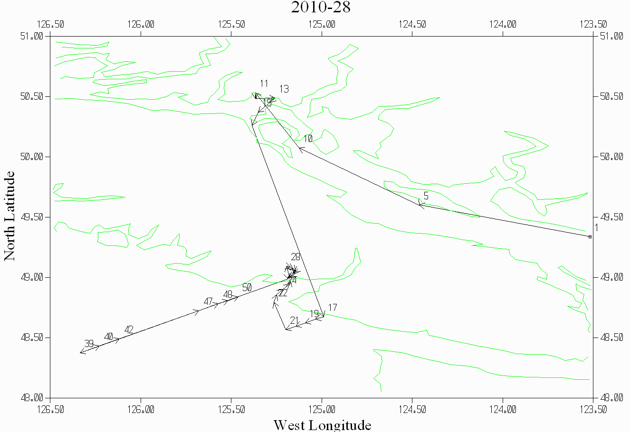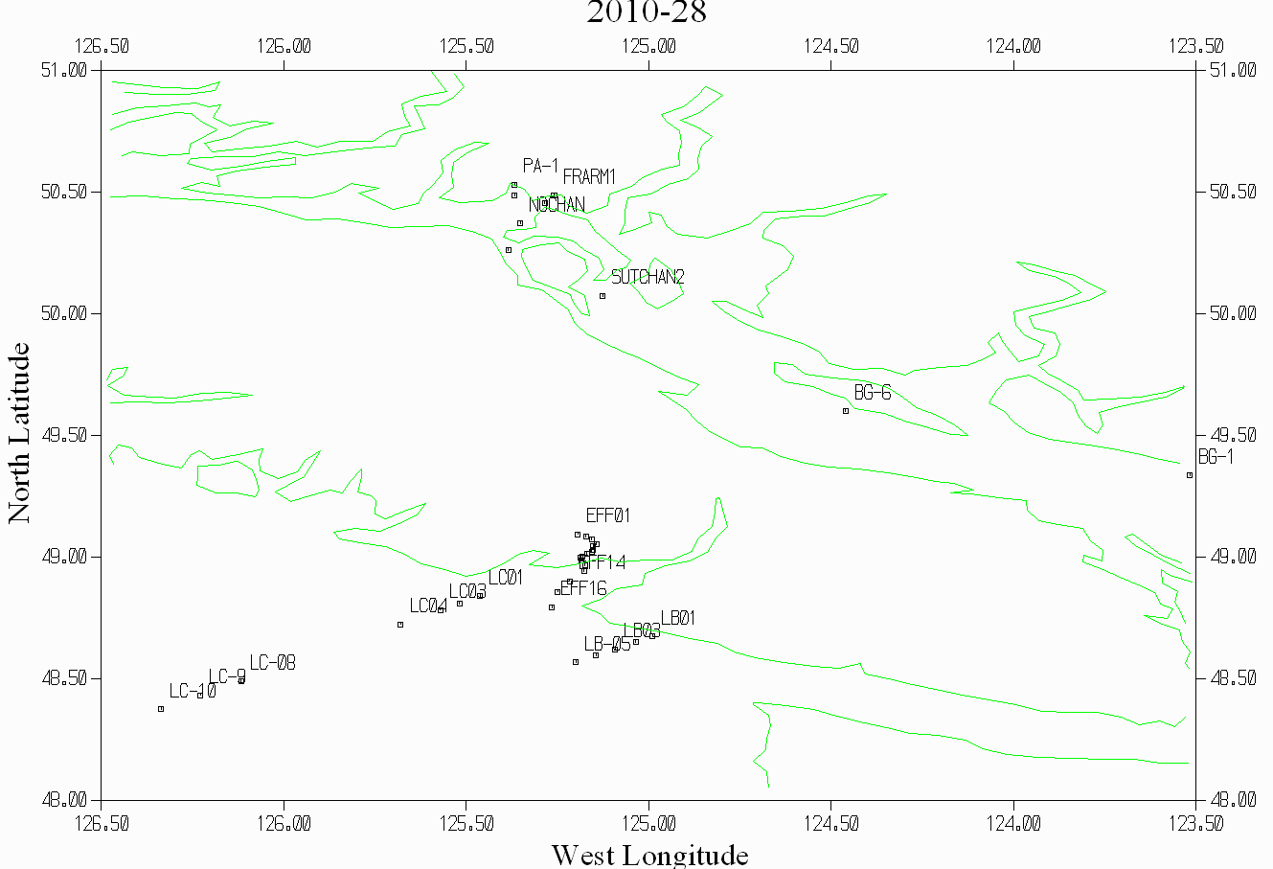

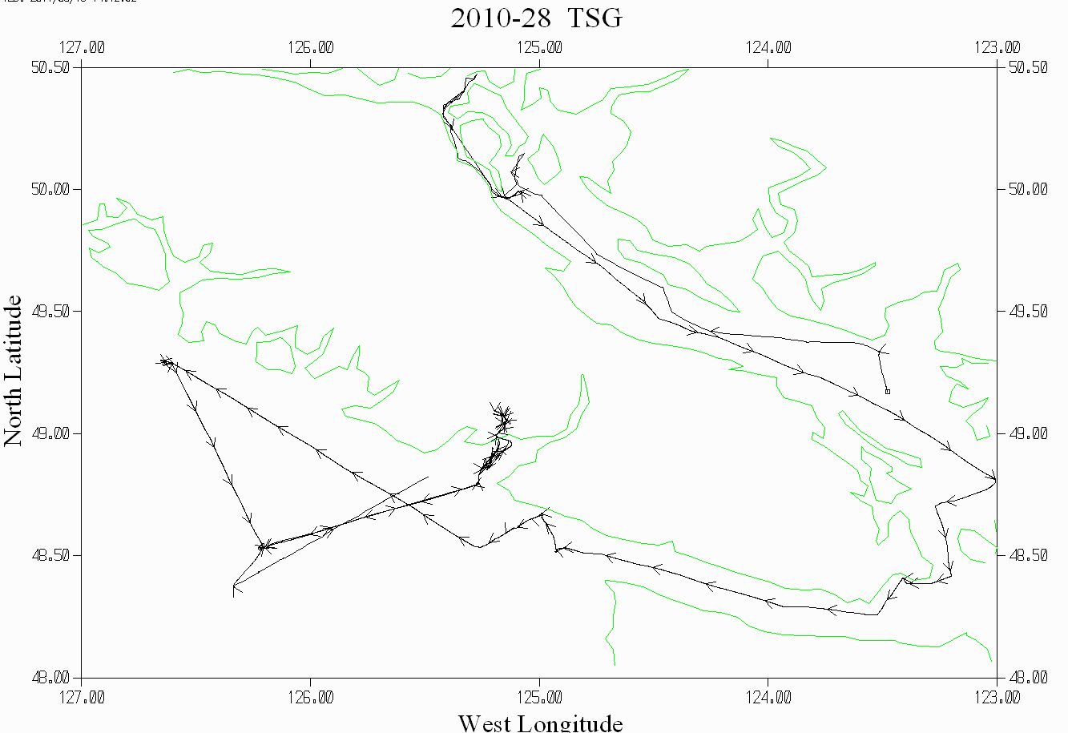

Cast 32 in Effinhgam Inlet Uncorrected Oxygen:Dissolved SBE and Pressure versus Scan Number

The SBE DO values drop quickly as DO goes below 1mL/L but slows down around 0.2mL/L. We generally expect the raw SBE DO to read higher than the bottles during the downcast and lower during the upcast. For this cast the SBE DO only shows the usual relationship to bottles when it gets out of the hypoxic layer. These errors are small but if you want the best results in hypoxic water it would be wise to stop at the top of the hypoxic layer for about 4 to 5 minutes, or until the DO voltage trace appears to have equilibrated.

Pressure | Temperature | Bottle # | Sample # | DO:CTD | Oxygen:Bottle | SBE-Bottle
196.652 | 7.9867 | 1 | 144 | 0.15 | 0.00 | 0.15
178.01 | 7.9971 | 2 | 145 | 0.11 | 0.03 | 0.08
152.687 | 8.0402 | 3 | 146 | 0.10 | 0.07 | 0.03
126.929 | 8.1433 | 4 | 147 | 0.10 | 0.06 | 0.04
101.642 | 8.6047 | 5 | 148 | 0.19 | 0.13 | 0.06
77.055 | 9.4224 | 6 | 149 | 4.07 | 4.16 | -0.09
51.333 | 9.4491 | 7 | 150 | 4.21 | 4.36 | -0.15
31.325 | 9.3062 | 8 | 151 | 3.61 | 3.77 | -0.16
21.339 | 9.3726 | 9 | 152 | 4.17 | 4.33 | -0.16
11.194 | 9.4789 | 10 | 153 | 4.72 | 4.60 | 0.12
2.06 | 10.726 | 11 | 154 | 7.46 | 7.66 | -0.20

