**XCTD Profiles**

*PIs: Itoh (JAMSTEC), Shimada (Tokyo University), Proshutinsky (WHOI))*

XCTD (expendable conductivity, temperature and depth profiler, Tsurumi-Seiki Co., Ltd.) probes provided by JAMSTEC, WHOI and Tokyo University of Marine Science and Technology were deployed from the ship’s stern with temperature, salinity and depth data acquired by computer located in the stern (AVGAS) hold. The data converter, MK-130 and Mk150 (Tsurumi-Seiki Co., Ltd.) were used for XCTD deployment and data conversion from original binary to ascii data.

The casts took approximately 5 minutes or 10 minutes for the released probe to reach its final depth of 1100m or 2000m. In open water, we deployed XCTD-3, which can be deployed when ship steams at 15Knot but in heavy ice the ship had to stop for deployment, because probe’s wire can easily break due to ice.

|  |  |
| --- | --- |
| IMG_5910.jpg | Figure 1: Kohei Mizobata deploying XCTD probe from the ship’s stern |

The locations of XCTD deployment were determined 1) to increase the spatial resolution of CTD data and 2) to make all cross-section data comparable deploying a certain isobaths Typically 1 probe was deployed between CTD casts.

According to the manufacturer’s nominal specifications, the range and accuracy of parameters measured by the XCTD are as follows;

Parameter Range Accuracy

Conductivity 0 ~ 60 [mS/cm] +/- 0.03 [mS/cm]

Temperature -2 ~ 35 [deg-C] +/- 0.02 [deg-C]

Depth 0 ~ 1000 [m] 5 [m] or 2 [%] (either of them is major)

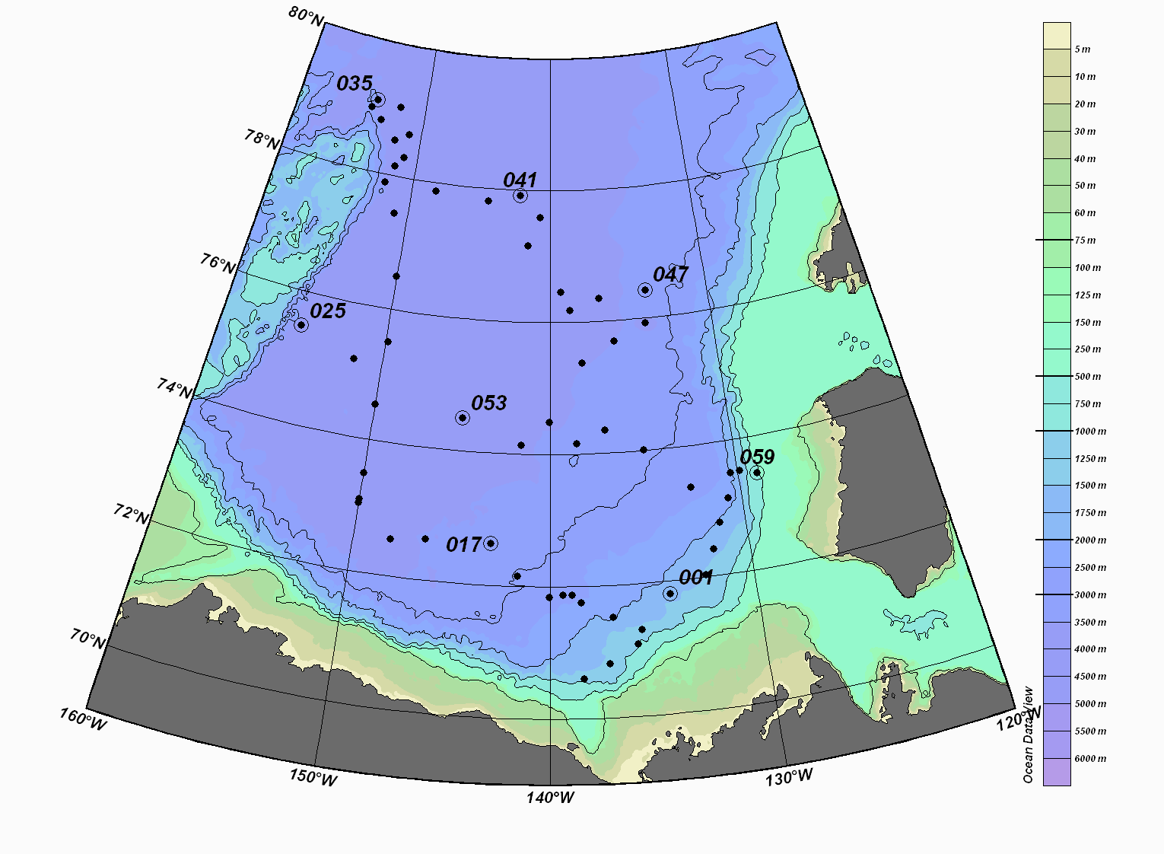

Figure 2: XCTD stations of the JOIS2010-07 cruise

During this cruise, 58 XCTDs were successfully launched, and 2 failed. 1 of the working XCTDs had shortened profiles (700m) presumably due to broken wires which was resulted from heavy sea ice. Two XCTD-2 probes, which reached 2000m, were deployed for seeking eddy structure along the 150o W Line, while three XCTD-2 probes were deployed at Northwind Ridge area.

After each deployment, binary raw data was immediately converted to 1-m interval data. To make it comparable to CTD data, temperature data was converted using a following equation,

t=temp\*1.00024 : [ITS68-->ITS90];

The deployment locations for the XCTD are listed as follows.

|  |  |  |  |  |  |  |  |  |  |  |  |  |  |
| --- | --- | --- | --- | --- | --- | --- | --- | --- | --- | --- | --- | --- | --- |
| **Stn.#** | **Filename** | **Time** |  |  |  | **Lat** |  |  | **Lon** |  |  | **Bot. Depth** | **comments** |
| 1 | 201000-XCTD-001 | 2010 | 9 | 18 | 20:12 | 71 | 48.35 | N | 134 | 12.22 | W | 1448 |  |
| 2 | 201000-XCTD-002 | 2010 | 9 | 19 | 22:00 | 71 | 05.11 | N | 135 | 55.15 | W | 1024 |  |
| 3 | 201000-XCTD-003 | 2010 | 9 | 19 | 00:01 | 70 | 48.737 | N | 137 | 15.38 | W | 1470 |  |
| 4 | 201000-XCTD-004 | 2010 | 9 | 20 | 01:44 | 70 | 35.81 | N | 138 | 27.04 | W | 1155 | SST >6oC, foggy |
| 5 | 201000-XCTD-005 | 2010 | 9 | 23 | 14:57 | 73 | 22.48 | N | 132 | 33.93 | W | 2652 | Open water in ice area |
| 6 | 201000-XCTD-006 | 2010 | 9 | 23 | 22:38 | 73 | 07.97 | N | 130 | 43.32 | W | 2187 | Open water |
| 7 | 201000-XCTD-007 | 2010 | 9 | 24 | 00:09 | 72 | 47.28 | N | 131 | 18.89 | W | 1953ー＞1927 | Ice conc. 10% |
| 8 | 201000-XCTD-008 | 2010 | 9 | 24 | 01:47 | 72 | 24.19 | N | 131 | 49.73 | W | 1664 |  |
| 9 | 201000-XCTD-009 | 2010 | 9 | 24 | 03:24 | 72 | 02.05 | N | 132 | 22.25 | W | 1438 |  |
| 10 | 201000-XCTD-010 | 2010 | 9 | 26 | 07:59 | 71 | 18.33 | N | 135 | 40.95 | W | N/A | Open Water |
| 11 | 201000-XCTD-011 | 2010 | 9 | 26 | 09:52 | 71 | 30.44 | N | 136 | 59.83 | W | N/A | Open Water |
| 12 | 201000-XCTD-012 | 2010 | 9 | 26 | 12:01 | 71 | 44.79 | N | 138 | 29.96 | W | N/A | Open Water |
| 13 | 201000-XCTD-013 | 2010 | 9 | 26 | 13:34 | 71 | 51.84 | N | 138 | 56.02 | W | N/A | Ice conc. 50%　Swelling |
| 14 | 201000-XCTD-014 | 2010 | 9 | 26 | 14:42 | 71 | 52.28 | N | 139 | 22.36 | W | N/A | Ice conc. 80% Multi-year |
| 15 | 201000-XCTD-015 | 2010 | 9 | 26 | 16:19 | 71 | 49.85 | N | 140 | 03.41 | W | 2664 | Ice conc. 90% |
| 16 | 201000-XCTD-016 | 2010 | 9 | 26 | 19:53 | 72 | 08.84 | N | 141 | 38.50 | W | 2993 | Open Water |
| 17 | 201000-XCTD-017 | 2010 | 9 | 26 | 23:08 | 72 | 37.53 | N | 143 | 02.00 | W | 4243 | Ice conc. 90% |
| 18 | 201000-XCTD-018 | 2010 | 9 | 27 | 08:17 | 72 | 37.54 | N | 146 | 21.63 | W | N/A | Open Water |
| 19 | 201000-XCTD-019 | 2010 | 9 | 27 | 10:31 | 72 | 33.75 | N | 148 | 06.78 | W | N/A | Open Water |
| 20 | 201000-XCTD-020 | 2010 | 9 | 27 | 22:02 | 73 | 02.08 | N | 149 | 59.61 | W | 3736 | Open Water |
| 21 | 201000-XCTD-021 | 2010 | 9 | 27 | 22:37 | 73 | 05.46 | N | 150 | 00.17 | W | 3743 | Open Water |
| 22 | 201000-XCTD-022 | 2010 | 9 | 28 | 00:17 | 73 | 29.31 | N | 149 | 59.62 | W | 3796 | Open Water |
| 23 | 201000-XCTD-023 | 2010 | 9 | 28 | 08:08 | 74 | 32.51 | N | 149 | 59.37 | W | 3808 | Open Water |
| 24 | 201000-XCTD-024 | 2010 | 9 | 29 | 01:02 | 75 | 09.44 | N | 151 | 40.28 | W | 3838 | Ice conc. 5% |
| 25 | 201000-XCTD-025 | 2010 | 9 | 29 | 08:13 | 75 | 28.64 | N | 155 | 10.32 | W | 3846 | Open Water |
| 26 | 201000-XCTD-026 | 2010 | 9 | 30 | 02:18 | 75 | 30.24 | N | 149 | 52.25 | W | 3831 | Ice conc. 100% |
| 27 | 201000-XCTD-027 | 2010 | 9 | 30 | 11:23 | 76 | 30.17 | N | 149 | 59.93 | W | 3847 | Ice conc. 100% |
| 28 | 201000-XCTD-028 | 2010 | 9 | 30 | 20:14 | 77 | 26.16 | N | 150 | 55.62 | W | 3828 | Ice conc. 100% 10cm |
| 29 | 201000-XCTD-029 | 2010 | 9 | 30 | 23:24 | 77 | 52.63 | N | 151 | 58.88 | W | 3835 | Ice conc. 100% 10cm |
| 30 | 201000-XCTD-030 | 2010 | 10 | 01 | 10:04 | 78 | 08.77 | N | 151 | 32.29 | W | N/A | Ice conc. 100% 10cm~20cm |
| 31 | 201000-XCTD-031 | 2010 | 10 | 01 | 23:55 | 78 | 18.17 | N | 150 | 59.93 | W | 3831 | Ice conc. 100% 10cm~20cm |
| 32 | 201000-XCTD-032 | 2010 | 10 | 02 | 02:26 | 78 | 32.30 | N | 151 | 55.38 | W | 3830 | Ice conc. 100% 10cm~30cm |
| 33 | 201000-XCTD-033 | 2010 | 10 | 02 | 06:13 | 78 | 48.14 | N | 153 | 15.52 | W | 3828 | Ice conc. 100% 10cm~30cm |
| 34 | 201000-XCTD-034 | 2010 | 10 | 02 | 08:07 | 78 | 57.48 | N | 154 | 13.38 | W | 3666 | Ice conc. 100% |
| 35 | 201000-XCTD-035 | 2010 | 10 | 03 | 4:15 | 79 | 5.0532 | N | 153 | 51.4583 | W | 3579 | Ice conc. 100% 10cm~100cm |
| 36 | 201000-XCTD-036 | 2010 | 10 | 03 | 06:45 | 79 | 02.28 | N | 151 | 56.50 | W | 3836 | Ice conc. 100% 10cm~200cm |
| 37 | 201000-XCTD-037 | 2010 | 10 | 03 | 15:43 | 78 | 39.41 | N | 150 | 54.73 | W | 3829 | Ice conc. 100% 10cm~200cm |
| 38 | 201000-XCTD-038 | 2010 | 10 | 04 | 10:02 | 77 | 52.52 | N | 148 | 16.54 | W | 3819 | Ice conc. 100% 10cm~200cm |
| 39 | 201000-XCTD-039 | 2010 | 10 | 05 | 04:32 | 77 | 48.35 | N | 144 | 24.80 | W | 3798 | Ice conc. 100% 100cm~200cm |
| 40 | 201000-XCTD-040 | 2010 | 10 | 05 | 09:38 | 77 | 54.64 | N | 142 | 10.43 | W | 3781 | Ice conc. 100% 100cm~200cmHeavy Ice XCTD cast was shorten (700m) due to ice |
| 41 | 201000-XCTD-041 | 2010 | 10 | 05 | 09:47 | 77 | 54.64 | N | 142 | 10.43 | W | 3781 | second trial |
| 42 | 201000-XCTD-042 | 2010 | 10 | 05 | 20:00 | 77 | 34.99 | N | 140 | 43.92 | W | 3750 | Ice conc. 100% 100cm~200cm |
| 43 | 201000-XCTD-043 | 2010 | 10 | 06 | 08:49 | 77 | 09.52 | N | 141 | 31.40 | W | 3751 | Ice conc. 100% 100cm~200cm |
| 44 | 201000-XCTD-044 | 2010 | 10 | 07 | 02:56 | 76 | 27.26 | N | 139 | 18.88 | W | 3672 | Ice conc. 100% 100cm~200cm |
| 45 | 201000-XCTD-045 | 2010 | 10 | 07 | 11:58 | 76 | 10.536 | N | 138 | 46.21 | W | 3645 | Ice conc. 100% 100cm |
| 46 | 201000-XCTD-046 | 2010 | 10 | 07 | 15:05 | 76 | 20.69 | N | 136 | 54.50 | W | 3588 | Ice conc. 100% 30cm |
| 47 | 201000-XCTD-047 | 2010 | 10 | 08 | 06:49 | 76 | 24.64 | N | 133 | 52.44 | W | 3367 | Ice conc. 100% 100cm |
| 48 | 201000-XCTD-048 | 2010 | 10 | 08 | 17:31 | 75 | 55.39 | N | 134 | 06.89 | W | 3339 | Ice conc. 100% 100cm |
| 49 | 201000-XCTD-049 | 2010 | 10 | 09 | 04:50 | 75 | 40.88 | N | 136 | 07.20 | W | 3530 | Ice conc. 100% 10cm-30cm |
| 50 | 201000-XCTD-050 | 2010 | 10 | 09 | 08:35 | 75 | 22.39 | N | 138 | 07.85 | W | 3555 | Ice conc. 100% 10cm-50cm |
| 51 | 201000-XCTD-051 | 2010 | 10 | 09 | 17:33 | 74 | 29.14 | N | 140 | 03.54 | W | 3643 | Ice conc. 100% 10cm-30cm |
| 52 | 201000-XCTD-052 | 2010 | 10 | 10 | 06:36 | 74 | 08.01 | N | 141 | 37.71 | W | 3635 | Ice conc. 100% 10cm-50cm |
| 53 | 201000-XCTD-053 | 2010 | 10 | 10 | 15:46 | 74 | 29.65 | N | 144 | 58.93 | W | 3737 | Ice conc. 100% 10cm-100cm |
| 54 | 201000-XCTD-054 | 2010 | 10 | 12 | 01:10 | 74 | 08.99 | N | 138 | 32.05 | W | 3426 | Ice conc. 100% 10cm-50cm, relative warm air temperature |
| 55 | 201000-XCTD-055 | 2010 | 10 | 12 | 04:46 | 74 | 20.41 | N | 136 | 56.64 | W | 3300 | Ice conc. 100% 10cm-50cm |
| 56 | 201000-XCTD-056 | 2010 | 10 | 12 | 08:24 | 74 | 00.11 | N | 134 | 53.20 | W | 3066 | Ice conc. 100% 10cm-30cm |
| 57 | 201000-XCTD-057 | 2010 | 10 | 13 | 10:36 | 73 | 30.08 | N | 130 | 22.10 | W | N/A | Ice conc. 100% heavy ice, 100-300cm |
| 58 | 201000-XCTD-058 | 2010 | 10 | 13 | 12:05 | 73 | 31.15 | N | 129 | 51.78 | W | 1367 | Ice conc. 100% |
| 59 | 201000-XCTD-059 | 2010 | 10 | 13 | 18:13 | 73 | 26.19 | N | 128 | 57.97 | W | 573 | Ice conc. 100% |