LSSL 2010-07
Underway Measurements
Cruise Report

Seawater Loop
The ship’s seawater loop system draws seawater from below the ship’s hull at 9m, to the TSG lab, a small room just off the main lab (“aft lab”). This system allows measurements to be made of the sea surface water without having to stop the ship for sampling. The water is as unaltered as possible coming directly from outside of the hull through stainless steel piping without recirculation in a sea-chest. The manifold in the TSG has been insulated to minimize condensation. Flow rate is controlled to the lab by a Honeywell electronic system which has a data feed from a pressure sensor in the lab, and on one arm of the manifold, by a Kates mechanical flow rate controller. This arm also has a vortex debubbler so that the water provided to the TSG and other instruments is as bubble free as possible.

Autonomous measurements were made using:
- SBE38: Temperature.
Sensor was installed in-line, approximately 4m from pump at intake. This is the closest measurement to actual sea-temperature.
- SBE21 Seacat Thermosalinograph: Temperature and Conductivity, Fluorescence and CDOM
5 second sample rate, fed by water that has gone through the debubbler
(Jane Eert, DFO)
- Blue Cooler: Total gas (Gas Tension Device) 40s sampling, Oxygen.
5 second sample rate, fed by water that has gone through the debubbler
(Svein Vagle, DFO)
- Black Box: Methane, Oxygen, pCO2.
Hourly sample, run off the manifold in the main lab
(Patricia Ramlal, DFO)

Part of the system, but not attached to the seawater loop:
- SBE48: Temperature was also measured through the hull using a temperature sensor mounted on the ship’s hull, inside, aft of the pump approximately 15m, starboard side. Sampling rate is once per minute

Discreet Water Samples drawn for calibration of sensors:
- Salinity, Chlorophyll-a, Dissolved Oxygen (these 3 analysed on board), and CDOM (samples sent back to Celine Gueguen at Trent University)

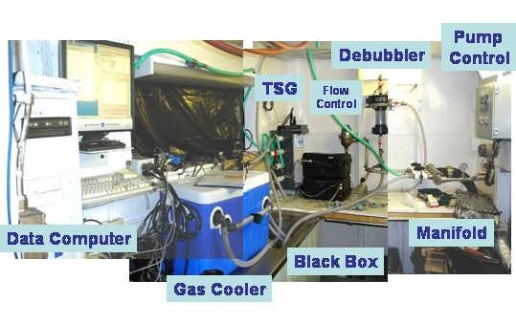
Figure 1. Seawater loop system providing uncontaminated seawater from 9m depth to the science lab for underway measurements.

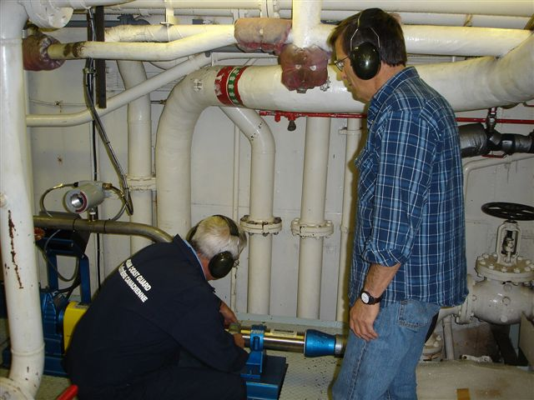
Figure 2. Pump for seawater loop at intake in engine room.

Some of the instruments were self-contained; others were connected to a single data storage computer. The data storage computer provided a means to pass ship’s GPS for integration into sensor files, to pass the SBE38 data from the engine room to the TSG instrument, and to pass the TSG and SBE48 data to the ship’s data collection system (SCS).

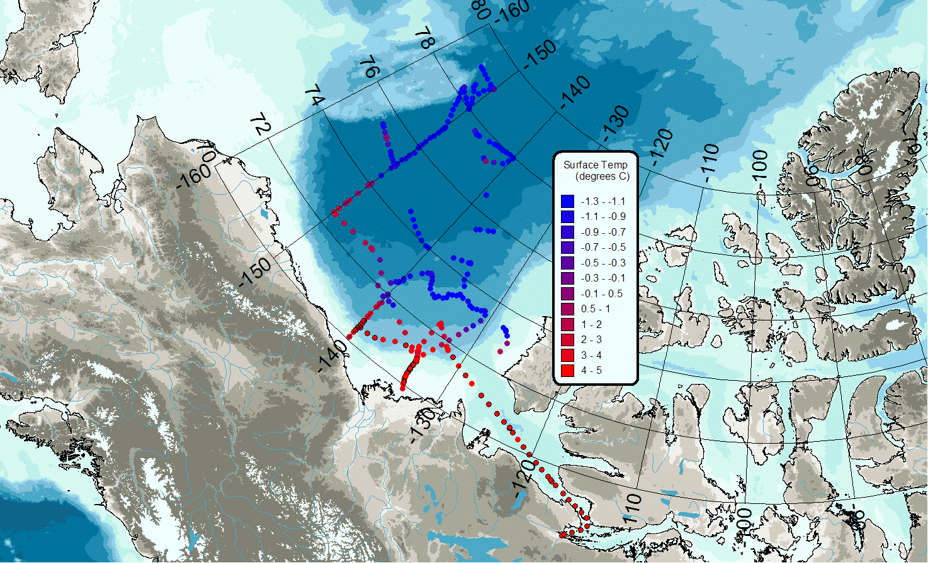

Figure 3. Underway sea surface Temperature.
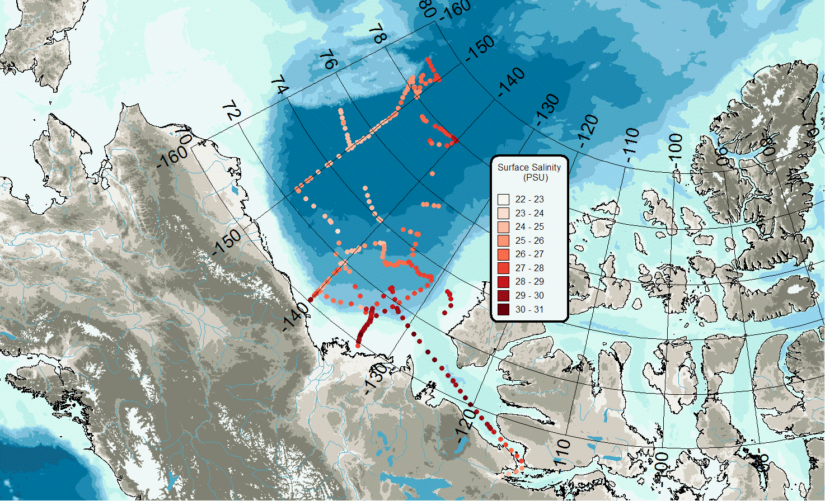
Figure 4. Underway sea surface Salinity.
PAR Data
Photosynthetically available radiation (PAR) was measured continuously. Location was on the hanger top aft of the stack in the most unobstructed spot possible. However, the PAR sensor was seldom wiped clean and it was dark and snowed in a lot of the time….

Ice Cameras
Ice Cameras mounted on above the bridge took pictures every 5 to 30minutes depending on ice conditions. Two cameras were installed, one looking forward, the other looking aft along the side of the ship to observe upturned ice. See the complete report on this system by Alice Orlich.

SCS Data Collection System
The ship uses the Shipboard Computer System (SCS) written by the National Oceanographic and Atmospheric Administration (NOAA), to collect and archive underway measurements. This system takes data arriving via the ship’s network (LAN) in variable formats and time intervals and stores it in a uniform ASCII format that includes a time stamp. Data saved in this format can be easily accessed by other programs or displayed using the SCS software.

The SCS system on a shipboard computer called the “NOAA server” collects:

- Location, speed over ground and course over ground as well as information about the quality of GPS fixes from the ship’s GPS (GPGGA and GPRMC sentences)
- Heading from the ship’s gyro (HEHDT sentences)
- Depth sounding from the ship’s Knudsen sounder (SDDBT sentences)
- Air temperature, apparent wind speed, apparent and relative wind direction, barometric pressure, relative humidity, and apparent wind gusts from the ship’s AVOS weather data system (AVRTE sentences). SCS derives true wind speed (see note on true wind speed below).
- Sea surface temperature, conductivity, salinity, CDOM and fluorescence from the ship’s SBE 21 thermosalinograph and ancillary instruments
- Sea surface temperature from the SBE48 hull mounted temperature sensor

The RAW files were set to contain a day’s worth of data, restarting around midnight. The ACO and LAB files grew until they were moved out of the datalog/compress directory for archiving.

We experienced few problems this year with the system losing data. Major gaps in the TSG records are due to the system being turned off in ice. There was one gap of about 6 hours when the system was accidentally shut down by other users of the NOAA computer.

Ship Notes on the Sea Water Plumbing
Engineering Dept

SW SAMPLING SYSTEM FOR THERMAL SALINOGRAPH
ABOARD THE LOUIS S. ST. LAURENT

SEA SUCTION

This consists of a 4” diameter suction fitting fitted flush with the hull. It is located between Frame 179 and Frame 180 and 5’ 3” to Port of the ship’s centerline. The 4” dia. stainless steel suction plate is press fit into the opening and fastened by 4 – ½” stainless steel countersunk screws. The suction plate has a cross pattern across it of 3/8” width yielding 4 quadrants open for suction.

A 4” stainless steel angle globe valve with de-icing connection is directly bolted to the flush fitting at the hull using 8 – 5/8” steel cadmium plated studs on 7 ½” PCD. The valve is fitted with a lazy rod supported by a deck stand at tank top level to allow operation of the valve above the tank top by 10” hand wheel.

PIPING TO PUMP

From the 4” outlet of the valve is a 4” 90⁰ stainless steel elbow connected to a 4” to 2” stainless steel concentric reducer.

Height from the hull plating to the end of the concentric reducer is 1’ 10”.

From concentric reducer, pipe continues vertically via 2” stainless steel, schedule 40 pipe to the tank top. This is a distance of 4 ft..

From the tank top, 2” stainless steel schedule 40 pipe continues 6’ 7” to a 2” – 150# flanged stainless steel ball valve and directly into the 2” Hayward 6036 (CF8M) stainless steel duplex basket strainer c/w changeover cock, 5/32” basket perforations. There is another identical flanged ball valve on the outlet of the strainer.

From the outlet valve, 2” stainless steel schedule 40 piping leads another 6” 5” to a 2” to 3” concentric bushing to a flanged 3” connection on the pump suction.

SW PUMP

The pump is a 3” Moyno Progressive Cavity pump Model #2L6SSQ3SAA, customized seal arrangement, L-frame pump, L6 drive frame. This pump is driven by a geared motor. The pump rated flowrate is 10 GPM. It is composed of a stainless steel rotor and nitrile rubber stator and has a John Crane carbon/ceramic single mechanical seal.

The pump is controlled by a ACTech Model #1450C variable speed controller and gets it’s setpoint from a Honeywell UDC Controller mounted in Lab 426B.

The gearbox is an SEW Eurodrive Type RX67. The motor is an SEW Eurodrive Type RX76DT10044, 5 HP motor.

An Akron Electric (Delta Corporation)VS5100 Flowswitch acts as a drypipe sensor to shut down the pump via the VFD should the duplex basket strainers become clogged with ice.

A pressure transmitter is also fitted in the pipe on the outlet of the pump to provide a pressure alarm signal to the SIMOS system in the Machinery Control Room.

PUMP OUTLET TO LAB 426B

From the pump outlet, 1 ½” sch. 40 stainless steel pipe continues another 12’ to a 1 ½” SS ball valve. From here it continues another 16” via 1 ½” pipe to a 1 ½” “T” where the flow can then be diverted to the SBE 38 via 24” of 1” sch. 40 stainless steel pipe or continue in 1 ½” another 11’ to the 19’ flat of the engine room.(Boiler Flat)

An RTD for measuring temperature is installed just prior to the SBE branch connection.

From the 19’ Flat the 1 ½” pipe continues vertically 16’ 6” to the Incinerator Deck.

From the Incinerator Deck the 1 ½” pipe continues on a 26’ vertical run to the Main Deck.

The same pipe then runs horizontally 85’ along the Main Deck Stbd Alleyway.

From the alleyway to Lab 426B is another 8’ horizontally (athwartships) and 14” vertically.

In Lab 426B, another 6” of 1 1/2'” pipe, then a 1 ½” stainless steel, flanged, ball valve, then a 4’ run of 1 ½” pipe to the 3” pipe manifold.

Manifold has 4 – 1” NPT process connections along it’s length and 1 – 1” threaded process connection at the end to provide a pressure signal from the Honeywell ST 3000 Smart Pressure Transmitter to the Honeywell UDC Controller.

Louis NOAA SCS system, October 2010
The SCS system on the NOAA server collects data from

-the Ship’s GPS (GPGGA and GPRMC sentences)
-the Ship’s gyro (HEHDT sentences)
-the Knudsen sounder (SDDBT sentences)
-the AVOS weather data system (AVRTE sentences)
-the thermosalinograph, and
-the SBE48 hull mounted temperature sensor.

Variables derived from each sentence are:

GPGGA:
time-UTC, HHMMSS
LAT, dd.ddddd
LONG, ddd.ddddd
Quality, 1=gps 2=dgps
#-of-Sats
HDOP, horizontal dilution of precision

GPRMC:
SOG, Knots
COG, degrees

HEHDT:
Gyro-Heading, Deg

SDDBT:
depth, Meters

AVRTE:
time, HHMMSS
date, YYMMDD
apparent-wind-speed, knots
apparent-wind-direction, degrees
relative-wind-direction, degrees
barometric-pressure, mmhg
air-temp, C
relative-humidity, %
apparent-wind-gust, knots

TSG:
SBE21-T, Degrees-C
SBE21-S, PSU
SBE38-T, Degrees-C

SBE48:
Hull-Temp, Degrees-C

As well, the SCS system derives true wind speed based on the AVRTE apparent wind speed and direction and the GPRMC speed over ground and course over ground.
***Note on true wind speed: Since this system was set up in 2006, true wind speed has been derived from apparent wind speed and direction along with the ship’s COG and SOG. It turns out that this is incorrect, and the direction that should be used in this calculation is the relative wind direction. The error was noticed and corrected on October 1 at 1330 UTC. All true wind data before this should be recalculated.
***Editorial comment: I think that SCS should be calculating true wind speed from apparent wind direction and not relative wind direction. Or if it wants to use the relative wind direction, it should take into account the ships heading. As it is now, the calculation assumes that the ship is moving (COG) in the same direction the bow is heading. In practical terms, it unlikely that large errors are introduced by making this assumption since the times when one usually has a large mismatch between ships head and COG are when the ship is moving slowly.

Data for each type of sentence is stored in 3 types of files:

RAW: a comma separated file, each record starts with a timestamp, followed by the sentence received at that time.
ACO: a comma separated file, each record starts with a timestamp (year, decimal Julian day, integer Julian day, fractional Julian day) followed by the variables extracted from each record.
LAB: a blank separated file, each record is as for ACO, but decimated in time, so the LAB files are about 1/10th the size of the ACO files.

Setup in 2010: The RAW files were set up to contain a day’s worth of data, restarting at 10 minutes past midnight, UTC. They are named, for example, GPGGA-Parent_20070821-100257.RAW, and stored in the main SCS datalog directory. The ACO and LAB files grow until they are moved out of the datalog/compress directory for archiving. The files were restarted at the beginning of the 2010 filed season. Naming for these files is like GPGGA-Parent.ACO. As well, there are template files, named like GPGGA-Parent.TPL which contain a list of the variables derived for each sentence. .

Timestamps: The timestamps generated by SCS are based on the time settings in Windows.

***Note on SCS timestamps: This year (unlike some previous years) the NOAA server stayed in UTC. However, this computer’s clock does not keep very accurate time; if you need to synchronize data across the files, use the timestamp, but if you are trying to synchronize with outside data that is properly keeping UTC, then use the time of day found in the GPGGA sentence. At worst on this cruise, the NOAA server clock was ahead by 8 minutes; this was corrected on October 12, 2010.

Gaps: There are gaps in the data collection, some of which can be filled by post processing from independent records.

SDDBT: The sounder depth is recorded but not the sound speed used to calculate the depth. An external log of sound speed was kept and is included here:
Date | Time (UTC) | Sound Speed (m/s)
start |  | 1500
17/09/2010 | 1:28:45 | 1448
21/09/2010 | 7:01 | 1455
21/09/2010 | 9:20 | 1465
22/09/2010 | 7:27 | 1470
27/09/2010 | 14:36:00 | 1473
12/10/2010 | 10:14:30 | 1470
13/10/2010 | 14:08 | 1455
13/10/2010 | 14:41:30 | 1445

Note: The Knudsen Sound speed is the assumed average sound speed from surface to sea floor. We change it during the cruise so that the sounder reports reasonably accurate depths which can be used to predict the bottom of a rosette cast.

