Measurements:

- Ice Observations
- Ice Observations (KIT)
Underway measurements of ice thickness from an electromagnetic induction sensor, Passive microwave Radiometers(PMR), and fixed forward-looking camera.

PROGRAM COMPONENT DESCRIPTIONS
Ice Observations
PI: Kazutaka Tataeyama, Kitami Institute of Technology, Japan

Underway measurements
Underway measurements of ice thickness were made using, an Electromagnetic induction (EM) sensor, Passive Microwave Radiometers (PMR) and a forward looking camera. These data will be used to help interpret satellite images of sea ice which have the advantage of providing extensive area and thickness but lack the groundtruthing of just what the images represent. The EM sensor was deployed from the foredeck’s crane on the port side, collecting data while underway. The passive microwave sensor was mounted one deck higher also on the ship’s port side looking out over the EM’s measurement area and collected data continuously.

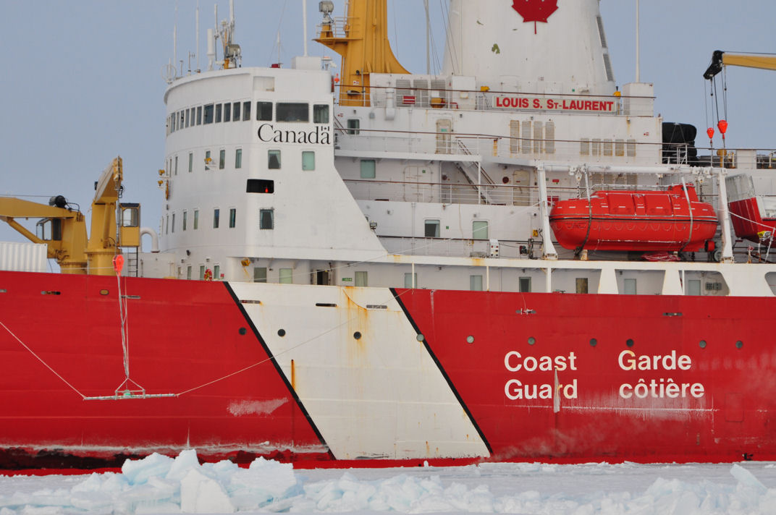
EM
PMR
Camera
Figure 1. Pictures of EM , PMR and forward-looking camera.

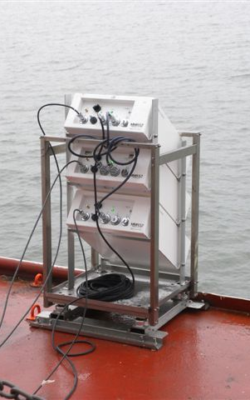
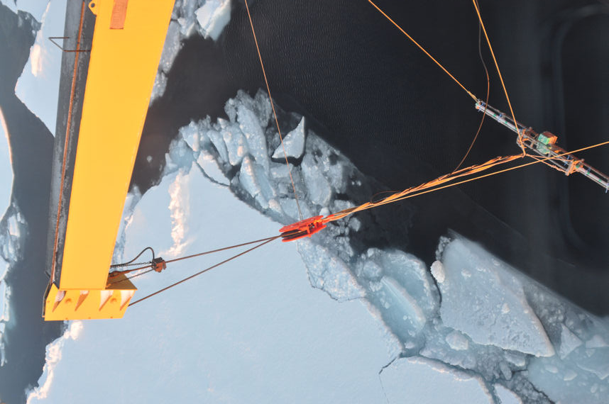
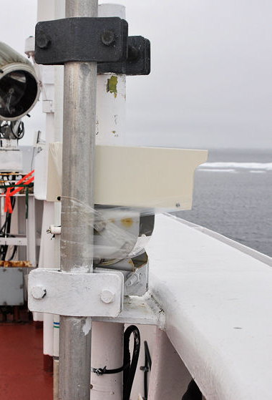

Figure 2. Pictures of EM, PMR and forward-looking camera.

EM ice thickness profiles and PMR observation
An Electro-Magnetic induction device EM31/ICE (EM) and laser altimeter LD90 will be used for sea-ice thickness sounding. EM provides apparent conductivities in mS/m which can be converted to a distance between the instrument and sea water at sea-ice bottom (H_{E}) by using inversion method. LD90 provides a distance between the instrument and snow/sea-ice surface (H_{L}). The total thickness of snow and sea-ice (H_{T}) can be derived by subtracting H_{L} from H_{E}. Ice concentration can be measured by EM system.
To develop new algorithm for estimation of the Arctic snow/sea-ice total thickness by using satellite-borne passive microwave radiometer (PMR), snow/sea-ice brightness temperatures and surface temperature measurements will be conducted. The portable PMR, called MMRS2A, which is newly developed by Mitsubishi Tokki System Co. Ltd., Japan, have 5 channels which are the vertically polarized 6GHz, 18GHz and 36GHz, the horizontally polarized 6GHz and 36GHz with radiation thermometers and CCD cameras. The radiation thermometers IT550, which are developed by HORIBA Corp., Japan, were used. Those sensors were mounted on the port side below the bridge in 55 incident angle which is same angle as the satellite-borne passive microwave radiometer AQUA/AMSR-E. All data are collected every 1 second continuously except CTD stations and maintenance.

EM ice thickness observation started at 29 September and ended at 13 October. 12 ice thickness profiles are observed as shown in figure 4 and summarized in table 1. The total distance of 12 profiles are 7,919 km. EM was calibrated twice on Oct. 1 and Oct 13 over open water and nilas, respectively.

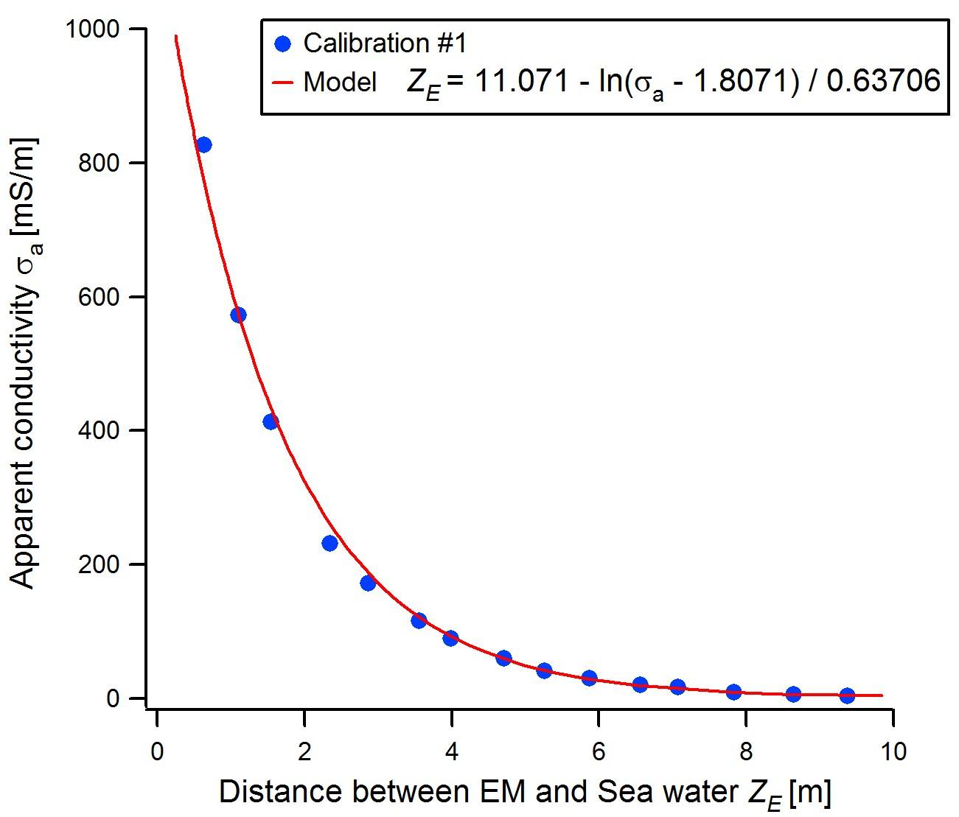

Figure 3. Result of EM calibration over open water.
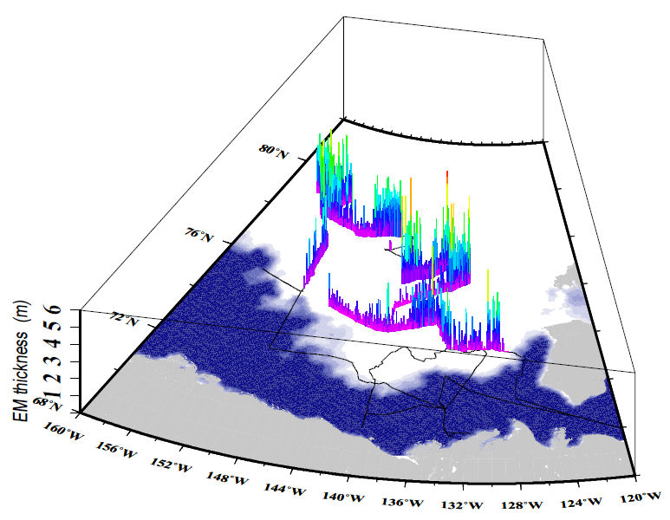
Figure 4. EM thickness profile during 29 Sep. – 13 Oct., 2010. Background image is
sea ice concentration on 7 Oct., 2010 derived from AMSR-E.

Table 1. EM and PMR observation log.
Profile  Number | Start  Time(UTC) | Start  Position | End  Time(UTC) | End  Position | Length of profile [km]
1 | Sep. 30  01:02 | 75.36058N  149.9227W | Sep. 30  16:22 | 76.99203N  149.9022W | 273.82
2 | Sep. 30  16:38 | 76.99263N  149.8889W | Oct. 1  04:26 | 78.28362N  153.077W | 415.92
3 | Oct 1  05:15 | 78.28047N  153.0698W | Oct. 1  15:41 | 78.0093N  149.9918W | 434.16
4 | Oct 1  21:06 | 77.99005N  150.0956W | Oct. 2  16:14 | 79.15653N  155.2464W | 724.86
5 | Oct 2  21:55 | 79.10118N  154.5471W | Oct. 3  20:55 | 77.99942N  149.9973W | 803.87
6 | Oct 4  03:10 | 77.97948N  150.0831W | Oct. 5  10.47 | 77.9332N  141.6666W | 976.43
7 | Oct 6  23:16 | 78.98383N  139.6039W | Oct. 8  02:17 | 76.71253N  135.1826W | 794.82
8 | Oct 8  03:33 | 76.70915N  135.1832W | Oct. 9  12:51 | 75.00415N  140.0134W | 1174.89
9 | Oct 9  14:16 | 74.98305N  140.0327W | Oct. 9  19:39 | 74.07478N  140.1222W | 102.37
10 | Oct 10  03:35 | 73.98072N  139.9978W | Oct. 10  19:24 | 74.71073N  146.6217W | 750.93
11 | Oct 10  22:09 | 74.6962N  146.6156W | Oct. 11  07:50 | 74.02882N  139.9895W | 746.16
12 | Oct 13  00:00 | 73.49852N  134.1779W | Oct. 13  22:22 | 73.37783N  128.4495W | 720.83

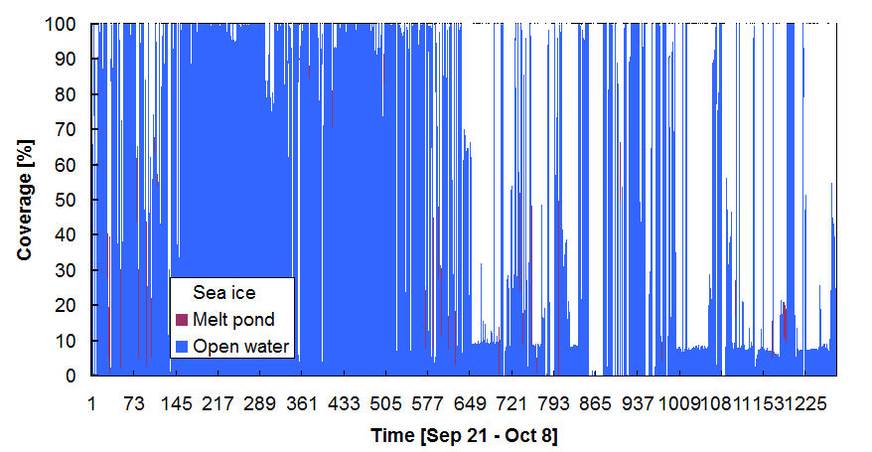
A looking-forward digital camera on upper bridge will be set to record sea ice condition in ice covered area. These images will be used for calculation of concentrations of open water, melt pond, and ice.

Figure 4. Result of automated ice-pond-water detection from camera images.
Ice station measurements

Snow depth, skin temperature, internal temperature, density, salinity, strategy(crystal type and size) measured in ice stations 2-4. Sampling intervals are 1cm and 3cm for internal temperature and density/salinity, respectively. Snow strategy was recorded in each snow layers.
Those snow properties will be compared with PMR brightness temperatures in order to validate general microwave radiation transfer model for satellite remote sensing. Those data will be used for evaluation of snow and sea-ice conditions in the end of melting and the begging of freezing periods with ice core data.
The total thickness of snow and ice distributions were investigated representative sea-ice morphology by drilling and using EM31SH which is shorter than EM31/ICE. Apparent conductivities (mS/m) of the Vertical Magnetic Dipole (VMD) and Horizontal Magnetic Dipole (HMD) modes were collected every 2 m in order to synchronize drill-hole (every 10m).

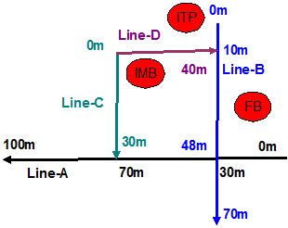
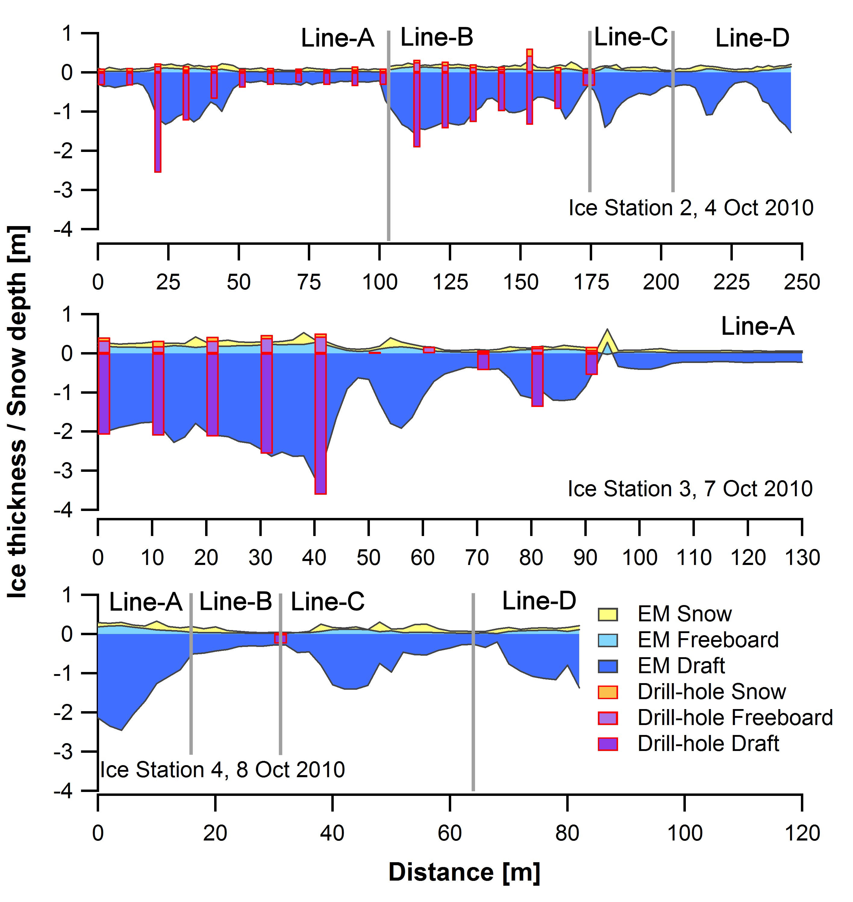
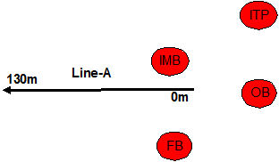
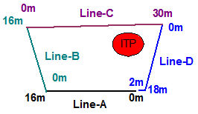

Figure 5. Transects of EM 31SH and drill-holes on the ice station 2-4. Maps of profiles are shown in right side.
Table 2. Summery of snow depth and ice thickness on the ice station 2-4.
Station  name | Lat  Lon | Line name | Length of profile [m] | Snow depth [m] |  | Ice thickness [m]
 |  |  |  | mean | std | mean | std
St.2 | 77.66441N  146.29408W | Line-A | 100 | 0.07 | 0.03 | 0.54 | 0.40
St.2 | 77.66441N  146.29408W | Line-B | 70 | 0.09 | 0.03 | 1.11 | 0.32
St.2 | 77.66441N  146.29408W | Line-C | 30 | 0.06 | 0.03 | 0.71 | 0.35
St.2 | 77.66441N  146.29408W | Line-D | 40 | 0.08 | 0.02 | 0.73 | 0.43
St.3 | 76.71900N  135.19353W | Line-A | 130 | 0.09 | 0.09 | 1.35 | 0.98
St.4 | 75.8566N  134.65028W | Line-A | 16 | 0.10 | 0.05 | 1.85 | 0.73
St.4 | 75.8566N  134.65028W | Line-B | 16 | 0.05 | 0.05 | 0.43 | 0.13
St.4 | 75.8566N  134.65028W | Line-C | 30 | 0.09 | 0.08 | 0.92 | 0.43
St.4 | 75.8566N  134.65028W | Line-D | 20 | 0.07 | 0.03 | 0.94 | 0.45

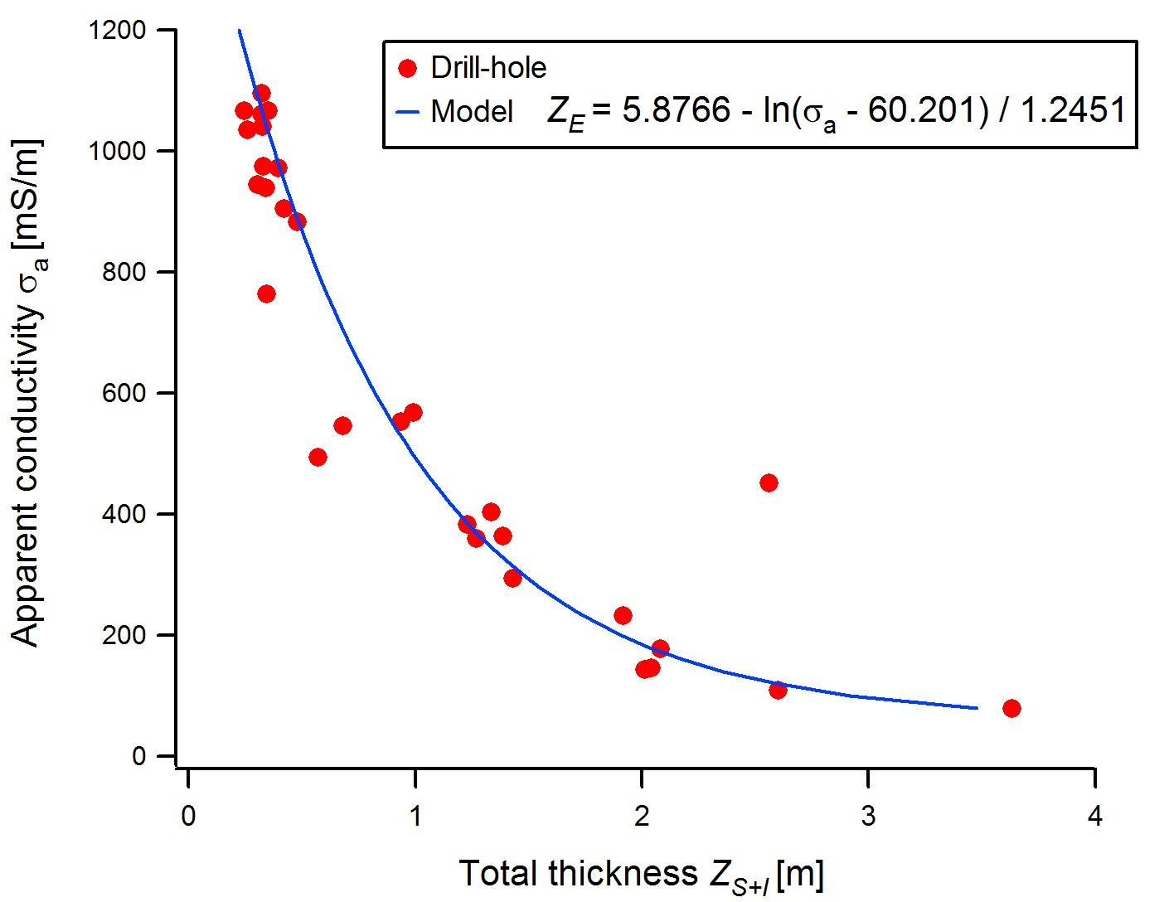

Figure 6. Comparison of total thicknesses between drill-hole and EM31SH.

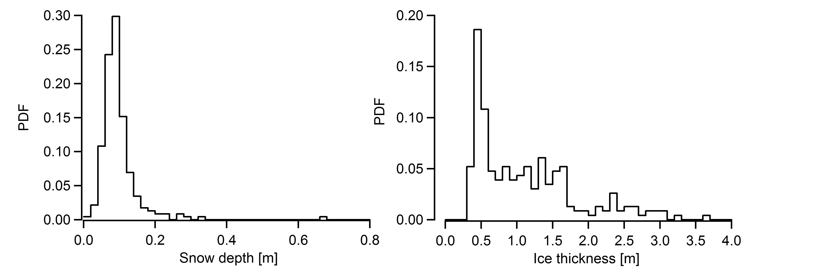

Figure 7. PDF of snow and ice thickness observed by EM31SH.

