Salinity Report
2010-07 JOIS cruise
LSSL
September 16-October 15, 2010
Report written by: Chelsea Stanley and Mike Dempsey

1.0 Overview:

During the 2010 JOIS cruise, 71 stations were sampled using a CTD and at 71 of these stations water samples were taken. At all sampled stations, salinity samples were taken. XX duplicate samples were taken. XX loop samples were also taken from the underway system. At stations CB-28b, CB-3 and CB-6, excess deep water (>2000m) was collected from the bottom two bottles and was sub-sampled to use as reference water. Samples were analyzed by Mike Dempsey, Kenny Scozzafava and Chelsea Stanley.

2.1 Analysis at Sea:

Onboard, samples were analyzed with the Guildline Autosalinometer Model 8400B (S/N: 69086). Analysis method as outlined in the standard IOS protocol. Water samples were collected from Niskin bottles into 200mL glass bottles immediately following a rosette cast. Salinity bottles were used with a two cap system, an insert plug followed by a screw on cap. Salinity bottles and insert caps were rinsed 3 times before filling. Samples were transferred to the temperature controlled room (salinity/oxygen container) for storage until they were analyzed within one week of collection. Room and sample temperature was maintained consistently between 22 and 23°C. The addition of a fan at head height installed at the end of the C3O cruise in August worked well in maintaining a more homogenous temperature throughout the lab. An ordered numbering system was established within the room whereby salinity cases were cycled in order to establish a constant sample temperature, as there was a considerable temperature gradient within the room from the cold floor. Two shelves at head level (warmest position) could store 4 cases and labeled 1 to 4. Two positions on the salinometer bench were labeled 5 and 6. If there were greater than 6 sample cases being stored in the room, they were placed on top of a container until they could be moved into a numbered position. Cases were analyzed sequentially, starting from position #1, then #2, etc. Once a case had been analyzed, new cases were cycled through the numbering sequence. This system ensured two things: 1) Each analyst knew which case to analyze first and location of each subsequent case for analysis, 2) each case was held at a stable temperature for an extended period of time before analysis (usually > 12 hours). Bottles were inverted several times prior to analysis to reduce any stratification.

The salinometer was calibrated with IAPSO standard water (Batch P151, K15 = 0.99997, Batch Date – May 20, 2010, Salinity – 34.999) to identify any instrument drift. Calibration took place every 24 hours or when there was a backlog of 6+ cases. Standard salt water reference samples taken from depths of greater than 2000m were collected from four different stations – 8-Bel-8 from the 2010-06 C3O cruise and CB-28b, CB-3 and CB-6. The standard seawater was run before the first case and between each case during the period of analysis. This was used to identify any instrument drift between calibrations.

Due to problems with the salinometer (see below), 34 cases of samples were unable to be sampled at sea and will be sent to IOS for analysis at a later date (Appendix 1). Two cases of deep water standard from station CB-6 will also return to IOS for future use.

2.2 Analysis at IOS:

To be completed by analyst

3.1 Results:

989 samples from 42 casts were analysed prior to the problems encountered with the salinometer. Of these, 72 were replicates and 21 were loop samples from the underway system.

3.2 Calibration

The IAPSO standard calibration was ran within the salinometer data logger file that also has all the analyzed samples. When calibrating the machine, if the value obtained was within ±0.0001 of the standard K₁₅ value on the IAPSO standard bottle, the value was accepted. If the value was outside of this range than the cell was flushed and another reading was taken. If the second reading was still not within the range then the standardize knob was used to adjust the salinometer to bring it as close as possible to the accepted K₁₅ value.

There were 21 calibrations run prior to the problems with the salinometer. The corrections from these calibrations ranged from -0.000009 to 0.000015. Resulting stand-by numbers ranged from 24+6084 to 24+6099.

3.3 Deepwater Standard:

Deepwater standard was collected from four stations. During the 2010-08 cruise, water was collected from station 8-Bel-8, and was used at the beginning of the JOIS 2010-07 cruise. CB-28b, CB-3 and CB-6 were also sampled for deepwater standard. The standard was taken from niskins 1 and 2. Niskin 1 was not avoided as in 2009, as casts were not going within 200m off the seafloor, and there was no worry about sediment contaminating the water. Table 1 shows the average salinity of the deepwater standard from each station. No water from CB-6 was analyzed, but will be taken back to IOS for future use.

Table 1: Deepwater Standards for 2010-07
Station | Average Salinity | Standard Deviation
8-Bel-8 (2010-06) | 32.6343 | 0.0018
CB-28b | 34.8777 | 0.0010
CB-3 | 34.9573 | 0.0012
The drift seen between calibrations was monitored by the routine analysis of Deep Water Reference water from the aforementioned stations. The water taken from 8-Bel-8 showed minor flux in corrected salinity from 32.6310 to 32.6364 (Figure 1). The water from CB-28b showed a range in corrected salinity from 34.8752 to 34.8808 (Figure 2). Reference water from CB-3 (Figure 3) showed a range of 34.9561 to 34.9595. The steep drop in salinity around October 9 reflects the instability of the salinometer.

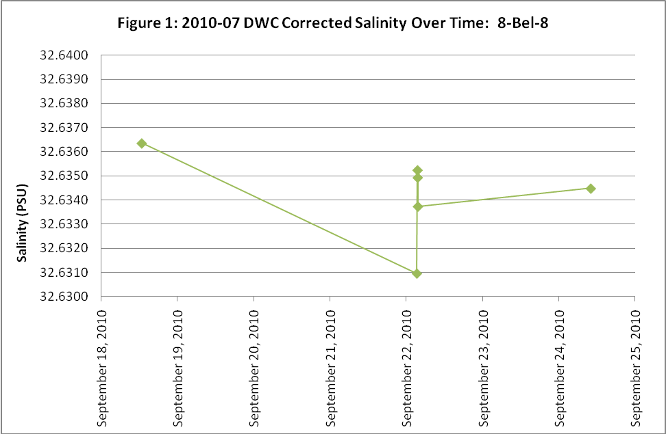

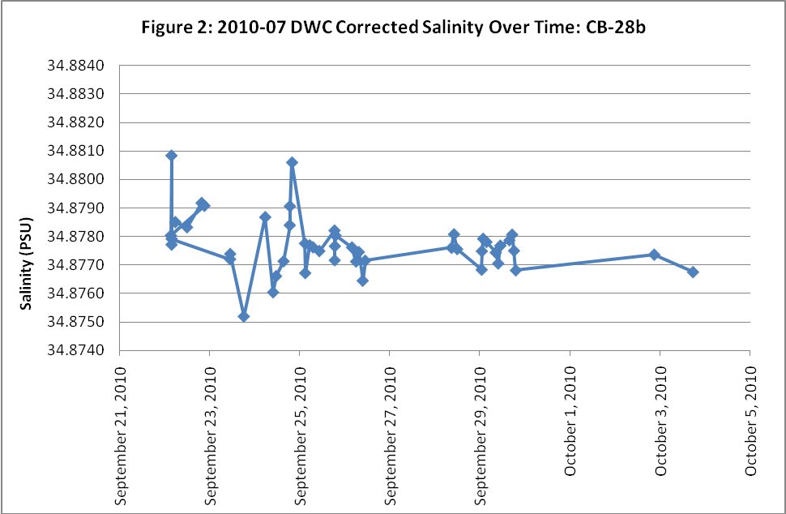

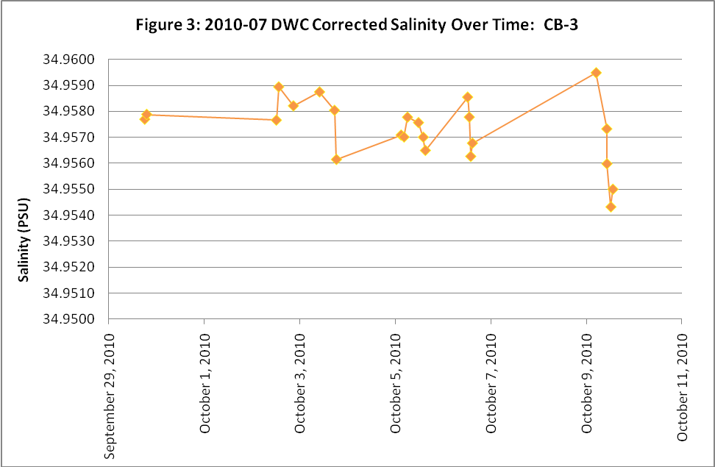

3.4 Replicates:

72 replicates were run from the first half of the cruise. Of these, only one set of replicates was rejected based on Chauvenet’s criteria. The pooled standard deviation after removal of the outlier was 0.0021.

4.1 Problems:

Stability of the salinometer was affected by the movement of the ship, with observable jumps in the stand-by number when the ship rolled as well as when the ship was jarred while in ice. The rolling motion appeared to affect the salinometer more drastically than the jarring motion. There was not a significant change in the stand-by number over the course of the survey, ranging from 24.6085 to 24.6090.

One problem encountered was the unreliable filling of sidearm 4 (rightmost arm of cell). Each of the side arms when filling vents through a small polyethylene tube. The same tube is used with positive air pressure to flush a small out of the cell. When salt or debris collects in this tube, the arm will not fill or flush properly. Repeat flushing cleaned out the tube eventually.

Bubbles within the side-arms of the interior of the cell caused problems during analysis. A variety of tactics were used to try and clean the cell, in an attempt to remove bubbles as well as any debris which may have stopped the bubbles from exiting the cell. The problem with small bubbles on the platinum-rhodium electrodes was never satisfactorily remedied. The cell was rinsed with Isopropanol, Triton–x and CLR with no change. The cell was removed and cleaned with Kim wipes and again cleaned with the 3 agents with little result. The cell was then disassembled and the coil electrodes cleaned directly. This did not remove the bubbles so the whole cycle was completed.

During the second inspection of the cell, it was noticed that the coil spacing was very tight and irregular. The coils were replaced by using a finger nail and re-installed. This time a lab grade surfactant Witconate was also used and appeared to remove the bubbles. When the AutoSal was tried again, fluctuations of 0.00100 in the conductivity ratio were observed and it was not clear whether this represented the effect of very small bubbles on the conductivity cell or if some electrical change had occurred during the intense cleaning and disassembly. Due to this instability, the decision to take the remaining cases of samples back to IOS for analysis was made.

4.2 Action to be taken:

AutoSal 69086 will be re-set up at IOS in December 2010 and the troubles re-investigated. As the troubles were similar in 2009 but were cleared at IOS after the 2009 JOIS cruise, Guildline will be contacted for additional advice. There are a couple of other institutions (SIO, BIO and WHOI) operating AutoSal 8400B’s at sea and at least one (USCGC Healy) aboard an ice breaker. An attempt will be made to find any other tips for shipboard operation. The possibility of a training session at Guildline or the visit of rep to IOS for training will also be looked into. It is likely the unit will be sent back to the factory for cleaning and re-calibration and or cell replacement in early 2011.

Appendix 1:

34 Cases returning to IOS include the following:

Case | Station
1 | DWR (CB-6)
2 | DWR (CB-6)
3 | CB-40
4 | CB-13
5 | DWR (CB-3)
6 | PP-7
7 | CB-15
8 | CB-15
9 | CB-15
10 | DUPS (CB-9, 12, 12a, 16, 13, 15, PP-7)
11 | PP-6
12 | CB-21
13 | CB-21
14 | DUPS (PP-6,7, CB-DW, CB-18, 19, 6, 21)
15 | CB-18
16 | CB-16
17 | CB-19
18 | PP-6
19 | PP-7
20 | DUPS (CB-7, 8, 10, 70, 11, 9, 21, 40)
21 | CB-12a
22 | CB-19
23 | CB-DW
24 | PP-6
25 | CB-6
26 | CB-13
27 | CB-21
28  29  30  31  32  33  34  35 | CB-17  CB-50  CB-51  CB-52  CB-53  CB-54  DUPS (CB-40, 15, 50, 51, 52, 53, 54)  Loop Salinities

