Nutrient Report Cruise LSSL 2010-06 C3O
December 13, 2010
Linda White

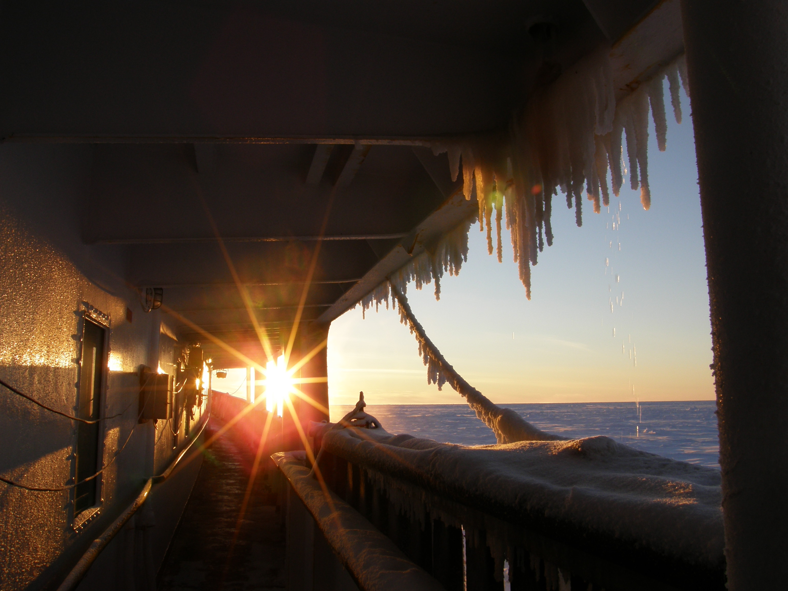

Nutrient analysis of frozen seawater samples taken on the leg up were analyzed for nitrite + nitrate, silicate and phosphate on a Three Channel Technicon Autoanalyzer while at sea on Cruise 2010 -07.

Samples were thawed at 50C for 30 minutes and shaken prior to analysis.
Stock standards prepared at the Institute of Ocean Sciences, May, 2010 and were calibrated against Wako nitrate 20ug atoms/l and Wako silicate 50ug atoms/l, there is no calibration standard available for phosphate. These were the same stock standards used for anlaysing fresh samples of 2010-07.

Dates for analyses are as follows:

6-Bel-6/14 October 5, 2010
QM10/18 October 5, 2010
CG10/25 October 5, 2010
BB10-02/6 October 7, 2010
PS-3/10 October 7, 2010
LS10-01/1 October 7, 2010
LS10-02/2 October 7, 2010
DS10-01/4 October 7, 2010
8-Bel-/12 October 9, 2010
LS10-03/3 October 9, 2010
FR10-01/15 October 9, 2010
VS10/02/17 October 9, 2010
BB10-01/5 October 10, 2010
PS-1 October 10, 2010

The colorimeters, cables and analog-digital converter were interchanged with a set from Water Properties/Janet Barwell-Clarke’s Technicon system in hopes to eliminate any offsets that may have been introduced by the Arctic system as uncovered in the 2009 phosphate and nitrate data.

A 3.2% sodium chloride(Sigma) solution is used to dilute the stock solutions for the daily working standards of the following concentrations: nitrite + nitrate 0, 8.0, 16.0, 24.0µm/l, silicate 0, 16.0, 32.0, 48.0µm/l and phosphate 0, 0.8, 1.60, 2.40µm/l (nominal).

Fresh standards were prepared daily along with silicate and phosphate ascorbic acid wetting agents. Standard concentrations were chosen to bracket the range of samples.

A set of standards were analyzed at the beginning of the day’s run. A frozen reference sample from MK-7 #352, 2,600m depth and medium check standard plus two zeroes were analyzed between profiles and a full set of standards was analyzed after each profile and at the end of the day followed by a de ionized water zero. All reference materials, medium check standards and regression curve concentrations were run in triplicate.
The best 2 values for each concentration in the regression were used to calculate slope.
Wako 20ug atoms/l nitrate and Wako 50ug atoms/l were used to calibrate the working standard solutions. Nitrate concentrations were; 8.0µm/l, 16.0µm/l and 24.0µm/l, silicate; 16.0µm/l, 31.9µm/l and 47.9µm/l, phosphate; 0.81µm/l, 1.62µm/l and 2.41µm/l. Values were adjusted for pipette delivery.

Quadratic C2 (slope) values;
Nitrate + nitrite; 0.0208 +/- 0.0003 where n = 17
Silicate; 0.0512 +/- 0.0006 where n = 17
Phosphate; 0.0033 +/- 0.00006 where n = 18

No adjustments were made to the apertures after initial peaking of the colorimeters at the beginning of analyses September 17, 2010.

Wako standards were analyzed once a week to validate the primary nutrient stock solutions were holding true.

KANSO Lot AY series; nitrate 6.28µm/l, silicate 30.3µm/l and phosphate 0.50µm/l. These are the assigned values from KANSO. There is some variability within each batch/bottle of reference material.

Charts for the medium check standard, KANSO reference samples and the frozen MK reference material on board sample were established to check sampling procedures, instrument stability and analytical precision.

A Model Diamond Nanopure ion exchange water system was installed in the nutrient lab which was fed from ship’s water supply. Ship’s water is prepared by reverse osmosis and distillation of seawater. 18.0 – 18.2 Mega ohms resistance water was produced for the entire trip.

Observations

The Autoanalyzer system produced a very stable baseline for nitrate + nitrite.

Silicate baseline was slightly noisy for the entire trip and Peakbase smooth was used to smooth out the peak tops for calculation. New platen tubing was installed for oxalic acid, molybdate and ascorbic wetting agents to try and clear up the noise. It was not very successful.
Phosphate baseline would take a slight shift during the last two days of analysis.
New tubing was replaced for ascorbic acid wetting agent and molybdate solutions.
At the end of each day’s run the tubing and coils were cleaned with 3N NaOH, 1N HCl and 30 minutes of double deionised water.
Most days the Autoanalyser ran for a minimum of 10 hours.

The entire pump tubing was replaced with new after 500 samples.

Detection limit was determined as three times the standard deviation of the blank where n = 10 replicates.

Detection limits were: nitrate 0.041, silicate 0.081 and phosphate 0.006 mmol/m³

Three cadmium reduction columns were used for nitrate throughout the 4 weeks of analysis.

A set of approximately 1000 new /er nutrient tubes were cycled through sampling and analysis for the entire trip. The tubes were rinsed with hot tap water, acid cleaned in 1N HCL for >4hours and rinsed 3 times with Nanopure water.

Once the nutrient samples were taken from the Niskin bottles they were wiped dry prior to storage in the refrigerator for fresh analysis. A set of samples for each station was frozen for re-analysis at IOS where required.

Quality assurance data follows:

Nutrient | Nitrate + Nitrite | Silicate | Phosphate
Nutrient | mmol/m³ | mmol/m³ | mmol/m³
Sample Replicates | Fresh samples | Fresh samples | Fresh samples
Sp | 0.19 | 0.32 | 0.02
No. of duplicates | 24 | 24 | 24
Medium check standard
Calibrated value | 16.0mmol/l³ | 31.9mm0l/m³ | 1.62mmol/m³
Average and std dev | 16.1 +/- .07 | 31.9 +/- 0.15 | 1.62 +/- 0.01
n | 38 | 39 | 38
Wako Standard | 20.1 +/- 0.1 | 50.2 +/- 0.2 | n/a

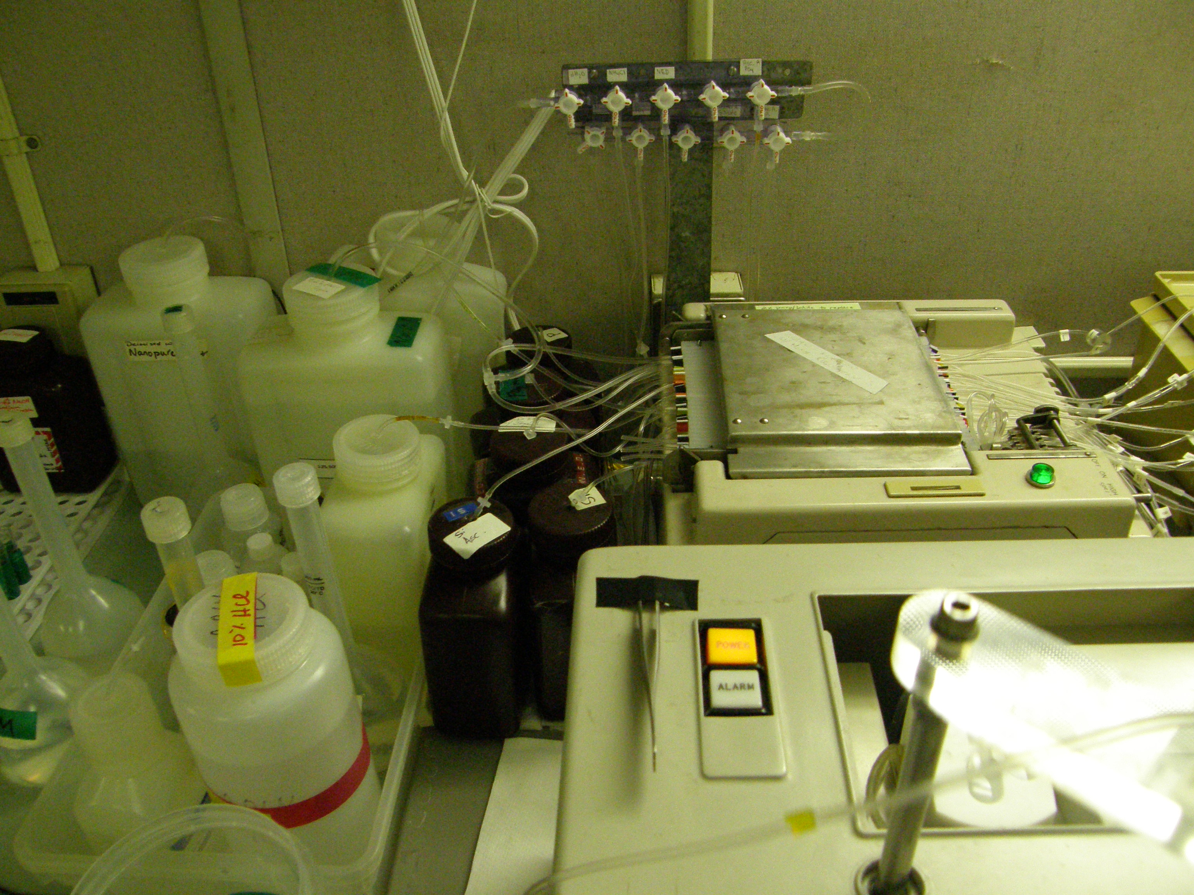

 | Nitrate | Silicate | Phosphate
KANSO Reference Sample: AY | 6.28 mmol/m^{3*} | 30.3mmol/m^{3*} | 0.50mmol/m^{3*}
Analyzed | 6.24+/-0.12 | 30.04+/-0.3 | 0.50+/ 0.01
n | 89 | 87 | 87
MK-7 #352 Frozen shipboard reference  2010-07 | 14.60+/-0.2 | 14.13+/-0.14 | 1.04+/-0.02
n | 141 | 140 | 139

AY Measured by Marine Works Lab, Japan.

1. KANSO – The General Environmental Technos C. Ltd of Osaka, Japan

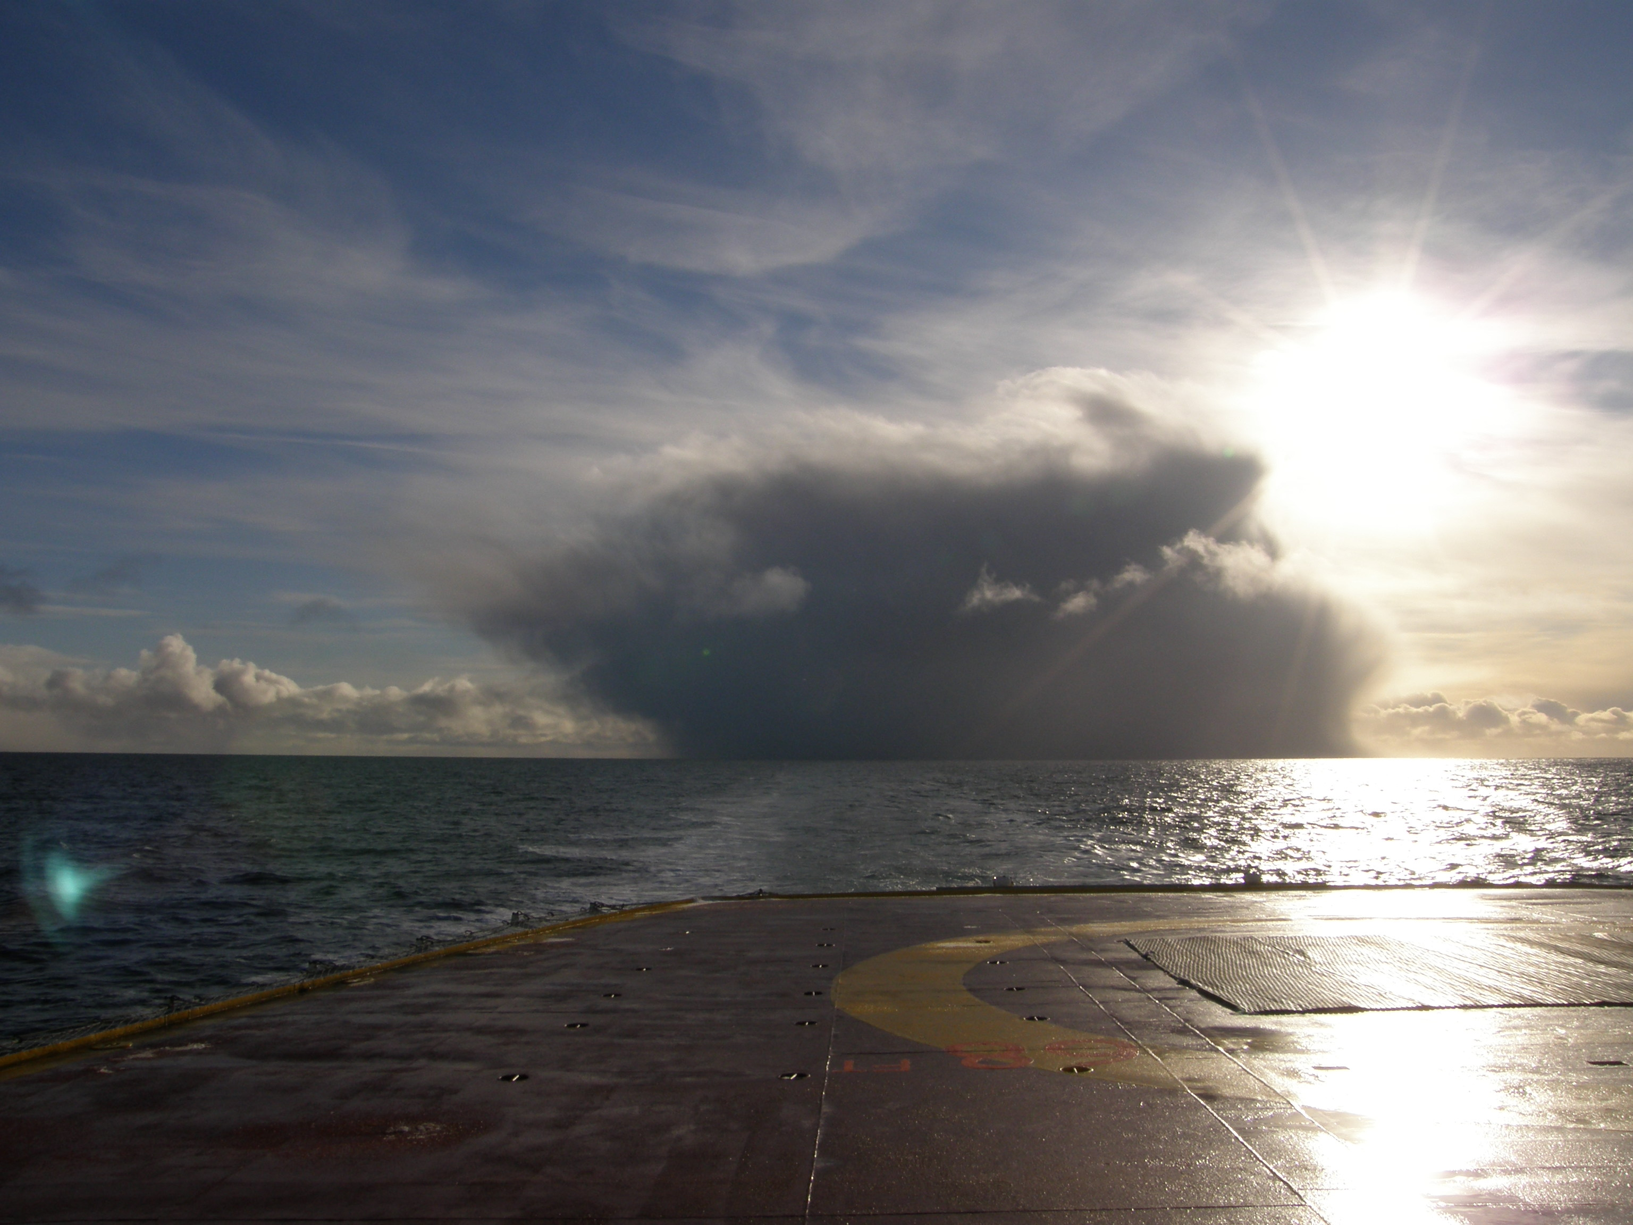
Storm front catching up with the Louis-2010-07

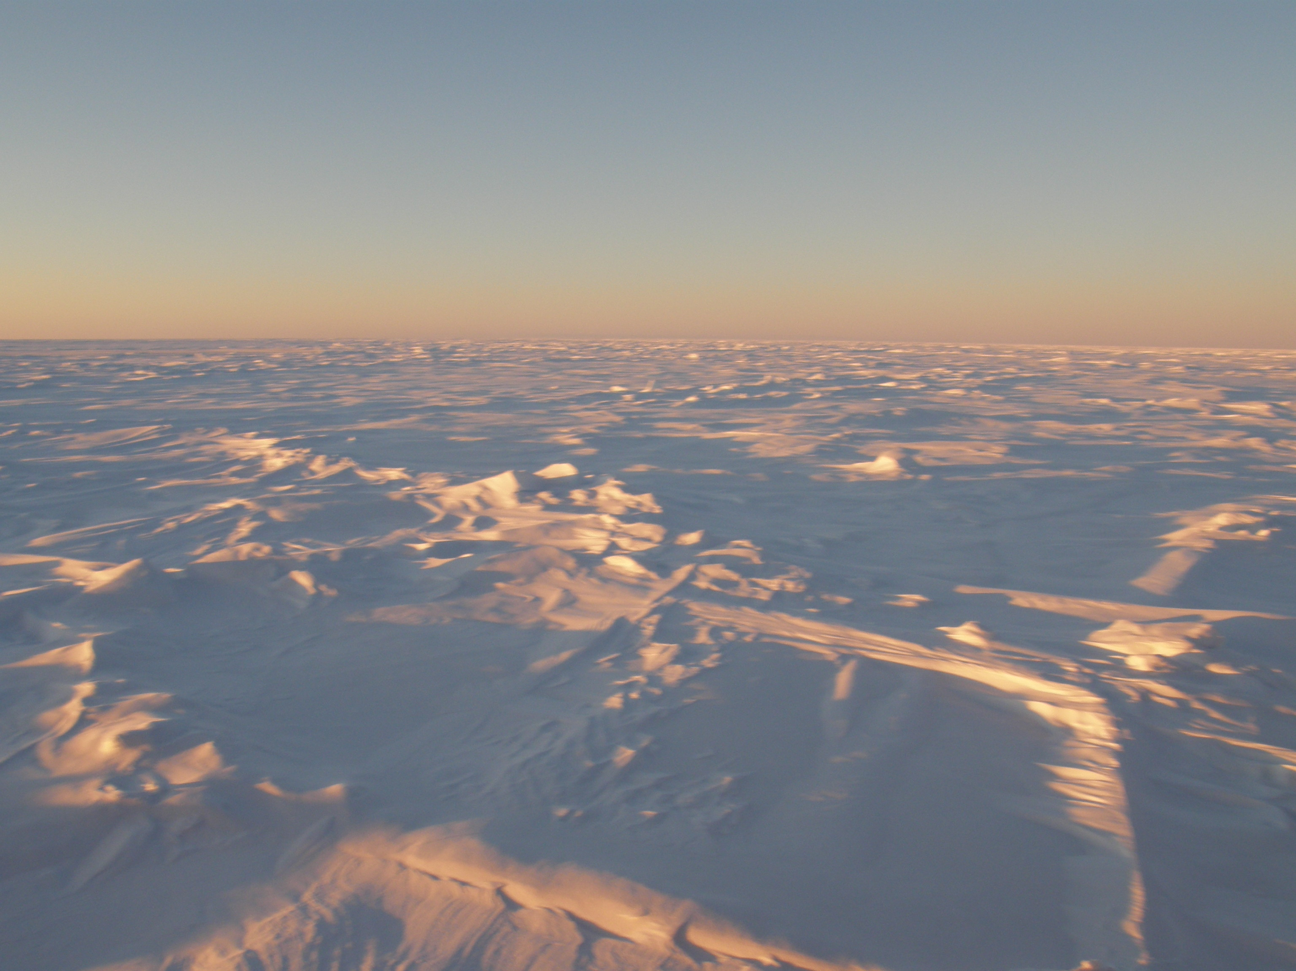
Windswept ice and snow.

