LSSL 2010-07 Chummy Report. By Jeffrey Charters.

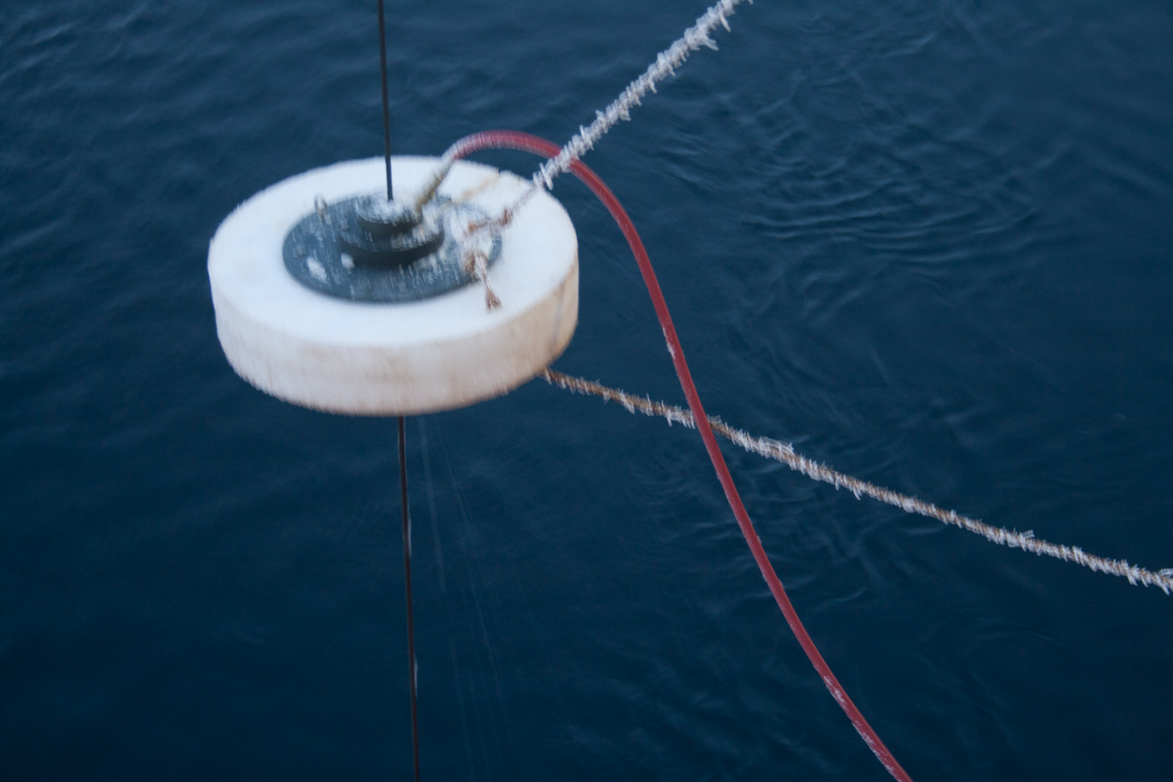
Figure 1. The Chummy in action during the 2009-20 JOIS cruise. Photo: JWC.

The “Chummy” is an apparatus which can be affixed to the rosette wire during upcast in order to dry out the line before it passes through the block. This is done by blowing compressed air on the wire in an enclosed space, and is effective in removing both water and slush from the wire. In past years, the cruise happened during the summer months where temperatures well below the freezing point were not an issue. Early in the 2009-20 cruise, it was found that water was getting from the wire to the block, which would then freeze. This would result in the wire skipping along the block rather than the entire unit turning. The ‘cable out’ and ‘CTD data’ reported at the winch would then be quite different, by as much as many tens of meters. Several plastic block component were also ground down to nothing by the friction caused by the wire against frozen parts.

The Chummy has mostly solved these problems. It was used on all casts during the 2010-07 cruise when the temperature was below freezing, and seems to have resolved the issues encountered during the 2009-20 cruise. It is also simple to use. When the rosette was at it’s lowest point of the cast, the A-frame was drawn toward the ship, and the operator then just slides the wire through an opening in the Chummy, rotates the upper portion by a quarter turn and the A-frame can then be extended once again. This same process then occurs in reverse when the rosette is at the 10m mark (to avoid hitting the ship). While on the wire, the Chummy is supported by ropes hooked by carabiners to the deck above and below the operating level on the line.

The Chummy is highly recommended during casts with temperatures below freezing.
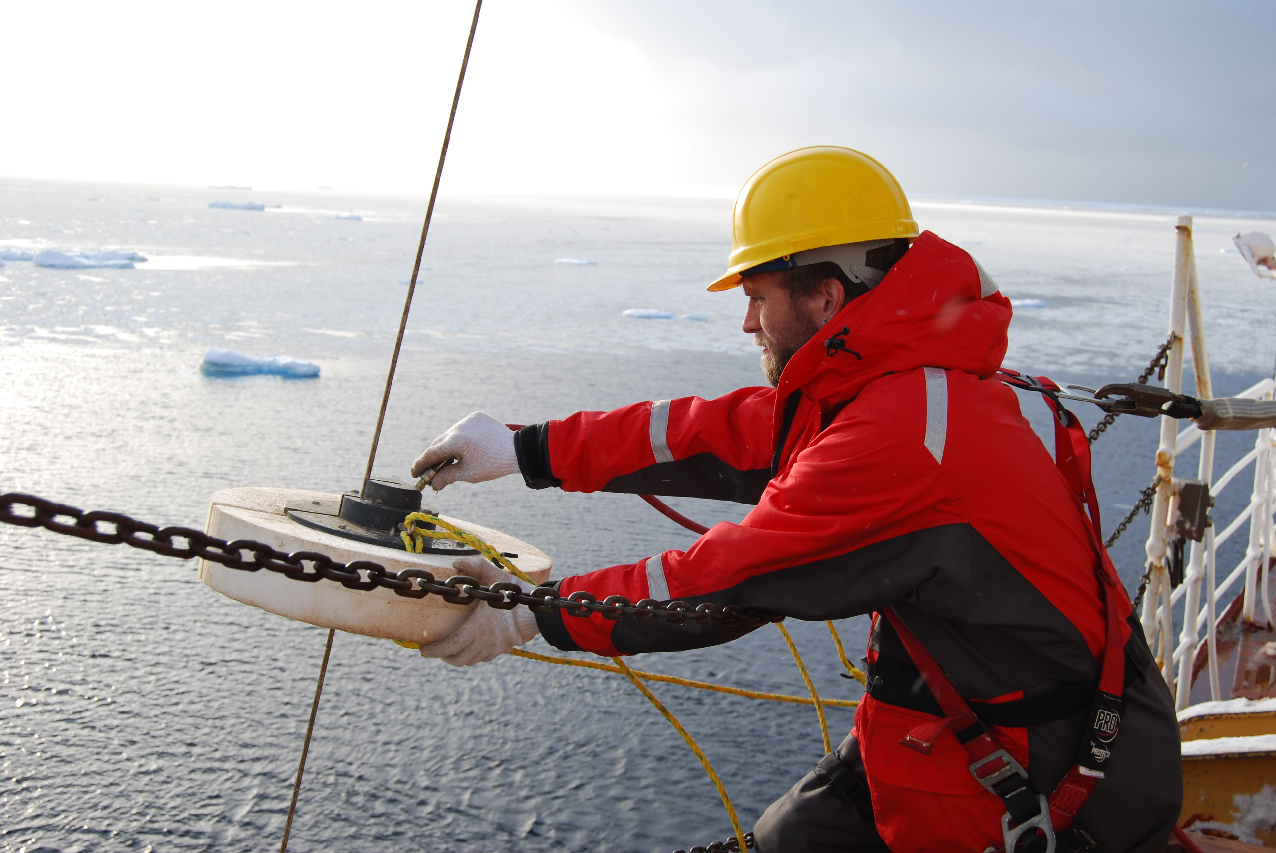
Figure 2. CTD-guy Jeffrey Charters attaches the chummy in frigid conditions according to the Coast Guard motto: safety first, service always. Photo: Chelsea Stanley.

Problems and Solutions

As simple as the Chummy may be, several problems were reported, mainly a result of cold temperatures.

Several times, as soon as the air hose was hooked into the Chummy, the air pressure would drop and eventually fail completely. On removing the air hose, the male air port on the Chummy would be entirely clogged with ice. Using spikes could remove this ice without much difficulty, but time can be lost during the unclogging process. This was resolved by hooking the air hose to the Chummy indoors prior to being needed on deck and allowing moisture which may be in the Chummy or the air hose to dissipate.

While retrieving the Chummy from the line, the opening is often clogged with ice. This seems inevitable, and has never posed too much of a problem.

If there is a large wire angle during the rosette cast, a longer line may be necessary to avoid unnecessary strain. This was done early during the 2010-07 cruise.

Occasionally there are casts which call for “yo-yo” bottle stoppages, in which the rosette is raised 1 meter, lowered 2 meters and raised 1 meter, in order to mix surrounding waters. When this was done in temperatures around -15°C, the Chummy would freeze to the line when it was not moving. The best we could do to resolve this situation was to “jig the Chummy” by pulling on the upper rope to keep the apparatus moving along the line, not giving it a chance to freeze anywhere. Often this would not work completely, and as the winch operator began bringing the line in, the Chummy would rise and gently contact the block, which would force it to fall back down the line. In this case, holding the top rope and easing the descent would be wise in order to not snap the chain to which it is attached.

