CTD/Rosette Report

IOS Cruise ID: 2010-07, CCGS Louis S St-Laurent

Dates: September 16 to October 15, 2010
Mike Dempsey and Sarah Zimmermann

The primary CTD system used on board was a Seabird SBE9+ CTD s/n 0756, configured with a 24- position SBE-32 pylon with 10L Niskin bottles fitted with internal stainless steel springs in an ice-strengthened rosette frame. The data were collected real-time using the SBE 11+ deck unit and computer running Seasave V7.20f acquisition software. The CTD was set up with two temperature sensors, two conductivity sensors, two oxygen sensors, fluorometer, transmissometer, CDOM fluorometer and altimeter. In addition, an ISUS nitrate sensor, paired with a PAR sensor was used on select casts until a leak in the battery casing halted the use of the ISUS. A surface PAR sensor was used through the cruise, though these data will be removed from the final data set.

During a typical deployment:
The syringes full of DI water attached to the TC-ducts, as well as the cap over the CDOM sensor were removed. The transmissometer and CDOM sensor windows were sprayed with deionised (DI) water and wiped with a DI water-soaked wipe prior to each deployment. The package was lowered to 10m to cool the system to ambient sea water temperature, remove bubbles from the sensor’s plumbing and equilibrate the oxygen sensor. The pumps were turned on manually after the CTD was immersed and the system was left to soak 3 minutes. The package was then brought up to just below the surface to begin a clean cast, and lowered at 30m/min for the first 300m and then at 60m/min to within 10m of the ocean floor. Niskin bottles were closed during the upcast with a 30second stop while we were in open water (approximately Casts 1-19) and with no stop after we entered the ice. Niskin bottles were closed at specific salinities in the upper 400m and at specific depths below this. The instrumented sheave (Brook Ocean Technology) readouts to the winch operator, CTD operator and bridge allowed all three to monitor cable out, wire angle and CTD depth. Once air temperature dropped to approximately -5C the pressurized air de-icer for the CTD wire was used on all the upcasts to prevent seawater from freezing on the wire and clogging the block.

Data/Performance notes:

The SBE9+ CTD overall performance was good. Editing and calibration have not yet been done, but the data will likely meet or exceed the SBE9+ performance specifications given by Seabird. Header information of position, station name, and depth has not been quality controlled yet. Salinity and oxygen water samples will be used to calibrate the sensors. Due to the asymmetrical plumbing on the temperature and conductivity sensor pairs, some post processing may be required for phase adjustment.

Several “calibration” casts were performed where select bottles were tripped after using a an unusual bottle stop of : wait 30sec, down 1m, up 2 m, down 1m, wait 30sec and then close the Niskin. The intent is to have well mixed water so a good comparison can be made between the CTD sensors and the water in the Niskin being sampled for salinity, oxygen and chlorophyll.

The ISUS sensor failed on Cast 5. A seawater leak was discovered in the battery pack. Using pressure tests of the empty battery case, the leak was discovered to be a crack in the case itself, not in the o-ring seals, preventing repair or further use of the ISUS.

An issue with the meter block display freezing at the start of each cast was fixed by changing the operational procedure to exiting the IMS software after each cast and restarting it only after CTD data acquisition was begun.

For next year: The rosette shack’s floor at the junction of the double doors was worn and should be fibreglass repaired to prevent water from entering the insulated floor. The floor should also be re-surfaced as it has become worn since initial installation. Please see more suggestions for next year below:

This year the JOIS cruise took place, like last year, from mid-September to mid-October, a month later than per usual (2003-2008). We had sustained periods of colder temperatures than even last year, and as a result there were issues related to the colder temperatures (0 to -20C).
- The bearing of the CTD winch will need servicing. An intermittent squealing sound was coming from the winch for the last two weeks. It may have been due to over greasing of the winch which then solidified in the cold weather displacing the mechanical part and/or this sound could have been a result of a worn bearing. The winch is a vital cornerstone to our program and its good operation and the availability of spare parts is the highest priority for 2011.
- Problems were encountered with icing up of the Brooke Ocean technology (BOT) block. Using the pneumatic air blower, clipped to the CTD wire during the upcast, to dry the wire as it came in, as soon as conditions were cold enough (about -5C), prevented many of the problems we had last year: Ice accumulated on the downcast as slush on the wire was packed onto the PVC sheave and accumulated on the two fairlead arms. The ice would cause the fairlead rollers and occasionally the sheave to seize, changing the calibration of the line out counter. Occasionally we would still need a pike pole to chip ice out of the groove. In 2009, the fairlead rollers became grooved when they froze solid. In 2010, ice removal was more thorough using the “ice chummy” and the rollers appear to not have been damaged.
- Due to the cold temperatures, effort was made to reduce the time of the Rosette on deck to prevent freezing of the sensor. The Rosette lab’s doors would remain closed until the bridge gave permission to start the cast. The Rosette was then brought out and lowered into the water as quickly as possible. This step was repeated in reverse at the end of the cast. During a couple casts, the dual T and C sensors were not in agreement during the initial soak indicating their was freezing around the sensors or in the line obscuring the flow. The CTD was left to soak longer and/or lowered deeper to warmer waters until the ice thawed. The CTD C sensor drifted much more than typical, associated with the cold weather. The sensor does not appear to be cracked, just a calibration shift.
- With the increased hours of darkness, working lights were necessary for the CTD operation. A light mounted on the inboard rail a deck above the CTD operation, a light on the boat deck forward and aft of the CTD operation were very useful in providing enough light for the work.
- The freezing temperatures caused the drains of the rosette shack to freeze. A fix was attempted by using a removable longer drain pipe to connect to the shack’s short drain pipe during the rosette sampling to redirect water off the deck and over the side. The shack’s short drain pipe and this longer pipe would both freeze during the hour to two hours of sampling however, requiring more detaching – unfreezing- reattaching and finally shovelling off the drained water that managed to collect next to the rosette shack. Solution? Perhaps a pipe running directly over the side insulated with heat tape? Or a heated line that can be left inside the pipe?
- The wooden rosette deck’s no-slip stick-on grips were detaching after a season of use. A replacement to these grips is needed. Sections of wire grid were stapled to the deck to provide grip which worked well. Over the winter, more expanded metal should be installed (larger hole size if possible) or a paint on non skid surface applied.
- During the cruise the heater electrical wiring was fixed for the CTD shack which allowed the room to maintain 18C during the -10C weather. Thank you!

Improvements for 2010:
Helpful improvements made by the ship for the 2010 CTD operations included:
Additional lights put up for the CTD and ADCP area
Assistance by sending the Brooke Ocean Block out for repair, covered by IOS.
Any other?

Photos:

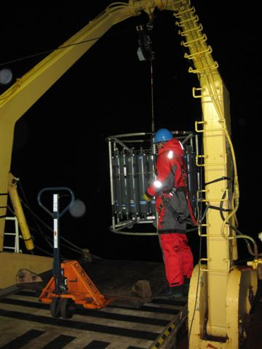

Figure 1. The 24-bottle rosette with the SBE9+ CTD is deployed by Mike Dempsey.

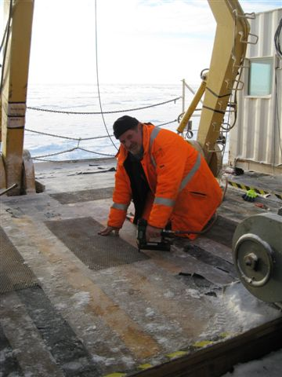

Figure 2. Carpenter Eugene Jones adds strips of metal gridding to the CTD deck to replace the worn non-slip adhesive.

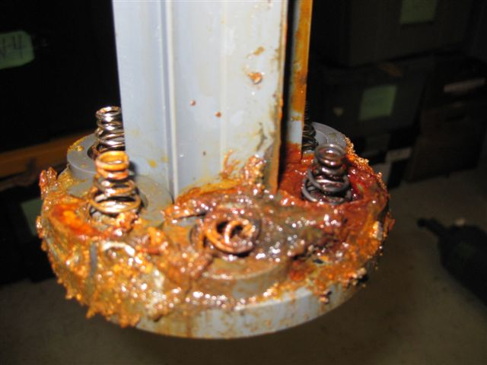

Figure 3. Seawater leak of the ISUS sensor’s battery case.

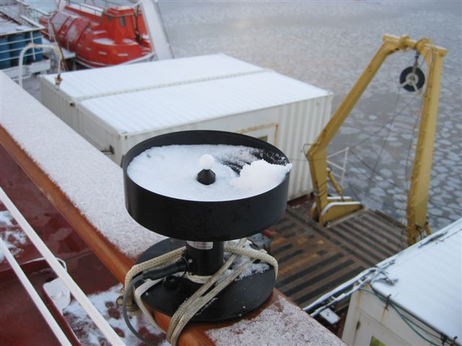

Figure 4. Surface reference PAR data collected but not to be kept.

