Data Collection Report for LSSL 2010-06 and LSSL 2010-07 (July –Oct 2010)
19 Oct 2010
Mike Dempsey and Sarah Zimmermann

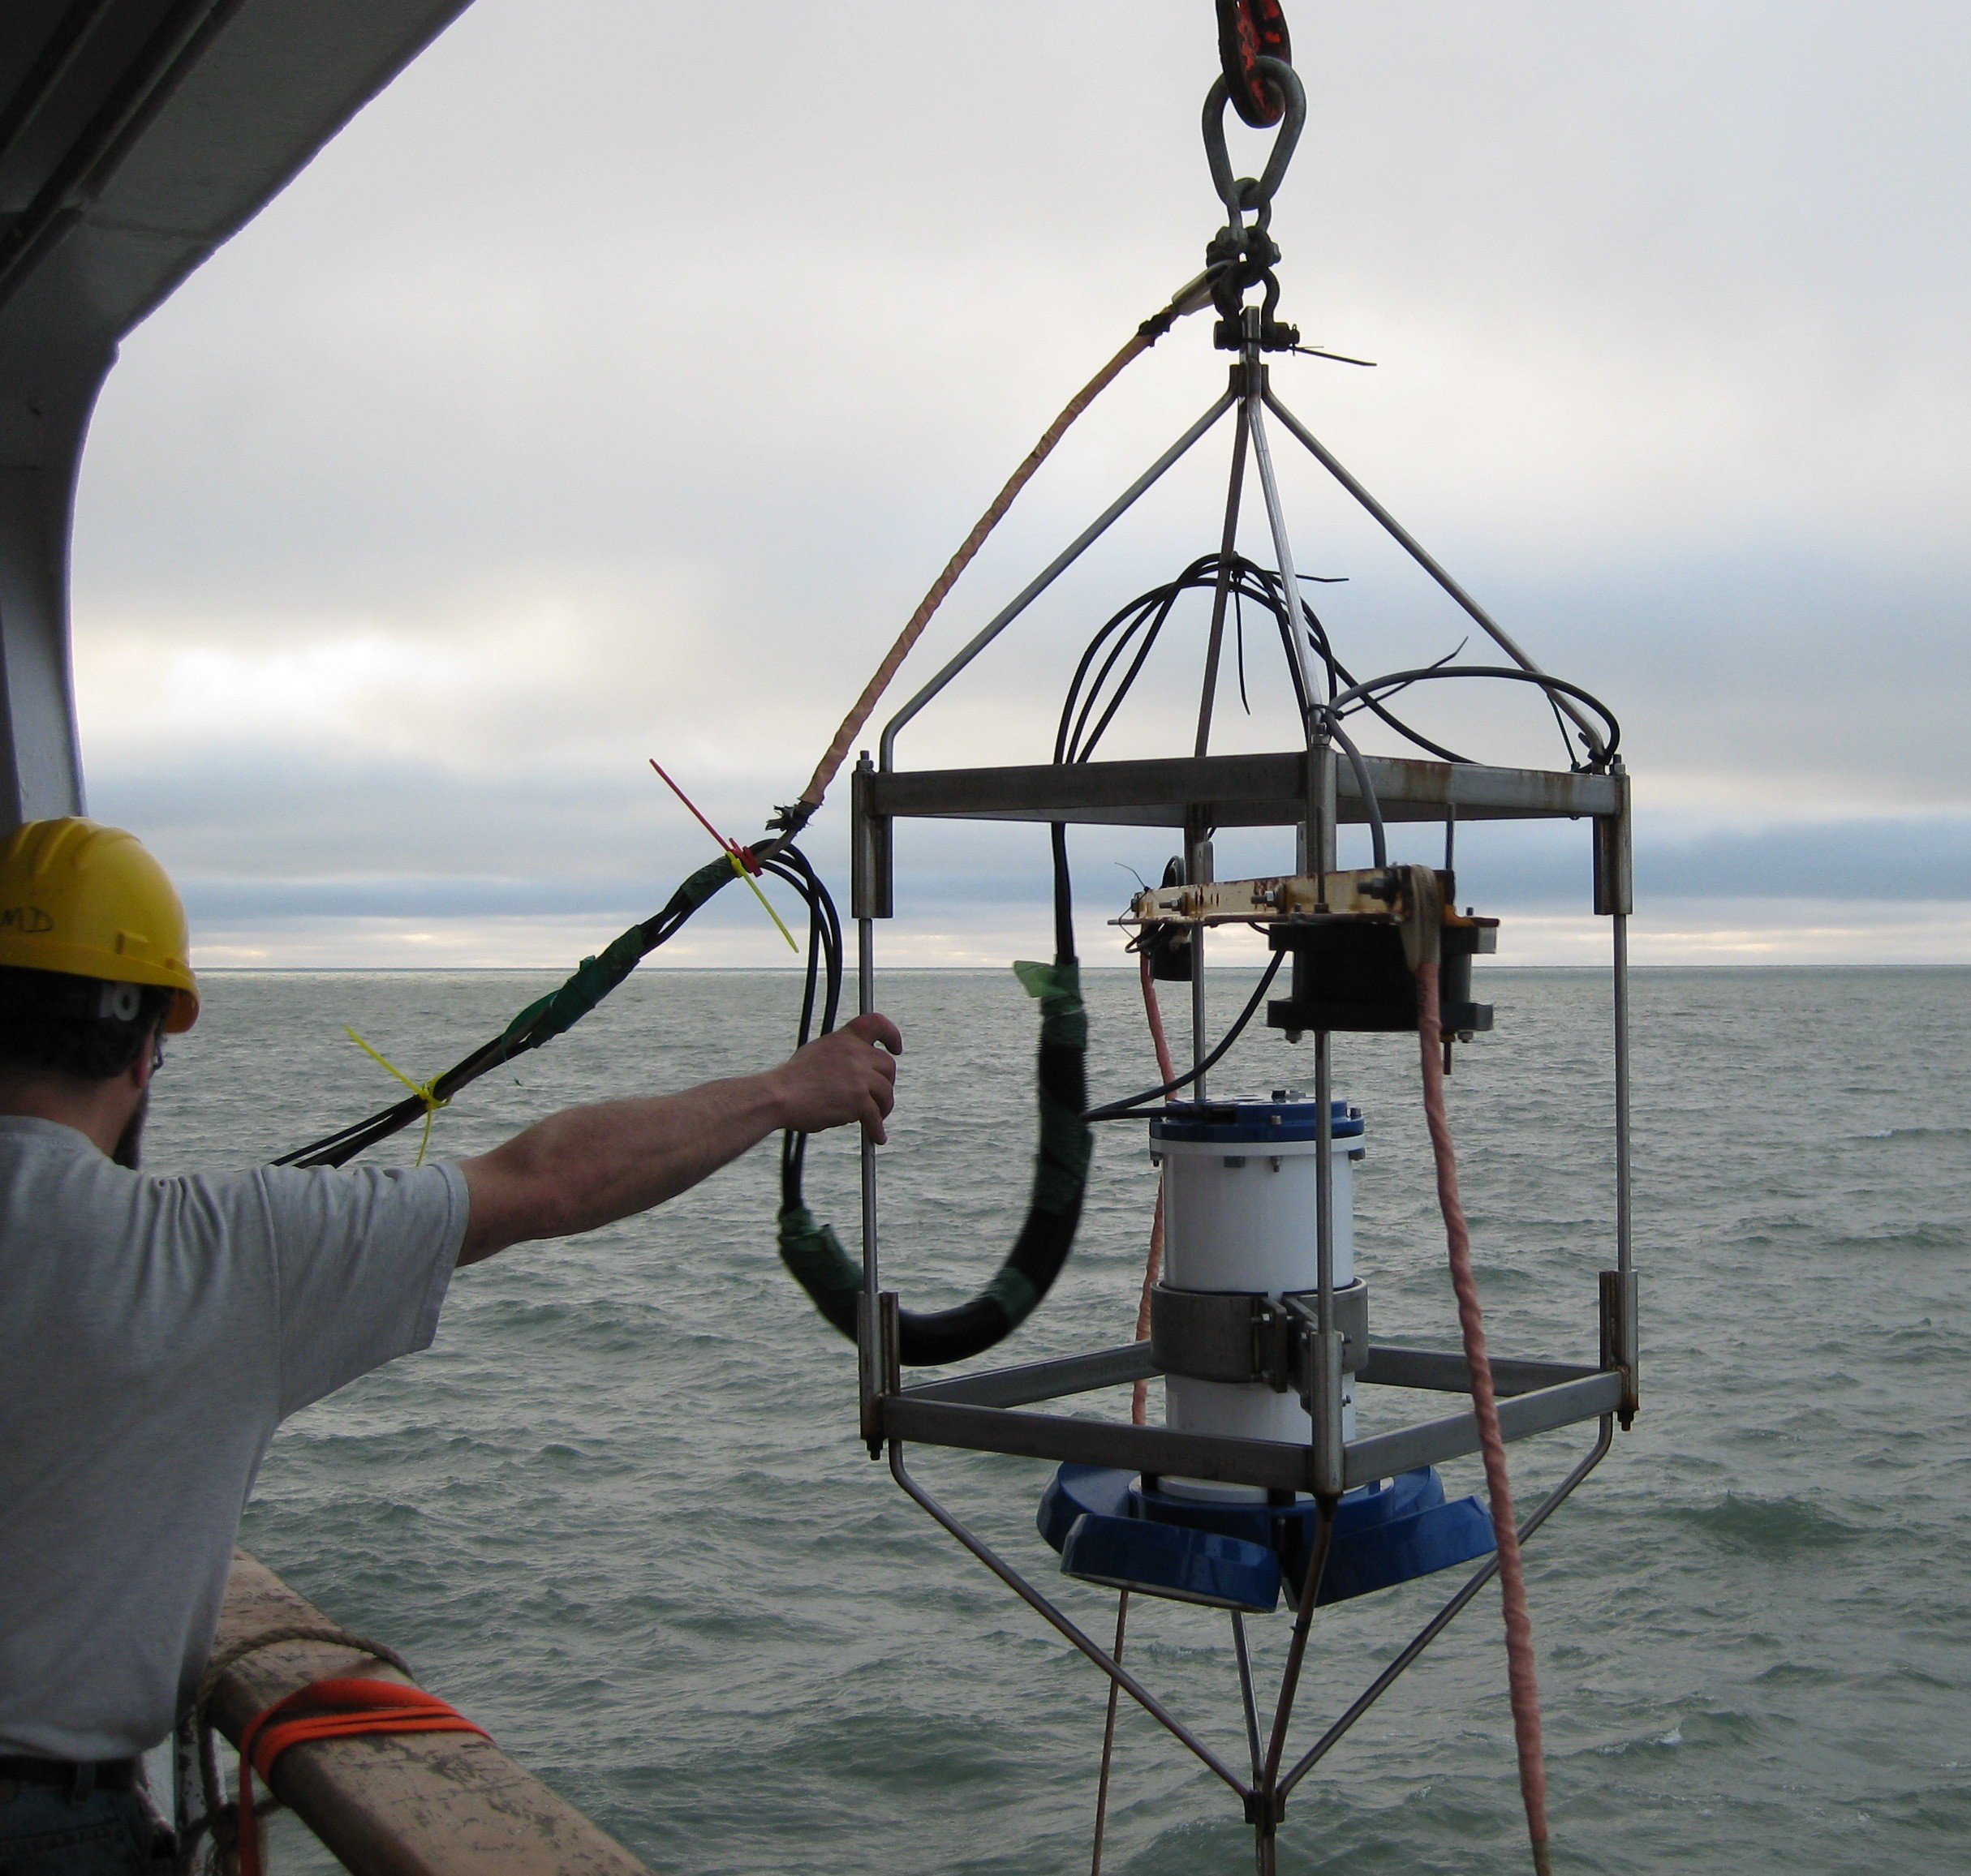
In conjunction with the CTD/Rosette Casts, an Acoustic Doppler Current Profiler (ADCP) was lowered over the side to measuring currents in the upper 150 m. The package was lowered by crane from the boat deck to approximately 5m beneath the surface and left in place until the completion of the CTD cast.

Two backscatter transducers that were attached to a crosspiece above the ADCP from to look for zooplankton. The frequencies used were 50 and 200 kHz. The effective range was approximately 100 m.
Figure 1. Need figure showing backscatter sounders!

Typical Deployment:
The ADCP was deployed ‘time –invisible’ to the CTD casts. Following the CTD’s deployment, the ADCP would be lowered over the side to a depth of approximately 5m, with the weight transferred from the crane to the two tag lines, fore and aft of the ADCP, and the software for the ADCP and sounders started in the main lab. The ADCP would be left in for a minimum of 15 minutes unless for the safety of the ADCP it was necessary to pull it out sooner. Typically the ADCP was left in for the entire cast (full depth basin casts would give the ADCP ~2 hours in the water) and pulled out when the CTD was 500m from the surface. Where other considerations were more important, the ADCP deployment was either shortened or omitted. Factors effecting the deployment included ice and sea conditions, manpower shortages on deck and conflicts of crane use with flight ops (rescue boat). The ADCP was lifted to the main deck’s rail and secured outboard with the ratchet straps to the rail. If weather conditions or ship’s operations warranted, the ADCP would be lifted inboard either on the main deck or up on the boatdeck.
The ADCP data collection included the ship’s GPS and heading

Issues:
The ADCP would typically be in the path of any propeller wash resulting from ship’s repositioning during station.

The freezing seawater temperatures (sea-ice actively freezing) incased the ADCP in ice. After CTD Cast 68 the Ready Heater was aimed at the transducer heads and after approximately 6 hours had melted ice off the faces. Temperatures were checked regularly (hand warm) to confirm the bottom of the transducers were not ‘cooked’ in the process. However, after only 4 casts the transducer faces had grown a new layer of ice. See pictures below.
Following CTD Cast 68 2010-10-12 23:20 UTC the gradual ice accumulation (shown below) was melted off using a mobile gas powered heater (“Ready Heater”). During the four following casts (end of the cruise) the ice accumulated quickly (see below).

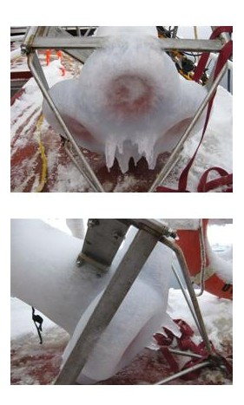

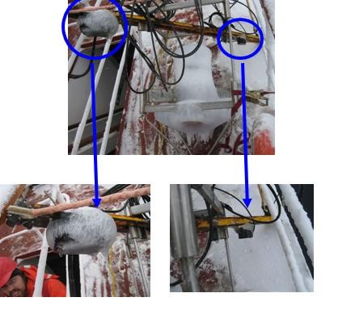

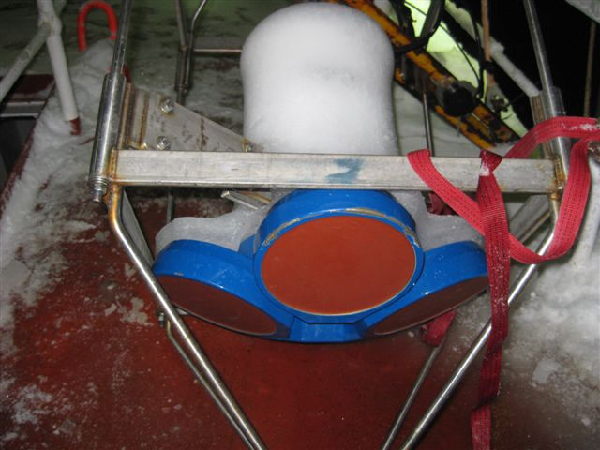

After melting ice with Ready Heater for ~6 hours:

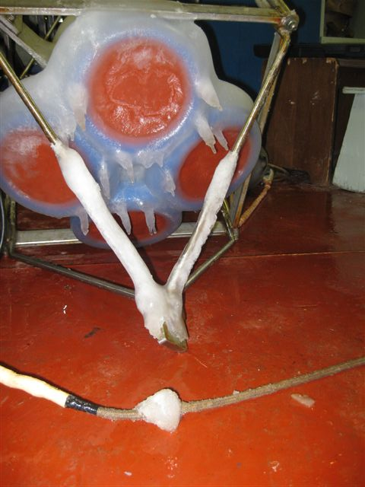

Four casts later:

Table 1. ADCP and Sounder Log for 2010-07
Date (UTC) | Time (UTC) | CTD Cast# | ADCP file name | Sounder file name | Comments
9/17/2010 | 430 | 1 | ADCP011 | 2010-08174303.dat | AG5
 |  | 2 | ADCP012 | 2010-081742310.dat | CABOS
 |  | 3 | ADCP013 | 2010-0817194225.dat and 2010-0817205757.dat | CB31b, not sure why there are two sonar files.
 |  | 4 | ADCP014 | 2010-0818023918.dat | CB60
 |  | 5 | ADCP015 | 2010-0819012744.dat | CB61
 |  | 6 | ADCP016 | 2010-0819045004.dat | CB62
 |  | 7 | ADCP017 | 2010-0819060835.dat | CB63
 |  | 8 | ADCP018 | 2010-0819072329.dat | CB65
 |  | 9 | ADCP019 | 2010-0820040544.dat | MK-3
 |  | 10 | ADCP020 | 2010-0820082222.dat | MK-2
 |  | 11 | ADCP021 | 2010-0820104931.dat | MK-1
 |  | 14 | ADCP022 | 2010-0820124240.dat | CB-28aa
9/20/2010 | 1630 | 15 | ADCP023 | 2010-0820162945.dat | MK-3a
9/20/2010 | 2049 | 16 | ADCP024 | 2010-0820204659.dat | MK4
9/21/2010 | 137 | 17 | ADCP025 | 2010-0821013711.dat | MK6
9/21/2010 | 646 | 18 | ADCP026 | 2010-0821064840.dat | CB28b
9/21/2010 | 942 | 19 | ADCP027 | 2010-0821094256.dat | CB28B second cast
9/21/2010 | 1652 | 20 | ADCP028 | 2010-0821165310.dat | CB-29
9/21/2010 | 2319 | 21 | ADCP029 | 2010-0821231846.dat | MK7
9/22/2010 | 611 | 22 | ADCP030 | 2010-0822061034.dat | CB-27
9/22/2010 | 1327 | 23 | ADCP031 | 2010-0822132920.dat | CB-22
9/22/2010 | 2138 | 24 | ADCP032 | 2010-0822213747.dat | CB-23a
9/23/2010 | 914 | 26 | ADCP033 | 2010-0823091458.dat | CB-50
9/23/2010 | 1847 | 27 | ADCP034 | 2010-0823184755.dat | CB-51
9/27/2010 | 352 | 28 | ADCP035 | 2010-0827035229.dat | STN-A
9/27/2010 | 1331 | 30 | ADCP036 | 2010-0827133140.dat | CB-2a
9/27/2010 | 1845 | 31 | ADCP037 | 2010-0827184519.dat | CB-2
9/28/2010 | 320 | 32 | ADCP038 | 2010-0828032016.dat | CB-3
9/28/2010 | 1219 | 33 | ADCP039 | 2010-0828121951.dat | CB-4
9/28/2010 | 2033 | 34 | ADCP040 | 2010-0828203347.dat | CB-4
9/29/2010 | 324 | 35 | ADCP041 | 2010-0829032528.dat | CB-5
9/30/2010 | 539 | 36 | ADCP042 | 2010-0830053953.dat | CB-6
9/30/2010 | 15:11 | 37 | ADCP043 | 2010-0830151139.dat | CB-8
10/1/2010 | 339 | 38 | ADCP044 | 2010-0901033957.dat | CB-10 sounder software crashed??
10/2/2010 | 1229 | 40 | ADCP045 | 2010-0902122950.dat | CB-70/ITP 35 recovery
10/3/2010 | 1045 | 41 | ADCP046 | 2010-0903104613.dat | CB-11
10/4/2010 | 348 | 42 | ADCP047 | 2010-0904032026.dat | CB-9
10/4/2010 | 1521 | 43 | ADCP048 | 2010-0904152051.dat | CB-12
10/5/2010 | 1513 | 49 | ADCP049 | 2010-0905151300.dat | CB-16
10/6/2010 | 158 | 50 | ADCP050 | 2010-0906015851.dat | CB-13 - sounder software crashed during operation?
10/6/2010 | 1218 | 52 | ADCP051 | 2010-0906121724.dat | CB-15 sounder s/w crashed ?
10/7/2010 | 716 | 55 | ADCP052 | 2010-09071635.dat | CB-17
10/7/2010 | 2224 | 56 | ADCP053 | 2010-0907222348.dat | PP-7 - short time in water
10/8/2010 | 155 | 57 | ADCP054 | 2010-0908015437.dat | PP7-during long cast
10/8/2010 | 1224 | 59 | ADCP055 | 2010-0908122447.dat | PP-6
10/9/2010 | 1231 | 61 | ADCP056 | 2010-0909123156.dat | CB-18 lots of prop wash
10/10/2010 | 954 | 62 | ADCP057 | 2010-0910095401.dat | CB-19
10/10/2010 | 1932 | 63 | ADCP058 | 2010-0910193226.dat | CB-6
10/11/2010 | 1337 | 66 | ADCP059 | 2010-0911133703.DAT | CB-21
10/12/2010 | 9:10 | 67 | ADCP060 | 2010-0912090842.DAT | CB-40
10/12/2010 | 20:12 | 68 | ADCP61 | 2010-0912201243.DAT | CB-50. Melted ice off transducer faces after this cast.
10/13/2010 | 7:09 | 69 | ADCP62 | 2010-0913070834.DAT | CB-51
10/13/2010 | 14:15 | 70 | ADCP63 | 2010-0913141519.DAT | CB-52
10/13/2010 | 19:27 | 71 | ADCP064 | 2010-0913192719.DAT | CB-53
10/14/2010 | 113 | 72 | ADCP065 | 2010-0914011341.dat | CB-54

