Data Collection Report for LSSL 2010-06 and LSSL 2010-07 (July –Oct 2010)
19 Oct 2010
Mike Dempsey and Sarah Zimmermann

For the past 4 seasons, an over the side RDI ADCP and two echo sounders have been lowered into the water when suitable at rosette stations. The installation due to its temporary nature, has been rigged as simply as possible to allow quick deployment. The ADCP can be lowered into the water in 5-7 minutes with one ship’s crew and one science personnel. The deployment is invisible to ship time and is completed entirely within the span of the CTD cast.
The three sensor acoustically profile the upper water column The ADCP uses backscatter from 4 150kHz transducers to determine currents at discreet intervals (bins) to a maximum of 350 m. Due to the clear water encountered off shore in the Canada Basin and the small currents in largely ice covered waters the instrument is working quite often to the limits of detection. Also in order to determine direction as well as velocity it is necessary to be able to correlate instrument north with geodetic north. Since traditional compasses are not accurate in the higher latitudes and the instrument is in close proximity to the steel ship, and alternate orienting method is used. The ADCP is aligned in a known orientation relative to the ship’s heading and the ship’s NMEA gyro string is used for direction.
In addition there are two transducers mounted on the ADCP rig. 50 and 200 kHz echosounders with a range of approximately 100 m are used to give some estimate of the scattering intensity of zooplankton populations. This data is later compared with net tow and ADCP data for correlation.
There are 3 kevlar lines for lowering the frame – 2 x 22m lines for the fore and aft lines and 1 x 8m line for the stainless frame.

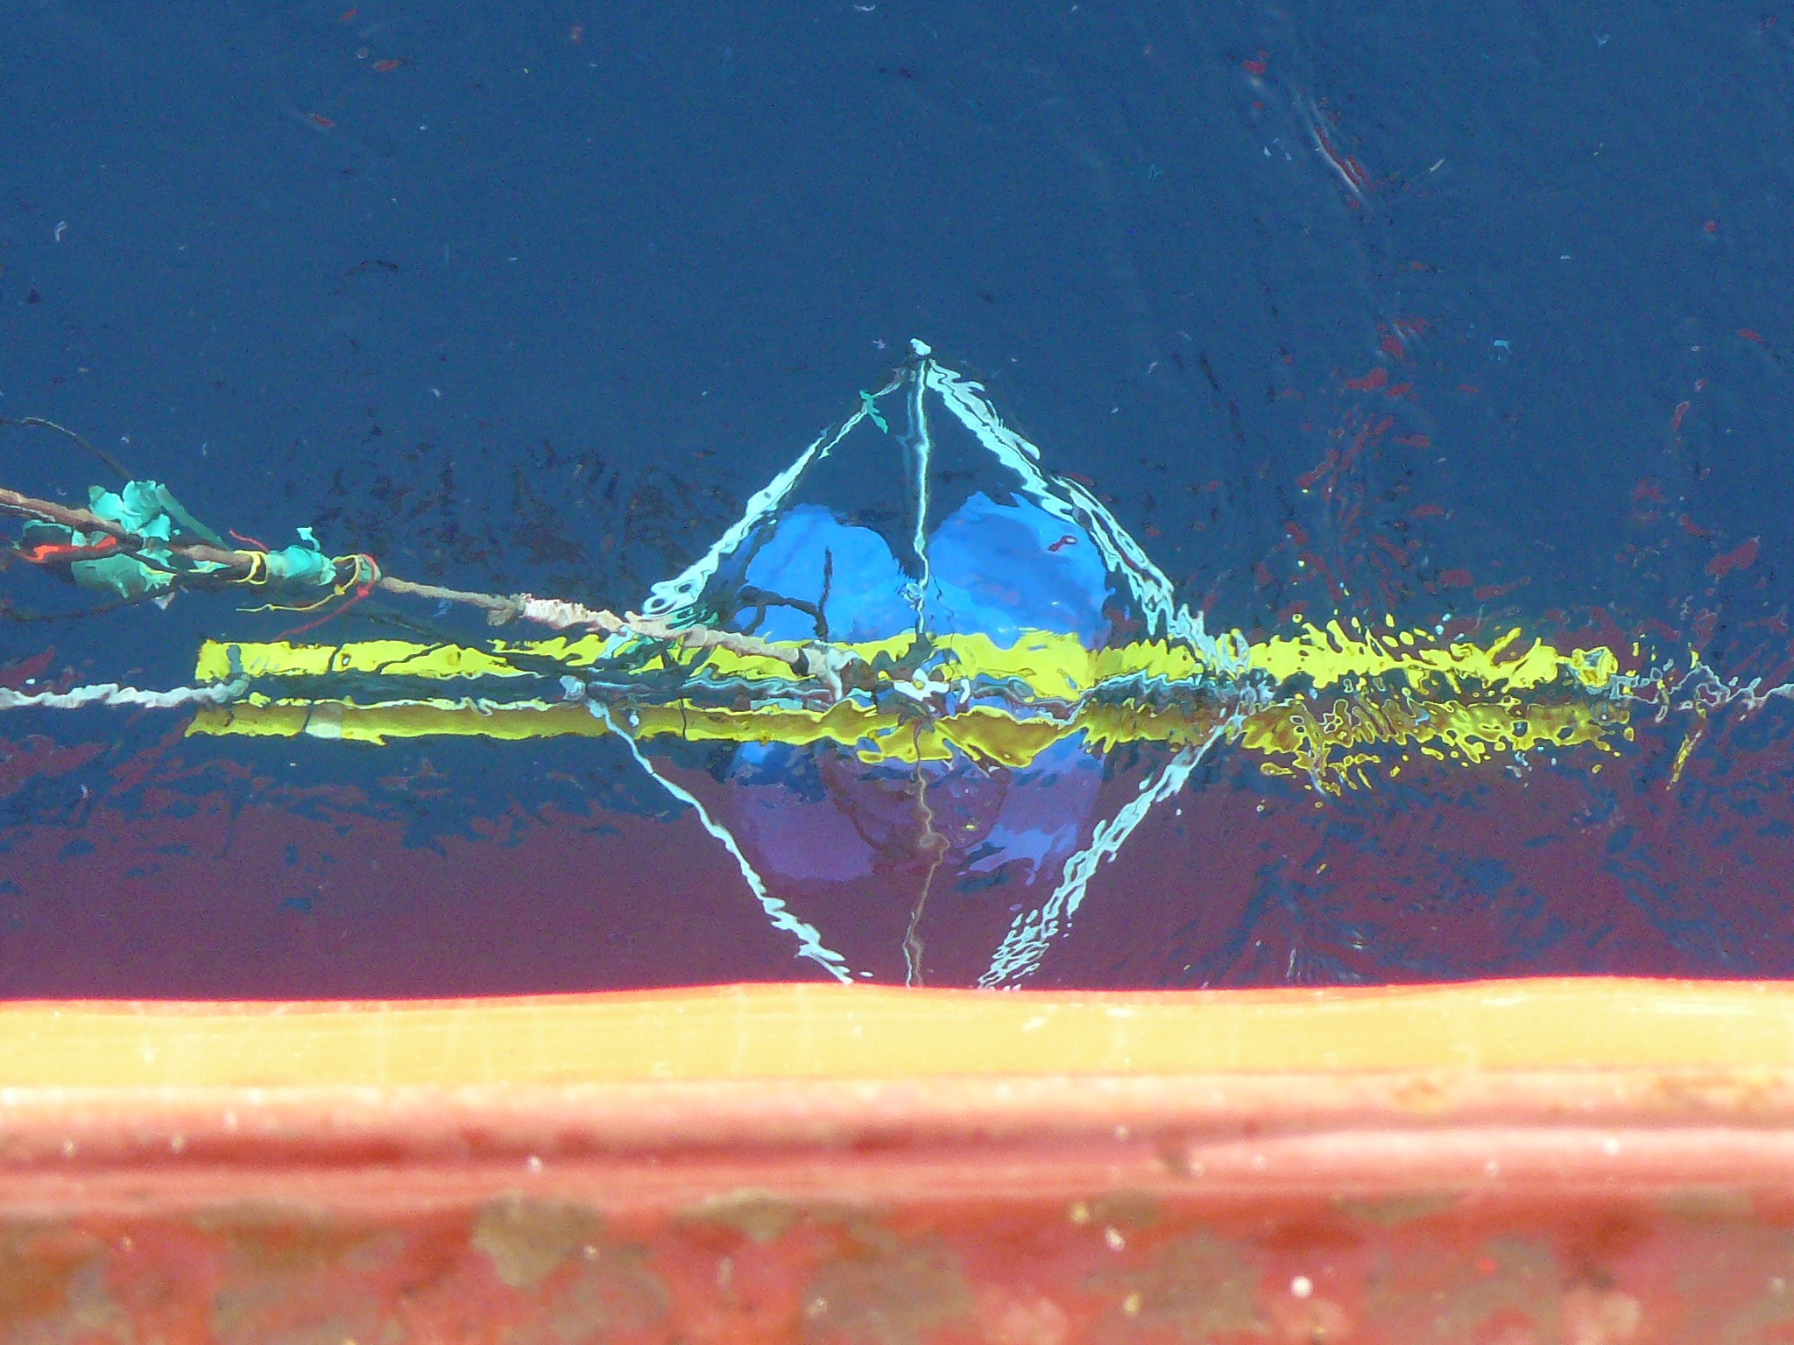

Figure 1. Aerial view of ADCP going into the water.

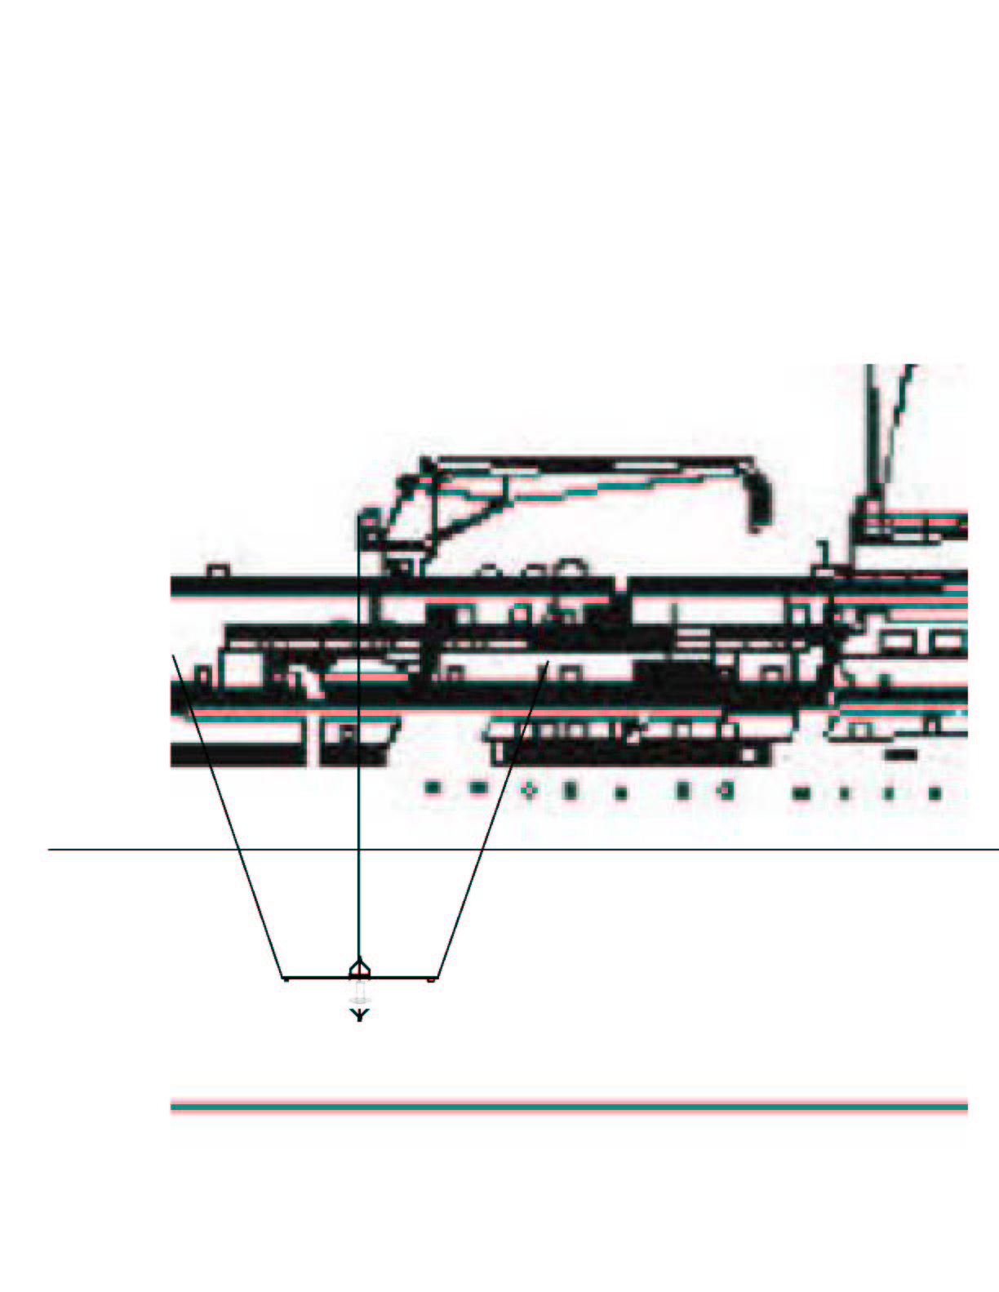 | 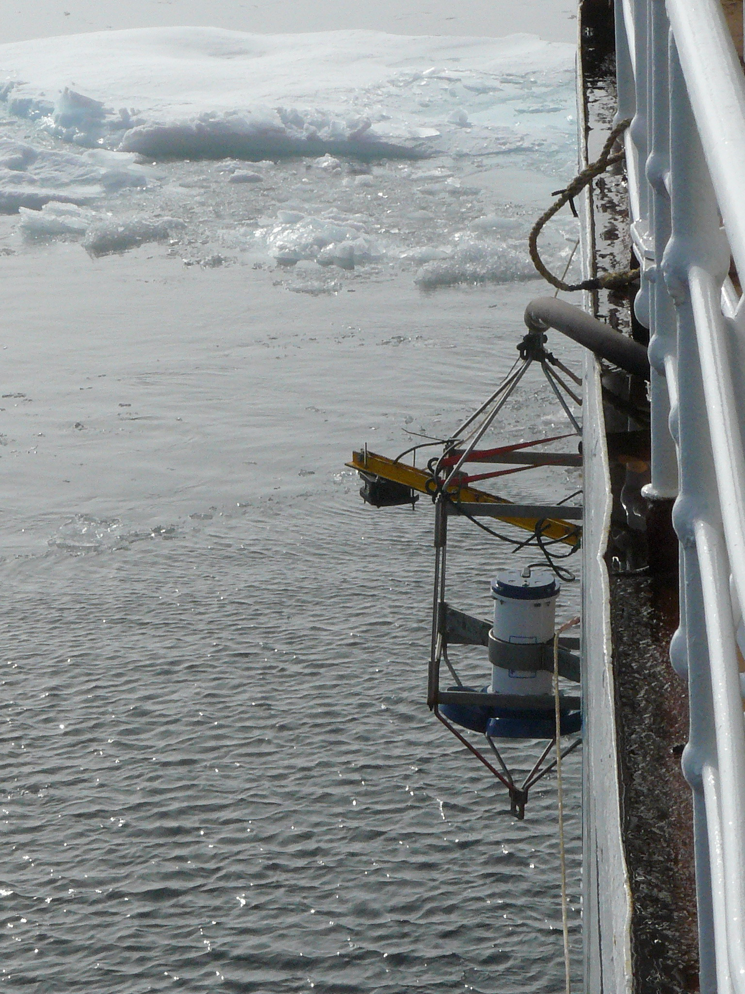
Figure 2. Drawing of general orientation of frame while deployed. | Figure 3. ADCP frame stowed on the rail between stations

Issues:
No real data quality assessment was made at sea. The checks for data quality were very basic. For the ADCP, during acquisition, it was ensured that the ADCP went through its start up and was receiving GPS and Gyro. Once acquiring data, a quick check was made that the good returns seemed consistent and that all beams were showing a return. A brief assessment of at what range the strongest returns were was compared with the 50 and 200 kHz sonar and the chlorophyll maximum and transmissivity minimums in the CTD profile.
For the sonar, checks were even more basic. The start was monitored to see that acquisition started and that GPS was incoming. A brief visual check was made on the depth of maximum scattering and whether the plots “looked like a sonar signal”.

The ADCP would typically be in the path of any propeller wash resulting from ship’s repositioning during station. During events where the starboard screw was going astern, the ADCP frame would be moved forward and the angle of the downward looking beams would be skewed beyond the 15 degree limit of the 3 axis tilt sensor. These events do not included valid data can be identified by large tilt angles and high currents.

The freezing seawater temperatures (sea-ice actively freezing) incased the ADCP in ice. After CTD Cast 68 the Ready Heater was aimed at the transducer heads and after approximately 6 hours had melted ice off the faces. Temperatures were checked regularly (hand warm) to confirm the bottom of the transducers were not ‘cooked’ in the process. However, after only 4 casts the transducer faces had grown a new layer of ice.
When air temperatures are below -10C, the water dripping off the lines, frame and ADCP tend to form an ice sheath around all transducers and in the future this should be taken into account as to the efficacy of the operation.
Following CTD Cast 68 2010-10-12 23:20 UTC the gradual ice accumulation (shown below) was melted off using a mobile gas powered heater (“Ready Heater”). During the four following casts (end of the cruise) the ice accumulated quickly (see below).

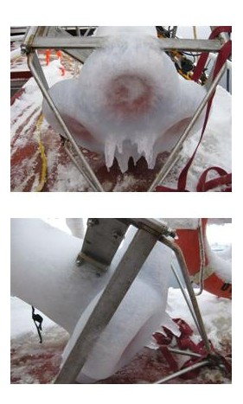

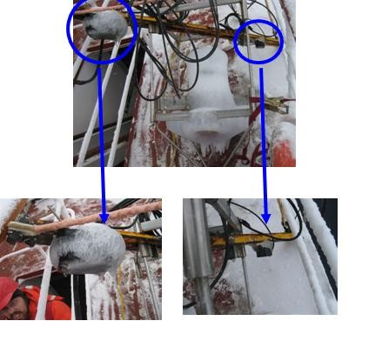

After melting ice with Ready Heater for ~6 hours:

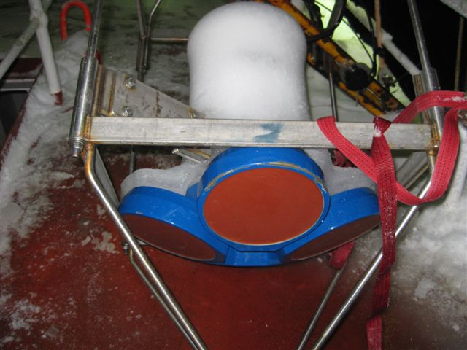

Four casts later:

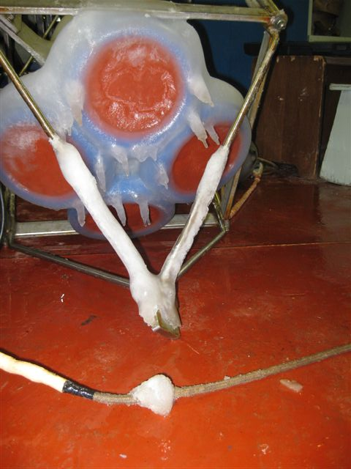

Table 1. ADCP and Sounder Log for 2010-07
Date (UTC) | Time (UTC) | CTD Cast# | ADCP file name | Sounder file name | Comments
9/17/2010 | 430 | 1 | ADCP011 | 2010-08174303.dat | AG5
 |  | 2 | ADCP012 | 2010-081742310.dat | CABOS
 |  | 3 | ADCP013 | 2010-0817194225.dat and 2010-0817205757.dat | CB31b, not sure why there are two sonar files.
 |  | 4 | ADCP014 | 2010-0818023918.dat | CB60
 |  | 5 | ADCP015 | 2010-0819012744.dat | CB61
 |  | 6 | ADCP016 | 2010-0819045004.dat | CB62
 |  | 7 | ADCP017 | 2010-0819060835.dat | CB63
 |  | 8 | ADCP018 | 2010-0819072329.dat | CB65
 |  | 9 | ADCP019 | 2010-0820040544.dat | MK-3
 |  | 10 | ADCP020 | 2010-0820082222.dat | MK-2
 |  | 11 | ADCP021 | 2010-0820104931.dat | MK-1
 |  | 14 | ADCP022 | 2010-0820124240.dat | CB-28aa
9/20/2010 | 1630 | 15 | ADCP023 | 2010-0820162945.dat | MK-3a
9/20/2010 | 2049 | 16 | ADCP024 | 2010-0820204659.dat | MK4
9/21/2010 | 137 | 17 | ADCP025 | 2010-0821013711.dat | MK6
9/21/2010 | 646 | 18 | ADCP026 | 2010-0821064840.dat | CB28b
9/21/2010 | 942 | 19 | ADCP027 | 2010-0821094256.dat | CB28B second cast
9/21/2010 | 1652 | 20 | ADCP028 | 2010-0821165310.dat | CB-29
9/21/2010 | 2319 | 21 | ADCP029 | 2010-0821231846.dat | MK7
9/22/2010 | 611 | 22 | ADCP030 | 2010-0822061034.dat | CB-27
9/22/2010 | 1327 | 23 | ADCP031 | 2010-0822132920.dat | CB-22
9/22/2010 | 2138 | 24 | ADCP032 | 2010-0822213747.dat | CB-23a
9/23/2010 | 914 | 26 | ADCP033 | 2010-0823091458.dat | CB-50
9/23/2010 | 1847 | 27 | ADCP034 | 2010-0823184755.dat | CB-51
9/27/2010 | 352 | 28 | ADCP035 | 2010-0827035229.dat | STN-A
9/27/2010 | 1331 | 30 | ADCP036 | 2010-0827133140.dat | CB-2a
9/27/2010 | 1845 | 31 | ADCP037 | 2010-0827184519.dat | CB-2
9/28/2010 | 320 | 32 | ADCP038 | 2010-0828032016.dat | CB-3
9/28/2010 | 1219 | 33 | ADCP039 | 2010-0828121951.dat | CB-4
9/28/2010 | 2033 | 34 | ADCP040 | 2010-0828203347.dat | CB-4
9/29/2010 | 324 | 35 | ADCP041 | 2010-0829032528.dat | CB-5
9/30/2010 | 539 | 36 | ADCP042 | 2010-0830053953.dat | CB-6
9/30/2010 | 15:11 | 37 | ADCP043 | 2010-0830151139.dat | CB-8
10/1/2010 | 339 | 38 | ADCP044 | 2010-0901033957.dat | CB-10 sounder software crashed??
10/2/2010 | 1229 | 40 | ADCP045 | 2010-0902122950.dat | CB-70/ITP 35 recovery
10/3/2010 | 1045 | 41 | ADCP046 | 2010-0903104613.dat | CB-11
10/4/2010 | 348 | 42 | ADCP047 | 2010-0904032026.dat | CB-9
10/4/2010 | 1521 | 43 | ADCP048 | 2010-0904152051.dat | CB-12
10/5/2010 | 1513 | 49 | ADCP049 | 2010-0905151300.dat | CB-16
10/6/2010 | 158 | 50 | ADCP050 | 2010-0906015851.dat | CB-13 - sounder software crashed during operation?
10/6/2010 | 1218 | 52 | ADCP051 | 2010-0906121724.dat | CB-15 sounder s/w crashed ?
10/7/2010 | 716 | 55 | ADCP052 | 2010-09071635.dat | CB-17
10/7/2010 | 2224 | 56 | ADCP053 | 2010-0907222348.dat | PP-7 - short time in water
10/8/2010 | 155 | 57 | ADCP054 | 2010-0908015437.dat | PP7-during long cast
10/8/2010 | 1224 | 59 | ADCP055 | 2010-0908122447.dat | PP-6
10/9/2010 | 1231 | 61 | ADCP056 | 2010-0909123156.dat | CB-18 lots of prop wash
10/10/2010 | 954 | 62 | ADCP057 | 2010-0910095401.dat | CB-19
10/10/2010 | 1932 | 63 | ADCP058 | 2010-0910193226.dat | CB-6
10/11/2010 | 1337 | 66 | ADCP059 | 2010-0911133703.DAT | CB-21
10/12/2010 | 9:10 | 67 | ADCP060 | 2010-0912090842.DAT | CB-40
10/12/2010 | 20:12 | 68 | ADCP61 | 2010-0912201243.DAT | CB-50. Melted ice off transducer faces after this cast.
10/13/2010 | 7:09 | 69 | ADCP62 | 2010-0913070834.DAT | CB-51
10/13/2010 | 14:15 | 70 | ADCP63 | 2010-0913141519.DAT | CB-52
10/13/2010 | 19:27 | 71 | ADCP064 | 2010-0913192719.DAT | CB-53
10/14/2010 | 113 | 72 | ADCP065 | 2010-0914011341.dat | CB-54

