2010-07 Chlorophyll Calibration

2017-11-23:
Added missing Chl in Cast 33 using out_finish_201007_Chlfix.m.
Updated *.CNV files with 2013 calibration (using 2013 mat files). Used out_finish_201007_option_2.m.

2013-05-21:
Applied the new calibration (Range 0.025 to 0.6) using out_finish_201007_justChl.m.
Chem data added to spreadsheet from CTDchlforchem_20130521 wHeader.xls.
New mat files for casts and chem made. Still need to make new *.cnv files.

2013-05-10:
For comparison, chlorophyll were recalibrated using only range 0.025 to 0.6.
64 ot 76 observations used, residual is STD 0.01
Slope = 0.3815, Bias = 0.0066.
This makes a difference of up to 4% (-0.05 at 1.2mg/m3)
This has not been applied, just determined for comparison. CTD and Chem sheet do not have raw voltage so will be necessary to remove existing fit and apply new fit.
Note that Processing comments would need to be updated as well.

2011-04-15:
2010-07 Chlorophyll Data Set calibrated using routine cal_fluorometer.m

Fit using all bottle data (not enough of USM only and US gave quite a noisy fit…and looked off due to trying to match high chlorophyll values.

Alignment has been applied to down and upcast though fit points in chem file are straight from the upcast before alignment or filter applied.

Fit results for:
STD 2.5 for observation acceptance, only bottle values >0.025 mg/m3. This criteria excludes those below sensitivity of CTD Flr and excludes the collection of compromised chlorophyll samples that gave ‘0’ readings.

All samples
66 out of 80 observations used, STD 0.02
Slope = 0.3978, Bias = 0.0020

Samples using bottle stop method ‘USM’ (yo-yo stop mixing water)
11 out of 11 observations used, STD 0.03
Slope = 0.3933, Bias = 0.0183

Samples using bottle stop method ‘US’ (stop for 30 seconds)
16 out of 18 observations used, STD 0.08
Slope = 0.3455, Bias = 0.0839
Fit does not look good due to trying to fit a few large values

Samples using bottle stop method ‘UN’ (no stop, -4.4 sec offset)
11 out of 11 observations used, STD 0.03
Slope = 0.3933, Bias = 0.0183

Fit using all samples seemed the best. USM samples were good, though not many samples due to issue of some samples being compromised and not useful.

The CTD fluro is typically very close to a 1:1 relationship without calibration, however in this data set the CTD is reading almost double the chlorophyll value. This appears due to large values of phaeophytin. When chlorophyll and phaeophytin are combined the ratio is again close to 1:1. The purpose of calibrating the CTD fluorometer is to create an estimate for Chlorophyll, so the calibration is only done to the Chlorophyll.

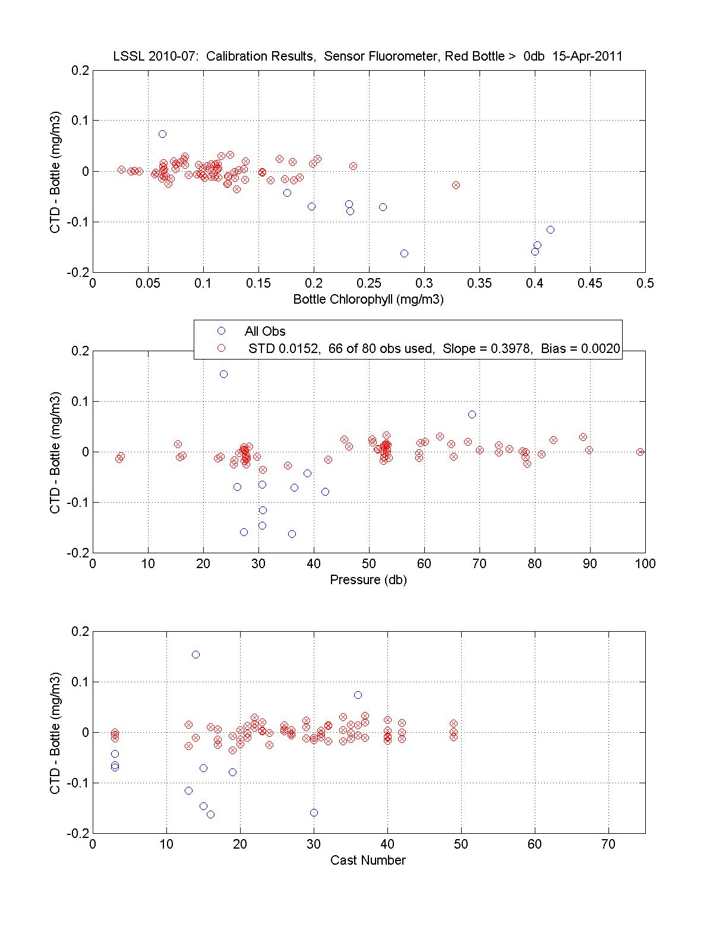
Figure 1. Calibration results to all the data. Residuals plotted v. Chlorophyll, Pressure and Cast Number.

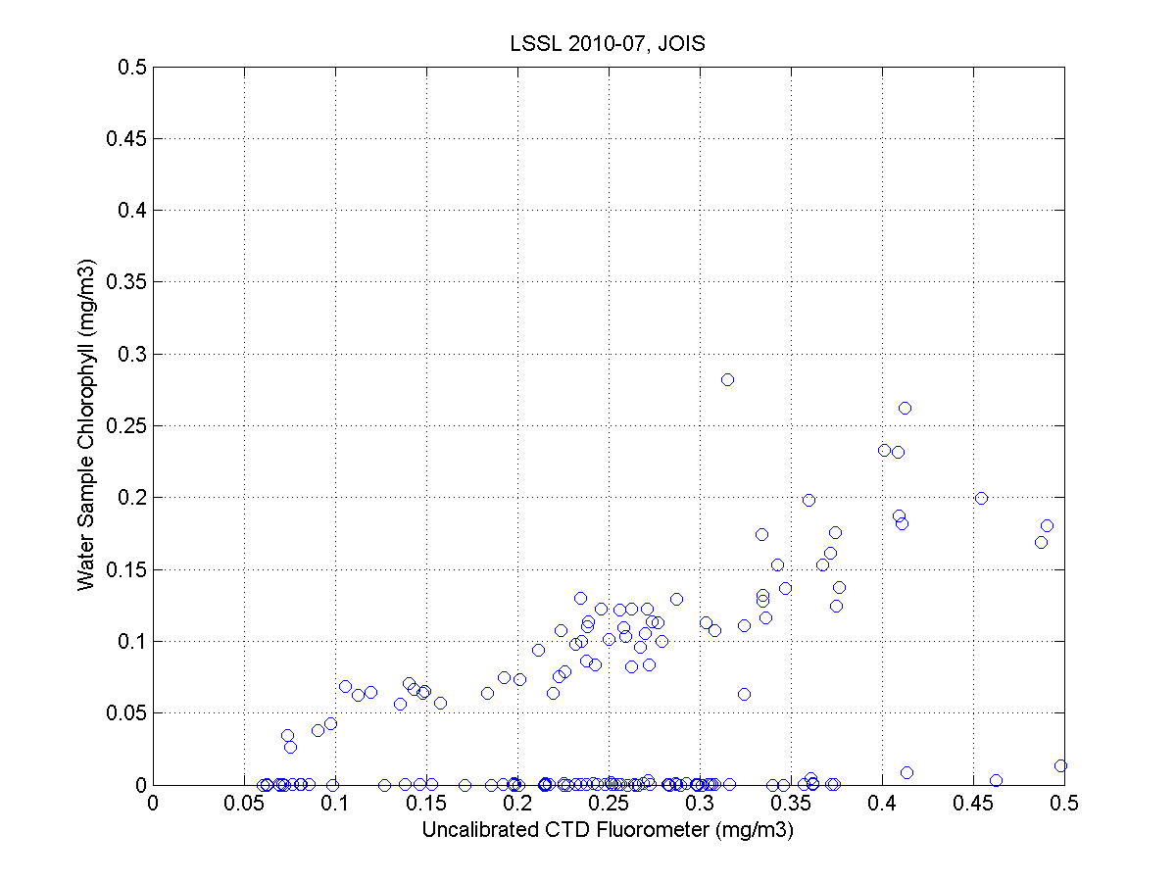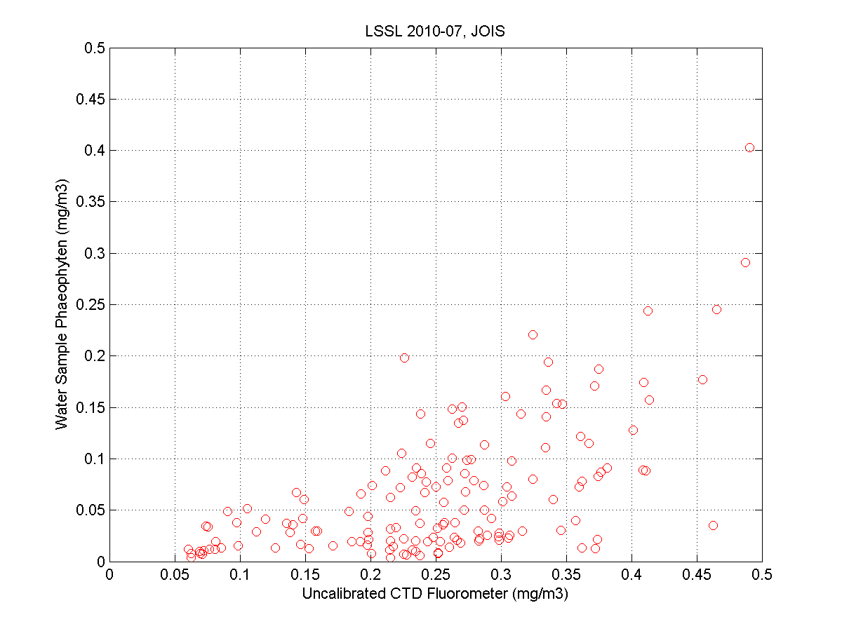

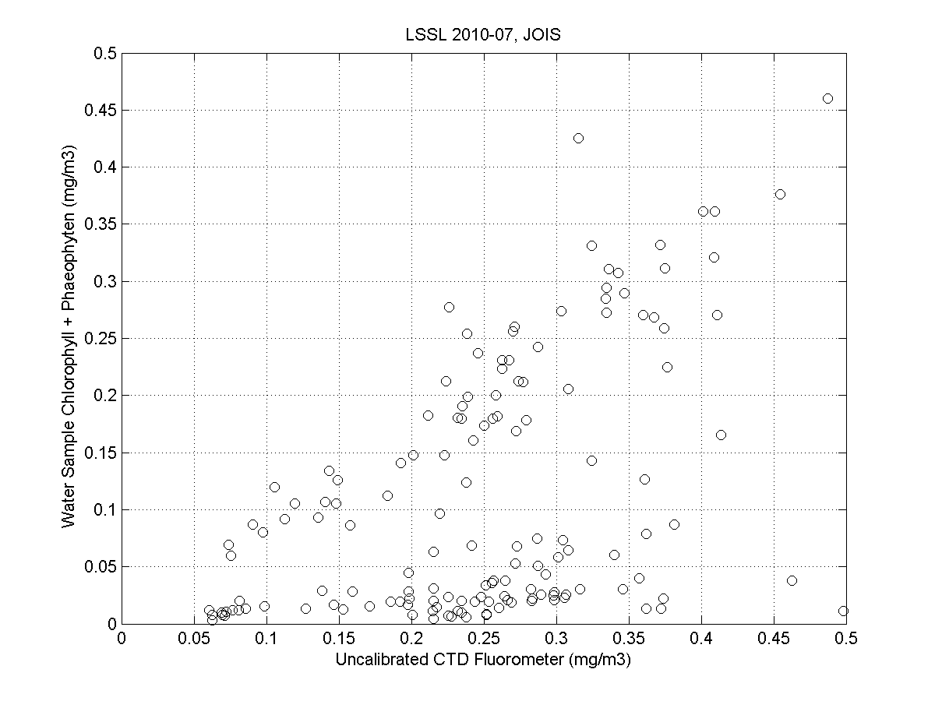
Figure 2. Uncalibrated CTD plotted against Chlorophyll (blue) , Phaephytin (red) and against the sum Chlorophyll and Phaeophytin (black ). The Chlorphyll samples reading zero are compromised samples and should be ignored.

