**Physical and Chemical Data from the Canadian Arctic Archipelago, July 20-August 2, 2010 and Canada Basin, September 15 to October 15, 2010**

F. McLaughlin, A. Proshutinsky, E. Carmack, K. Shimada, J. Charters, M. Corkum, M. Dempsey, J. Dunn, J. Eert, C. Guay, C. Gueguen, J. Hutchings, H. Isernhagen, M. Itoh, M. Kawai, R. Krishfield, B. Li, K. Mizobata, R. Nelson, J. Nelson, K. Newhall, S. Nishino, A. Orlich, D. Perovich, P. Peterson, C. Rauschenberg, Z. Sandwith, K. Scozzafava, J. Smith, C. Stanley, M. Steele, N. Sutherland, K. Tateyama, M.L. Timmermanns, J. Toole, S. Vagle, L. White, B. Williams, K. Young, S. Zimmermann

Fisheries and Oceans

Science Branch, Pacific Region

Institute of Ocean Sciences

9860 West Saanich Road

Sidney, B.C. V8L 4B2

20XX

**Canadian Data Report of**

**Hydrography and Ocean Sciences XXX**

**Canadian Data Report of Hydrography and Ocean Sciences**

Data reports provide a medium for the documentation and dissemination of data in a form directly useable by the scientific and engineering communities. Generally, the reports will contain raw and/or analyzed data but will not contain interpretations of the data. Such compilations will commonly have been prepared in support of work related to the programs and interests of the Oceans and Science sectors of Fisheries and Oceans Canada.

The correct citation for data reports ap­pears above the abstract of each report. Each report is abstracted in the data base *Aquatic Sciences and Fisheries Abstracts.*

Data reports are produced regionally but are numbered nationally. Requests for individual reports will be filled by the issuing establishment listed on the front cover and title page.

Regional and headquarters establishments of the former Ocean Science and Surveys sector ceased publication of their various report series in December 1981. A complete listing of these publications and the last number issued under each title are published in the *Canadian Journal of Fisheries and Aquatic Sciences*, Volume 38: Index to Publications 1981. The current series began with Report Number 1 in January 1982.

**Rapport statistique canadien sur l'hydrographie et les sciences océaniques**

Les rapports statistiques servent de véhicule pour la compilation et la diffusion des données sous une forme directement utilisable par les scientifiques et les ingénieurs. En général, les rapports contiennent des données brutes ou analysées mais ne fournissent pas d'interprétations des données. Ces compilations sont préparées le plus souvent à l'appui de travaux reliés aux programmes et intérêts des secteurs des Océans et des Sciences de Pêches et Océans Canada.

Le titre exact des rapports statistiques figure au-dessus du résumé de chaque rapport. Les rapports statistiques sont résumés dans la base de données *Résumés des sciences aquatiques et halieutiques*.

Les rapports statistiques sont produits à l'échelon régional, mais numérotés à l'échelon national. Les demandes de rapports seront satisfaites par l'établissement auteur dont le nom figure sur la couverture et la page de titre.

Les établissements de l’ancien secteur des Sciences et Levés océaniques dans les régions et à l'ad­ministration centrale ont cessé de publier leurs diverses séries de rapports en décembre 1981. Vous trouverez dans l'index des publications du volume 38 du *Journal canadien des sciences halieutiques et aquatiques*, la liste de ces publica­tions ainsi que le dernier numéro paru dans chaque catégorie. La nouvelle série a commencé avec la publication du rapport numéro 1 en janvier 1982.

Canadian Data Report of

Hydrography and Ocean Sciences XXX

20XX

Physical and Chemical Data from the Canadian Arctic ArchipelAgo, July 20-August 2, 2010 and Canada Basin, September 15 to October 15, 2010

by

F. McLaughlin, A. Proshutinsky, E. Carmack, K. Shimada, J. Charters, M. Corkum, M. Dempsey, J. Dunn, J. Eert, C. Guay, C. Gueguen, J. Hutchings, H. Isernhagen, M. Itoh, M. Kawai, R. Krishfield, B. Li, K. Mizobata, R. Nelson, J. Nelson, K. Newhall, S. Nishino, A. Orlich, D. Perovich, P. Peterson, C. Rauschenberg, Z. Sandwith, K. Scozzafava, J. Smith, C. Stanley, M. Steele, N. Sutherland, K. Tateyama, M.L. Timmermanns, J. Toole, S. Vagle, L. White, B. Williams, K. Young, S. Zimmermann

Fisheries and Oceans

Science Branch, Pacific Region

Institute of Ocean Sciences

9860 West Saanich Road

Sidney, B.C. V8L 4B2

© Her Majesty the Queen in Right of Canada – 20XX

Cat. No. Fs 97-16/XXXE ISSN 0711-6721

Correct citation for this publication:

F. McLaughlin, A. Proshutinsky, E. Carmack, K. Shimada, J. Charters, M. Corkum, M. Dempsey, J. Dunn, J. Eert, C. Guay, C. Gueguen, J. Hutchings, H. Isernhagen, M. Itoh, M. Kawai, R. Krishfield, B. Li, K. Mizobata, R. Nelson, J. Nelson, K. Newhall, S. Nishino, A. Orlich, D. Perovich, P. Peterson, C. Rauschenberg, Z. Sandwith, K. Scozzafava, J. Smith, C. Stanley, M. Steele, N. Sutherland, K. Tateyama, M.L. Timmermanns, J. Toole, S. Vagle, L. White, B. Williams, K. Young, S. Zimmermann. 20XX. Physical and Chemical Data from the Canadian Arctic Archipelago, July 20-August 2, 2010 and Canada Basin, September 15 to October 15, 2010. Can. Data Rep. Hydrogr. Ocean Sci. XXX: xx + XXX p.

# Table of Contents

Table of Contents iii

List of Tables v

List of Figures vi

Abstract viii

Acknowledgements x

1. INTRODUCTION 1

1.1 FIELD WORK SUMMARY 2

1.1.1 Transit Leg – Canada’s Three Oceans (C3O) 2010-06 2

1.1.2 Joint Ocean Ice Study (JOIS) 2010-07 3

1.2 STUDY AREA 5

2. METHODS AND ANALYSIS 11

2.1 SCIENCE PLATFORM: *CCGS Louis S. St-Laurent* 11

2.2 FIELD SAMPLING: CTD/ROSETTE CASTS 11

2.2.1 2010-06: C3O 11

2.2.2 2010-07: JOIS 12

2.3 CTD DATA ACQUISITION, PROCESSING AND VALIDATION – NEEDS DATA 15

2.3.1 Overview/Highlights for 2010-07 15

2.3.2 Acquisition and Processing Steps 18

2.3.3 CTD Pressure 18

2.3.4 CTD Temperature 18

2.3.5 CTD Conductivity 19

2.3.6 CTD Salinity 19

2.3.7 CTD Oxygen 20

2.3.8 CTD Transmission 21

2.3.9 CTD Fluorescence 21

2.3.10 Data Spike Removal 21

2.3.11 CTD Data at Bottle Depths for Water Chemistry File 21

2.4 CHEMISTRY SAMPLING AND ANALYSIS 22

2.4.1 Overview/Highlights 2010-07 22

2.4.2 Salinity 24

2.4.3 Dissolved Oxygen 30

2.4.4 Nutrients – IN PROGRESS 37

2.4.5 Ammonium 41

2.4.6 Oxygen Isotope Ratio (δ18O) – TO BE DONE 46

2.4.7 Barium – TO BE DONE 46

2.4.8 Dissolved Inorganic Carbon and Alkalinity– IN PROGRESS, NEEDS DATA 47

2.4.9 Alkalinity Only (run at sea) 48

2.4.10 Chlorophyll-a 50

2.4.11 Bacteria – need to add figs to appendix 53

2.4.12 Radionuclides (Iodine 129 and Cesium 137) 54

2.4.13 Chlorofluorocarbons (CFCs) – in progress 55

2.4.14 Coloured Dissolved Organic Matter (CDOM) – TO BE DONE 57

2.5 OTHER FIELD SAMPLING 58

2.5.1 Over-the-side ADCP 58

2.5.2 Underway sampling 61

2.5.3 XCTD 67

2.5.4 Vertical Net Tows 70

2.5.5 Limacina helicina experiment 72

2.5.6 Moorings and Buoys –IN PROGRESS – just editing 74

2.5.7 Ice Observations 81

2.5.8 Drift Bottles – TO BE DONE 88

2.5.9 2010-06 C3O Seabird Survey 88

3. REFERENCES 91

APPENDIX 98

# List of Tables

Table 1. CTD Accuracy for Seabird SBE911plus CTD systems used during 2010-07 16

Table 2. Comparison of calibrated CTD salinity and water sample data using CTD - Water Sample. 19

Table 3. Coefficients for CTD oxygen equation using lag-corrected oxygen voltage. 20

Table 4. Comparison of calibrated CTD oxygen and water sample data. 20

Table 5. Water Sample Summary for 2010-07 NEEDS DATA 22

Table 6. Water Sample Precision NEEDS DATA 23

Table 7. Salinity Deep Water Reference values 27

Table 8. Precision of salinity samples analyzed at sea and onshore 29

Table 9. Quality control and assurance for nutrient samples. NEEDS DATA 40

Table 10. QA/QC of chlorophyll-a analysis 52

Table 11. Precision of chlorophyll-a samples analyzed onshore 53

Table 12. Log of Knudsen sound speed used to calculate depth. 66

Table 13. The range and accuracy of parameters measured by the XCTD according to the manufacturer’s nominal specifications. 68

# List of Figures

Figure 1. View of the Arctic showing the Canada Basin (blue box) and the Canadian Archipelago and Baffin Bay (red circle). 6

Figure 2. Cruise track and XCTD cast locations performed on Leg 1 (2010-06) 6

Figure 3. The JOIS (2010-07) cruise track showing the location of science stations. 7

Figure 4. RADARSAT-2 mosaic from 13-16 September 2010 (created by Erik Thibault, Canadian Ice Service) showing ice conditions at the beginning of the expedition. 8

Figure 5. RADARSAT-2 mosaic from 12-14 October 2010 (created by Erik Thibault, Canadian Ice Service) showing ice conditions at the end of the expedition. 9

Figure 6. Canadian Ice Service ice concentration charts from the beginning (September 15) and end (October 13) of the cruise. 10

Figure 7. Bringing the full rosette in the sampling room. 14

Figure 8. The ‘de-icer’ attached to the CTD wire. 15

Figure 9. Lab calibration of (a) primary temperature sensor #XXXX; and (b) secondary temperature sensor #XXXX. The red line shows the calibration change for this cruise (from [DAY MONTH] to [DAY MONTH] 20XX). 18

Figure 10. Lab calibration of (a) primary conductivity #XXXX; and (b) secondary conductivity #XXXX. The red line shows the calibration change for this cruise (from [DAY MONTH] 20XX to [DAY MONTH] 20XX). 19

Figure 11. Calibration of (a) primary conductivity #XXXX and (b) secondary conductivity #XXXX to water samples. The samples in red were those used in the calibration. 19

Figure 12. Salinity residual (CTD - Salinity) scaled to show deep water residuals. 19

Figure 13. Salinity residual (CTD - Salinity) shown for the top 500 db. 19

Figure 14. A pressure dependant shape in the oxygen residual was removed by subtracting the mean shown by the black line. 20

Figure 15. Oxygen residuals (CTD - Bottle). 20

Figure 16. Applying (a) no lag correction; and (b) a -X.X s lag correction. 21

Figure 17. Deep Water Reference corrected salinity over time: 8-Bel-8 28

Figure 18. Deep Water Reference corrected salinity over time: CB-28b 28

Figure 19. Deep Water Reference corrected salinity over time: CB-3 analyzed at sea. 29

Figure 20. Deep Water Reference (CB-3 and CB-6) salinity analyzed at IOS 29

Figure 21. Thiosulfate normalities (filled diamonds) and blank values (open squares) measured during dissolved oxygen analysis between September 16 and October 14 during cruise 2010-07. 36

Figure 22. DO WE HAVE? Deep water (>2800 m) dissolved oxygen values plotted for the first two Niskin bottles fired 37

Figure 23. Comparison of two 2010 ammonium chloride secondary standards. 42

Figure 24. Standard Sets 3-11, all instrument calibrations included. From the fifth calibration onwards, the curve showed good reproducibility. 43

Figure 25. Results of a cap test to see if parafilming the top of tubes was necessary. 45

Figure 26 a. Drawing of general orientation of ADCP frame while deployed; b. Aerial view of ADCP sitting in the water alongside the hull. 59

Figure 27. ADCP encased in ice. 60

Figure 28 a. ADCP After melting ice with Ready Heater for ~6 hours; b. Four casts later. 60

Figure 29. Seawater loop system providing uncontaminated seawater from 9 m depth to the science lab for underway measurements. 63

Figure 30. Underway sea surface temperature during cruise 2010-07. 64

Figure 31 Underway sea surface salinity during cruise 2010-07. 65

Figure 32. XCTD stations of the JOIS2010-07 cruise. 69

Figure 33. Modified bongo frame used during JOIS. 70

Figure 34. DO WE HAVE? BGOS Ice based observatory #1. 77

Figure 35. DO WE HAVE? BGOS Ice based observatory #2. 77

Figure 36. The instrumentation for the O-buoy. 79

Figure 37. Kris Newhall (R) and Jim Dunn (L) guide the O-buoy into position. 80

Figure 38. Left: Peter (L) and Carlton (R) pause for a photo-op during assembly. Right: Completed O-Buoy. 81

Figure 39. Pictures of the EM, PMR and forward looking camera. 82

Figure 40. Locations of the EM, PMR and forward looking camera. 83

Figure 41. EM thickness profile during 29 Sep. – 13 Oct., 2010. Background image is sea ice concentration on 7 Oct., 2010 derived from AMSR-E. 84

Figure 42. Result of EM calibration over open water. 84

Figure 43. Results of automated ice-pond-water detection from camera images. 85

Figure 44. Transects of EM 31SH and drill-holes on the ice station 2-4. Maps of profiles are shown in right side. 86

Figure 45. Comparison of total thicknesses between drill-hole and EM31SH. 87

Figure 46. PDF of snow and ice thickness observed by EM31SH. 87

# Abstract

F. McLaughlin, A. Proshutinsky, E. Carmack, K. Shimada, J. Charters, M. Corkum, M. Dempsey, J. Dunn, J. Eert, C. Guay, C. Gueguen, J. Hutchings, H. Isernhagen, M. Itoh, M. Kawai, R. Krishfield, B. Li, K. Mizobata, R. Nelson, J. Nelson, K. Newhall, S. Nishino, A. Orlich, D. Perovich, P. Peterson, C. Rauschenberg, Z. Sandwith, K. Scozzafava, J. Smith, C. Stanley, M. Steele, N. Sutherland, K. Tateyama, M.L. Timmermanns, J. Toole, S. Vagle, L. White, B. Williams, K. Young, S. Zimmermann. 20XX. Physical and chemical data from the Canada Basin, September 15 to October 15, 2010. Can. Data Rep. Hydrogr. Ocean Sci. XXX: xx + XXX p.

A hydrographic survey of the Arctic Ocean’s Canada Basin was conducted during a Joint Ocean Ice Study (JOIS) expedition aboard the *CCGS Louis S. St-Laurent* from 15 September to 15 October 2010 (Institute of Ocean Sciences Mission Number 2010-07). The objective of the program was to investigate ocean circulation, Pacific and Atlantic-origin water mass distributions, storage of freshwater in the Beaufort Gyre, inter-annual variability and the distribution and concentration of bacteria and zooplankton. This report provides a summary of all science activities conducted during the cruise and includes data collected from CTD/rosette casts. The CTD consists of pressure, temperature, salinity, oxygen, transmission and fluorescence sensor data and the rosette bottle data include salinity, oxygen, nutrients including ammonium, oxygen isotope ratio, barium, dissolved inorganic carbon, alkalinity, chlorophyll-a and phaeopigment, cesium and iodine radionuclides, halocarbons including CFCs and carbontetrachloride, total suspended solids and particulate organic carbon. Sample collection and analytical methods are described. Other samples collected during the expedition, not reported here, are also listed.

**Résumé**

F. McLaughlin, A. Proshutinsky, E. Carmack, K. Shimada, J. Charters, M. Corkum, M. Dempsey, J. Dunn, J. Eert, C. Guay, C. Gueguen, J. Hutchings, H. Isernhagen, M. Itoh, M. Kawai, R. Krishfield, B. Li, K. Mizobata, R. Nelson, J. Nelson, K. Newhall, S. Nishino, A. Orlich, D. Perovich, P. Peterson, C. Rauschenberg, Z. Sandwith, K. Scozzafava, J. Smith, C. Stanley, M. Steele, N. Sutherland, K. Tateyama, M.L. Timmermanns, J. Toole, S. Vagle, L. White, B. Williams, K. Young, S. Zimmermann. 20XX. Physical and chemical data from the Canada Basin, September 15 to October 15, 2010. Can. Data Rep. Hydrogr. Ocean Sci. XXX: xx + XXX p.

Une enquête hydrograhique de l’eau du bassin Canada, dans l’océan Arctique, ont été évaluées lors d’une expédition menée dans le cadre des Études conjointes sur les glaces (JOIS) à bord du NGCC *Louis S. St-Laurent*, du [JOUR MOIS] au [JOUR MOIS] 20XX (mission numéro 20XX-XX de l’Institut des sciences de la mer). L’objet du programme était d’étudier les mouvements de circulation océaniques, notamment la distribution des masses d’eau d’origine atlantique et pacifique, les réserves d’eau douce de la gyre de Beaufort, les variabilités interannuelles et la distribution/concentration de bactéries et de zooplancton. Ce rapport présente un sommaire de toutes les activités scientifiques ainsi que les données des profils de conductivité-température-profondeur(CTP)/Rosette. Les données de CTP informent sur la pression, la température, la salinité et la teneur en oxygène, alors que les données captées par transmission et fluorescence et les données de bouteille (données recueillies dans des échantillons d’eau) touchent la salinité ainsi que la teneur en oxygène, en nutriments, en ammoniaque, le ratio des isotopes de l’oxygène, en baryum, en carbone inorganique dissous, l’alcalinité, en chlorophylle *a* et en phaéopigments, en radionucléides de l’iode et du césium, halocarbures, y compris les CFS, le total a suspendu solids et en carbone organique particulaire. Les méthodes d’échantillonnage et d’analyse sont décrites. D'autres échantillons prélevés au cours de l’expédition mais non traités dans ce rapport sont également mentionnés.

# Acknowledgements

The science team would like to thank the Coast Guard for their support, particularly Captain Marc Rothwell and the crew of the CCGS Louis S. St-Laurent. We’d like to acknowledge DFO and the Canadian International Polar Year Programme for their continued support of this program.

At sea, we were very grateful for everyone’s top-notch performance and assistance with the program. We’d like to thank Erik Thibault and the Canadian Ice Service for their assistance with ice images and weather information as well as Chris Swannell, the helicopter pilot for his and Steve Lloyd the helicopter mechanic’s valuable help with ice reconnaissance flights, support on the ice and transport. Importantly, we’d like to acknowledge DFO, NSF and JAMSTEC for their continued support of this program.

This work was supported by Fisheries & Oceans Canada in collaboration with scientists from the Japan Agency for Marine-Earth Science and Technology and Woods Hole Oceanographic Institution. [<2005], the latter supported by the U.S. National Science Foundation. [2005 and onwards]. A portion of the costs of the JWACS cruise and hydrographic station data, and the BGFE mooring and buoy installations was provided by grant number XXX-##### as part of the Beaufort Gyre Freshwater Experiment (A. Proshutinsky, Principal Investigator). Any opinions, findings, and conclusions or recommendations expressed in this publication are those of the authors and do not necessarily reflect the views of the National Science Foundation.

# INTRODUCTION

The 2010 Joint Ocean Ice Study (JOIS) involved the collaboration of Fisheries and Oceans Canada (DFO) researchers with colleagues primarily from the U.S.A and Japan. This program forms an important Canadian contribution to international climate research programs and is comprised of two ongoing programs: the Beaufort Gyre Exploration Project (BGEP), a collaboration with Woods Hole Oceanographic Institution scientists and the Pan-Arctic Climate Investigation (PACI), a collaboration with Japan Agency for Marine-Earth Science and Technology (JAMSTEC) scientists. In 2010 JOIS also included ancillary programs carried out by researchers from: the International Arctic Research Center (IARC) in Fairbanks Alaska; Tokyo University of Marine Science and Technology (TUMSAT), Japan; and Kitami Institute of Technology (KIT), Japan.

The program objective was to study the effects of climate variability and the relationships between the physical environment and biota across shelf break, slope and basin domains. Research questions sought to understand the impacts of global change on the physical environment and corresponding biological responses by tracking and linking decadal scale perturbations in the Arctic atmosphere to inter-annual basin-scale changes in freshwater content, water mass properties, water mass distribution, ocean circulation and biota distribution in the Beaufort Gyre of the Canada Basin. Specifically, the objectives were:

* To understand the impacts of global change on sea ice and other fresh water products by utilizing a suite of stable isotopes and geochemical markers to quantify freshwater components and investigate water mass pathways.
* To investigate physical processes such as ice formation and gas exchange, turbulence and heat transfer, thermohaline intrusions, ventilation, boundary currents, and geothermal heating.
* To investigate distribution of phytoplankton and zooplankton.

The program was conducted aboard the CCGS Louis S. St-Laurent from September 15th and finished October 15th, 2010 (Institute of Ocean Sciences Mission Number 2010-07). The research was conducted in the Canada Basin from the Beaufort Shelf in the south to 80°N by a research team of 23 people (**Appendix 1**).

This report briefly describes all science activities conducted on the *CCGS LSSL* in 2010. In particular, it provides a summary of all JOIS science activities and data collected from CTD/rosette casts. The CTD data include pressure, temperature, salinity, oxygen, transmission and fluorescence sensor data. Rosette bottle data include salinity, dissolved oxygen, nutrients including nitrate plus nitrite (hereafter referred to as nitrate), reactive silicate, orthophosphate (hereafter referred to as phosphate), ammonium, oxygen isotope ratio (δ18O), dissolved inorganic carbon (DIC), alkalinity, chlorophyll-a and phaeopigment (hereafter referred to as chlorophyll). Other samples collected but not included in this report are bacteria, barium, chlorofluorocarbons (CFC), colored dissolved organic matter (CDOM), and iodine and cesium radionuclides (129I and 137Cs). Sample collection procedures and analytical methods for the CTD rosette water chemistry program, conducted primarily by the team from IOS, are also reported.

At every station samples for salinity, dissolve oxygen, nutrients, barium, δ18O, bacteria, alkalinity, DIC, CDOM, and chlorophyll-a were collected, and at select stations ammonium, CFCs, DIC (full profile), 129I and 137Cs were collected.

Deployment of expendable temperature and salinity probes (XCTDs) increased the spatial resolution of CTD measurements. Moorings and ice-buoys were serviced and deployed in the deep basin for long term daily time-series. Underway ice observations were taken and on-ice surveys were conducted. Zooplankton net tows, phytoplankton and bacteria measurements were collected to examine distributions of the lower trophic levels. Underway measurements were made of the surface water. Daily dispatches were posted to the web.

The goals of the JOIS program, led by Bill Williams of Fisheries & Oceans Canada, were met during the successful four-week program. However, this year, as last year, the late season ship schedule meant that science operations were less efficient and significant difficulties were encountered due to cold weather and the limited hours of daylight. In addition, we expected the refueling of the ship to take place prior to 15 September, before we boarded. This did not occur and a delay of 4 days (with 350 additional nm of steaming) was incurred at the beginning of the cruise for refueling. Our science program was completed despite these delays and winter conditions thanks to:

a) Efficiency and multitasking of the Captain and crew in their support of science.

b) Relatively light ice conditions leading to faster transit times.

c) Minimizing the science program prior to the cruise, in part due to:

i) JAMSTEC taking over sampling of the southern end of the 150W line near Barrow Canyon from the R/V Mirai

ii) no additional projects that might require wire-time were brought on board.

iii) selecting the minimal geographic extent needed for the science stations.

## FIELD WORK SUMMARY

### Transit Leg – Canada’s Three Oceans (C3O) 2010-06

Science was also conducted opportunistically in Baffin Bay and the Canadian Arctic Archipelago during the transit of the ship from St. John’s, NFLD to Kugluktuk, NU. The Canada Three Oceans project (C3O) is part of Canada’s contribution to International Polar Year research efforts. The focus of this collaboration between government institutes and universities is to study impacts of climate variability on the sub-arctic and Arctic water circulation and on the associated ecosystems. A science group with members from DFO, Environment Canada and Laval University carried out physical, chemical and biological sampling of ocean waters. As well, members of the media, international scientists and personnel from DFO Communications Branch were on board.

Mission #2010-06 accomplishments are summarized below and data included in this report are listed in bold font. In St John’s, 5 scientists embarked for the leg to Resolute. At Resolute, 17 participants for a workshop on C3O came aboard as part of the science group, with this science leg ending at Kugluktuk, NU. Specific location and time of events are listed in **Appendix ##**. This was a transit/repositioning leg and science activities were restricted to sampling along the cruise track.

Mission 2010-06 Transit Survey

July 20 – August 2 2010 from St. John’s, NFLD to Kugluktuk, NU:

* CTD/Rosette casts at 26 stations
* Upper ocean current measurements from Acoustic Doppler Current Profiler during 7 CTD/Rosette casts in relatively ice-free waters
* 206 Water Samples each to be analyzed for: Salinity, Oxygen, Nutrients, Barium, O-18, Bacteria, and a near-surface subset for Chlorophyll-a.
* Underway data collection of ship’s meteorological, depth, and navigation sensors. Underway collection of sea surface temperature, salinity fluorescence, gas tension, pCO2 and dissolved oxygen
* 16 XCTD (expendable temperature, salinity and depth profiler). Casts typically to 1100m depth or full water column if water is shallower than 1100m
* 16 Zooplankton vertical net casts to maximum 100m depth
* 47 Drift Bottles deployed at 2 locations
* Underway Seabird survey

### Joint Ocean Ice Study (JOIS) 2010-07

Mission 2010-07: Canada Basin Survey (JOIS)

September 15 – October 15 2010, Kugluktuk to Kugluktuk, NU

(Distance Covered: 4964nm)

* At CTD/Rosette Stations:
* 72 CTD/Rosette Casts at 56 Stations (DFO) with 1728 water samples collected for hydrography, geochemistry and pelagic biology (bacteria and phytoplankton) analysis (DFO, TrentU).
* At all stations: Salinity, Oxygen, Nutrients, Barium, 18O, Bacteria, Alkalinity, Dissolved Inorganic Carbon (DIC), at surface only), Coloured Dissolved Organic Matter (CDOM), Chlorophyll-a, Chlorofluorocarbons (CFC).
* At selected stations: Ammonium, DIC (full profile), I-129, Cs-137
* Upper ocean current measurements from Acoustic Doppler Current Profiler during most CTD casts (DFO)
* 100 Vertical Net Casts at 47 select Rosette stations typically to 100m with occasional casts up to 1000m deep (DFO)
* 59 XCTD (expendable temperature, salinity and depth profiler) Casts typically to 1100m depth (JAMSTEC, WHOI , Tokyo University,)
* Mooring and buoy operations
* 3 Mooring Recoveries (3 deep basin (WHOI))
* 3 Mooring Deployments (3 deep basin (WHOI))
* 2 Ice-Based Observatories (IBO, WHOI), the first consisting of :

1 Ice Tethered Profiler (ITP, WHOI)

1 Ice Mass Balance Buoy (IMBB, CRREL)

1 Flux buoy

and the second:

1 Ice Tethered Profiler (ITP, WHOI)

1 Ice Mass Balance Buoy (IMBB, CRREL)

1 Flux buoy

1 O-buoy (Bigelow, UAF)

* 2 Ice Tethered Profilers deployed on their own (ITP, WHOI)
* 1 Ice Tethered Profiler recovery (ITP, WHOI)

NOTE: The CABOS mooring was not recovered and redeployed this year, owing to funding constraints. It remains in the water, collecting data, for another year.

* Ice Observations
* Ice Observations (IARC)
* Hourly visual observations from bridge and automated fixed-camera photos.
* Opportunistic aerial observations during helicopter flights

On-ice observations of ice-depth transects and ice-cores

* Ice Observations (KIT)
* Underway measurements of ice thickness from passive microwave sensor, an electromagnetic inductive sensor (EM-31), and a fixed camera.
* On-ice observations of snow composition and ice-depth transects.
* Underway collection of meteorological, depth, near-surface seawater, and navigation data with 152 water samples collected from the underway seawater loop for: Salinity, Oxygen, and CDOM. (DFO,TrentU)
* Drift Bottles deployed at 1 site (DFO)
* Daily dispatches to the web (WHOI)

Other:

* Fuel (~2000m³ litres) loaded by barge near Tuktoyaktuk and McKinley Bay. The total loss to the program for refuelling was 4 days and 350nm of steaming.

## STUDY AREA

The station locations and accompanying ice conditions for Missions 2010-06 and 2010-07 are shown in Figures 1-6 below. Position information was collected from the ship’s GPS. The GPS’s NMEA string was fed directly into cruise track software (Fugawi) and the CTD acquisition software (Seasave by Seabird Inc.). Specific station locations are listed in **Appendix 2.**

We had a substantial amount of open water in our study area again this year since our cruise was timed during the sea ice minimum and 2010 had low summer ice extent, similar to 2007-2009. The southern region and the 150°W line north to 77°N were mostly ice free and our return along 140°W contained a lot of new ice (Figure 4). The thickest multiyear ice was generally to the east of 140°W near the northwestern boarder of the Canadian Arctic Archipelago. We encountered some of this ice when heading east from BGOS site D towards Banks Island. In general, ice was not a constraint during our program. Instead it was a challenge to find ice thick enough to install the ice-buoys in the northern area.

The ship’s route had to be adjusted as the lack of ice in our study area this year affected the ice-based programs. Additionally, the lack of ice meant an increased sea-state with the passing storms, requiring us to give up stations and/or plan alternate routes to continue working. We had a substantial amount of open water and/or weak and thin first and second year ice in our study area (Figure 6). The thickest multiyear ice was generally to the east of 140°W near the northwestern border of the Canadian Arctic Archipelago. In general, ice was not a constraint during our program. Instead, it was a challenge to find ice thick enough and far enough away from the ice edge to install the ice-buoys of the Iced Based Observatories in the northern area.

Due to lack of ice, work-stopping storms, return for spare parts, ship repair, SAR and med-evac, stations were occupied opportunistically throughout the basin to allow full coverage of the area and completion of as much of the program as possible within the above constraints. Stations along the southern basin and shelf lines were occupied first from east to west, before returning east and zig-zagging through the central basin stations. The ship then headed north-east to find ice and complete mooring operations, and then headed west to the Northwind Ridge before returning east to finish remaining stations. Four sections were measured in the Canada Basin, two north-south and two approximately east-west. The four deep BGEP mooring stations are located at the section intersections. XCTDs and UCTDs were deployed between CTD/Rosette stations to increase the spatial resolution of CTD measurements.

[Any addition comments]

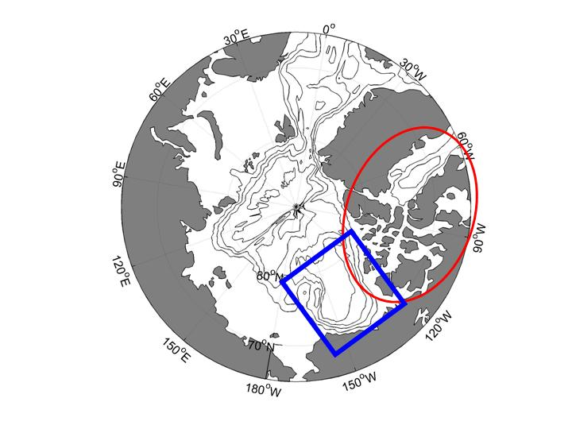

Figure 1. View of the Arctic showing the Canada Basin (blue box) and the Canadian Archipelago and Baffin Bay (red circle).

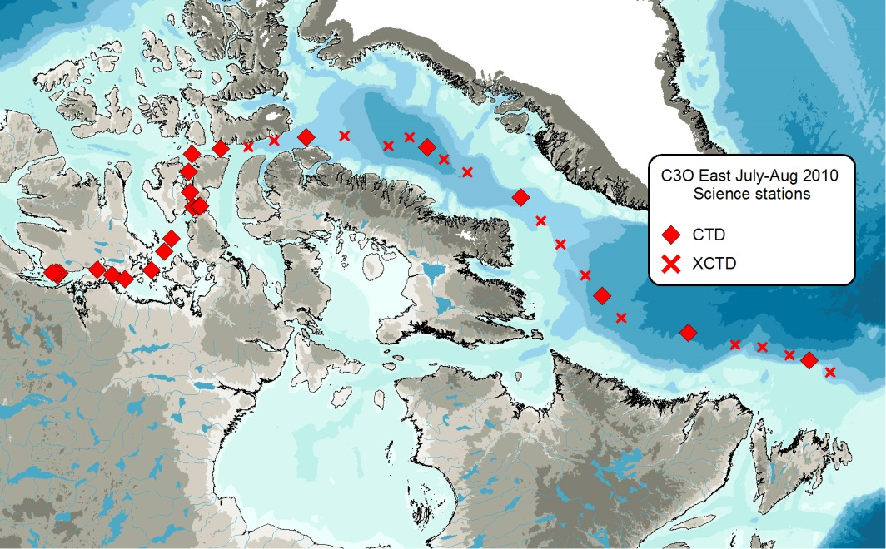

Figure 2. Cruise track and XCTD cast locations performed on Leg 1 (2010-06)

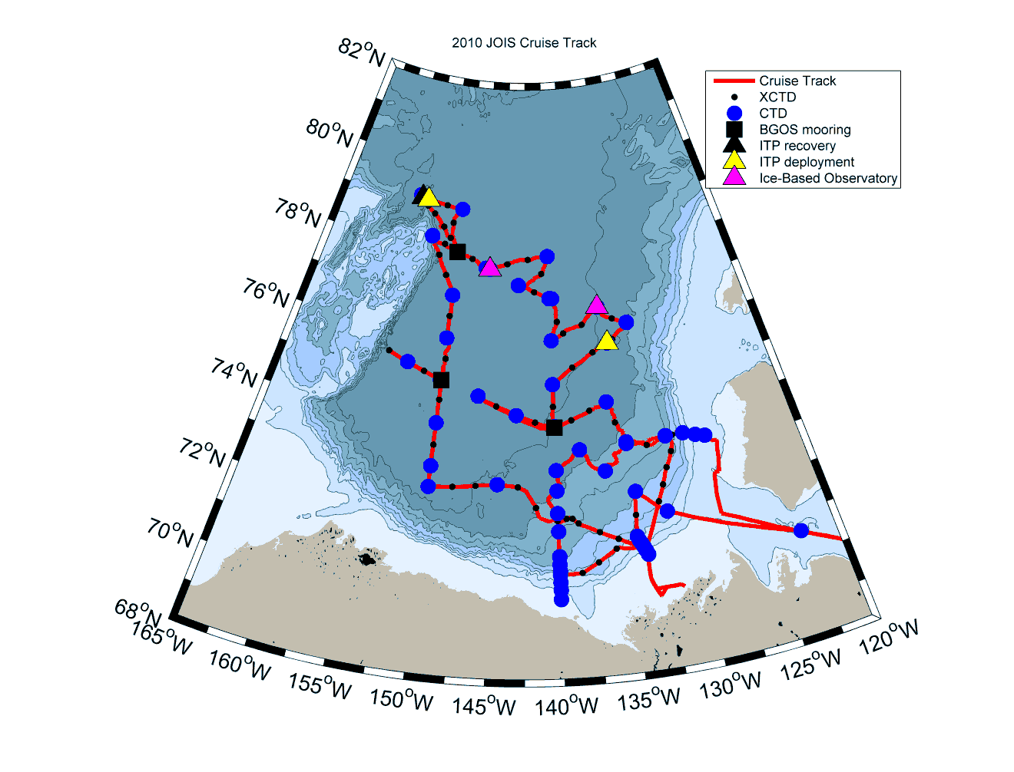

Figure 3. The JOIS (2010-07) cruise track showing the location of science stations.

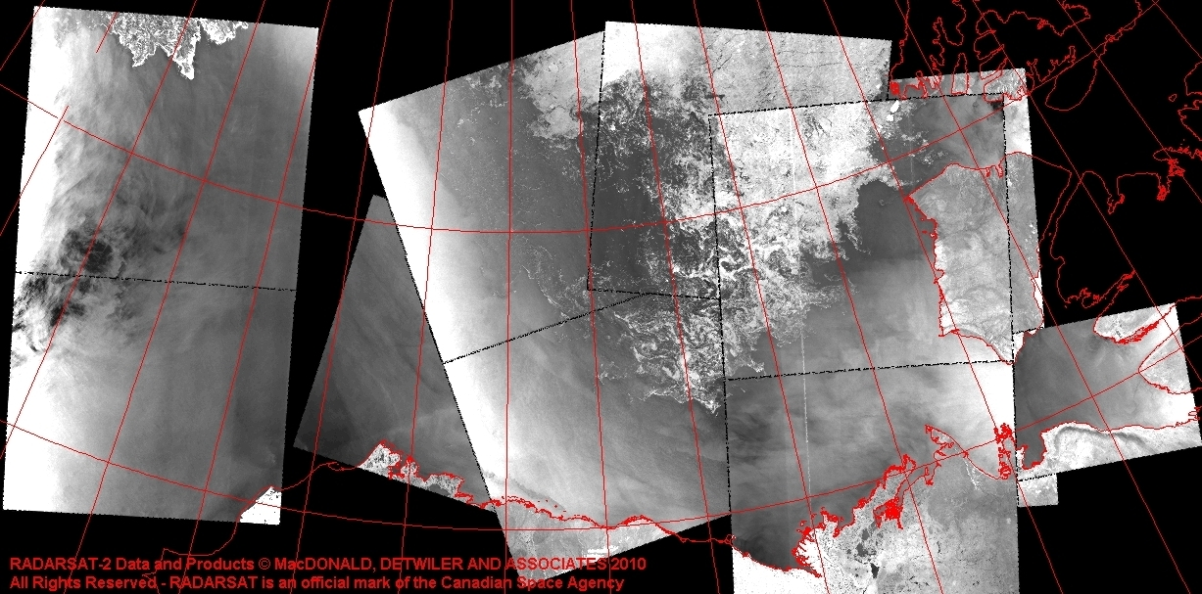

Figure 4. RADARSAT-2 mosaic from 13-16 September 2010 (created by Erik Thibault, Canadian Ice Service) showing ice conditions at the beginning of the expedition.

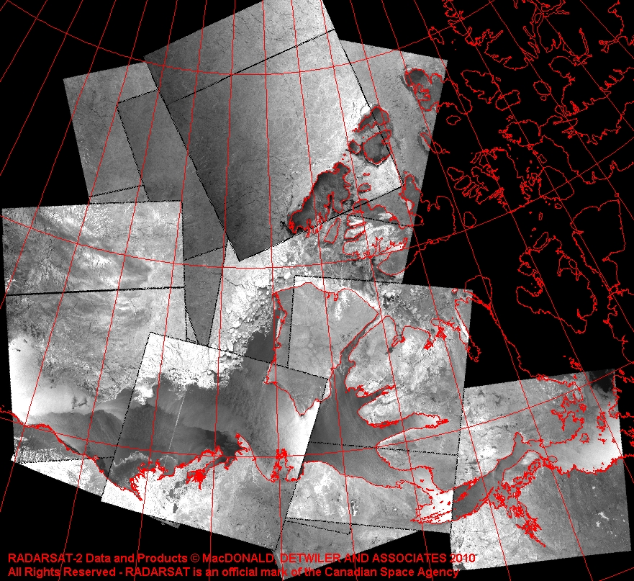

Figure 5. RADARSAT-2 mosaic from 12-14 October 2010 (created by Erik Thibault, Canadian Ice Service) showing ice conditions at the end of the expedition.

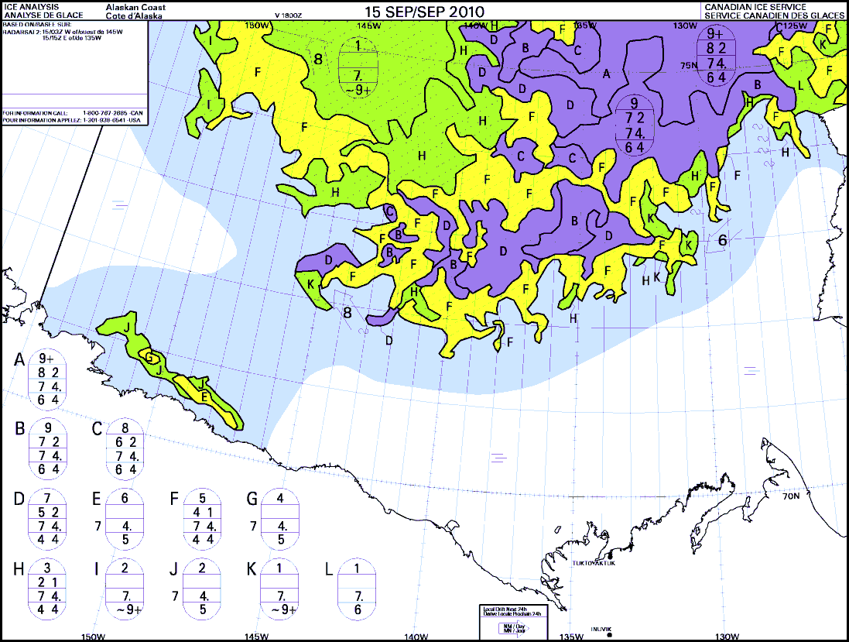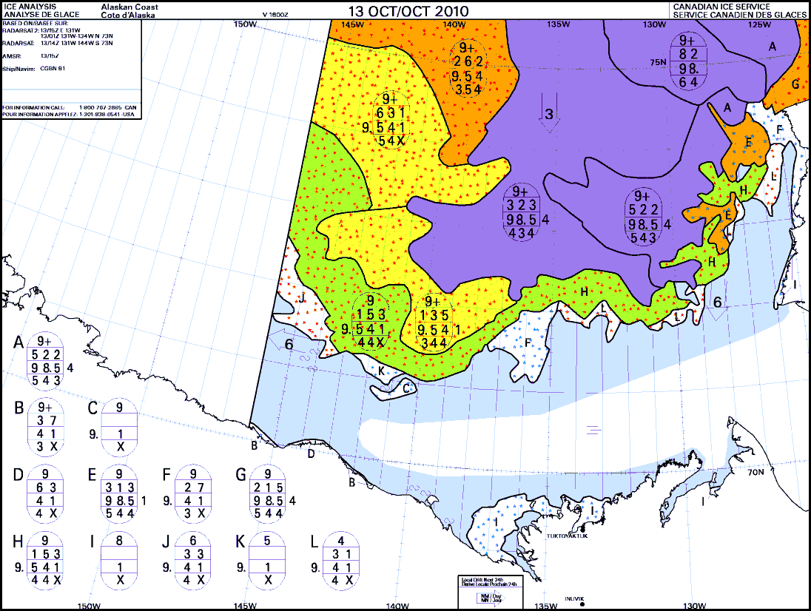

Figure 6. Canadian Ice Service ice concentration charts from the beginning (September 15) and end (October 13) of the cruise.

# METHODS AND ANALYSIS

## SCIENCE PLATFORM: *CCGS Louis S. St-Laurent*

The *CCGS Louis S. St-Laurent* is a 26,000 HP Canadian Coast Guard icebreaker equipped with helicopter and deployable rigid hull boats. An ice specialist from the Canadian Ice Service received frequent Radarsat ice images and weather forecast information from shore, sent daily ice and weather observations and assisted in navigation and information regarding science station locations.

Moorings and vertical net tow operations were performed from the ship’s foredeck using the starboard crane and A-frame. The CTD/Rosette casts were performed on the boat deck, mid-ships, using a starboard A-frame. XCTDs were deployed from the aft deck by a handheld launcher. Ice buoys and ice tethered profilers (ITPs) were deployed away from the ship, using a portable gantry set up on the ice.

The ship’s forward science lab was used as a mooring instrument shop; the rosette and CTD operations were performed from the boat deck container labs. Nutrient, alkalinity analyses, and chlorophyll filtration were performed in the main lab. Ammonium analysis was performed in a back lab (Lab B) to avoid possible contamination with ammonium chemicals found in the main lab. Oxygen and salinity analyses were performed in a temperature-controlled container lab on the boat deck (next to the CTD operations). Zooplankton preservation and microbial work was done in the main lab fumehood.

Underway surface samples were collected from the ship’s seawater loop system in the TSG lab, a small room just off the main lab. The ship’s seawater loop system draws seawater from below the ship’s hull at 9m.

Ships soundings were taken using a 12-kHz Knudsen sounder and existing ship’s 35 kHz transducer. Although continuous measurements were taken, the quality was typically poor while travelling through ice. The quality was good when stopped on station or moving through ice-free areas.

## FIELD SAMPLING: CTD/ROSETTE CASTS

### 2010-06: C3O

The primary CTD system used on board was a Seabird SBE9+ CTD configured with a 24- position SBE-32 pylon and ice-strengthened rosette frame with 10L Niskin bottles fitted with internal stainless steel springs. The data were collected real-time using the SBE 11+ deck unit and computer running Seasave V7 acquisition software. The CTD was set up with two temperature sensors, two conductivity sensors, SBE43 oxygen sensor, fluorometer, transmissometer, and altimeter. On all rosette casts we sampled for salinity, dissolved oxygen, nutrients (Nitrate (NO3), Silicate (SiO4), Phosphate (PO4)), Chlorophyll-a (filtered at 0.7 µm), oxygen-18 isotope (O18), and barium.

For a typical cast, the CTD was powered on while still on the deck. The transmissometer windows were wiped with deionized water soaked optical microfiber cloth prior to each deployment. The rosette package was lowered to 5m. the pCTD pumping system was turned on manually and the package soaked for 2 minutes to equilibrate the oxygen sensor. The package was then raised to the surface and lowered at 60m/min to 1000m or, in water shallower that 1000m, to within 5m of the ocean floor. After closing the first bottle at the bottom of the cast, the package was raised at 60 m/min to the surface. During casts 1-6, the package was stopped for 30s before closing Niskin bottles; for the remainder of the casts, bottles were closed without stopping. The CTD/Rosette cast locations are listed in event log in **Appendix ##.**

Sampling took place immediately after each cast in the heated rosette room. The order of sampling was fixed, based on sampling water most susceptible to temporal changes first. Salinity was analyzed on board. All other samples were prepared and stored for analysis on shore. Note that while dissolved oxygen samples were taken from the rosette on the first three casts, the analysis system suffered from a fault that was not corrected until the following JOIS mission in September.

When ice concentrations were low enough, an acoustic doppler current profiler (ADCP) measuring currents of the upper 60m and two backscatter transducers looking for layers of zooplankton were lowered over the side. The package was lowered by crane from the boat deck to approximately 5m beneath the surface and left in place until the completion of the CTD cast. The instrument package was tethered fore and aft by lines intended to keep it oriented parallel to the ship’s keel and the package was snugged up against the hull. In ice-covered waters, the ADCP was not deployed due to the risk of losing it in the difficult conditions.

### 2010-07: JOIS

The primary CTD system used on board was a Seabird SBE9+ CTD (s/n 0756), configured with a 24- position SBE-32 pylon with 10 litre Niskin bottles fitted with internal stainless steel springs in an ice-strengthened rosette frame. The data were collected real-time using the SBE 11+ deck unit and computer running Seasave V7 acquisition software. The CTD was set up with two temperature sensors, two conductivity sensors, an oxygen sensor, fluorometer, transmissometer, CDOM fluorometer and altimeter. In addition, an ISUS nitrate sensor and PAR sensor were used on select casts shallower than 1100 m. These sensors have 0-5v analogue output which is included in the CTD data string. Note that early on in the cruise the pressure housing for the battery pack of the ISUS leaked and resisted repair for the remainder of the cruise so that we have little ISUS or PAR data.. See Table 1 for sensor serial numbers, calibration information and position on frame.

A typical full depth cast took 3.5 hours to complete. The ship stopped near the pre-determined location to find a position that would keep the wire clear of ice during the deployment. If ice approached the wire during deployment the wire was moved closer to the ship for protection or the winch spooling stopped while the ice pushed by, preventing the wire from sawing into and getting caught in the ice. The ship’s bubbler system was also used to push ice out of the way although the bubblers’ location is most suited to clear the foredeck area, forward of the CTD/rosette launch area.

During a typical cast, the rosette would be deployed followed by the ADCP. While the rosette was deployed, two zooplankton vertical net hauls (bongos) to 100m were conducted from the foredeck. The ADCP was recovered just before the CTD/Rosette reached the surface. Please see the individual report sections for more information on the ADCP and bongo operations.

At the start of a station, the CTD/rosette package was rolled out of the heated sampling container, the protective water-filled plugs removed from the temperature, conductivity and oxygen sensors, and the CTD turned on while on deck to record in-air information. Prior to each deployment of the CTD/Rosette package, the transmissometer and CDOM sensor windows were sprayed with deionised water and wiped with a DI water-soaked lens cloth to prevent sensor drift due to window fouling during the month-long cruise.

At the beginning of each CTD cast, the package was lowered to 5 m to cool the system to ambient sea water temperature, remove bubbles from the sensor’s plumbing and equilibrate the oxygen sensor. The pumps for the T/C/DO2 ducts were manually turned on when the CTD/Rosette package was lowered into the water. The sensors were soaked for 3 minutes at 5 m, and at the end of the soak the package was then brought up to just below the surface to begin a clean cast. For the cast, the package was lowered at 30 m/min down to 300 m (changed to 500 m for the later part of the cruise) and then lowered to within 8-10 m of the bottom at 60 m/min. Niskin bottles were closed during the upcast either by stopping the package, waiting 30 seconds then closing the bottle or by closing the bottle ‘on the fly’ without slowing down the ascent of the package. At the beginning of the cruise, in open water with waves, the bottles were closed by stopping the package but this was changed relatively quickly to closing the bottles without a stop. In the upper 400 m, the sampling depths were chosen to match a set of salinity values. During the downcast, the depths of the salinity values were noted so that on the upcast the bottle could be closed at the pre-determined depths.

During a CTD/Rosette cast, the instrumented sheave (Brook Ocean Technology) read out data to the winch operator, CTD operator and bridge, allowing all three to monitor cable out, wire angle and CTD depth. CTD data acquisition was not stopped until after the CTD/rosette was brought back on deck, again to record in-air measurements. Once all measurements were completed, the CTD/rosette was rolled back into the heated rosette room (Figure 7), the water-filled sensor plugs re-attached and the water sampler rinsed with fresh water. Care was taken to avoid rinsing the Niskin bottles prior to being sampled.

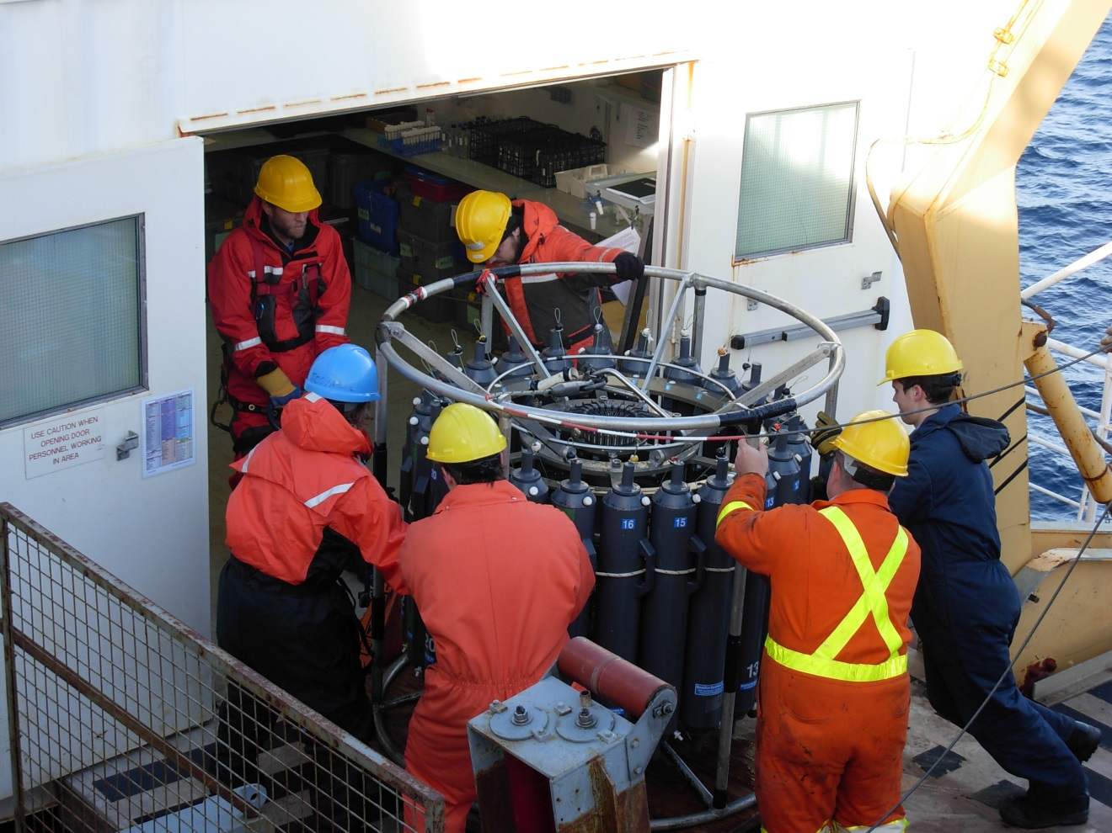

Figure 7. Bringing the full rosette in the sampling room.

Effort was made to reduce the time of the Rosette on deck to prevent freezing of the sensor. The Rosette lab’s doors would remain closed until the bridge gave permission to start the cast. The Rosette was then brought out and lowered into the water as quickly as possible. This step was repeated in reverse at the end of the cast. Between CTD casts, the T/C/DO2  sensors and ducts are kept full of distilled water. When air temperatures are below freezing, the residual distilled water in these ducts can freeze, especially at the intake by the temperature thermistor, and this changes the temperature and salinity readings in the water until the ice melts. In freezing conditions care was taken to remove as much water as possible from the ducts, including dabbing the end of the ducts with a kim wipe, before putting the package in the water. Once in the water, the dual T/C sensors will disagree during the 3 minute soak if there is freezing in the ducts. If this is the case, a longer soak is used and if necessary the CTD is lowered into warmer water (either the subsurface temperature max or the warm Atlantic Water) until the ice melts and the dual sensors agree.

Sampling took place immediately after each cast in the heated rosette room. The order of sampling was fixed, based on sampling water most susceptible to gas exchange or temporal changes, with CFCs, dissolved oxygen and DIC samples being collected first. CFCs, dissolved oxygen, nutrients, salinity, alkalinity and ammonium were analyzed on board. All other samples were prepared as required and stored for analysis on shore. All water sample data were collated to one Excel spreadsheet with station location and time, and CTD data and water sample results referenced to a unique sample number.

Overall, the SBE9+ CTD performance was very good. The primary oxygen sensor, a SBE-43, performed well. There were shifts in the readings requiring calibration but no issues with the membrane.

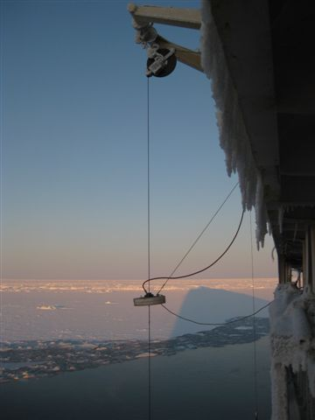Due to the colder temperatures (0 to -20°C) resulting from the timing of this year’s cruise, problems were encountered with icing up of the Brooke Ocean technology (BOT) block. A pneumatic air blower (the “de-icer”) was clipped onto the wire to dry the wire as it came in.

Results were very good and after a few deployments, the installation required only an extra couple of minutes for each cast.

Figure 8. The ‘de-icer’ attached to the CTD wire.

## CTD DATA ACQUISITION, PROCESSING AND VALIDATION – NEEDS DATA

### Overview/Highlights for 2010-07

[Description of CTD units, serial number and con files used]

The SBE9+ CTD overall performance was good. Two CTD units were used during this cruise, deployed according to the following:

* Casts 1 to 3 used CTD s/n 756
* Casts 4 to 27 used CTD s/n 724
* Casts 28 to 56 used CTD s/n 756

A single configuration file (.con file) per CTD was applied throughout. The .con file included the ISUS and PAR even though they were used only on a few of the casts. The data fields will be ignored in processing on casts when the sensors were not installed.

[Calibration of sensors] Salinity and oxygen were sampled from the water and will be used to calibrate the sensors. Due to the asymmetrical plumbing on the temperature and conductivity sensor pairs, some post processing will be required for phase adjustment. CDOM and Chlorophyll-a water samples were collected and can be used for calibration at the user’s discretion.

[Problems/Issues and Solutions] The biggest issue was trouble with delayed closure of the bottles (latches stuck/hung-up), and with incomplete flushing of the bottles. The pylon head was replaced during the cruise which helped improve the miss-trip problems. Washing the pylon head with hot soapy water freed some of the sticking latches. Readjusting the weight on the bottom of the frame also helped with some of the bottle flushing issues. The salinity samples taken from each bottle are very useful at determining if there has been a miss-trip or bottle flushing problem.

Rough weather caused snapping in CTD wire resulting in a slight kink in the wire. When changing between CTDs at cast 28, it was noticed that the bulkhead connector on the CTD (s/n 724, coming off) had corrosion on the pins. The cable was cleaned and the replacement CTD (s/n 756) bulkhead connector was inspected after ~10 casts and no corrosion was seen. At the end of cruise there was still no corrosion seen.

ISUS performed when installed except for cast 41 where it is likely that the ISUS was not powered on long enough in advance of the CTD. The ISUS data flickered on and off during cast. On cast 44 the profile is odd, and afterwards it was found that both the ISUS and PAR data were configured on the 2nd auxiliary channel due to an adapter mistakenly on the PAR cable. The profile has high values at the surface, reducing to near zero at 60 m with a normal looking ISUS profile below. The data look like they may be the sum of the output voltages on the PAR and the ISUS as 0 to 60 m is where PAR values go from highest to zero while nitrate is depleted but increases below this.

See **Appendix 5** for CTD cast notes and list of interpolations. Potential problems for 2010-07 to note are listed below:

* [LIST ANY PROBLEMS]

See Table 1 below for details on CTD accuracy. [UPDATE SERIAL NUMBERS IN TABLE]

Table 1. CTD Accuracy for Seabird SBE911plus CTD systems used during 2010-07

|  |  |  |  |  |
| --- | --- | --- | --- | --- |
| **SBE9-0756 (Casts 1-3, 28-56)** | | | | |
| **Sensor (s/n)** | **Accuracy** | **Lab Calibration Applied** | **Correction to Lab Calibration** | **Comment** |
| Pressure (91164) |  |  |  |  |
| Temperature, Primary (SBE3 4397) |  |  |  |  |
| Temperature, Secondary (SBE3 4402) |  |  |  |  |
| Conductivity, Primary (SBE4 2992) |  |  |  |  |
| Conductivity, Secondary (SBE4 2984) |  |  |  |  |
| **SBE9-0724 (Casts 4-27)** | | | | |
| **Sensor (s/n)** | **Accuracy** | **Lab Calibration Applied** | **Correction to Lab Calibration** | **Comment** |
| Pressure (##) |  |  |  |  |
| Temperature, Primary (SBE3 ####) |  |  |  |  |
| Temperature, Secondary (SBE3 ##) |  |  |  |  |
| Conductivity, Primary (SBE4 ##) |  |  |  |  |
| Conductivity, Secondary (SBE4 ##) |  |  |  |  |
| **Other Sensors (All casts)** | | | | |
| Salinity, Primary |  |  |  |  |
| Salinity, Secondary |  |  |  |  |
| Oxygen (SBE 43 435) |  |  |  |  |
| Transmission (Wetlabs CST-993DR) |  |  |  |  |
| Fluorescence (Seapoint SCF 2841) |  |  |  | Gain x30, plumbed with secondary sensors |
| Altimeter (Benthos Datasonics PSA-916D 1161) |  |  |  |  |
| ISUS (v2 72) |  |  |  | From Jay Cullen |
| CDOM (Wetlabs 1076) |  |  |  |  |
| PAR (Biospherical QSP2300 70123) |  |  |  |  |
| SPAR (QSR2200 20279) |  |  |  |  |

### Acquisition and Processing Steps

### CTD Pressure

### CTD Temperature

**[INSERT FIGURE – CALIBRATION OF TEMP SENSORS]**

Figure 9. Lab calibration of (a) primary temperature sensor #XXXX; and (b) secondary temperature sensor #XXXX. The red line shows the calibration change for this cruise (from [DAY MONTH] to [DAY MONTH] 20XX).

### CTD Conductivity

*Laboratory Results*

*Dual Sensor Results*

*Bottle Salt Results*

**[INSERT FIGURE – LAB CALIBRATION OF CONDUCTIVITY]**

Figure 10. Lab calibration of (a) primary conductivity #XXXX; and (b) secondary conductivity #XXXX. The red line shows the calibration change for this cruise (from [DAY MONTH] 20XX to [DAY MONTH] 20XX).

**[INSERT FIGURE – CALIBRATION OF CONDUCTIVITY TO WATER SAMPLES]**

Figure 11. Calibration of (a) primary conductivity #XXXX and (b) secondary conductivity #XXXX to water samples. The samples in red were those used in the calibration.

### CTD Salinity

CTD salinity was recalculated from the calibrated conductivity (Table 2).

Table 2. Comparison of calibrated CTD salinity and water sample data using CTD - Water Sample.

|  |  |  |  |
| --- | --- | --- | --- |
| **Depth Range (db)** | **STD** | **Mean** | **Number of Observations** |
|  |  |  |  |
|  |  |  |  |
|  |  |  |  |

**[INSERT FIGURE – SALINITY RESIDUAL DEEP]**

Figure 12. Salinity residual (CTD - Salinity) scaled to show deep water residuals.

**[INSERT FIGURE – SALINITY RESIDUAL SHALLOW]**

Figure 13. Salinity residual (CTD - Salinity) shown for the top 500 db.

### CTD Oxygen

Performance

CTD oxygen accuracy is ±X.XX mL/L (±X.X µmol/kg) based on the calibration results with the bottles.

*Problems addressed:*

Calibration

Table 3. Coefficients for CTD oxygen equation using lag-corrected oxygen voltage.

|  |  |  |  |  |  |  |
| --- | --- | --- | --- | --- | --- | --- |
| **Casts** | **Boc** | **Tau** | **Tcor** | **Pcor** | **Voffset** | **Soc** |
|  |  |  |  |  |  |  |
|  |  |  |  |  |  |  |
|  |  |  |  |  |  |  |

**[INSERT FIGURE – OXYGEN RESIDUALS]**

Figure 14. A pressure dependant shape in the oxygen residual was removed by subtracting the mean shown by the black line.

Table 4. Comparison of calibrated CTD oxygen and water sample data.

|  |  |  |  |
| --- | --- | --- | --- |
| Depth Range  (db) | STD | Mean | Number of Observations |
|  |  |  |  |
|  |  |  |  |
|  |  |  |  |
|  |  |  |  |

**[INSERT FIGURE – OXYGEN RESIDUALS]**

Figure 15. Oxygen residuals (CTD - Bottle).

### CTD Transmission

|  |  |
| --- | --- |
| Serial number |  |
| Calibrated on |  |
| M |  |
| B |  |
| Path Length |  |

*M and B as defined in Seabird Application Note 7 (Seabird 2008).

Units are either in [%] with pathlength 0.25 m or have been standardized to [%/m] where pathlength 1 m, such that the beam attenuation coefficient remains the same.

### CTD Fluorescence

### Data Spike Removal

Criteria for temperature and salinity spike identification:

**[LIST]**

Interpolations are listed in **Appendix X**.

### CTD Data at Bottle Depths for Water Chemistry File

**[INSERT FIGURE – LAG CORRECTION]**

Figure 16. Applying (a) no lag correction; and (b) a -X.X s lag correction.

## CHEMISTRY SAMPLING AND ANALYSIS

### Overview/Highlights 2010-07

Samples were collected for 14 water properties, listed below in Table 5.

Table 5. Water Sample Summary for 2010-07 NEEDS DATA

| **Parameter** | **Canada Basin Casts** | **Depths** | **Analyzed** | **Investigator** | **Comment** |
| --- | --- | --- | --- | --- | --- |
| Salinity | 1-48 | Full depth | Ship | Bill Williams (IOS) | In report |
| 49-73 | Shore lab (2-11 Feb 2011) |
| Dissolved Oxygen | All | Full depth | Ship | Bill Williams (IOS) | In report |
| Nutrients (Nitrate, Silicate, Phosphate) | All | Full depth | Ship | Bill Williams (IOS) | In report |
| CASTS | Shore lab (DATE) |
| Ammonium | 11-16, 19, 26, 27, 69-72 | 0 to 350 m | Ship | Bill Williams (IOS) | In report |
| Oxygen-18 isotope (δ18O) | All | 0 to 400 m | Shore lab (DATE) | Bill Williams (IOS) | In report |
| Barium | All | 0 to 400 m | Shore lab (DATE) | Chris Guay | Data not reported here |
| Dissolved Inorganic Carbon (DIC)/ Alkalinity | All | Surface | Shore lab  (April 2011) | Bill Williams (IOS) | In report |
| 13-15, 19, 20, 22, 29, 34, 44, 54, 57, 61, 62 | Full Depth |
| Alkalinity only | All | 0-50m | Ship | Bill Williams (IOS) | In report |
| Select | 0-300m |
| Chlorophyll-a and Phaeopigment (Total using 0.7 µm filter) | All | 0 to 70 m | Shore lab (DATE) | Bill Williams (IOS) | In report |
| Bacteria | All | Full depth | Shore lab (Aug 2011) | Bill Li (BIO) | In report |
| Iodine-129 isotope (129I) | Select | Full depth | Shore lab (DATE) | John Smith (BIO) | Data not reported here |
| Cesium-137 isotope (137Cs) | Select | Surface (4 to 6 m) and 300 to 1000 m | Shore lab (DATE) | John Smith (BIO) | Data not reported here |
| Chlorofluorocarbons (CFC) | Select | Full depth | Ship | Bill Williams (IOS) | In report? |
| CDOM | All | 0-1000 m | Shore lab (DATE) | Céline Guéguen (IARC/Trent) | Data not reported here |

The precision of the methods was estimated by analyzing replicates and is expressed as the pooled standard deviation, *S*p, and calculated using the equation:



where *c*(1) and *c*(2) are the concentrations of duplicate samples and *n* refers to the number of pairs. The precision of the reported data are summarized below in Table 6. Outliers are removed according to Chauvenet’s Criterion (Taylor 1997).

Table 6. Water Sample Precision NEEDS DATA

|  |  |  |  |  |  |  |
| --- | --- | --- | --- | --- | --- | --- |
| **Chemistry Sample** | **Precision (*s*p)** | **Units** | **Number of Replicates (*n*)** | **Outliers removed** | **Minimum Range** | **Maximum Range** |
| Salinity (all samples) | 0.003 | PSU | 159 | 6 | 24.434 | 34.973 |
| Salinity (at sea all depths) | 0.002 | PSU | 71 | 1 | 24.474 | 34.959 |
| Salinity (all, > 500db) | 0.001 | PSU | 42 | 2 | 34.776 | 34.958 |
| Salinity (at sea/on shore mix) | 0.001 | PSU | 23 | 2 | 30.785 | 34.958 |
| Salinity (On Shore) | 0.005 | PSU | 59 | 3 | 24.723 | 34.973 |
| Dissolved oxygen | 0.006 | mL/L | 166 in duplicate  50 in triplicate | 3 | 5.430 | 9.452 |
| Nitrate (fresh) | 0.08 | mmol/m3 | 155 | 2 | 0 | 16.877 |
| Nitrate (frozen) | 0.09 | mmol/m3 | 13 | 0 | 0 | 15.8 |
| Silicate (fresh) | 0.18 | mmol/m3 | 157 | 0 | 1.918 | 37.558 |
| Silicate (frozen) | 0.08 | mmol/m3 | 13 | 0 | 4.4 | 34.9 |
| Phosphate (fresh) | 0.01 | mmol/m3 | 157 | 0 | 0.333 | 2.004 |
| Phosphate (frozen) | 0.01 | mmol/m3 | 13 | 0 | 0.3 | 1.9 |
| Ammonium | 0.02 | mmol/m3 | 143 | 24 | 0 | 0.44 |
| Oxygen isotope ratio (δ18O) | 0.2 | ‰ | 23 |  | -5.879 | 0.559 |
| DIC - Shore | 0.950 | µmol/kg | 31 | 0 | 1412.04 | 2240.23 |
| Alkalinity- Shore | 1.319 | µmol/kg | 30 | 1 | 1798.92 | 2308.91 |
| Alkalinity- Ship | 1.9 | µmol/kg | 108 | ? | 1788.3 | 2303.1 |
| Chlorophyll a | 0.01 | mg/m3 | 177 | 3 | 0 | 1.009 |
| Phaeopigment | 0.01 | mg/m3 | 180 | 0 | 0 | 0.694 |
| CFC |  | nmol/ m3 |  |  | 0.00 | 7.50 |

Of note: **[INSERT COMMENTS]**

All samples were referenced to a unique sample number associated to each Niskin closure. See **Appendix 6** for single cast plots, **Appendix 7** for group property-property plots and **Appendix 8** for section plots.

### Salinity

#### Sampling

Salinity samples were collected from all bottles on all rosette casts. Water samples were collected from Niskin bottles immediately following a rosette cast, after the gases and other sensitive samples have been collected. Salinity bottles used a two cap system, an insert cap followed by a screw on cap. Salinity bottles and insert caps were rinsed 3 times with sample water before filling. Samples were transferred to the temperature controlled room for storage until they were analyzed within one week of collection. Salinity samples were also occasionally collected from the loop system for system calibration. At stations CB-28b, CB-3 and CB-6, deep water (>2000m except CB28b, see Table 7) was collected from the bottom two bottles and was sub-sampled to use as reference water (Deep Water Reference, see Section 2.4.2.5 below).

#### Analysis at Sea

Onboard, samples were analyzed on the Guildline Autosalinometer Model 8400B (S/N: 69086) by Mike Dempsey, Kenny Scozzafava and Chelsea Stanley. Procedure followed methods as outlined in the standard IOS protocol (Minkley, 2003). Room and sample temperature was maintained consistently between 21 - 23 °C. An order numbering system was established within the room whereby salinity cases were cycled in order to establish a constant sample temperature. This system ensured two things: 1) the analyst knew which case to begin analysis and location of each subsequent case, and 2) each case was held at a stable temperature for an extended period of time before analysis (usually > 12 hours). Bottles were inverted several times prior to analysis to reduce any stratification.

The salinometer was calibrated with IAPSO standard water (Batch P151, K15 = 0.99997, Batch Date – May 20, 2010, Salinity – 34.999) to identify any instrument drift. Calibration took place every 24 hours or when there was a backlog of 6+ cases. If the standard value obtained was within ±0.0001 of the standard K15 value on the bottle, the value was accepted. If the value was greater, the cell was flushed and another reading was taken. If it was still unable to get within the range then the standardize knob was used to bring it within range. A Deep Water Reference was run before the first case and between each case during the period of analysis. This was used to identify any instrument drift between calibrations. There were 21 calibrations run. The corrections from these calibrations ranged from -0.000009 to 0.000015. Resulting stand-by numbers ranged from 24+6084 to 24+6099. Data are reported in practical salinity units (PSU; Lewis & Perkin 1981).

Due to problems with the salinometer (see below), 34 cases of samples were unable to be analyzed at sea and were sent to IOS for analysis at a later date (casts 48-73 plus some loop and duplicate samples; see Table 5). Two cases of Deep Water Reference from stations CB-3 and CB-6 were also returned to IOS.

989 samples from 47 casts were analyzed prior to the problems encountered with the salinometer. Of these, 72 were replicates and 21 were loop samples from the underway system.

#### Issues with Salinometer at Sea

Stability of the salinometer was affected by the movement of the ship, with observable jumps in the stand-by number when the ship rolled as well as when the ship was jarred while in ice. The rolling motion appeared to affect the salinometer more drastically than the jarring motion. There was not a significant change in the stand-by number over the course of the survey, ranging from 24.6085 to 24.6090.

One problem encountered was the unreliable filling of sidearm 4 (rightmost arm of cell). Each of the side arms when filling vents through a small polyethylene tube. The same tube is used with positive air pressure to flush a small amount out of the cell. When salt or debris collects in this tube, the arm will not fill or flush properly. Repeat flushing cleaned out the tube eventually.

Bubbles within the side-arms of the interior of the cell caused problems during analysis. A variety of tactics were used to try and clean the cell, in an attempt to remove bubbles as well as any debris which may have stopped the bubbles from exiting the cell. The problem with small bubbles on the platinum-rhodium electrodes was never satisfactorily remedied. The cell was rinsed with Isopropanol, Triton–x and CLR with no change. The cell was removed and cleaned with Kim wipes and again cleaned with the 3 agents with little result. The cell was then disassembled and the coil electrodes cleaned directly. This did not remove the bubbles so the whole cycle was completed.

During the second inspection of the cell, it was noticed that the coil spacing was very tight and irregular. The coils were replaced by using a finger nail and re-installed. This time a lab grade surfactant Witconate was also used and appeared to remove the bubbles. When the AutoSal was tried again, fluctuations of 0.00100 in the conductivity ratio were observed and it was not clear whether this represented the effect of very small bubbles on the conductivity cell or if some electrical change had occurred during the intense cleaning and disassembly. Due to this instability, the decision to take the remaining cases of samples back to IOS for analysis was made.

#### Analysis onshore

Onshore at IOS, samples were analyzed on the Guildline Autosalinometer 8400B (SN: 69572) by Doug Sieberg and Mary Steel on 2-11 February 2011. Procedure followed methods as outlined in the standard IOS protocol. All samples were stored in proper salinity bottles with separate inserts and caps which helps in minimizing evaporation and leakage. Ocean Scientific International Salinometer Data Logger software was used to log the conductivity readings from the Guildline Autosal calculating salinity value.

IAPSO Standard Seawater (OSIL, batch P151, expiry 20 May, 2012, K15 = 0.99997) was run at the start of each day before analysis started. Correction values were within manufactures specs for all but one day. Standardizing was necessary on February 9, 2010, when the Rs was adjusted from 5.56 to 5.54 and the standby value changed from 24+5984 to 24+5986. A Deep Water Reference sample was run after every 24th sample to check for any drift in the salinometer. The salinometer remained stable and within the Guildline specs of 0.002 PSU.

Samples were analyzed in a temperature controlled lab with an ambient temperature changing between 20.4°C -23.6°C overall with a 1.0°C maximum change during an analyzing session. Sample temperatures ranged from 20.3°C to 24.1°C overall with a 1.9°C maximum change during an analysis session.

The sample bottles were inverted and mixed prior to analysis. All samples had minimum 3 flushes and minimum 2 readings. Each reading is the average of 5 readings taken in a 5 second period.

Arctic waters are very cold; after sampling when the sample warms to ambient temperature; inserts should be checked to ensure that they have not popped up (which can lead to evaporation and compromise the sample). To help maintain the sample integrity during storage and transportation, continue to use proper salinity bottles with separate insert and cap mechanisms and assure that transport of samples are protected from freezing.

A comparison of 23 samples where the primary sample was run at sea and duplicate run on shore shows at sea values are greater than those run at IOS by 0.001 PSU. The average difference between the primary and duplicates run on shore is also 0.001. The 0.001 PSU offset between primaries and duplicates is based on when the samples were run at IOS. All duplicates were run on the Feb 9th. Primaries run before the 9th are 0.0016 PSU higher and those run after match the duplicate (no offset). This is not consistent with the Deep Water Check data that show CB-3, run before the 9th, is 0.001 PSU lower than expected (34.956 PSU) and CB-25 run after the 9th is as expected (34.957 PSU). In other words, before the 9th, the duplicates are reading high but the DWC is reading low. Therefore, just need to accept +/- 0.001 PSU error.

#### Deep Water Reference

Deep Water Reference was collected from three stations during 2010-07 (CB-28b, CB-3 and CB-6) as well as one station from the 2010-06 cruise (8-Bel-8, used at the beginning of the JOIS 2010-07 cruise). The standard was taken from Niskins 1 and 2. Niskin 1 was not avoided as in 2009, as casts were not going within 200m off the seafloor, and there was no worry about sediment contaminating the water. Table 7 shows the average salinity of the Deep Water Reference from each station. No water from the CB-6 Deep Water Reference was analyzed during the cruise, but was taken back to IOS for future use.

Table 7. Salinity Deep Water Reference values

|  |  |  |  |
| --- | --- | --- | --- |
| **Sample** | **Mean (PSU)** | **St. deviation** | **n** |
| 8-Bel-8 (2010-06) (390m ?) | 32.6343 | 0.0018 | 6 |
| CB-28b (1013m) | 34.8777 | 0.0010 | 48 |
| CB-3 (>3000m) | 34.9573 | 0.0012 | 23 |
| CB-3 (>3000m) – IOS analysis | 34.9558 | 0.0008 | 16 |
| CB-6 (>3000m) – IOS analysis | 34.9569 | 0.0011 | 14 |

The drift seen between calibrations was monitored by the routine analysis of Deep Water Reference water from the aforementioned stations. The water taken from 8-Bel-8 showed minor flux in corrected salinity from 32.6310 to 32.6364 PSU (Figure 17). The water from CB-28b showed a range in corrected salinity from 34.8752 to 34.8808 PSU (Figure 18). Reference water from CB-3 showed a range of 34.9561 to 34.9595 PSU when analyzed at sea (Figure 19). The steep drop in salinity around October 9 2010 reflects the instability of the salinometer at sea. Reference water from CB-3 measured at IOS ranged from 34.9542 to 34.9666 PSU, with the greatest flux measured on February 4, 2011 (Figure 20). Reference water from CB-6, measured at IOS, had a lower range of 34.9556 to 34.9596 PSU (Figure 20).

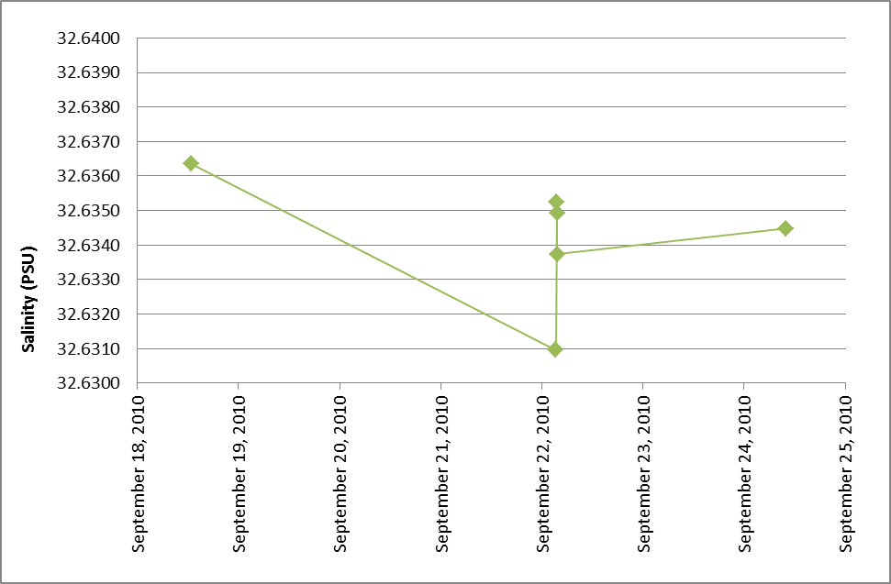

Figure 17. Deep Water Reference corrected salinity over time: 8-Bel-8

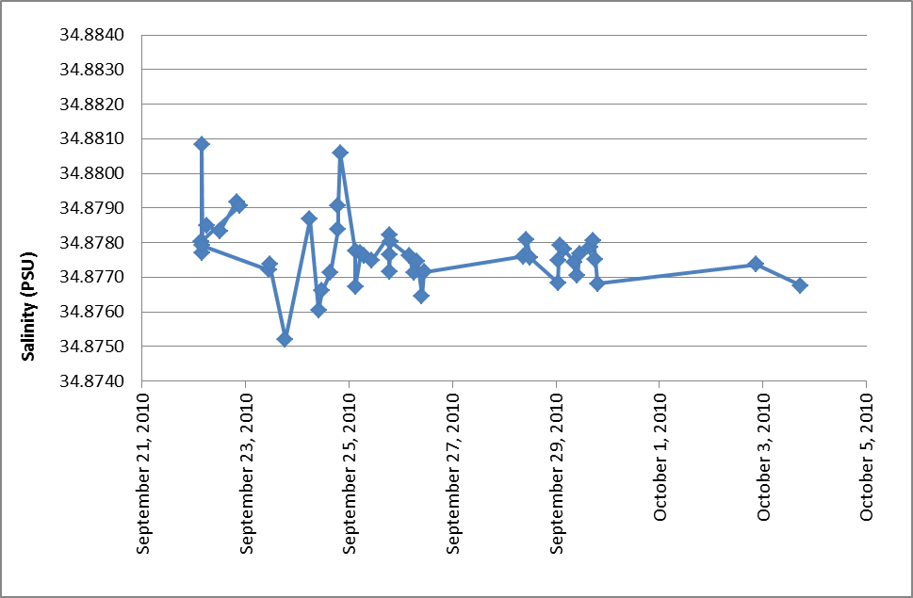

Figure 18. Deep Water Reference corrected salinity over time: CB-28b

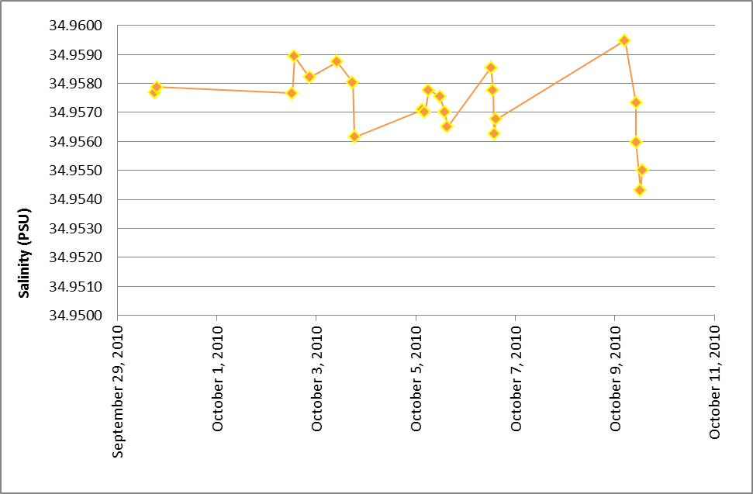

Figure 19. Deep Water Reference corrected salinity over time: CB-3 analyzed at sea.

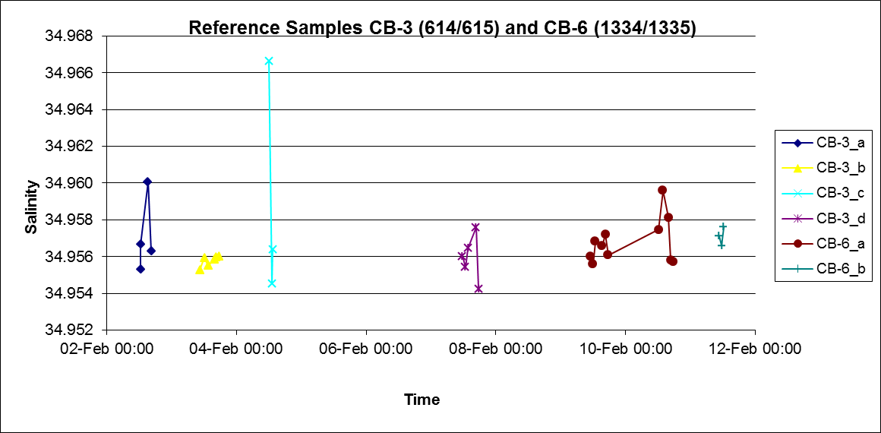

Figure 20. Deep Water Reference (CB-3 and CB-6) salinity analyzed at IOS

#### Salinometer Precision

Table 8. Precision of salinity samples analyzed at sea and onshore

|  |  |  |  |  |  |
| --- | --- | --- | --- | --- | --- |
| **Samples** | ***Sp*** | ***n* pairs** | **No. outliers removed** | **Minimum Range** | **Maximum Range** |
| All samples | 0.003 PSU | 159 | 6 | 24.434 | 34.973 |
| At sea | 0.002 PSU | 71 | 1 | 24.474 | 34.959 |
| At IOS | 0.005 PSU | 59 | 3 | 34.776 | 34.958 |
| Mix a | 0.001 PSU | 23 | 2 | 30.785 | 34.958 |
| Samples >500 db b | 0.001 PSU | 42 | 2 | 24.723 | 34.973 |

1. One replicate run at sea, the other replicate run at IOS
2. Combination of samples run at sea and run at IOS

### Dissolved Oxygen

#### Sampling

Samples were collected in ~140 mL calibrated ground glass stoppered Erlenmeyer flasks. Oxygen sampling was conducted by Jane Eert and Kenny Scozzafava (Kelly Young and Mike Dempsey pickling) between 0000-1200, and by Miranda Corkum (Chelsea Stanley pickling) between 1200-2400. Seawater temperatures at time of sampling were measured with a Fisher Scientific digital probe thermometer potted into one arm of a y-connector with sampling tubing attached to the other two arms (one to the Niskin spigot and one into flask). The response was not rapid enough to record accurate temperatures for Niskin 1 which generally had positive draw temperature readings despite the sub-zero seawater temps. Once equilibrated, the readings were generally lower than in situ temps in the deep water before reversing and reading higher than in situ temps in the upper water column (~500 m). The sample was immediately pickled with 1.0 mL of manganous chloride then 1.0 mL alkaline iodide, the stopper inserted and the flask shaken to mix the contents. Samples were re-shaken after initial settling (~20-30 minutes later), water-sealed and allowed to settle again before being moved to the oxygen lab to ensure that if any expansion occurred no precipitate would be lost from the sample. All samples were stored at ambient temperature in either the rosette shack or oxygen lab with a water seal on the neck and were analyzed between 30 minutes and 32 hours after collection. Occasionally tiny bubbles would appear in some samples after storage (most likely nitrogen offgassing), but these did not seem to affect the final DO value or reproducibility of replicates.

#### Pre-cruise preparation

##### Reagents

All chemicals were prepared in soap and acid-washed glassware and plastic ware according to the protocols outlined in the Scripps Institute of Oceanography (SIO) Oxygen Titration Manual (Version 10-Apr-2003 updated in July 2010 by Nina Nemcek).

Pickling reagents were not prepared prior to the cruise this year as there was sufficient inventory from previous years still in stock. The reagents had been prepared in May 2008 and 2009 and even after 2 years were found to have satisfactorily low blanks.

A fresh batch of thiosulfate was prepared with an increased concentration of 60 g/l to avoid titers >1mL. Four separate 2L batches of potassium iodate standard solution were prepared in May/June 2010 from WAKO stock (#EWQ5825) that had been weighed into appropriate sized aliquots in May 2009. Small 250 mL subsamples of each prepared solution were collected and tested against each other on Kit “A” prior to shipping. All were found to agree within 0.0003 thiosulfate normality. In addition, a commercially prepared potassium iodate standard (WAKO TSK3592) was used during the cruise as an external comparison standard. Three ~300mL bottles of the same batch of standard were combined in a single 1L standard bottle to facilitate Dosimat dispensing.

##### Equipment Calibrations

Bottle top dispensers and 10 mL exchange units were not re-calibrated this year. Calibrations for exchange units are not expected to change and 10 mL graduated cylinders are provided for checking accuracy of dispensing of bottle-top dispensers. Several oxygen flasks had to have stoppers replaced or were new flasks added to the inventory and these were calibrated in April 2009. Flask files were replaced with the deployable (o2flasks.vol) produced with the new Flask Inventory manager program in use at IOS that is compatible with the updated version of LV02.

#### Analysis at sea

Dissolved oxygen concentrations were measured by Miranda Corkum on board the CCGS Louis S. St-Laurent (LSSL) from September 15 to October 15, 2010 during the JOIS mission in the Canada Basin. A total of 1383 samples (1167 + replicates) were collected from 52 rosette casts in the Canada Basin and the Beaufort Slope along a cruise track starting and ending in Kugluktuk, Nunavut. Oxygen concentrations during the survey ranged from 5.430-9.452 mL/L with greater than 10% of samples analyzed in at least duplicate with one triplicate sample per cast. An additional 31 samples were collected from the underway seawater loop for calibrating the O2 optode of the underway gas tension device (GTD). All samples were analyzed with the recently acquired Scripps Institute of Oceanography (SIO) Winkler-based titration kit “B” with an updated version of LVO2 software installed July 2010. The system differs in three major ways from the ones previously used at IOS:

1. Instead of a colorimeter probe that is inserted into the sample, the SIO system uses a UV light source that shines through the flask and is detected on the other side with a photodiode detector. Endpoint detection is based on the strong absorbance of UV light at 365 nm by the tri-iodide ion consumed during the titration. The progress of the titration is monitored as a voltage output from the detector, increasing from 0 V at the start of the titration (when all UV light @ 365 nm is being absorbed by I3-) to ~2.3-2.6 V at the endpoint (when all the I3- is consumed). A LabView based software (LVO2) developed by SIO is used to control and plot the titration.
2. Aside from the Dosimat used to dispense the thiosulfate, the SIO system employs a second Dosimat to accurately dispense the KIO3 standard, thereby minimizing pipetting error and improving system accuracy.
3. The SIO system uses 2 PRT temperature sensors attached to the glass burette of the Dosimats (and insulated from the room) to constantly monitor the temperatures of the thiosulfate and KIO3 solutions, which obviates the need to run the system in a temperature controlled lab.

System Components:

* 1. System controller laptop with a USB to RS232 converter (KEYSPAN)
  2. 2 Brinkmann 665 dosimats, one with a handheld keyboard and a 10 mL calibrated burette for the KIO3 standard, and the other with a software-controlled 1 mL burette for thiosulfate.
  3. Spectronics pencil lamp UV source with mount and power supply
  4. UV100BQ photodiode detector equipped with a 365 nm filter
  5. VWR mini stirrer with a water bath sample holder mounted on top
  6. 2 Platinum Resistance Thermometers (PRT) to monitor solution temperatures
  7. An A2D converter to convert voltages from the detector and the 2 PRTs to a digital signal.

##### Preparation for Analysis

Prior to analysis each day, the UV light source and stir plate were turned on and allowed to warm up and stabilize for 20-30 minutes. The water bath which holds the sample was drained, cleaned and refilled with fresh deionized water to ensure good light transmission. The Dosimat lines leading from the thiosulfate and KIO3 bottles were checked thoroughly for bubbles and these were purged as needed. The bottle top dispensers on the three reagents were flushed as were the Dosimat burettes. Stirring was optimized to ensure rapid mixing without drawing bubbles into the light path.

##### Blank and Standard Preparation

Blanks and standards were run daily just prior to the sample runs. A dedicated Dosimat was used to accurately dispense either 1.00 mL (blanks) or 10.00 mL (standards) of KIO3. Blanks and standards were always made up in Nanopure water produced on board. The resistivity of the water and all reagent changes were noted (never below 17.9 Mega ohm-cm). Blanks and standards were run in sets of 4 with the criteria that 3 out of 4 had to agree to within 0.0003 (blank value or THIO titer in mL). Generally this was easy to achieve; only occasionally did an additional set of standards or blanks need to be run because of bubbles in the Dosimat lines or problems with the titration or standard preparation. Ship vibrations and variability in the second dose of KIO3 (1 mL) seemed to be the primary cause of poor blank replication. The temperature of both the standard and the thiosulfate were recorded by the program and used to correct the delivered mass of both reagents to 20°C in order to calculate the thiosulfate normality.

##### Analytical Procedure

Following standardization, the sample run was started. Sample flasks were inspected for bubbles, the water was removed from atop the stopper, 1.0 mL of sulfuric acid and a stir bar were added to the flask which was then placed inside the water bath. The thiosulfate burette was inserted into the flask and the titration initiated. The titration would proceed with the voltage displayed on the screen; however, only the final portion of the titration curve between 1.6-2.8 V was plotted (with the endpoint generally occurring between 2.3-2.6 V). The two options at the end of every sample run were either “FINISH SAMPLE”, which displays the DO value and resets the thiosulfate burette, or “OVER-TITRATE” which allows one to salvage a bad titration curve (or an over-shot endpoint) by adding 1.0 mL of KIO3 standard and re-titrating the sample. The amount of thiosulfate needed to titrate 1.0 mL of KIO3 is then subtracted by the software from the final titer. After every sample, the DO value was noted on the cast log sheet. All endpoints were inspected for accuracy and recalculated if necessary by the “O2CHECK” function of the LVO2 software. At the end of each sample set the software produced a *.LST file and an extension-less “noname” file with the titration parameters. The “noname” file allows one to edit all titration parameters such as temperature, thiosulfate titer, normality, flask ID etc. in order to recalculate a new DO value with the “HYDOX” program.

#### Issues during sampling and analysis

*Bubbles:* There were a number of problems with bubbles being introduced to the samples via the bottle-top dispensers despite dispensers always being primed prior to sampling. This was likely caused by the temperature difference between the ice cold samples and the room temperature reagents. Samples with bubbles were always redrawn. For the first half of the cruise samples were redrawn into the original flask after 3 full rinses. After one redrawn flask was shown to have a higher value than replicates, presumably because precipitate from the original samples was not adequately rinsed out prior to redrawing, a new flask was always substituted. Comments on this are noted in the 2010-07 OXY spreadsheet. It is important to establish a sampling protocol on this issue.

*Storage Temperature:* It was noticed that the floor of the oxygen lab where the samples were stored was ~10 ºC cooler than the ambient lab temp (~22.5 ºC) and samples were still cold to the touch at time of analysis.

*Overshot Endpoints*: There were no problems with overshot endpoints on this cruise. The OT function was used on a number of occasions when either the titration curve had errant points near the endpoint, or would continue past the endpoint due to unstable detector signal. In most cases the OT worked well despite the 1.2 mL/min initial dosing rate.

*Stalled Thiosulfate Burette:* Last year, on random high DO samples with titers greater than 1 mL, the thiosulfate burette stalled after dispensing 1.0 mL and the titration did not continue. The thiosulfate concentration was increased to 60 g/L this year based on a recommendation by Nina Nemcek from the 2009-20 oxygen report and, as a result, there were no problems at all with thiosulfate burette stalls this year.

*No Dosimat Display:* As noted in the 2009-19/21 and 2009-20 reports, the Thio dosimat occasionally failed to display the volume dispensed until after titration curve plotting began at 1.6 V, after that it displayed normally and presumably accurately, with no ill effects on the final DO value.

*Offscale Titration Curve:* Several times the titration curve was not plotted because the X axis range (volume of Thio dispensed) on the software display was incorrectly set. A point would appear at 1.0 mL and 1.6 V on the titration plot despite the fact that the dosimat had dispensed well under 1 mL volume. This occurred seemingly randomly on both standard and sample runs and did not appear to affect the final endpoint calculation.

*Problems with Stirring:* There were many curves with errant points or “bumps” and delayed endpoints that were likely caused by inconsistencies in stirring. This problem seemed to worsen with increased ship motion.

*Pipette Tip in Light Path:* There was a group of problem curves that were either unusually “short” or else flat with a sharp increase at the end of the titration (October 3rd, cast 42, station CB-11, samples 871 to 877 and standards and blanks run to test this problem on October 3rd and 4th). Troubleshooting steps included: cleaning water bath and UV detector windows, unplugging dosimat and exchange unit and re-starting oxygen computer, and swapping out UV detector. Finally, Jane Eert discovered the problem was the pipette tip in the light path – once this was adjusted away from the center of the flask there were no further problems.

*S-shaped curves:* There was a group of problem curves that were “s-shaped” at or near the endpoint (cast 012, station MK-2 and cast 013, station MK-1). This issue seemed to resolve itself and no cause was ever determined.

**Note**: there remain two endpoints that need to be revisited: sample no. 194 and 1520. For sample 1520, I tried using the OT function twice since both the original and OT curve were not usable – I am not sure how to deal with this? (It was a pipette problem in the end).

*Thiosulfate Normality Change*: Daily thiosulfate normalities and blank values measured over the course of the cruise are plotted below in Figure 21.

Two bottles of the same batch of thiosulfate (Batch #1001A) were used during the cruise with the change occurring on October 2nd. Five batches of standard were used throughout the cruise and the thiosulfate normality ranged between 0.24172 and 0.24277 N (diff = 0.0011 N). The standard normality observed was within the limits of acceptable day-to-day variability (<0.0005 N) with the exception of the change between the first and second bottle of standard on September 23rd. While this first bottle of standard started out with a stable thio normality, as the volume of standard in the bottle decreased the normality began to decrease. It is likely this apparent decrease in thio N was caused by insufficient mixing/swirling of the standard solution before standardization (needed to mix in droplets formed by evaporation) and by allowing the standard volume to become too low (<200 mL) before swapping bottles (creating a “bottle effect”). After switching to the second bottle of standard and observing a large jump in thio N (from 0.24172 to 0.24254 N) I began taping the lid of the standard bottle to further prevent evaporation (although the water trap should be preventing this) and more vigorously swirling the standard solution. I also attempted to switch out standard solution once it reached ~300 mL.

Data affected by this problem with the first standard bottle were adjusted using a “Thio N correction factor” which was simply the ratio of expected/measured Thio N. Expected Thio N was determined by taking an average of the following 3 standardizations of standard batch 1006A. This correction factor may need to be adjusted depending on the view of more experienced analysts.

See 2010-07_Oxy spreadsheet: “Adjusted OXY 29Sept” tab for recalculated values. For a complete record of all reagent change and standardization info see the 2010-07 OXY spreadsheet “THIO N” tab.



Figure 21. Thiosulfate normalities (filled diamonds) and blank values (open squares) measured during dissolved oxygen analysis between September 16 and October 14 during cruise 2010-07.

#### Precision and Accuracy

Of the 1167 unique samples collected during the course of this survey, 166 were collected in duplicate and 50 in triplicate. Of the replicated samples, the first replicate was always chosen as the Final DO value, except when a problem was noted with it during analysis (i.e. sample redrawn due to bubble addition during fixing). Triplicates were run at the same time as the other two replicates.

The precision of the dissolved oxygen measurements was excellent with a pooled standard deviation of 0.006 after the removal of three outliers (0.005 with 3 outliers removed when determined using duplicates only as in previous years). This is comparable to the pooled standard deviation obtained during 2009-20 of 0.007 (one outlier removed).

[Dissolved oxygen values from the two deepest bottles (those stations with depths greater than 2500 m) are plotted in Figure 22. Deep water values are in excellent agreement to within ~0.02 mL/L from previous years and range from 6.507 mL/L to 6.537 mL/L on Niskin bottle 1. In addition to the above, with daily standardizations, excellent sampling, and timely analyses post standardization, it could be stated within reasonable confidence that the system produced accurate dissolved oxygen concentrations.]

[INSET FIG – Do we have?]

Figure 22. DO WE HAVE? Deep water (>2800 m) dissolved oxygen values plotted for the first two Niskin bottles fired

### Nutrients – IN PROGRESS

#### Sampling

Water samples for nutrient determination were collected in duplicate into nutrient tubes after the tube and cap had been rinsed three times with the sample water. One sample was analyzed on board and one was frozen as a backup for analysis on shore at IOS. For the samples analyzed at sea, if analysis could be performed within 24 hours the samples were stored at 4 °C; if not they were frozen at -20 °C before being run. At least ten percent of the samples were collected in triplicate for duplicate samples to be run at sea.

A set of approximately 1000 new Falcon nutrient tubes were cycled through sampling and analysis for the entire trip. The tubes were rinsed with hot tap water, acid cleaned in 1N HCL for >4 hours and rinsed 3 times with Nanopure water.

#### Analysis

Nutrients (nitrate + nitrite, silicate and orthophosphate) of fresh seawater samples were analyzed by Linda White onboard ship using a three channel Technicon Auto Analyzer, following the methods described by Barwell-Clarke and Whitney (1996). The colorimeters, cables and analog-digital converter were interchanged with a set from Water Properties/Janet Barwell-Clarke’s Technicon system in hopes to eliminate any offsets that may have been introduced by the Arctic system as uncovered in the 2009 phosphate and nitrate data.

Reagents were prepared onboard using water from a NANOpure system that produced 18.0 – 18.2 mega ohm-cm resistance Type I reagent grade water. The system was supplied with ship’s distilled water. Reagent bottles were topped up daily. A 3.2% weight-to-volume solution of sodium chloride (Sigma) was prepared daily and used to rinse the system between samples and to prepare working standards. Three cadmium reduction columns were used for nitrate throughout the 4 weeks of analysis.

At the end of each day’s run the tubing and coils were cleaned with 3N NaOH, 1N HCl and 30 minutes of double deionised water. Most days the Autoanalyser ran for a minimum of 10 hours. The entire pump tubing was replaced with new after 500 samples.

##### Standard and blank preparation

Primary Stock standards were prepared at the Institute of Ocean Sciences in May, 2010 and were calibrated against Wako Nitrate (20 µg atoms/L) and Wako Silicate (50 µg atoms/L); there is no calibration standard available for phosphate.

NANOpure water was analyzed daily before connecting the reagents and analyzing the initial standards, and after the last set of standards to establish the baseline.

A set of working standards (low, medium and high) were prepared from the stock standard solution, using freshly prepared 3.2% sodium chloride solution. The daily working standards were made of the following concentrations: nitrite + nitrate 0, 8.0, 16.0, 24.0 µm/L, silicate 0, 16.0, 32.0, 48.0 µm/L and phosphate 0, 0.8, 1.60, 2.40 µm/L (nominal).. Wako (20 µm/L nitrate and 50 µm/L silicate) were used to calibrate the working standard solutions. Nitrate concentrations were; 8.0 µm/L, 16. µm/L and 24.0 µm/L, silicate; 16.0 µm/L, 31.9 µm/L and 47.9 µm/L, phosphate; 0.81 µm/L, 1.62 µm/L and 2.41 µm/L. Values were adjusted for pipette delivery. Fresh working standards were prepared daily along with silicate and phosphate ascorbic acid wetting agents. Concentrations of the standards were selected to bracket the expected nutrient levels in the samples. Wako standards were analyzed once a week to validate the primary nutrient stock solutions were holding true.

Standards purchased from KANSO (Lot AY series, measured by Marine Works Lab, Japan) were analyzed at the end of each day. The assigned values from KANSO were nitrate 6.28 µm/L, silicate 30.3 µm/L and phosphate 0.50 µm/L. There can be variability within each batch/bottle of reference material.

An onboard deep seawater reference (DWR) sample was collected at sea from casts 21 (sample 352, depth 2600 m) and 66 (samples 1406-1407, depths 3400 m and 3050 m). All deep water reference material from a single cast was collected in a carboy then subsampled into acid cleaned plastic test tubes and frozen at -20°C.

A set of standards were analyzed at the beginning of the day’s run. A frozen reference sample (#352) and medium check standard plus two zeroes were analyzed between profiles and a full set of standards were analyzed after each profile and at the end of the day followed by a de ionized water zero. All reference materials, medium check standards and regression curve concentrations were run in triplicate. The best two values for each concentration in the regression were used to calculate slope. Charts for the medium check standard, KANSO reference samples and the frozen MK reference material on board sample were established to check sampling procedures, instrument stability and analytical precision.

The order of the sample analysis was from the surface to depth, and sample peaks that appeared to be out of order were re-analyzed. Ten percent of samples were taken in duplicate. Samples with questionable values were re-run from the frozen sample after the cruise at IOS. Re-runs were done in January, 2011.

The turbidity of surface samples where salinity is less than 27 PSU were analyzed through the phosphate channel with no reagents being added to the sample. When the nitrate level in surface samples was the same or slightly lower than the 3.2% sodium chloride solution it was reported as zero.

#### Problems and Solutions

##### General Issues

ANY? – NOTE about Nitrate offset?

##### Issues: Phosphate

Phosphate baseline took a slight shift during the last two days of analysis. New tubing was replaced for ascorbic acid wetting agent and molybdate solutions.

##### Issues: Silicate

Silicate baseline was slightly noisy for the entire trip and “Peakbase smooth” was used to smooth out the peak tops for calculation. New platen tubing was installed for oxalic acid, molybdate and ascorbic wetting agents to try and clear up the noise. It was not very successful.

#### Precision

Detection limit was determined as three times the standard deviation of the blank where n = 10 replicates. Detection limits were: nitrate 0.041, silicate 0.081 and phosphate 0.006 mmol/m3.

Table 9. Quality control and assurance for nutrient samples.

|  |  |  |  |
| --- | --- | --- | --- |
| **Nutrient** | **Nitrate + Nitrite**  **(mmol/m3)** | **Silicate**  **(mmol/m3)** | **Phosphate**  **(mmol/m3)** |
| **Sample replicates: fresh** |  |  |  |
| *\*s*p | 0.08 | 0.18 | 0.01 |
| No. of duplicates | 155 | 157 | 157 |
| **Sample replicates: frozen** |  |  |  |
| *\*s*p | 0.09 | 0.08 | 0.01 |
| No. of duplicates | 13 | 13 | 13 |
| **Medium check standard**  (analyzed as unknown) |  |  |  |
| Calibrated value | 16.0 mmol/l3 | 31.9 mm0l/m3 | 1.62 mmol/m3 |
| Average and SD | 16.1 +/- 0.11 | 31.9 +/- 0.19 | 1.62 +/- 0.018 |
| No. of duplicates | 154 | 156 | 154 |
| **Wako standard** (analyzed as unknown)  Calibrated value | 20 | 50 |  |
| Average and SD | 19.9 +/- 0.2 | 49.95 +/- 0.2 | n/a |
| No. of duplicates | 17 | 16 |  |
| **KANSO reference sample: AY** (analyzed as unknown)  Calibrated value | 6.28 mmol/m3 | 30.3 mmol/m3 | 0.5 mmol/m3 |
| Average and SD | 6.24 +/- 0.12 | 30.04 +/- 0.3 | 0.5 +/- 0.01 |
| No. of duplicates | 89 | 87 | 87 |
| **Deep water reference sample #352** |  |  |  |
| Average and SD | 14.60 +/- 0.2 | 14.13 +/- 0.14 | 1.04 +/- 0.02 |
| No. of duplicates | 141 | 140 | 138 |

### Ammonium

#### Sampling

Ammonium was sampled for the LSSL 2010-07 program occurred along shelf transects throughout the Canada Basin, primarily those along the lines extending North from the Mackenzie River (MK Line) and west of Banks Island.

Ammonium concentrations were determined by Jeffrey Charters following the Holmes *et al.* 1999 protocol A (0 to 3 µM), modified for 40 mL sample volume. Samples of 40.5 (± 0.58) mL of seawater were collected in duplicate from 10 L Niskin bottles at each station from a depth of 34.6 PSU and shallower, with a zero value sample set (blank water) taken at 450-500 m depth, into 50 mL acid washed glass test tubes. 167 samples were collected in duplicate and processed during this cruise along with 14 sets of standards.

In order to analyze stations that were close together some samples were stored in the fridge in the alkalinity lab (Lab D, away from any ammonium based chemicals) for up to 72 hours before adding working reagent. This was not the most satisfactory protocol and was the result of a combination of factors, but it was assumed samples should be stable for up to 96 hours. These samples were analyzed in batches with one set of standards and almost always prepared for analysis within 24 hours of sampling.

#### Analysis

Reagents were prepared on board in the main lab fume hood and allowed to sit for at least 48 hours prior to use. Samples were collected in 50 mL glass test tubes with plastic screw top lids and sealed with Parafilm (see Problems & Solutions section). After being used for a sample, glassware was rinsed three times in the ships de-ionized tap water and twice in DMQ water, before being immersed in a 10% HCl acid bath for > 4 hours (usually overnight). Vials were then rinsed three times with DMQ water and dried on racks. The plastic screw top test tube lids were cleaned with DMQ water after the 10% HCl rinse and then soaked for > 4hrs in DMQ water. Caps were then dried on the lab bench top in Lab B. All rinsing & acid additions were carried out between the ammonium lab (Lab B) and the main lab fume hood, with subsequent air drying done in Lab B.

Samples were prepared by adding 10.0 (±0.1) mL of working reagent (WR, prepared according to Holmes et al. 1999) and let sit in the dark for 5-8 hours at room temperature. After sitting for 5-8 hours, samples were measured with a Trilogy fluorometer (Turner Designs) in UV mode. Standard sets (0, 0.25, 0.5, 0.75 and 1.0 µM) were run with every station or group of stations and prepared with samples using seawater collected from the 500m bottle from the same rosette or from a cubitainer of water collected from a deep bottle at station MK-3 (cast 11, sample 152, 376m) and stored in the cold room on the ship.

##### Standard Preparation

Ammonium chloride standards from past years would generally be brought on board along with a new standard, in order to ensure that accurate measurements are being taken. Due to what was likely a miscommunication during the packing stage of the trip, this did not happen for the current cruise. In order to have something to compare with the new standard, a second ammonium chloride standard was prepared by myself (JWC) and Linda White (LW) using ammonium chloride salts which were weighed out on land and brought on board. The standard brought on board in solution was labeled 2010-1 and the solution made on-board 2010-2. Standard 2010-2 appears to be 7% higher in concentration than 2010-1, with no immediate explanation (Figure 23). Given the fairly low concentrations of ammonium found during the analyses and what seems to be a fairly high inherent imprecision in the method, it is debatable whether this discrepancy is important. Regardless, it would be useful to compare these standards to past standards in order to establish which values would be considered correct. The term “secondary standard” refers to the stock solution diluted 25-fold, given a working solution with 100 µmol L-1.



Figure 23. Comparison of two 2010 ammonium chloride secondary standards.

Figure 24 shows the calibration curves for most of the analyses save for the first two, which were embarrassingly poor. This plot makes it seem quite obvious that a certain level of reproducibility was achieved after the fourth calibration curve, when the curves all begin to show low blanks and relatively reproducible slopes. A number of factors could influence the slope of the calibration curve, the most likely of which would be the reaction of the ammonium with the working reagent which takes several hours to come to completion and would be affected by the temperature of the water initially and the temperature of the room in which the reaction was taking place. This latter consideration is important, because the aft labs of LSSL are susceptible to temperature fluctuations, especially when temperatures change considerably outside (ie. ranging from 5°C to -21°C on this cruise). In order to determine the possibility of incorrect measurements due to these effects, the 0.5 µmol/L standard was analyzed in duplicate. The result showed that there was a good degree of stability throughout an analysis session, with < 2% change in sensitivity in most cases, and often < 1% change.



Figure 24. Standard Sets 3-11, all instrument calibrations included. From the fifth calibration onwards, the curve showed good reproducibility.

##### Blanks

The consistency of the reagent blank value over the course of the cruise is a good indicator of working reagent quality, sampling/cleaning protocol reliability, and instrument performance. The initial calibration curves (for STD sets 1 – 4) indicated a strong likelihood of some sort of contamination. The following calibrations showed low and quite consistent blank values, with a mean of 9309.58 raw fluorescence units (rfu) and a standard deviation of 2891.51 rfu. The range on these values was from 4462.64 rfu to 15080.51 rfu. There is a possibility that since the low blank values and reproducible calibration curves began during the use of WR 2 that WR 1 may have been contaminated (see Problems and Solutions). However, it is thought to be more likely that the test tubes themselves are responsible for this, as a contaminated WR should have more reproducible results.

#### Problems & Solutions

Due to an inexperienced analyst, WR was not made as early in the cruise as it should have been, which resulted in a hasty test calibration curve with high blanks and low reproducibility. This was considered to be a possible result of not letting the WR sit long enough, since it should be aged at least a day before use but in this case it was used after roughly twelve hours. Samples were already being collected by this point in the cruise, and the stability of samples in the fridge for extended periods (> 24 hours) was not known. An attempt was made to analyze samples from stations CB-31b and CB-60 shortly after being collected, which resulted in high blanks and low reproducibility. This same problem was experienced the year prior on the same cruise with a different analyst (KAB), who performed multiple tests and found that Parafilm wrapping the tops of all tubes would correct the problem. During all analyses to this point, all tubes were being covered in Parafilm whenever possible.

Contact with the KAB was made via email, who informed JWC that another possibility was that the test tubes themselves could be a source of contamination. The mechanism is not entirely obvious, as the tubes were all acid cleaned by KAB on-board a year prior and kept in Ziploc bags during the interim. Following this, all remaining test tubes were acid cleaned (>4 hours in 10% HCl) before being used. From what followed, this seemed to decrease blanks and increase precision. However, along with the samples from CB-31b and CB-60, those from CABOS and AG-5 were also collected in dirty tubes and had erratic values and are thusly all discarded from the final data set. The possibility of WR 1 being contaminated exists, but it is considered highly unlikely because CB-28aa was analyzed using WR 1 along with AG-5 and CABOS, but unlike the two latter stations it showed very low values and good duplicate values.

Since CB-28aa was analyzed using standards collected at AG-5, the values seem to make no sense based on the calibration curve produced during that analysis. Since the results appear to be reasonable based on other results from the MK line, it was decided that an average of the four analyses performed within a reasonable timeframe would be used to calculate results in lieu of dismissing the data entirely. The results using this method are well within the expected range and seem congruent with other ammonium data along the MK line. The slope used was 147 086 rfu/(mmol/m3) and the intercept was 7213 rfu.

Tests were also performed to determine whether the vast amount of Parafilm and time spent on parafilming the tubes was necessary. “Old caps” are caps that have been used in the past, but rinsed with acid and soaked in DMQ and should thus not be confused with ‘dirty’ lids. “New lids” are blue polypropylene caps that were opened on the ship and acid rinsed/DMQ soaked prior to use. The results show that there does not seem to be a significant difference between most caps at the 1σ level as shown, and no differences at the 2σ level (Figure 25). As such, the practice was discontinued following station CB-51.



Figure 25. Results of a cap test to see if parafilming the top of tubes was necessary.

Two things should be done immediately upon boarding the ship:

1. at least one batch of WR should be prepared, and
2. an acid bath be set up to begin washing test tubes so they can be cleaned prior to the first station.

Possibly keeping some test tubes from being cleaned and collecting a few duplicate samples in these could help determine if this would ultimately be the source of contamination seen over the past couple of years. It was determined that setting up an acid bath early in the cruise would be too much effort, but based on the amount of effort that has gone into eliminating contamination that likely comes from this source makes it seem like a worthwhile proposition.

Parafilming test tubes is tedious and appears to be redundant, and can cease to be implemented.

#### Precision

Data collected during the 2010-07 cruise show good duplicate precision. Once contamination issues at the first 5 stations were resolved (see Problems & Solutions section), reproducibility between sample duplicates was fair, with Sp values for the whole data set of 0.07 uM (n=167) and an Sp of 0.02 (n=143) if Chauvenet rejected outliers and samples pairs with suspected contamination of one of the duplicates are removed (i.e. if one sample gives a high fluorescence reading and the duplicate sample gives a zero value this is expected to indicate that the high value is a contaminated sample).

*Sp* (all pair sets) = 0.07 μM (n = 167)

*Sp* (pair sets without flagged data) = 0.02 μM (n = 143)

Several NH4 samples throughout the 2010-07 data set have been flagged as questionable (3 flag) or removed from the data set completely (5 flag). The decision to include (3 flag) or exclude (5 flag) these samples was based on their evaluation against two criteria: (1) the known occurrence of contamination or sample mishandling; and/or (2) a statistical improbability of such large deviation from the pooled sample mean (difference between duplicates greater than 2 standard deviations of the mean of the data set).

Sample sets from stations AG-5, CABOS, CB31b & CB23a (casts 1-3 & 24) were rejected based on criterion (1) known sample contamination (see Problems & Solutions section). In addition, 24 sample pairs were rejected based on above criterions, and 5 duplicate pairs were flagged “3” questionable as they had one of the two duplicates that was questionably high but could not be discarded for any obvious reason.

### Oxygen Isotope Ratio (δ18O) – TO BE DONE

#### Overview

The 18O/16O ratio of natural waters is determined using the common CO2-H2O equilibration technique (Epstein, 1953; O'Neil et al., 1975) in which millimole quantities of CO2 are equilibrated with water samples under constant temperatures. Subsequently, the CO2 is cryogenically purified and analyzed mass spectrometrically for its 18O/16O ratio. Note that this technique measures the isotopic activity of 18O and not the actual 18O concentration. For dilute waters, differences between isotopic activity and concentration are negligible. For saline waters and brines, however, supplemental water chemistry data and longer equilibration times are needed to obtain true isotopic compositions (Horita, 1993; Sofer, 1972).

#### Sampling

Samples were drawn from the Niskin into 30 mL glass vials following three rinses of the vials with sample water. Once at room temperature the caps were retightened and the vials inverted for storage until analysis back onshore.

#### Analysis

Samples were analyzed on 16 May-19 June 2012 at the Stable Isotope Laboratory, Department of Physics and Astronomy, University of Calgary by Jennifer McKay using a mass spectrometer connected to a H2O-CO2 equilibration unit. Aliquots of water samples are equilibrated with CO2 typically for 18 hours. During the equilibration period, samples are kept at a constant temperature and are shaken gently. Between 0.5 and 5.0 mL water are typically used for analysis.

The pH value of the water samples must be in a range such that H2CO3 and HCO3- are abundant (pH = 6 to 7). For alkaline waters, anhydrous phosphoric acid may be added to achieve this pH. After 18 hours of equilibration, the CO2 gas is cryogenically purified. Subsequently, the 18O/16O ratio is analyzed either by dual inlet isotope ratio mass spectrometry (Micomass 903), or by continuous flow isotope ratio mass spectrometer (Gilson sampler + VG Sira 10).

The oxygen isotope composition is referenced to Vienna-Standard Mean Ocean Water (V-SMOW):

(V-SMOW): δ18O = ((H218O/H216O)sample / (H218O/H216O)VSMOW - 1) × 103 [‰].

The obtained “raw” δ18O values are drift corrected and normalized using internal laboratory standards, which was calibrated periodically using international standards (V-SMOW, V-SLAP, V-GISP). Internal lab standards are analyzed repeatedly within each sample set (1 standard per 5 samples) to guarantee quality control. Isotopically enriched water samples are calibrated using additional standards with positive δ18O values provided by the IAEA (e.g. IAEA 302 and 304). Corrected δ18OH2O values are reported in the per mil (‰) notation relative to V-SMOW.

#### Precision

Accuracy and precision for δ18O values of natural waters are generally better than ±0.2‰ (one standard deviation based on n=50 lab standards).

Duplicate samples were used to determine precision: *sp* = X.XX ‰; *n* = XX pairs after XX pairs removed.

### Barium – TO BE DONE

#### Sampling

Barium samples were drawn from the Niskin into small (~20 mL) plastic vials following three rinses of the vials. Once at room temperature the caps were retightened.

#### Analysis

Barium concentrations were determined at Oregon State University by Christopher Guay on a VG Thermo Excel inductively coupled quadrupole mass spectrometer. An isotope dilution method was used as described in Falkner et al. (1994) with minor modifications. Briefly, 250 µL aliquots of sample were spiked with an equal volume of a 135Ba-enriched solution (Oak Ridge National Laboratories) and diluted with 10 mL of 1% HNO3. The spectrometer was operated in peak jump mode, and data were accumulated over three 20 s intervals for masses 135 and 138. Based on replicate analyses of samples and standardized reference materials, the precision (2-sigma) of the analytical procedure ranges from < 5% at 10 nmol/Ba to < 3% at 100 nmol/Ba.

#### Precision

Duplicate samples were used to determine precision: *sp* = X.XX µmol/m3; *n* = XX pairs after XX pairs removed.

### Dissolved Inorganic Carbon and Alkalinity– IN PROGRESS, NEEDS DATA

#### Sampling

Samples for measuring dissolved inorganic carbon (DIC) and alkalinity were collected from the surface samples at all rosette stations, and from a full profile at select stations (stations ##). Seawater was collected into a glass 250 mL reagent bottle following the collection of CFC’s and dissolved oxygen samples. The sampling tube was connected to the spigot of the Niskin bottle and, by holding the tube above the spigot, was rinsed by flowing approximately one tube volume of sea water through the tube. Any trapped air bubbles were removed by tapping or squeezing the tube. The bottle was filled smoothly from the bottom (tubing touching the bottom of the bottle) and the bottle overflowed by two times its volume. The tubing was withdrawn to the neck and the spigot valve closed or the flow in the tubing squeezed off before the tubing was removed from the bottle. One percent of the stoppered sample volume was removed to leave a headspace (about 1 % of the bottle volume - i.e., 2.5 mL for a 250 mL bottle) by inserting a nylon plug into the bottle. 100 L of saturated mercuric chloride solution (HgCl2) was added to the bottle. A greased stopper was inserted and sealed with elastic bands or electrical tape. Samples were stored at 4 °C until analysis.

#### Analysis

Samples were analyzed at IOS by Marty Davelaar on DATE using a VINDTA 3D - analysis system to determine the concentration of dissolved inorganic carbon (or total carbon dioxide). The VINDTA (Versatile Instrument for the Determination of Titration Alkalinity) is a sea-going, computer-controlled automated dynamic headspace analysis, constructed in Kiel Germany by Ludger Mintrop of Marianda Instruments. The VINDTA uses a Windows based PC and LabView software along with a coulometric detector (UIC Coulometrics, model 5011). The VINDTA dispenses and acidifies a known volume of seawater, strips the resultant CO2 from solution, dries it and delivers it to the coulometric detector.

At the start of each day, seawater was run through the system to condition the cell. Next a system blank is started. If the blank is below 0.90 g Carbon or approximately 360 counts in a ten minute period a Dickson CRM sample is analyzed to confirm the system is working properly. For each analysis (standard or sample) a peristaltic pump is used to pull the sample out of the bottle and into the water-jacketed calibrated pipette. The water from the pipette is then forced into a scrubber compartment with UHP nitrogen to which approximately 0.5 mL of 8.5 % ortho-phosphoric acid had been added. UHP nitrogen is then pushed through a bottom mounted frit, the nitrogen pushes the CO2 which has been stripped from the sample by the acid through a Peltier cooler which is used to keep water vapor from entering the cell where the CO2 is titrated The coulometer was operated in the g C mode which is converted into counts by the LabView program. The software then uses the counts total along with the pipette’s temperature, the salinity of the water and other constants to calculate the mol/kg value of each sample. At the start of each sample or standard, the system is rinsed twice with the sample being analyzed and a system clear check is performed to ensure there is no CO2 in the system. The final concentrations are calibrated with the daily measured Dickson CRM where:

*corrected value = (raw value * certified value)*

*(measured value * correction for mercuric chloride volume)*

The mercuric chloride correction is 1.0004, for 250 mL samples. DIC values are reported in units of µmol/kg.

#### Problems and Solutions

Any?

#### Precision, Standards, and Blanks

The accuracy of DIC analysis was assured by daily analysis of Dickson CRM sea water (batch 115, concentration 2007.45 µmol/kg; DOE 1994; Dickson 2001; Dickson et al. 2003) supplied by Andrew Dickson (Scripps Institute of Oceanography, San Diego, USA).The difference between the measured value and calibrated value of the IOS standard seawater was less than ±1 (0.05%).

Precision is given by the pooled standard deviation of sample replicates. *sp* = 0.69 mol/kg, where *n* = 70 pairs, one outlier removed.

### Alkalinity Only (run at sea)

#### Sampling

During the 2010 JOIS cruise, seawater samples were collected for alkalinity analysis from 0-50m of the water column at all CTD/R stations. At selected stations, deeper samples (0-300m or 0-bottom) were also taken. Samples were analyzed by Michiyo Kawai on board the ship during the cruise.

A total 433 samples were collected from Niskin bottles into 500 mL glass bottles and stored in the cooler (4 °C). Samples were brought to the lab and kept at room temperature for 1-12 hours and then put in water bath (20 °C) at least 1 hour before being analyzed. The total alkalinity was determined by potentiometric titration using 0.1 N HCl, with the new system introduced to IOS in 2008 (designed by Paul Covert, University of Washington). Alkalinity values are reported in units of µmol/kg.

#### Analysis – SEE NOTE

At the start of each day, seawater was run through the system to condition the instruments. Once the system appeared to be working well, certified reference material (CRM) was run to confirm proper operation. Concentration of acid were chosen to give the assigned alkalinity values for CRM.

102.78 mL (at 20 °C) of seawater was transferred from the sample bottle to a glass beaker by using a glass syringe equipped with a stopper to take a same volume of sample water every time. An initial amount (2.4 or 2.6 mL) of 0.1N HCl was added to the seawater and then 0.1 mL aliquots of acid were added to the seawater until sample water takes its pH to approximately 3.5. After seawater was stirred for 360 sec to degas CO2, reading of pH (EMF) and addition of 0.1mL of acid were repeated until a final pH of approximately 3.0 was obtained. 108 of 433 samples (25%) were analyzed in duplicate or in triplicate.

Drift throughout the day was monitored by checking the values of replicate analysis of samples and no obvious drift was found during the cruise. Samples analyzed in the previous 1-2 days were also reanalyzed to check the stability of the system throughout the cruise.

A plot of total alkalinity measurements vs. CTD-salinity, CTD-depth or Niskin bottle number was made simultaneously during analysis, and samples that seemed unusual in the plot were re-analyzed. In addition, a couple of samples were randomly chosen for each station and analyzed in duplicate. CTD salinity values were used to calculate alkalinity of seawater and therefore data should be re-calculated with bottle salinity data, especially for samples taken from highly stratified surface layers.

#### Precision and Standards

The accuracy of the alkalinity analysis was assured by daily analysis of certified reference material (batch 98, concentration of S=33.366, alkalinity=2231.11 µmol/kg; DOE 1994; Dickson 2001; Dickson et al. 2003) supplied by Andrew Dickson (Scripps Institute of Oceanography, San Diego, USA).

Precision is given by the pooled standard deviation of sample replicates. S*p* = 1.9 µmol/kg, where *n* = 108 pairs.

### Chlorophyll-a

#### Sampling

At standard stations, chlorophyll-a was sampled from three depths (above, at and below the chlorophyll-a maximum) in duplicate at 71 stations, and from the underway system.

Samples were drawn from the rosette into pre-calibrated 1L brown or 2L white Nalgene bottles; each bottle was rinsed three times with the sample water prior to filling. Once sampled, the bottles were covered to reduce exposure to light. The water was then filtered immediately under low pressure onto 0.7µm pore size GF/F 25mm filters (Advantec GF7525MM). If the sample could not be filtered immediately, it was kept cool and in the dark until filtered, and the time taken until filtered noted. Filters were then folded in half in aluminum foil and stored at -80°C for later analysis at IOS. Chlorophyll-a samples were filtered by either Kelly Young (DFO) or Chelsea Stanley (DFO).

A total of 335 samples were taken at 42 stations, plus 2 filter blanks. A total of 34 underway samples were also taken. Five calibration stations were done, where up to 18 depths were sampled for chlorophyll-a (CB-4, CB-21, CB-31b, CB-70, CB-DW). Four stations were sampled twice for chlorophyll-a, either on a consecutive cast (CB-4, casts 33-34; CB-21, casts 65-66) or casts separated in time (CB-50, casts 26 and 68; CB-51, casts 27 and 69).

#### Lab Analysis

Chlorophyll-a samples were processed by Linda White at the Institute of Ocean Sciences (Lab 2418A) in November, 2010 following Strickland and Parsons (1972) and modifications from the Joint Global and Ocean Flux Study (JGOFS) Protocols (1994). Filtered chlorophyll-a samples were transferred from an aluminum pouch and placed in a 20 mL scintillation vial. Ten ml of 90%acetone/10% double distilled water was added and the samples were extracted in a -20°C freezer for a 24 +/-2 hours extraction period. Filter blanks (packaged at sea) and acetone blanks (10 mL 90 % acetone placed in a vial when the filters were being extracted) were processed like samples.

The samples were then removed and gently swirled and allowed to equilibrate to room temperature in the dark before reading (1-2 hours). All work was done in a darkened room. Fluorescence was read on the Water Properties Turner 10 AU Field Fluorometer, calibrated in May, 2010.

Extracts were then transferred to clean borosilicate test tubes, the outside of the test tubes were wiped clean on the outside with a Kimwipe, and placed in the sample holder making sure the sample cover is in place. Samples were read before acidification (Fo) and after acidification (Fa) with 2-3 drops of 10% HCl. Filter and acetone blanks were treated in the same manner as the samples.

A solid standard (low ~12 fsu and high ~64 fsu) was used to record any instrument instability throughout each of analysis. This showed a high reading on Nov 20th. A Sigma Chl-a standard solution (100µg/mL) was also read to check that calibrations had not changed since May 2010 (see Table 10 in Section 2.4.10.4).

Clean borosilicate test tubes were used for each sample to eliminate possible contamination with acid to the next sample. The tubes and vials were cleaned by soaking in hot soapy water, rinsing with hot tap water and air-drying overnight.

#### Problems and Solutions

##### Field

To avoid having to adjust the volume filtered while filtering, it would be helpful to have more brown 1L pre-calibrated Nalgene sampling bottles available, rather than use the 2L bottles. Although there is low chlorophyll in the water, 2L volumes still take over 30mins to filter, which may degrade the sample. It should be determined what the ideal volume/filtering time value is for quality samples.

The vacuum pumps are being returned to IOS and should be serviced before being used for the 2011 field season.

##### Lab

Part way through analysis it was observed that the acidified chlorophyll a (Fa) fluorescence readings were near exactly the same as non-acidified (Fo). The samples fall into two groups (A and B) when compared to CTD Fluorometer. Group A are close to a 1:1 ratio between the water samples and the CTD as expected, and Group B have a less defined fit, maybe a 10:1 ratio with the water samples. In fact Group B fit may be solely based on Phaeophytin as the Chlorophyll values are all very close to 0. Plotted by extraction date, Group A samples are all from Nov 17 and 18th; whereas Group B samples were analyzed Nov 19-20th.

The following tests were performed at analysis time to determine any procedural causes for there to be no change in fluorescence readings upon the addition of acid:

1. Analyzed the solid standard
2. Analyzed the 100ug/L Sigma chlorophyll-a standard solution.
3. Ran several 90% acetone blanks – each in a new cuvette.
4. Added 2 extra drops of acid to sample when no change was observed after first addition.
5. And checked that the cuvette holder was in place. On two occasions the cuvette holder was misaligned resulting in no fluorescence at all.

All checks performed confirmed that the 10%HCl acid, Turner Fluorometer and cuvettes were working properly.

Samples (in the foil pouches) were packaged for storage and transport in two plastic Ziploc bags at -80°C (Sep 15-Oct 15, 2010). They were then flown home after the cruise as luggage in a cooler with ice packs (travel time 36 hours, seawater samples in cooler remained frozen) and stored at IOS in a -80°C freezer (Oct 16, 2010) until they were analyzed. It was noted that the first bag of samples (run Nov 17-18) was not damaged; however, the second bag (run Nov 19-20) was torn and split.

It is suspected that sample storage and transportation from the ship to the lab caused half of the samples (Group B) to degrade somehow, since no analytical cause could be found for the no acid addition effect.

#### Precision and Standards

The Turner Designs 10 AU - 005 Field Fluorometer (serial - OSD) was calibrated May 12, 2010 by Linda White with Sigma pure Chlorophyll a (C6144, Batch 1420-409 10209144). The resultant equations (R2 = 0.9998) used to calculate chlorophyll-a and phaeophytin are:

Chl-a (µg/L) = 0.9788*(1.94/(1.94-1)*(Fo-Fa)*(vol-ex / vol-filt)

Phaeo = 0.9788*(1.94/(1.94-1)*((1.94*Fa)-Fo)*(vol-ex / vol-filt)

Where: Fo = abs before acidification; Fa = abs after acidification; vol-ex = volume extracted; vol-filt = volume filtered.

Table 10. QA/QC of chlorophyll-a analysis

|  |  |  |  |  |  |  |
| --- | --- | --- | --- | --- | --- | --- |
| **Solid standard** | | | | **Sigma Chla std 100µg/ml** | | |
|  | **Low (12)** | **High (64)** | **Time** | May2010 preparation | |  |
| **Date** | **Fo** | **Fa** | **Time** |
| November 16, 2020 | 11.7 | 63.9 |  |  |  |  |
| November 17,2010 | 11.8 | 64.2 | 11:00a.m. |  |  |  |
| November 18,2010 | 11.9 | 64.8 | 9 a.m. | 106 | 53.7 | 1:00 p.m. |
| November 19, 2010 | 11.7 | 64.1 | 10:00a.m. |  |  |  |
| November 20, 2010 | 12.2 | 66.4 | 11:15a.m. | 95.2 | 40.9 | last of the std in flask |
| **Acetone Blanks** | | | |  |  |  |
| November 19,2010 | 90%acetone/10%ddH2O blank | | | 0.000 | 0.000 | 2:15 p.m. |
| November 20, 2010 | 90%acetone/10%ddH2O blank | | | 0.000 | 0.000 | 11:25 a.m. |
| November 20, 2010 | 90%acetone/10%ddH2O | | blank | 0.000 | 0.000 | 2:10 p.m. |
| **Filter Blanks** | | | |  |  |  |
| November 16, 2010 | 1 | |  | 0.038 | 0.028 |  |
| November 19, 2010 | 2 | |  | 0.000 | 0.000 |  |

Duplicate samples were used to determine precision:

Sp* (all) = 0.006 µg/L Chl-a, n=177, range; 0.000 – 1.009 (3 discarded)

Sp (all) = 0.014 µg/L Phaeo-pigment, n=183, range; 0.000-0.694

Sp (group a) = 0.008 µg/L Chl-a, n=90, range; 0.000 – 1.009 (3 discarded)

Where Sp is standard pool and n is the number of duplicate pairs. *Sp skewed because of the numerous zero Chl-a readings.

Table 11. Precision of chlorophyll-a samples analyzed onshore

|  |  |  |  |  |  |
| --- | --- | --- | --- | --- | --- |
| **Samples** | ***Sp***  **(µg/L Chl-a)** | ***n* pairs** | **No. outliers removed** | **Minimum Range** | **Maximum Range** |
| All samples | 0.006 | 177 | 3 | 0 | 1.009 |
| Group a | 0.008 | 90 | 3 | 0 | 1.009 |
| Group b | 0.0006 | 82 | 3 | 0 | 0.014 |

See Section 2.4.10.3.2 for a description of groups.

### Bacteria – need to add figs to appendix

#### Sampling

Phytoplankton and bacterioplankton samples collected for Dr. Bill Li (BIO) were preserved in aliquots of seawater sampled from the Niskin bottles. Following standard protocol (Marie et al. 1999), 1.8 mL seawater was dispensed into a 2 mL capacity cryogenic vial and immediately fixed with 0.2 mL of 10% paraformaldehyde by vortex mixing. Samples were maintained for at least 15 min at laboratory temperature to allow fixation, and then stored at -80 °C until analysis at BIO.

1154 samples were collected between September 17 - October 14, 2010 on board the CCGS Louis S. St-Laurent during the JOIS. Paul Dainard from Trent University and Hugh Maclean from IOS processed the bacteria samples for storage.

#### Lab Analysis

Cell concentrations of picophytoplankton, nanophytoplankton, and bacterioplankton (i.e. non-autofluorescent picoplankton) in thawed samples were analyzed by flow cytometry (Becton Dickinson FACSort) following protocols in routine use (Li and Dickie 2001). Phytoplankton were detected by native autofluorescence using blue laser excitation (488 nm) and long-pass red emission (>650 nm). Cells smaller than 2 µm equivalent spherical diameter were classified as picoplankton and those larger as nanoplankton. In turn, picophytoplankton were partitioned into two groups according to the presence (cyanobacteria) or absence (picoeukaryotes) of the pigment phycoerythrin detected in the orange waveband (585 ± 21 nm). Bacterioplankton were stained with SYBR Green 1 (Molecular Probes, Oregon), a nucleic-acid binding fluorochrome, and detected in the green waveband (530 ± 15 nm).

Measurements of fluorescence and light scatter were collected using logarithmic amplification and recorded in relative units in a 4-decade range spanned by 256 channels. Fluidic flow rate was calibrated by regression of the aspirated volume versus duration of analysis. Data were extracted from listmode format using WinMDI Version 2.8 (copyright Joseph Trotter: <http://facs.scripps.edu/>).

See **Appendix 6.1.5** for bacteria data plots.

### Radionuclides (Iodine 129 and Cesium 137)

There are two basic tracer applications of these radionuclides in the Arctic Ocean:

(1) Measurements of 129I and 137Cs, separately provide evidence for Atlantic-origin water labeled by discharges from European reprocessing plants; and

(2) Measurements of 129I and 137Cs, together can be used to identify a given year of transport through the Norwegian Coastal Current (NCC) thereby permitting the determination of a transit time from the NCC to the sampling location (Smith et al., 1998).

In addition samples were collected at stations CAP10 and TU1 to assess the 137Cs levels in Pacific water in-flowing into the Canada Basin.

#### Sampling

Water samples for 129I analyses were collected from selected depths in one litre PVC bottles that had been pre-rinsed with seawater to remove any foreign debris and returned to the laboratory of the Atlantic Environmental Radioactivity Unit (AERU) at the Bedford Institute of Oceanography (BIO) for analysis by John Smith. Fourteen stations were sampled and 204 samples were collected.

Water samples for 137Cs were collected from full rosette casts of 24 bottles to construct six depth profiles for Cs. Forty liter samples were collected at selected depths and 137Cs was concentrated on 5 g columns of potassium ferrocyanide (KCFC) coated silica gel. The KCFC was dried and returned to the laboratory for analysis. 137Cs is determined using Gamma Spectrometry with HPGE detectors. Twelve stations were sampled and 69 samples were collected.

#### Lab Analysis – 129I

DATE RUN? In the laboratory, a NaI carrier was added to a 200 mL aliquot of the seawater sample, it was slightly acidified, purified using multiple hexane extractions and iodine was precipitated as NaI. The NaI precipitate was shipped to the IsoTrace Laboratory at the University of Toronto where 129I analyses were performed by accelerator mass spectrometry (Smith et al. 1998; 1999; 2005). The sample data were normalized to the IsoTrace Reference Material #2 (129I/127I = [1.313 ± 0.017] x 10-11 atom ratio) which is calibrated using the NIST 3230 I and II standard reference material. The blank (KI carrier added to distilled and deionized water) for this procedure is 0.75 ± 0.10 x 107 atoms/L and the standard deviation (one sigma) ranged from 5 to10% (Edmonds et al. 1998). 129I concentrations in seawater are generally expressed in units of 107 atoms/L. IsoTrace has participated in a number of 129I International intercomparison exercises, including the NIST SRM 4359 Seaweed, the Lawrence Livermore 129I intercomparison, phases I and II and the IAEA-0375 Radionuclides in Soil intercomparison. IsoTrace 129I procedures and sample handling protocol have been approved by the United States Office of Civilian Radioactive Waste Management, through on-site inspections by Bechtel SAIC Inc.

#### Lab Analysis – 137Cs

DATE RUN? 137Cs concentrations in seawater are expressed either as Bq/m3 or mBq/L. The KCFC resin (processed at sea after water sampling) was deployed in a standard geometry and measured using a hyperpure Ge detector having an efficiency of 25 %. Numerous analytical intercomparisons (including publicly reported blind exercises) have been carried out with other laboratories by the (AERU) over the past 30 years for quality assurance purposes. Intercomparison samples have been provided by the United States Environmental Protection Agency (USEPA), the United States Environmental Measurements Laboratory (EML) and the United States Department of Energy as part of their Mixed Analyte Performance Evaluation Program, MAPEP. Marine environmental samples (eg. IAEA-315; IAEA-326; IAEA-327) provided by the IAEA (International Atomic Energy Agency) have been analyzed to insure compliance with international standards in the marine radioactivity community. NIST (National Institute of Standards and Technology) ocean and river sediment reference materials are analyzed on the detectors on a regular basis as a calibration check.

### Chlorofluorocarbons (CFCs) – in progress

Need background paragraph?

#### Sampling

Halocarbons were sampled at 28 stations. Niskin O-rings were replaced with IOS solvent cleaned and baked O-rings while the ship was enroute to the Arctic in July 2010. Halocarbon samples were the first to be drawn from the Niskin following the Niskin bottle integrity checks. The sample was collected in a Perfektum 250 mL glass syringe (Popper and Sons Inc.) Syringes were rinsed three times with sample water and filled, taking care not to allow air bubbles to enter the syringe. Syringes were submerged in a bucket filled with cold seawater, and stored outside the lab door until analysis to prevent contamination from the high CFC concentration in air. When exterior air temperatures plummeted, the bucket temperatures were monitored and moved in and out as necessary.

#### Analysis

Analyses for CFC-12, CFC-11, CFC-113, and CCl4 were carried out by Rick Nelson and Nes Sutherland on the IOS automated purge and trap system. Separation and detection of the components was achieved using a 75 m, 0.53 mm DB624 fused silica column and a Hewlett Packard GC/Electron Capture Detector, respectively. Standardization was done using a gas standard (ALM065156) prepared and calibrated by Brad Hall of NOAA in early 2010. The calibration was then converted to the SIO1998 scale. Air samples were taken as a further check on the operation of the system.

The CFC team participated in 28 of the 70 casts, sampling most depths, with 3-5 sets of duplicates per cast. The system was kept running 24 hours a day. In general, a full set of standards preceded each station’s samples, with a blank and standard 7 bracketing every 7-10 syringes. Air was sampled when possible, and end standards became the initial standards for the next station.

The system was set up the same as for the 2008 cruise, with modifications only in the loops chosen. Because the new standard gas had a much higher F12, the 1.0 mL loop was replaced with a 0.5mL loop. This 0.5 mL loop was inserted on V5, where the standard 2 loop originally was; this latter was then moved to V4 to replace the 1mL loop. As well, the standard gas had much lower CT, necessitating the programming of two double injection standards: STD10x2 and STD15x2, giving 20 and 30 mL injections. This was still not enough to bracket the highest sample concentrations found in near surface waters.

#### Problems and Solutions

Problems encountered this trip were of a different nature than previous cruises. The V3 remained tight, and gas flows constant; a flow meter was kept on the exit port and checked at the start of each injection. Near the beginning there were occasional trap problems, where the solenoid did not push the cold water unit out far enough, and heating was impaired. This manifested itself in poor F12 peak form. Adjustments to the solenoid screw were made, and a change of bungee.

On Sept 29th, the F12 peak started rising significantly, indicating a gas problem. The entire system from mol sieves to GC was baked out, but the blanks that followed were still bad. A decision was made to replace the mol sieve material with fresh – MS 13X 45/60 from Chromatographic Specialties, and to change gas cylinders. The columns were then baked for 24 hours at ~200°C, and the unwrapped ends heat gunned. The ships’ Senior Engineer created a new SS trap to use as a spare; this was soaked in solvent for 24 hours, first hexane, then methanol, dried, filled with the MS and baked.

Blanks improved and CFC’s carried on. However 5 days later, the blanks were contaminated again. Having the spare mol sieve trap already baked made for a fast swap out. Only the purge MS trap was changed, as it has a direct impact on the peaks. For the rest of the trip the MS had to be exchanged every 4 days on average.

Perhaps it would be an idea in the future to order gas cylinders from two separate companies in hopes of having at least one good one.

### Coloured Dissolved Organic Matter (CDOM) – TO BE DONE

NEED SUMMARY – sent email

## OTHER FIELD SAMPLING

Short summaries of additional data collected but not included in this report are given below.

### Over-the-side ADCP

*PI: Svein Vagle, DFO-IOS*

The RDI Acoustic Doppler Current Profiler (ADCP) acoustically profiles the upper water column from 4 150kHz transducers, measuring current speed and direction, from approximately 10 m below the ocean surface to approximately 350 m. Two backscatter transducers (50 and 200 kHz) were also attached to a crosspiece above the ADCP to look for zooplankton. The effective range was approximately 100 m. Due to the clear water encountered offshore in the Canada Basin and the small currents in largely ice covered waters, the instrument is working quite often to the limits of detection. In order to determine absolute current direction it is necessary to be able to relate instrument magnetic north with geodetic north. Since traditional compasses are not accurate in the higher latitudes and the instrument is in close proximity to the steel ship, an alternate orienting method is used. The ADCP is aligned in a known orientation relative to the ship’s heading and the ship’s gyro compass data are used for direction.

The ADCP was lowered over the side in conjunction with the CTD/Rosette casts. The installation has been rigged as simply as possible to allow quick deployment. The ADCP can be lowered into the water in 5-7 minutes with one ship’s crew and one science personnel. The deployment is invisible to ship time and is completed entirely within the span of the CTD cast. The package was lowered by crane from the boat deck to approximately 5m beneath the surface and left in place until the completion of the CTD cast (Figure 26). The ADCP would be left in for a minimum of 15 minutes unless for the safety of the ADCP it was necessary to pull it out sooner. Typically the ADCP was left in for the entire cast (full depth basin casts would give the ADCP ~2 hours in the water) and pulled out when the CTD was 500m from the surface.

Please see list of cast locations in Appendix 3.2.

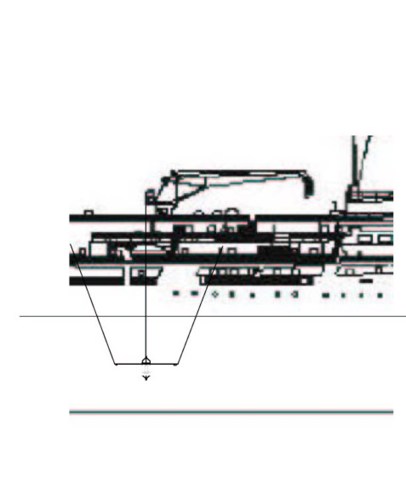a. 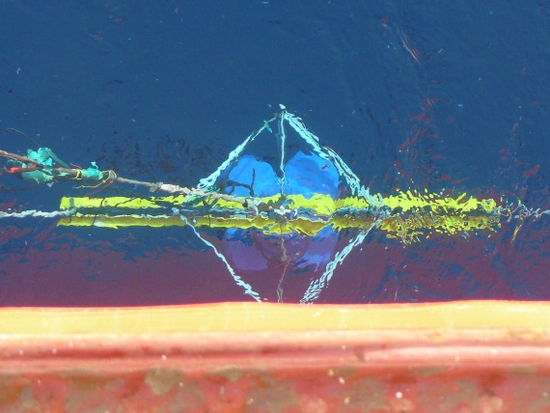 b.

Figure a. Drawing of general orientation of ADCP frame while deployed; b. Aerial view of ADCP sitting in the water alongside the hull.

#### ADCP Problems and Solutions

No real data quality assessment was made at sea. The checks for data quality were very basic. For the ADCP, during acquisition, it was ensured that the ADCP went through its startup and was receiving GPS and Gyro. Once acquiring data, a quick check was made that the good returns seemed consistent and that all beams were showing a return. A brief assessment of at what range the strongest returns were was compared with the 50 and 200 kHz sonar and the chlorophyll maximum and transmissivity minimums in the CTD profile.

For the sonar, checks were even more basic. The start was monitored to see that acquisition started and that GPS was incoming. A brief visual check was made on the depth of maximum scattering and whether the plots “looked like a sonar signal”.

The ADCP would typically be in the path of any propeller wash resulting from ship’s repositioning during station. During events where the starboard screw was going astern, the ADCP frame would be moved forward and the angle of the downward looking beams would be skewed beyond the 15 degree limit of the 3 axis tilt sensor. These events do not included valid data and can be identified by large tilt angles and high currents.

The freezing seawater temperatures (sea-ice actively freezing) incased the ADCP in ice (Figure 27). After CTD cast 68 the Ready Heater was aimed at the transducer heads and after approximately 6 hours had melted ice off the faces (Figure 28a). Temperatures were checked regularly (hand warm) to confirm the bottom of the transducers were not ‘cooked’ in the process. However, after only 4 casts the transducer faces had grown a new layer of ice (Figure 28b).

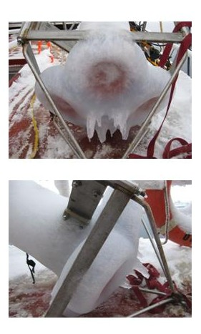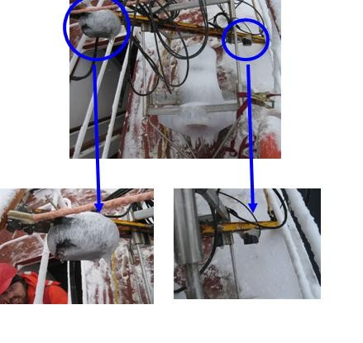

Figure . ADCP encased in ice.

Blue circles: Detail of the two backscatter transducers (50 and 200 kHz).

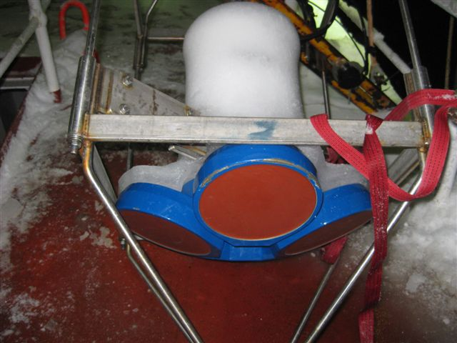 **a**. 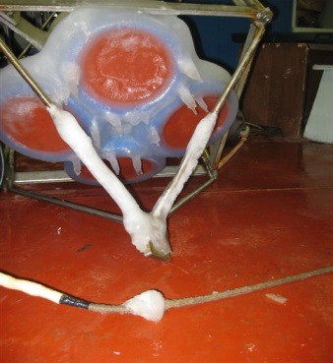 **b.**

Figure a. ADCP After melting ice with Ready Heater for ~6 hours; b. Four casts later.

When air temperatures are below -10°C, the water dripping off the lines, frame and ADCP tend to form an ice sheath around all transducers, and in the future this should be taken into account as to the efficacy of the operation.

### Underway sampling

*Jane Eert*

*PIs: Svein Vagle (DFO-IOS), Celine Gueguen (Trent University), Patricia Ramlal (DFO)*

#### 2010-06 C3O

##### Seawater Loop

The ship’s seawater loop system draws seawater from below the ship’s hull at 9m, to the main lab (“aft lab”). This system allows measurements to be made of the sea surface water without having to stop the ship for sampling. The water is as uncontaminated as possible coming directly from outside of the hull through stainless steel piping without recirculation in a sea-chest. The manifold has been insulated this year to minimize condensation. The rate is controlled for systematic measurements, and allows for continuous autonomous sampling. Measurements were taken by installing sensors in-line, and by diverting water through a manifold to run through various sensors.

Autonomous measurements made:

* SBE38: Temperature.

Sensor was installed in-line, approximately 4m from pump at intake. This is the closest measurement to actual sea-temperature.

* SBE21 Seacat Thermosalinograph: Temperature and Conductivity, Fluorescence

5 second sample rate, run off the manifold in the main lab

(Svein Vagle, DFO)

* Blue Cooler: Total gas (Gas Tension Device), Oxygen.

5-40s second sample rates, run off the manifold in the main lab.

(Svein Vagle, DFO)

* Black box: Partial pressure of CO2 in seawater; run off a beaker filled from the mainfold in the main lab (Patricia Ramlal, DFO)

Independent of the seawater loop:

* SBE48: Hull Temperature

This measurement is an approximation of seawater temperature, and is taken using a temperature sensor mounted on the ship’s hull, inside, aft of the pump approximately 15m, starboard side.

Discreet Water Samples drawn for analyses on other instruments

* Salinity, Chlorophyll

Some of the instruments were self-contained; others were connected to a single data storage computer. The data storage computer provided a means to pass ship’s GPS for integration into sensor files, to pass the SBE38 data from the engine room to the TSG instrument, and to pass the TSG and SBE48 data to the ship’s data collection system (SCS).

##### SCS Data Collection System

The ship uses the Shipboard Computer System (SCS) written by the National Oceanographic and Atmospheric Administration (NOAA), to collect and archive underway measurements. This system takes data arriving via the ship’s network (LAN) in variable formats and time intervals and stores it in a uniform ASCII format that includes a time stamp. Data saved in this format can be easily accessed by other programs or displayed using the SCS software.

Data collected by SCS:

* Location from the ship’s GPS (GPGGA and GPRMC sentences)
* Heading from the ship’s gyro (HEHDT sentences)
* Depth sounding from the ship’s Knudsen sounder (SDDBT sentences)
* Air temperature, apparent wind speed, apparent and relative wind direction, barometric pressure, relative humidity, and apparent wind gusts from the ship’s AVOS weather data system (AVRTE sentences). SCS derives true wind speed.
* Sea surface temperature, conductivity, salinity, and fluorescence from the ship’s SBE 21 and SBE38 thermosalinograph
* Sea surface temperature from the SBE48 hull mounted temperature sensor
* Speed over ground and course over ground

The RAW files contain a day’s worth of data, restarting around midnight. The ACO and LAB files grew until they were moved out of the datalog/compress directory for archiving.

#### 2010-07 JOIS

Underway sampling during 2010-07 included:

1. From the seawater loop system: salinity, temperature (inlet and lab), fluorescence, CDOM, gas tension, oxygen saturation, methane and *p*CO2.
2. SCS system was used to log
   1. From the Novatel GPS: all NMEA strings (GPRMC, GPGGA, HEHDT, among others) as well as position, time, speed and total distance
   2. AVOS weather observations of: air temperature, humidity, wind speed, barometric pressure
   3. Sounder reported depth and applied soundspeed
3. Photosynthetically Active Radiation (PAR)

#### Seawater Loop – update s/n

The ship’s seawater loop system draws seawater from below the ship’s hull at 9m using a 3” Moyno Progressive Cavity pump (Model #2L6SSQ3SAA) to the TSG lab, a small room just off the main lab (“aft lab”; Figure 29). This system allows measurements to be made of the sea surface water without having to stop the ship for sampling. The water is as unaltered as possible coming directly from outside of the hull through stainless steel piping without recirculation in a sea-chest. The manifold in the TSG has been insulated to minimize condensation. Flow rate is controlled to the lab by a Honeywell electronic system which has a data feed from a pressure sensor in the lab, and on one arm of the manifold, by a Kates mechanical flow rate controller. This arm also has a vortex de-bubbler so that the water provided to the TSG and other instruments is as bubble free as possible.

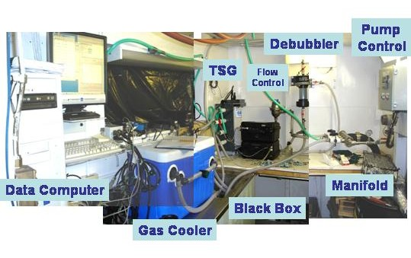

Figure . Seawater loop system providing uncontaminated seawater from 9 m depth to the science lab for underway measurements.

Autonomous measurements were made using [UPDATE]:

* SBE38: Temperature (s/n 0319). Sensor was installed in-line, approximately 4m from pump at intake. This is the closest measurement to actual sea-temperature.
* SBE21 Seacat Thermosalinograph (s/n 3297) with Temperature and Conductivity, Fluorescence (WET Labs WETStar fluorometer) and CDOM (WET Labs CDOM s/n WSCD-1281). The Fluorometer and CDOM sensors were plumbed off of a separate manifold output than that supplying the Temperature and Conductivity. GPS was provided to the SBE-21 data stream using the NMEA from PC option rather than the interface box. A 5 second sample rate was recorded.
* Blue Cooler: Total gas (Gas Tension Device)- 40 s sampling interval, Oxygen- 5 second sample rate, fed by water that has gone through the de-bubbler. (Svein Vagle, DFO)

Part of the system, but not attached to the seawater loop:

* SBE48: Temperature was also measured through the hull using a temperature sensor mounted on the ship’s hull, inside, aft of the pump approximately 15m, starboard side. Sampling rate is once per minute

Discreet Water Samples taken:

* Salinity, Chlorophyll-a, Dissolved Oxygen (analyzed on board), and CDOM (samples sent back to Celine Gueguen at Trent University)

Some of the instruments were self-contained; others were connected to a single data storage computer. The data storage computer provided a means to pass ship’s GPS for integration into sensor files, to pass the SBE38 data from the engine room to the TSG instrument, and to pass the TSG and SBE48 data to the ship’s data collection system (SCS).

Underway measurements of sea surface temperature and salinity are shown in Figure 30 and Figure 31.

##### 2010-07 TSG temp

Figure . Underway sea surface temperature during cruise 2010-07.

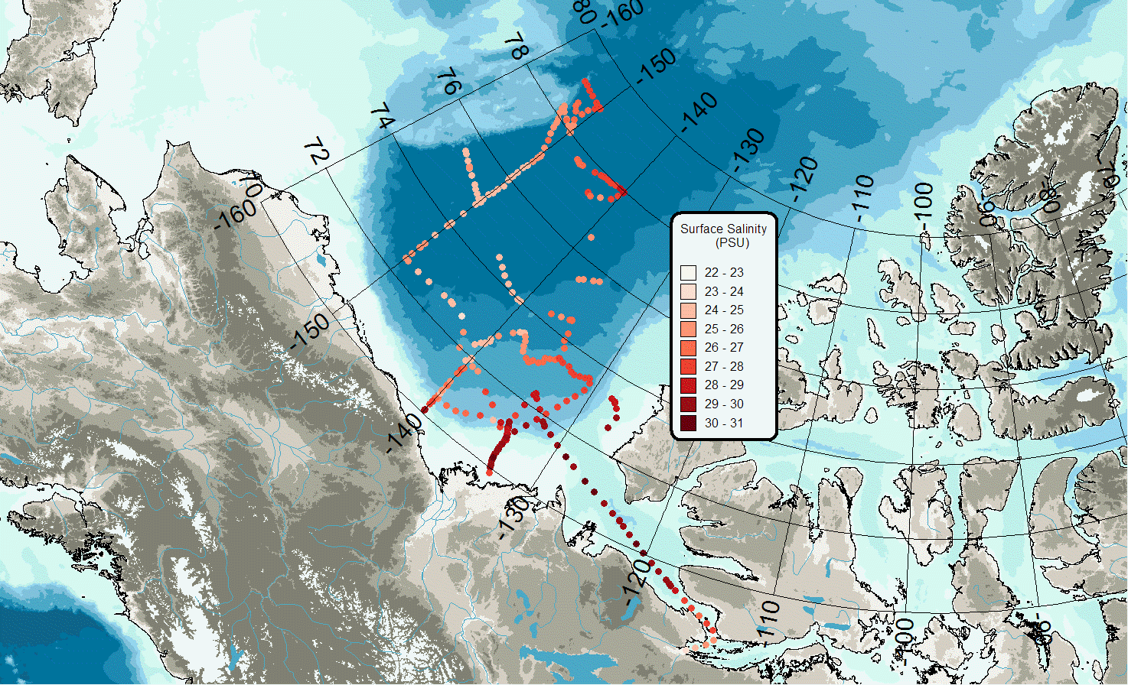

Figure Underway sea surface salinity during cruise 2010-07.

##### Seawater Loop Problems

We experienced few problems this year with the system losing data. Major gaps in the TSG records are due to the system being turned off in ice. There was one gap of about 6 hours when the system was accidentally shut down by other users of the NOAA computer. Some of data gaps can be filled by post processing from independent records.

#### SCS Data Collection System

The ship uses the Shipboard Computer System (SCS) written by the National Oceanographic and Atmospheric Administration (NOAA), to collect and archive underway measurements. This system takes data arriving via the ship’s network (LAN) in variable formats and time intervals and stores it in a uniform ASCII format that includes a time stamp. Data saved in this format can be easily accessed by other programs or displayed using the SCS software.

The SCS system on a shipboard computer called the “NOAA server” collects:

* Location, speed over ground and course over ground as well as information about the quality of GPS fixes from the ship’s GPS (GPGGA and GPRMC sentences)
* Heading from the ship’s gyro (HEHDT sentences)
* Depth sounding from the ship’s Knudsen sounder (SDDBT sentences; see note below)
* Air temperature, apparent wind speed, apparent and relative wind direction, barometric pressure, relative humidity, and apparent wind gusts from the ship’s AVOS weather data system (AVRTE sentences). SCS derives true wind speed and direction (see note on true wind speed below).
* Sea surface temperature, conductivity, salinity, CDOM and fluorescence from the ship’s SBE 21 thermosalinograph and ancillary instruments
* Sea surface temperature from the SBE48 hull mounted temperature sensor.

The RAW files were set to contain a day’s worth of data, restarting around midnight. The ACO and LAB files grew until they were moved out of the datalog/compress directory for archiving.

The sounder depth is recorded but not the sound speed used to calculate the depth. An external log of sound speed was kept and is included in Table 12.

Table 12. Log of Knudsen sound speed used to calculate depth.

|  |  |  |
| --- | --- | --- |
| **Date** | **Time (UTC)** | **Sound Speed (m/s)** |
| start |  | 1500 |
| 17/09/2010 | 1:28:45 | 1448 |
| 21/09/2010 | 7:01 | 1455 |
| 21/09/2010 | 9:20 | 1465 |
| 22/09/2010 | 7:27 | 1470 |
| 27/09/2010 | 14:36:00 | 1473 |
| 12/10/2010 | 10:14:30 | 1470 |
| 13/10/2010 | 14:08 | 1455 |
| 13/10/2010 | 14:41:30 | 1445 |

Note: The Knudsen Sound speed is the assumed average sound speed from surface to sea floor. We change it during the cruise so that the sounder reports reasonably accurate depths which can be used to predict the bottom of a rosette cast.

##### SCS Data Collection System Problems and Solutions

The SCS system derives true wind speed based on the AVRTE apparent wind speed and direction and the GPRMC speed over ground and course over ground. Since this system was set up in 2006, true wind speed has been derived from apparent wind speed and direction along with the ship’s COG and SOG. It turns out that this is incorrect, and the direction that should be used in this calculation is the relative wind direction. The error was noticed and corrected on October 1 at 1330 UTC. All true wind data before this should be recalculated. ***Editorial comment: I think that SCS should be calculating true wind speed from apparent wind direction and not relative wind direction. Or if it wants to use the relative wind direction, it should take into account the ships heading. As it is now, the calculation assumes that the ship is moving (COG) in the same direction the bow is heading. In practical terms, it unlikely that large errors are introduced by making this assumption since the times when one usually has a large mismatch between ships head and COG are when the ship is moving slowly.

The timestamps generated by SCS are based on the time settings in Windows. This year (unlike some previous years) the NOAA server stayed in UTC. However, this computer’s clock does not keep very accurate time; if you need to synchronize data across the files, use the timestamp, but if you are trying to synchronize with outside data that is properly keeping UTC, then use the time of day found in the GPGGA sentence. At worst on this cruise, the NOAA server clock was ahead by 8 minutes; this was corrected on October 12, 2010.

#### Photosynthetically Active Radiation (PAR) – NEED SENSOR #

The continuous logging Biospherical Scalar PAR Reference Sensor, QSR2100, (sn10350, calibration date 2/27/2007), was mounted above the helicopter hanger, with an unobstructed view over approximately 300 degrees. The blocked area is due to the ship’s crane and smoke stack which are approximately 50 feet forward of the sensor. Data was sampled at 1/5 second intervals but averaged and recorded at 1 minute intervals. However, the PAR sensor was seldom wiped clean and it was dark and covered with snow a lot of the time.

### XCTD

*Kohei Mizobata (TUMSAT)*

*PIs: Koji Shimada (TUMSAT), Motoyo Itoh (JAMSTEC), Andrey Proshutinsky (WHOI)*

XCTD (Expendable Conductivity, Temperature and Depth profiler, Tsurumi-Seiki Co., Ltd.) probes provided by JAMSTEC, WHOI and TUMSAT were deployed from the ship’s stern with temperature, salinity and depth data acquired by computer located in the stern (AVGAS) hold. The data converter, MK-130 and Mk150 (Tsurumi-Seiki Co., Ltd.) was used for XCTD deployment and for data conversion from raw binary to ASCII data (original and 1 m interval). Salinity, density and sound speed were automatically calculated after XCTD probe deployment. To make it comparable to CTD data, temperature data was converted using a following equation:

t=temp*1.00024 : [ITS68-->ITS90]

Types of XCTD probe were XCTD-2 and XCTD-3 which can be deployed when ship steams at up to 15 knots. The probes fell freely in the water measuring temperature and conductivity every 0.15 m from the surface down to 1100 m. The casts took approximately 5 minutes or 10 minutes for the released probe to reach its final depth of 1100m or 2000m. In open water, XCTD-3 were deployed, which can be deployed when ship steams at 15 Knot but in heavy ice the ship had to stop for deployment because the probe’s wire can easily break due to ice.

XCTD deployments were spaced every 20-30 nm on the ship track typically between CTD casts to increase the spatial resolution and to make all cross-section data comparable deploying a certain isobaths. Typically one probe was deployed between CTD casts.

Table 13. The range and accuracy of parameters measured by the XCTD according to the manufacturer’s nominal specifications.

|  |  |  |
| --- | --- | --- |
| **Parameter** | **Range** | **Accuracy** |
| Conductivity | 0 ~ 60 [mS/cm] | +/- 0.03 [mS/cm] |
| Temperature | -2 ~ 35 [deg C] | +/- 0.02 [deg C] |
| Depth | 0 ~ 1000 [m] | 5 [m] or 2 [%] (either of them is major) |

During this cruise, 58 XCTDs were successfully launched, and 2 failed (Figure 32). One of the working XCTDs had shortened profiles (700m) presumably due to broken wires which was resulted from heavy sea ice. Two XCTD-2 probes, which reached 2000m, were deployed for seeking eddy structure along the 150° W line, while three XCTD-2 probes were deployed at the Northwind Ridge area. Locations are listed in **Appendix 3.4**.

For more information and data see the JAMSTEC website: <http://www.jamstec.go.jp/e/>.

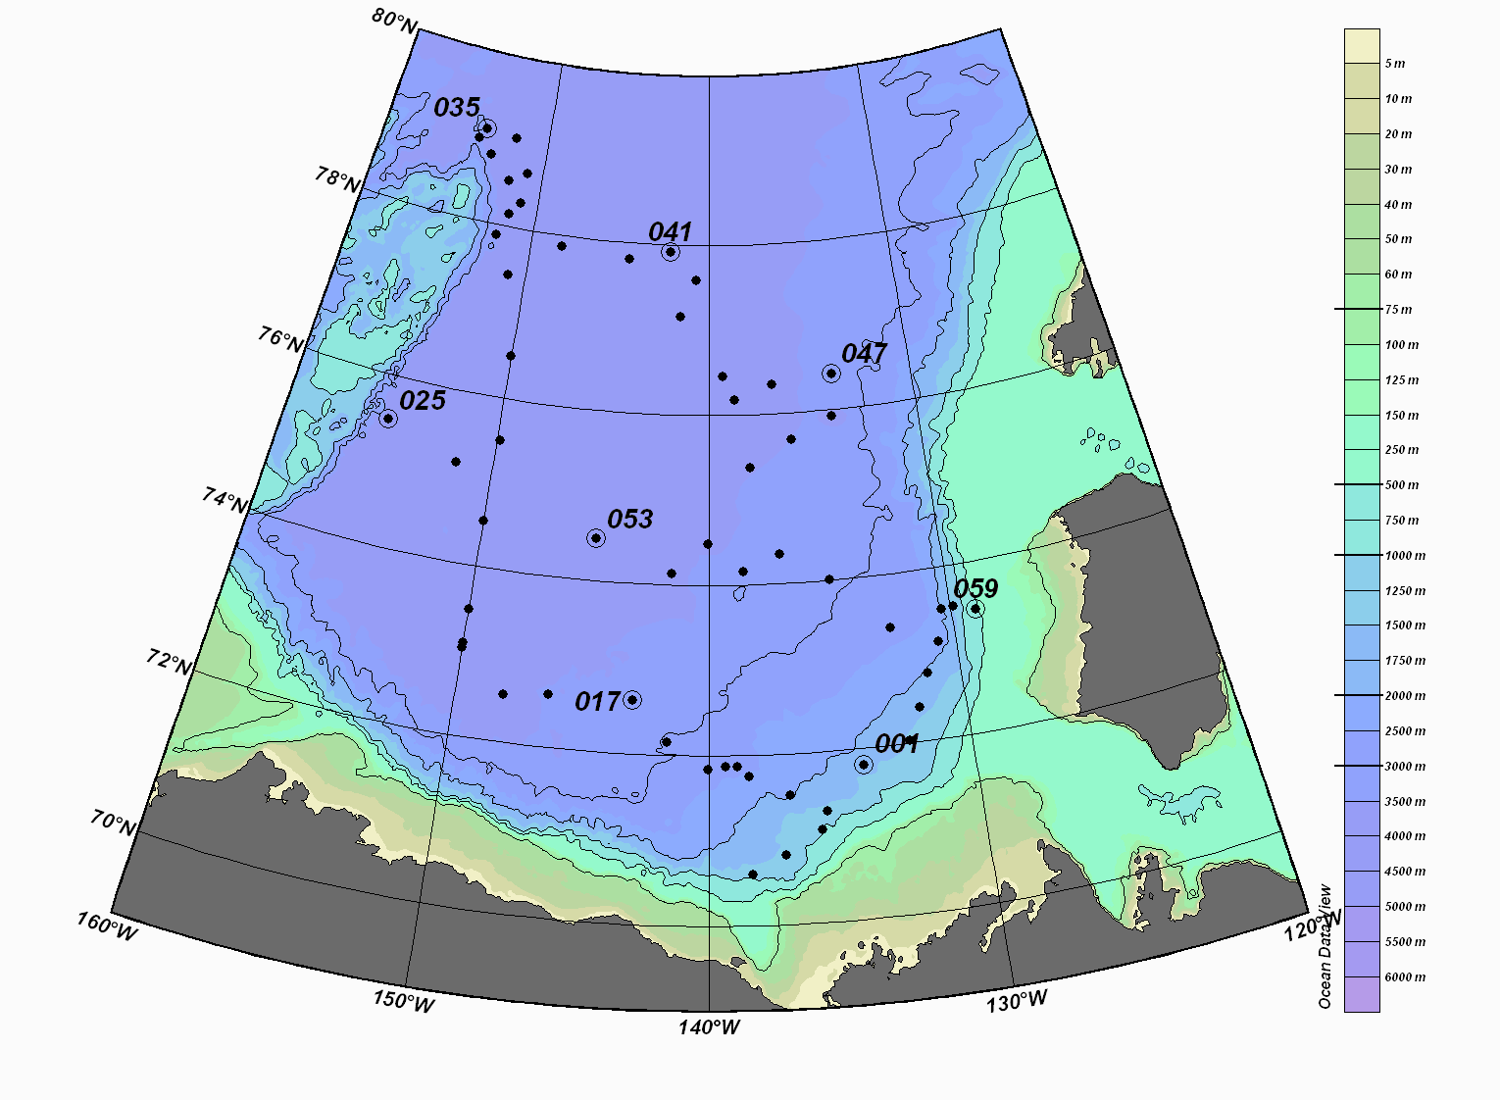

Figure 32. XCTD stations of the JOIS2010-07 cruise.

### Vertical Net Tows

#### 2010-06 C3O

*Corinne Pomerleau (University of Laval), PI: John Nelson (DFO-IOS)*

A total of 16 Bongo net hauls were completed during the 2010-06 Arctic cruise onboard the Louis S. St-Laurent. Zooplankton samples were collected at every station between St-John’s to Resolute Bay and at as many stations as possible between Resolute Bay and Kugluktuk. The Bongo used comprised 4 nets, two 50cm hoops and two 15cm hoops. The large hoops were harnessed with a 236 µm and a 150 µm mesh, while the two smaller hoops were harnessed with 53 µm mesh. Each net had its own flowmeter. The 236 µm was equipped with a TSK mechanical flowmeter while the 150 µm and both 53 µm nets were harnessed with MF-315 flowmeters. One of the 53 µm net was not collecting equal material from the water column compared to the other 53 µm. Zooplankton samples were collected with a vertically towed Bongo net from 100 m (or from 10 m off the seafloor if sampling was done in shallower area) to the surface hauling at 0.8 to 1.0 meter per second. The net was operated using the starboard A-frame near the bow of the ship. Once on deck the nets were washed down using a fire hose connected to the on deck sea-water line.

We did one vertical haul per station. The 236 µm and one 53 µm were preserved into buffered 10% formalin. The 150 µm and the other 53 µm were preserved in 95% Ethanol. Zooplankton preservation in formalin allows for taxonomic analysis study (biomass, population study etc.) while preservation in ethanol is for genetic analysis.

List of the stations where zooplankton samples were collected:

LS10-2, LS10-3, DS10-01, BB10-01, BB10-02, PS-3, PS10-04, 8-BEL-8, 6-BEL-6, FS10-01, VS10-02, QM10-01, CG10-01, 30-CG, CG10-0, 24-CG

#### 2010-07 JOIS

*Kelly Young (DFO-IOS), PI: John Nelson (DFO-IOS)*

Zooplankton sampling was conducted on board by Kelly Young with help from the CTD watch (Chelsea Stanley, Zoe Sandwith and Kenny Scozzafava) using a modified Bongo net system consisting of four nets. One bongo frame (56 cm diameter) was fitted with a 236 µm and a 150 µm mesh nets. A second, smaller frame (20 cm diameter) was fitted with two 50 µm mesh nets and was attached perpendicular to the first bongo frame. Each net contained a unidirectional flowmeter (either a TSK or Seagear MF-315 flowmeter) to measure the amount of water flowing through the nets. The vertical net tows were 100 m deep, with two tows per station except where weather and time restraints limited the deployment to one 100 m tow (CB-2, CB-2a, CB-10, CB-65, MK-3a). In addition to the routine tows, additional tows to depths of 500 and 1000m were conducted at select stations (Appendix 3.6). A total of 100 bongo net hauls were completed at 47 stations.

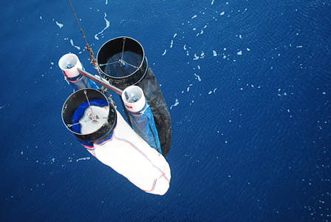

Figure . Modified bongo frame used during JOIS.

Samples from the first tow were preserved in 10% buffered formalin, individually from the 150 and 236 µm mesh nets, and combined into one sample from the 53 µm nets. From the second tow, the 236 µm net sample and the combined 53 µm net sample were preserved in 95% ethanol, and the 150 µm net sample was frozen in a whirl-pak at -80°C. For the deep casts (500 and 1000m), the 236 µm net sample and the combined 53 µm net sample were preserved in 10% buffered formalin, and the 150 µm net sample was preserved in 95% ethanol. The formalin samples will be examined for species identification and the ethanol samples for DNA sequence analysis. The frozen sample can be used to provide a measurement of biomass, as well as provide samples for possible future analyses such as stable isotopes or fatty acids.

Locations of zooplankton casts can be found in Appendix 3.6.

#### New Additions

##### RBR pressure/temperature sensor

An RBR pressure/temperature sensor was provided by Svein Vagle to attach to the bongo frame which provided an accurate depth measurement for the net tows. This was important considering both the flowmeters and winch meter were often frozen (see Challenges, next section), making it impossible to get an accurate depth of tow or volume estimate. However, it was found that ice build-up on the pressure sensor would also cause the RBR sensor to fail. This was solved by immediately removing the sensor between casts to a warm place, either in the lab between stations or inside a jacket between casts.

##### Limacina Experiment

An additional 100m tow was done at PP7 using a closed cod end to collect Limacina for an ocean acidification experiment. Please see Section 2.5.5 for more information.

#### Problems and Solutions

Similar problems occurred with the MF-315 flowmeters as in previous years. They froze up quickly, sometimes in between duplicate tows. To prevent the flowmeters from freezing between stations, they were removed immediately following the cast and brought inside the lab to defrost, and replaced immediately before the next cast. Occasional freezing up still occurred, especially for the multi-tow casts (deep tows) or on very chilly, windy days. The gears would also jam occasionally, and adjacent numbers would roll over out of sequence. Since similar problems were encountered last year, a TSK flowmeter was also used on one side of the large bongo frame. The TSK worked well in the cold for the first half of the cruise; however, once temperatures dipped below -10C the gears would seize up and the TSK was removed from the nets to prevent damage. Two TSK’s were used at the start of the cruise, but TSK 5294 gears were constantly jamming and was replaced with a MF-315.

Two stations were not completed due to a frozen winch caused by a disconnected winch heater. This was eventually repaired. To avoid the winch from freezing up for a station, the winch and heater were turned on at least half an hour before the cast.

The winch counter flywheel was also frozen for most casts, making the wire-out meter readings unreliable. This seems to be caused by an excess of ice forming on the winch from the wet wire and freezing up the block. An ice chummy for the forward winch cable may help prevent the meter block from freezing up.

The forward A-frame power switch started freezing up during the cold stations (-18°C), causing delays while the electrician was called to repair the switch. This was avoided by powering up the A-frame from the below-deck control panel.

The fire hose froze at the start of the cruise, and was no longer available to use. A cheap plastic garden hose was provided, which cracked in the cold weather and was unusable. Good quality hoses should be purchased and brought by IOS, preferably thick rubber hoses that resist icing or cracking in cold conditions.

Currently samples have to be transported from the foredeck, to the main lab for sieving, then upstairs to the fumehood in the container lab beside the CTD operations, and back down to the main lab. It would be helpful if a container would be available on the foredeck for wet work (either a sink or just a drain) that has adequate ventilation so all the sample processing (including preservation with formalin and ethanol) could take place on the foredeck.

Spare cod ends for the 53um nets are needed (there are currently only 2).

The bongo box is awkward to slide over the staples on the foredeck, and several times the staples slipped up between the bottom of the net box and the side. What may work better is a box with a sturdier frame with legs at the corners which raise the box up above the level of the foredeck staples. The frame for the bongos which sits inside the box needs reinforcing or replacement.

It would have been great to have a microscope on board - perhaps a dissecting scope with a camera attachment in order to be able to show samples to media and other JOIS science participants.

### Limacina helicina experiment

*Michiyo Kawai (IOS), John Nelson (IOS)*

In order to study the influence of ocean acidification and melting of sea ice on shells of Pteropod, *Limacina helicina*, an experiment was performed during the 2010-07 JOIS cruise. *L. helicina* were collected and kept in 5 different seawaters with different aragonite-saturation states.

#### Sampling

Seawater for the experiment were collected from 450, 150, 50 and 5 m depths from the CTD/R system with 10L-Niskin bottles at station PP-7 (cast 56). Seawater was transferred from each Niskin bottle into a carboy, which were sub-sampled for salinity and nutrient analysis. The carboys were stored in the walk-in cooler (4°C).

Zooplankton samples were collected from 100m vertical net tow at PP-7 on 7 October 2010 (19:00-19:30 LTC). Nets were not washed with water when came up board the ship. Closed cod ends were used, and once on board with collected plankton and seawater they were immediately put in a bucket filled with cold seawater (~0°C) and brought the lab.

In the lab, all samples collected by the four nets were combined and filtered through a stacked sieve with largest mesh (236 µm) to remove large plankton and then collected on a 53 µm mesh. Sample collected on the 53 µm mesh were transferred into a glass jar filled with cold seawater (from ~50 m deep, seawater collected after filtered for chlorophyll a) and stored in the walk-in cooler (4°C) until 01:45am 08 October.

#### Experiment

Seawater from a carboy was mixed and transferred into one 250 mL glass bottle (for DIC/TA analysis) and two 1 L brown glass bottles (for the experiment) following the sampling instruction for DIC. The leftover seawater from 5 m deep (~3.8L) was mixed with ~800 mL of DMQ to make low-salinity, low-alkalinity seawater. This water (5m+DMQ) was also transferred into a 250 mL DIC/TA bottle and two 1 L experiment bottles.

From the plankton sample kept in the glass jar, *Limacina helicina* was picked up using a Pastur pipet and dropped into one of the experiment bottles. Approximately 5-10 individuals of *L. helicina* were put in each experiment bottle. These transfers were done in a walk-in cooler . Sampling was started at 01:00 and everything was done by 02:30 on 8 October.

Experiment bottles were kept in a box filled with iced seawater placed in the 4°C walk-in cooler until 17:45 on 13 October. Temperature was monitored using an EasyLog USB kept in the same box (USB-sensor was kept in a plastic bag , put in a glass bottle, and put in the box). Experiment bottles were slowly mixed and opened to make sure there was no plankton left on the surface of the cap once a day.

After six days, DIC/TA and nutrient samples were taken from each experiment bottle (17:45-19:00, 13 October). Then, the *L. helicina* were filtered out of the experiment bottles onto 53 µm mesh and stored in ethanol in 50 mL glass bottles. Shells of *L. helicina* will be checked using SEM after the cruise to determine if they had any damage by aragonite-undersaturated waters.

### Moorings and Buoys –IN PROGRESS – just editing

*Rick Krishfield, Kris Newhall, Jim Dunn, (WHOI)*

*PI’s not in attendance: Andrey Proshutinsky, John Toole (both WHOI), and Mary-Louise Timmermanns (Yale University)*

From Cruise Plan:

Mooring and buoy operations overview:

Recover and deploy 3 moorings (WHOI)

Deploy 4 ITP ice-buoys (WHOI)

Deploy 2 O-buoys (CRREL)

Deploy 2 UpTempO open water buoys (APL)

Recover as possible 2 ITP ice-buoys: ITP#35, ITP#22 (WHOI)

Recover as possible 1 O-buoy (alongside ITP#35)

As part of the Beaufort Gyre Observing System (BGOS; http://www.whoi.edu/ beaufortgyre), three bottom-tethered moorings deployed in 2009 were recovered, data was retrieved from the instruments, refurbished, and redeployed at the same locations in September-October 2010 from the CCGS Louis S. St. Laurent during the JOIS 2010 Expedition. In addition, four Ice-Tethered Profiler (ITP; http://www.whoi.edu/itp) buoys were deployed, one in combination with an Arctic Ocean Flux Buoy (AOFB) and Ice Mass Balance (IMBB), and one with an AOFB, IMBB, and an atmospheric chemistry O-Buoy. One ITP was also recovered. The CABOS mooring was not recovered this year, it was left in the water until next year.

See **Appendix 2.5** for details on mooring and buoy deployment locations.

Dispatches documenting all aspects of the expedition were posted in near real time on the WHOI website at: www.whoi.edu/beaufortgyre/2010-dispatches.

#### Moorings

The centerpiece of the BGOS program are the bottom-tethered moorings which have been maintained at 3 or 4 locations since 2003. The moorings are designed to acquire long term time series of the physical properties of the ocean for the freshwater and other studies described on the Beaufort Gyre webpage (www.whoi.edu/beaufortgyre). In previous years, the top floats were positioned approximately 45 m below the surface to avoid ice ridges, but this year the floats were brought up to 35 m due to thinner ice conditions and to increase the scope of the underwater instruments.

The instrumentation on the moorings include an Upward Looking Sonar mounted in the top flotation sphere for measuring the draft (or thickness) of the sea ice above the moorings; a vertical profiling CTD and velocity instrument which samples the water column from 50 to 2050 m twice every two days; sediment traps for collecting vertical fluxes of particles (on two moorings); and a Bottom Pressure Recorder mounted on the anchor of the mooring which determines variations in height of the sea surface with a resolution better than 1 mm. One mooring (D) also includes a number of discrete temperature and salinity devices clamped to one deep segment of the mooring wire.

The moorings are deployed anchor first, rather than top float first (as is typical in lower latitudes), because of the presence of the ice pack. This requires the use of a dual capstan winch system to safely handle the heavy loads. Typically it takes around 5 hours to deploy the 3800 m long system.

Recovering the moorings in pack ice is extremely tricky, as the mooring needs to be released so that the top float does not surface under an ice floe where it cannot be accessed. However, in this case, there is a backup floatation at the bottom of the mooring, which also can be used to recover the moorings.

First, the locations of the moorings have to be pinpointed by triangulating acoustically on the releases at the bottom of the mooring. Then the Captain of the icebreaker creates a pond in the ice over the mooring, and acoustic release commands are sent to the release instruments just above anchor to let go of the anchor, so that the floatation on the mooring can bring the system to the surface. Then the floatation, wire rope, and instruments are hauled back on board. Data are uploaded from the scientific instruments, and batteries, sensors, and other hardware are replaced as necessary. The systems are then subsequently redeployed for another year.

So far, seven years of data have been acquired by the mooring systems, which document the state of the ocean and ice cover in the Beaufort Gyre. The seasonal and interannual variability of the ice draft, ocean temperature, salinity and velocity, and sea surface height in the deep Canada Basin are being documented and analyzed to discern the changes in the heat and freshwater budgets. Trends in the data show an increase in freshwater in the upper ocean in the 2000s, some of which can be accounted for by the observed decrease in ice thickness, but Ekman (surface driven) forcing is also a significant contributor.

The mooring deployment and recovery operations were conducted from the foredeck using a dual capstan winch as described in WHOI Technical Report 2005-05 (Kemp et al., 2005). Before each recovery, an hour long precision acoustic survey was performed using an Edgetech 8011A release deck unit connected to the ship’s transducer and MCal software in order to fix the anchor location to within ~10 m. The mooring top transponder (located beneath the sphere at about 45 m) was also interrogated to locate the top of the mooring. In addition, at every station the sphere was located by the ship’s 400 khz fish finder. All top spheres successfully released into open water.

All of the mooring recovery and deployment operations were conducted without incident. The actual recovery operations varied from between 3.5 and 5 hours after release. The deployment operations normally entailed an hour of deck preparation once on site, followed by a 4 to 5 hour anchor first deployment. The extra instrumentation devices clamped to a deep segment of the wire on Mooring D added less than half an hour to that operation.

Complete yearlong data sets with good data were recovered from all MMPs, 2 out 3 ULSs, every BPR, and all of the temperature and salinity loggers. Unfortunately, the ULS on Mooring B had a low battery problem, so it is unclear whether any data from that instrument will be recovered, but further attempts will be made back in our laboratory.

#### Buoys

Because the moorings only extend up to about 30 m from the ice surface, we use automated ice-tethered buoys to sample the upper ocean and sea ice. On this cruise, we deployed four Ice-Tethered Profiler buoys (or ITPs), and assisted with the deployments of two Naval Postgraduate School Arctic-Ocean Flux Buoys, two US Army CRREL Ice-Mass Balance buoys, and an O-Buoy. The combination of multiple platforms at one location is called an Ice Based Observatory (IBO).

Ice-buoy operations require the location of a thick ice floe ( >2m) to set the buoy on. Either helicopters or sleds were used to move the people and gear to the ice for the buoy set-up. For the ice-tethered profiler (ITP) deployment, a hole was drilled; a gantry system was set over the hole to assist in the lowering of the underwater portion of the buoy and positioning of the surface part; and after the buoy is in place the gantry is removed. Recoveries used an ice-melter to free the ITP and the gantry system was used to raise the ITP.

The ITPs obtain profiles of seawater temperature and salinity from 7 to 760 m twice each day and broadcast that information back by satellite telephone. The flux buoys measure the fluxes of heat, salt, and momentum at the ice ocean interface, and the ice mass balance buoys measure the variations in ice and snow thickness, and obtain surface meteorological data. Most of these data are made available in near-real time on the different project websites (see Table 4 in Appendix 1).

The acquired CTD profile data from ITPs document interesting spatial variations in the major water masses of the Canada Basin, show the double-diffusive thermohaline staircase that lies above the warm, salty Atlantic Layer, measure seasonal surface mixed-layer deepening, and document several mesoscale eddies. The IBOs that we have deployed on this cruise are part of an international collaboration to distribute a wide array of systems across the Arctic as part of an Arctic Observing Network to provide valuable real-time data for operational needs, to support studies of ocean processes, and to initialize and validate numerical models.

The ITP deployment operations were conducted with the aid of helicopter transport to and from each site according to procedures described in a WHOI Technical Report 2007-05 (Newhall et al., 2007). ITPs 41, 42, 43 (with dissolved oxygen sensor), and 44 (with prototype MAVS current sensor) were deployed on 2.5, 2.4, 2.5, and 1.6 m thick ice floes, respectively. Not including the time to reconnaissance, drill and select the ice floes, the deployment operations took between 3 and 8 hours each (depending on the number of systems installed in each IBO) including transportation of gear and personnel each way to the site. Ice analyses were also performed by others in the science party (see Section 2.5.7), while the ITP deployment operations took place.

Since deployment, all of the ITPs have begun profiling and transmitting data. However, ITP 41 seems to be returning corrupted data, which we will attempt to resurrect back in our laboratory. In addition, after the first down profile, ITP 44 appears to have a problem communicating with the surface package. A similar problem occurred with ITP 35 (deployed in 2009), which was recovered this cruise using helicopter support, and provided information on 1357 more profiles that were taken while the profiler was unable to communicate with the surface package. This unit will be examined back in our laboratory to determine the cause of the failure.

[INSERT FIG]

Figure 34. DO WE HAVE? BGOS Ice based observatory #1.

[INSERT FIG]

Figure 35. DO WE HAVE? BGOS Ice based observatory #2.

#### [Additional program?]

#### UpTempo Program – TO BE DONE – WERE ANY DEPLOYED?

*PI: Mike Steele (UW)*

**[NOTE: according to cruise plan, 2 were to be deployed. However, there is no mention of them in the BGOS cruise report, or the JOIS cruise report. Not sure what to report?]**

Two buoys were deployed by the WHOI team during JOIS as part of the UpTempo Program (<http://psc.apl.washington.edu/UpTempO/UpTempO.php>). The two buoys were configured with ARGOS antenna, SST thermistor, and sea level pressure barometer and a 50m string below of 11 thermistor/barometer pairs. They were to be deployed in warm surface water in the southern Canada Basin between the ice edge and the ice edge and the shelfbreak - likely near Station A. The buoys were to be deployed in different locations.

Two were manufactured by MetOcean (60 m long SVP buoys) and two by Marlin-Yug (80 m long UpTempo buoys). Surface Velocity Program (SVP’s) buoys are described at this link: <http://www.metocean.com/ProdCat.aspx?CatId=1&SubCatId=5&ProdId=1>

Uptempo buoy types and deployment locations are listed in Appendix 3.9 (Table 17).

#### International Arctic Buoy Program – TO BE DONE– WERE ANY DEPLOYED?

*PI: Champika Gallage, Environment Canada*

**[ANY DONE THIS YEAR?]**

[Two buoys were deployed by the WHOI team during JOIS for Champika Gallage of Environment Canada in support of the International Arctic Buoy Program. The ice mass balance buoy was part of the second ice based observatory (IBO) where several buoys were placed on the same ice floe to provide information on ocean and atmosphere processes which in turn support the wider Arctic Observing Network.

Environment Canada buoy deployment locations are listed in Appendix 3.9 (Table 18).]

#### O-buoy Program

*Carlton Rauschenberg (Bigelow Laboratory), Peter Peterson (UAF)*

*PI’s: Patricia Matrai (Bigelow Laboratory), Bill Simpson (UAF)*

The O-buoy Project ([www.o-buoy.org](http://www.o-buoy.org)) is an NSF funded research project involving the collaboration of Bigelow Laboratory, Purdue University, University of Alaska – Fairbanks, the U.S. Army Cold Regions Research and Engineering Laboratory, Environment Canada, Monterey Bay Aquarium Research Institute, SRI and CH2M HILL Polar Services. The O-buoy is an autonomous, multi-instrument, sea-ice tethered buoy with the ability to measure surface level ozone, carbon dioxide, bromine oxide, meteorological conditions, and its own location using a GPS device. The goal of the project is to deploy a large network of O-buoys across the Arctic to further our understanding of current Arctic ozone and carbon dioxide chemistry, both important greenhouse gases, and to help us predict how that chemistry might change as the Arctic environment changes.

Ozone has been observed to precipitously decrease from background levels of ~30 ppbv to near zero levels during the Arctic spring time when the sun rises. It is believed that bromine plays the major role in Arctic ozone depletion chemistry, and bromine oxide (a product of the reaction between bromine radical and ozone) provides evidence of ozone destruction. Long term ozone, bromine oxide, and meteorological measurements over the ocean will help us understand the conditions that initiate, contribute to, and terminate ozone depletion events.

Real-time data can be found at: <http://obuoy.datatransport.org/monitor>.

##### Pre-deployment Assembly and Testing

Assembly and testing of the O-Buoy occurred in the ship’s hanger. The instrument tray was pulled out of the buoy casing and the standards for the CO2 sensor were set. An inspection was also made of the instrumentation for any damage during shipping. The mast with two gas inlets, scanhead for the spectrometer, communication component and meteorological sensors were then assembled (Figure 36).

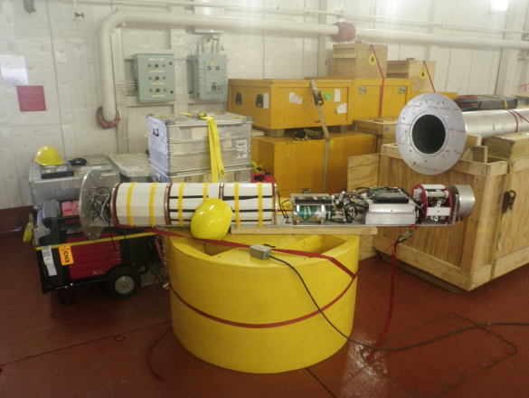

Figure 36. The instrumentation for the O-buoy.

**Starting from the left of the picture the tray holds: 3 Li battery packs for power during winter months when the solar array does not work, CO2 tanks used as standards for the CO2 sensor, the ozone detector and supervisory computer which controls buoy operations, the CO2 sensor, and finally the spectrometer for the differential optical absorption spectroscopy done by the buoy to detect BrO.**

After assembly, the buoy was hoisted up to the top of the hanger deck using the ships crane and oriented at a thirty degree angle with the deck to facilitate iridium data transmission. The buoy was switched into deployment mode while project members back on land examined the transmitted data to ensure the buoy was working properly. A problem was found with the CO2 inlet tube, so the buoy was moved back into the hanger for troubleshooting. The length of the CO2 tubing was examined and a kink was found in a section of tubing on the mast designed to dry the incoming sample. This was corrected and the CO2 readings indicated the instrument had returned to normal function. During this time a horizon alignment was performed on the scan head to verify the instrument could properly detecting the horizon for data collection. The flotation collar was attached to the buoy and the Li batteries were changed out in preparation for deployment. The buoy was hoisted back onto the top of the hanger so it could send data back to land to verify proper function of the CO2 instrument. This was the conclusion of pre-deployment testing.

The day prior to deployment the buoy was hoisted down and the mast removed in preparation for being transported via chopper to the deployment site. Temporary covers were made for all connections while transport was taking place.

##### Deployment

The site was a multi-year ice floe roughly 25 m across (76 42.950° N, 135 11.702 °W). The buoy was deployed in a thin section adjacent to a ridge to avoid having to melt a hole. The WHOI team prepped the site for deployment of the O-buoy by chain-sawing a 30 cm deep hole in the ice. This was less ice then ideal for deployment but with the loss of daylight and late start to the day, there was no time to melt an ideal hole. The buoy was then slung out to the floe via chopper and guided into position by the WHOI team (Figure 37).

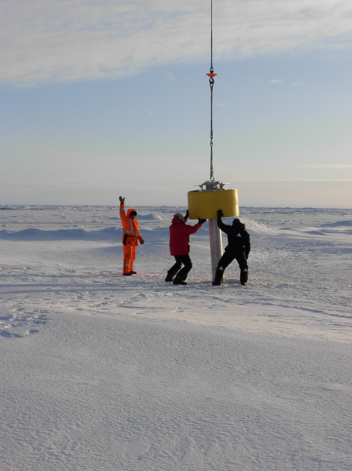

Photo by Rick Krishfield

Figure 37. Kris Newhall (R) and Jim Dunn (L) guide the O-buoy into position.

The mast was slung out to the site attached to another crate going out, minus the windbird and DOAS scanhead. The solar panels, lead acid batteries, windbird, scanhead, and charge controller were put in the back of the chopper for transport. The O-Buoy was assembled by making the mast connections, attaching the DOAS scanhead, and bolting the mast to the buoy body with the assistance of Miranda Corkum (IOS). Next, the solar panels were installed and wired to the charge controller which lit up to indicate the panels were connected properly. The rechargeable batteries were placed in the flotation collar and hooked up to the solar array.

Pictures were taken for later determination of the buoy azimuth and direction of the scan- head (Figure 38). GPS marks were also taken for this purpose, but may not work well due to the small size of the floe. Due to time constraints (visibility was dropping) there was no time to connect to the buoy via RS-232, so listening for sounds of the scanhead operating was used to verify that the buoy had in fact come on.

The buoy made its first transmission to the land lab soon after and other members of the O-buoy team looked at the data set.

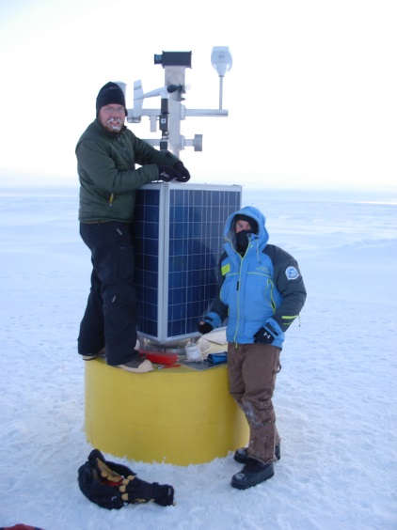 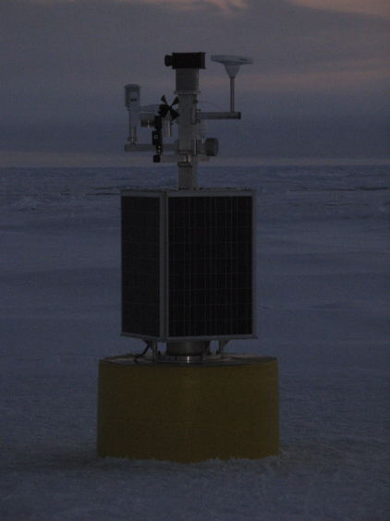 Photos by Rick Krishfield

Figure 38. Left: Peter (L) and Carlton (R) pause for a photo-op during assembly. Right: Completed O-Buoy.

### Ice Observations

#### Ice Observation Program (IARC) TO BE DONE – NO CRUISE REPORT

*Alice Orlich, University of Alaska Fairbanks, PI: Jennifer Hutchings, International Arctic Research Center*

[INSERT CRUISE REPORT]

##### Observations from the Bridge: Methodology

##### Webcam Imagery

Webcams have been positioned atop the rail of monkey island for multiple seasons. The images serve to supplement the hourly visual in-situ observations made from the bridge while traveling in ice. Frequency of image capture is altered by changing the settings manually via the software program.

##### Aerial Ice Observations

[ANY DONE THIS YEAR?]

##### On-ice measurements

Floe thickness transects and ice core samples are conducted when the IARC team is invited onto ice floes chosen for buoy deployments. The general goal is to provide characterization of the floe by completing one or more ice thickness survey drill transect lines and sampling ice with a 9 mm corer at multiple locations.

##### GPS buoy deployment

[ANY DONE? The buoys will be tracked as they continue to transmit their location on the International Arctic Buoy Program website: <http://iabp.apl.washington.edu/index.html>.]

##### Synopsis of ice types along cruise

#### Ice Observations (Japan)

*Kazu Tataeyama (KIT), Kohei Mizobata (TUMSAT)*

##### Underway measurements

Underway measurements of ice thickness were made using, an Electromagnetic induction (EM) sensor, Passive Microwave Radiometers (PMR) and a forward looking camera (Figure 39). These data will be used to help interpret satellite images of sea ice, which have the advantage of providing extensive area and thickness but lack the ground-truthing of just what the images represent. The EM sensor was deployed from the foredeck’s crane on the port side, collecting data while underway. The passive microwave sensor was mounted one deck higher also on the ship’s port side looking out over the EM’s measurement area and collected data continuously (Figure 40).

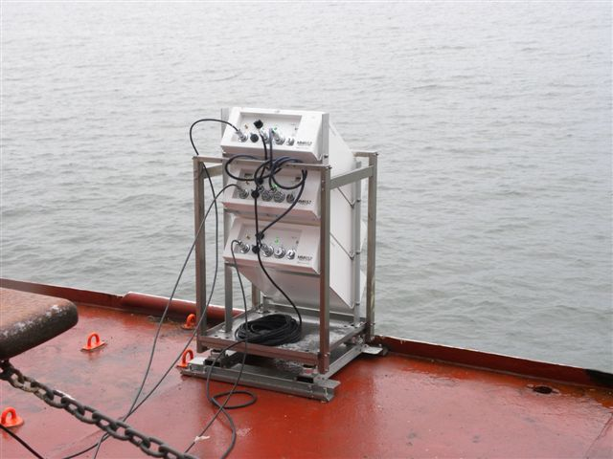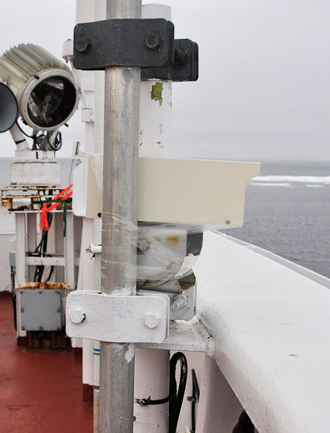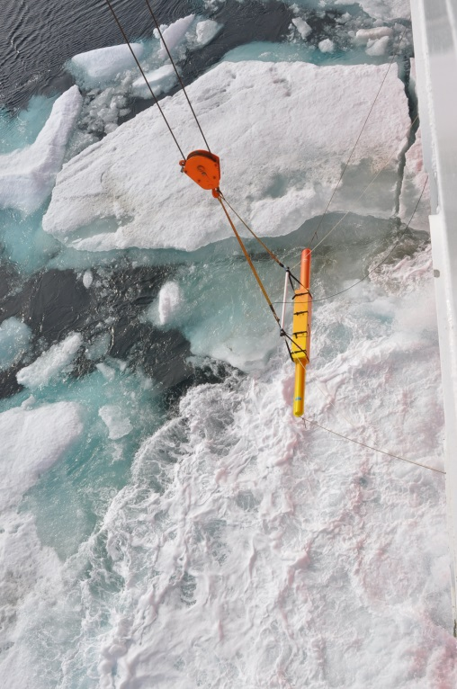

Figure . Pictures of the EM, PMR and forward looking camera.

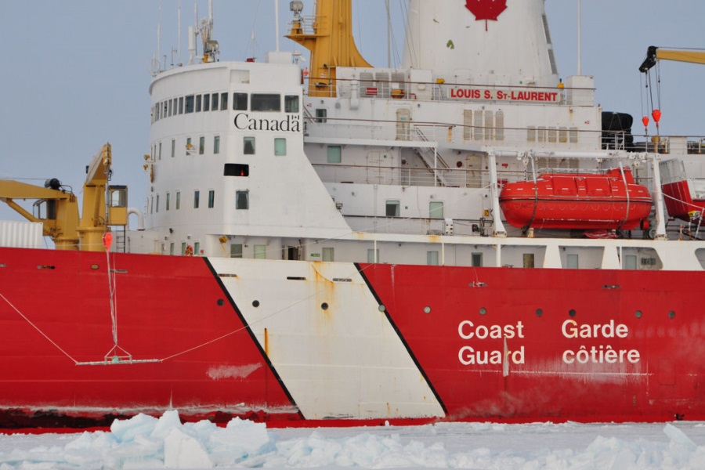

EM

PMR

Camera

Figure . Locations of the EM, PMR and forward looking camera.

##### EM ice thickness profiles and PMR observation

An Electro-Magnetic induction device EM31/ICE (EM) and laser altimeter LD90 was used for sea-ice thickness sounding. EM provides apparent conductivities in mS/m which can be converted to a distance between the instrument and sea water at sea-ice bottom (HE) by using inversion method. LD90 provides a distance between the instrument and snow/sea-ice surface (HL). The total thickness of snow and sea-ice (HT) can be derived by subtracting HL from HE. Ice concentration can be measured by EM system.

To develop new algorithm for estimation of the Arctic snow/sea-ice total thickness by using satellite-borne passive microwave radiometer (PMR), snow/sea-ice brightness temperatures and surface temperature measurements were conducted. The portable PMR, called MMRS2A (newly developed by Mitsubishi Tokki System Co. Ltd., Japan) has 5 channels which are the vertically polarized 6GHz, 18GHz and 36GHz, the horizontally polarized 6GHz and 36GHz with radiation thermometers and CCD cameras. Radiation thermometers IT550 (developed by HORIBA Corp., Japan) were also used, mounted on the port side below the bridge in 55 incident angle which is same angle as the satellite-borne passive microwave radiometer AQUA/AMSR-E. All data are collected every one second continuously except during CTD stations and maintenance.

EM ice thickness observations started on 29th September and ended on 13th October. Twelve ice thickness profiles were observed, as shown in Figure 41 and summarized in **Appendix 2.6**. The total distance of the 12 profiles was 7,919 km. The EM was calibrated twice on Oct. 1 and Oct 13 over open water and nilas, respectively (Figure 42).

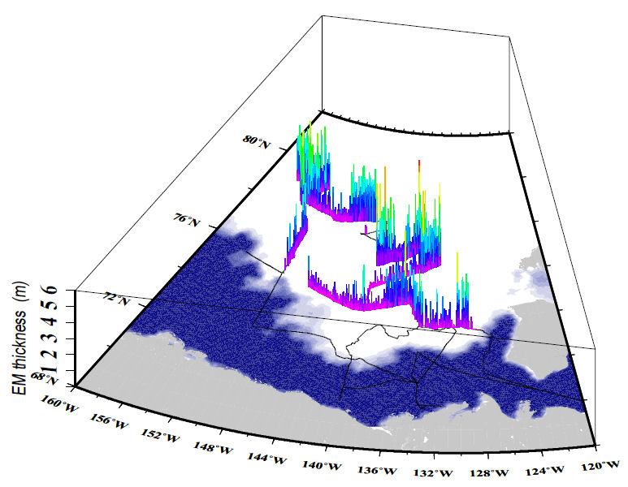

Figure . EM thickness profile during 29 Sep. – 13 Oct., 2010. Background image is sea ice concentration on 7 Oct., 2010 derived from AMSR-E.

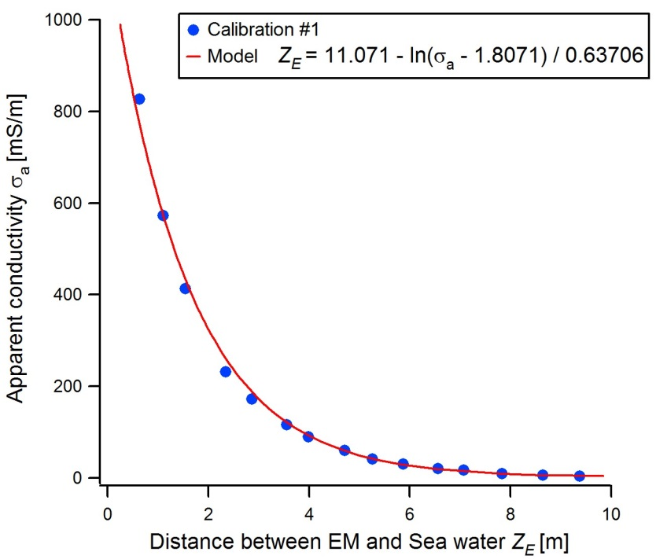

Figure . Result of EM calibration over open water.

A looking-forward digital camera on the upper bridge was set to record sea ice condition in ice covered areas. These images will be used for calculation of concentrations of open water, melt pond, and ice (Figure 43).

##### JOIS2010icecam

Figure . Results of automated ice-pond-water detection from camera images.

##### Ice Station Measurements

Snow depth, skin temperature, internal temperature, density, salinity, strategy (crystal type and size) were measured on Ice Stations 2-4. Sampling intervals were 1cm and 3cm for internal temperature and density/salinity, respectively. Snow strategy was recorded in each of the snow layers. The snow properties will be compared with PMR brightness temperatures in order to validate a general microwave radiation transfer model for satellite remote sensing. Those data will be used for the evaluation of snow and sea-ice conditions at the end of melting and the beginning of freezing periods with ice core data.

The total thickness of snow and ice distributions were investigated using representative sea-ice morphology by drilling and by using EM31SH which is shorter than the EM31/ICE. Apparent conductivities (mS/m) of the Vertical Magnetic Dipole (VMD) and Horizontal Magnetic Dipole (HMD) modes were collected every 2m in order to synchronize drill-hole (every 10m; Figure 44-Figure 46; **Appendix 2.6**).

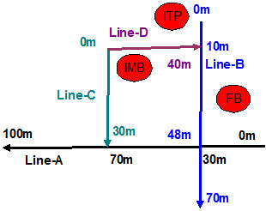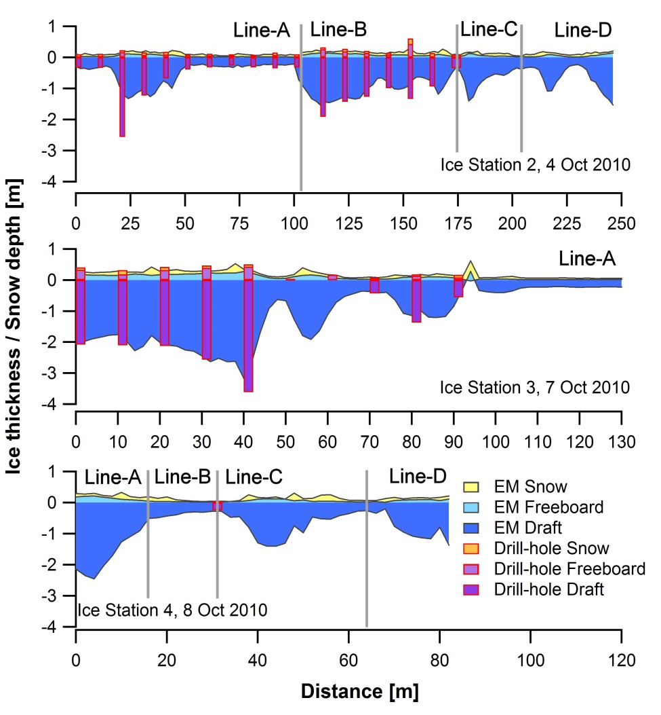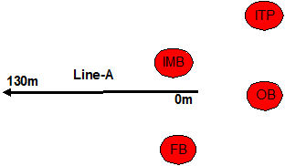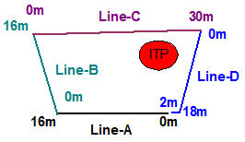

Figure . Transects of EM 31SH and drill-holes on the ice station 2-4. Maps of profiles are shown in right side.

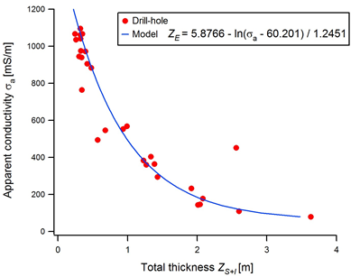

Figure . Comparison of total thicknesses between drill-hole and EM31SH.

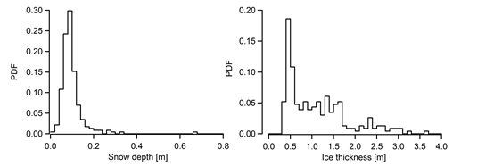

Figure . PDF of snow and ice thickness observed by EM31SH.

#### [Additional Ice obs?]

### Drift Bottles – TO BE DONE

*Sarah Zimmermann, DFO*

[Twenty drift bottles were deployed from each of 3 locations on the JOIS cruise: Station A, farthest west and east. Please see Appendix 3.13 for a log of the drop information.]

### 2010-06 C3O Seabird Survey

*Sarah Wong, Environment Canada*

#### Background

Marine birds play an important role in marine ecosystems and as indicator species, they can be used to monitor changes in the marine environment. Data on their offshore distribution and abundance is crucial for understanding their responses to oceanographic variability and to identify and minimize human impacts on birds at sea. Information on the distribution of pelagic seabirds in Eastern Canadian waters was pioneered by R. G. B. Brown through PIROP (Programme Intégré de Recherches sur les Oiseaux Pélagiques), a joint initiative between the Canadian Wildlife Service and P. Germaine at L’Université do Moncton. Most of the data was collected in the 1970’s, although the program ran from 1966-1992. Canadian Wildlife Service of Environment Canada resurrected the pelagic seabird monitoring program in eastern Canada in 2005 and developed standardized survey protocols based on those used elsewhere in the Atlantic. The goal of the program is to map the abundance and distribution of seabirds at sea. This data will help to evaluate the roles of pelagic seabirds in the ecosystem and will supply a benchmark to monitor future changes and conservation efforts. Seabirds are an important part of Canada’s Arctic ecosystem and this Artic trip was part of Environment Canada’s Pelagic Seabird Monitoring Program. This trip provided a valuable opportunity to collect baseline data, which is a small, yet fundamental part of understanding ecosystem processes that affect all Arctic marine life.

#### Methods

Observations were conducted on the port side of the bridge. This high position on the ship increases detection rates of birds, especially species that dive to escape, such as alcids. Surveys were conducted while looking forward from the moving platform and scanning at a 900 angle from the port side. Observation periods were 5 minutes in duration and the transect width was 300m. Distances to birds were recorded for use in detectability analysis (distance sampling) for calculating bird density. During the survey, priority was placed on recording birds considered “in transect”, but if time allowed, birds considered “out of transect” were also recorded (see below for explanation).

For birds observed on the sea surface, the following was recorded: species, number of individuals and perpendicular distance to the ship. All birds with a perpendicular distance of 300m or less were considered “in transect”. Those birds observed beyond 300m were still recorded but were considered “not in transect”.

Birds observed in flight present more difficulty for density estimates because the faster the birds fly relative to the ship’s speed, the greater the number of birds passing through during a 5 minute period. If all flying birds encountered are counted, their density will be overestimated. Therefore, flying birds were recorded using a series of instantaneous counts, or “snapshots”, at regular intervals throughout the observation period. The time interval between the snapshots varied with the speed of the ship and was chosen so that the ship moved about 300m between snapshots. At the time of the snapshot, all flying birds within 300m radial distance of the observer were identified and counted. These birds are considered “in transect”. All flying birds seen beyond 300m radial distance or between snapshot intervals were recorded as “not in transect”. After a flying bird is recorded, it is subsequently ignored if it is following the ship. Some birds, such as Northern fulmars, are known to circle ships in large numbers and estimates of the number of birds following the ship were made at regular intervals. These birds are considered “out of transect”.

#### Results

Surveys were conducted from July 20 to August 2, 2010 when the ship was moving and visibility was over 300m. A total of 980 five-minute observation periods were completed, which is equivalent to nearly 82 hours of survey time. Survey conditions were excellent for the most part, although there was some fog in the Labador Sea and Davis Strait that prevented surveying. A total of 2458 birds were observed “in transect” (**Appendix 8**). Dovekies were the species most commonly observed (29% of the total), followed by Northern fulmars (16%) and Thick-billed murres (14.5%). The species composition changed as we moved north and then west through the Northwest Passage. Upon departing St John’s, Newfoundland, the most common species encountered were Atlantic puffins, murres and Northern gannets. As we moved further offshore, storm petrels were most commonly seen (both Wilson’s and Leach’s) as well as Greater shearwaters. In the Labrador Sea and Davis Strait, Northern fulmars were most common, followed by Black-legged kittiwakes (Figure 46).

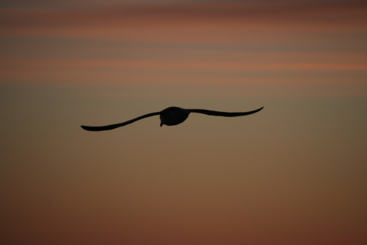 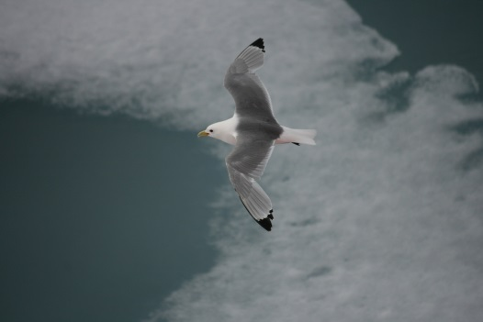

Black-legged kittiwake

Northern fulmar

Figure . Northern fulmar (left) and a Black-legged kittiwake (right).

Large numbers of Thick-billed murres and dovekies were observed in Lancaster Sound, as well as Northern fulmars and Black-legged kittiwakes. As we moved down Peel Sound, very few alcids were seen. Glaucous gulls and Thayer’s gulls (especially in the Bellot Strait) were most common in this area. Red phalaropes were observed in large groups as we approached Lancaster Sound. Very few birds were observed from Franklin Strait to Kugluktuk. Of interest, 13 ivory gulls (listed as endangered) were seen in Lancaster Sound (2 “in in transect”, 4 “not in transect” and 7 observed while the ship was stationary). All three species of jaegers (Pomarine, Parasitic and Long-tailed) were also observed.

Marine mammal sightings were also recorded. A total of 17 polar bears were observed during the trip. Ten of these bears were seen in a single day while we were in Peel Sound and in the Bellot Strait. Many ringed seals were also observed during the trip. Cetaceans observed included humpback whales (close to Newfoundland, mainly near Bacalieu Island), two sei whales, one bottlenose whale (in the Labrador Sea) and a minke whale (near Bacalieu Island). During helicopter operations, a group of about 60 narwhals were seen in Wellington Channel and 6 were seen in Bellot Strait.

# REFERENCES

Barwell-Clarke, J. and Whitney, F. 1996. Institute of Ocean Sciences Nutrient Methods and Analysis. Can. Technical Rep. Hydrogr. Ocean Sci. 182:vi + 43 p.

Dickson, A. 2001. Reference materials for oceanic measurements. Oceanography. 14(4):21-22.

Dickson, A.G., Afghan, J.D., Anderson, G.C. 2003. Reference for oceanic CO2 analysis: a method for the certification of total alkalinity. Mar. Chem. 80(2‑3):185-197.

DOE. 1994. *In*: Dickson, A.G. and Goyet, C. (Eds.). Handbook of Methods for the Analysis of the Various Parameters of the Carbon Dioxide System in Sea Water, Version 2. ORNL/CDIAC-74.

Edmonds, H.N., Smith, J.N., Kilius, L.R., Livingston, H.D. and Edmond, J.M. 1998. 129I in archived seawater samples: Source functions and tracer comparisons. Deep-Sea Research I. 45(6):1111-1125.

Epstein, S. and T. K. Mayeda, 1953, Variation of O18 content of waters from natural sources: Geochimica et Cosmochimica Acta, v. 4, p. 213-224.

Falkner, K.K., MacDonald, R.W., Carmack, E.C., and Weingartner, T. 1994. The potential of barium as a tracer of Arctic water masses. p. 63-76. *In:* O.M. Johannessen, R.D. Muench and J.E. Overland [eds.]. The Polar

Oceans and Their Role in Shaping the Global Environment: The Nansen

Centennial Volume, AGU Geophys. Monograph Series, AGU Books,

Washington, DC.

Holmes, R.M., Aminot, A., Kérouel, R., Hooker, B.A., and Peterson, B.J. 1999. A simple and precise method for measuring ammonium in marine and freshwater ecosystems. Can. J. Fish. Aquat. Sci. 56(10): 1801-1808, doi:10.1139/cjfas-56-10-1801.

Horita, J., Wesolowski, D., and Cole, D. 1993, The activity-composition relationship of oxygen and hydrogen isotopes in aqueous salt solutions: I. Vapor-liquid water equilibration of single salt solutions from 50 to 100 oC.: Geochimica et Cosmochimica Acta, v. 57, p. 2797-2817.

JGOFS. 1994. Protocols for the Joint Global Ocean Flux Study (JGOFS) core measurements, Manual and guides 29, Scientific Committee on Ocean Research, United Nations Educational, Scientific and Cultural Organization, Paris, 170 pp.

Kemp, J., Newhall, K., Ostrom, W., Krishfield, R., and Proshutinsky, A. 2005. The Beaufort Gyre Observing System 2004: Mooring Recovery and Deployment Operations in Pack Ice; WHOI Technical Report WHOI-2005‑5.

Lewis, E.L. and Perkin, R.G. 1981. The Practical Salinity Scale 1978: Conversion of existing data. Deep Sea Res. 28 A:307-328.

Li, W.K.W. and Dickie, P.M. 2001. Monitoring phytoplankton, bacterioplankton, and virioplankton in a coastal inlet (Bedford Basin) by flow cytometry. Cytometry. 44:236-246.

Marie, D.M., Partensky, F., Vaulot, D., and Brussaard, C. 1999. Enumeration of phytoplankton, bacteria, and viruses in marine samples. Current Protocols in Cytometry. 11.11.1-11.11.15. Wiley & Sons, New York.

Minkley, B. 2003. Instructions for Oceanographic Technicians. Institute of Ocean Sciences, updated 17 June, 2009. Internal Document.

Newhall, K., Krishfield, R., Perters, D. and Kemp, J. 2007. Deployment operation procedures for the WHOI ice-tethered profiler. Technical Report - Woods Hole Oceanographic Institution, WHOI-2007-05: iii + 41p.

O'Neil, J.R., Adami, L.H., Epstein, S., 1975, Revised value for the 18O fractionation factor between CO2 and water at 25oC: J. Res. U.S. Geol. Surv., v. 3, p. 623-624.

Seabird. 2008. Calculation of Calibration Coefficients for Sea Tech, Chelsea (Alphatracka) and WET Lab Cstar Transmissometers. Application Note No. 7.

Smith, J.N., Ellis, K.M. and Kilius, L.R. 1998. 129I and 137Cs tracer measurements in the Arctic Ocean. Deep-Sea Research I. 45(6):959-984.

Smith, J.N., Ellis, K.M. and Boyd, T.M. 1999. Circulation features in the Central Arctic Ocean revealed by nuclear fuel reprocessing tracers from SCICEX 95 and 96, 1999. Journal of Geophysical Research. 104(C12):29,663-29,677.

Smith, J.N., Jones, E.P., Moran, S.B., Smethie Jr., W.M. and Kieser, W.E. 2005. 129I/CFC-11 Transit times for Denmark Strait Overflow Water in the Labrador and Irminger Seas. Journal of Geophysical Research. 110, C05006, doi:10.1029/2004JC002516.

Sofer, Z.a.G.J.R., 1972, Activities and concentrations of oxygen-18 in concentrated aqueous salt solutions: analytical and geochemical implications: Earth Planet. Sci. Lett., v. 15, p. 232-238.

Strickland, J.D.H. and Parsons, T.R. 1972. A practical handbook of seawater analysis. Fisheries Research Board of Canada.

Taylor, J.R. 1997. An Introduction to Error Analysis: Second Edition. University Science Books, CA, 327 pp.

Worby, A. P. and I. Allison. 1999. A technique for making ship-based observations of Antarctic sea ice thickness and characteristics, Part I: Observational technique and results. Antarctic CRC Research Report, 14, pp 1-23.RELATED DATA REPORTS IN THE CANADIAN DATA REPORT OF HYDROGRAPHY AND OCEAN SCIENCES SERIES

**(Add Fiona’s new reports – oldest to newest i.e. increasing data report number)**

Birch, J.R., Lemon, D.D., Fissel, D.B., and Melling, H. 1987. Arctic data compilation and appraisal. Volume 12, Beaufort Sea and Amundsen Gulf: physical oceanography: temperature, salinity, currents, water levels and waves: revised and updated to include 1914 through 1986. *Can. Data Rep. Hydrogr. Ocean Sci.* 5(12): 469 p.

Carmack, E., Papadakis, J.E., Macdonald, D.M., and Macdonald, R.W. 1989. NOGAP B.6. Volume 6, Physical data collected in the Beaufort Sea, summer, 1987. *Can. Data Rep. Hydrogr. Ocean Sci.* 60(6): 219 p.

Carmack, E.C., Macdonald, R.W., O'Brien, M., Pearson, R., Timmermans, L., Sieberg, D., Von Hardenberg, B., Sutherland, N., Tuele, D., Jackson, F., and L. White, L. 1996. Physical and chemical data collected in the Beaufort Sea and the Canadian archipelago, August-September 1995. *Can. Data Rep. Hydrogr. Ocean Sci.* 147: 281 p.

Cornford, A.B., Lemon, D.D., Fissel, D.B., Melling, H., Smiley, B.D., Herlinveaux, R.H., and Macdonald, R.W. 1982. Arctic data compilation and appraisal. Volume 1, Beaufort Sea: physical oceanography: temperature, salinity, currents and water levels. *Can. Data Rep. Hydrogr. Ocean Sci.* 5(1): 279 p.

Cuypers, L.E., Blaskovich, A.W., Carmack, E.C., and Macdonald, R.W. 1988. NOGAP B.6: physical data collected in the Beaufort Sea, September 1986. *Can. Data Rep. Hydrogr. Ocean Sci.* 59: 149 p.

Macdonald, D.M., Cuypers, L.E., McCullough, D., Carmack, E., and Macdonald, R.W. 1988. NOGAP B.6. Volume 2, Physical data collected in the Beaufort Sea, March-June 1987. *Can. Data Rep. Hydrogr. Ocean Sci.* 60(2): 157 p.

Macdonald, R.W., Iseki, K., Carmack, E.C., Macdonald, D.M., O'Brien, M.C., and McLaughlin, F.A. 1988. Data report: NOGAP B.6: Beaufort Sea oceanography, September, 1986. *Can. Data Rep. Hydrogr. Ocean Sci.* 58: 68 p.

Macdonald, R.W., Iseki, K., O'Brien, M.C., McLaughlin, F.A., McCullough, D., Macdonald, D.M., Carmack, E.C., Adams, H., Yunker, M., Miskulin, G., and Buckingham, S. 1988. NOGAP B.6. Volume 4, Chemical data collected in the Beaufort Sea, Summer, 1987. *Can. Data Rep. Hydrogr. Ocean Sci.* 60(4): 103 p.

Macdonald, R.W., Iseki, K., O'Brien, M.C., McLaughlin, F.A., McCullough, D., Macdonald, D.M., Carmack, E.C., Yunker, M., Buckingham, S., and Miskulin, G. 1988. NOGAP B.6. Volume 5, Chemical data collected in the Beaufort Sea and Mackenzie River delta, March-July 1987. *Can. Data Rep. Hydrogr. Ocean Sci.* 60(5): 55 p.

Macdonald, R.W., Carmack, E.C., O'Brien, M.C., McLaughlin, F.A., Minkley, B.G., and Berger-North, K. 1990. Oceanographic data collected from the Sir John Franklin in the Beaufort Sea, September 1989. *Can. Data Rep. Hydrogr. Ocean Sci.* 80: 100 p.

Macdonald, R.W., Carmack, E.C., McLaughlin, F.A., Sieberg, D., O'Brian, M.C., Paton, D., Pearson, R., Liangfeng, Y., and Gobeil, C. 1991. Oceanographic data collected from the HENRY LARSEN in the Beaufort Sea, August-September 1990. *Can. Data Rep. Hydrogr. Ocean Sci.* 97: 142 p.

Macdonald, R.W., Pearson, R., Sieberg, D., McLaughlin, F.A., O'Brien, M.C.

Paton, D.W., Carmack, E.C., Forbes, J.R., and Barwell-Clarke, J. 1992. NOGAP B.6, Physical and chemical data collected in the Beaufort Sea and Mackenzie River delta, April-May 1991. *Can. Data Rep. Hydrogr. Ocean Sci.* 104: 154 p.

Macdonald, R.W., Sieberg, D., Pearson, R., Paton, M., O'Brien, M.C., McLaughlin, F.A., and Carmack, E.C. 1992. Oceanographic data collected from the Henry Larsen in the Beaufort Sea, September 1991. *Can. Data Rep. Hydrogr. Ocean Sci.* 112: 108 p.

Macdonald, R.W., O'Brien, M., Carmack, E.C., Pearson, R., McLaughlin, F.A., Sieberg, D., Barwell-Clarke, J., Paton, D.W., and Tuele, D. 1995. Physical and chemical data collected in the Beaufort, Chukchi and east Siberian seas, August-September 1993. *Can. Data Rep. Hydrogr. Ocean Sci.* 139: 287 p.

McLaughlin, F., Carmack, E.C., Zimmermann. S., Sieberg, D., White, L., Barwell-Clarke, J., Steel, M., and Li, W.K.W. 2008. Physical and chemical data from the Canada Basin, August 2004. *Can. Data Rep. Hydrogr. Ocean. Sci.* 140: vi + 185 p.

McLaughlin, F., Carmack, E., O’Brien, M., Bacle, J., Gatien, G., Tuele, D., White, L., Moody, G., Balsom, A., and Corkum, M. 2009. Physical and Chemical Data from the Beaufort Sea and Western Canadian Arctic Archipelago, September 2 to 16, 2000. *Can. Data Rep. Hydrogr. Ocean Sci.* 180: viii + 167 p.

McLaughlin, F., Carmack, E., O’Brien, M., Barwell-Clarke, J., Gatien,G., Harris, J., Itoh, M., Lichiota, G., Shimada, K., Sieberg, D., Steel, M., Toews, S., VanHardenberg, B., White, L., Smith, J., Zimmermann, S. and Corkum, M. 2009. Physical and Chemical Data from the Beaufort Sea and Canada Basin, August 16 to September 5, 2002. *Can. Data Rep. Hydrogr. Ocean Sci.* 181: vii + 223 p.

**[OTHER McLaughlin REPORTS]**

Paton, D.W., Knight, V., and Macdonald, R.W. 1997. NOGAP B.6 oxygen isotope data from water and ice cores from the Beaufort Sea, May 1992. *Can. Data Rep. Hydrogr. Ocean Sci.* 149: 23 p.

Paton, D.W., Abehennah, A., Grieve, W., and Macdonald, R.W. 1994. NOGAP B.6, oxygen isotope data from water and ice cores from the Beaufort Sea, September 1990 and May 1991. *Can. Data Rep. Hydrogr. Ocean Sci.* 134: 118 p.

Pearson, R., O'Brien, M., Sieberg, D., McLaughlin, F.A., Paton, D.W., Tuele, D., Barwell-Clarke, J., Carmack, E.C., Macdonald, R.W., and Galbraith, M. 1994. NOGAP B.6, Physical and chemical data collected in the Beaufort Sea and Mackenzie River delta, April-May and September, 1992, and ice core data collected in 1991-1992. *Can. Data Rep. Hydrogr. Ocean Sci.* 129: 199 p.

Thomas, D.J., Macdonald, R.W., and Cornford, A.B. 1982. Arctic data compilation and appraisal. Volume 2, Beaufort Sea: chemical oceanography. *Can. Data Rep. Hydrogr. Ocean Sci.* 5(2): 243 p.

Thomas, D.J., Noone, F., Blyth, A., and Smiley, B.D. 1990. Arctic data compilation and appraisal. Volume 20 (Part 2), Beaufort Sea: chemical oceanography: hydrocarbons, metals, pigments, nutrients, oxygen and others : revised and updated to include 1950 through 1987. *Can. Data Rep. Hydrogr. Ocean Sci.* 5(20): Pt 1&2 2 v.

Woods, S.M., and Smiley, B.D. 1987. Arctic data compilation and appraisal. Volume 9, Beaufort Sea: biological oceanography: bacteria, plankton, epontic community, 1914 to 1985. *Can. Data Rep. Hydrogr. Ocean Sci.* 5(9): 394 p.

APPENDIX