Vertical Net Tows Pre-2008
Zooplankton sampling was conducted on board by Hugh Maclean with help from the CTD watch using a modified Bongo net system consisting of four nets. One bongo frame was fitted with a 150 µm mesh net and a 236 µm mesh net. A second frame was fitted with two 53 µm mesh nets and was attached perpendicular to the first bongo frame. Each net contained a unidirectional flowmeter to measure the amount of water flowing through the nets. The vertical net tows were 100 m deep, with two tows per station. The station locations of all zooplankton casts are reported in Error: Reference source not found.
Samples from the first tow were preserved in formalin, individually from the 150 and 236 µm mesh nets, whereas the samples from the 53 µm nets were combined into one sample. From the second tow, the 236 µm net sample and the combined 53 µm net sample were preserved in 100% ethanol, and the 150 µm net sample was washed with 4% ammonium formate and dried at 50 °C [in pre-weighed Petri dishes? How were they stored?] for 24 hours. The formalin samples will be examined for species identification and the ethanol samples for DNA sequence analysis. The dried sample provided a measurement of biomass. The samples from the 236 µm mesh were collected for John Nelson and samples from the 150 µm and 53 µm mesh for Russ Hopcroft (UAF). The 53 µm ethanol sample was collected for the Census of Marine Life’s DNA barcoding study, an affiliated program of the International Council of Science, Scientific Committee on Oceanic Research.

2008-30 Method Summary

Brian Hunt (UBC)
Kelly Young (UVic/DFO)

A total of 74 Bongo net hauls were completed during 2008-30, at 37 of 57 oceanographic stations. The Bongo used comprised 4 nets, two 50cm hoops and two 15cm hoops. The large hoops were harnessed with a 236 µm and 150 µm mesh, while the two smaller hoops were harnessed with 53 µm mesh.

Each net had its own flowmeter. The 53 µm and 236 µm nets were harnessed with MF-315 flowmeters, and the 150 µm nets with a TSK mechanical flowmeter. Glenn Cooper had communicated having inconsistent readings with the MF-315 flowmeters. These MF-315 flowmeters were given a basic service by B. Hunt on arrival on the ship, involving cleaning and greasing the propeller axels. One of the MF-315 flowmeters had a permanent malfunction and so was removed from the net configuration, leaving only three operational flowmeters. One of the 53 µm nets was therefore used without a flowmeter for the duration of the voyage and volume filtered was assumed to be the same as that for the second 53 µm net. Problems with inconsistent readings were encountered periodically with the remaining MF-315 flowmeters throughout the voyage.

The net was operated using the starboard A-frame near the bow of the ship. With the winch in low gear for adequate speed control, the net was lowered to the desired depth at ~ 0.5 m.s⁻¹ and raised at the maximum speed possible at this gear ratio (~ 0.8 m.s⁻¹). The hauling speed was higher to increase the catching efficiency of larger more mobile mesozooplankton species, and was consistent throughout the voyage. Once on deck the nets were washed down using a fire hose connected to the on deck sea-water line. This water line was not permanently open and it was necessary to request it be turned on prior to net deployment. It was important to run the water some minutes prior to washing the nets as it was invariably rusty in the beginning. It is required that the hose be left running once the line has been opened in order to prevent pressure build up and freezing when the air temperature was less than zero.

Routine sampling involved conducting two vertical hauls to 100m depth. The 53 µm net samples were combined for each cast leaving a total of 6 samples at these stations. Zooplankton preservation aimed to provide samples suitable for taxonomic / population / biogeographic studies (Formalin), DNA analysis (ethanol), and biomass estimation. The latter was intended to be performed by dry mass estimation after salt removal using ammonium formate. A pre-requisite for this was pre-weighed pans for drying the zooplankton in, however, these were not provided. Consequently, samples for biomass estimation were transferred to petri-dishes and frozen in the -80ºC freezer. This may not be ideal for biomass estimation, but does enable more to be done with the samples than just bulk biomass estimation e.g. stable isotope analyses. The breakdown of sample preservation at a typical two net station was as follows:

Cast 1 (100m):
236 µm into formalin
150 µm into formalin
both 53 µm combined to single formalin sample

Cast 2 (100m):
236 µm ethanol
150 µm frozen
both 53 µm combined ethanol (optional if ethanol is in short supply)
2009-20 Summary
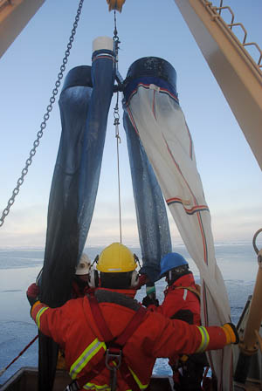
Kelly Young (IOS)
Lori Waters (IOS)

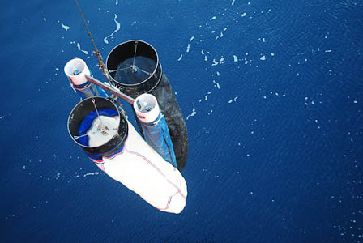
Photos by Alex Kain

A total of 63 bongo net hauls were completed at 25 stations (Fig.1). Bongos were harnessed and deployed in the same manner as the 2008-30 JOIS cruise. Standard, duplicate tows to 100m were sampled at all stations except one where weather and time restraints limited the deployment to one 100m tow (MK-3). In addition to the routine tows, additional tows to depths of 200, 500 and 1000m were conducted at select stations (Table 1). Samples were preserved following the method in 2008-30, with the following additions for the deep tows:

Cast 1 (100m):
- 236 µm into buffered formalin (10%)
- 150 µm into buffered formalin (10%)
- both 53 µm combined to single buffered formalin (10%) sample

Cast 2 (100m):
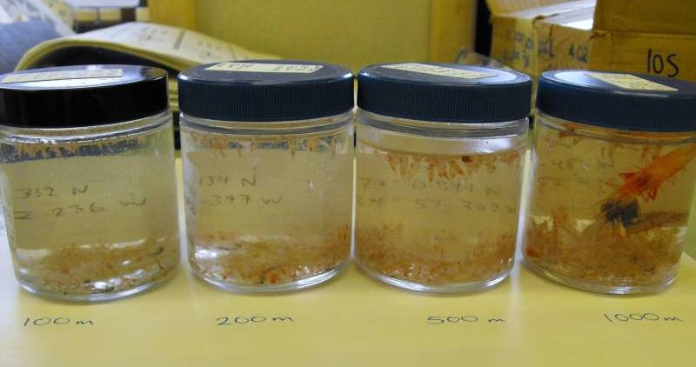
- 236 µm 95% ethanol
- 150 µm frozen in whirl-pak at -80°C
- both 53 µm combined 95% ethanol

Deep Casts (200, 500 & 1000m):
- 236 µm 95% ethanol
- 150 µm into buffered formalin (10%)
- both 53 µm combined to single buffered formalin (10%) sample

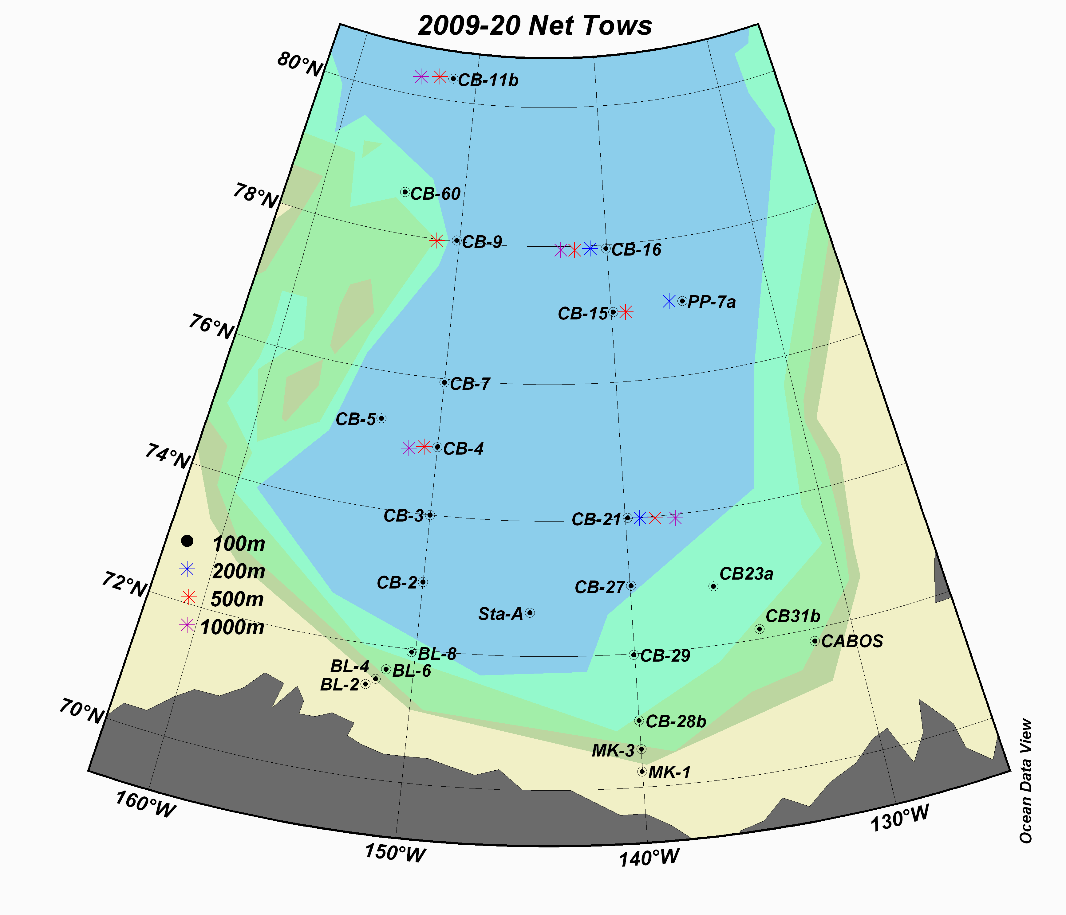

Figure 1. Map of zooplankton net tows for cruise 2009-20
Table 1. Summary of the number of samples taken at each station, based on net mesh size (53, 150 or 236μm) and tow depth (100, 200, 500 or 1000m).

Depth | Mesh | CABOS | CB31b | CB23a | CB-27 | CB-29 | Sta-A | MK-1 | BL-6 | CB-28b | MK-3 | BL-2 | BL-4 | BL-8 | CB-2 | CB-3 | CB-4 | CB-5 | CB-7 | CB-9 | CB-60 | CB-11b | CB-16 | PP-7a | CB-15 | CB-21 | Grand Total
100 | 53 | 2 | 2 | 2 | 2 | 2 | 2 | 2 | 2 | 2 | 1 | 2 | 2 | 2 | 2 | 2 | 2 | 2 | 2 | 2 | 2 | 2 | 2 | 2 | 2 | 2 | 49
100 | 150 | 2 | 2 | 2 | 2 | 2 | 2 | 2 | 2 | 2 | 1 | 2 | 2 | 2 | 2 | 2 | 2 | 2 | 2 | 2 | 2 | 2 | 2 | 2 | 2 | 2 | 49
100 | 236 | 2 | 2 | 2 | 2 | 2 | 2 | 2 | 2 | 2 | 1 | 2 | 2 | 2 | 2 | 2 | 2 | 2 | 2 | 2 | 2 | 2 | 2 | 2 | 2 | 2 | 49
200 | 53 |  |  |  |  |  |  |  |  |  |  |  |  |  |  |  |  |  |  |  |  |  | 1 | 1 |  | 1 | 3
200 | 150 |  |  |  |  |  |  |  |  |  |  |  |  |  |  |  |  |  |  |  |  |  | 1 | 1 |  | 1 | 3
200 | 236 |  |  |  |  |  |  |  |  |  |  |  |  |  |  |  |  |  |  |  |  |  | 1 | 1 |  | 1 | 3
500 | 53 |  |  |  |  |  |  |  |  |  |  |  |  |  |  |  | 1 |  |  | 1 |  | 1 | 1 |  | 1 | 1 | 6
500 | 150 |  |  |  |  |  |  |  |  |  |  |  |  |  |  |  | 1 |  |  | 1 |  | 1 | 1 |  | 1 | 1 | 6
500 | 236 |  |  |  |  |  |  |  |  |  |  |  |  |  |  |  | 1 |  |  | 1 |  | 1 | 1 |  | 1 | 1 | 6
1000 | 53 |  |  |  |  |  |  |  |  |  |  |  |  |  |  |  | 1 |  |  |  |  | 1 | 1 |  |  | 1 | 4
1000 | 150 |  |  |  |  |  |  |  |  |  |  |  |  |  |  |  | 1 |  |  |  |  | 1 | 1 |  |  | 1 | 4
1000 | 236 |  |  |  |  |  |  |  |  |  |  |  |  |  |  |  | 1 |  |  |  |  | 1 | 1 |  |  | 1 | 4
Grand Total |  | 6 | 6 | 6 | 6 | 6 | 6 | 6 | 6 | 6 | 3 | 6 | 6 | 6 | 6 | 6 | 12 | 6 | 6 | 9 | 6 | 12 | 15 | 9 | 9 | 15 | 186

Problems with the flowmeters were a common occurrence during this cruise, as the MF-315 flowmeters had a tendency for freezing up in the Arctic conditions (Fig. 2).

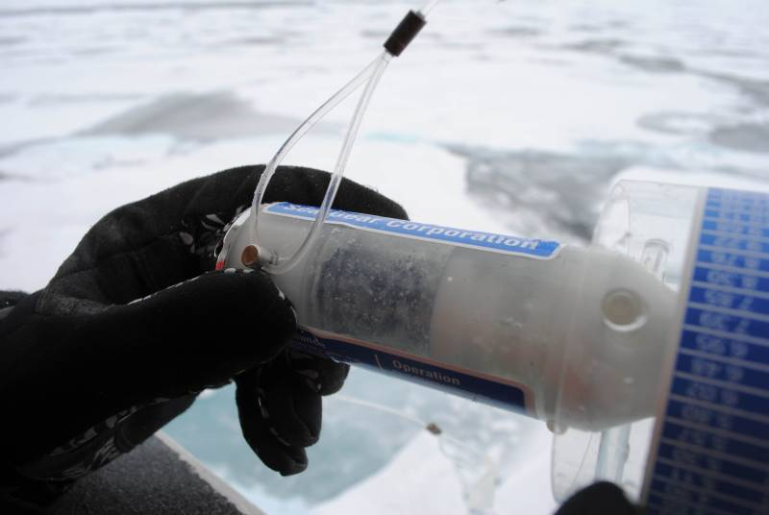

Figure 2. The MF-315 flowmeter frozen up. Photo by Alex Kain.

The gears would also jam occasionally, and adjacent numbers would roll over out of sequence. To prevent the flowmeters from freezing between casts, they were removed immediately following the cast and brought inside the lab to defrost, and replaced immediately before the next cast. Occasional freezing up still occurred, especially for the multi-tow casts (deep tows) or on very chilly, windy days. Since similar problems were encountered last year, a TSK flowmeter was also used on one side of the large bongo frame. The TSK worked well in the cold; however errors occurred from the occasional misreading of the dial. This type of error would be reduced with experience and by having multiple people reading the dial to check for consistency.

An attempt was made to calibrate the flowmeters onboard near the end of the trip (at CB-12, 12-Oct-09). The nets were removed from the bongo frame, and the flowmeters attached. The frame was then lowered to 100m and raised to the surface in the same manner as a standard tow. Ideally the ascent rate should be constant at 1 m s⁻¹, and multiple tows and depths conducted; however only 2 tows to 100m were completed due to time constraints. The flowmeter values varied greatly between the two tows, making calibration difficult. The calibration coefficient was calculated using only the first of the calibration tows, as the other values did not agree well with expected trends for a 100m tow (Table 2). The calibration coefficients in Table 2 should be used with caution, if at all, until a complete sequence of calibration tows can be done (preferably 10-100m, plus a set of depths ranging from 50-1000). The net efficiency was then summarized for each type of net used (Table 3).

Table 2. Flowmeter calibration coefficients obtained from one 100m tow during 2009-20

Flowmeter | frame | Revs m⁻³ | coeff
TSK 2767 | large | 27.51 | 0.036
MF-315 #1 | small | 92.78 | 0.011
MF-315 #2 | small | 94.28 | 0.011
MF-315 #3 | large | 20.50 | 0.049

Table 3. Net efficiency for each net used during 2009-20. These are preliminary values, and should not be used with confidence until a complete set of calibration tows can be done.

Flowmeter | Mesh (μm) | Depth (m) | Average Net Efficiency (%) | σ (%)
MF-315 #3 | 236 | 100 | 65.2 | 10.9
TSK 2767 | 150 | 100 | 81.7 | 11.1
#1 & 2 | 53 | 100 | 75.7 | 24.1

The weight and weight-line of the bongos were adjusted this cruise to make it easier to deploy and retrieve the nets. The weight-line needs to be long enough so the weight does not interfere with the cod ends and the nets can hang freely, while short enough so the cod-end guidelines are not too long to get tangled during the tow. The solution was to slightly shorten the weight-line and attach the 2-53μm nets to the top of the weight, and attach the 236 and 150μm (which are longer than the smaller nets) to the bottom of the weight.

One of the 53μm mesh nets was damaged on 27-Sept-09 (MK-3) and removed from the frame for repair. It was thought at the time that there were no replacements available so only one 53 μm was used until the net was repaired on 1-Oct-09 (CB-9). However, it was discovered at the end of cruise that there are 2 more 53 μm nets available, and can be used for next year with the 2 older 53 μm nets available as spares.

Suggestions for next year
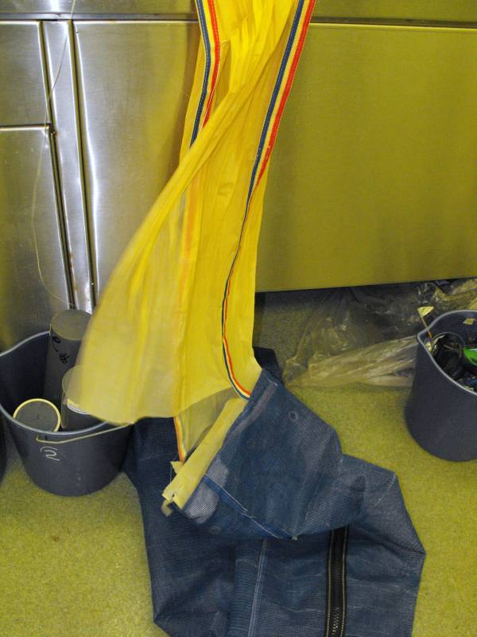
• The 53 μm nets we were using seem to be very old, as the fabric is brittle. Lori Waters replaced the one top panel when the net ripped (see picture, left), which should hold for a while. There is a set of newer 53μm (packed with the other nets) that can be used for next year, with the older nets to be used as spares.

• New nets are needed for the 150 and 236 μm mesh. Currently there is no spare net available onboard during the cruise for the 150 μm, and the fabric of the 150 μm & 236 μm nets have quite a few repairs. The older nets could then be used as spares.

• Cod ends - the clasps which hold the cod ends onto the 53 μm nets work much better than those on the 150 & 236 μm nets. The clasp system for the cod ends for both of these nets was loose, and problematic to get on and off. The positive clasp system on the 53 μm cod ends which clips in and clicks down is easier to use in cold conditions wearing lots of layers of gloves, and it seems to work much better.

• Having additional sets of cod-ends to cover off multiple casts might help make casting and pickling more efficient, and could save trips back and forth with samples. For example, on days when there are 2x 100, 1x200, 1x500, and 1x1000, it may help to have three or four sets of cod-ends to cycle through, rather than only two sets, which causes a delay while the pickling is done, to clean the cod ends between the first and subsequent net casts.

• The bongo box is awkward to slide over the staples on the foredeck, and several times the staples slipped up between the bottom of the net box and the side. What may work better is a box with a sturdier frame with legs at the corners which raise the box up above the level of the foredeck staples. The frame for the bongos which sits inside the box needs reinforcing or replacement.

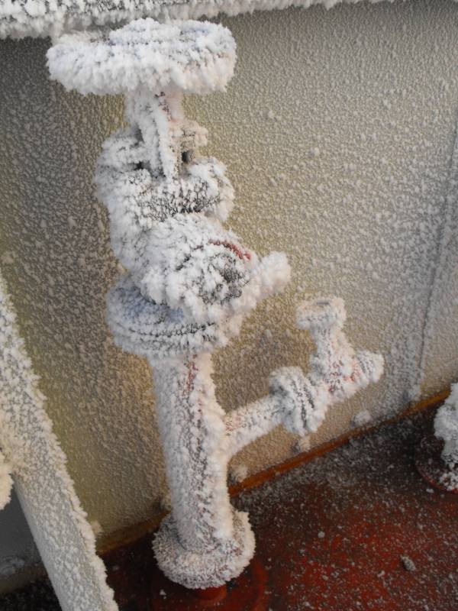
• The fire hose froze several times during this cruise, which was sometimes solved by ships engineering, and by the deck crew storing the hoses in a warm container. When the fire hose was not available, the net was “dipped” to rinse by slowly raising the bongos clear of the surface, lowering them slowly back down until the frame was just above the surface, and then raising them slowly again. This method may not have worked well on the particularly cold and windy nights as the mesh would freeze as soon as they cleared the water.

• Currently samples have to be transported from the foredeck, to the main lab for sieving, then upstairs to the fumehood in the container lab beside the CTD operations, and back down to the main lab. It would be helpful if a container would be available on the foredeck for wet work (either a sink or just a drain) that has adequate ventilation so all the sample processing (including preservation with formalin and ethanol) could take place on the foredeck.

• In future perhaps an excess of jars and preservatives could be sent so that it would be possible to do additional zooplankton sampling when/if additional opportunities arise, without worrying that there won't be enough jars to store samples, or chemicals to preserve them.

• It would have been great to have a microscope on board - perhaps a dissecting scope with a camera attachment in order to be able to show samples to media and other JOIS science participants.

• Currently we are using an older logsheet version that includes information that is not needed, and does not have adequate space for other observations that are needed for this cruise. The log book should be formatted for the JOIS program to make station logging and note taking easier and more efficient for next year.

