Underway Systems Report

Cruise ID: 2009-19 and 2009-21

Analyst: Jane Eert

Dates: July 20 to September 16, 2009

Overview

This report describes measurements taken at frequent regular intervals throughout the cruise. These measurements include:

- From the seawater loop system: salinity, temperature (inlet and lab), fluorescence, CDOM (2009-19 only), gas tension, and oxygen saturation.
- Hull temperature
- From the Novatel GPS: all NMEA strings (GPRMC, GPGGA, HEHDT, among others) as well as position, time, speed and total distance
- AVOS weather observations of: air temperature, humidity, wind speed, barometric pressure
- Sounder reported depth

Methods

See section below for technical description of monitoring procedures, data flow and network setup.
The Louis uses a 3” Moyno Progressive Cavity pump Model #2L6SSQ3SAA, driven by a geared motor. The pump rated flow rate is 10 GPM. It supplies seawater to the TSG lab, where a manifold distributes the sweater to instruments and sampling locations. On one of the manifold arms, a vortex debubbler is installed inline to remove bubbles in the supply to the SBE-21 thermosalinograph (TSG) and the blue cooler containing the gas tension device and the oxygen sensing optode. Control of the pump from the lab is via a panel with on/off switch and a Honeywell controller. The Honeywell allows setting a target pressure, feedback parameters and limits on pump output.
During 2009-19 and 2009-21, set point pressures varied from 17.1PSI to 20PSI depending on ice and sea conditions. Flow rates to the gas cooler varied from 3-5 liters/min and to the TSG from 8-10 l/min. Salinity, and during 2009-19, CDOM and chlorophyll samples were taken at intervals from the loop to calibrate the instruments.
Two remote temperature sensors are installed in the engine room: an SBE-38 inline thermometer, readings from which are integrated into the SBE-21 data stream, and an SBE-48 hull mounted temperature sensor which is logged separately.
GPS is provided to the SBE-21 data stream using the NMEA from PC option rather than the interface box as in past years. In 2008, it was observed that the GPS data was not properly recognized by Seasave while logging the TSG data; this was true in 2009 as well until the source of the NMEA was changed.
Weather observations are collected by the AVOS system, provided and maintained by Environment Canada.
Depth is provided by the Knudsen 12KHz sounder. Reported values are digitized depth rather than travel time, so it is important to independently log the average sound speed setting on the Knudsen.

Instruments in the TSG were:
Seabird SBE 21 Thermosalinograph s/n 3297
Seabird SBE-38 Thermometer s/n
WET Labs WETStar fluorometer s/n WS3S-521P
WET Labs CDOM s/n WSCD-1281

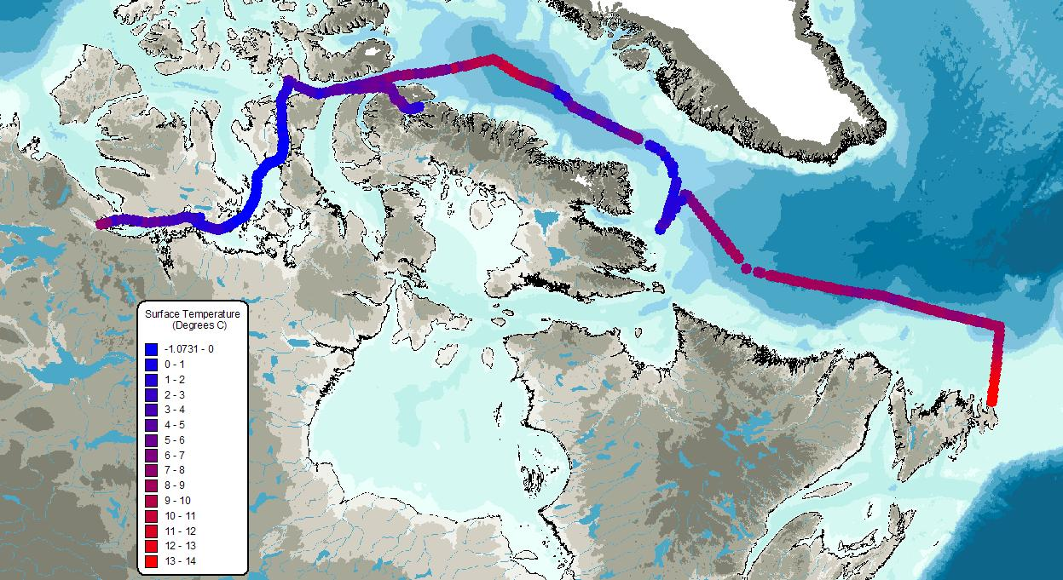

Figure 1: TSG inlet temperature 2009-19
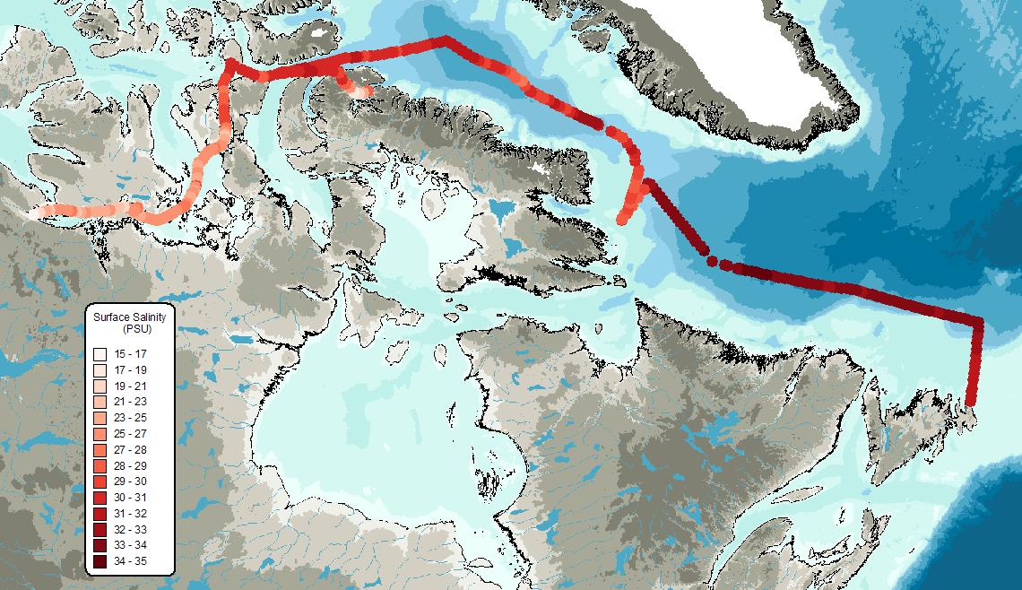

Figure 2: TSG salinity 2009-19

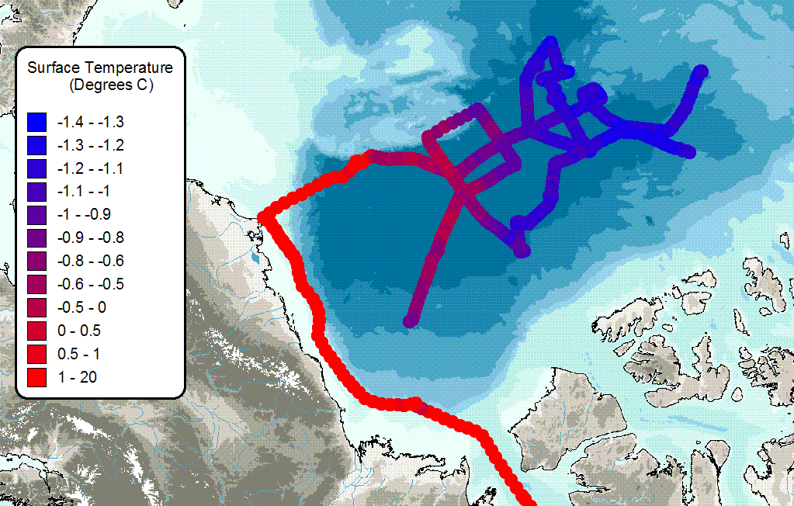
Figure 3: TSG inlet temperature for 2009-21
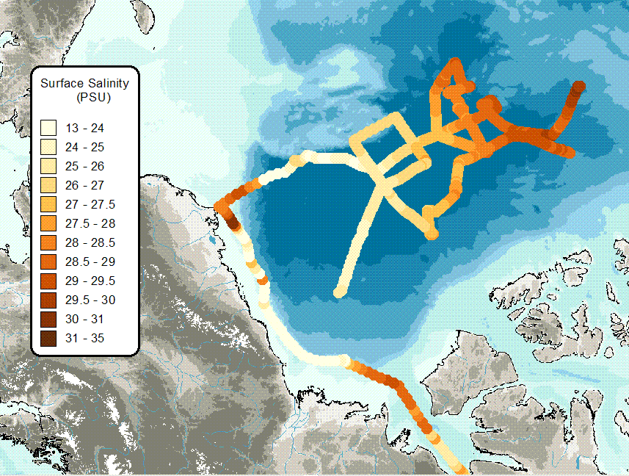
Figure 4: TSG salinity for 2009-21

Logging:

- TSG laptop:
Via Seasave: Time, latitude, longitude, lab temperature, SBE-38 inlet temperature, conductivity, CDOM (2009-19 only), fluorescence.
Via Hyperterm: SBE-48 temperature at hull
Via Hyperterm: NMEA strings distributed on network from Novatel GPS and ship’s gyro
Via GTD logging program: Oxygen saturation, gas tension.

- Knudsen computer, main lab:
Via Fugawi: Ship’s track, including GPS time, latitude, longitude, speed and total distance.
- SCS Data Collection System:
The ship uses the Shipboard Computer System (SCS) written by the National Oceanographic and Atmospheric Administration (NOAA), to collect and archive underway measurements. This system takes data arriving via the ship’s network (LAN) in variable formats and time intervals and stores it in a uniform ASCII format that includes a time stamp. Data saved in this format can be easily accessed by other programs or displayed using the SCS software.

The SCS system on a shipboard computer called the “NOAA server” collects:

- Location from the ship’s GPS (GPGGA and GPRMC sentences)
- Heading from the ship’s gyro (HEHDT sentences)
- Depth sounding from the ship’s Knudsen sounder (SDDBT sentences)
- Air temperature, apparent wind speed, apparent and relative wind direction, barometric pressure, relative humidity, and apparent wind gusts from the ship’s AVOS weather data system (AVRTE sentences). SCS derives true wind speed.
- Sea surface temperature, salinity fluorescence and CDOM from the ship’s SBE 21 and SBE38 thermosalinograph and ancillary instruments
- Sea surface temperature from the SBE48 hull mounted temperature sensor
- SCS derives speed over ground and course over ground

Problems

The CDOM sensor showed almost no variation during 2009-19. The cause appears to be that it was set to coastal sensitivity range, which is for waters with much larger CDOM content. It was removed at the end of 2009-19 and sent back to Wet Labs to have the sensitivity range changed to ‘Open Ocean’, the most sensitive.

The Fluorometer also seemed unexpectedly insensitive. It did show some variation, however after the two day shutdown in the NE corner of the Canada Basin values had shifted – a larger offset was seen. While the TSG was shut down during the Healy visit, the fluorometer flow tube was flushed with dilute Trition-X in DI water; glass or quartz shards were found in the rinse water and the instrument was removed from the system.

The Moyno pump and Honeywell controller worked very well again this year. Ice under pressure continues to be a difficult environment for the pump, though, and it had to be shut down for 2 days while the Louis was breaking ice for the Healy in the NE corner of the Canada Basin. The point at which the engine room alarm is triggered should be checked – 10PSI would be a good value; if it is higher than that, normal lab sampling operations may set it off as the pressure drops temporarily when a valve is opened.

Monitoring Underway Systems

Group 1 in TSG Lab
Flow rate
- Regularly (once a week/or when settings change) measure flowrate to all attached systems
Reading Honeywell Pump Controller
- Check PSI and %output
- call duty engineer to clean science pump filter if OUT percentage is 35%
- Duty Engineer phone # 117
Check TSG SBE21, SBE38
- Check Seasave software to confirm data are reasonable and file size/date are updating
- Stop & Start once a week
Check Blue Cooler box
- Check if software, GTDlog.exe, is running.
- Check pump is running
Check SBE48 capture
- Use SBE48 hyperterminal to capture data
- Restart file once a week
Check GPS capture
- Use Ship GPS hyperterminal to capture data
- Restart file once a week

Group 2
Fugawai Track
- Check file size is increasing and track is visable. Save new copy of track file daily.
Knudsen System
- Record sound speed being used
SCS (NOAA Server)
- There should be seven files, all with current date.

Underway system shutdown procedures
- Turn pump off by pushing “STOP” on Honeywell Pump controller. It will turn off slowly once STOP is pushed. Eventually, it will give reading such as 0.01 PSI, OUT 0%.
- Turn off Blue cooler power, 12V Power Supply (see Power Box for Blue Cooler + Optode.jpg)
- If pump is off for more than one day, then stop Seasave and turn off data interface box, stop GTD software.

Honeywell Pump Controller

- Pump – need to call duty engineer to clean science pump filter if OUT percentage is 35%
- Duty Engineer phone # 117
- See Honeywell Controller Setup for more details

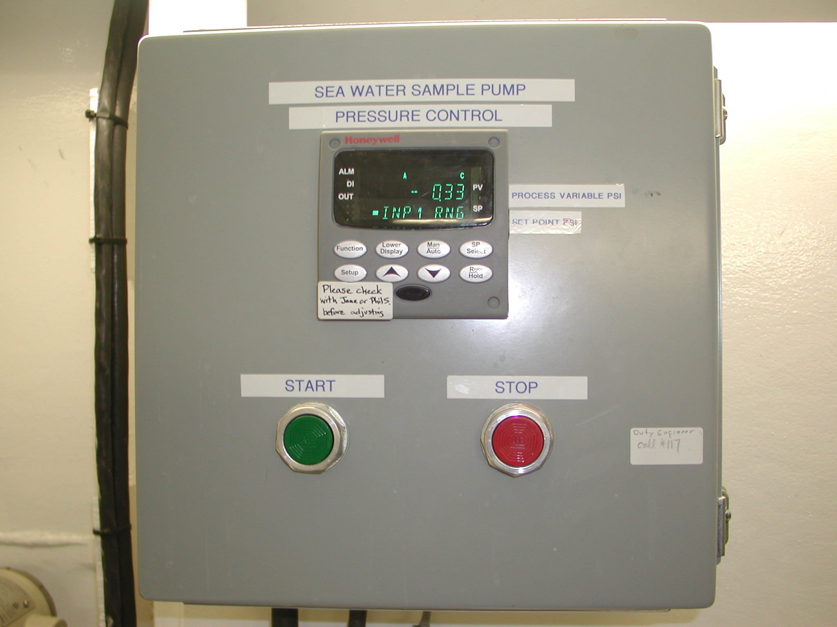

Starting and stopping the science pump

Two places have control of pump, the lab (Honeywell controller) and the engine room.

Honeywell Controller Setup (2008 Jul 04), if necessary

Cycle through “Lower Display” button by repeatedly clicking on it.
Check if SP is set at 20.0 – Target Pressure
Check if SP is set at 19.0 – Target Pressure (2009 Sep setting)
When exit, leave when display shows OUT (pump % output), it shows how hard the pump is working

If all is well, no need to change anything under SETUP function. In manual mode, MAN at the first line of display, you can set pump output by cycling through the lower display to OUT and then change it with arrow keys. In automatic mode, A, the pump output will automatically change to keep target pressure, but with a maximum output of 35% to avoid startup transients. 35% has been put in the settings, so pump will not work harder than this.

Tuning/Settings
Under SETUP go to SETUP TUNING
Press FUNCTION and set
GAIN 0.330
RATE MIN 0.01
RSET MIN 0.20
SECURITY 0

Under SETUP go to SP RAMP, nothing is set here

Under SETUP go to CONTROL
OUTHiLim 35%
SP HiLim 30 PSI
These two CONTROL settings mean the output will not go past 35% and the set point can not be made higher than 30 PSI.

Engine room has alarm PSI drops below 15. If you change flow by opening a valve (to take a loop samples, for example, check to make sure you have not made pressure go below 15PSI, or if you have, call the duty engineer at 117 to let him or her know it’s the lab rats playing, not something they need to check out.

TSG Computer (10.1.20.53)
- The current DHCP address for TSG computer is 10.1.20.53
- To avoid other system getting the address, the system should connect to the SCIENCE network and running all time.
- Recommendation for next time - use static IP address
- Data directory:
  - C:\2009-LSSL\TSG
  - C:\2009-LSSL\gtd_data
  - C:\2009-LSSL\GPS
  - C:\2009-LSSL\SBE48

Com Ports on Keyspan
Two KeySpan USB-to-Serial Ports (1 to 4) are used, the following ports are created:
COM 4, 5, 6, 7, 8, 9, 10,11.
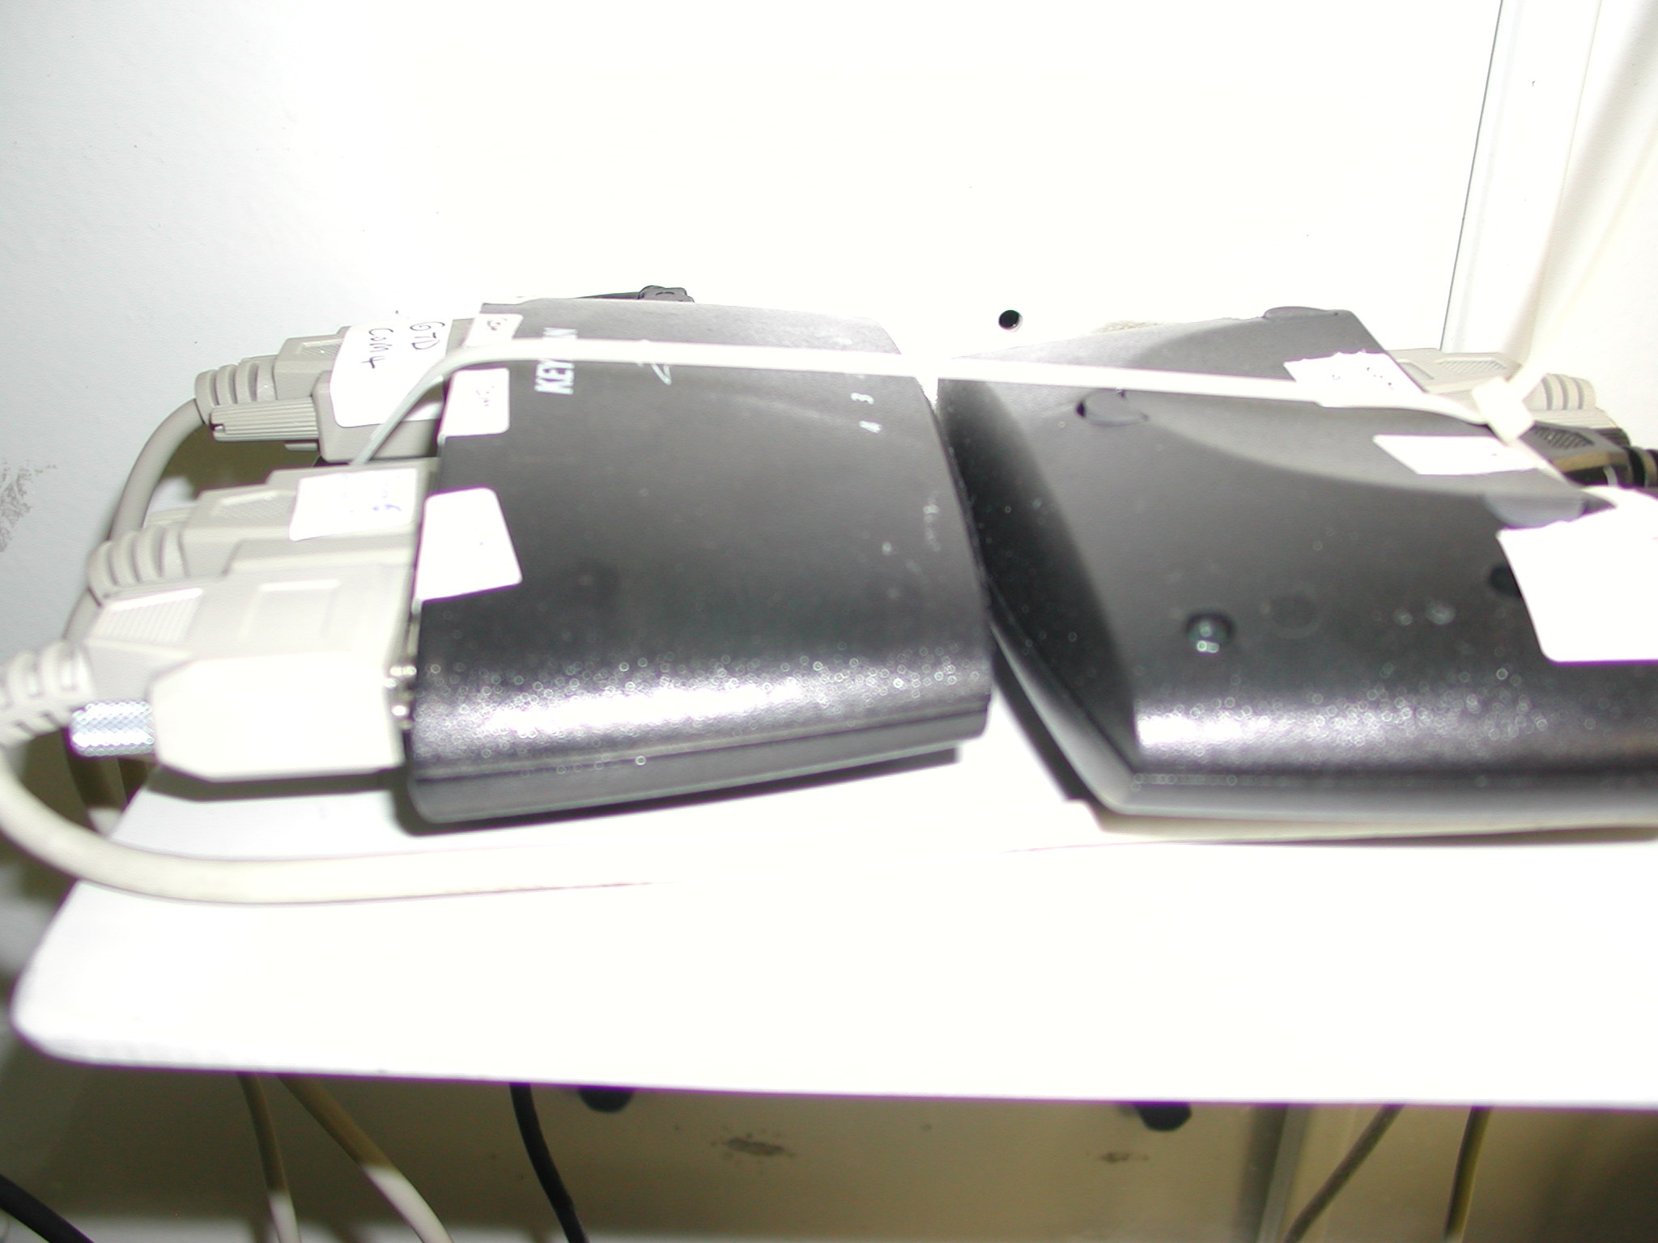

Ship GPS (NAVDATA #1) connects to COM9 of KeySpan

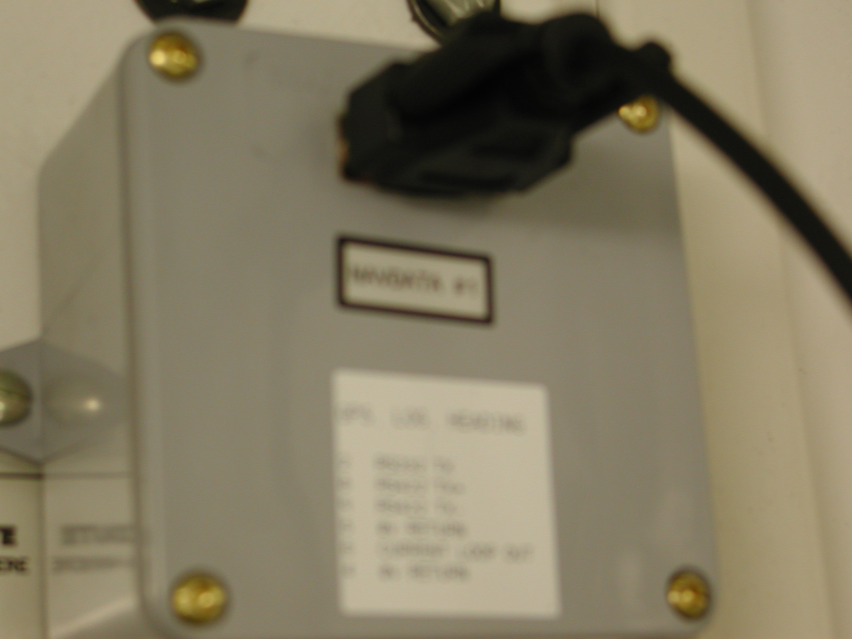

Programs on TSG computer to log TSG and SBE21 data
- Seasave
- Restart acquire data once per week, by “Real Time Data -> Stop” and “Real Time Data -> Start”, in Seasave.
- Configuration file (C:\2009-LSSL\TSG\3297_2009_test2009-07-05.con file)
- Location of data c:\2008-LSSL\TSG\2009mmddhhmm.hex . Note that file name does not have cruise ID, just date, as the TSG records for the whole season
- There are three current configurations under “configure output” in Seasave for reference only, see TSG-Serial Ports.bmp, TSG-TCP-IP out.bmp, TSG-TCP-IP ports.bmp. (Note these bmp’s are from 2008, not updated for 2009)
- Data is sent out to TCP/IP port 49161 for SCS system.
- Com 8 (TSG data) is input to Seasave from TSG (SBE21 3297 interface box), 9600,7,Even
- Com 15 (GPS) comes through GPSGate direct to Seasave instead of having NMEA go through interface box
- T2 comes from SBE38 via VLINX and GPSgate

- Hyperterm
- Use Hyperterm desktop icon to log Ship GPS, (COM 2, 4800,8,N,1), capture input to C:\2009-LSSL\GPS\2009-mm-dd.txt
- Use Hyperterm desktop icon to log SBE48, (COM 14, 9600,8,N,1) capture input to C:\2009-LSSL\SBE48\2009-mm-dd.txt

When TSG computer is rebooted or restarted

- Make sure system time sets to UTC.
- Make sure com ports are available, see GPSgate.
- Restart GTD data logging program, GTDLog.exe,
- Start Digiquartz Interactive v1.2 program
- Select Com4 and detect instrument (be patient and wait)
- Once it is detected, go to Configuration tab, check the following setting:
- PR=12000, TR=48000, Pressure integrating time=39.6 secs.
- Then go to “sampling” tab, start-> select P4 -> send (again be patient and wait at least two minutes, string from instrument will appear on Response window.
- Then press “STOP” and wait.
- Start GPSgate if necessary.
- Use Hyperterm to capture SBE48 data.
- Use Hyperterm to capture Ship GPS data.
- Start GTDLog.exe, log data to C:\2008-LSSL\gtd_data and configure COM ports in the program.
GPS -> COM1, 4800,N,8,1,None
Pressure -> No input
Optode -> COM6, 9600,N,8,1,None
GTD -> COM4, 9600,N,8,1,None
- Make sure “Start” is clicked.

VLINX Settings
Once VLINX is configured on TSG computer, VLINX ESP manager does not need to be. TSG VLINX ESP manager pools information from two VLINX boxes (10.1.20.5 and 10.1.20.15) and outputs to Virtual COM port.

TSG Vlinx com port:
10.1.20.15:4000 Com 12 Novatel on LAN, don’t believe use by
anything
10.1.20.5:4000 Com 13
SBE38 data through VLINX box Com 13, out GPS gate Com 10 to SBE21 bulk head connector
10.1.20.5:4001 Com 14
SBE48 data through LINX box Com 14, currently use hyperterm to capture data.

TSG-VLINX-Serial Server-List:
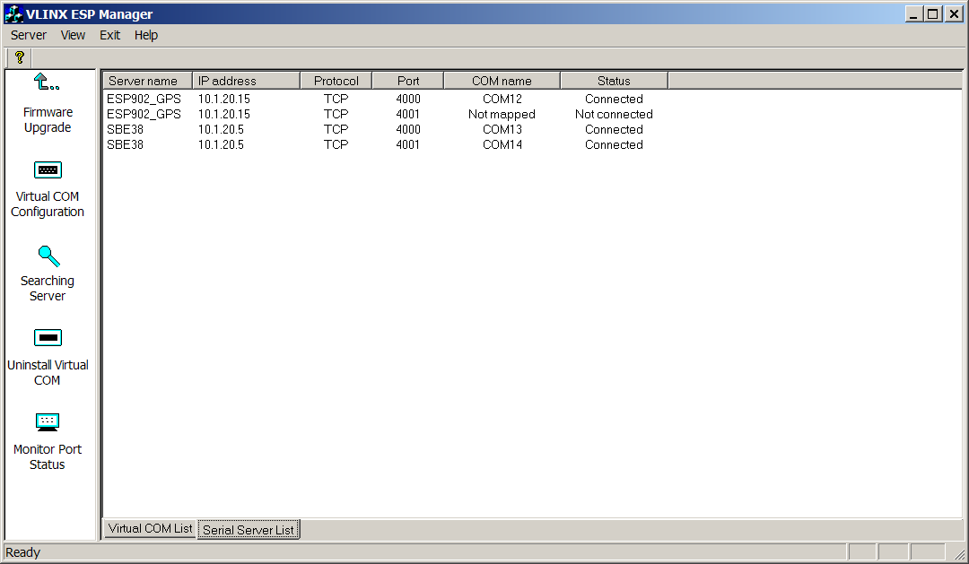

TSG-VLINX-Virtual COM-List
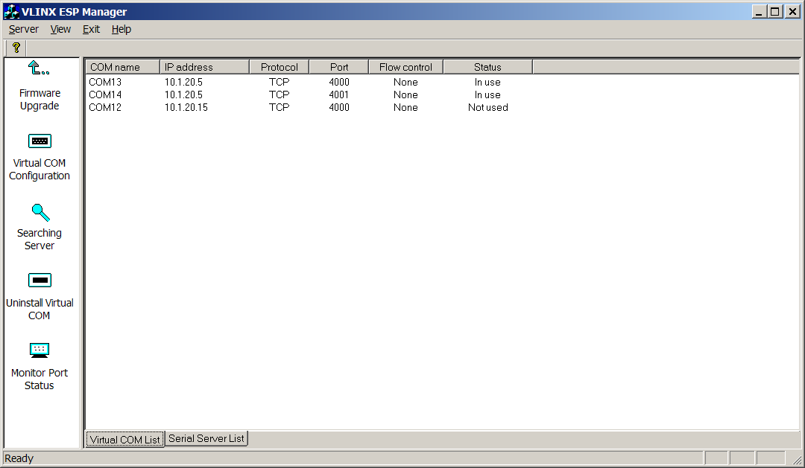

GPSGate Settings

GPS + Heading
Input: COM9, 9600 (from Navidata box)
Output:GpsGate Direct
TCP server 20175 (TSG laptop)
Virtual COM2
Virtual COM1 / ($GPRMC,…) NMEA filter (create filter by selecting on output tab “Com port, filtered”, then go through options)

Virtual COM15 (NMEA input to Seasave)

GPS to TSG (not used, needed to feed GPS to interface box)

SBE38 (remote inline temp, near pump intake in engine room)
Input: COM13, 9600 (vlinx - from SBE38 sensor via 10.1.20.5 TCP 4000)
Output:COM10 (to SBE21 bulk head connector)

TSG Check (not active)
Input: localhost 49161, TCP/IP
Output: Virtual COM16

