Carbon and nitrogen productions of phytoplankton and their species compositions and physiological characteristics in the Canada Basin (CCGS Louis S St-Laurent)

Mi Sun Yun, Korea Polar Research Institute (KOPRI)

Objectives:
- To quantify primary production (carbon and nitrogen uptakes) of phytoplankton using a stable isotope
- To define and compare effects of light and nutrient on the primary production of phytoplankton in the chl a maximum layer
- To identify phytoplankton species compositions
- To measure physiological characteristics of phytoplankton and estimate primary production using PAM (Pulse Amplitude Modulated) fluorescence
- To compare primary production with different method (Carbon and PAM method)

Methods
1. To quantify carbon and nitrogen uptake of phytoplankton at different locations, productivity experiments were executed by incubating phytoplankton in the incubators on the top-deck for 3-4 hours after stable isotopes (¹³C, ¹⁵NO₃, and ¹⁵NH₄) into each bottle were inoculated. Total 11 carbon and nitrogen uptakes experiments (Table 1) were completed. Seawaters (using 500ml bottles with different screen depending on depth) were collected from Niskin at 6 different light depths (100, 50, 30, 12, 5, and 1%). After the incubation, all productivity sample waters were filtered on GF/F (ø = 25 mm) filters and dried in the 60ºC oven. For laboratory isotope analysis, these samples will be sent to University of Alaska Fairbanks after this cruise.

Along with the carbon and nitrogen uptakes experiments, 13 light enrichment experiments and 10 nutrient enrichment experiments (Table 1) were conducted from 1% light depth to define and compare effects of light and nutrient on the primary production of phytoplankton in the chl a maximum layer.

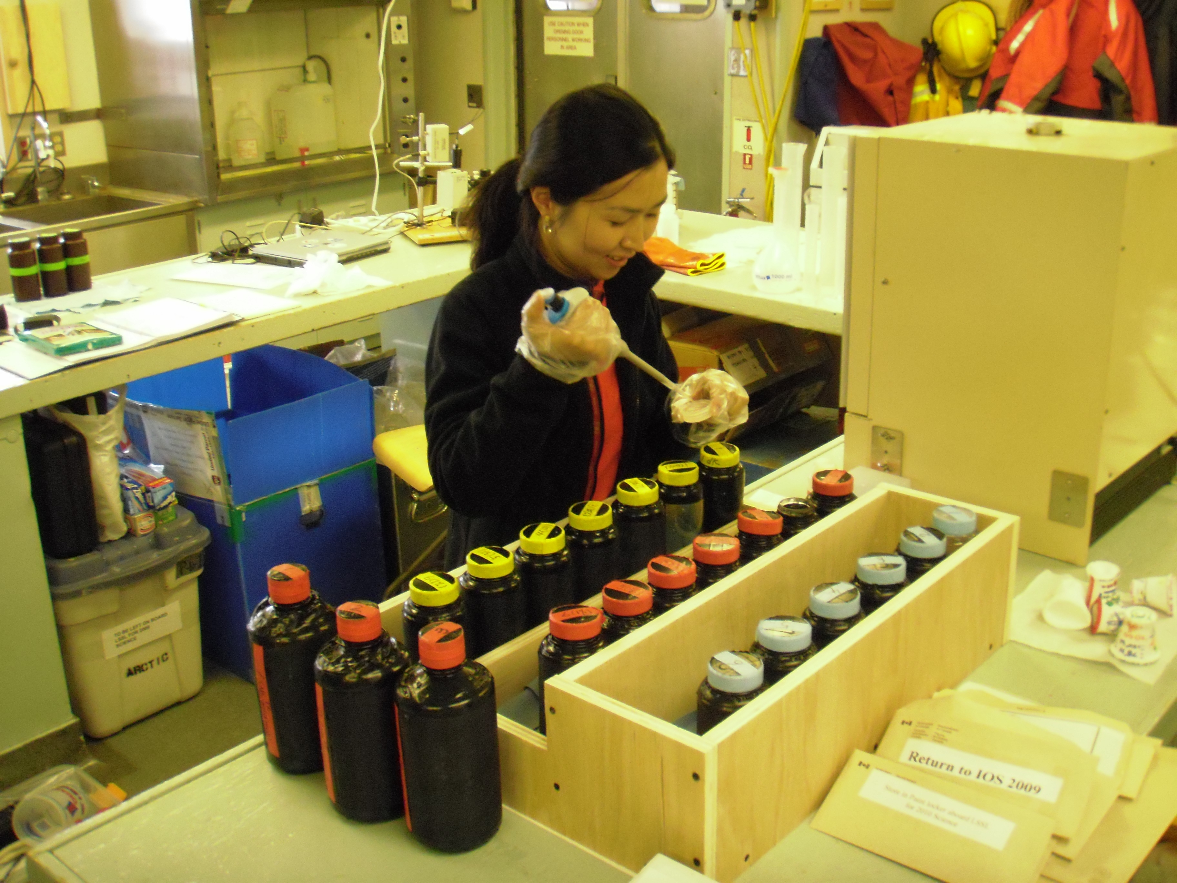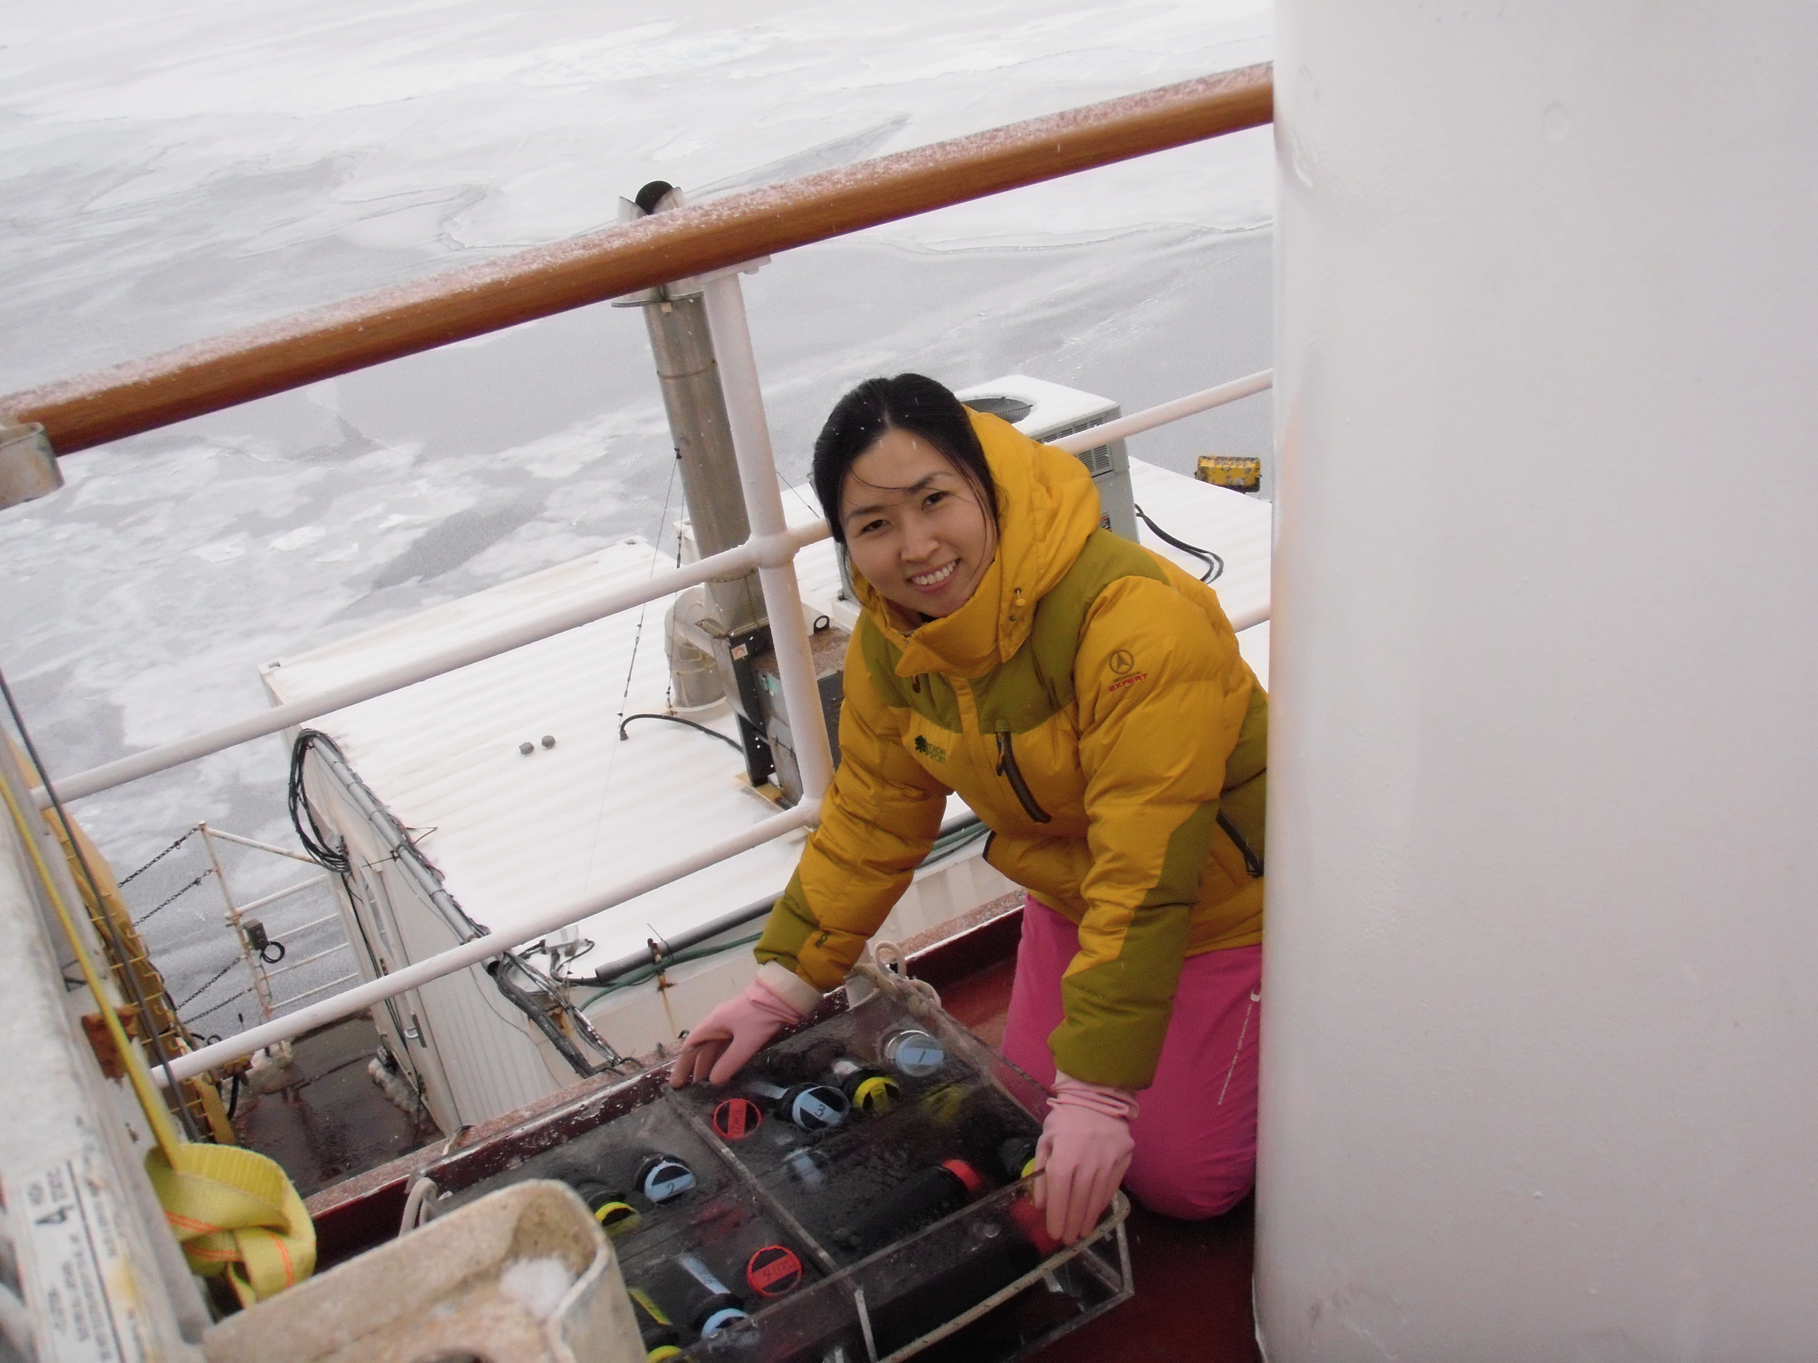
2. To identify species composition of phytoplankton, water samples were taken from 100, 30, and 1 % of light depth at every productivity station. Based on the HPMA slide method, the total 39 samples were fixed for identifying species compositions of phytoplankton later at the laboratory in KOPRI.

3. To measure chlorophyll fluorescence using Phyto-PAM (Walz, Effecltrich, Germany), water samples (50ml) were taken from 100, 30, and 1 % of light depth at every productivity station. The total 39 samples were measured for analysis of physiological characteristics of phytoplankton. Physiological condition could be assessed by measuring the effective quantum yield of PSII (Φ_{PSII}) which measures the proportion of the light absorbed by chlorophyll associated with PSII used in photochemistry. Photosynthetic activities were assessed using rapid-light curves (RLCs), where samples were exposed to nine incremental steps of irradiance (20 s per step) ranging from 0 to 764 μmol photons∙m⁻²∙s⁻¹. Photosynthetic parameters will be derived by fitting to the model of Platt et al. (1980). These parameters will be compared with parameters by carbon method.

4. 2 ice algae were taken at the bottom 3cm of ice core in the different stations (ITP 3, 4: One is new-year ice. Another is multi-year ice). These samples were fixed for identifying species compositions of ice algae. Two samples can be compared with difference of species compositions.

Table 1. Sampling list

St. | Primary Production |  |  |  | Species Composition | PAM  Measurement
St. | Carbon Production | Nitrogen Production | Effect of Light Enrichment | Effect of Nutrient Enrichment | Species Composition | PAM  Measurement
CABOS | √ | √ | √ | √ | √ | √
CB-23a | √ | √ | √ |  | √ | √
MK-7 | √ | √ | √ |  | √ | √
CB-28b |  |  |  |  | √ | √
CB-2a | √ | √ | √ | √ | √ | √
CB-4 | √ | √ | √ | √ | √ | √
CB-9 | √ | √ | √ | √ | √ | √
CB-10a | √ | √ | √ | √ | √ | √
CB-11b | √ | √ | √ | √ | √ | √
CB-11 |  |  | √ |  | √ | √
CB-15/17 | √ | √ | √ | √ | √ | √
CB-40b | √ | √ | √ | √ | √ | √
CB-21 | √ | √ | √√ | √√ | √ | √

