LSSL 2009-20 CB Ammonium (Oct 20, 2009 KAB)

Methods (differences from 2008-30 highlighted)
Ammonium sampling during the LSSL 2009-20 program occurred along shelf transects throughout the Canada Basin, including those along the lines extending North from the Mackenzie River (MK Line) and Barrow Canyon (BL Line). Ammonium concentrations were determined following the procedures outlined by Holmes et al. 1999. Samples of 40.5 (± 0.58) mL of seawater were collected in duplicate from the 10 L niskin bottles collected at each station from a depth of 34.6 psu and shallower, with a zero value sample set taken at ~ 450 - 500 m depth. Samples were then prepared by adding 10.00 mL of working reagent (prepared according to Holmes et al. 1999) and let to sit in the dark for 5-8 hrs at room temperature. After sitting for 5-8 hrs, samples were measured with a TD-700 fluorometer (Turner Designs), in simple mode, with sensitivity calibrated to a 0.5 μM standard (S2) and 0.75 μM standard (S3), reading sensitivity levels of 30 and 29 respectively, depending on the sample concentration range expected. Samples with concentrations falling outside of either the S2 or S3 calibrated standard curves were evaluated again with the instrument calibrated to a 1.0 μM standard (S4), reading a sensitivity level of 28. 169 samples were collected in duplicate and processed during this cruise along with 15 sets of standards.

Standard sets were run with every station or group of stations and prepared with samples using seawater collected from the 500 m bottle from the same rosette or from a cubitainer of water collected from deep bottles at station CB31b and stored in the cold room on the ship. In order to analyze stations that were close together some samples were stored in the fridge in the alkalinity lab (away from any ammonium based chemicals) for up to 24 hours before adding working reagent. These samples were analyzed in batches with one set of standards and almost always prepared for analysis within 12 hrs of sampling.

Reagents were prepared on board in the main lab fume hood and allowed to sit for at least 48 hrs prior to use. Samples were collected in 50 mL glass test tubes with plastic screw top lids and sealed with parafilm (see Problems & Solutions section). After being used for a sample, glassware was rinsed three times in the ships de-ionized tap water and twice in DMQ water, before have 10 mL of 10 % HCl added to the vial, as this year no large acid bath was available. Vials were recapped and allowed to sit for at least 4 hrs (usually overnight) and then rinsed again three times in DMQ and allowed to air dry. The plastic screw top test tube lids were cleaned with DMQ water after the 10% HCl rinse and then soaked for > 4hrs in DMQ water. Caps were then dried on the lab bench top in Lab B. All rinsing & acid additions were carried out between the ammonium lab (Lab B) and the main lab fume hood, with subsequent air drying done in LAB B.

Standards
Ammonium chloride secondary standards from 2008 and 2009 were run concurrently to test standard solutions between years. In this comparison, the 2009 secondary standard used in analysis was measured against a new batch of secondary standard made from the primary standard used in 2008. As can be seen in Figure 1 below, the 2009 ammonium chloride standard differed little from the 2008 standard.

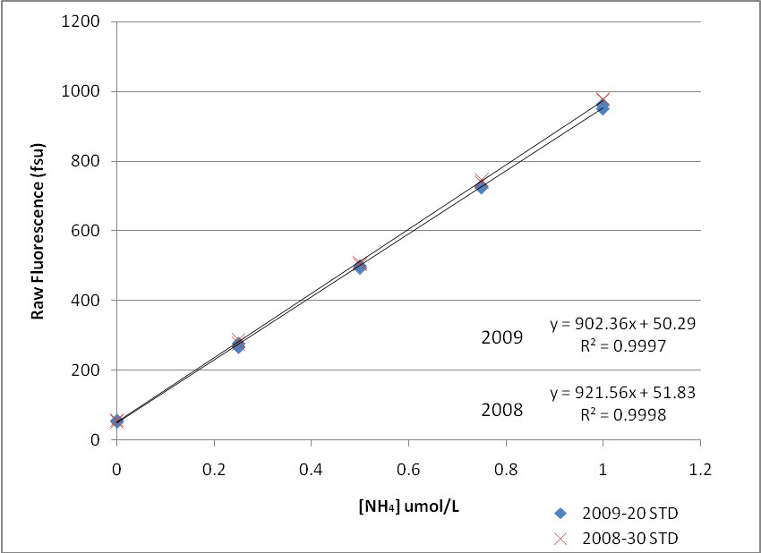

Figure 1. 2009 vs 2008 Ammonium Chloride Secondary Standard.

Reagent Blank & Blank Test
The consistency of the reagent blank value over the course of the cruise is a good indicator of working reagent quality, sampling/cleaning protocol reliability, and instrument performance. The average reagent blank value for all working reagent batches and TD700 calibration ranges (S2, S3, & S4) are given in Table 1. This table illustrates the consistently low blank values achieved once samples & standards were parafilm sealed (STD Batches 3 – 15, see Problems & Solutions section). Indicating that not only were working reagent batches quite similar, but the parafilm sealing protocol maintained reproducibility throughout the cruise. In addition, the cap test carried out at STNA can also be used to compare reproducibility of blank values using one working reagent (WR2). The standard deviation from the mean of 12 replicate blank samples differed by just over 10% from the mean value, further reinforcing the reproducibility of the sample collection method.

12 Blanks STNA Test (500m bottle)
Average: 22.5 fsu (n=12)
Standard Deviation: 2.4 fsu

A reagent blank between 30-50fsu with the S2 instrument calibration is consistent with results obtained in 2007 using the TD700 fluorometer. However, the 2009-20 data set was evaluated using several calibrations of the TD700 fluorometer depending on the required range of sample concentrations. Figure 2 illustrates the linearity of each of the standard sets, as well as the tradeoff between sensitivity and fluorometer range. Only samples which fell outside of the S2 calibration curve (ie. read OVER when being evaluated against an S2 instrument calibration) would be reevaluated against the higher, less sensitive, curve.

Table 1. Comparison of Working Reagent Blanks & Instrument Calibration
BLANKS - STD SET 3 to 15 (none of the contaminated sets included)
Calibration | WR | Avg (fsu) | STDEV (fsu) | % Diff
S2 | 2 | 50.8 | 2.0 | 4.0
 | 3 | 47.5 | 10.1 | 21.4
S3 | 2 | 85.7 | 1.5 | 1.7
 | 3 | 42.3 | 10.0 | 23.7
S4 | 3 | 20.5 | 1.1 | 5.5

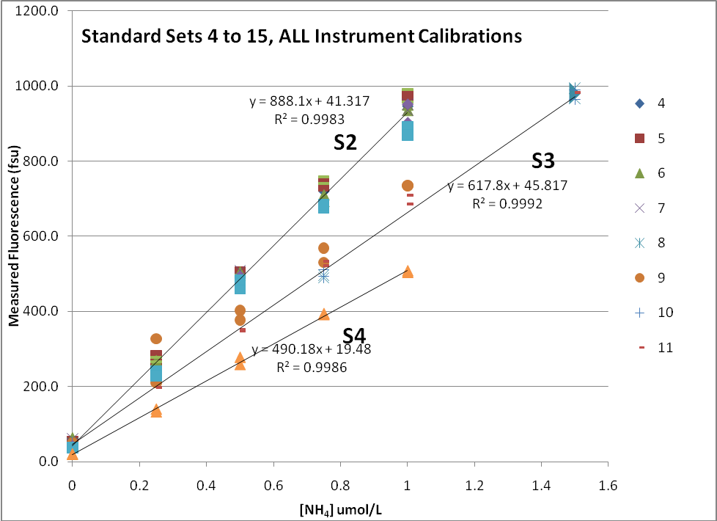

Figure 2 Standard Sets 4-15, All instrument calibrations included
(Simple Mode Mid Range = 500 fsu @ S2 = 0.5uM, S3 = 0.75uM, S4=1.0 uM [NH₄])

Duplicates
Data collected during the 2009-20 cruise represents the tightest duplicate values seen in the past 4 years. Once contamination issues at the first 4 stations were resolved (see Problems & Solutions section), reproducibility between sample duplicates was very very good, with Sp values for the whole data set of 0.02 uM (n=120) and an Sp of 0.01 (n=116) if samples pairs with suspected contamination of one of the duplicates are removed (ie. if one sample gives a high fluorescence reading and the duplicate sample gives a zero value this is expected to indicate that the high value is a contaminated sample).

Sp (all pair sets) = 0.02 μM (n=120)

Sp (pair sets without flagged data) = 0.01 μM (n=116)

Rejected Data Points (d flag)
Several NH₄ samples throughout the 2009-20 data set have been flagged as questionable (c flag) or removed from the data set completely (d flag). The decision to include (c flag) or exclude (d flag) these samples was based on their evaluation against two criteria: (1) the known occurrence of contamination or sample mishandling; and/or (2) a statistical improbability of such large deviation from the pooled sample mean (difference between duplicates greater than 2 standard deviations of the mean of the data set).

Sample sets from stations CB31b, CB23a, AMG, & CABOS were rejected based on criterion (1) known sample contamination (see Problems & Solutions section). In addition, 4 sample pairs were flagged based on criterion (2) duplicate difference falls outside of 2 standard deviations of the mean of the data set, and 5 duplicate pairs were flagged “c” questionable as they had one of the two duplicates that was questionably high (ie. one duplicate value of zero and the other non-zero) but could not be discarded for any obvious reason.

Problems & Solutions

Sample sets for stations CB31b, AMG, & CABOS were analyzed together as the first batch during the 2009-20 cruise. It was apparent from the first set of standards (CB31b STD set 1) that blank values were extremely high (241 & 318 fsu) and standard duplicates were not found to be as precise as expected. Due to the need to run samples after 4-6hrs of incubating (once the working reagent is added) it was decided to run the samples from CABOS, AGM, & CB31b, anyway and attempt to determine the source of the high blank value after the fact. Although the duplicates for each of these three stations were not terrible, it is expected that these profiles (with the exception of AGM) should have below detection limit NH₄ concentrations throughout most, if not all, of the depth profile. With this in consideration, it is expected that the high values measured at these stations are due to the contamination that caused the high blank and should therefore be discarded from the data set (flagged “d”).

Although the working reagents (WR) had ample time to for the background fluorescence to dissipate (>48hrs, made 10:30am Sept 19th and used 9am Sept 21st), the first culprit was thought to be contamination in the WR used for the first batch of samples (WR2). The WR test section tab of the analysis notes (2009-20 NH4 FINAL.xls) details the method used for the WR test. In short, three standard sets were made in room temperature DMQ water according to previous methods. WR 2, 3 or 4 was then added to each of the three standard sets and they were capped with new, clean (2+ hr DMQ soaked) plastic test tube caps with rubber liners. The samples were then allowed to incubate in the dark (beneath a plastic garbage bag) for 3 hours before measuring on the TD700 (S3 calibration, simple mode). Blanks from these standard sets were outrageously high & duplicates were inconsistent, as the use of DMQ water or the garbage bag covering likely exacerbated the contamination problem. Although the high blank was not alleviated, the WR batches all appeared to behave the same, eliminating contamination of WR2 as a possible explanation to the originally high blanks.

To attempt to run a similar test with seawater, a depth profile of samples from CB23a were taken to check the reliability of the new plastic caps with rubber liners, compared to the old metal caps with conical inserts. The CAP TESTS section tab of the analysis notes details the methods used for the three cap tests. Before carrying out any other tests, all the new caps (plastic with rubber liners) were rinsed and soaked in DMQ water overnight, the DMQ water carbuoy was cleaned with 10% HCl, rinsed and refilled with new DMQ from the nutrient lab, and blanks were attempted with each of the three kinds of “new” cap, flat rubber liners vs hatched rubber liners, and DMQ soaked vs unsoaked caps. Unfortunately, the results from this test also yielded little information. New caps and old caps behaved consistently badly, with new caps usually showing slightly higher values than the old caps. Although blank values appeared to be much lower for samples with new/soaked/flat caps, illustrating that blank values were in fact dropping, the reason for this difference between the inner liner of the new caps was not clear, and it was determined that the test should be carried out again with a larger sample size. While a reliable standard curve was produced for the samples taken at CB23a, the variability between duplicate samples, and the discrepancy between new & old caps makes these values questionable as well, and it is felt that they too should be discarded “d”.

The second cap test (CAP TEST 2) was carried out at CB27. Samples from 500m were drawn from the rosette and capped with a new cap/flat insert, new cap/hatched insert, or new cap/parafilm. These samples were drawn on the night watch and then sat in the fridge before WR was added to them the next morning. Despite care taken in the drawing and the WR addition, this test was also inconclusive, with blank samples remaining high and variable. It was expected after this test that either a contaminant source existed in the rosette shack (worst case scenario!), or that the caps were not going onto the test tubes tight enough (it was difficult to depress the rubber liners…) and allowing outside air to interact with the samples, thus yielding high blanks. A third test was designed to attempt to check the cap sealing, basically by making the caps obsolete, by covering the cap and neck of the test tube with parafilm (presumed to be air-tight).

The third cap test (CAP TEST 3) was a last ditch effort to attempt to solve the blank problem and was carried out by sampling deep water from STNA and running all the samples as blanks. By this time we had worked through all the test tube glassware so it had all been newly acid cleaned on board (as per the usual protocols described in the methods) and the WR had been stored in its bottle for almost 5 days, so blanks should have been as low as possible if contamination could be avoided. Samples were drawn from the rosette, WR added in the rosette shack, capped with new/clean plastic caps with rubber liners, and sealed with parafilm. Samples were then allowed to incubate as per the original methods, in the dark in back lab B, before analysis on the TD700. Thankfully the parafilm worked like a dream! Blanks were the lowest ever recorded (20 – 28fsu) and consistently low. After the STNA test it was determined that although using parafilm to seal the caps/test tubes is cumbersome, it is worth the effort. For the rest of the 2009-20 cruise, samples were always parafilmed after sampling (before leaving rosette shack). If WR could be added right away (in the rosette shack) it was added before parafilming. If samples needed to sit in the fridge to await the accumulation of several stations in a row to be run (for a batch), then parafilm was used to seal the caps of the samples before they left the rosette shack to be stored in the fridge until the subsequent cast(s) were drawn. Refrigerated samples were then taken up to the rosette shack, parafilm removed, and WR added. They were then re-parafilmed with new parafilm before being allowed to incubate in the dark. Although this procedure was time consuming it did appear to work very well, with the Sp for the whole data set the lowest in the last four years (0.02!).

Results & data from all tests can be found the NH₄ data workbook: 2009-20 NH4 FINAL.xls

Suggestions resulting from this problem exercise: It would be suggested that another type of cap is looked into for next year’s ammonium analysis. Although parafilm worked well for the 2009-20 samples I would consider it only a temporary solution, as its use is time consuming and not without its own problems. Finding a good re-useable cap that consistently seals and can be used between years would be ideal for this method.

A Note on Acid Cleaning Test Tubes: It was noticed that a large portion of the test tubes that were acid cleaned at IOS were in bags marked “A.C. 2007”. It is unclear if this means these test tubes had not been cleaned since 2007 (perhaps they were a batch that came out of the box from the SWL trip?) or if the bags the 2009 cleaned test tubes were put in were recycled (ie. had the 2007 cleaned test tubes in them and then used again when these tubes were re-cleaned at IOS in 2009? As traditionally the test tubes are re-cleaned at IOS between field seasons). Either way it is possible that the test tubes used at the beginning of the cruise were not cleaned again before being packed and became a source of contamination to the samples until they were acid cleaned again on board. Although I feel this is unlikely, I believe it can not be ruled out. The difficulty with acid cleaning all the glassware at the beginning of the cruise is the timeframe required to do this. Other years sampling is well underway while the ammonium & nutrient labs are still being set up, meaning the acid baths are not yet available to clean glass ware. During the 2009-20 cruise this would not have been a problem as we had a few days before sampling really got underway, and instead of using acid baths the tubes were cleaned by sitting with acid inside them on the bench top. In the future it would be recommended that test tubes be acid cleaned before use, whether on the ship, or at the very least, acid cleaning at IOS prior to packing glassware, as seems to have worked in other years.

Trends in the Data 2006-2009

MK LINE

Figure 3: This figure illustrates NH₄ (µM) concentration & transmissivity in the upper 400m along the MK line transiting south to north from the shelf into the deep basin. The figure is broken up into four quadrants. The upper left quadrant depicts 2006 data with the upper panel illustrating the NH₄ distribution (colour bar scale 0-2.5 µM), overlain by CTD salinity contours in black, and the lower panel illustrating CTD Transmissivity data (colour bar scale 80 – 91%), also overlain by CTD salinity contours in black. The remaining three quadrants follow the same layout as 2006, depicting 2007, 2008, & 2009 data respectively in a Z pattern.

Some trends to note

Like other years, 2009’s NH₄ signal along the MK Line is minimal, but there are a few features of interest when comparing 2009 to 2006, 2007 & 2008:
- Like 2007, 2009 has a slight NH₄ peak associated with summer waters (S~32) coming off the shelf (CB28aa & CB28b in 2009, MK3 in 2007);
- Both 2006 & 2008 had a visible peak in NH₄ associated with a transmission signal in the winter water (S~33) seen at the shelf-most station;
- Like 2008, the transmission signal appears much more developed in 2009 than 2006 or 2007; however, unlike 2008 it does not appear to have much of an NH₄ peak associated with it.

BL LINE

Figure 4: This figure illustrates NH₄ (µM) concentration & transmissivity in the upper 400m along the BL line transiting south to north from the shelf into the deep basin. As in Figure 3, Figure 4 is broken up into four quadrants. The upper left quadrant depicts 2006 data with the upper panel illustrating the NH₄ distribution (colour bar scale 0-2.5 µM), overlain by CTD salinity contours in black, and the lower panel illustrating CTD Transmissivity data (colour bar scale 80 – 91%), also overlain by CTD salinity contours in black. The remaining three quadrants follow the same layout as 2006, depicting 2007, 2008, & 2009 data respectively in a Z pattern.

Some trends to note

The most interesting thing about the NH₄ transect along the BL line is how much it changes from year to year. Time of year, strength of the gyre, and productivity along the Chukchi & Beaufort Shelves would all be expected to play large rolls in the propagation of this shelf tracer into the deep Canada Basin (Nishino et al 2005), and the combination of these forcings have yet to fail in producing a fascinating picture to attempt to understand.

- NH₄ features more consistently follow transmission along the BL line than is usually seen along the MK line, which can be clearly seen in 2006, 2007 & 2008. 2009 however, shows a plume of high ammonium water at stations BL2, BL6 & BL8 that seems to be shifted slightly in the water column with respect to the transmission signal.

- 2009 data along the BL line are also characterized by an NH₄ peak within the Pacific Summer Water layers (S = 31 to 32.4). Other years also showed a similar trend of an NH4 peak associated with PSW in near shelf stations (2008 PSW peak @ BL2, 2007 PSW peak @ BL2, 2006 PSW peak @ BS3), however 2008 & 2006 both had NH4 maxima associated with winter waters coming off the shelf (2008 PWW max @ BL8, 2006 PWW max @ BS3c).

- 2009 NH₄ data also appear to illustrate an eddy-like feature over BL8. A similar feature was also seen in 2008 over the same station. The main difference in the two years is the absence of any NH4 signal at BL6 in 2008, whereas 2009 does show some signal in the BL6 summer water, and would likely slow more of a signal except that a shift in the depths of the summer waters meant they were under sampled over this line in 2009.

- The CB2 NH₄ features seen in 2008 are expected to be due to contamination and should be disregarded. Neither 2009, nor 2007 saw any NH₄ signal at CB2, though 2006 did see a slight peak in the winter water at CB2. Maybe real --- needs more analysis before being disregarded (FM).
