  - Ice Measurements
PIs: Kazutaka Tataeyama, Kitami Inst. Of Tech.

Underway measurements
Underway measurements of ice thickness were made using a passive microwave system, an EM sensor and a forward looking camera. These data will be used to help interpret satellite images of sea ice which have the advantage of providing extensive area coverage but lack the groundtruthing of just what the images represent. The EM sensor was deployed from the foredeck’s A-frame on the starboard side, collecting data while underway. The passive microwave sensor was mounted one deck higher also on the ship’s starboard side looking out over the EM’s measurement area and collected data continuously.
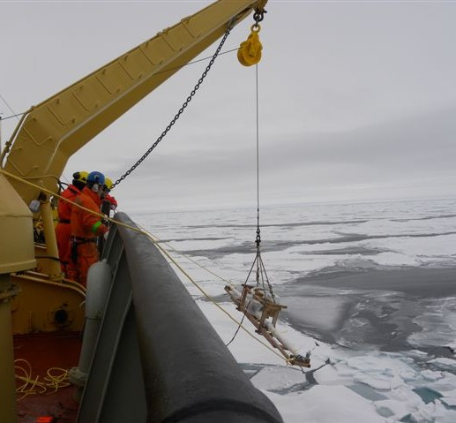
Figure 1. EM Sensor
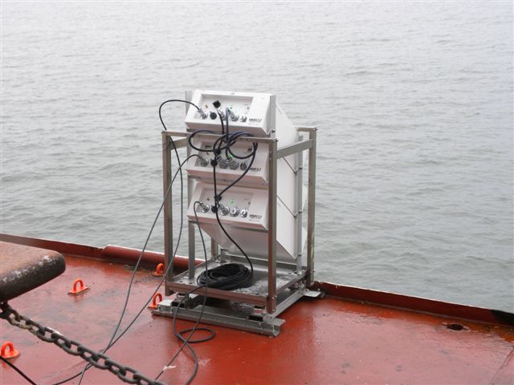
Figure 2. Passive Microwave

Ice station measurements
1. Snow properties survey
Snow depth, skin temperature, internal temperature, density, salinity, storategy(crystal type and size) were measured the in stations 2nd and 3rd. Sampling intervals are 1cm and 3cm for internal temperature and density/salinity, respectively. Snow strategy was recorded in each snow layers.
Those snow properties will be compared with PMR brightness temperatures in order to validate general microwave radiation transfer model for satellite remote sensing. Those data will be used for evaluation of snow and sea-ice conditions in the end of melting and the begging of freezing periods with ice core data.

2.EM transects
The ice team measured total snow and ice thickness distribution in the ice stations 2nd and 3rd to investigate representative sea-ice morphology by drilling and using EM. Apparent conductivities (mS/m) of the Vertical Magnetic Dipole (VMD) and Horizontal Magnetic Dipole (HMD) modes were collected every 2-4 m in order to synchronize ice core and drill-hole. For transformation from apparent conductivity to total snow and ice thickness, Standard 1-D model (Taeteyama et al., 2006) was used.

