LSSL 2009-20 Sampling Report – Kristina Brown, UBC

2009-20 Field Season Objectives

The objectives for the 2009-20 field season were designed to build on the work carried out during LSSL 2008-30 and further attempt to associate changes in the physical properties of sea ice with the vertical export of particulate organic (POC) and dissolved inorganic (DIC) carbon at several locations within the Canada Basin. During this field program the attempt was to sample for a variety of key chemical tracers (such as DIC, POC, Alk, & δ¹⁸O-H₂O (referred to herein as ¹⁸O)) from regions of seasonal, semi-permanent, and permanently ice covered regions throughout the basin at sites that represent the transition from the shallow Beaufort Shelf, to shelf break, into the deep northern portion of the Canada basin, as sampling opportunity would allow. It is hoped that the investigations involving these main chemical tracers will be further strengthened by the use of stable carbon isotope signatures (δ¹³C-DIC & δ¹³C-POC) to help discern the influences of ice cover on tracer distributions in these different regions.

Building on the sampling objectives outlined during the 2008-30 field season, the goals for the 2009-20 field season included:
- Characterizing the vertical export of sea ice-associated DIC & POC from the surface to deep waters, and lateral export from the shelf to the deep basin, using stable carbon isotopes (δ¹³C-DIC & δ¹³C-POC), stable oxygen isotopes (¹⁸O), and temperature & salinity, from water column profiles throughout the basin;
- Establishing a relationship between the character of ice associated DIC & POC and the physical & biological characteristics of sea ice (i.e. thickness, brine content, porosity, chl a concentration etc);
- Identifying the extent to which sea ice-associated POC contributes to surface water particulate carbon composition, relative to pelagic POC, separating the two using stable carbon isotope signatures (δ¹³C-POC ); and,
- Illustrating the presence of inorganic carbonate precipitates (such as Ikaite CaCO₃·6H₂O) in sea ice samples, as well as the isotope effects imparted by the precipitation of these minerals in sea ice associated brines, including their effects on δ¹³C-DIC & δ¹³C-POC.

The following pages outline the sampling accomplished over the course of the 2009 field season aboard the CCGS Louis S St. Laurent as depicted in Figure 1. Sampling reports are organized into the following categories for clarity:

(1) Surface Water Underway System (Loop)
(2) Sea Ice Sampling
(3) BL Line (Water Column Profiles)
(4) Mooring A & B Profiles

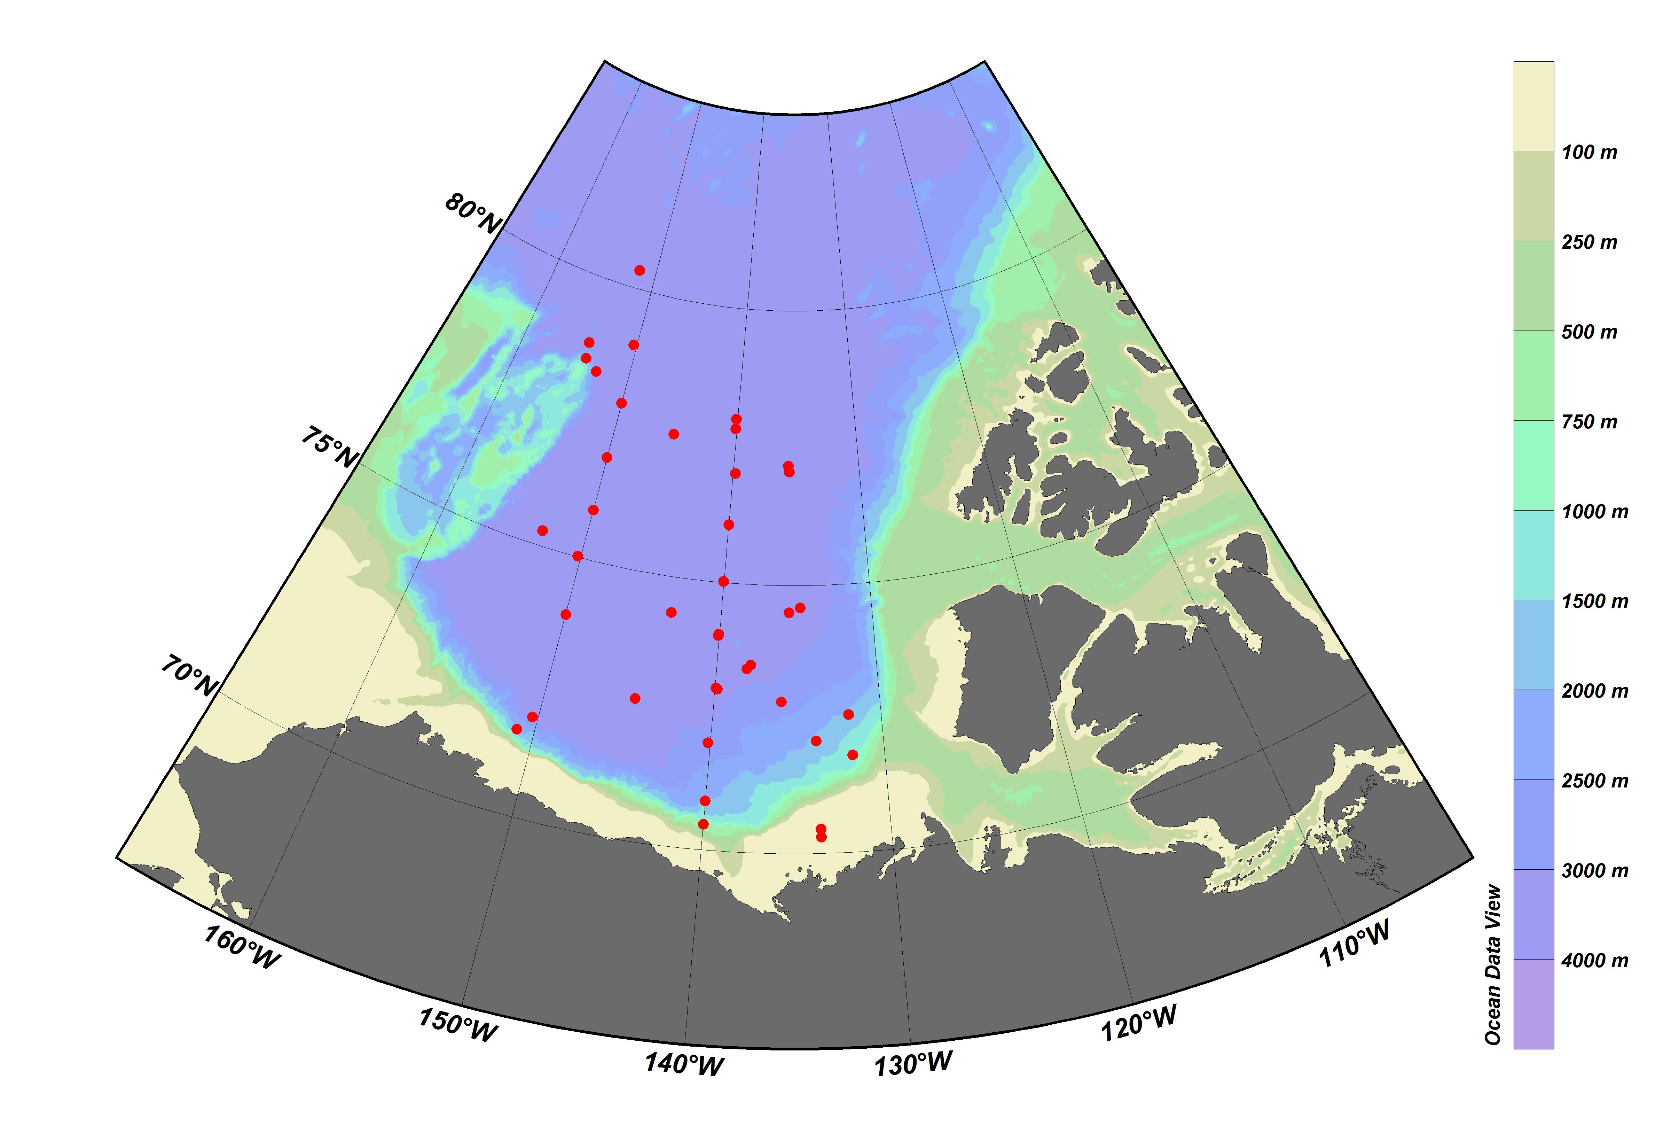
Ice Camp
Zodiac Site
Water Column
Underway

Figure 1. 2009-20 Sampling Stations. Red circles illustrate the locations of underway sampling stations (which also correspond to rosette sampling station locations). Ice camp locations are depicted as yellow triangles, with a green triangle illustrating the zodiac sampling location. Water column samples were collected from stations along the western side of the basin as marked by purple circles.

Surface Water Underway Sampling (Loop)

Surface water was collected at a total of 37 stations throughout the Canada Basin using the ships underway sampling system (Figure 1). Samples were collected for δ¹³C-POC (6-8 L each), δ¹³C-DIC (2x 30 mL each), DIC/Alk (combined in one 250mL bottle), 18O (20 mL), Ba (20 mL), salinity (200 mL), nutrients (2x 15 mL) & Chl a (2 L) (as listed in Appendix 1). As the emphasis of the underway sampling program was to obtain a broad spectrum of ice conditions, sampling was carried out most heavily at off-shelf stations and in association with ice camp stations. A map of AMSR-E sea ice concentration at each underway sampling station is depicted in Figure 2.

Two main factors were considered when designing the underway sampling methods for this field season: first was to consider spatial and temporal continuity with surface rosette samples, and second was to ensure contamination from ship influences was minimized. Spatial and temporal proximity to surface rosette samples was considered important to assess differences between the two collection methods and assess the feasibility of relying more heavily on the underway system to characterize chemical tracer distributions in the surface waters. Sampling for surface water chemical properties is complicated by many factors, one of which is the influence of the ship itself, both in its ability to stir up the surface water column while on station, and to potentially contaminate natural surface water concentrations of certain chemical tracers (for example DOC). Because of these potential negative effects, the location & timing of sampling from the underway system became an important variable to attempt to control. In an effort to standardize sampling methods, sampling of the underway system was conducted once the ship was 20 min from the station location (as it was calculated to require 15mins to draw all the samples from the seawater line), so sampling could be complete once the ship was in place on station. To reduce any “smear” introduced by large volume samples being collected over an extended distance while the ship moved, POC samples in particular were collected in a single volume and mixed before sampling. Discrete samples were collected from a stream split from the intake line which was connected in line with the CDOM & Fluorometer sensors. This split allowed a direct flow from the underway system to the sample container without travelling through the debubbler.

After a few test stations, sampling methods at each station were as follows: (1) Check for absence of bubbles and acceptable flow rates from underway system; (2) UTC data, Time, Lat & Lon recorded; (3) Rinse 10 L cubetainer 3x with underway system water; (4) begin to fill 10 L cubetainer & prep other sample bottles; (5) while cubetainer is filling, remove tubing and draw DIC sample (rinse 500 mL DIC bottle & tube, place tube at bottom of DIC bottle and overflow 1 full volume, place tubing back in cubetainer to continue filling, gently pour off 1% headspace from DIC sample, add 100 uL HgCl2 and stopper bottle with pre-greased stopper); (6) use the same procedure (removing underway sample tube from cubetainer, 3x rinses, fill sample bottle and replace tube in cubetainer) to collect other samples as the cubetainer fills (underway sampling procedures are identical to rosette sampling procedures and sampled in the following order: DIC/TALK, 13C-DIC, 18O, Ba, Salts, nuts); (7) finish filling cubetainer, then draw 2 L Chl a sample; (8) Record UTC Date, Time, Lat & Lon once sampling complete; (9) tape DIC bottle closed, parafilm δ¹³C -DIC vials, label bottles and put away; (10) Filter δ¹³C-POC & Chl a samples.

If δ¹³C-POC & Chl a samples could not be filtered immediately after sampling they were stored in the breezeway outside of the main chemistry lab in a closed Rubbermaid container to keep them cold and limit their exposure to light. Chl a samples were usually filtered immediately after collection and δ¹³C-POC samples were almost always filtered within 4hrs of collection.

Before filtering δ¹³C-POC samples the cubetainer is mixed and separate 2 L small mouth nalgene bottles were rinsed 3x’s with water from the cubetainer. Nalgene bottles were then filled (in duplicate) and filtered on 25 mm precombusted GF/F filters at -0.25 to -0.3 bar pressure. Up to two full 2 L nalgene bottles were filtered for each of the duplicate δ¹³C-POC samples. Filters were stored in tinfoil in the -80degC freezer until being transported to UBC at the end of the cruise.

Chlorophyll a samples were filtered on the same tower set up. Samples were filtered immediately after drawing and covered in a black garbage bag to shield them from ambient light. Chl a samples were filtered according to rosette methods (see Chl a Report) and collected onto new 25 mm GF/F filters after filtering for 20-30 mins (filtering 500 – 1500 mL). Chl a sample filter were stored in glass scintillation vials at - 80degC.

Problems Associated with the Underway System
Uneven Filtering & Clogging (δ¹³C -POC)
Several stations where underway samples were taken produced filters with uneven filtering (splotches) or clogging before almost no water was filtered (Figure 3). This was seen most dramatically in the first few days of the trip but continued intermittently throughout the course of the cruise. After conducting several different tests it was determined that neither the combustion process (combusted vs non-combusted filters), filter batch (2008 vs 2009 filters), bubbles retained on the filter (pre-wetted vs wetted filters), visible ice crystals (none visible), nor clogging by gelatinous substances (none visible) seemed to be the cause. Although no direct cause was determined, several noteworthy observations came out of the tests conducted: (1) samples taken from the rosette at the same location as underway samples did not exhibit the same filter clogging/splotches, indicating that the cause might be associated solely with the underway collection system; and (2) as the cruise continued it seemed δ¹³C –POC filter blotches were more often present when the ship was transiting through a marginal ice zone, and while underway in open water or 100 % ice cover splotches/clogging were less frequent. Detailed records of the conditions of the filters and underway system sampling were recorded in the underway notebook.

Length of Filtering Time (δ¹³C -POC)
Due to the problems with clogging δ¹³C -POC filters it was decided that to attempt to attain maximum material deposition on filters δ¹³C –POC filtering would be carried out for a time period of 1.5 – 2 hours or until all 4.4 L of water were filtered, whichever came first. This ensured that samples were not left to filter for so long that they might bias stable carbon isotope ratios, but also hopefully allowed for enough material to be deposited to yield a reliable signal. Filter times for each sample and duplicate are recorded in the underway system sampling notebook.

Clogging of Underway Line
On occasions when the ship was transiting through thin ice & ice edge conditions the underway sampling system would become clogged with slush and have to be cleaned out by the engine room. Clogging of the system would often be preceded by a decreased flow rate or visible bubble entrainment in the flow stream. When these signs were apparent the engine room was alerted and the underway system pump was shut down to clear the screen at the intake of slush. Often this was something noted and dealt with by the engine room only, so records of the frequency of this occurrence are not complete. When these signs were noted before sampling from the underway system the engine room was informed and slush cleared out before sampling began. On some occasions clogging was experienced soon after underway samples were taken and this was noted in the sampling comments. As the cruise got underway, routine checks of the underway system conditions were recorded by watch keepers over both day & night watches. A record of the underway system conditions is included in the 2009-20 Chem Spreadsheet.

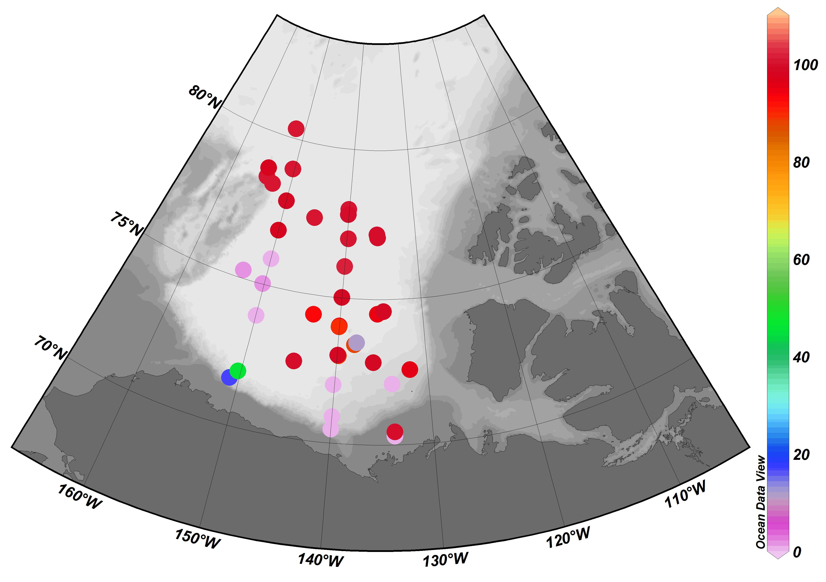

Figure 2. Preliminary* AMSR-E Sea Ice Concentration (%) at Underway Sampling Stations. AMSR-E Sea Ice concentration determined from daily images of % concentration as calculated from surface brightness temperature over 12.5 x 12.5 km grid cells. Nearest neighbour grid cells surrounding station locations are averaged using bi-linear interpolation, resulting in a weighted average for ice concentrations depending on the proximity of stations to grid cell center or corners. *Results still need to be checked against daily images and checked against on ship observations.

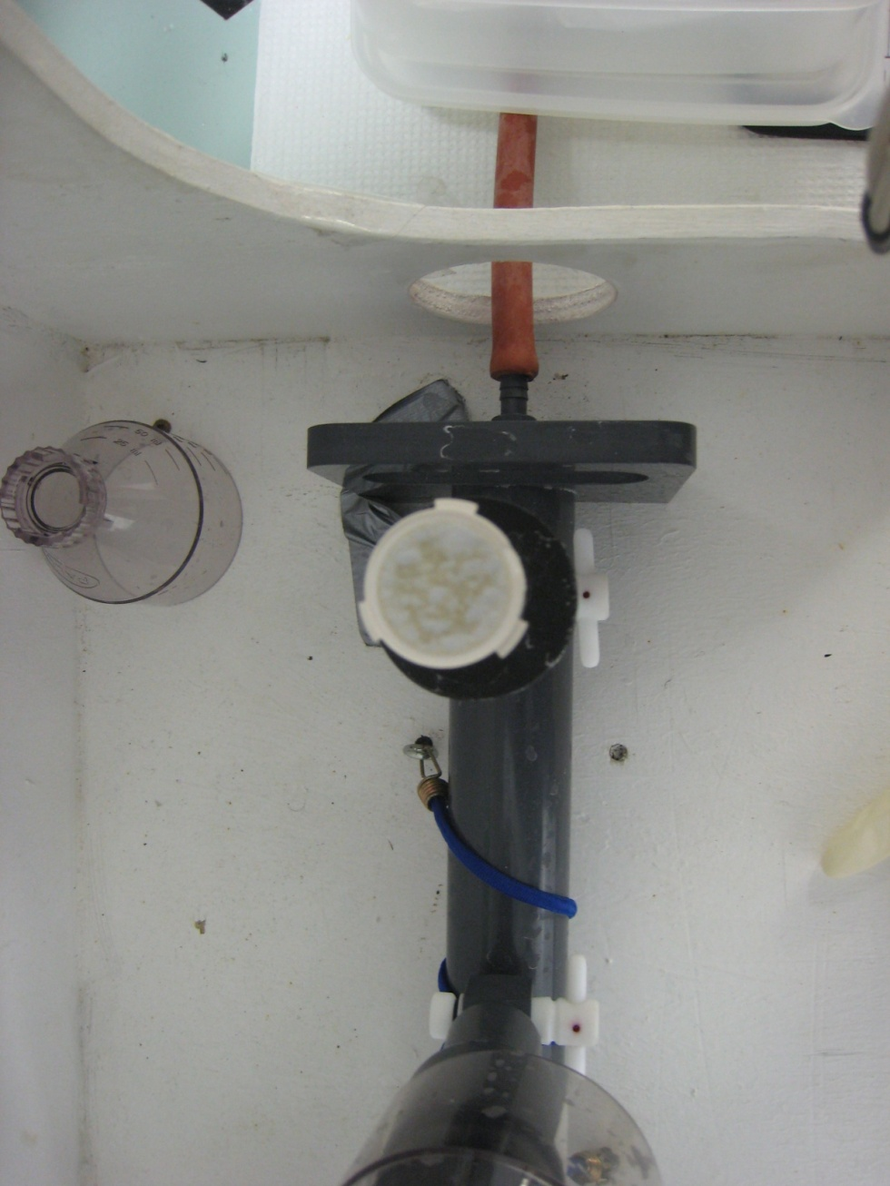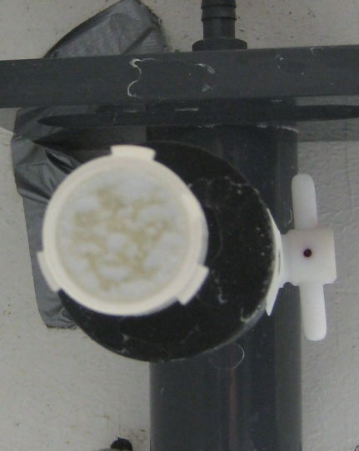

Figure 3. Clogged & splotchy 25 mm pre-combusted GF/F filters after filtering POC sample from underway system.

Sea Ice Sampling

Ice cores and ice/water interface water samples were collected for the determination of chemical tracer concentrations at four different WHOI Ice Tethered Profiling (ITP) sites and one lead site accessed with a zodiac, during the LSSL 2009-20 cruise. These sites were chosen in combination with the Sea Ice Floe Mapping (Jenny Hutchings & Alice Orlich), Snow & EMI Data Collection (Kazutaka Tateyama) and WHOI-ITP (Rick Krishfield et al) programs. ITP 8, 33, 35, & 34, provided sites that were both easily accessible to the coring team and allowed enough time for some combination of ice coring, ice auguring, snow sampling and EM transects to take place as time allowed (yellow triangles in Figure 1). Sea ice core locations were chosen based on accessibility and proximity to WHOI program as some sites were quite small (i.e. ITP 8). When sites provided a mix of first year and multiyear ice, locations were chosen to try and take advantage of this situation (i.e. ITP 35).

At each station location, sea ice cores were collected to obtain a profile of temperature & salinity and samples for assessing chemical characteristics of the ice floe. Sea ice cores collected for temperature profiles were measured on site, with holes drilled at 10cm intervals down the core for a measurement of floe in situ temperature. Following this, cores were cut up into 10cm pieces to be melted on the ship for salinity analyses (Alice Orlich). After temperature profiles were completed, one or two more cores were obtained to asses changes in sea ice chemistry at various depth intervals in the floe (effectively 10cm below the surface, mid-core, & bottom of core). Chemistry cores were cut up on site in 2x10cm pieces at each depth interval and pieces were partitioned into air-tight tedlar bags. Tedlar bags were then evacuated of outside air using a hand pump, and taken back to the ship to be melted in the dark in the aft portside labs.

In total 5 cores were collected for temperature and salinity profile measurements, and 6 cores were collected for chemical parameter sampling back on the ship. Once ice core sections were melted on the ship, samples of the homogenized melt were taken for δ¹³C -DIC, DIC/Alkalinity, Salinity, 18O, δ¹³C -TOC, bacterial abundance and nutrients where volumes allowed. Full cores were also melted for the determination of δ¹³C -POC when possible. In total, 20 individual core sections were sampled for chemical parameters from the 6 cores obtained. Appendix 2a lists the chemistry samples collected from each melted core section and Appendix 2b illustrates results of temperature and salinity profile measurements (courtesy of Alice Orlich).

When site conditions (weather/time) permitted ice/water interface samples were collected down the chemistry core hole using a submersible aquarium pump. Samples were collected through DMQ rinsed Tygon tubing into a 10 L cubetainer from a depth of 1.3 m down the chemistry core hole. Once back on the ship each 10 L cubetainer was sub-sampled for the following parameters: δ¹³C -DIC, DIC/Alkalinity, Salinity, 18O, Ba, Chl a, δ¹³C -POC and nutrients. Appendix 2a lists the chemistry samples collected while pumping from each core hole.

Ice conditions at between stations CB15 & CB17 provided a unique opportunity to collect young ice from the zodiac. New ice between 4 and 8 cm thick was collected over the side of the zodiac either using the SIPREE ice corer (without the power head) or cutting chunks of ice with a hand saw. Samples of cored ice were placed in tedlar bags and crimped sealed, while hand cut chunks were placed either in large, heavy clear plastic bags, or in double length tedlar bags. Surface ice temperature, air temperature, and a sample for surface water salinity were also taken. Once back on the ship, tedlar bags were evacuated of excess head space and melted in the dark. Once melted, cored ice pieces & hand cut pieces in tedlar bags were sampled for δ¹³C -DIC, DIC/Alkalinity, Salinity, del¹⁸O, δ¹³C -TOC, bacterial abundance and density. The large hand cut ice pieces in heavy plastic bags were melted in the dark over 36-48hrs and filtered for δ¹³C -POC after melting. Appendix 2a lists the chemistry samples collected from young ice sampled with the zodiac.

BL Line (Water Column Profiles) (in conjunction with Michiyo Yamamoto-Kawai)

As was carried out during the 2008-30 field program, water column profiles at stations BL-8, BL-4, BL-3 & BL-2 were revisited during 2009 program in an attempt to capture the δ¹³C-DIC, DIC, TALK & ¹⁸O signatures of Pacific Summer & Pacific Winter Waters entering the south western corner of the Canada Basin, near Barrow, Alaska. Appendix 3 lists the depths and chemical tracer samples collected at each station.

Mooring A & B Profiles (in conjunction with Brian Hunt, UBC/IOS)

In an effort to repeat water column sampling carried out at the mooring stations in 2008, samples for DIC, δ¹³C -DIC, 18O & δ¹³C-POC were collected at WHOI-A (CB4) & WHOI-B (CB9) during the 2009-20 program. As niskin bottle water was under heavy demand, and time constraints limited the number of full depth casts possible at each of the stations, the volume filtered for δ¹³C-POC samples was limited to the remaining volume in the niskin bottle after other parameters were sampled (usually about 4 L). δ¹³C-POC samples were filtered on pre-combusted 25 mm GF/F filters immediately after sampling was completed and filters were stored in tinfoil in the -80degC freezer until being transported to UBC at the end of the cruise. Results compiled from the 2008 & 2009 δ¹³C -POC data set will hopefully be used in conjunction with zooplankton net cast data to gain a better understanding of food web interactions and particulate material export.

Depths and details of the chemical parameters sampled at Moorings A & B are listed in Appendix 3.

Appendix 1: Surface Water Underway Sampling Stations & Samples Collected during the LSSL 2009-20 program
UTC Date | Time | Lat (N) | Lat dec (rough) | Long (W) | Lon dec (rough) | Sample # | POC | DIC | C13-DIC | O18 | Chl-a | SAL | Ba | NUTS
09/20/2009 | 12:12 |  |  |  |  | UW-1 | 2 | 1 | 2 | 2 |  | 1
09/21/2009 | 1:09 | 72 6.864 | 72.1144 | 133 53.355 | -133.88925 | UW-5 | 2 | 1 | 2 | 2 | 1 | 1
09/21/2009 | 23:50 | 70 18.689 | 70.31148333 | 133 43.921 | -133.7320167 | UW-9 | 2
09/22/2009 | 0:26 | 70 27.582 | 70.4597 | 133 43.864 | -133.7310667 | UW-10 | 2
09/22/2009 | 15:37 | 72 50.971 | 72.84951667 | 135 56.363 | -135.9393833 | UW-15 | 2 | 1 | 2 | 2 |  | 1
09/23/2009 | 0:41 | 73 26.416 | 73.44026667 | 137 67.656 | -138.1276 | UW-21 | 2 | 1 | 2 | 1 | 1 | 1 | 1 | 2
09/23/2009 | 9:12 | 73 1.756 | 73.02926667 | 139 51.836 | -139.8639333 | UW-24 | 2 | 1 | 2 | 1 | 1 | 1 | 1 | 2
09/23/2009 | 11:49 | 73 02.92 | 73.04866667 | 139 56.081 | -139.9346833 | UW-25 | 2
09/23/2009 | 16:08 | 72 35.173 | 72.58621667 | 131 55.800 | -131.93 | UW-27 | 2 | 1 | 2 | 1 |  | 1 | 1 | 2
09/24/2009 | 8:08 | 72 39.886 | 72.66476667 | 144 42.00 | -144.7 | UW-31 | 2 | 1 | 2 | 1 | 2 | 1 | 1 | 2
09/24/2009 | 22:17 | 72 1.250 | 72.02083333 | 140 8.537 | -140.1422833 | UW-35 | 2 | 1 | 2 | 1 | 1 | 1 | 1 | 22
09/27/2009 | 6:42 | 70 29.130 | 70.4855 | 140 0.324 | -140.0054 | UW-47 | 2 | 1 | 2 | 1 | 1 | 1 | 1 | 2
09/27/2009 | 9:42 | 70 55.542 | 70.9257 | 140 0.524 | -140.0087333 | UW-48 | 2 | 1 | 2 | 1 | 1 | 1 | 1 | 2
09/28/2009 | 4:08 | 71 37.3 | 71.62166667 | 151 00.00 | -151 | UW-54 | 2 | 1 | 2 | 1 | 1 | 1 | 1 | 2
09/28/2009 | 14:57 | 71 54.919 | 71.91531667 | 150 19.214 | -150.3202333 | UW-55 | 2 | 1 | 2 | 1 | 1 | 1 | 1 | 2
09/29/2009 | 9:17 | 73 55.164 | 73.9194 | 149 58.722 | -149.9787 | UW-62 | 2 | 1 | 2 | 1 | 1 | 1 | 1 | 2
09/30/2009 | 5:40 | 75 16.822 | 75.28036667 | 153 3.314 | -153.0552333 | UW-67 | 2 | 1 | 2 | 1 | 1 | 1 | 1 | 2
09/30/2009 | 12:00 | 75 1.211 | 75.02018333 | 150 13.33 | -150.2221667 | UW-68 | 2 | 1 | 2 | 1 | 1 | 1 | 1 | 2
10/01/2009 | 1:57 | 75 54.203 | 75.90338333 | 149 59.839 | -149.9973167 | UW-72 | 2 | 1 | 2 | 1 | 1 | 1 | 1 | 2
10/01/2009 | 9:28 | 76 53.981 | 76.89968333 | 150 1.051 | -150.0175167 | UW-73 | 2 | 1 | 2 | 1 | 1 | 1 | 1 | 2
10/01/2009 | 16:35 | 77 55.348 | 77.92246667 | 150 0.151 | -150.0025167 | UW-75 | 2 | 1 | 2 | 1 | 1 | 1 | 1 | 2
10/02/2009 | 9:28 | 78 20.749 | 78.34581667 | 152 53.773 | -152.8962167 | UW-80 | 2 | 1 | 2 | 1 |  | 1
10/02/2009 | 20:17 | 78 31.081 | 78.51801667 | 154 7.198 | -154.1199667 | UW-83 | 2 | 1 | 2 | 1 | 1 | 1 | 1 | 2
10/03/2009 | 0:28 | 78 48.28 | 78.80466667 | 154 18.014 | -154.3002333 | UW-85 | 2 | 1 | 2 | 1 | 1 | 1 | 1 | 2
10/04/2009 | 3:06 | 80 19.385 | 80.32308333 | 151 46.130 | -151.7688333 | UW-88 | 2 | 1 | 2 | 1 | 1 | 1 | 1 | 2
10/04/2009 | 20:25 | 79 0.139 | 79.00231667 | 150 17.813 | -150.2968833 | UW-92 | 2 | 1 | 2 | 1 | 1 | 1 | 1 | 2
10/05/2009 | 6:51 | 77 34.564 | 77.57606667 | 145 11.461 | -145.1910167 | UW-96 | 2 | 1 | 2 | 1 | 1 | 1 | 1 | 2
10/06/2009 | 1:05 | 77 59.831 | 77.99718333 | 140 7.445 | -140.1240833 | UW-102 | 2 | 1 | 2 | 1 | 1 | 1
10/07/2009 | 2:02 | 77 49.26 | 77.821 | 140 6.650 | -140.1108333 | UW-104 | 2 | 1 | 2 | 1 | 1 | 1 |  | 2
10/07/2009 | 11:11 | 77 11.304 | 77.1884 | 135 38.933 | -135.6488833 | UW-110 | 2 | 1 | 2 | 1 | 1 | 1 | 1
10/08/2009 | 2:26 | 77 4.920 | 77.082 | 135 33.142 | -135.5523667 | UW-111 | 2
10/08/2009 | 10:30 | 77 0.683 | 77.01138333 | 139 49.691 | -139.8281833 | UW-116 | 2 | 1 | 2 | 1 | 1 | 1 | 1
10/08/2009 | 21:57 | 76 4.279 | 76.07131667 | 140 0.412 | -140.0068667 | UW-119 | 2 | 1 | 2 | 1 | 1 | 1 | 1 | 2
10/09/2009 | 6:47 | 75 1.493 | 75.02488333 | 140 1.378 | -140.0229667 | UW-121 | 2 | 1 | 2 | 1 | 1 | 1 | 1 | 2
10/09/2009 | 16:56 | 74 2.839 | 74.04731667 | 140 3.169 | -140.0528167 | UW-123 | 2 | 1 | 2 | 1 | 1 | 1 | 1
10/10/2009 | 10:30 | 74 30.186 | 74.5031 | 135 31.420 | -135.5236667 | UW-131 | 2 | 1 | 2 | 1 | 1 | 1 | 1 | 2
10/10/2009 | 22:03 | 74 35.515 | 74.59191667 | 134 46.189 | -134.7698167 | UW-133 | 2 | 1 | 2 | 1 | 1 | 1 | 1 | 2
10/12/2009 | 5:04 | 74 20.563 | 74.34271667 | 143 16.594 | -143.2765667 | UW-141 | 2 | 1 | 2 | 1 | 1 | 1 | 1 | 2
10/12/2009 | 15:46 | 74 1.145 | 74.01908333 | 140 4.056 | -140.0676 | UW-145 | 2 | 1 | 2 | 1 | 1 | 1 | 1 | 2
10/13/2009 | 5:00 | 73 30.958 | 73.51596667 | 137 53.033 | -137.8838833 | UW-149 | 2 | 1 | 2 | 1 | 1 | 1 | 1 | 2
10/13/2009 | 23:20 | 71 49.77 | 71.8295 | 131 49.41 | -131.8235 | UW-152 | 2 | 1 | 2 | 1 | 1 | 1 | 1 | 2

Appendix 2a: Sea Ice Camp & Zodiac Sampling
Date | Station | Type of Sample | Depth of Sample |  | Bag # |  | 13C-POC | DIC/TALK | 13C-DIC | 13C-TOC | 18O | Bacteria | salinity
03/10/2009 | ITP8 | Core 2: Section 1 | 5-25cm |  | 10 |  |  | 1 | 2 | 1 | 1 | 1 | 1
03/10/2009 | ITP8 | Core 2: Section 2 | 40-60cm |  | 13 |  |  | 1 | 2 |  | 1
03/10/2009 | ITP8 | Core 2: Section 3 | 70-90cm |  | 12 |  |  | 1 | 2 |  | 1 | 1 | 1
03/10/2009 | ITP8 | Core 2: Section 4 | 116-126cm |  | 9 |  |  | 1 | 2 | 1 | 1 | 1 | 1
03/10/2009 | ITP8 | Core 2: Section 5 | bottom 20 |  | 3 |  |  | 1 | 2 | 1 | 1 | 1 | 1
06/10/2009 | ITP33 | PUMP 1 | 110cm |  | 1 |  | 2 | 1 | 2 |  | 2 |  | 1
06/10/2009 | ITP33 | PUMP 2 | 110cm |  | 2 |  | 1 | 1 | 2 |  | 2 |  | 1
07/10/2009 | ITP35 | Core 2: Section 1 | 28 - 54cm |  | 10 |  |  | 1 | 2
07/10/2009 | ITP35 | Core 2: Section 2 | 98-118cm |  | 1 |  |  | 1 | 2 | 2 | 1 | 1 | 1
07/10/2009 | ITP35 | Core 2: Section 3 | 157-177cm |  | 20 |  |  | 1 | 2 | 2 | 1 | 1 | 1
07/10/2009 | ITP35 | Core 2: Section 4 | 186-206cm |  | 7 |  |  | 1 | 2 | 2 | 1 | 1 | 1
07/10/2009 | ITP35 | Core 2: Section 5 | 226-251cm |  | 5 |  |  | 1 | 2 | 2 | 1 | 1 | 1
07/10/2009 | ITP35 | Core 2: Section 6 | 302-322cm |  | 6 |  |  | 1 | 2 |  | 1 | 1 | 1
07/10/2009 | ITP35 | Core 2: Section 7 | bottom chunks |  | 2 |  |  | 1 | 2 | 2 | 1 | 1 | 1
07/10/2009 | ITP35 | SNOW | upper snow layer (loose) |  |  |  |  |  |  |  | 2 | 1
07/10/2009 | ITP35 | SNOW | lower hard pack snow |  |  |  |  |  |  |  | 2 | 1
07/10/2009 | ITP35 | SNOW | Kazu's snow pits 18O |  |  |  |  |  |  |  | 17
07/10/2009 | ITP35 | Core 4: Section 1 | 0-21cm |  | 21 |  |  | 1 | 2 | 2 | 1 | 1 | 1
07/10/2009 | ITP35 | Core 4: Section 2 | 21-46cm |  | 22 |  |  | 1 | 2 | 2 | 1 | 1 | 1
07/10/2009 | ITP35 | Core 4: Section 3 | 46-79cm |  | 23 |  |  | 1 | 2 | 2 | 1 | 1 | 1
07/10/2009 | ITP35 | Core 5: Section 1 | 0-88cm |  | 1 |  | 2
07/10/2009 | ITP35 | Core 6: Section 1 | 0-80cm |  | 2 |  | 2 |  |  |  |  |  | 1
08/10/2009 | Zodiac SITE 1 | POC-1 | 7cm |  | 1 |  | 1
08/10/2009 | Zodiac SITE 1 | POC-2 | 6.5cm |  | 2 |  | 1
08/10/2009 | Zodiac SITE 1 | DIC-1 | 6.5cm |  | L3 |  |  | 4 | 2 | 2 | 1 | 1 | 1
08/10/2009 | Zodiac SITE 1 | DIC-2 | 7cm |  | L1 |  |  | 4 | 2 | 2 | 1 | 1 | 1
08/10/2009 | Zodiac SITE 1 | Core 1 | 6cm |  | S17 |  |  |  | 2 |  |  |  | 1
08/10/2009 | Zodiac SITE 1 | Core 2 + 3 | 4 + 4cm |  | S14
08/10/2009 | Zodiac SITE 2 | Core 4 + 6 | 6.5cm + 7 cm |  | S15 |  |  | 1 | 2 |  | 1 | 1 | 1
08/10/2009 | Zodiac SITE 2 | DIC-3 | 7cm + 8cm |  | L5 |  |  | 7 | 2 | 2 | 1 | 1 | 1
08/10/2009 | Zodiac SITE 2 | POC-3 | 8cm |  | 3 |  | 2
10/10/2009 | ITP34 | T&S Core | 295cm |  |  |  |  |  |  |  | 30
10/10/2009 | ITP34 | CORE 2: Section 1 | 113 |  | 1 |  | 2
10/10/2009 | ITP34 | CORE 2: Section 2 | 104 |  | 2 |  | 2
10/10/2009 | ITP34 | CORE 2: Section 3 | 77.3 |  | 3 |  | 2
10/10/2009 | ITP34 | PUMP 1 | 110 cm |  | 2 |  | 1 | 1 | 2 |  | 1 |  | 1
10/10/2009 | ITP34 | PUMP 2 | 110 cm |  | 1 |  | 1 | 1 | 2 |  | 1 |  | 1
TOTAL |  |  |  |  |  |  | 19 | 35 | 48 | 25 | 75 | 19 | 23

Appendix 2b : Physical Ice Core Data from Ice Camps (courtesy of Alice Orlich)
Ice Core results from JOIS 2009 - Alice Orlich
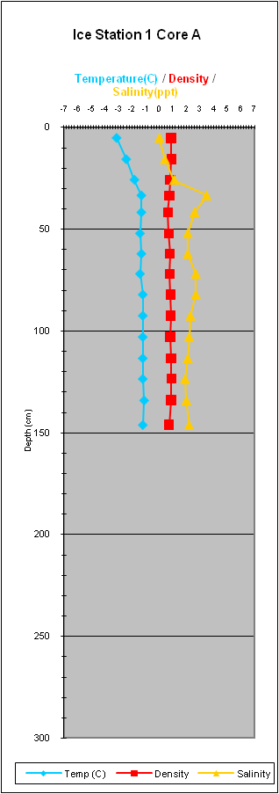
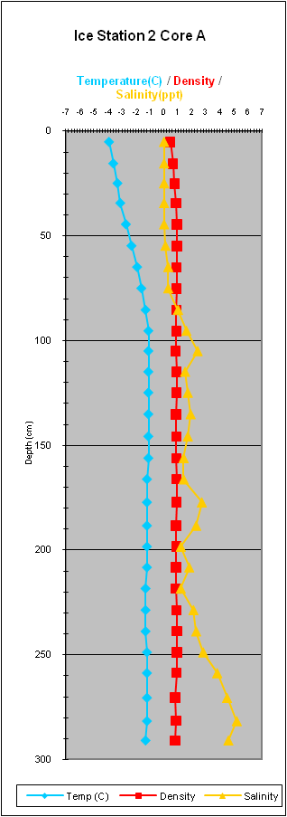
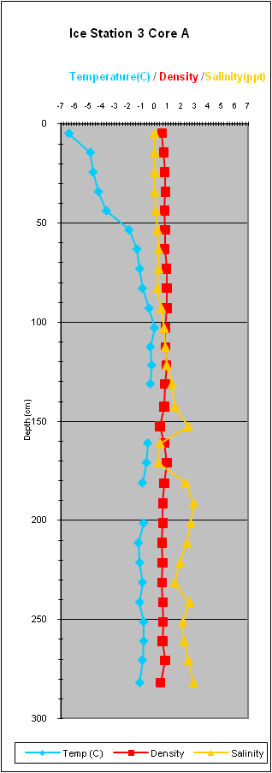
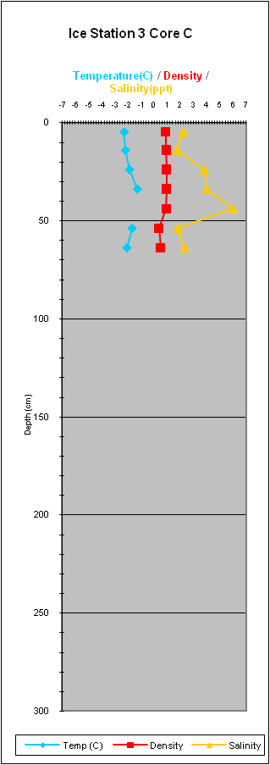
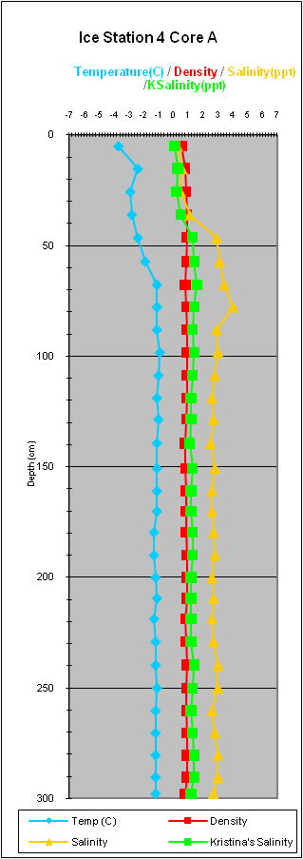

Detail of Density and Salinity - Ice Core results from JOIS 2009 - Alice Orlich
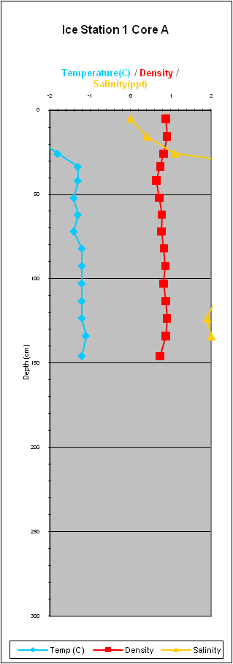
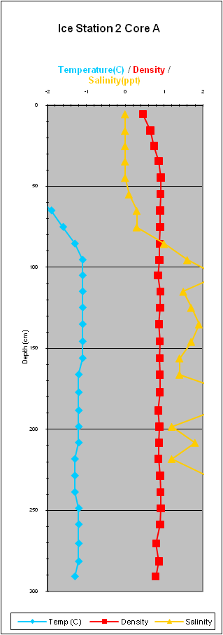
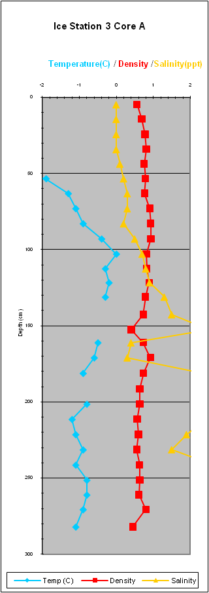
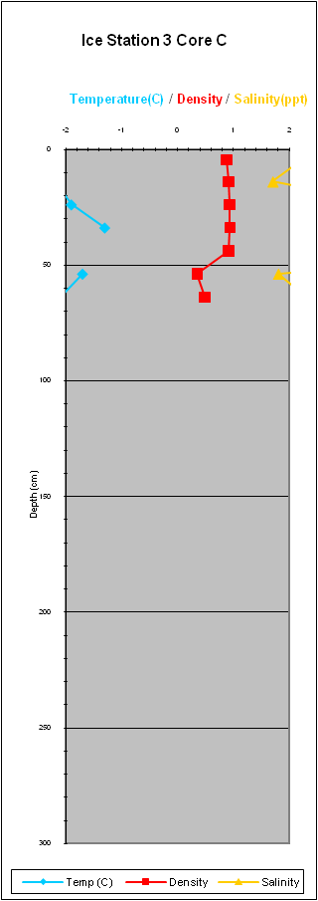
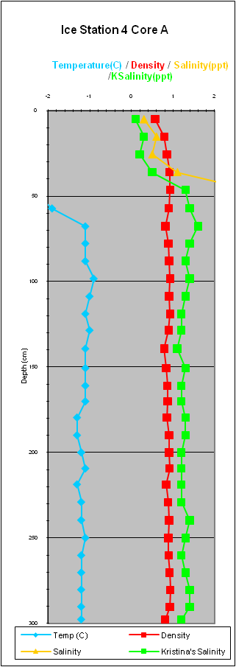

Appendix 3: Water Column Samples
LSSL 2009-20 |  |  |  |  | GEOCHEMISTRY
CTD Cast # | Stn | Raw pressure (dbar) | Sample# | Niskin # | Bottle Quality | Oxygen | DIC/ALK | DIC (KB) | 13C-DIC (KB) | Chl a (Total) | FW Alk | NUT | Salt | O18 | Ba | POC
15 | BL-6 | 2038.886 | 297 | 1 | 0 | 1 |  | 2 | 2 |  | 1 | 3 | 1 | 1 | 1
15 | BL-6 | 1828.822 | 298 | 2 | 0 | 1 |  |  |  |  |  | 3 | 1
15 | BL-6 | 1523.346 | 299 | 3 | 0 | 3 |  |  |  |  |  | 3 | 1
15 | BL-6 | 1217.985 | 300 | 4 | 0 | 1 |  | 1 | 2 |  | 1 | 3 | 1 | 1 | 1
15 | BL-6 | 1014.907 | 301 | 5 | 0 | 1 |  |  |  |  |  | 3 | 1
15 | BL-6 | 811.514 | 302 | 6 | 0 | 1 |  |  |  |  |  | 3 | 1
15 | BL-6 | 609.027 | 303 | 7 | 0 | 1 |  | 1 | 2 |  | 1 | 3 | 1 | 1 | 1
15 | BL-6 | 508.121 | 304 | 8 | 0 | 1 |  |  |  |  |  | 3 | 2
15 | BL-6 | 456.456 | 305 | 9 | 0 | 1 |  | 1 | 2 |  | 1 | 3 | 1 | 1 | 1
15 | BL-6 | 406.888 | 306 | 10 | 0 | 1 |  |  |  |  |  | 3 | 1
15 | BL-6 | 321.641 | 307 | 11 | 0 | 1 |  |  |  |  |  | 3 | 1
15 | BL-6 | 299.58 | 308 | 12 | 0 | 1 |  |  |  |  |  | 3 | 1
15 | BL-6 | 270.299 | 309 | 13 | 0 | 1 |  |  |  |  | 1 | 3 | 2 | 1 | 1
15 | BL-6 | 242.908 | 310 | 14 | 0 | 1 |  |  |  |  | 1 | 3 | 1 | 1 | 1
15 | BL-6 | 215.445 | 311 | 15 | 0 | 1 |  | 1 | 2 |  | 1 | 3 | 1 | 1 | 1
15 | BL-6 | 188.37 | 312 | 16 | 0 | 1 |  | 1 | 2 |  | 1 | 3 | 1 | 1 | 1
15 | BL-6 | 171.088 | 313 | 17 | 0 | 1 |  | 2 | 2 |  | 1 | 3 | 1 | 1 | 1
15 | BL-6 | 158.242 | 314 | 18 | 0 | 2 |  | 1 | 2 |  | 1 | 3 | 1 | 1 | 1
15 | BL-6 | 133.69 | 315 | 19 | 0 | 1 |  | 1 | 2 |  | 1 | 3 | 1 | 1 | 1
15 | BL-6 | 113.716 | 316 | 20 | 0 | 1 |  |  |  |  | 1 | 3 | 2 | 1 | 1
15 | BL-6 | 82.421 | 317 | 21 | 0 | 1 |  |  |  |  | 1 | 3 | 1 | 1 | 1
15 | BL-6 | 46.683 | 318 | 22 | 0 | 1 |  |  |  |  | 1 | 3 | 1 | 2 | 1
15 | BL-6 | 21.472 | 319 | 23 | 0 | 1 |  |  |  |  | 1 | 3 | 1 | 1 | 1
15 | BL-6 | 5.313 | 320 | 24 | 0 | 1 | 1 |  |  |  | 1 | 3 | 1 | 1 | 1
16 | BL-2 | 140.535 | 321 | 1 | 0 | 1 |  | 2 | 2 |  | 1 | 3 | 1 | 1 | 1
16 | BL-2 | 102.447 | 322 | 2 | 0 | 2 |  | 1 | 2 |  | 1 | 3 | 1 | 1 | 1
16 | BL-2 | 92.406 | 323 | 3 | 0 | 1 |  | 1 | 2 |  | 1 | 3 | 1 | 2 | 2
16 | BL-2 | 72.782 | 324 | 4 | 0 | 1 |  | 2 | 2 |  | 1 | 3 | 1 | 1 | 1
16 | BL-2 | 47.02 | 325 | 5 | 0 | 1 |  | 1 | 2 |  | 1 | 3 | 1 | 1 | 1
16 | BL-2 | 31.589 | 326 | 6 | 0 | 1 |  | 1 | 2 |  | 1 | 3 | 1 | 1 | 1
16 | BL-2 | 21.37 | 327 | 7 | 0 | 1 |  | 1 | 2 |  | 1 | 3 | 2 | 1 | 1
16 | BL-2 | 5.919 | 328 | 8 | 0 | 1 | 1 | 1 | 2 |  | 1 | 3 | 1 | 1 | 1
17 | BL-4 | 827.326 | 329 | 1 | 0 | 1 |  | 1 | 2 |  | 1 | 3 | 1 | 1 | 1
17 | BL-4 | 812.089 | 330 | 2 | 0 | 1 |  | 1 | 2 |  | 1 | 3 | 2 | 1 | 1
17 | BL-4 | 608.502 | 331 | 3 | 0 | 3 |  | 1 | 2 |  | 1 | 3 | 1 | 1 | 1
17 | BL-4 | 508.09 | 332 | 4 | 0 | 1 |  | 2 | 2 |  | 1 | 3 | 1 | 1 | 1
17 | BL-4 | 457.132 | 333 | 5 | 0 | 1 |  | 1 | 2 |  | 1 | 3 | 1 | 1 | 1
17 | BL-4 | 322.059 | 334 | 6 | 0 | 2 |  | 1 | 2 |  | 1 | 3 | 1 | 1 | 1
17 | BL-4 | 292.021 | 335 | 7 | 0 | 1 |  | 1 | 2 |  | 1 | 3 | 2 | 1 | 1
17 | BL-4 | 270.34 | 336 | 8 | 0 | 1 |  | 1 | 2 |  | 1 | 3 | 1 | 1 | 1
17 | BL-4 | 234.637 | 337 | 9 | 0 | 1 |  | 1 | 2 |  | 1 | 3 | 1 | 1 | 1
17 | BL-4 | 211.625 | 338 | 10 | 0 | 1 |  | 1 | 2 |  | 1 | 3 | 1 | 1 | 1
17 | BL-4 | 182.225 | 339 | 11 | 0 | 1 |  | 1 | 2 |  | 1 | 3 | 1 | 2 | 2
17 | BL-4 | 157.116 | 340 | 12 | 0 | 2 |  | 1 | 2 |  | 1 | 3 | 1 | 1 | 1
17 | BL-4 | 143.13 | 341 | 13 | 0 | 1 |  | 2 | 2 |  | 1 | 3 | 1 | 1 | 1
17 | BL-4 | 136.047 | 342 | 14 | 0 | 1 |  | 1 | 2 |  | 1 | 3 | 1 | 1 | 1
17 | BL-4 | 118.521 | 343 | 15 | 0 | 1 |  | 1 | 2 |  | 1 | 3 | 1 | 1 | 1
17 | BL-4 | 111.588 | 344 | 16 | 0 | 1 |  | 1 | 2 |  | 1 | 3 | 1 | 1 | 1
17 | BL-4 | 52.168 | 345 | 17 | 0 | 1 |  | 1 | 2 | 2 | 1 | 3 | 1 | 1 | 1
17 | BL-4 | 46.872 | 346 | 18 | 0 | 1 |  | 1 | 2 | 2 | 1 | 3 | 1 | 1 | 1
17 | BL-4 | 21.474 | 347 | 19 | 0 | 1 |  | 1 | 2 | 2 | 1 | 3 | 1 | 1 | 1
17 | BL-4 | 6.112 | 348 | 20 | 0 | 1 | 1 | 1 | 2 |  | 1 | 3 | 1 | 1 | 1
18 | BL-8 | 3033.068 | 349 | 1 | 0 | 1 |  | 2 | 2 |  | 1 | 3 | 1 | 1 | 1
18 | BL-8 | 2543.186 | 350 | 2 | 0 | 1 |  | 1 | 2 |  | 1 | 3 | 2 | 1 | 1
18 | BL-8 | 2032.659 | 351 | 3 | 0 | 1 |  | 1 | 2 |  | 1 | 3 | 1 | 1 | 1
18 | BL-8 | 1523.364 | 352 | 4 | 0 | 2 |  | 1 | 2 |  | 1 | 3 | 1 | 1 | 1
18 | BL-8 | 1023.763 | 353 | 5 | 0 | 1 |  | 1 | 2 |  | 1 | 3 | 1 | 1 | 1
18 | BL-8 | 812.203 | 354 | 6 | 0 | 1 |  | 1 | 2 |  | 1 | 3 | 1 | 1 | 1
18 | BL-8 | 610.183 | 355 | 7 | 0 | 1 |  | 1 | 2 |  | 1 | 3 | 1 | 1 | 1
18 | BL-8 | 508.734 | 356 | 8 | 0 | 1 |  | 1 | 2 |  | 1 | 3 | 1 | 1 | 1
18 | BL-8 | 457.222 | 357 | 9 | 0 | 1 |  | 1 | 2 |  | 1 | 3 | 1 | 1 | 1
18 | BL-8 | 400.261 | 358 | 10 | 0 | 1 |  | 2 | 2 |  | 1 | 3 | 1 | 1 | 1
18 | BL-8 | 338.216 | 359 | 11 | 1 | 3 |  | 1 | 2 |  | 1 | 3 | 1 | 1 | 1
18 | BL-8 | 309.652 | 360 | 12 | 0 | 1 |  | 1 | 2 |  | 1 | 3 | 2 | 2 | 2
18 | BL-8 | 275.47 | 361 | 13 | 0 | 1 |  | 1 | 2 |  | 1 | 3 | 1 | 1 | 1
18 | BL-8 | 242.136 | 362 | 14 | 0 | 1 |  | 1 | 2 |  | 1 | 3 | 1 | 1 | 1
18 | BL-8 | 214.167 | 363 | 15 | 0 | 1 |  | 1 | 2 |  | 1 | 3 | 1 | 1 | 1
18 | BL-8 | 196.71 | 364 | 16 | 0 | 1 |  | 1 | 2 |  | 1 | 3 | 1 | 1 | 1
18 | BL-8 | 178.56 | 365 | 17 | 0 | 2 |  | 2 | 2 |  | 1 | 3 | 1 | 1 | 1
18 | BL-8 | 164.15 | 366 | 18 | 0 | 1 |  | 1 | 2 |  | 1 | 3 | 2 | 1 | 1
18 | BL-8 | 141.08 | 367 | 19 | 0 | 1 |  | 1 | 2 |  | 1 | 3 | 1 | 1 | 1
18 | BL-8 | 110.765 | 368 | 20 | 0 | 1 |  | 1 | 2 |  | 1 | 3 | 1 | 1 | 1
18 | BL-8 | 59.321 | 369 | 21 | 0 | 1 |  | 1 | 2 | 2 | 1 | 3 | 1 | 1 | 1
18 | BL-8 | 32.649 | 370 | 22 | 0 | 1 |  | 1 | 2 | 2 | 1 | 3 | 1 | 1 | 1
18 | BL-8 | 21.558 | 371 | 23 | 0 | 1 |  | 1 | 2 | 2 | 1 | 3 | 1 | 1 | 1
18 | BL-8 | 7.284 | 372 | 24 | 0 | 1 | 1 | 1 | 2 |  | 1 | 3 | 1 | 1 | 1
23 | CB-4 | 3891.86 | 445 | 1 | 0 | 1 | 1 |  | 1 |  |  | 3 | 1 | 1 | 1 | 2
23 | CB-4 | 3774.541 | 446 | 2 | 0 | 3 |  |  |  |  |  | 3 | 1 | 1 | 1
23 | CB-4 | 3671.548 | 447 | 3 | 0 | 1 |  |  |  |  |  | 3 | 1 | 1 | 1
23 | CB-4 | 3568.372 | 448 | 4 | 0 | 1 |  |  |  |  |  | 3 | 2 | 1 | 1
23 | CB-4 | 3466.382 | 449 | 5 | 0 | 1 | 2 |  | 2 |  |  | 3 | 1 | 1 | 1 | 2
23 | CB-4 | 3363.546 | 450 | 6 | 0 | 1 |  |  |  |  |  | 3 | 1 | 1 | 1
23 | CB-4 | 3261.06 | 451 | 7 | 0 | 2 |  |  |  |  |  | 3 | 1 | 1 | 1
23 | CB-4 | 3158.959 | 452 | 8 | 0 | 1 | 1 |  | 1 |  |  | 3 | 1 | 1 | 1 | 2
23 | CB-4 | 3056.703 | 453 | 9 | 0 | 1 |  |  |  |  |  | 3 | 1 | 1 | 1
23 | CB-4 | 2953.465 | 454 | 10 | 0 | 1 |  |  |  |  |  | 3 | 1 | 1 | 1
23 | CB-4 | 2851.831 | 455 | 11 | 0 | 1 |  |  |  |  |  | 3 | 2 | 1 | 1
23 | CB-4 | 2749.022 | 456 | 12 | 0 | 2 |  |  |  |  |  | 3 | 1 | 1 | 1
23 | CB-4 | 2645.568 | 457 | 13 | 0 | 1 |  |  |  |  |  | 3 | 1 | 1 | 1
23 | CB-4 | 2543.824 | 458 | 14 | 0 | 1 | 1 |  | 1 |  |  | 3 | 1 | 1 | 1 | 2
23 | CB-4 | 2032.744 | 459 | 15 | 0 | 2 | 1 |  | 1 |  |  | 3 | 1 | 1 | 1 | 2
23 | CB-4 | 1829.872 | 460 | 16 | 0 | 1 |  |  |  |  |  | 3 | 1 | 1 | 1
23 | CB-4 | 1523.937 | 461 | 17 | 0 | 2 | 1 |  | 1 |  |  | 3 | 1 | 1 | 1 | 2
25 | CB-4* | 1014.362 | 493 | 1 | 0 | 1 | 1 |  | 2 |  |  | 3 | 1 |  |  | 2
25 | CB-4* | 811.881 | 494 | 2 | 0 | 2 | 1 |  |  |  |  | 3 | 1
25 | CB-4* | 606.335 | 495 | 3 | 0 | 1 | 1 |  |  |  |  | 3 | 1
25 | CB-4* | 507.454 | 496 | 4 | 0 | 1 | 1 |  | 2 |  |  | 3 | 1 |  |  | 2
25 | CB-4* | 454.845 | 497 | 5 | 0 | 1 | 1 |  |  |  |  | 3 | 1
25 | CB-4* | 408.345 | 498 | 6 | 0 | 1 | 1 |  |  |  |  | 3 | 1
25 | CB-4* | 383.991 | 499 | 7 | 0 | 1 | 1 |  |  |  |  | 3 | 1
25 | CB-4* | 349.253 | 500 | 8 | 0 | 1 | 1 |  |  |  | 1 | 3 | 1 | 1 | 1
25 | CB-4* | 315.064 | 501 | 9 | 0 | 1 | 1 |  |  |  | 1 | 3 | 1 | 1 | 1
25 | CB-4* | 279.495 | 502 | 10 | 0 | 1 | 1 |  |  |  | 1 | 3 | 1 | 1 | 1
25 | CB-4* | 247.905 | 503 | 11 | 0 | 1 | 1 |  |  |  | 1 | 3 | 1 | 1 | 1
25 | CB-4* | 217.377 | 504 | 12 | 0 | 1 | 2 |  | 2 |  | 1 | 3 | 1 | 1 | 1 | 2
25 | CB-4* | 201.871 | 505 | 13 | 0 | 1 | 1 |  | 2 |  | 1 | 3 | 1 | 1 | 1 | 2
25 | CB-4* | 168.438 | 506 | 14 | 0 | 1 | 1 |  |  |  | 1 | 3 | 1 | 1 | 1
25 | CB-4* | 138.183 | 507 | 15 | 0 | 1 | 1 |  |  |  | 1 | 3 | 1 | 1 | 1
25 | CB-4* | 117.119 | 508 | 16 | 0 | 1 |  |  |  |  | 1 | 3 | 1 | 1 | 1
25 | CB-4* | 93.049 | 509 | 17 | 0 | 1 | 1 |  |  |  | 1 | 3 | 1 | 1 | 1
25 | CB-4* | 79.253 | 510 | 18 | 0 | 2 | 1 |  |  |  | 1 | 3 | 2 | 1 | 1
25 | CB-4* | 54.684 | 511 | 19 | 0 | 2 | 1 |  | 2 |  | 1 | 3 | 1 | 1 | 1 | 2
25 | CB-4* | 42.026 | 512 | 20 | 0 | 1 | 1 |  |  |  | 1 | 3 | 1 | 1 | 1
25 | CB-4* | 35.619 | 513 | 21 | 0 | 2 |  |  |  |  | 1 | 3 | 2 | 2 | 2
25 | CB-4* | 25.307 | 514 | 22 | 0 | 1 | 1 |  |  |  | 1 | 3 | 1 | 1 | 1
25 | CB-4* | 5.552 | 515 | 23 | 1 | 2 | 1 |  | 2 |  | 1 | 3 | 2 | 1 | 1 | 2
29 | CB-9 | 3889.714 | 587 | 1 | 0 | 1 | 1 |  |  |  | 1 | 3 | 1 | 1 | 1 | 2
29 | CB-9 | 3774.502 | 588 | 2 | 0 | 2 |  |  |  |  | 1 | 3 | 2 | 1 | 1
29 | CB-9 | 3672.197 | 589 | 3 | 0 | 1 |  |  |  |  | 1 | 3 | 2 | 2 | 2
29 | CB-9 | 3569.25 | 590 | 4 | 0 | 32 |  |  |  |  | 1 | 3 | 1 | 1 | 1
29 | CB-9 | 3494.754 | 591 | 5 | 0 | 1 |  |  |  |  | 1 | 3 | 1 | 1 | 1
29 | CB-9 | 3261.308 | 592 | 6 | 0 | 1 |  |  |  |  | 1 | 3 | 1 | 1 | 1
29 | CB-9 | 3158.514 | 593 | 7 | 0 | 2 | 2 |  | 1 |  | 1 | 3 | 2 | 1 | 1 | 2
29 | CB-9 | 3055.426 | 594 | 8 | 0 | 1 |  |  |  |  | 1 | 3 | 1 | 1 | 1
29 | CB-9 | 2851.065 | 595 | 9 | 0 | 1 |  |  |  |  | 1 | 3 | 1 | 1 | 1
29 | CB-9 | 2748.544 | 596 | 10 | 0 | 1 |  |  |  |  | 1 | 3 | 1 | 1 | 1
29 | CB-9 | 2544.346 | 597 | 11 | 0 | 1 | 1 |  | 1 |  | 1 | 3 | 1 | 1 | 1 | 2
29 | CB-9 | 2032.91 | 598 | 12 | 0 | 1 | 1 |  | 1 |  |  | 3 | 1 |  |  | 2
29 | CB-9 | 1524.28 | 599 | 13 | 0 | 2 | 1 |  | 1 |  |  | 3 | 1 |  |  | 2
29 | CB-9 | 1016.254 | 600 | 14 | 0 | 1 | 1 |  | 1 |  |  | 3 | 1 |  |  | 2
29 | CB-9 | 812.987 | 601 | 15 | 0 | 1 | 1 |  | 1 |  |  | 3 | 1 |  |  | 2
29 | CB-9 | 609.024 | 602 | 16 | 0 | 1 | 1 |  | 1 |  |  | 3 | 1 |  |  | 2
29 | CB-9 | 507.42 | 603 | 17 | 0 | 1 | 1 |  | 1 |  |  | 3 | 2 |  |  | 2
29 | CB-9 | 449.976 | 604 | 18 | 0 | 1 | 1 |  | 1 |  |  | 3 | 1 |  |  | 2
29 | CB-9 | 407.586 | 605 | 19 | 0 | 1 | 1 |  | 1 |  |  | 3 | 1 |  |  | 2
29 | CB-9 | 360.532 | 606 | 20 | 0 | 1 |  |  |  |  |  | 3 | 1
29 | CB-9 | 340.205 | 607 | 21 | 0 | 1 |  |  |  |  |  | 3 | 1
29 | CB-9 | 185.478 | 608 | 22 | 0 | 1 | 1 |  | 1 |  |  | 3 | 1 |  |  | 2
29 | CB-9 | 167.03 | 609 | 23 | 0 | 1 |  |  |  |  |  | 3 | 1
29 | CB-9 | 9.373 | 610 | 24 | 0 | 1 | 1 |  | 1 |  |  | 3 | 1 |  |  | 2

