Data Collection Report for LSSL 2008-29 and LSSL 2008-30 (July –Aug 2008)
2Mar2009

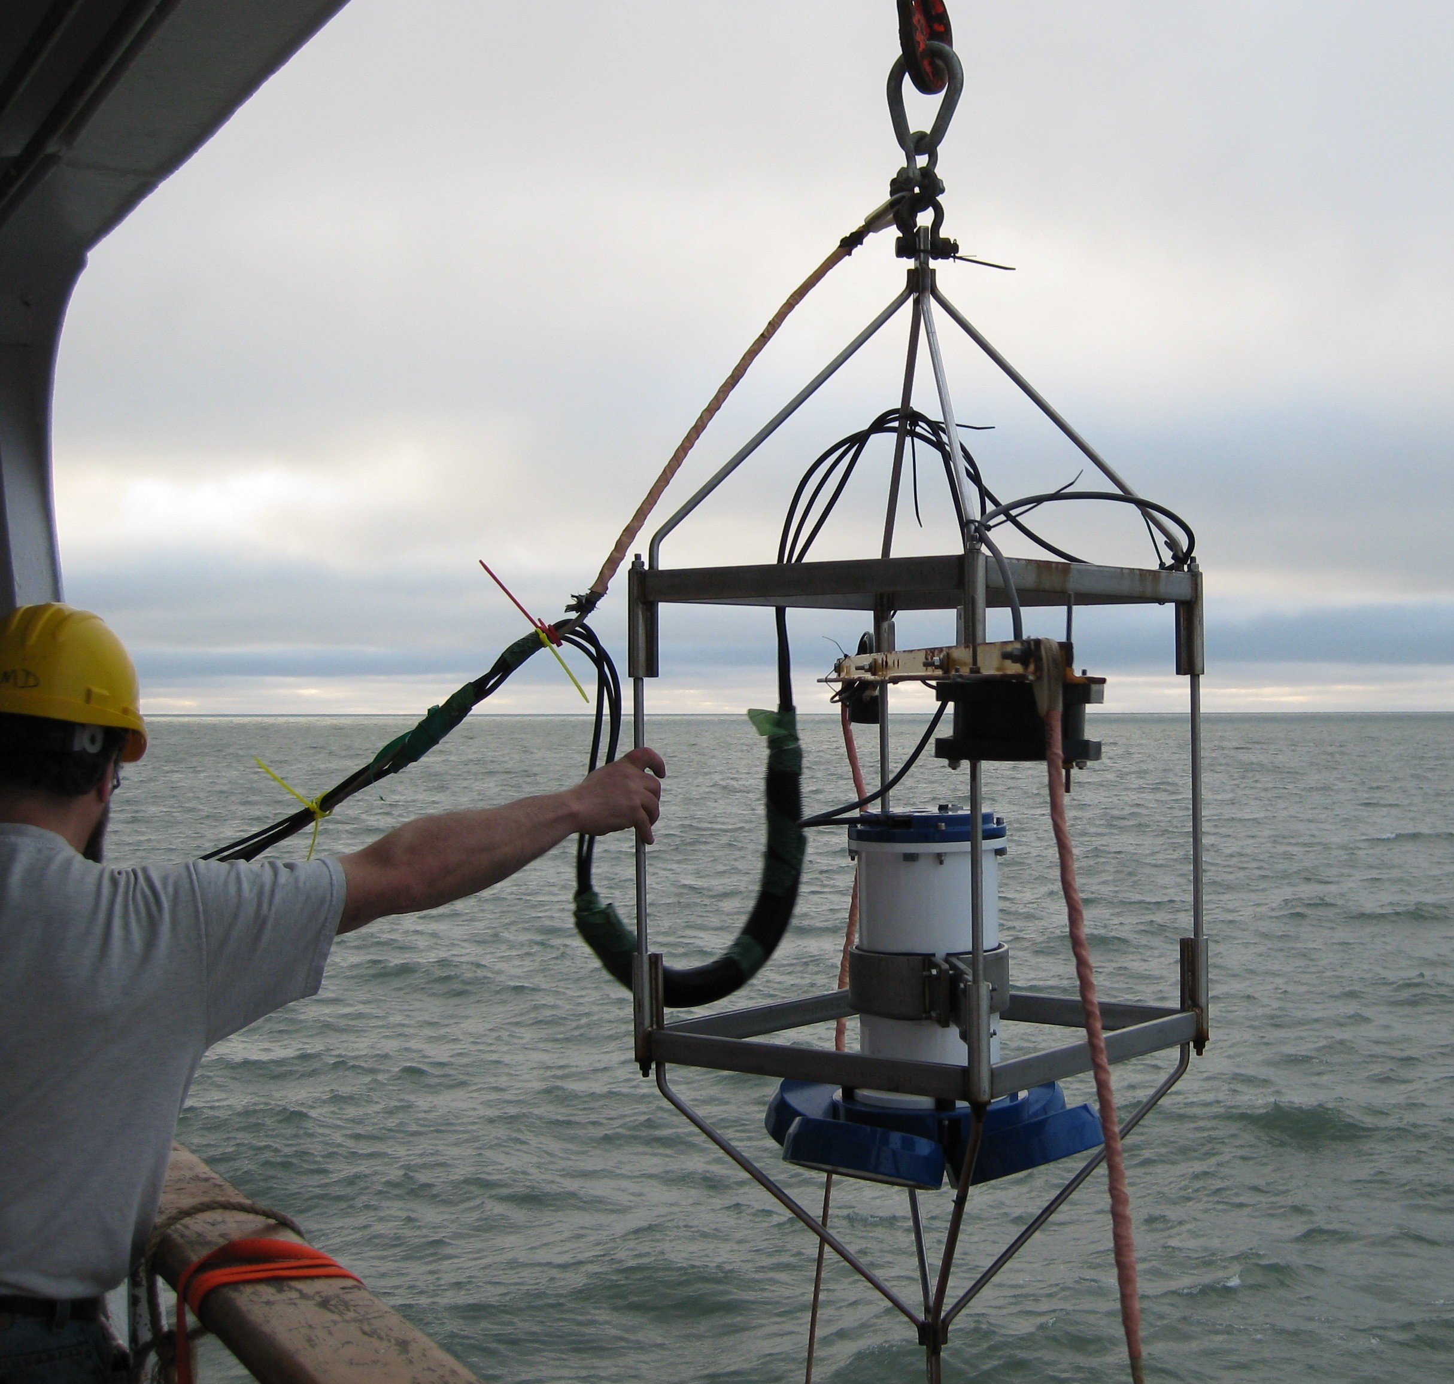
In conjunction with the CTD/Rosette Casts, an acoustic doppler current profiler (ADCP) measuring currents of the upper 60m lowered was over the side. The package was lowered by crane from the boat deck to approximately 5m beneath the surface and left in place until the completion of the CTD cast.

The two backscatter transducers that were to be configured with the ADCP and used to look for layers of zooplankton did not work and were never used. Due to….

Table 1. ADCP Deployment List for 2008-30 JOIS
File Name (ADCP###_00000.LOG) | DATE + TIME (UTC) | STATION | Lat Deg N | Lat Min N | Lon Deg W | Lon Min W | Approx BOTTOM DEPTH | Comments
18 | 2008/07/21 05:55 | AG5 | 69 | 30.500 | 117 | 40.900 | 378
19 | 2008/07/22 10:48 | CABOS | 71 | 49.650 | 131 | 45.580 | 1100
20 | 2008/07/23 07:07 | MK6 | 71 | 35.150 | 140 | 0.540 | 2447
22 | 2008/07/23 15:12 | MK4 | 70 | 48.730 | 140 | 0.883 | 1484
23 | 2008/07/23 19:10 | MK-3 | 70 | 34.440 | 140 | 0.180 | 1484
24 | 2008/07/23 22:43 | MK-1 | 70 | 13.778 | 140 | 0.130 | 230
25 | 2008/07/24 01:09 | CB28-aa | 69 | 59.986 | 140 | 0.078 | 50
26 | 2008/07/24 14:44 | STN-A | 72 | 41.250 | 144 | 41.432 | 3410
27 | 2008/07/25 07:09 | BL-08 | 71 | 57.886 | 150 | 13.595 | 2980
No Data Found | 2008/07/25 13:56 | BL-04 | 71 | 30.072 | 151 | 39.451 | 1007
28 | 2008/07/25 17:01 | BL-02 | 71 | 23.738 | 152 | 2.215 | 149
29 | 2008/07/25 19:04 | BL-03 (near) | 71 | 27.334 | 151 | 49.284 | 412
30 | 2008/07/25 20:00 | BL-03 | 71 | 28.174 | 151 | 46.649 | 640
31 | 2008/07/25 23:57 | BL-05 | 71 | 35.596 | 151 | 21.570 | 1557
32 | 2008/07/26 02:03 | BL-06 | 71 | 39.509 | 151 | 13.930 | 1993 | .LOG file incomplete
33 | 2008/07/26 09:46 | CB-2 | 73 | 0.000 | 150 | 0.010 | 3680
34 | 2008/07/26 17:02 | CB-3 | 73 | 59.981 | 150 | 0.262 | 3749
35 | 2008/07/26 23:41 | CB-6 | 74 | 29.975 | 147 | 44.113 | 3709
36 | 2008/07/27 21:44 | CB-4 | 74 | 59.519 | 150 | 3.377 | 3819
38 | 2008/07/29 04:35 | CB-5 | 75 | 19.160 | 153 | 16.822 | 3838
39 | 2008/07/29 11:19 | RS-06 | 75 | 30.790 | 155 | 16.135 | 3840
40 | 2008/07/29 18:08 | RS-01 | 75 | 44.593 | 157 | 5.600 | 1000
41 | 2008/07/29 21:18 | RS-02 | 75 | 39.626 | 156 | 15.565 | 1593
42 | 2008/07/30 08:10 | CB-7 | 75 | 59.790 | 149 | 58.618 | 3825
43 | 2008/07/30 16:18 | CB-8 | 76 | 59.866 | 150 | 2.576 | 3826
44 | 2008/07/31 03:20 | CB-12 | 77 | 40.697 | 146 | 44.723 | 3805
46 | 2008/08/01 00:52 | CB-9 | 78 | 0.176 | 150 | 10.510 | 3818
47 | 2008/08/02 06:54 | CB-10 | 78 | 19.753 | 153 | 1.256 | 3197
48 | 2008/08/02 10:44 | CB-10a2 | 78 | 20.170 | 153 | 21.571 | 2281
49 | 2008/08/03 04:41 | CB-11 | 79 | 1.046 | 149 | 53.396 | 3819
50 | 2008/08/04 07:04 | NW-1 | 81 | 1.714 | 149 | 50.994 | 3796
52 | 2008/08/05 04:07 | NW-2 | 82 | 0.280 | 149 | 57.738 | 3169
53 | 2008/08/05 15:33 | NW-3 | 83 | 1.788 | 149 | 59.498 | 2918
54 | 2008/08/07 06:50 | NE-2 | 81 | 1.222 | 140 | 6.316 | 3753
55 | 2008/08/08 06:56 | CB-16N | 79 | 0.359 | 139 | 55.973 | 3764
56 | 2008/08/10 03:45 | CB-15 | 76 | 59.534 | 140 | 0.763 | 3721
57 | 2008/08/11 02:45 | PP-06 | 76 | 15.955 | 132 | 31.816 | 3059
58 | 2008/08/11 08:15 | PP-05 | 76 | 15.955 | 132 | 31.816 | 2476 | .LOG file incomplete
59 | 2008/08/12 02:22 | CB-17 | 75 | 57.034 | 140 | 4.934 | 3703
62 | 2008/08/13 00:09 | CB-18 | 75 | 0.024 | 140 | 0.010 | 3620
68 | 2008/08/13 07:32 | CB-19 | 74 | 17.958 | 143 | 18.364 | 3693 | numerous files (63-67) created soon before but contain seemingly no data
69 | 2008/08/14 03:49 | CB-21 | 74 | 1.944 | 140 | 0.150 | 3519
70 | 2008/08/14 11:24 | CB-21 | 74 | 0.600 | 139 | 56.942 | 3506
71 | 2008/08/14 23:11 | CB-22 | 73 | 27.001 | 137 | 59.990 | 3127
72 | 2008/08/15 05:13 | CB-27 | 73 | 0.037 | 139 | 59.878 | 3221
73 | 2008/08/15 14:06 | STN-A | 72 | 36.048 | 144 | 41.795 | 3428

