CTD Report

CCGS Louis S St-Laurent

IOS Cruise Number 2009-20
3 November 2009
Sarah Zimmermann and Mike Dempsey

:

The primary CTD system used on board was a Seabird SBE9+ CTD s/n 0756, configured with a 24- position SBE-32 pylon with 10L Niskin bottles fitted with internal stainless steel springs in an ice-strengthened rosette frame. The data were collected real-time using the SBE 11+ deck unit and computer running Seasave V7 acquisition software. The CTD was set up with two temperature sensors, two conductivity sensors, two oxygen sensor, a fluorometer, a transmissometer, a CDOM fluorometer and altimeter. These sensors have 0-5v analogue output which is included in the CTD data string.

A second CTD, SBE19 s/n 2688, was used for a few casts from zodiac and ship. The internally recording SBE19 CTD is configured with pumped temperature and conductivity. During one use, 1.7 and 5L Niskins were attached to the foredeck winch wire to trip bottles with better flushing than from the rosette.

During a typical deployment:
The transmissometer(s) and CDOM sensor windows were wiped with deionized water soaked Kimwipe prior to each deployment.
The package was lowered to 5m to cool the system to ambient sea water temperature and remove bubbles from the sensors. The pumps were turned on and the system soaked for 3 minutes. The package was then brought up to just below the surface to begin a clean cast, and lowered to 400m at 30m/m then speed increased to 60m/m to 20 m above the sounder depth. The casts were typically to within 10 metres of the bottom. Niskin bottles were closed during the upcast generally without a stop. Different methods of flushing bottles were tried such as “ up-down-up” (up 1 metre, down 2 metres and up one metre) to explore more complete mixing. The rosette was also ballasted for level (<2 ° tilt) operation when LADCPs were added and removed. The instrumented sheave (Brook Ocean Technology) readouts to the winch operator, CTD operator and bridge allowed all three to monitor cable out, wire angle and CTD depth.

Improvements to the CTD system this year:
- The latest version (ver 7.17, 2008) of Seasave V7 was used. Many improvements in display features (zoomable plots and faster and complete re-draws) were appreciated. The s/w also appeared to be more stable with only a few crashes.
- New wet-pluggable cables were used on the sensors. (There have been no failures of wet-pluggable cables or connectors since used in 2007)
- Niskin spigot o-rings replaced with Silicon rubber (less sticky when cold)

Data/Performance notes:

The SBE9+ CTD overall performance was good. Editing and calibration have not yet been done, but the data will likely meet or exceed the SBE9+ performance specifications given by Seabird. Header information of position, station name, and depth has not been quality controlled yet. Salinity, oxygen, CDOM and chlorophyll-a were all sampled from the water and can be used to calibrate the sensors.

Problems were seen with the SBE43 oxygen sensors used. Initially intermittent drop outs and full scale voltage events appeared to be cable related but were later assessed to be associated with the two sensors. Two sensors, including one bought new in 2007 (and failed in 2007 & repaired prior to cruise) failed during the cruise.
As mentioned before 2 RDI LADCPs were mounted on the rosette in 2008. Unfortunately, the upward looking unit was mounted directly above bottle 1 and provided a partial shadow to bottles 24 and to a lesser extent 23. Since bottle 1 is closed at the bottom, it is effectively flushed from below, and should show no effect on flow. Bottles 23 and 24 did however appear from the data to be flushing poorly and an alternative “up-down-up” triggering method was used later in the cruise to correct this.

A new Wetlabs CDOM fluorometer was used in 2008. The unit is 6000 m depth rated and was left on for all casts. The initial factory calibration was used and seems to follow well other associated sensors (transmissometer, fluorometer, DO, temperature and conductivity) to measure likely CDOM concentration. Calibration will be done using the water sample values from Celine Guegen.
There were no communication errors between computer and deck unit as seen in 2007. There were however a couple of s/w and full system crashes during casts. In all instances the crash was an isolated event.

Photos:

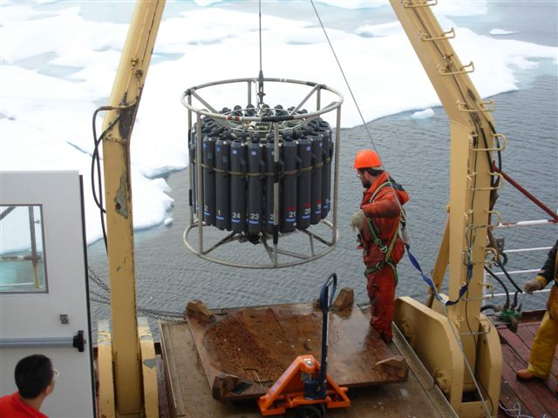

Figure 1. The 24-bottle rosette with the SBE9+ CTD is deployed by Mike Dempsey.

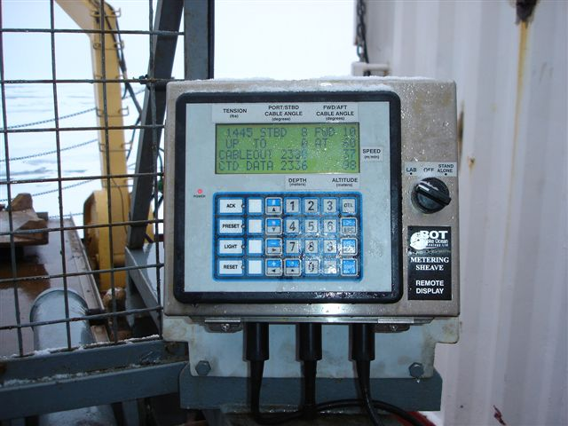

Figure 2. Integrated sheave and CTD display for winch operator.

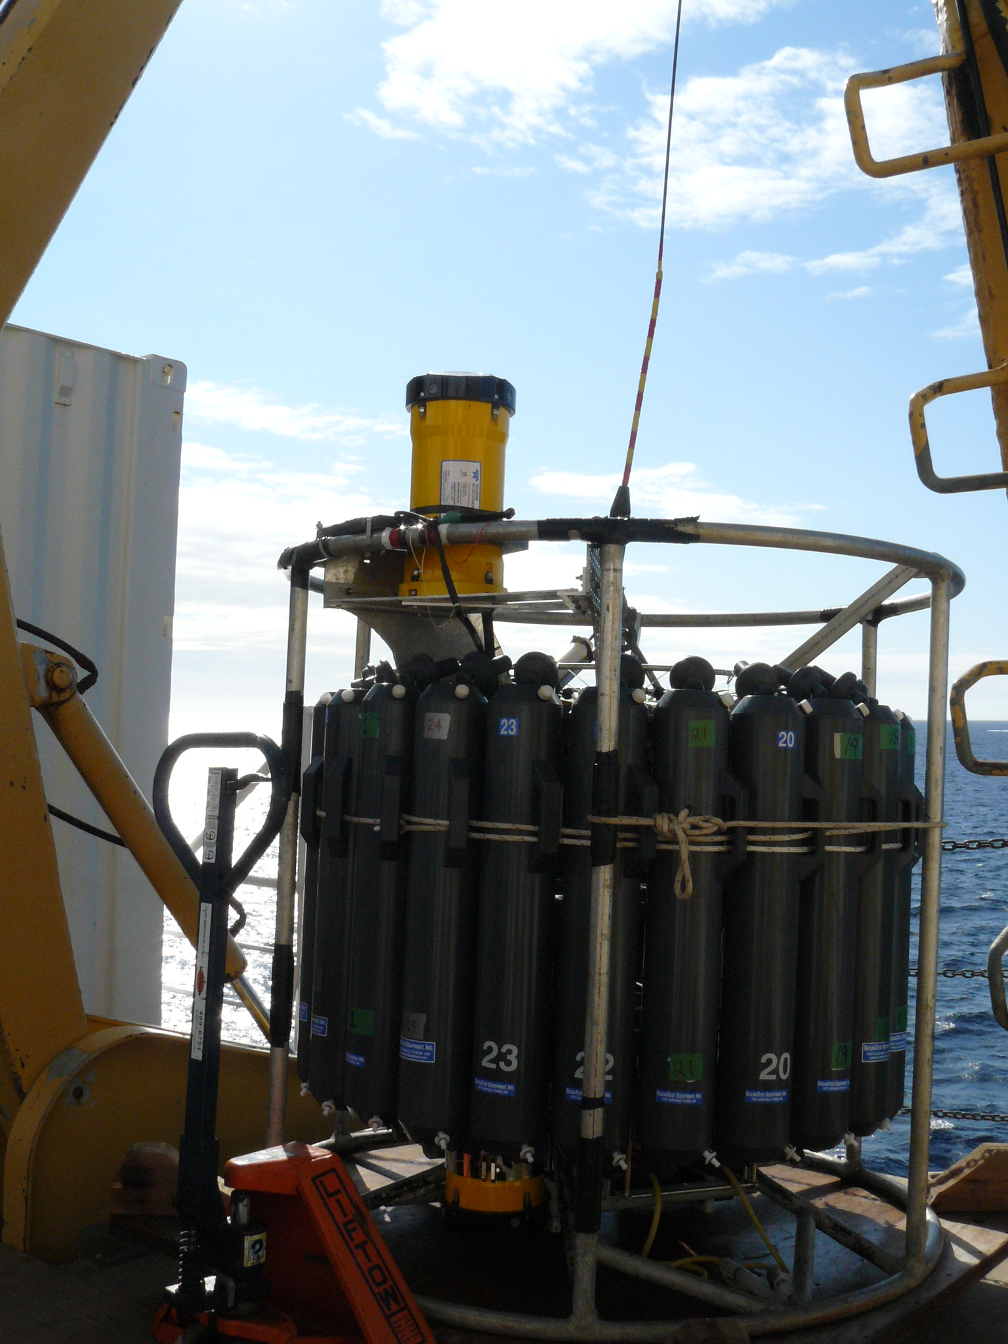

Figure 3. Installation of upward and downward looking LADCPs

