LSSL 2009-20 CTD Data
Sarah Zimmermann

Version 2018-03-20

CTD Processing for Cruise ID 2009-20

Contents
CTD Processing for Cruise ID 2009-20 1
1. CTD Data Acquisition, Processing and Validation 2
1.1 Processing Notes 2
1.2 Overview/Highlights 2
1.3 Instrument Summary 5
1.4 Acquisition and Processing Steps 8
1.4.1 CTD Pressure Calibration 11
1.4.2 CTD Temperature Calibration 12
1.4.3 CTD Conductivity and Salinity Calibration 18
1.4.4 CTD Oxygen 28
1.4.5 CTD Transmission 37
1.4.6 CTD Fluorescence 40
1.4.7 CTD CDOM Fluorescence 45
1.4.8 CTD ISUS Nitrate Sensor 45
1.4.9 CTD Surface Reference PAR 47
1.4.10 CTD Altimeter 48
1.4.11 Data Spike Removal 48
1.4.12 Determination of CTD Data at Bottle Depths 48
1.5 CTD File Preparation 51
1.6 Bottle File Preparation 52
Appendix: 52
LIST OF INTERPOLATIONS 52

CTD Data Acquisition, Processing and Validation

Cruise Summary
Cruise: 2009-20
Agency: Ocean Sciences Division, DFO
Location: Arctic Ocean
Project: Joint Ocean Ice Study (JOIS)
Chief Scientist: Sarah Zimmermann, IOS
Platform: CCGS Louis S. St-Laurent
Date: 17 September to 15 October, 2009

Processed by: Sarah Zimmermann
Date of Last Processing: 19 Jun 2011
Number of original HEX files: 53 Number of CTD files: 53
Number of bottle casts: 53

Overview/Highlights

A Seabird SBE9 s/n 0756 was used for the entire cruise with s/n 0724 in reserve as a spare. The CTD was mounted on an ice-strengthened rosette frame configured with a 24- position SBE-32 pylon with 10L Niskin bottles fitted with internal stainless steel springs. The data were collected real-time using the SBE 11+ deck unit and computer running Seasave V7.17 acquisition software. The CTD was set up with two temperature sensors, two conductivity sensors, a dissolved oxygen sensor with pumped flow and a secondary new type of dissolved oxygen sensor for trial, a chlorophyll fluorometer with pumped flow, a transmissometer, CDOM fluorometer, altimeter, an ISUS nitrate sensor used on casts shallower than 1100m and finally a surface reference PAR for Cast 11 onward (however no underwater profiling PAR).

A second CTD, SBE19 s/n 2688, was used for a few casts from zodiac and ship. The internally recording SBE19 CTD is configured with pumped temperature and conductivity. During one use, 1.7 and 5L Niskins were attached to the foredeck winch wire to trip bottles with better flushing than from the rosette. Processing of these data are not reported here.

Performance Notes

Data acquisition
Of concern for future operations was the standard Seabird automatic control. On at least one occasion during the prior leg (2009-19 Cast 22), the pump turned off in the fresh surface water after the soak and did not turn on again until 60 m. It is recommended that the pump control be modified to manual control (like SBE9plus s/n 724) in the future.

Sea Cable
The conducting CTD wire was re-terminated prior to the first cast.

ISUS Nitrate Sensor
There were initially problems with cross-talk between the CDOM sensor and the ISUS nitrate sensor that shared a cable and differential input connector on the CTD. This was improved with cable changes before Cast 11 however voltage signal was still seen on the ISUS channel even when the sensor was not installed. To correct this, after Cast 39 the sensors were separated with the ISUS put onto another differential input pair typically used by the JFE-Alec Rinko III oxygen sensor. As the Rinko is a two channel sensor (T and DO voltages), the Rinko was blanked off during casts when the ISUS was used on casts 41, 48 and 53.
There are useable ISUS data, for Casts 1, 2, 8, 13, 16, 17, 19, 28, 32, 41, and 53 however they are uncalibrated and unprocessed.

CDOM Sensor
Due to the cross-talk with the ISUS Nitrate Sensor, data on Casts 1, 2, 8 are not useable and have beene removed. On Cast 42 the sensor’s cap was accidentally left on so again the data have been removed. For Cast 39 the cable was changed to no longer allow pairing with the ISUS sensor with an associated shiftt seen in the CDOM data of about +0.02V.

Oxygen Sensors
In addition to the usual SBE43 Oxygen sensor a Rinko III oxygen sensor was installed to see how it performed in the Arctic environment. It is an optical sensor with fast time-response unlike the SBE43 with a chemical response and fragile membrane that can tear from ice in the cold. The data are not processed here but the voltage channels for oxygen and oxygen temperature have been kept in the final files. Due to temporary replacement by the ISUS sensor, no data exist for Casts 41, 48 and 53.

Deck Unit
At the start of Cast 39, the deck unit blew the 0.5Amp fuse. As the Rosette was only at 50 m, the package was brought on deck and checked over. No fault was found and the source of the failure was assumed to be the fuse itself which have been seen to break with age and vibration. Another possibility could be a power related problem associated with the ISUS/CDOM crosstalk. For the following test cast the ISUS was removed, but the ISUS channel was showing 0.5V instead of the expected 0V. For the next (successful) Cast 39, the cabling was changed for the CDOM sensor and there were no stray voltage readings. The acquisition display was odd for this cast with mismatch display values to property names. The recorded data were fine and the problem appeared to be a result of having too many display windows and/or too many display properties. Both were reduced following the cast and this wasn’t an issue again. There were no other issues with the acquisition system (it did not lock up, nor were there communication issues as it had in 2007).

Cold Weather
This year the JOIS cruise took place much later in the year than previously. As a result there were many more concerns due to colder air temperatures (0 to -20C).

- Problems were encountered with icing up of the Brooke Ocean technology (BOT) block. Ice accumulated on the downcast as slush on the wire was packed onto the PVC sheave and accumulated on the two fairlead arms. The ice would cause the fairlead rollers and occasionally the sheave to seize, changing the calibration of the line out counter. Initially a pike pole was used to chip ice out of the groove. Later the pneumatic air blower was clipped onto the wire to dry the wire as it came in. Results were very good and after a few deployments, the installation required only an extra couple of minutes for each cast. At the completion of the cruise it was noted however that all 4 fairlead rollers had seized at some time and had been grooved by the wire and will require replacement before next cruise.

- Due to the cold temperatures, effort was made to reduce the time of the Rosette on deck to prevent freezing of the sensor.. The Rosette lab’s doors would remain closed until the bridge gave permission to start the cast. The Rosette was then brought out and lowered into the water as quickly as possible. This step was repeated in reverse at the end of the cast. During one cast, Cast 45, the plumbing to the secondary temperature, conductivity and fluorometer was blocked, presumably with ice either formed while the CTD was on deck or in the surface waters. This resulted in fixed values for the upper 50m until the ice melted and flow was resumed. A suggestion for future casts is to check for dual sensor agreement during the initial surface soak and lower into warmer water (ex. 40m or into Atlantic Water at 400m) if there appears to be frozen plumbing or a frozen sensor before raising back to the surface.

- With the increased hours of darkness, working lights were found an installed to improve visibility of the CTD operation. A suggestion for future cruises is to have a light mounted on the rail on the deck above to illuminate the working deck and to have a light mounted on outboard, aft, corner of the rosette lab, illuminating the water surface

Instrument Summary

Table 1. CTD Accuracy, Calibration and Sensor List
CTD

CTD# | Make | Model | Serial# | Used with Rosette? | Casts Used
Primary | SeaBird | 911+ | 756 | Yes | All

 | Calibration and Accuracy Information CTD
Sensor |  |  | Accuracy | Pre-Cruise |  | Post Cruise |  | Comment
Name |  | S/N |  | Date | Location | Date | Location
Pressure Sensor |  | 91164 | 1dbar | 18 Mar 2004 | SeaBird Lab |  |  | Surface bias correction of +0.42 dbar
Temperature, SBE3plus |  | 4397 | +/- 0.001C | 3 Jan 2008 | SeaBird Lab | 16 Nov 2009 | SeaBird Lab | Prost-cruise calibration used
Conductivity,  SBE4C |  | 2992 |  | 4 Jan 2008 | SeaBird Lab | 30 Oct 2009 | SeaBird Lab | Post-cruise calibration and bias adjusted to match deep water value
Salinity from  primary temperature and conductivity sensors |  |  | STD (PSU) with water samples:  0.126 above 300m,  0.005 below 300m,  0.094 all samples.
Pump,  SBE5T |  | 053610
Secondary Temp., SBE3plus |  | 4402 | +/- 0.001C | 4 Jan 2008 | SeaBird Lab | 16 Nov 2009 | SeaBird Lab | Prost-cruise calibration used
Secondary Cond., SBE4C |  | 2984 |  | 28 Dec 2007 | SeaBird Lab | 30 Oct 2009 | SeaBird Lab | Post-cruise calibration and bias adjusted to match deep water value
Secondary Pump, SBE5T |  | 053615

Calibration and Accuracy Information, External Sensors
Sensor |  | Accuracy | Pre-Cruise |  | Post Cruise |  | Comment
Name | S/N |  | Date | Location | Date | Location
SBE 43 Dissolved Oxygen sensor | 0435 | See below | 7 Oct 2008 | SeaBird Lab | 6 Mar 2010 (After repair) | SeaBird Lab | On Primary pump;  All Casts
RINKO III Dissolved Oxygen sensor | 0010 |  |  |  |  |  | All except casts: 41, 48 and 53
Dissolved Oxygen |  | STD (ml/l) with water samples  0.20 above 300m,  0.02 below 300m,  0.15 for all samples |  |  |  |  | Calibrated to water samples
Datasoncis Altimeter, Benthos | PSA-916D, 1161 |  | 31 Mar 2005 | Benthos
Seapoint Fluorometer (Chl-a) | SCF 2745 |  |  |  |  |  | On Secondary Pump with 30x gain cable (0-5mg/l range)
Wetlabs Transmissometer | C-Star  CST-1050DR |  | 15 May 2008 | IOS 2 pt in-air calibration |  |  | Error in calculating seabird terms means nominal values will be 1.7% low.
WETLabs ECO CDOM | 1076 |  | 11 Jun 2006 | WETLabs |  |  | No data for casts 1, 2, 8, 42.
Satlantic ISUS Nitrate Sensor | 72 |  |  |  |  |  | Used on casts: 1, 2, 8, 13, 16, 17, 19, 25, 28, 32, 41, 48, and 53. All but Cast 25 have useable data.
BioSpherical Surface Reference PAR | QSR 2200 s/n 20279 |  | 13 Mar 2007 | BioSpherical |  |  | Used on cast 11 onwards.

Deck Units
Type | make | model | serial | comment
Deck Unit | Seabird | 11plus | 680
Deck Unit | Seabird | 11plus | 649

Rosette Pylons
Type | make | model | serial | comment
Water Sampler Carousel | Seabird | 32 | 498
Water Sampler Carousel | Seabird | 32 | 452

Seabird specifications on sensors:
SBE 3plus temperature sensor

Range -5.0 to +35 °C
Resolution 0.0003 °C at 24 samples per second
Initial Accuracy2 ± 0.001 °C
Response Time3 [sec.] 0.065 ± 0.010 (1.0 m/s water velocity)
Self-heating Error < 0.5 sec. to within 0.001 °C

SBE4c conductivity sensor

Measurement Range 0.0 to 7.0 Siemens/meter (S/m)
Settling Time 0.7 seconds to within 0.0001 S/m
Initial Accuracy 0.0003 S/m
Stability 0.0003 S/m/month
Time Response 0.060 seconds (pumped)

Digiquartz pressure sensor

Measurement Range Pressure 0 to 6800m (10,000 psi)
Accuracy 0.018% of full scale
Resolution (at 24 Hz) Pressure 0.001% of full scale
Time Response Pressure 0.015 second

Acquisition and Processing Steps

Acquisition:
On deck, the transmissometer and CDOM sensor windows were sprayed with deionized water and wiped with a lens cloth (Kimwipe) prior to each deployment. The CTD/Rosette was lowered to 5m and the pumps turned on. This soak cools the sensors to ambient sea water temperature and removes bubbles from the sensors. The pumps turned on automatically after the conductivity cell sensed salinity greater than 16 PSU for a period of 1 minute and then system was soaked for 2 minutes. After 2 minutes the package was brought up to just below the surface to begin a clean cast, and lowered at 30m/min to 300m, then at 60m/min to within 10m of the bottom. Routinely, the winch was switched from low to high gear and vice versa at 900m to make operation smoother. Niskin bottles were normally closed during the upcast without a stop to avoid the unpredictable wake effects. During a “calibration cast” and some shorter high volume casts, the rosette was yo-yo’d to mechanically flush the bottle, meaning it was stopped for 30sec, lowered 1 m, raised 2 m, lowered 1 m and stopped again for 30 seconds before bottle closure. The instrumented sheave (Brook Ocean Technology) provided a read out to the winch operator, CTD operator, main lab and bridge, allowing all to monitor cable out, wire angle, tension and CTD depth.

The configuration file changed only slightly during the cruise with the ISUS replacing the RINKO channels for casts 41, 48 and 53.

Initial configuration:

V0 = chlorophyll fluorometer
V1 = transmissometer
V2 = dissolved oxygen
V3 = altimeter
V4 = RINKO oxygen
V5 = RINKO temperature
V6 = CDOM fluorometer
V7 = ISUS nitrate
Surface Reference PAR

Prior to the cruise, the SBE3plus temperature, SBE4c conductivity and SBE43 oxygen sensors had factory calibrations. The Surface reference PAR was new this year. In addition, other sensors were checked for functionality and the plumbing tubing replaced and checked for functionality.

The CTD data were collected real-time using the SBE 11+ deck unit and computer running Seasave V7 acquisition software. The ship’s GPS position was added to each data file via the NMEA interface. Upon completion of the station, the data were copied to new directories for sharing and storage.

Processing:

Seabird’s Windows-based processing software, SBEDataProcessing v7.120b, was used to produce 1db averaged downcast and upcast profiles. The standard processing step as suggested by Seabird for the SBE9+ data were applied:

Data Conversion
Data were converted from raw hex to ascii format, skipping over the surface soak scans specified for each station.

Align CTD
Data were aligned by advancing variables relative to pressure based on time.
Conductivity primary -0.030
Conductivity secondary -0.020
Oxygen voltage 5 seconds
Note that conductivity data (primary and secondary) were already advanced 0.073 seconds by the deck unit during acquisition.

A few loops warranted looking at the alignment of the data. Plotting every scan with various alignments it was found that -0.03 sec was best for primary conductivity and -0.02 for secondary conductivity. However, applying these corrections made barely noticeable changes to the 1db binned data and the small loops at the very sharp interfaces still existed. The loops may be a result of turbulence or fluid dynamics around the package as opposed to a misalighnment between the temperature and conducitivity sensors.
For more details see: G:\Sorted\2009-20-new\Data\CTD\process\align_test

Wild Edit
Data spikes were removed from all the variables using the criteria of 10 standard deviations for pass1, 20 standard deviations for pass 2 and 100 scans per block.

Cell Thermal Mass
A correction for the thermal mass of the conductivity sensor was applied using the suggested values of 0.03 and 7.0 for alpha and 1/beta terms respectively.

Filter
Data were filtered with low pass filter of 0.030 seconds for Transmissometer, Fluorometer, CDOM sensor, Rinko oxygen and temperature, ISUS sensor, Surface reference PAR and the altimeter.
Data were filtered with a low pass filter 0.150 seconds for Pressure and Depth.

Loop Edit
Pressure reversals were removed by identifying all data with velocities below 0m/s.

Derive
Oxygen was derived. Oxygen used 1 second averaging of doc/dt and a fixed lag of 5 seconds however oxygen data are recalculated during the calibration step.
Salinity, potential temperature, density and sound velocity were derived.

Bin Average
Data are averaged into 1 dbar bins.

Split
The files are separated between down and upcast profiles.

Final processing was completed using Matlab-based routines to calibrate, plot and remove spikes in the data. The conductivity sensors were calibrated to the salinity of deep water samples. The calibrated conductivity was then used to determine a standard bottle depth offset due to closing bottles ‘on-the-fly’ through comparisons with salinities from shallow water samples. Using the corrected bottle depths, the downcast oxygen sensor data were calibrated with the bottle oxygen data. Data were plotted station by station to identify density inversions in the downcast. Inversions were replaced with linearly interpolated primary temperature and conductivity sensor data, and the derived properties (salinity, density, theta) recalculated. The interpolations are listed in the appendix. The cdom fluorometer, transmissometers, and altimeter data are unprocessed beyond using the factory provided calibration. See the table on Calibration and Accuracy Information, Sensors for the calibration dates.

    - CTD Pressure Calibration
Stated SBE911 Pressure Accuracy: 0.015% of full scale (6800m) is 1m. Results suggest this is appropriate for this data set.

Surface data from the start and end of each cast are plotted below. The on-deck pressure should be close to 0dbar with natural variations of +/- 0.1dbar due to weather however there was a consistent starting pressure bias of -0.49db, +/- .12db (1STD) and an ending pressure bias after the CTD was back on deck of -0.35db with a similar standard deviation of .13db. The data were corrected (down and upcast) with a pressure adjustment of +0.42db.

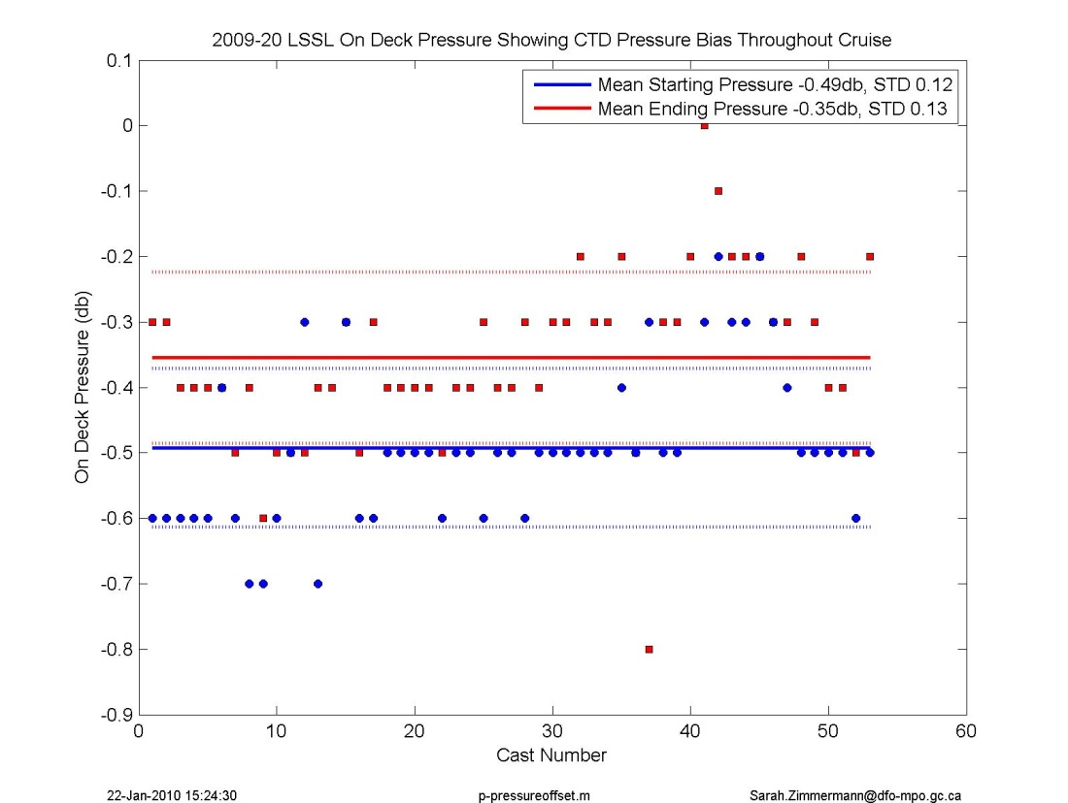
Figure 1. In-air pressure reading at the start and end of every cast.

    - CTD Temperature Calibration
Stated SBE911 Temperature Accuracy: 0.001degC
Results suggest this is appropriate for this data set. Dual sensor comparisons show the sensors are in agreement and have been stable throughout the cruise.

The post cruise calibrations are applied to the temperature sensors.

Laboratory calibrations show that primary temperature changed by 0.0009C and secondary temperature changed by 0.0005C (reading colder now). Dual sensors show the raw data are offset between -0.0002 and -0.0004C (primary colder than secondary) with no drift during the cruise. These numbers are in good agreement. The post cruise calibrations are applied as they are closer to the time of data collection. The result is slightly warmer water with the two sensors agreeing within 0.0002 C.

Laboratory Calibration
21Jan2010: The laboratory calibrations were performed by Seabird Inc. The calibration used for the pre-cruise reference was performed almost 2 years before the post-cruise calibration. Over the 22 month period the sensors show a drift of -0.00024 C and -0.00053 C per year. The post-cruise calibrations, which were done directly after the cruise, will be applied to both sensors.
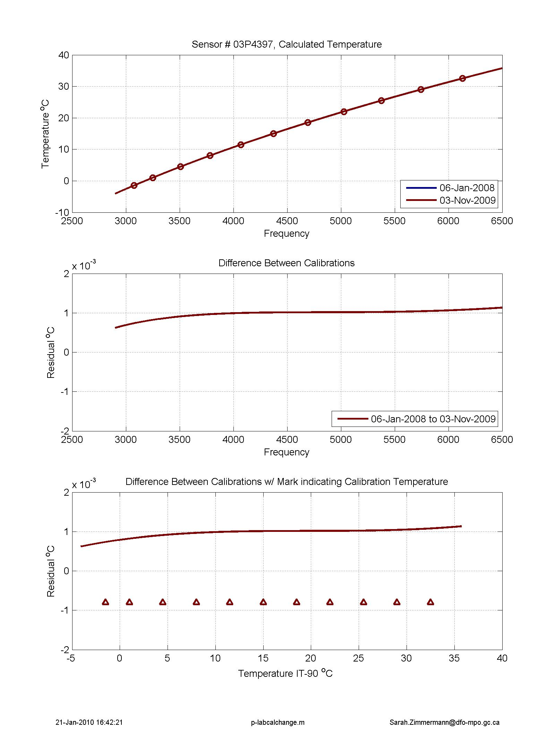
Figure 2. Lab calibration of primary temperature sensor # 4397. The brown shows the calibration change from before the cruise to after the cruise.
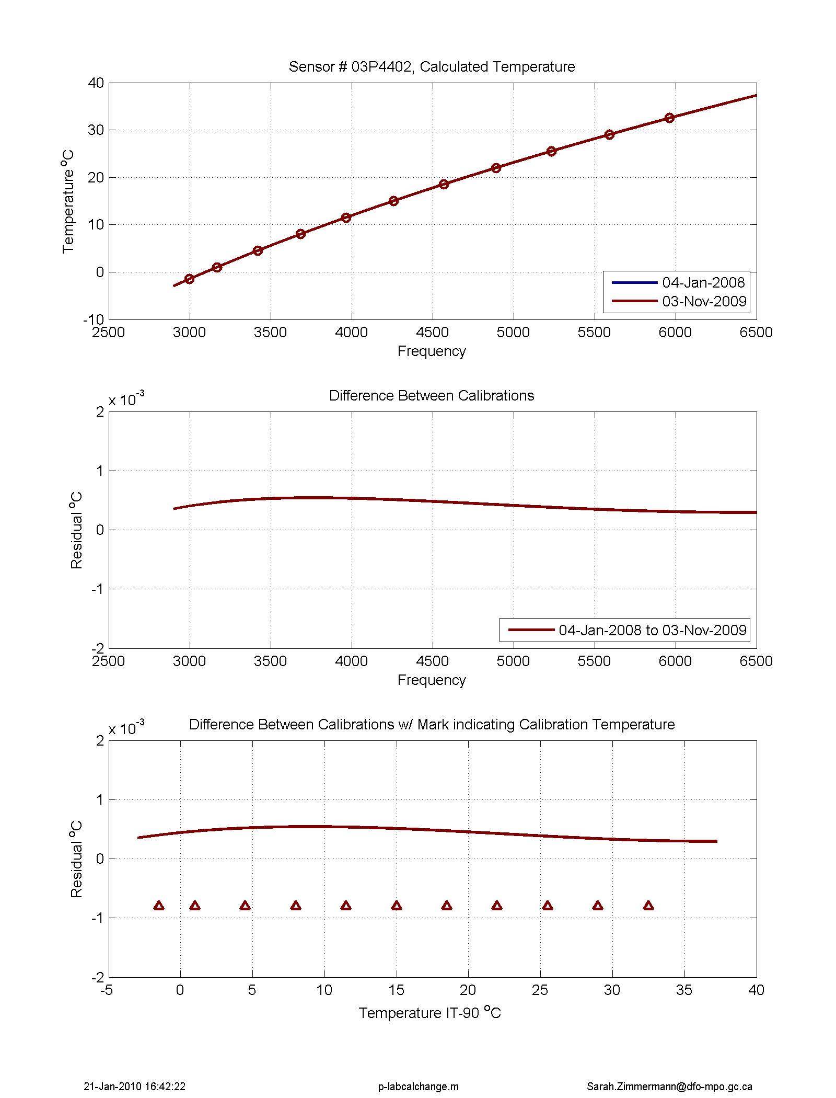
Figure 3. Lab calibration of secondary temperature sensor # 4402. The brown line shows the calibration change for this cruise.
Dual Sensor Comparison
22Jan2010
Matlab file:
p_ctd_delta_sensors_general.m plot the difference between the CTD’s dual sensors.

Comparisons between the primary and secondary sensors in the station data show very little difference in the deep water throughout the cruise (-0.0002°C offset below 1000db with standard deviation of 0.0001°C between casts where secondary is warmer than primary temperature). At warmer temperatures, between 300 and 500db, the difference is slightly larger, with a mean offset of -0.0004°C. In the coldest temperatures, between 0 and 200db, the difference is still fairly small at -0.0004°C. There is no shift in the offset during the cruise.

The top 400db of temperature and conductivity (and thus salinity) has a pressure dependant shape, perhaps due to the gradient of temperature and conductivity.

Figures are at:
G:\Sorted\2009-20\Data\CTD\process\dual_sensors
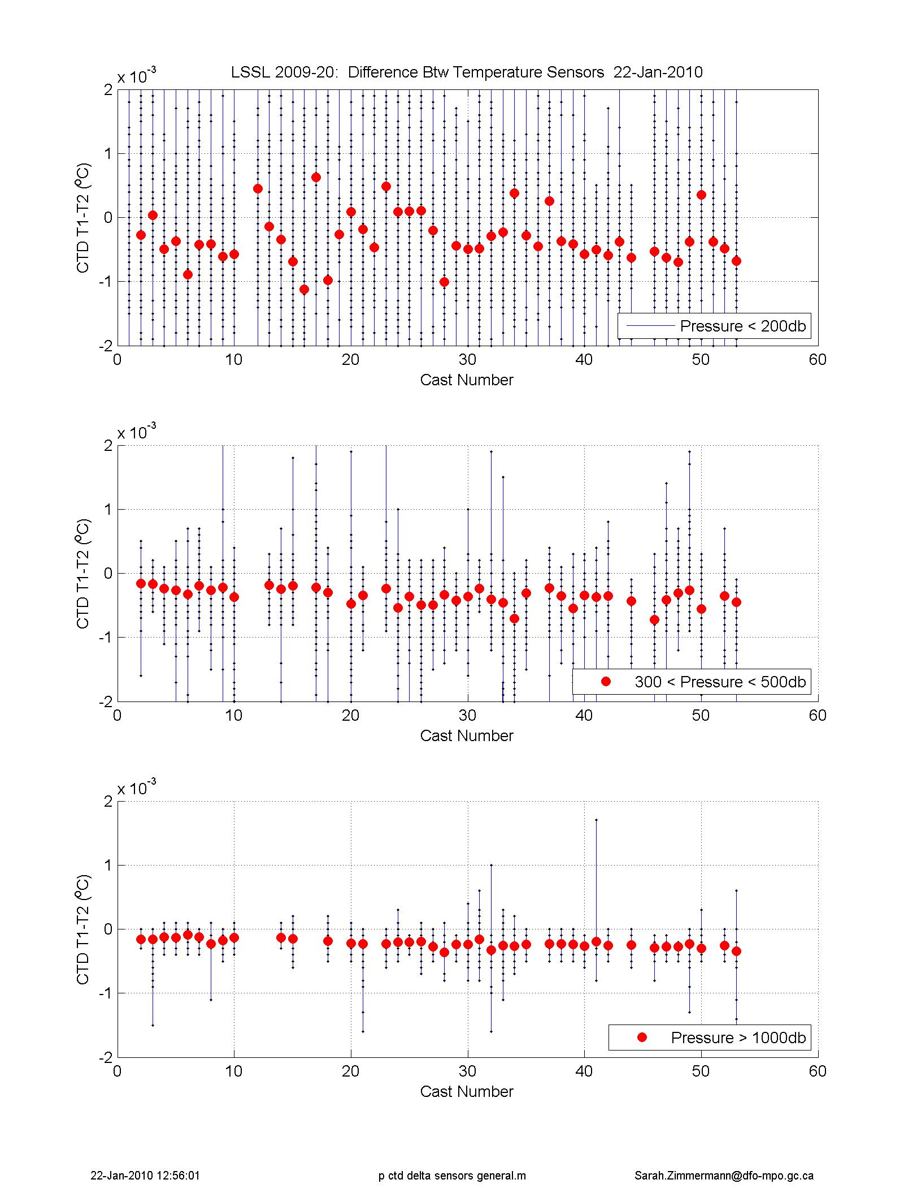
Figure 4. Difference between primary and secondary temperature per cast, divided into three depth regions.

    - CTD Conductivity and Salinity Calibration

Conductivity was calibrated using lab calibrations, dual sensor comparisons, expected deep water values and water sample comparisons. For both primary and secondary conductivity sensors, post-cruise laboratory calibrations were used and were further adjusted to match the known deep water value of 34.956PSU. Both primary and secondary CTD sensors were corrected for a drift of about -0.002mS/cm over the cruise.

Table 2. Comparison of final CTD salinity values and water samples. Mean and STD of residuals (CTD-WS) for salinity. All QC flagged salinity samples removed.
 | Primary | Primary | Secondary | Secondary
Pressure Range (db) | STD | Mean  (CTD-WS) | STD | Mean  (CTD-WS) | Number of Observations
0 to 300 | 0.1258 | -0.0194 | 0.1196 | -0.0203 | 542
300 to 5000 | 0.0052 | -0.0009 | 0.0055 | 0.0014 | 448
2000 to 5000 | 0.0019 | -0.0009 | 0.0019 | 0.0010 | 141
Full | 0.0937 | -0.0102 | 0.0892 | -0.0105 | 990

Laboratory Calibration
The laboratory calibrations were performed by Seabird Inc. The pre-cruise calibrations were performed almost 2 years before the cruise thus the post-cruise calibrations, performed less than a month after the cruise, were applied to the sensors. Over the 22 month period between the calibrations, the primary sensor drifted 0.001 to 0.004 mS/cm over the range of interest (20 to 31mS/cm). The secondary sensor drifted 0.0035 to 0.0065mS/cm.
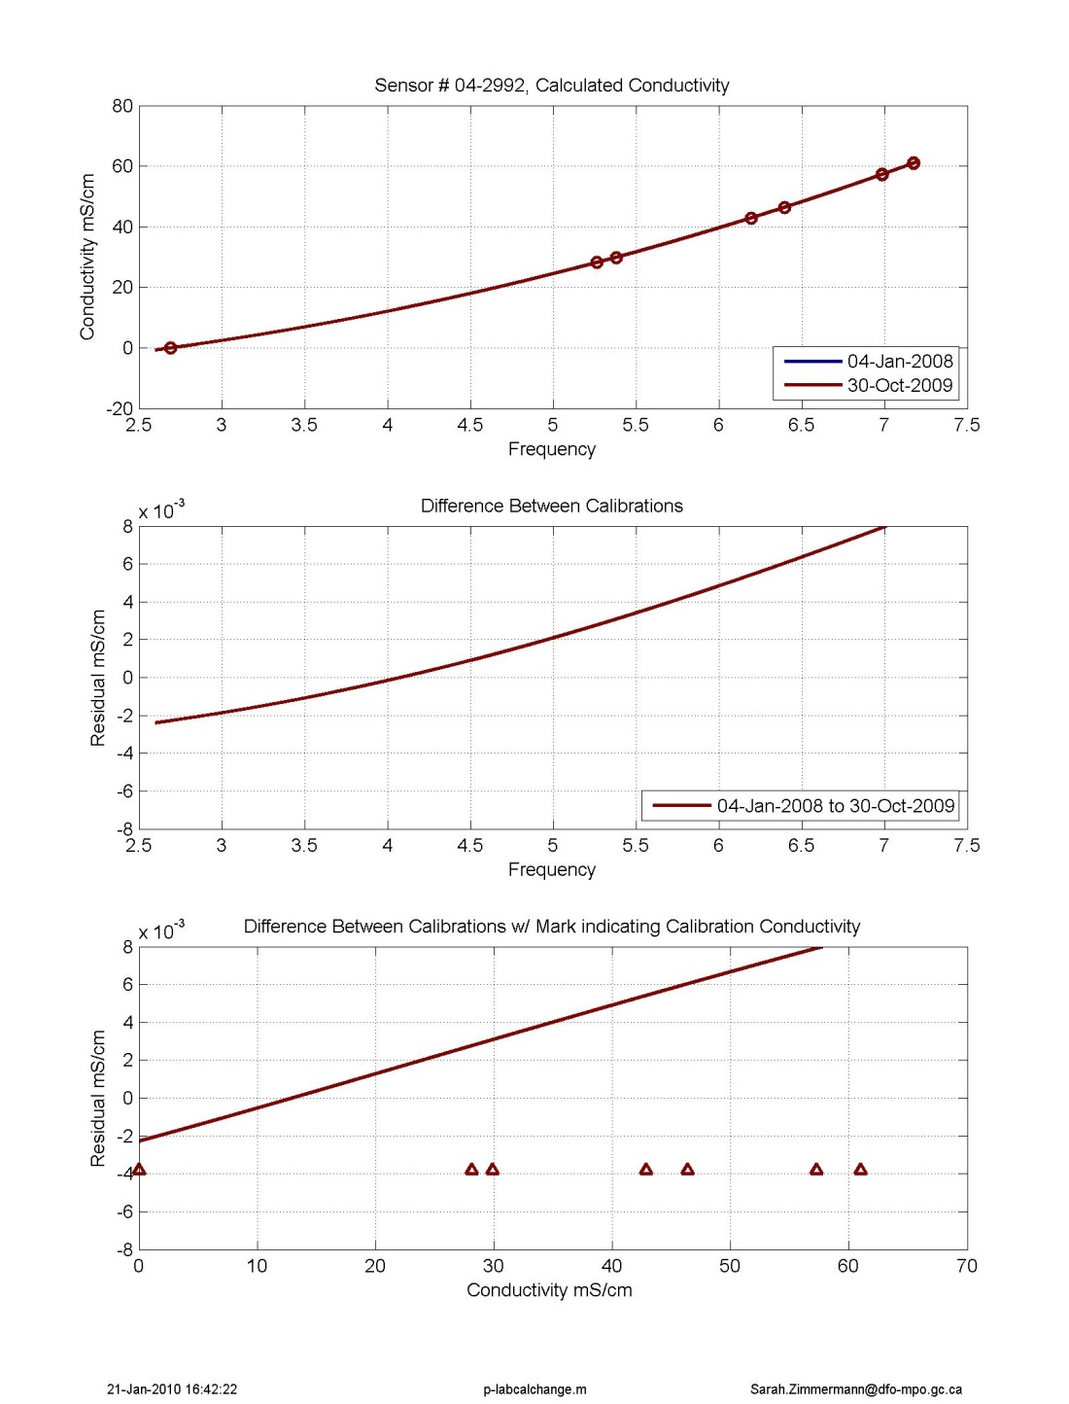
Figure 5. Lab calibration of primary conductivity # 2992. The brown line shows the calibration change for this cruise.

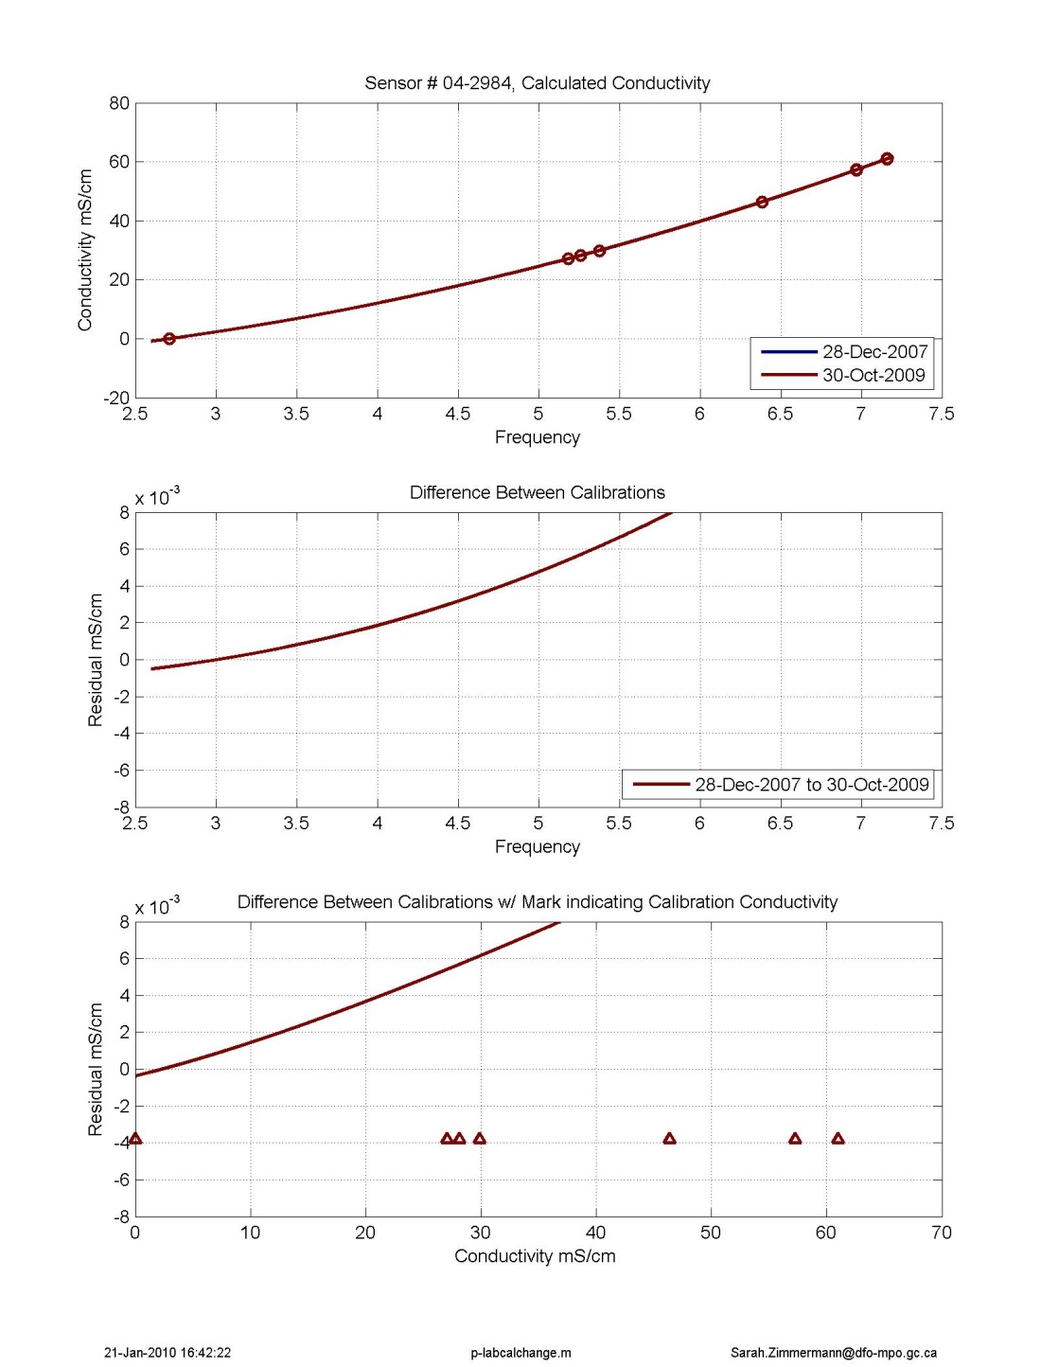
Figure 6. Lab calibration of secondary conductivity #2984. The brown line shows the calibration change for this cruise.

Dual Sensor Results
Comparisons between the primary and secondary sensors in the station data show little offset or drift using the pre-cruise calibration. There is no conductivity offset in the shallow water (less than 0.0001mS/cm) with a standard deviation of 0.0011. The offset increases only to 0.0005mS/cm in the deeper water over 1000db with a minimal standard deviation of 0.0002 (primary conductivity is larger than the secondary conductivity).

In salinity, the combined difference in conductivity and temperature show primary salinity is larger than secondary salinity by 0.0004 in the shallow water, 0.0008 at mid-depths, and 0.0009 in the deep water.

The top 400db of both temperature and conductivity (and thus salinity) has a pressure dependant shape, perhaps due to the gradient of temperature and conductivity. This could be due to pumping time or flow rate not being quite the same?

Figures are at:
G:\Sorted\2009-20\Data\CTD\process\dual_sensors

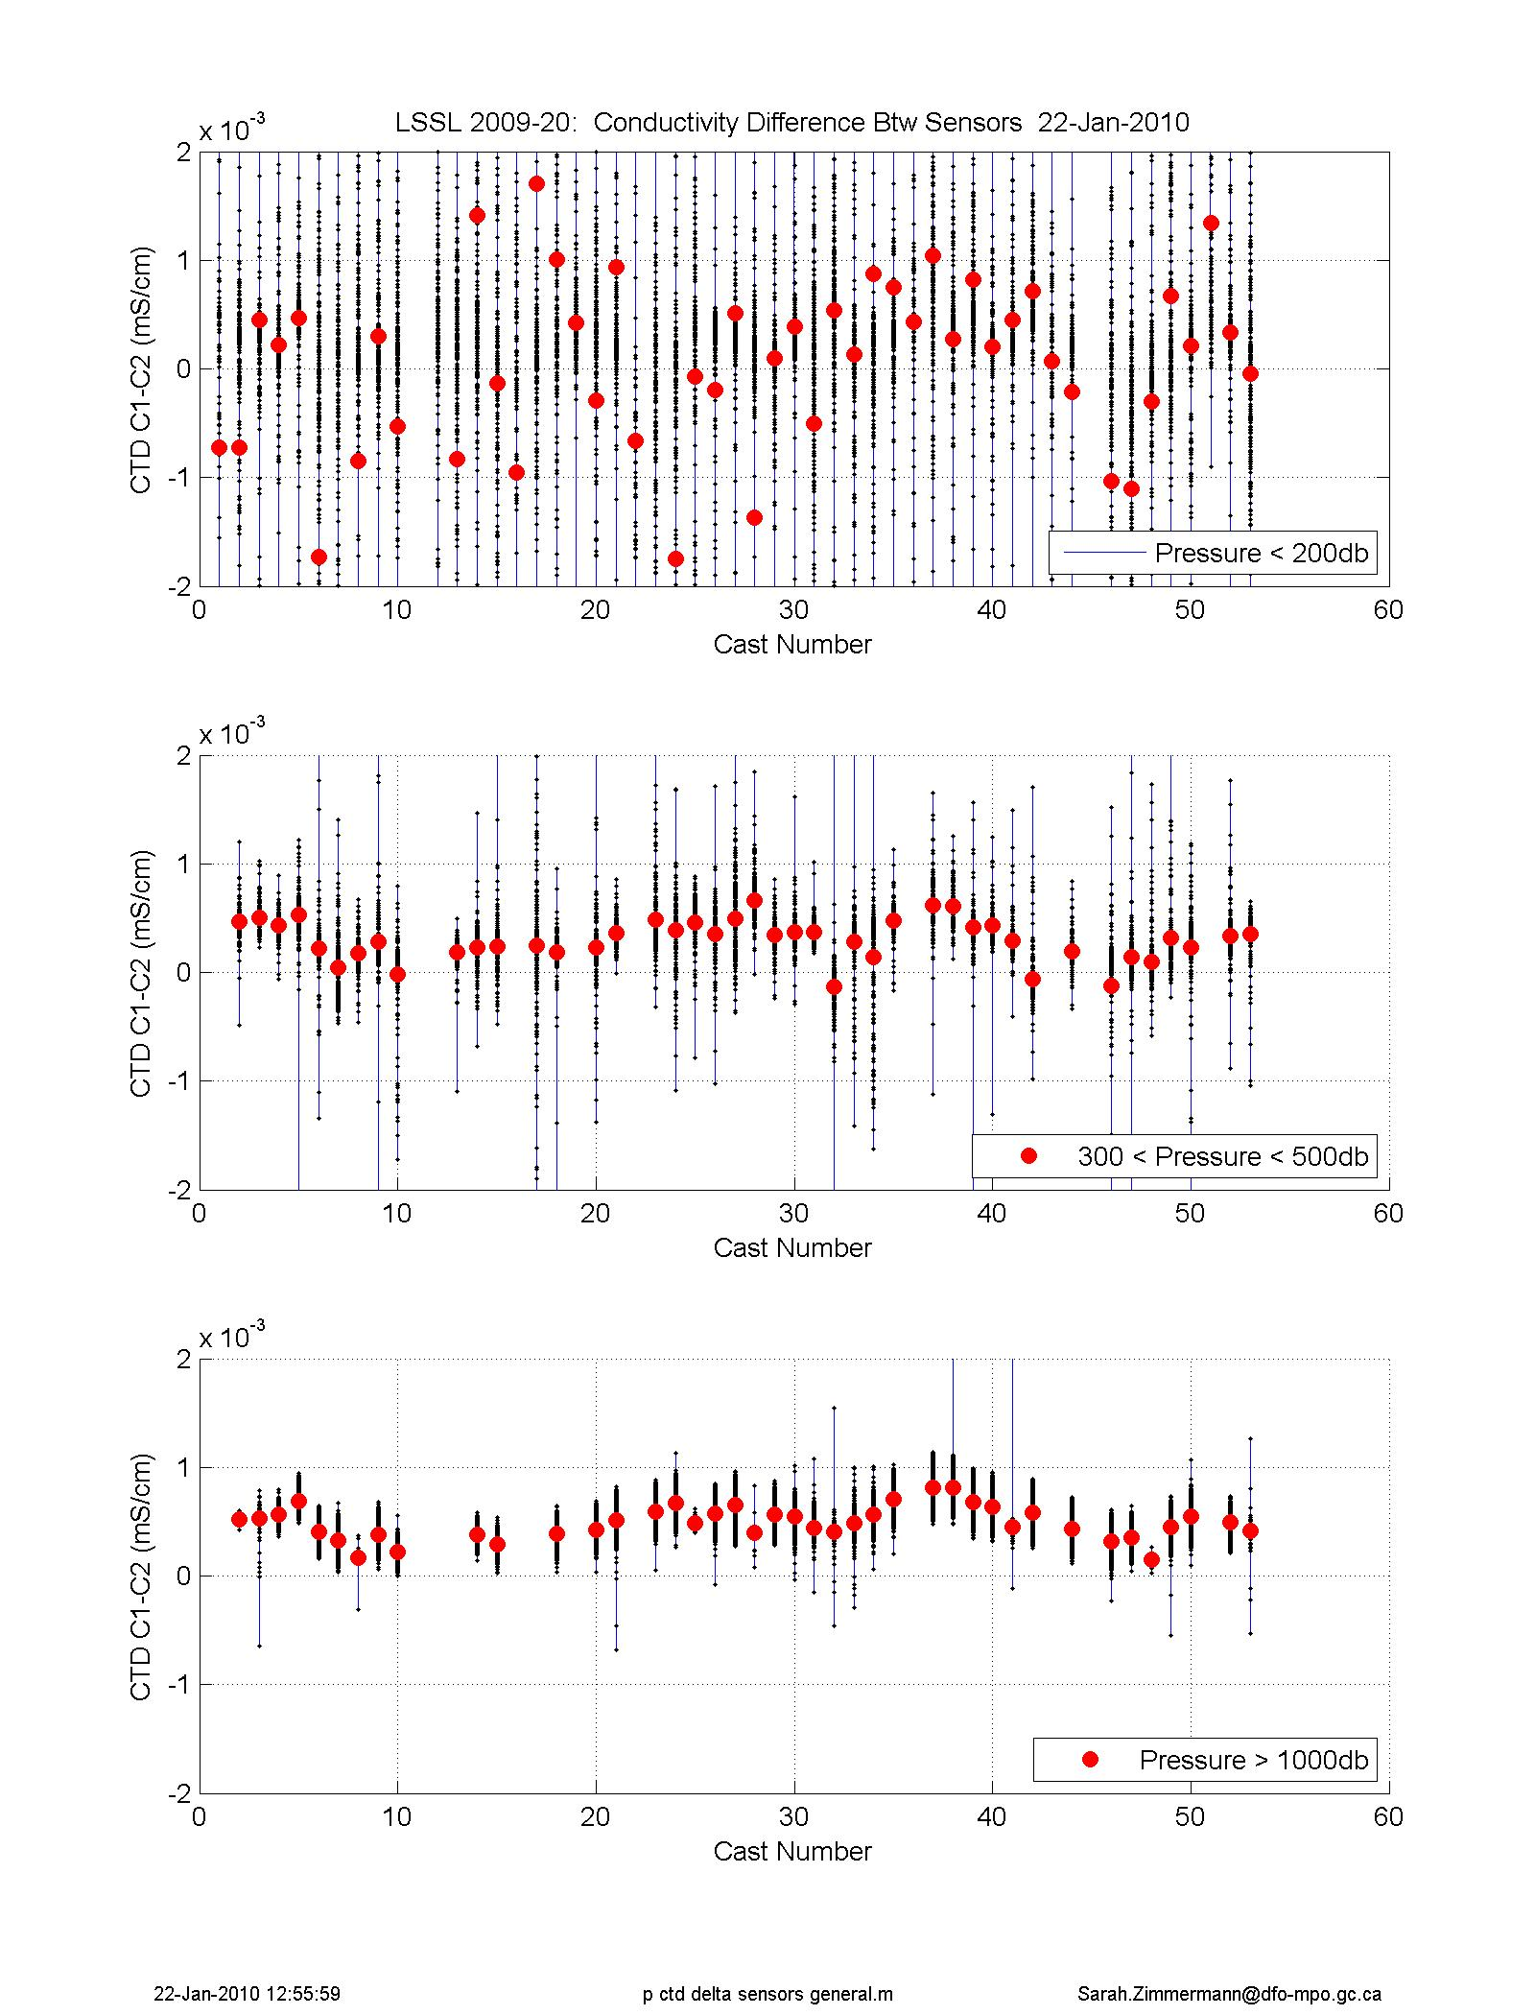
Figure 7. Difference between primary and secondary conductivity per cast, divided into three depth regions

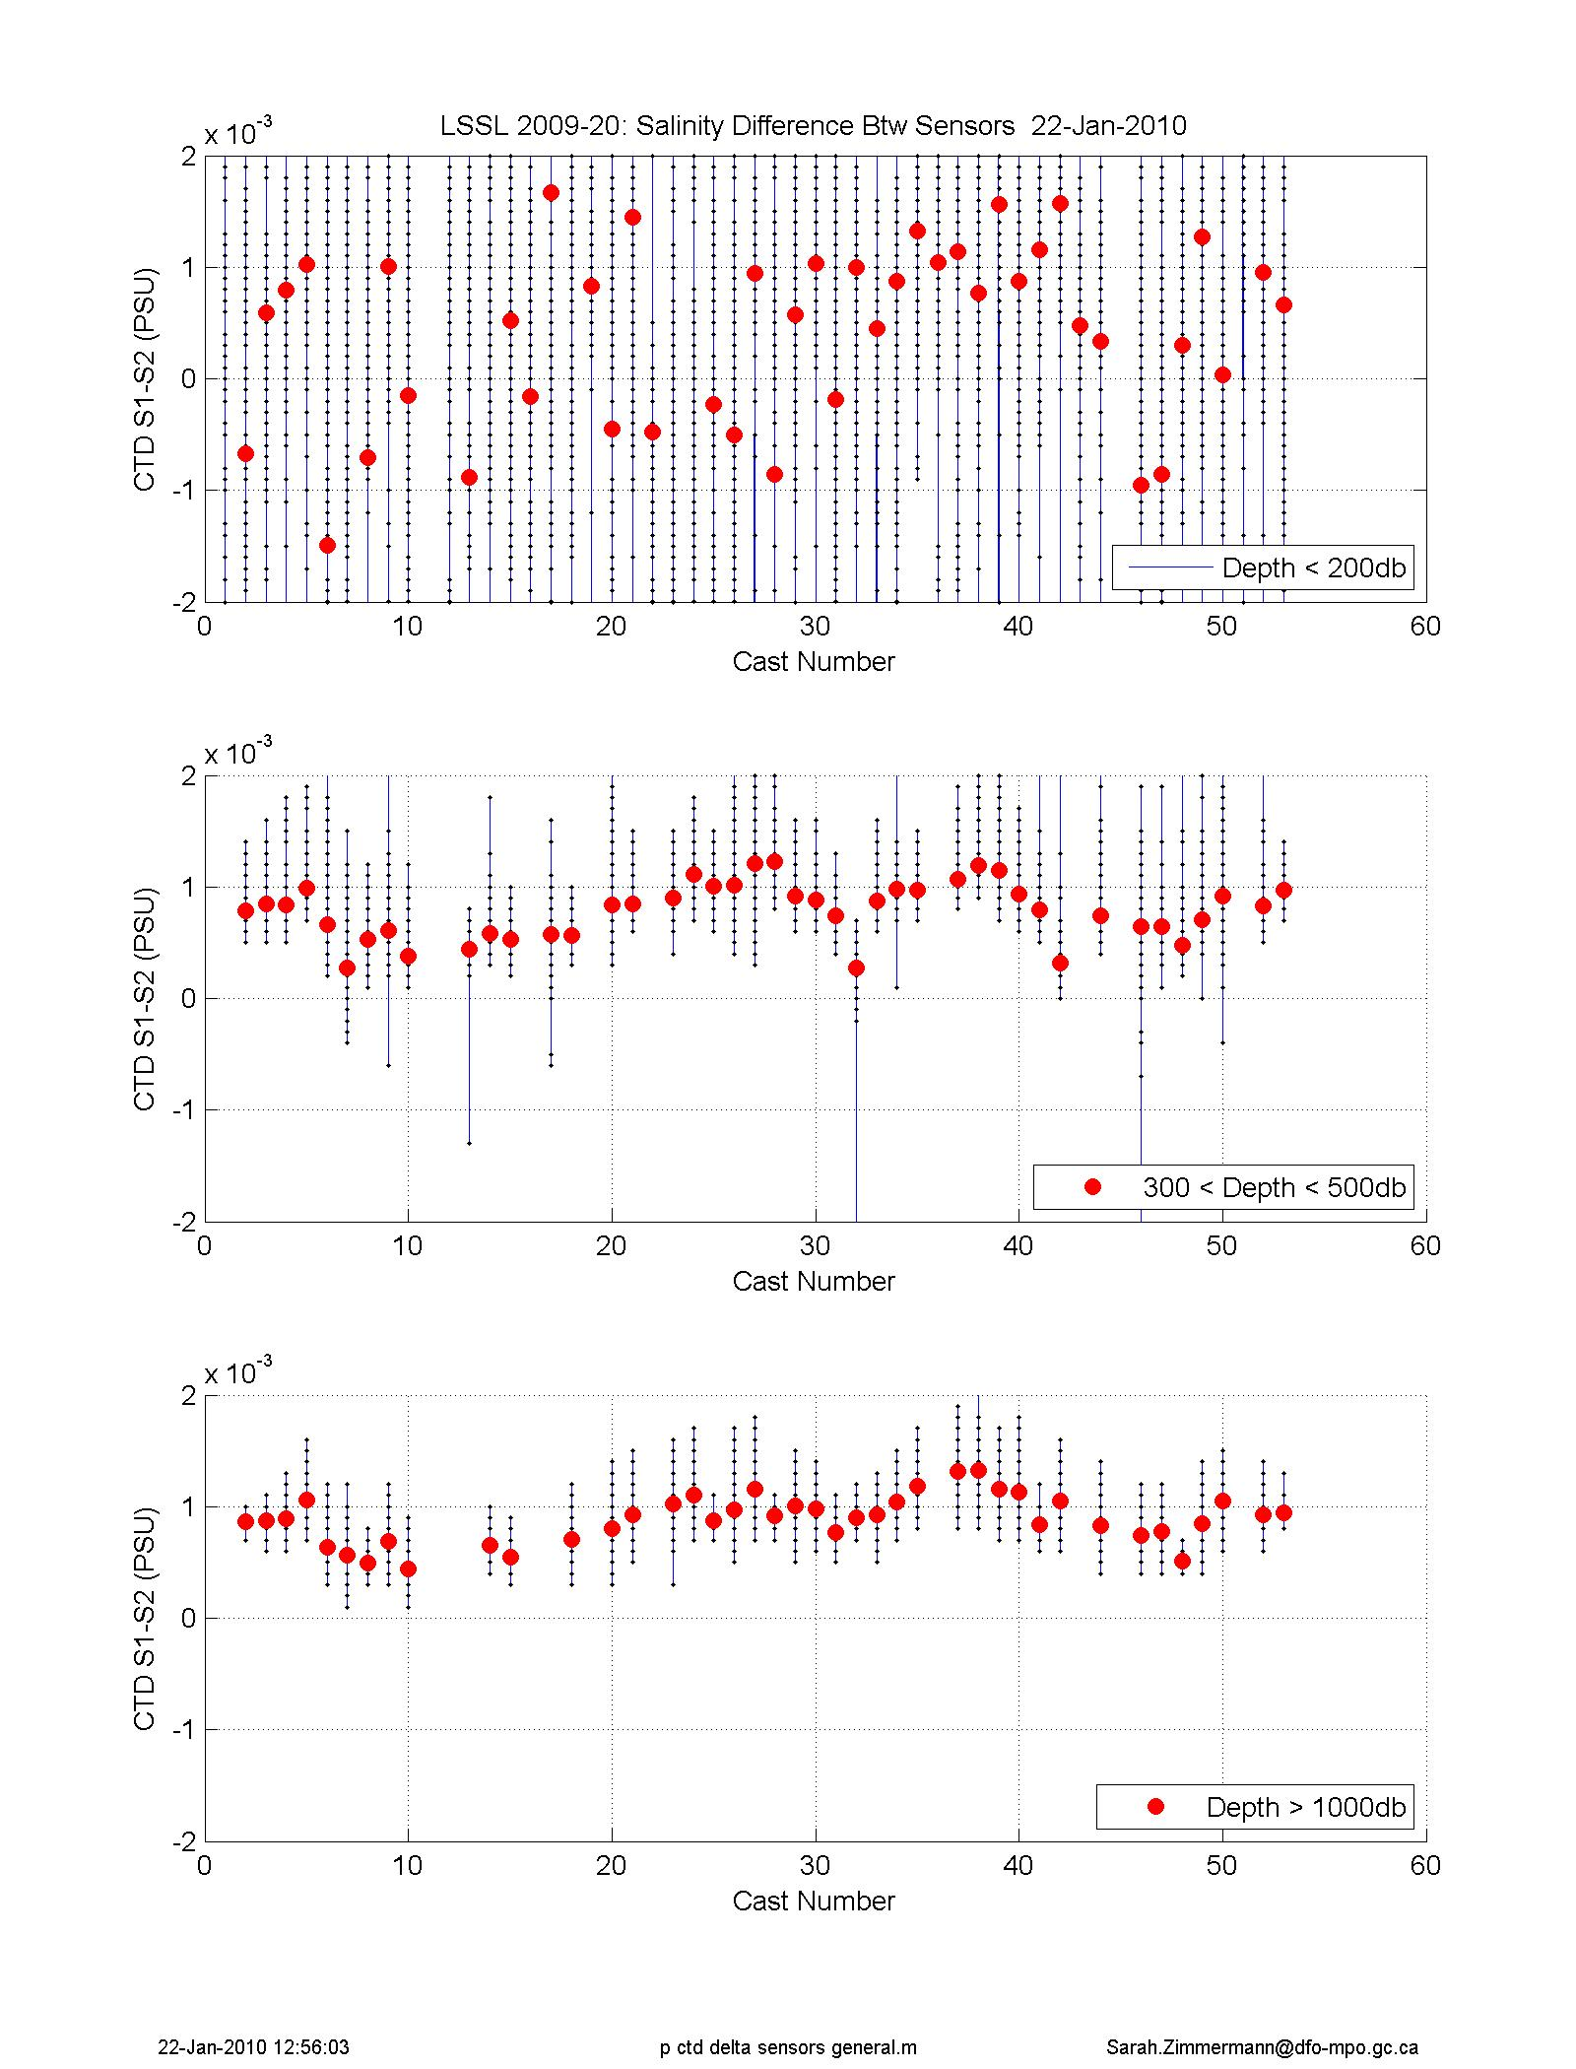
Figure 8. Difference between primary and secondary salinity per cast, divided into three depth regions

Water Sample and Deep Ocean Comparison

Conductivity was calculated using the post–cruise lab calibration and the bias was further adjusted to match the known deep water value of 34.956 PSU. Comparisons of final CTD values with fits to the bottle data over 2000m agree within 0.0012mS/cm. There were issues with the water sample analysis (autosalinometer – see report) with a higher than typical precision (standard pool of 0.007PSU at-sea and 0.004PSU on-shore analysis) although the mean deep water value for the cruise was 34.956 PSU, the same as the expected salinity. It was deemed better to use the stable deep water value based on measurements from 2004 to 2008 for calibrating the CTD this year rather than using the bottle data.
The bottle and calibrated CTD comparisons show a remaining pressure dependence with a 0.0005 to 0.001 PSU salinity difference between 700m and 1000m in both sensors (CTD fresher than water samples). No pressure dependent corrections were applied.

Table 3. Corrections applied to the post-cruise calibration (using cal_salt_200920.m). These values set the calculated conductivity in between what would have been given by the pre and post-cruise calibrations.
Group | Casts | Primary Conductivity | Secondary Conductivity
1 | 1-17 | -0.0021 | - 0.0047
2 | 18-28 | -0.0019 | - 0.0043
3 | 29-38 | - 0.0017 | - 0.0039
4 | 39-43 | - 0.0013 | - 0.0035
5 | 44 | - 0.0004 | - 0.0030
6 | 45-46 | - 0.0002 | - 0.0028
7 | 47-51 | - 0.0000 | - 0.0024
8 | 52-53 | + 0.0003 | - 0.0021

Figure 9. Calibrated primary CTD salinity compared to bottle salts.

Figure 10. Calibrated secondary CTD salinity compared to bottle salts.

Canada Basin Bottom Water Comparison

Bottles show bottom water salinity in 2009 is 34.9564 with a STD of 0.0013. This value is very close to the average of the 2002 to 2008 cruises listed below of 34.9570.

Table 5. Deep Bottle Salinity Values (from values deeper than 3000db, and within 34.954 and 34.960) from chemistry files. See compare_salt.m or N:\SHARE\DATA\Canada Basin Bottom Water\Deep Basin Salinity Figures\ DeepSaltTable.xls
Year | Cruise | Mean Bottle Salinity | STD Bottle Salinity | Number of Bottle Observa-tions | Mean CTD Salinity | STD CTD Salinity | Number of CTD Observa-tions
2002 | 2002-23 | 34.9573 | 0.0010 | 9 | 34.9577 | 0.0003 | 16
2002 | Mirai | 34.9576 | 0.0007 | 17 | 34.9587 | 0.001 | 25
2003 | 2003-21 | 34.9564 | 0.0013 | 26 | 34.9571 | 0.0003 | 57
2004 | 2004-16 | 34.9574 | 0.0008 | 64 | 34.9573 | 0.0002 | 64
2004 | Mirai | 34.9576 | 0.0004 | 20 | Too high | na | na
2005 | 2005-04 | 34.9563 | 0.0010 | 28 | 34.9568 | 0.0002 | 31
2005 | Oden | 34.9573 | 0.0012 | 29 | 34.9579 | 0.0004 | 31
2006 | 2006-18 | 34.9570 | 0.0013 | 33 | 34.9572 | 0.0002 | 40
2007 | 2007-20 | 34.9570 | 0.0010 | 56 | 34.9577 | 0.0003 | 68
2008 | 2008-30 | 34.9563 | 0.0009 | 58 | 34.9575 | 0.0005 | 63
2009 | 2009-20 | 34.9564 | 0.0013 | 26 | 34.9571 | 0.0003 | 57
Avg (2002 to 2008) |  | 34.9570 | 0.0010 |  | 34.9575 | 0.0004

    - CTD Oxygen

Summary
Oxygen Seabird SBE43 sensor had pumped flow and was installed in-line,
following the primary temperature and conductivity sensors. One sensor was used the full cruise.
Oxygen data were from a sensor installed with pumped flow in-line after the primary temperature and conductivity sensors. A lag of -5 seconds was applied to oxygen voltage in the Seabird processing step Align. Downcast CTD oxygen voltage and upcast temperature and salinity were used to calibrate CTD to water sample oxygen (upcast). The 53 casts were fit as one group using bottles deeper than 500m. Fitting method followed Seabirds Application Note 64-2 (“SBE 43 Dissolved Oxygen Sensor Calibration and Data Corrections using Winkler Titrations”). A drift between casts was corrected using a linear fit to the residuals. A remaining pressure dependent shape in the residual between water sample and CTD oxygen was removed by subtracting a mean curve. The mean curve was made by stitching together sections using spline interpolation after finding the sections by fitting data from discreet pressure ranges.

Calibrated CTD oxygen compared to water sample oxygens has a standard deviation of 0.15ml/l over the full depth and 0.02ml/l for bottles deeper than 300m.

Calibration

The downcast oxygen data were calibrated to the upcast oxygen water samples, with consideration given to the sensor lag, hysteresis, and water sample quality. Coefficients were primarily found following the Seabird method (Application Note 64-2: http://www.seabird.com/application_notes/AN64-2.htm). New sets of coefficients were determined for two of the six coefficients (voffset and soc) and applied together with the other pre-cruise laboratory calibration coefficients. The pre-cruise calibration was used because during the post-cruise calibration, Seabird found the sensor membrane had torn, and the calibration was performed after the calibration – altering repair.

Due to the slow response time of the oxygen sensor, the oxygen voltage was advanced 5 seconds using Seabird "align". The lag of the oxygen voltage was determined by comparing similar oxygen voltage features in the downcast and upcast.

The CTD oxygen upcast data were not used due to the large hysteresis resulting from deep casts at cold temperatures. We have not been using the Seabird depth correction parameters (pressure and temperature dependent lag or hysteresis correction) as the large variable lag applied to the local oxygen gradient creates an artificially large signal in the cold deep water.
The calibration is made using downcast oxygen voltage with upcast temperature and salinity. The downcast oxygen voltage is found by using the bottle trip information, matching the downcast on density for 0 to 600db and pressure below 600db. There will be some error due to the real difference between down and upcast profiles.

The pre-cruise laboratory calibration terms were used and new SOC and Voffset terms were found using the water sample data following Seabird Application
Note 64 – v2Jun2012 (http://www.seabird.com/document/an64-2-sbe-43-dissolved-oxygen-sensor-calibration-and-data-corrections )

Sensor #435
Applied coefficients:
Casts | d0 | d1 | d2 | a | b | c | e | Soc | Voffset | Lag
Pre-Cruise | 1 | 0.000193 | -0.04648 | -4.22E-04 | 9.46E-05 | -1.81E-06 | 0.036 | 0.4058 | -0.4920 | 0
1-53 | 1 | 0.000193 | -0.04648 | -4.22E-04 | 9.46E-05 | -1.81E-06 | 0.036 | 0.42386 | -0.42173 | 0

Following this, a drift through the cruise between stations was corrected using a linear fit to the residuals. A correction for the remaining pressure dependent shape in the residuals was applied. A correction profile was made by fitting to the residuals in a particular pressure range and interpolating between ranges to make a smooth correction profile. This correction profile was subtracted from each oxygen profile including the CTD data in the chemistry file.

The linear correction for the drift ranged from -0.05 to +0.05 ml/l using the equation :
y = -0.0017 x + 0.0490
where x = cast number, and y = correction subtracted from the profile’s values.

The pressure dependent correction was at most -0.12ml/l between 50 and 250m. Elsewhere, the correction was within +/- 0.05ml/l.

Table 6. JOIS program: Mean and STD of residuals (CTD-WS) for oxygen. All flagged oxygen samples removed.
Pressure Range (db) | STD | Mean  (CTD-WS) | Number of Observations
0 to 300 | 0.197 | 0.035 | 504
300 to 4000 | 0.018 | 0.000 | 427
Full | 0.146 | 0.019 | 931

Repeat station
Station CABOS (Casts 2,3 and 53) and CB22 (Casts 6 and 52) were sampled at the start and end of cruise. In the deeper waters (over 500dbar) the differences between casts for both water samples and CTD were minimal ~.01ml/l.

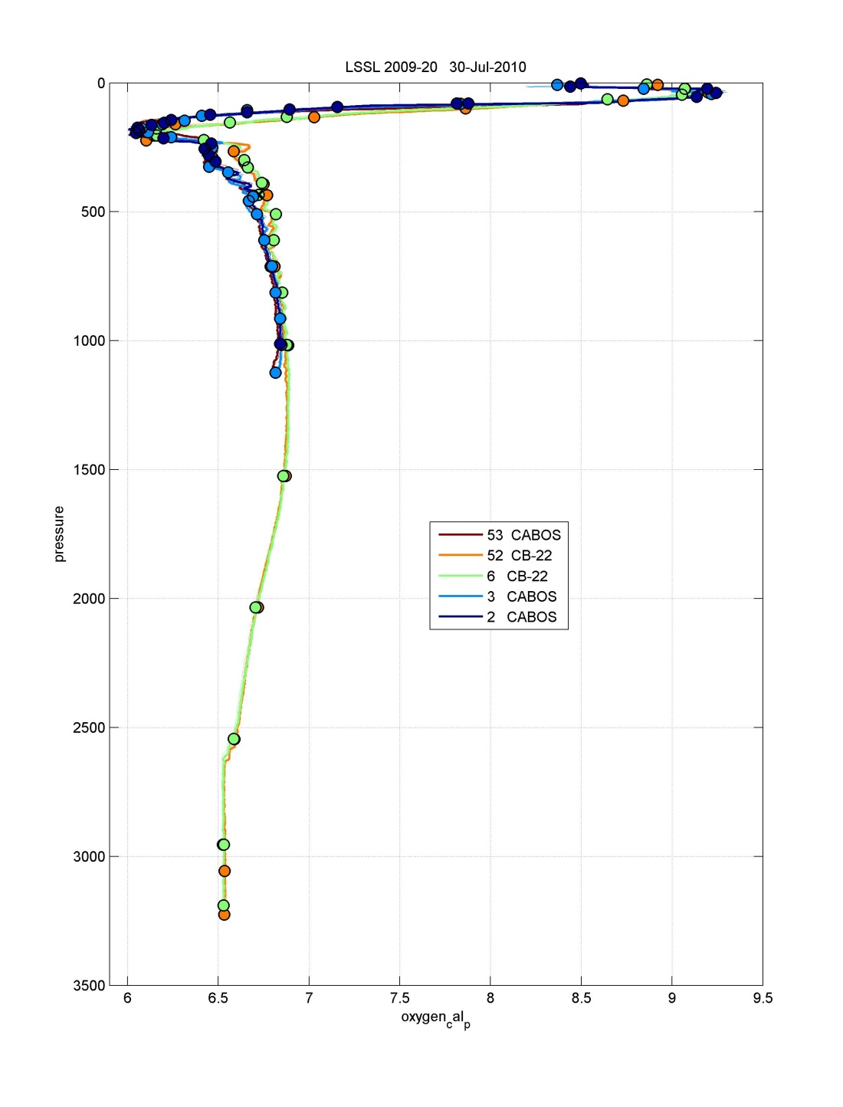
Figure 11. Repeat stations at start and end of cruise.

Canada Basin Bottom Water Comparison
The oxygen concentrations are slightly lower than the historic bottom water values. The 2009 mean of 6.54ml/l (for both CTD and water samples) is close to the JOIS program water sample average of 6.56 ml/l from years 2004, 2005, and 2008 (2006 and 2007 excluded due non-independent measurements). The yearly averages are made from samples deeper than 2950dbar with concentrations between 6.4 and 6.7 ml/l.

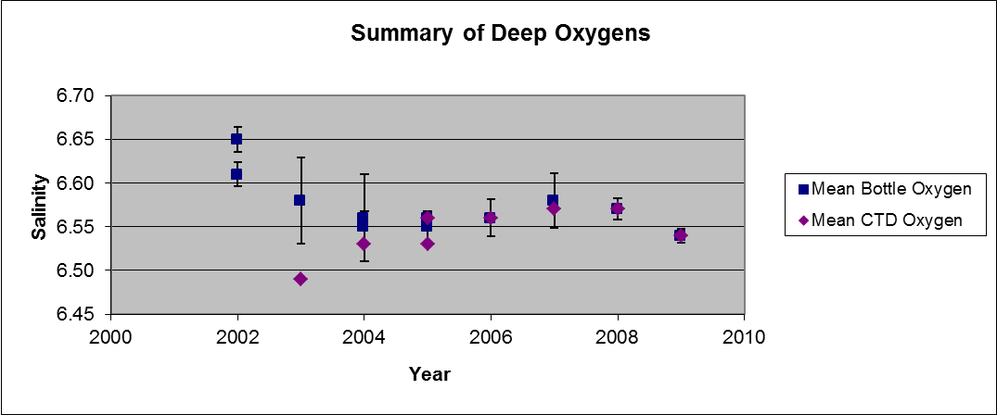
Figure 12. The yearly averages are made from samples deeper than 2950dbar with concentrations between 6.4 and 6.7 ml/l

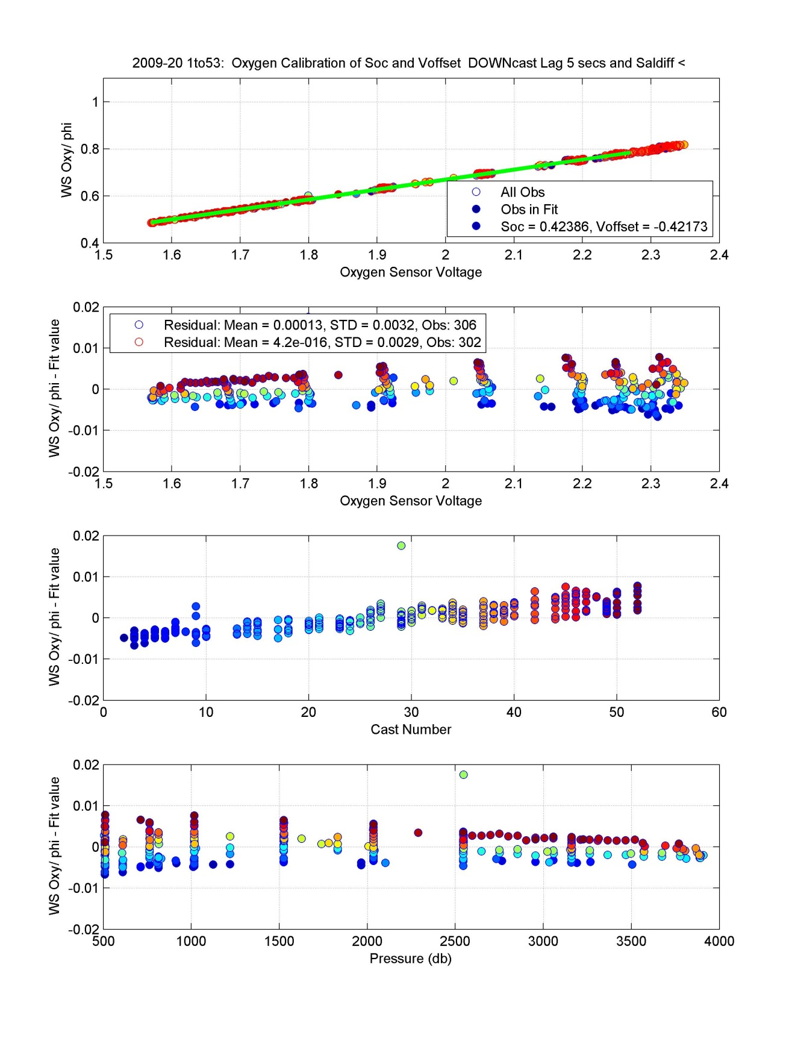
Figure 13. Results of fit, one group, for samples deeper than 500dbar.
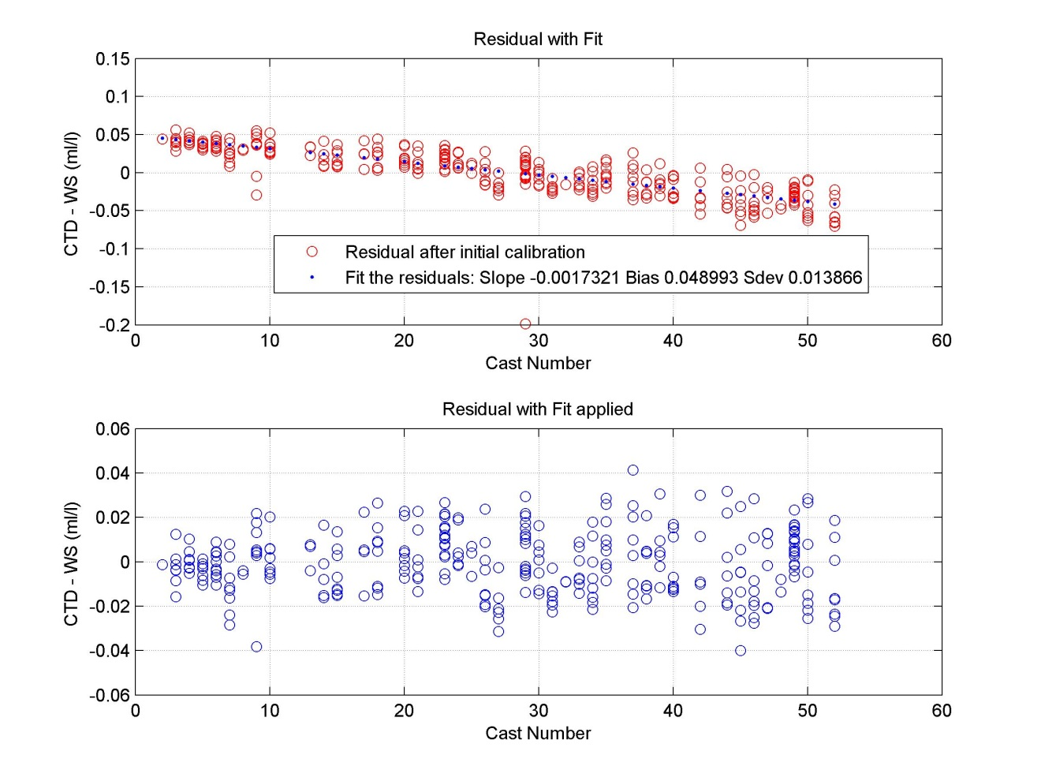
Figure 14. Correction for a linear drift between casts.
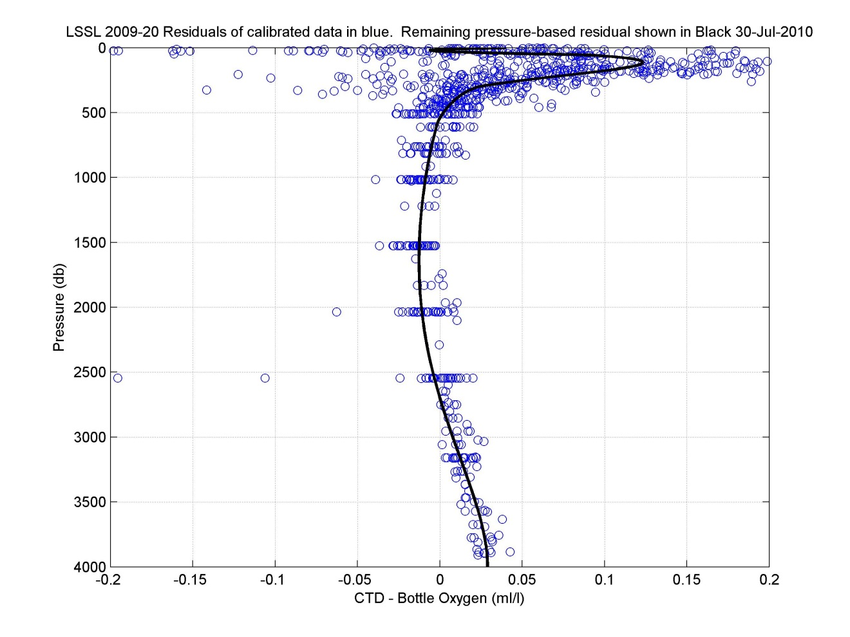
Figure 15. Residuals after calibration and drift correction but before correction for pressure dependent shape.

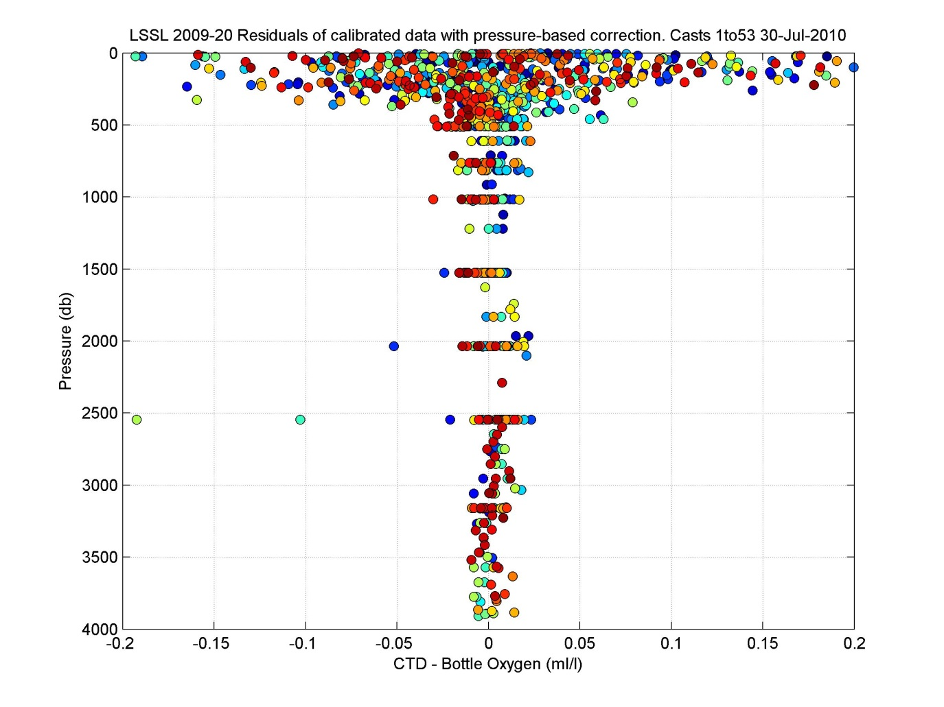
Figure 16. Mean and STD of final Oxygen Residuals (CTD-WS) in ml/l for JOIS program. All flagged oxygen samples removed.

    - CTD Transmission

Performance

One WETLabs CSTAR DR transmissometers with an optical path length of 0.25 m was used for the cruise.

Calibration

The data of the transmissometers were not processed except with nominal coefficients to compute percent transmission.

The windows were wiped with tissue soaked in deionized water prior to each cast as part of the CTD launching routine.
The nominal coefficients used for processing were:

Serial number : CST-1050DR; Calibrated on : 15-May-2008
M* : 19.758; B* : -1.254; Path length : 0.250 m
Note: parameters should have been
M: 20.117, B: -1.277 (so given values are ~1.7% low)

*M and B as defined in Seabird Application Note 7 (Seabird, 2008).

Units are either in [%] with pathlength 0.25 m or have been standardized to [%/m] where pathlength 1 m.

Figure 17. Transmissivity [%], all casts, full depth.
Figure 18. Transmissivity [%], all casts, top 160m.

    - CTD Fluorescence

Performance

Water was pumped past the Seapoint chl-a fluorometer, after passing through the secondary temperature and conductivity sensors to improve the consistency of the reading. The covered housing on the fluorometer prevented accessibility for cleaning during the cruise. A 30x gain cable was used with the fluorometer such that the 0-5 V fluorometer output is linearly converted to 0 - 5 mg/m³. The Seapoint fluorometer minimum detection level is 0.02 mg/m³, has an excitation wavelength of 470nm CWL, 30nmFWHM and emission wavelength of 685nm CWL, 30nmFWHM.

Calibration

A calibration with bottle data was performed using a linear fit to bottle chlorophyll values greater than 0.025 mg/m3. The number of observations used were 115 out of 160 with a standard deviation of 0.037 mg/m3 in the residuals.
No alignment was applied
Coefficients used: Slope: 0.8975, Bias -0.0781
Figure 19. CTD Fluorometer calibration. Casts <50 are from the cruise’s previous leg (2009-19) and Casts >100 are from 2009-20.

Figure 20. CTD Fluorometer calibration results.
Figure 21. Calibrated CTD fluorometer with water sample data.

    - CTD CDOM Fluorescence

Performance
The sensor, WETLabs FLCDRTD s/n1076, which optically measures Colored Dissolved Organic Material, was used on all casts. It was calibrated 11 Jun 2006 however only voltage was reported. CDOM water samples will be used to calibrate the voltage by program collaborator Celine Gueguen (Trent University).

Due to the cross-talk with the ISUS Nitrate Sensor, data on Casts 1, 2, 8 are not useable and have been removed. On Cast 42 the sensor’s cap was accidentally left on so again the data have been removed. Changes were made to the CDOM/ISUS cable for Cast 11 and again Cast 35 however voltage was still seen on the ISUS channel even when the sensor was not installed. For Cast 39 the cable was changed to no longer allow pairing with the ISUS sensor and the ISUS was moved to a different bulkhead connector. Associated with this changes was a small shift in the CDOM data of about +0.02V.
No data: Cast 1, 2, 8, 42
Values suspect high: Cast 11
Values suspect low: Cast 28, 30 to 34

    - CTD ISUS Nitrate Sensor

Performance
The ISUS Nitrate sensor s/n72, which optically measures Nitrate was used on casts less than 1000m due to physical instrument depth-limits. The linear response to Nitrate is given in voltage and can be calibrated to water samples. As mentioned in the Overview there were initially problems with cross-talk between the CDOM sensor and the ISUS nitrate sensor that shared a cable and differential input connector on the CTD. This was improved with cable changes before Cast 11 and again Cast 35, however voltage signal was still seen on the ISUS channel even when the sensor was not installed. To correct this, after Cast 39 the sensors were separated with the ISUS put onto another differential input pair typically used by the JFE-Alec Rinko III oxygen sensor. As the Rinko is a two channel sensor (T and DO voltages), the Rinko was blanked off during casts when the ISUS was used on casts 41, 48 and 53.
The ISUS data were also recorded internally and these raw data are available but have not been processed into the data set.

Figure 22. All ISUS data before blanking no data/bad data casts.

There are useable ISUS data, for Casts 1, 2, 8, 13, 16, 17, 19, 28, 32, 41, and 53 however they are uncalibrated and unprocessed.

    - CTD Surface Reference PAR

Performance
Data were collected using a Biospherical QSR-2200 starting on Cast 11. These data are nominal with applied calibration from 13Mar2007.
Figure 23. All SPAR data before blanking no-data casts.

    - CTD Altimeter

Performance
Altimeter data are from a Datasonics PSA-916D and are unprocessed, using calibration from Mar 2005.

    - Data Spike Removal
Data spikes were found in primary temperature and primary conductivity using the density inversion criteria listed below. Linear interpolations were performed on both primary temperature and conductivity if a spike was found in either property. Calculated variables including salinity were re-calculated following the interpolations. Interpolations were also performed for spikes found in oxygen data. All interpolations spanned less than 10 dbar.

Criteria for temperature and salinity spike identification:
0 to 200 m, density inversions over 0.004 kg/m³/m
200 to 600 m, density inversions over 0.001 kg/m³/m
600 m and deeper, density inversions over 0.0005 kg/m³/m

    - Determination of CTD Data at Bottle Depths

Bottle files were reprocessed using criteria of 0.5 second average (12 scans), centered at -3.8 seconds.

Niskin bottles were closed on-the-fly. Due to slow bottle flushing, this results in the water in the bottles coming from slightly deeper than the depth of the CTD measurement so the goal is to find and apply a standard time offset to the CTD data to best match the CTD and Niskin water samples. Salinity gradients are large in the upper ocean so comparisons between water samples and CTD in the upper 300 m were used to determine the best time offset.
The appropriate lag was found by comparing 0.2 second averaged CTD data to the bottle data. The comparisons were restricted to the upper 300 m where the vertical salinity gradient is large. Between 100 and 200 db, the vertical salinity gradient is 0.01 to 0.02 PSU/dbar and wire-speeds of 0.5m/sec created temporal salinity gradients of 0.005 to 0.01- PSU/sec. CTD salinities from 0 to 10 seconds prior to bottle closure were compared with the bottle salinities. Casts where the CTD rosette was stopped were excluded. The CTD salinity is uncalibrated for this test, however this difference is an order of magnitude less than the difference being looked at here.
There is a skew to the outliers, where bottle salinities tend to be higher than the CTD salinity, indicating bottles are not uniformly flushed and outliers are biased towards water from greater depths. It should be noted that the alternative, stopping the package for a bottle sample, also results in a bias due to the lack of normal ship-rock in ice covered waters that would mechanically flush the bottles. Closing on-the-fly is thought to reduce the size of the bias and produce a more repeatable response than stopping the package for bottle closures.

The best lags were dependent on the depth:
0 to 100db look the best at -4seconds. Salinity gradient is 0.07/db
100 to 150 db looks best at -5 seconds. Salinity gradient is 0.015/db
150 to 250 db looks best at -3.8 seconds. Salinity gradient is 0.02/db

A time offset of -3.8 seconds was chosen as the best compromise for the upper 250m. This is a larger offset than used previously. The Niskins and rosette frame are the same as in other years (2004 – 2009) though the arrangement of sensors and weights on the frame is different.

Table 7. Results of select CTD time offsets. Calibrated CTD and WS salinities were compared for data within 2.5 STD and 0 to 300 db.

 | Subset of samples using STD of 2.5 to remove outliers
Time Adjust (sec) | Salinity Difference Mean | Salinitity Difference STD | Number of Obs
-10 | -0.0270 | 0.0482 | 413
-5 | -0.0056 | 0.0276 | 408
-4 | -0.0018 | 0.0203 | 378
-3.8 | -0.0013 | 0.0192 | 375
-3 | 0.0017 | 0.0164 | 356
-2 | 0.0041 | 0.0124 | 322
-1 | 0.0079 | 0.0134 | 303
0 | 0.0110 | 0.0143 | 271

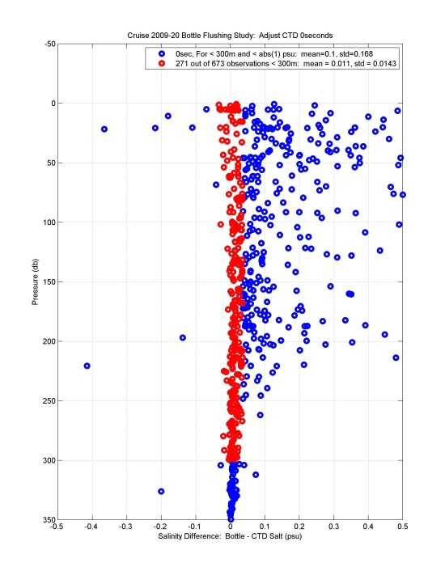
Figure 24.Adjust CTD with no (0 second) offset.

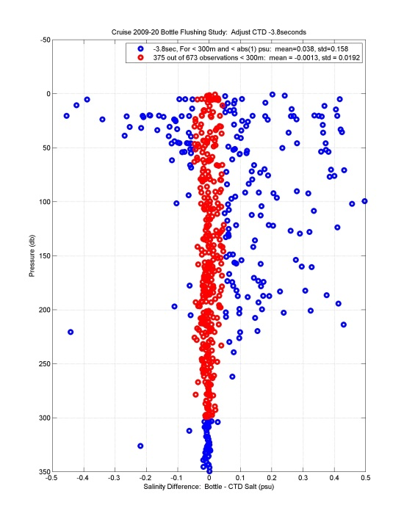
Figure 25. Adjust CTD with -3.8 second offset.

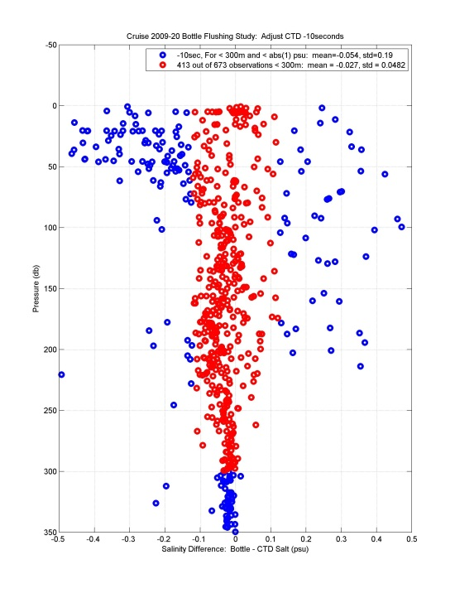
Figure 26. Adjust CTD applying -10 second offset.

CTD File Preparation

File Preparation

The CTD data for down and upcasts are provided in 1-db averaged files (*.cnv), in Seabird’s text format with one file per cast and separate files for down and up direction. The files contain both processed and unprocessed variables, described below. The downcast files are the primary data set however the upcast files are provided because of their usefulness for confirming unusual features seen in the downcast.

Header Processing Notes for Archived Data

Standard seabird processing steps were used. Pressure, primary and secondary temperature, primary and secondary conductivity, oxygen and fluorescence have been calibrated. Spikes in primary temperature and primary conductivity have been interpolated over and where needed secondary values (when available) have replaced the primary values. Derived variables, salinity, potential temperature, sigma-theta and sound velocity, were recalculated. Transmission, CDOM fluorescence, altimetry, RINKO oxygen and temperature, and ISUS have nominal calibrations.
For further information see: 2009-20_CTD SBE911 Processing_v2018-03-14.doc

CTD Pressure: The lab calibration was adjusted by applying +0.42dbar offset to the bias based on in-air surface readings of the CTD.

CTD Temperature: The post-cruise lab calibration was used after comparisons with dual sensor and post-cruise calibration information. Secondary temperature is preferred as performed better than the primary and should be used preferentially.

CTD Conductivity: The post-cruise lab calibration was adjusted after comparisons with dual sensor, expected deep water values and water sample data. There was a drift of 0.002mS/cm during the cruise. Over 8 groups, primary conductivity received offset of -0.0021 to +0.0003mS/cm. Secondary conductivity received an offset of -0.0047 to -0.0021 mS/cm.

CTD Oxygen: Oxygen data were collected with a SBE43 sensor installed with pumped flow in-line after the primary temperature and conductivity sensors. A lag of -5 seconds was applied to oxygen voltage in the Seabird processing step Align. Downcast CTD oxygen voltage and upcast temperature and salinity were used to calibrate CTD to water sample oxygen (upcast). The 53 casts were fit as one group using bottles deeper than 500m. Fitting method followed Seabirds Application Note 64-2 (“SBE 43 Dissolved Oxygen Sensor Calibration and Data Corrections using Winkler Titrations”). A drift between casts was corrected using a linear fit to the residuals. A remaining pressure dependent shape in the residual between water sample and CTD oxygen was removed by subtracting a mean curve. The mean curve was made by stitching together sections using spline interpolation after finding the sections by fitting data from discreet pressure ranges.

CTD Fluorometer: Data are from a Seapoint fluorometer with pumped flow in-line after the secondary temperature and conductivity sensors. Calibration with bottle data was performed using bottle chlorophyll values greater than 0.025mg/m3. The number of observations used were 115 out of 160 with a standard deviation of 0.04 mg/m3 in the residuals. Coefficients used: Slope:0.8975, Bias -0.0781. No alignment was applied.

CTD Transmissometer: Data are from a WETLabs CSTAR DR transmissometer. Data are unprocessed, using calibration coefficients from 15 May 2008 to convert from volts.

CTD CDOM Fluorometer: Data are from a WETLabs ECO CDOM FLCDRTD. They are unprocessed and given as raw voltage.

CTD Altimeter: Altimeter data are from a Datasonics PSA-916D and are unprocessed, using calibration from Mar 2005.

CTD Nitrate: Data are from an ISUS Nitrate sensor. Sensor used on casts 1, 2, 8, 13, 16, 17, 19, 28, 32, 41, 48, and 53. Data are unprocessed.

CTD Oxygen and Temperature from RINKO III Sensor: These data are unprocessed. Data are not available on Casts 41, 48 and 53.

CTD Surface Reference Photosynthetically Active Radiation (SPAR): Data collected using a Biospherical QSR-2200 starting on Cast 11. These data are nominal with applied calibration from 13Mar2007.

Bottle File Preparation

Chemistry and CTD Data Assembly

CTD and water sample data were initially combined and posted in a spreadsheet where all data associated with a sample number, consecutive for each Niskin and cast, were given a row. When two or three properties per sample showed questionable or bad data, the sample would be further examined to determine if there was a mis-trip or bottle flushing problem. Typically if water in the Niskin appeared to be from more than 10m away from intended depth, the Niskin would be flagged bad.

For the IOS Archives, the data have been separated into individual station files.

Appendix:

LIST OF INTERPOLATIONS
Table 8. List of Interpolations.
List of presure values to be interpolated over
Property Key:
(1) Temperature
(2) Conductivity
(3) Temperature and Conductivity
(4) Oxygen
(5) Transmission
(6) Fluorescence
Use:
If starting value is bad at start of cast,
Set Start(db) to first depth -1 and all data
will be set equal to the ending value.
Station Start (db) End(db) Property
******* ********** ******** ********
1 24 26 3
1 29 31 3
1 33 35 3
1 37 39 3
1 42 44 3
1 47 49 3
1 74 77 3
1 78 81 3
1 88 90 3
2 2 6 3
2 10 13 3
4 1 3 3
4 4 6 3
4 7 10 3
4 10 12 3
6 0 2 3
6 2 7 3
6 13 15 3
6 15 19 3
7 0 5 3
11 11 13 3
11 13 16 3
11 16 18 3
11 20 22 3
12 1 3 3
12 4 7 3
13 0 3 3
13 8 10 3
13 12 15 3
13 486 488 3
14 0 4 3
14 9 11 3
14 12 14 3
16 12 15 3
17 1 5 3
17 12 14 3
17 79 81 3
18 47 49 3
20 0 4 3
21 1 7 3
21 937 941 3
21 1014 1017 3
22 0 8 3
22 9 11 3
22 14 16 3
23 0 3 3
23 11 13 3
24 38 40 3
25 0 2 3
25 5 7 3
25 8 13 3
25 0 0 3
26 9 12 3
26 15 17 3
28 0 6 3
28 14 17 3
28 49 51 3
29 1 11 3
30 11 14 3
30 917 920 3
31 0 5 3
31 16 19 3
31 19 21 3
31 699 701 3
32 463 465 3
34 1 3 3
36 1 7 3
36 20 24 3
37 9 14 3
38 557 559 3
40 23 26 3
41 13 15 3
41 21 23 3
41 964 967 3
43 1 3 3
43 8 11 3
43 13 16 3
44 5 7 3
45 0 5 3
46 8 13 3
48 8 10 3
48 14 19 3
48 20 26 3
49 15 21 3
50 2 5 3
50 6 15 3
50 17 20 3
52 5 14 3
52 25 29 3

