Fluorometer Calibration Notes

2013-05-21

S.Zimmermann

2009-20 JOIS

**2017-03-21**

Confirmed: data are processed with 2010-07-02 cal and no lag. The 2013 information is just for comparison.

**2013-05-16**

For comparison, chlorophyll were recalibrated using only range 0.025 to 0.6.

109 of 133 observations used, residual is STD 0.03

Slope = 0.4162, Bias = 0.0146.

**This fit however does not look good. All values over 0.15mg/m3 are too low**.

This has not been applied, just determined for comparison. CTD and Chem sheet do not have raw voltage so will be necessary to remove existing fit and apply new fit.

Note that Processing comments would need to be updated as well.

Range of fluor is small (-.05 to 0.5), bottom values drift .075, hysteresis btw 0.01 and 0.05 in casts 2-10, 39-49, 52 with downcast sometimes being the odd looking cast, sometimes the upcast. So could consider using downcast values to calibrate to…**or just leave as is with large error bar.**

Have put in excel file: [Quality poor: signal drift in bottom waters of 0.075 is equal to 15% of signal range (0 to .5mg/m3) and hysterisis (inconsistant pressure dependent problem) of up to 0.05 mg/m3 is 10% of signal range.]

Plot showing CTD flr v. chl+phaeo does not show good 1:1 relationship as in other years.

**2010-07-02:**

2009-19 and 2009-20 Chlorophyll Data Sets combined into one fit with file names

*ctd_cal_19+20_fig_1.jpg* using fitting routine ***cal_fluorometer.m***

Figures 1:3 Larger delta axis to show all data

Figures 4:6 Smaller delta axis to show JOIS data

Fit is better for the JOIS data when using both data sets. The fitting process did remove a lot of points so standard deviation sounds better than the true accuracy of the CTD measurement. How to measure?

The down and upcast profiles on the C3O (Baffin Bay) leg are not very consistent and can differ by 0.3 (Cast 17), however I have not compared many casts.

Bottle stops were typically 1minute long. CTD chlorophyll would typically spike the direction of the deep water value and then come into line with downcast value though sometimes an offset would remain. The Baffin Bay data has higher variability, though the values of Chlorophyll are also higher than in the JOIS data.

Fit results for:

2009-20 only:

STD 2.5 for observation acceptance, only bottle values >0.04 mg/m3

84 out of 94 observations used, STD 0.019

Slope = 0.3220, Bias = 0.0293

2009-19 only:

STD 2.5 for observation acceptance, only bottle values >0.025 mg/m3

51 out of 60 observations used, STD 0.187

Slope = 0.7064, Bias = 0.1094

2009-19 and 20:

STD 2.5 for observation acceptance, only bottle values >0.025 mg/m3

115 of 160 obs used, STD 0.037; With all observations STD 0.046 mg/m3

***Slope 0.8975, Bias = -0.0781***

Data are in FlrFit_2009-19and20.mat with cal.* storing all the fit information.

I’m turned around with how to describe R2 value.

The actual fit, CTDraw(x) and Bottle(y), has a very high R2 value. But I think this says:

Bottle values are significantly dependent on CTD values….which is good as CTD Flr increases then Bottle values increase.

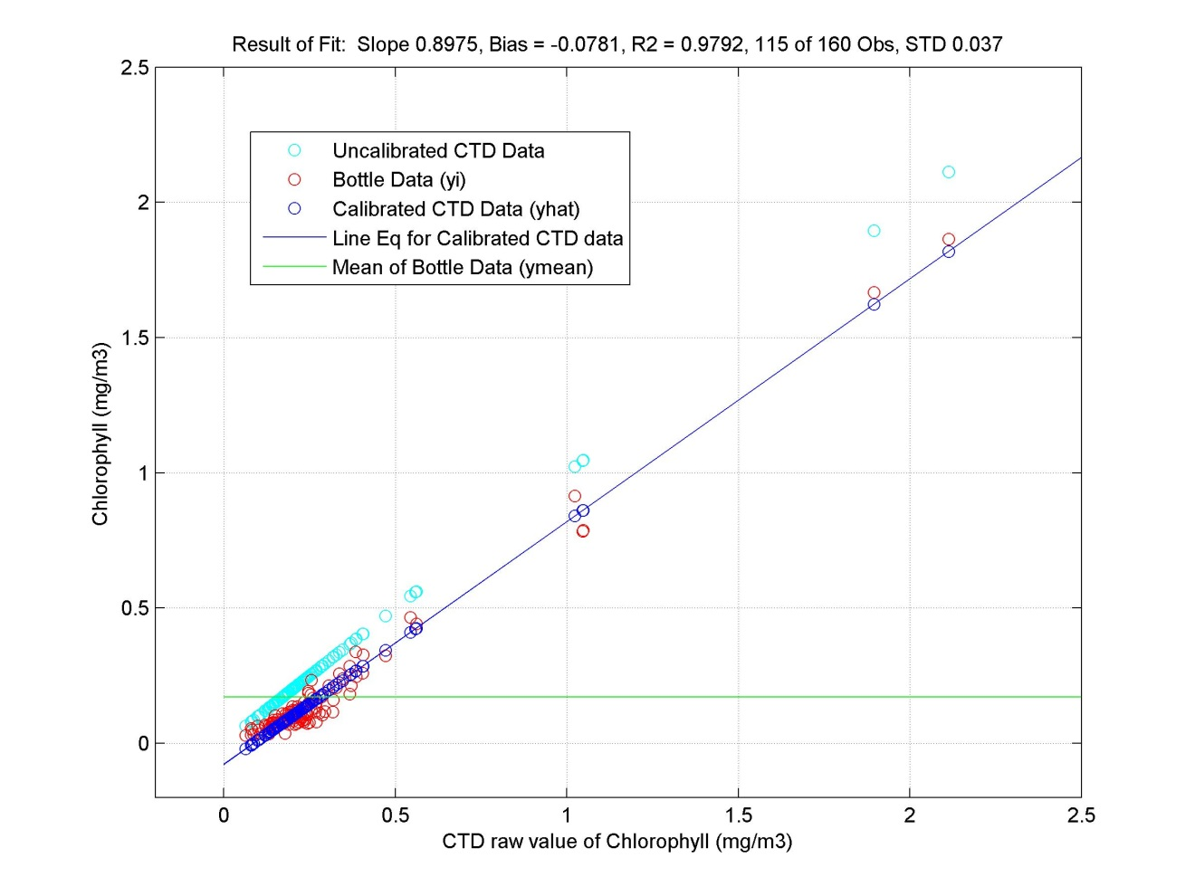

If all 160 observations were used:

STD is 0.2669 and R2 is 0.7775.

