REVISION NOTICE TABLE
DATE | DESCRIPTION OF REVISION
1 April 2025 | Updated channel names & formats in TOB files. GG
10 July 2020 | Fixed Julian Time in TOB files G.G.

PROCESSING NOTES
Cruise: 2009-07
Agency: OSD
Location: North Pacific / Bering Sea / Chukchi Sea
Project: C3O/IPY
Party Chief: Vagle S.
Platform: Sir Wilfrid Laurier
Date: 30 August 2009 – 5 September 2009

Processed by: Germaine Gatien
Date of Processing: 30 January 2019 – 7 March 2019
Number of original HEX files: 11
Number of CTD files: 11 Number of CHE files: 9
Number of original TSG files: 5 Number of TOB files: 5

INSTRUMENT SUMMARY
SeaBird Model SBE 911+ CTD (#0941) was used for this cruise. It was mounted in a 24-bottle rosette and attached were a Wetlabs CSTAR transmissometer (#993DR), a SeaPoint Fluorometer (#2336) with a 10X cable for events 1-13 and a 3X cable for events 14-28, an SBE 43 DO sensor (#1483), a Rinko III DO sensor (#005), an ISUS (#72) and an altimeter (#40853).

A thermosalinograph (SeaBird 21 S/N 3274) was mounted with a fluorometer (SCF2841) with either a 10X or a 30X cable and a remote temperature sensor #0271.

The data logging computer was SWL #1.
The data acquisition program was Seasave 7.18c.
The deck unit was a Seabird model 11, serial # 11P53201-0800.
The salinometer used at IOS was a Guildline model 8400B Autosal, serial # 69086. Bottles were analyzed in January 2010.

SUMMARY OF QUALITY AND CONCERNS
The CTD and rosette logs were generally in good order though the equipment list was incomplete.

Salinity samples were analyzed 4 months after the end of the cruise. The comparison with bottles suggests that the sensor was reading a little low, but there were only 9 bottles and a lot of scatter in the fit. A post-cruise calibration indicated that there was no significant drift. No recalibration was applied.

The DO sensor used during this cruise had been recalibrated 9 days before the cruise began. There was no calibration sampling but surface DO saturation values look reasonable. No recalibration was applied.

A SeaPoint fluorometer was mounted on the CTD for this cruise. There was no extracted chlorophyll sampling. During the previous cruise using the same equipment the SBE fluorescence was generally higher than extracted CHL for CHL<1ug/L. For CH L≥ 1ug/L the ratio gradually dropped with FL/CHL at 0.7 when CHL = 22.34ug/L.

Data from a Rinko oxygen sensor were converted but have not been processed for the OSD Data Archive. Sarah Zimmermann did a comparison of the Rinko data with the SBE43 data and details can be found in report 2009-07 RINKO SBE oxygen sensor comparison*.docx.

There were 5 thermosalinograph files. The first 4 were co-incident with CTD casts enabling some comparison but the 5th file contains data collected after this cruise. Recalibration of salinity from the TSG was based on the post-cruise factory calibration assuming an approximately linear drift with use. A singe value was chosen for the 4 files and a larger recalibration was applied to the 5th. Based on an earlier cruise, the TSG fluorometer is believed to be reading low for CHL >1ug/L with values about 40% of the CTD fluorometer. The 5th file required heavy editing as flow to the TSG and/or fluorometer was stopped for several lengthy periods.

PROCESSING SUMMARY

Seasave
This step was completed at sea; the raw data files have extension HEX.
The format for cruise numbers had changed after this cruise took place, so processed files will have the new standard, 2009-007 but some documents may use the old format.

Preliminary Steps
The Daily Science Log Book and rosette log sheets were obtained and a cruise report was available.
The pressure sensor, temperature and conductivity sensors had all been used once (2009-006) since the previous use on record.

The calibration constants were checked for all instruments and a few problems were found:
- The transmissivity calibration parameters were incorrect; they had been calculated incorrectly.
- The date for the Rinko calibration was incomplete.
- The serial number was wrong for the SPAR and the calibration date was wrong.
After corrections the file was saved as 2009-07-ctd.con.

There were post-cruise calibrations from November 2009 for many sensors
The pre-cruise calibrations were chosen for processing.

BOTTLE FILE PREPARATION
The file names were changed to standard format by replacing “_” with “-“.
The ROS files were converted to IOS Header format using 2009-07-ctd.con.
Station Names were not included in the headers.

The files were put through CLEAN to create BOT files.
Temperature and salinity were plotted for all BOT files. There was only 1 bottle per file and no significant outliers.

A preliminary header check showed no problems other than the absence of a signal in the RINKO temperature channel.

The BOT files were averaged on bottle number to enable preparation of file ADDSAMP.csv. That file was edited to add sample numbers and was then used to add sample numbers to the BOT files, creating SAM files. The files were then bin-averaged on bottle number to create SAMAVG files.

The salinity sample data were presented in spreadsheet QF cruise-2009-07 SAL_Arctic v2009-01-29.xls. This was simplified to include only the columns needed for addition to the BOT files and saved as 2009-07sal.csv. That file was then converted to individual MRG1 files. Those were put through CLEAN and SORT (on bottle #) and then merged with the SAMAVG files with output MRG.

These files were put through CLEAN to remove SeaBird headers and comments and to add 0 flags where flag channels were blank and to remove channels with no data.
A file was prepared with file names and station names and that was added to the MRGCLN2 headers using routine MRG CSV file to headers.

Next, text file 2009-06-bot-hdr.txt was prepared to add an explanation of quality flags and some general comments from analysts.

Compare
Salinity
Compare was run with pressure as reference channel.

There are only 9 samples, most from near the bottom of the cast. All were fired while stopped.
The variability in the CTD salinity was quite high with only 3 cases where it was <0.0011psu. Normally we hope to exclude bottles for which the standard deviation is >0.0008psu. Using those 3 bottles the primary CTD salinity is found to be low by 0.005psu and the secondary by 0.006psu, but the standard deviations were larger than the average and in 1 of the 3 cases the CTD was reading high.

There are 2 clear outliers:
- Event #8 has an extremely high variability in the CTD salinity. The bottle is higher than the CTD salinity by 0.2psu. The CTD profile is strange with a large change during the bottle stop a few metres above the bottom. The upcast looks totally different from the downcast above that point. There may have been a problem with the CTD or the ship may have drifted into waters with a very different profile. The downcast shows little variability The change in position during the cast does not suggest unusually large drift.
- Event #10 has a fairly high variability in the CTD salinity. The CTD reading is lower than the bottle by 0.04psu. This bottle was fired well above bottom so any inefficiency in flushing would lead to the bottle having higher salinity than ambient waters and make the CTD look like it is reading low. The local gradient is high enough to explain this outlier.

If only those 2 outliers are excluded the primary salinity is found to be low by 0.0015psu and the secondary by 0.0022psu, but the standard deviations in the fits are large: ~0.009psu for the primary and 0.008 for the secondary. The average standard deviation in the CTD salinity was 50% higher for the primary channel than for the secondary. During the previous cruise the primary salinity was found to be noisier than the secondary.

For full details for the COMPARE run see file 2009-07-sal-comp1.xls.

Conversion of Full Files from Raw Data
All files were converted using 2009-07ctd.con.
A few casts were examined and all expected channels are present, but there is no signal in the Rinko Temperature channel.

The two temperature and conductivity channels are very close during downcasts though there is quite a lot of noise in both channels during the upcasts.
Fluorescence looks normal and does not go off-scale. Transmissivity and SPAR look as expected.
Dissolved oxygen has the usual shape but for one cast the vertical offset seems unusually large.
Altimetry looks useful when the CTD got near the bottom.
The descent rate is generally high but with more variability than usual.
The file names were changed to standard format by replacing “_” with “-“.

WILDEDIT
Program WILDEDIT was run to remove spikes from the pressure, conductivity & temperature only.
Parameters used were: Pass 1 Std Dev = 2 Pass 2 Std Dev = 5 Points per block = 50
The parameter “Keep data within this distance of the mean” was set to 0 so all spikes would be removed.

ALIGN DO
Tests were done on a few casts to determine the offset between the DO channel and the primary temperature. It is very hard to judge because the temperature is noisy on the upcast. A number of settings were tested and an advance of 3.5s looks best overall.
ALIGNCTD was used to advance the DO Voltage by 3.5s relative to the pressure.

CELLTM
CELLTM was run using (α = 0.0245, β=9.5) for both the primary and secondary conductivity.
Tests show that this did improve the correspondence between downcast and upcast in T-S space.

DERIVE -
Program DERIVE was run twice:
on all casts to calculate primary and secondary salinity and dissolved oxygen concentration.
on the 2 deepest casts to calculate the differences between primary and secondary channels for temperature, conductivity and salinity. These were placed in a test directory and will not be archived.

Test Plots and Channel Check
The 2 deepest casts were plotted to check for agreement between the pairs of T and C sensors. The shaded entries are from the last cruise that used the same temperature and conductivity sensors.

Cast # | Press | T1-T0 | C1-C0 | S1-S0 | Descent Rate
2009-06-0003 | 1000 | +0.0006 | ~0 | -0.0011 | Fairly High, Moderate
2009-06-0007 | 1000 | +0.0006 | ~0 | -0.0013 | High, Noisy
2009-06-0015 | 1000 | +0.0007 | ~0 | -0.0013 | High, Very Noisy
2009-07-0009 | 280 | +0.0001 | ~0 | -0.0003 | High, moderate
2009-07-0011 | 370 | -0.0001 | ~0 | -0.0003 VN | High, moderate

All the differences are small. The differences between salinity channels is close to that indicated by the bottle comparison (-0.0007psu).
The small salinity inversion reported in the log for cast #11 is seen in the downcast. It is on the order of 0.05psu in size and is not seen in the upcast and it is unstable in T-S space. A smaller unstable feature is seen a little below that. This is seen in both channels though it is smaller in the secondary channels.

Conversion to IOS Headers
The IOSSHELL routine was used to convert SEA-Bird 911+ CNV files to IOS Headers.
CLEAN was run to add event numbers and to replace pad values in the pressure channel with interpolated values based on record number.
Program “MERGE CSV file to Headers” was used to add station names to the headers using file “stationName-mrg.csv”.

Next plots were examined to see how many records needed to be removed from the beginning of files to eliminate the soak periods.
CLIP was run to remove the soak records.

Checking Headers
The header check was run. No problems were found. There are some negative pressures but the most negative (-0.146db) comes from the beginning of a cast before the pumps were on and one salinity channel has near-zero values. So the CTD was likely partly out of water. At the end of casts there are some very slightly negative values, <0.1db that start just as the conductivity drops significantly and salinity values become very low.

Surface check was run and shows an average surface pressure for the cruise was 1.5db. There were 3 very low pressures (+0.01, +0.2, +0.3db) with low associated salinity values. The factory calibration
for pressure looks appropriate. There is no evidence that the sensor was reading high as indicated in the post-cruise calibration.

The cross-reference check was compared with the log book and no problems were found.
It was discovered that water depths had not been added to the headers so the MERGE CSV file to headers was rerun at this point with that information included.

The altimeter readings and bottom depths from the headers of the MRH files were exported to a spreadsheet. The calculation Check Value = (Max depth sampled + Altimetry header – Water depth) was used to look for bad altimetry headers. One value looked bad but there was a note in the header that the depth had shoaled notably there. Several others are more out of line than usual but the plots suggest there was some shoaling going on there as well.

The altimetry for the bottle files was also checked to ensure that there is no header entry for those with no sampling close to the bottom. The altimetry header was removed from event #10 to remove the suggestion that the bottle was fired close to the bottom. All other entries look appropriate.

The cruise track was plotted and added to the end of this report. No problems were found.

Shift
Fluorescence
SHIFT was run on all casts to advance the SeaPoint fluorescence channel by +24 records.
Conductivity
Tests were run on the conductivity channels for one cast to see if the settings used for 2009-006 were appropriate for this cruise as well and they looked like the best choice.
SHIFT was run on all casts to advance the conductivity by -0.5 records for the primary and -0.6 records for the secondary.
Dissolved Oxygen
The Dissolved Oxygen voltage channel was aligned earlier.

DELETE
The following DELETE parameters were used:
Surface Record Removal: Last Press Min
Maximum Surface Pressure (relative): 10.00
Surface Pressure Tolerance: 1.0 Pressure filtered over 15 points
Swells deleted. Warning message if pressure difference of 2.00
Drop rates < 0.30m/s (calculated over 11 points) will be deleted.
Drop rate applies in the range: 10db to 10db less than the maximum pressure
Sample interval = 0.042 seconds. (taken from header)
COMMENTS ON WARNINGS: There were no warnings.
After this step the date of the calibration of the DO sensor was changed in the headers.

Other Comparisons
Sensor History
The temperature, conductivity and salinity sensors were used on cruise 2009-006, at which time no recalibration was applied to those sensors. The dissolved oxygen sensor was used on cruise 2009-43 in June 2009 at which time it was reported to have malfunctioned; the sensor was repaired at the factory before this cruise.

Post- cruise reports
There were post-cruise calibrations from November 2009 for many sensors
The primary temperature was found to have drift high by 0.00018C°/year and the secondary high by 0.00054C°/year.
The primary conductivity was reported to have drifted low by 0.0001psu/month (-0.0008psu over the 8 months between calibrations.)
The secondary conductivity was reported to have no drift over the 8 months between calibrations.
The combined effect on salinity would lead to the primary being low by ~0.001psu and the secondary by ~0.0005psu.
Pressure was found to be high by 0.9039db.
Dissolved oxygen was repaired after this cruise but there was no report available on the calibration before repairs were made.
According to the Arctic Group’s calibration spreadsheet fluorometer #2336 was written off in June 2010.

Historic ranges –There was no local climatology available.

Repeat Casts –
There were 2 casts that were close in space but one went to 80m only and there was rapid shoaling during the deeper cast, so these are not useful for checking repeatability. The temperature and salinity are reasonably close.

DETAILED EDITING
The bottle comparison shows that the primary salinity is closest to bottles, but during 2009-006 it was much noisier than the secondary. The secondary sensors showed less calibration drift when the post-cruise calibration was done and they were selected for cruise 2010-01. The secondary channels were selected for editing and eventual archival for this cruise as well.

CTDEDIT was used to remove spikes that appear to be due to instrumental problems and slight misalignments of T and C channels that are likely to affect the bin-averaged values. Some records were removed near the surface as well as records corrupted by shed wakes, mostly near the bottom of casts.
All EDU files were copied to EDT.
All files were put through Bin Average using 0.5db bins. Plots were made to see if further editing was required. Many unstable features remain but most are fine-scale or have no obvious instrumental source so are likely real.

Comparison of Rinko and SBE43 Dissolved Oxygen concentration
Sarah Zimmermann did a quick comparison of the Rinko DO and SBE43 DO data; details can be found in report “2009-07 RINKO SBE oxygen sensor comparison*.docx.” Sarah found that the concentration difference between sensors looked fairly linear over the range of oxygen values (5.5 to 9ml/l). The RINKO differed from the SBE43 by about 0.05ml/l, mostly with the RINKO higher. The results from 2009-006 with a different SBE43 sensor that had been calibrated with bottle samples showed the RINKO to be lower.

Initial Recalibration
No recalibration was applied because:
- The pressure calibration looks fine.
- We have neither calibration sampling nor useful information from other cruises to guide us concerning recalibration of the SBE dissolved oxygen data. The sensor had been recalibrated immediately before the cruise, so it is assumed that drift would have been slight. Any drift is likely to be towards values that are slightly low. A preliminary look at the surface saturation of the SBE43 DO looks reasonable though there was a large range. See section 21 for plots.
- The secondary salinity was found to be low by 0.0022psu, but the standard deviation in the fit was ~0.008psu. That difference is slightly larger than found during 2009-006 when the secondary was low by an average of 0.0013psu. There was a lot of noise in the CTD salinity during many of the stops. In the case of 2009-006 there was cause to feel that incomplete flushing of Niskin bottles might account for the differences. The post-cruise calibration report does not suggest significant drift in salinity calibration.

Fluorometer Processing
There were no off-scale fluorescence data.
A median filter, fixed size=11, was applied to the fluorescence channel in the EDT files to reduce spikiness. A few casts were examined before and after this step and showed that the filter was effective.

BIN AVERAGE of CTD files
The following Bin Average values were applied to the FIL files (output AVG):
Bin channel = pressure Averaging interval = 0.5 Minimum bin value = .000
Average value will be used. Interpolated values are NOT used for empty bins.
After averaging, page plots were examined on screen. Some small unstable features remain, but they are not obviously due to instrumental issues and may be real. No further editing was applied.

The RINKO data were not processed beyond this point. They will not be placed in the OSD Data Archive.

Final CTD File Steps (REMOVE and HEADEDIT)
REMOVE was run on the AVG files to remove the following channels (Output *.REM):
Scan_Number, Temperature:Primary, Salinity:T0:C0, Conductivity:Primary, Oxygen:Voltage:SBE, Altimeter, Status:Pump, Descent_Rate,UPoly1, Upoly2 and Flag

A second SBE DO channel (with umol/kg units) was added to the REM files.

Dissolved oxygen saturation was derived and plots examined.
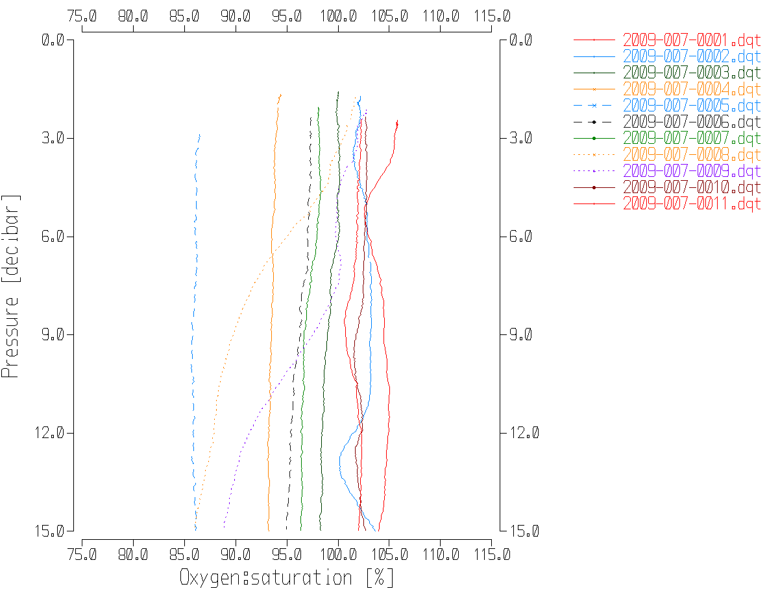

REORDER was run to get the two DO channels together.

HEADER EDIT was used to fix formats and channel names, to fix the one error in the headers and to add the following comments:

Data Processing Notes:
----------------------

Transmissivity, Fluorescence:SeaPoint and PAR:Reference are nominal and unedited except
that some records were removed in editing temperature and salinity.

There was no calibration sampling for dissolved oxygen but the sensor had been
calibrated very recently and the surface % saturation values were reasonable.

The post-cruise factory calibration indicates salinity drift was insignificant.

A Rinko III Dissolved oxygen sensor was mounted on the CTD, but the data from
that instrument have not been processed for the OSD Data Archive.
Sarah Zimmermann did a quick comparison of the Rinko data with the SBE43 data and
details can be found in report 2009-07 RINKO SBE oxygen sensor comparison*.docx.

For further processing details see the processing report 2009-007_Processing_Report.doc.

The cross-reference list was produced and no problems were found.
The Standards Check routine was run and no problems were found.
The Header Check was run and no problems were found.
The final files were named CTD.

Profile plots were made and look ok.
The track plot looks ok.
The sensor history files were updated.

Final Bottle Files

The MRGMRH files were put through SORT to order on increasing pressure.
REMOVE was run on the MRGSORT files to remove the following channels (Output *.REM):
Scan_Number, Temperature:Secondary, Salinity:T1:C1, Conductivity:Primary, Conductivity:Secondary, Oxygen:Voltage:SBE, Altimeter, Status:Pump, Descent_Rate, and Flag,
CHANGE UNITS were used to add DO channels in mass units for SBE DO.
REORDER was used to get the 2 SBE DO channels together.
HEADER EDIT was run to fix formats and units, fix one header entry, change the channel name Bottle_Number to Bottle:Firing_Sequence and the name Bottle:Position to Bottle_Number and to add a comment about quality flags and analysis methods and notes about the CTD data.

Standards check was run on all files; there were no problems found.
A header check was run on the final files and no problems were found.
A cross-reference list turned up no errors.
The track plot was produced on screen and no errors were found.

The sensor history was updated.

TSG Processing
Date were provided in 5 hex files.
All CON files were the same. One con file was saved as 2009-07-tsg.con.

a.) Checking calibrations
The calibrations were checked and no errors were found.

b.) The files were converted to CNV files using the configuration file 2009-07-tsg.con.
The TSG files were renamed with a f format based on the date on which the file started to match the format used for cruise 2009-006, ex. 2009-006-200907DD-HHMMSS.
Channel Voltage 0 was converted; plots show this is the fluorometer channel.
The 5th file includes only data collected after this cruise.

Tests were done during 2009-006 to see if it was better to apply WILDEDIT to salinity directly or to run WILDEDIT on a file with salinity not converted followed by applying WILDEDIT to conductivity and then deriving salinity. There was no notable difference.

Running WILDEDIT on both salinity and conductivity produced good results when run with the following settings:
Parameters used were: Pass 1 Std Dev = 2 Pass 2 Std Dev = 5 Points per block = 50
There remain some sections with many spikes where WILDEDIT is not effective as too many scans are involved.

The files were then converted to IOS HEADER format.
CLEAN was run to add End times and Longitude and Latitude minima and maxima to the headers.
ADD TIME CHANNEL was used to add Time and Date channels based on the Julian time.

Time-series plots were examined on-screen. The first 4 files look fine. The 5th file is very large and has some sections that look problematic. Early in the record it looks like the flow stopped – temperatures rose smoothly. Later in the file there are a number of drop-outs in salinity that could be flow related but the intake temperature seems ok, so perhaps this was a matter of ice getting into the loop.
Fluorescence did not go off-scale.

The track plot looked good and was added to the end of this report.

c.) Editing
The first 4 files required no editing.
The 5th file does require extensive editing, but because the file is large and unwieldy the editing will be delayed until after bin-averaging.

d.) Bin-averaging
The files were bin-averaged over 6 scans.

At this point file 2009-007-2009-0906-140500.avg was edited using Ultraedit.
The file contains data collected after this cruise. There are clearly bad data in some sections and there were no CTD casts or loop samples to confirm what happened. It is clear that flow was turned off at one point. Humfrey Melling examined the data and concluded that they are worth archiving but extensive editing is required.

For Humfrey’s comments see Appendix 1 and the plots referred to are in the DOC/TSG folder
Sarah Zimmermann made the following choices based on Humfrey’s study.

Pump off (all water measurements bad) from
2009/09/09 13:43:52 to 2009/09/10 14:40:22

T-intake and Fluorometer good but T-lab, C-lab, S-lab bad from
2009/09/10 14:40:22 to 2009/09/20 10:18:52

Pump off (all water measurements bad) from
2009/09/20 10:18:52 to 2009/09/20 14:10:52

Then all values fine again after
2009/09/20 14:10:52

Time-series plots after editing show reasonable values.
A track plot looks ok.

e.) Checking Time Channel
The CTD data were thinned to reduce the files to a single point from the downcast at or within 0.5db of 5db. Data from those files were exported to file 2009-007-ctd-tsg-comp.csv.

All files were opened in EXCEL and reduced to the times of CTD files. There were 9 matches in positions. There were no matches with the 5th file.

To check for problems in the TSG clock or bad matches of TSG and CTD data, the differences between latitudes and longitudes were found. The average differences in latitude and longitude were all <0.0001° with maximum differences of 0.0007°. This comparison shows that both the times and positions are reliable for both systems. The spreadsheet was saved as 2009-007-ctd-tsg-comp.xlsx and will be used in the comparisons in the next section.

f.) Comparison of T, S and Fl from TSG and CTD data
- T1 vs T2 The intake thermistor was connected throughout the cruise. The differences between the two TSG temperatures seen in this comparison ranged from 0.32Cº to 0.65Cº with an average of 0.40Cº. As expected, heating decreases as the intake temperature rises. The heating is a little higher than during the previous cruise but the intake temperatures are lower.
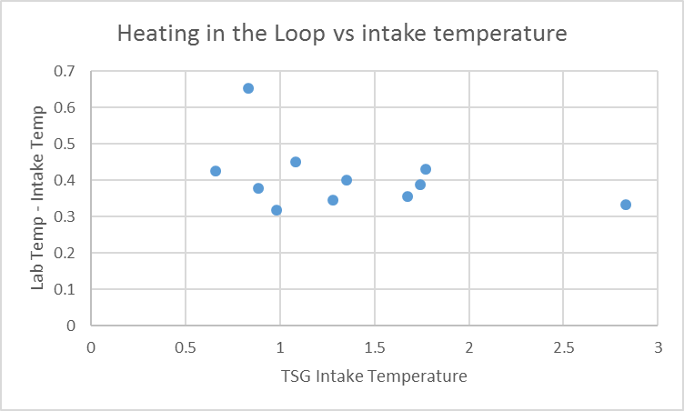

- TSG vs CTD The spreadsheet comparing CTD and TSG files was examined to find differences between the salinity, fluorescence and temperature channels for the CTD and the TSG. These comparisons are all from times when the ship was stopped. There was little difference between median and average values.
The TSG salinity is lower than the CTD salinity by a median of 0.246psu (standard deviation of 0.235psu). This is a much larger difference than observed during the previous cruise but all the casts came from Bellot Strait where conditions may have been challenging. A plot of the differences between TSG and CTD salinity versus CTD temperature suggests that the differences grow as temperature approaches zero which might suggest that ice is a factor. This could be due to the direct effect of ice getting into the loop or an indirect effect of ship activities to clear ice and flow may have been reduced to service other areas. There are few observations and they all come from a small area. These differences do not look suitable to guide recalibration. 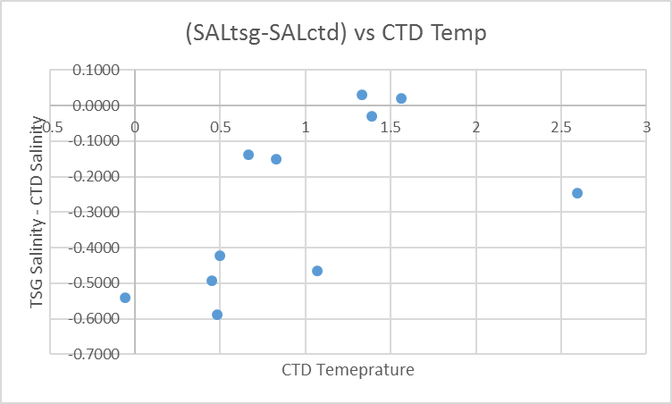

When all data were included the TSG intake temperature was higher than the CTD temperature by a median of 0.39Cº (standard deviation of 0.15Cº). This is a much larger difference than we usually see. When the differences are plotted against CTD salinity there is no obvious pattern but when plotted against CTD temperature there is a clear trend towards larger differences as CTD temperatures approach 0ºC. This would seem likely to be due to indirect effects of ice. For the 2 cases where temperatures were >1.5ºC the differences are about 0.2Cº. This is still larger than seen during 2009-006 when the median was 0.07Cº but the intake temperatures are lower.
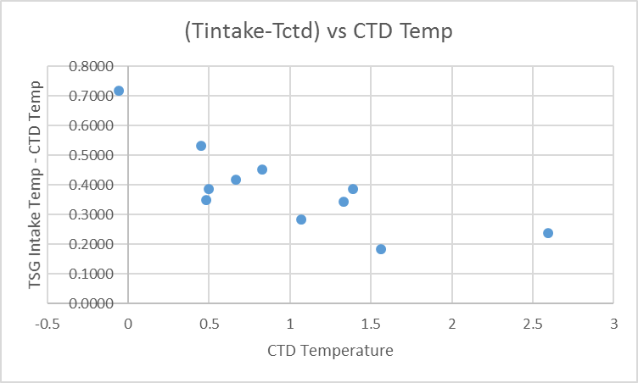

The ratio of TSG fluorescence to CTD fluorescence ranges from 1 to 1.7 with a median of 1.5.(standard deviation of 0..5). All fluorescence values were <0.7ug/L When CHL values are <1 SBE fluorometers do not do very well in comparison to CHL. The differences between 2 of them are likely significant at low CHL levels. During the previous cruise the TSG fluorometer was found to read higher than the CTD fluorometer for CHL<1ug/L, but about 40% of CHL when CHL>1ug/L. (See 2009-007-ctd-tsg-comp.xlsx.)
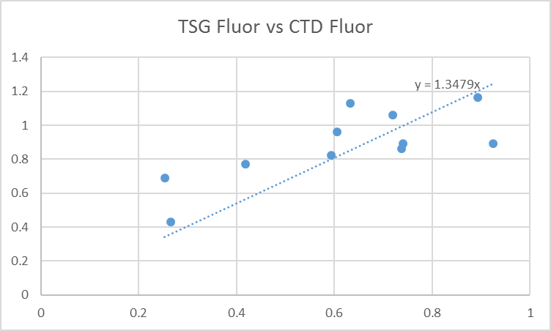

- Calibration History
The intake temperature sensor had drifted by -0.00015 C°/year. The TSG primary temperature and conductivity were recalibrated in November 2009. At that time the temperature was said to have drifted by +0.0004 C°/year and the salinity to have drifted by -0.0015psu/month, so drift in salinity over 9 months was ~0.014psu. During 2009-006, which preceded this cruise, a rough estimate was made that salinity was low by 0.003psu. There was 1 other cruise between this one and the post-cruise factory check. If the drift was linear with time the temperature would have been high by 0.0003C° in Sept 2009 and salinity low by ~0.010psu. If drift was related to use then these might be overestimates. The temperature drifts are insignificant.

Conclusions
1. The TSG clock worked well.
2. As expected, the temperature in the loop increased more when intake temperatures were lower. The median heating in the loop was ~0.39Cº. That value look reasonable.
3. The TSG intake temperature was higher than the CTD temperature at 5m by a median of 0.39Cº. This difference is larger than expected and much larger than the post-cruise calibration would explain. The differences are largest at near-zero temperatures, so ice is likely a factor.
4. The TSG Salinity read lower than the CTD salinity by a median of 0.25psu (standard deviation 0.23psu). This is much higher than drift estimates from the post-cruise calibration would explain. There is a lot of scatter in the comparison. The differences were smaller when CTD temperatures were higher, suggesting that ice was a factor. This could be a direct effect if ice got into the loop, or indirect if ship effects in ice lower the salinity near the intake.
5. No recalibration of temperature is required. For salinity it seems reasonable to apply a correction to reflect that there was likely some drift over the course of the cruise. A correction of +0.003psu was applied to TSG salinity for 2009-006, so an estimate of +0.008 was made for this cruise except for the 5th file for which +0.010psu was used since it covered 17 days.
6. The comparison of CTD and TSG fluorometers when chlorophyll values are low is not useful as small temporal changes and small instrument errors in two low signals lead to large errors in the comparison. From 2009-006 the TSG fluorometer is believed to be reading low for CHL >1ug/L with values about 40% of the CTD fluorometer.

g.) Recalibration
File 2009-007-recal1-tsg was prepared to add 0.008 to the TSG Salinity and applied to the AVG files for the first 4 files.
File 2009-007-recal2-tsg was prepared to add 0.010 to the TSG Salinity and applied to the EDT file for the 5th file.

i.) Preparing Final Files
REMOVE was used to remove the following channels from all casts: Scan Number, Temperature:Difference, Conductivity:Primary, Flag and Position:New.
REORDER was run to get the 2 fluorescence channels together (concentration and voltage).

HEADER EDIT was used to add a comment, change the DATA TYPE to THERMOSALINOGRAPH and add the depth of sampling to the header. Those files were saved as TOB files.
The header entry for the 5th file was amended to describe the particular problems with that file.

The TSG sensor history was updated.
As a final check plots were made of the cruise track and it looks fine.

Particulars
7. Shoaling rapidly to 140m – station drifting at 2 knots.
11. Salinity inversion during downcast 35-40m – real? Winch was a little fast (1.3m/sec) at the time.

Institute of Ocean Sciences Cruise Summary
CTDs
CTD# | Make | Model | Serial# | Used with Rosette? | CTD Calibration Sheet Competed?
1 | SEABIRD | 911+ | 0941 | Yes | Yes

Calibration Information CTD #941
Sensor |  | Pre-Cruise |  | Post Cruise
Name | S/N | Date | Location | Date | Location
Temperature | 5048 NEW | 21Feb2009 | Factory | 25Nov2009
Conductivity | 3579 NEW | 18Mar2009 | Factory | 25Nov2009 | Factory
Secondary Temp. | 5073 NEW | 21Feb2009 | Factory | 25Nov2009
Secondary Cond. | 3581 NEW | 17Mar2009 | Factory | 25Nov2009 | Factory
Transmissometer | CST0993 | 30Jun2009 | Local | 19May 2011 | Local
SBE 43 DO sensor | 1117 | 21Aug2009 | Factory | 25Nov2009 | Factory
SeaPoint Fluorometer | 2336
Rinko III DO sensor | 005 | 25Jun2009 | Factory | 25Oct2011 | Factory
SPAR | 20281 | 9April 2007 | Factory | 4April 2016 | Factory
Pressure Sensor | 941 (113140) NEW | 16Mar2009 | Factory | 7Dec2009 | Factory
Altimeter | 1252

TSG
Make/Model/Serial#: SEABIRD/21/3274 Cruise ID#: 2009-07

Calibration Information
Sensor |  | Pre-Cruise |  | Post Cruise
Name | S/N | Date | Location | Date | Location
Temperature | 3274 | 21/02/09 | Factory | 25Nov09 | Factory
Conductivity | 3274 | 21/02/09 | “ | 25Nov09 | “
Temperature2, SBE38 | 0271 | 12/02/09 | “

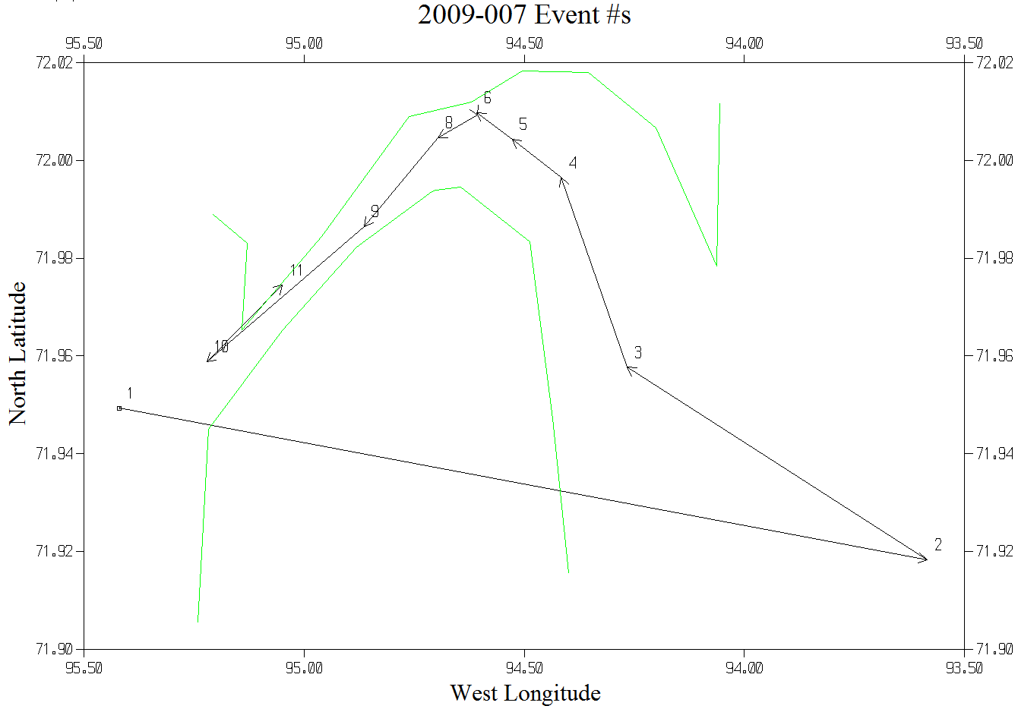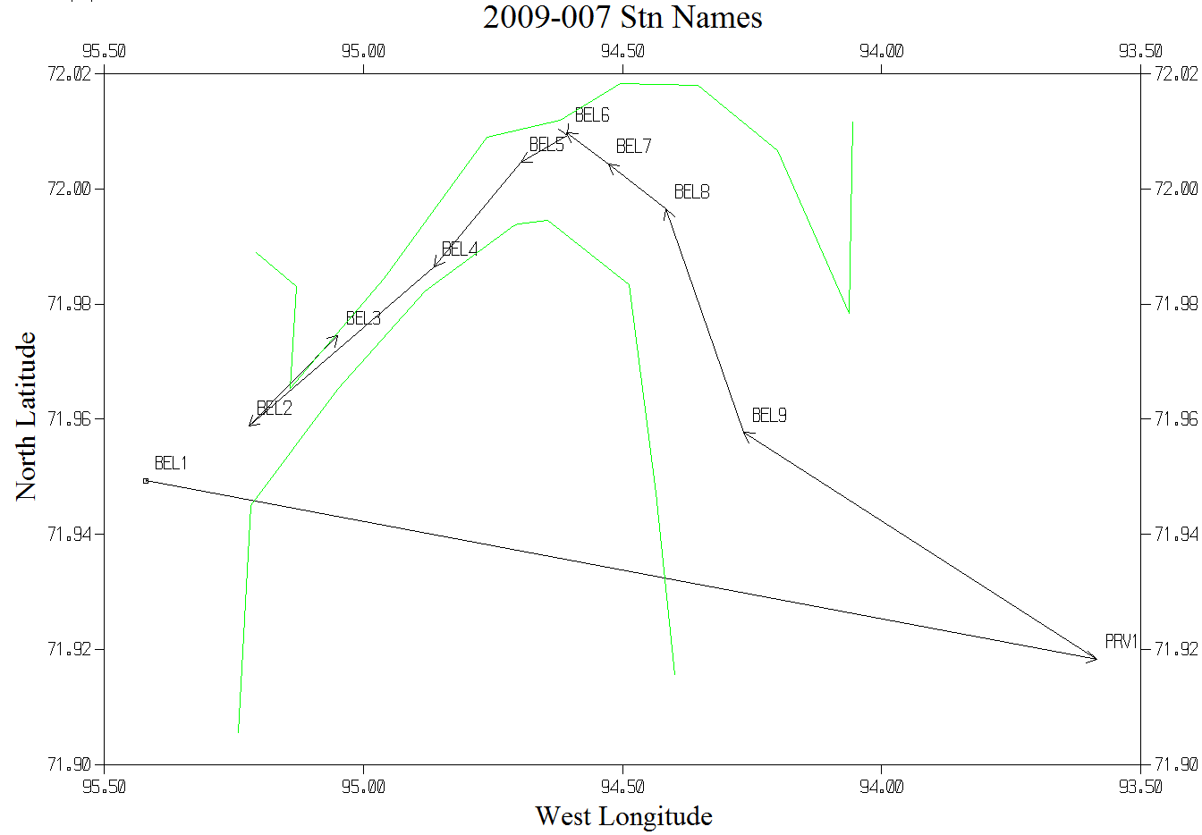

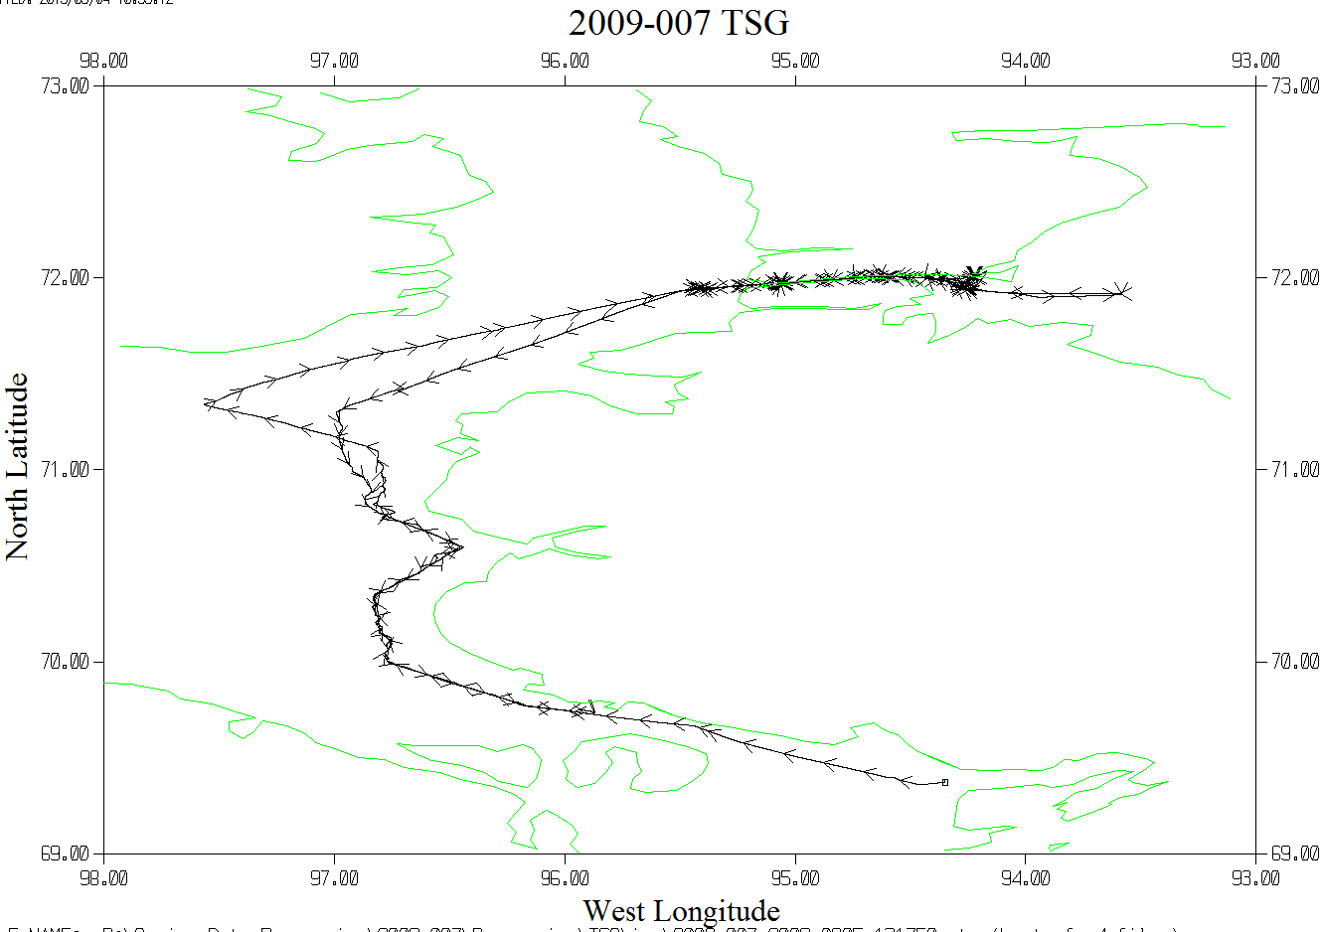

The plot above covers includes the 4 files that occurred during cruise 2009-007. Another file was collected after this and that track is shown below.
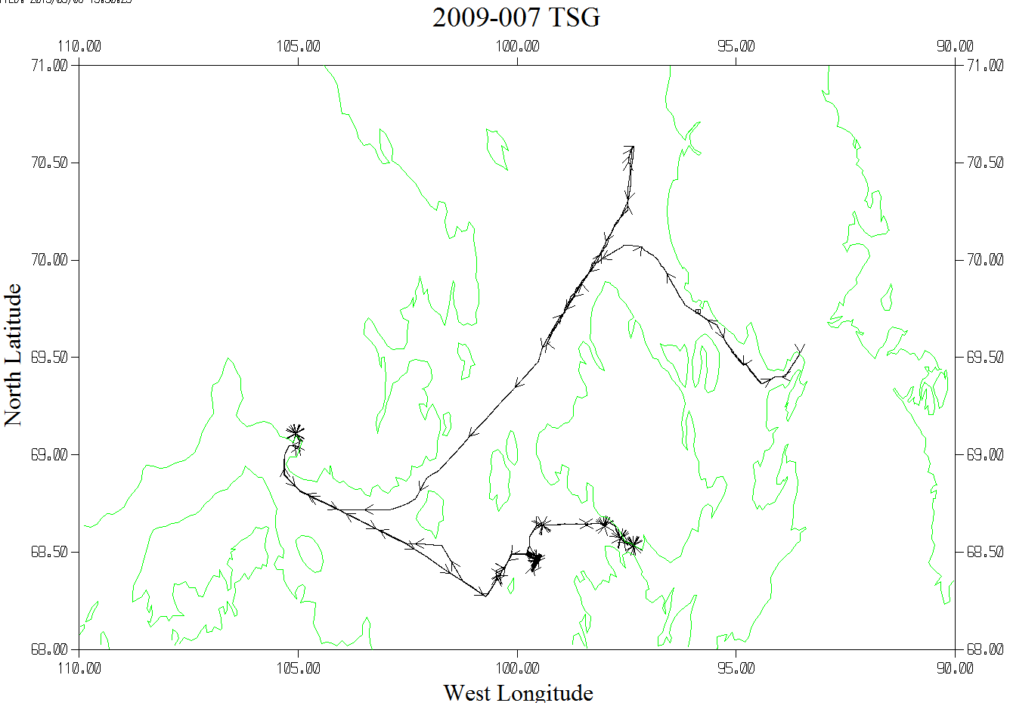
The plot above covers the track from file 2009-007-2009-0906-140500.tob; the data were collected after cruise 2009-007. Many data were removed due to there being no flow to the TSG and/or the fluorometer. See Appendix 1 for details.

Appendix 1 Notes from Humfrey Melling concerning TSG file 2009-007-2009-0906-140500

I attach two plots based on the data. (The plots can be found in the DOC/TSG folder)

The first is a versus-time plot of the two temperature signals, salinity and fluorescence. The temperature measured by the TSG (data column C, shown in red) in the lab is typically about 0.4C warmer than that at the intake for this ship’s installation under Arctic conditions (data column B, shown in blue). If the pump in the engine room is turned off, the water temperature at both sensors rises towards the ship’s inside temperature, warmer in the lab than down near the ship’s hull plating in the engine room; a consistent difference of 0.4C is no longer evident. The temperature signals reveal that water stopped flowing through the TSG about halfway through Sep 9 (day 252.58) and remained off until Sep 20 (day 263.59). The salinity calculated from measurements throughout this period represents that stagnating in the TSG, not the outside marine environment.

The traces for fluorescence and for intake temperature (blue) become plausible about a day later, while those for the T & C measured by the TSG do not. I interpret this to indicate that the pump was turned on, allowing ambient water to pass over the intake thermistor and through the fluorometer, but either not at all, or not properly (bubbles in the plumbing?), through the TSG. I believe that the data on ambient T and Fl are useful between day 253.58 and 263.45, when it appears (from the Fl & the blue T signals) that the pump was again shut off again (until 263.59).

The second is a map of the ship’s track from Taloyoak to Cambridge Bay, and then from Cambridge Bay to Simpson Strait and back to Cambridge Bay. There are two versions of the ships track; the one in yellow is the entire track; the overlay in red is the portion of the track traversed between day 252.58 and 263.59. The two appear to be identical because the shutdown of the water flow to the TSG occurred while the ship was at anchor in Cambridge Bay.

SO, we should certainly retain all the data recorded before 253.58 and after 263.59; these provide a good survey of this corner of the NWP. One could also contemplate retaining the T & Fl data recorded in Cambridge Bay. However, since neither signal is very exciting (apart from tidal modulation), you might want to junk it.

