LSSL 2008-30 Soot Sampling
Kristina Brown

Samples for the evaluation of black carbon (soot) in Arctic Sea Ice were collected during the 2008-30 JOIS cruise in an effort to determine the effect of this atmospheric contaminant on sea ice albedo. Sampling began once the ship reached the southern extent of the summer sea ice pack, and continued opportunistically during sea ice reconnaissance surveys, ITP deployment operations, and any other occasion available to obtain such samples. In total, 43 soot samples were collected at 14 different locations between 75 to 83 deg N and 139 to 153 deg W (Figure 1).

Sampling locations on each floe were selected based on the floe layout. Floe safety, visible distance from bear guard, location of floe edge, melt ponds, & ridging features, were all taken into consideration when selecting a site for soot samples. When possible, a location was chosen at the furthest distance upwind of the helicopter allowed by the safety precautions. Ideally samples were taken on a floe also upwind from the ship; however this was not always possible. At each location a sample of the upper snow layer (0-2cm) and lower granular layer (2-10cm) were taken from a 45cm x 45cm snow pit dug out with a metal spatula. As it was the summer season and melting was obvious at most locations, the upper snow layer (0-2cm) was often a layer of more loosely compacted granular snow/ice, followed underneath by more densely packed granular layers, and finally a harder layer of ice. In all instances the layer of hard ice was not sampled, but the granular layers were sampled in two sections (0-2cm & 2-10cm) even when separation between the two sections was not obvious. The depth of the upper snow layer was often determined by pushing a plastic ruler into the snow until feeling resistance, giving the upper “snow” layer. When new snow fall was obvious its depth determined the upper and lower layers of the samples. Duplicate samples of both the upper and lower snow/granular layers were obtained at almost all sites.

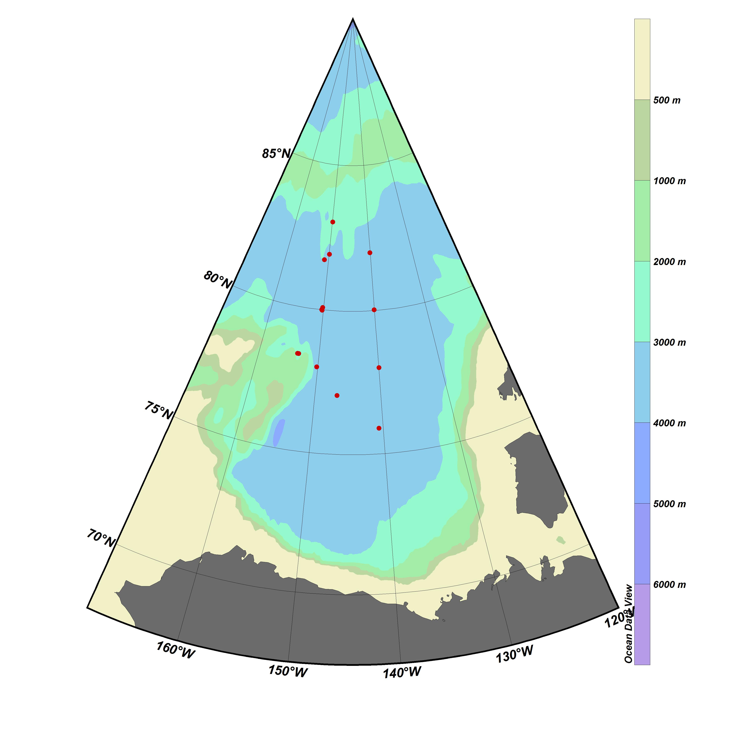
Figure 1 - 2008-30 Soot Sampling Locations

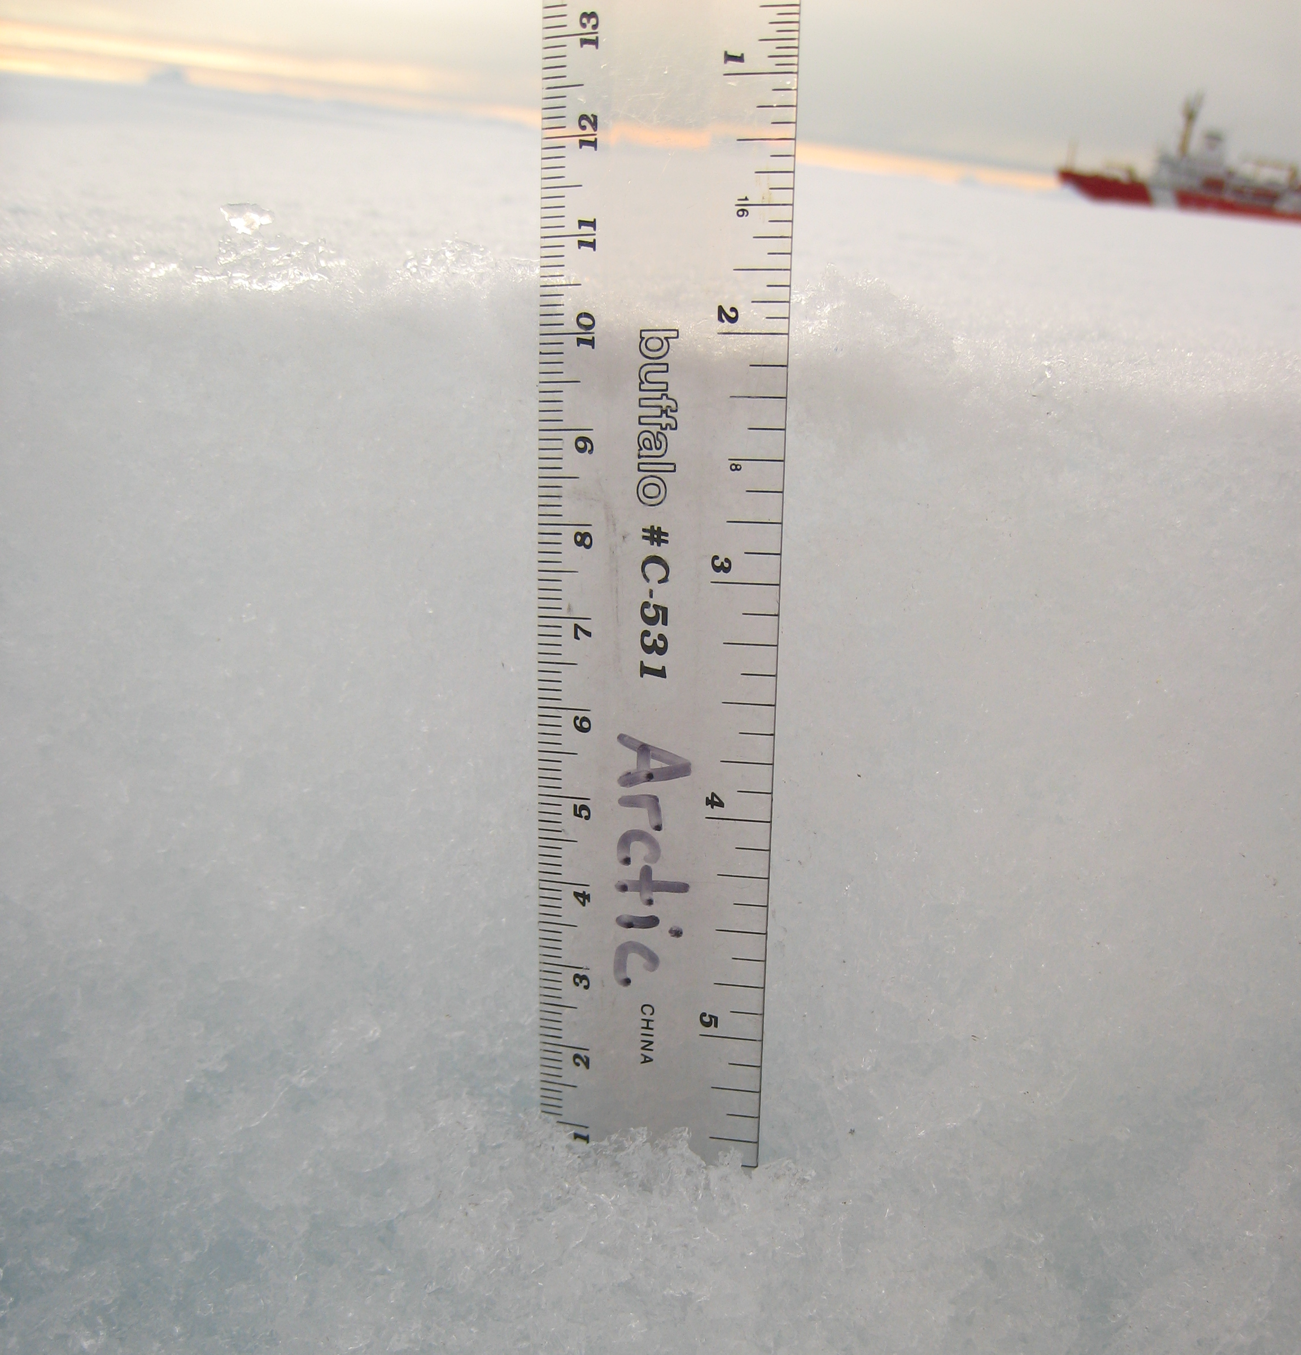
Figure 2 - Soot Sample Snow Pit (ITP26)

