Lowered Acoustic Doppler Current Profiler

CCGS Louis S St-Laurent

IOS Cruise Number 2008-30
21 August 2008
Waldemar Walczowski

Lowered Acoustic Doppler Current Profiler (LADCP) allows to measure the sea currents during standard CTD casts. Device transmits sound burst and receives echoes from particles carried by the water currents. Movement towards and out of the device produce the Doppler shift. The final ocean velocity profile is obtained during complicated data processing.
Using the LADCP in the Arctic Ocean, especially in the deep layers is difficult, because of low amount of particles. Therefore during the cruise two LADCP devices were used, both RDI 300 kHz WHS300.
The basic configuration were synchronized upper (slave) and down looking (master) LADCPs connected by RDI Star-cable. Sampling rate was 1 s, 1 ping/assemble, 20 bins, 10 m thick each. Because of problems with equipment, configuration has been changed during the cruise g and later the measurements were carried by means of one, down looking LADCP. Measurements were carried at 65 stations (Table 1), there are doubled data files from station 2-25.
Processing of raw data were done by means of LDEO IX software for Matlab. Some parts of software were modified. All files were processed in the same way. Profiles were averaged every 20m. Because of the very weak signal and increased error, filtration and smoothing of data were much higher than usually. CTD and GPS data were used in LADCP processing. Finally the theoretical velocity error is less than 5 cm/s.

Description of casts and data files
Casts 2-25
Device nr 10540 were used as the down looking, master LADCP, device 10746 as upper looking, slave LADCP. Both devices were connected RDI- Star cables. The pinging rate was 1 s, 20 bins, 20 m thick each. Both compasses were calibrated in Halifax, before 2008_29 leg. Files 200830_M02.000 - 200830_M25.000 origin from down looking (master) LADCP,
Files 200830_S02.000 - 200830_S25.000 origin from upper looking (slave) LADCP.
The results are very good, it was no problems with data processing.
Casts 26-33
During battery changes in the upper looking LADCP a small lick (few drops) to the device were noticed. Casts 26-33 were made by means of one, 10540 LADCP. All casts were made with 1s rate, 1 ping per assemble, 20 beans, 10 m thick each.
Files 200830_D26.000 - 200830_D33.000
Casts 34-42
After cleaning and drying LADCP 10746 were used again, but compass and pick&roll sensor did not work. Unfortunately all S-files are wrong, as a result of the water in the device, firmware was injured.
Files 200830_M34.000, 200830_M35.000, 200830_M37.000, 200830_M39.000, 200830_M40.000, 200830_M41.000, 200830_M42.000 are useful.
Casts 43-48 were not measured, because of LADCP 10540 injuring. After changes batteries water penetrated into the device and injured electronics.
Finally electronics from two devices were assembled into one and measurements started again from the cast 48.
Casts 48-56
Down looking LADCP were used. Ping ratio 0.5 s, 1 ping per assemble, 15 beans, 10 meter each
Weak beam 3 ! Results will be probably rejected. Too big currents
Files 200830_H48- 200830_H55
Cast 57
Down looking LADCP. Weak beam 3 !
Ping ratio 0.5 s, 2 ping per assemble, 15 beans, 10 meter each
File 200830_H57
Cast 58 - 72
Down looking LADCP. Weak beam 3 !
Ping ratio 1 s, 1 ping per assemble, 20 beans, 10 meter each
File 200830_W58 - 200830_W72

Table 1. LADCP Stations

Station | Year | Month | Day | Hour | Min | Latitude | Longitude | max_depth | meanU | meanV | maxVel
200830_02 | 2008 | 7 | 21 | 5 | 58 | 70.552 | -122.902 | 620 | 0.8 | 4 | 7.2
200830_03 | 2008 | 7 | 22 | 11 | 6 | 71.827 | -131.757 | 1080 | 0.9 | -1.4 | 10.1
200830_04 | 2008 | 7 | 23 | 6 | 11 | 71.586 | -140.009 | 2420 | -2.1 | -0.3 | 8.7
200830_05 | 2008 | 7 | 23 | 11 | 14 | 71.001 | -139.999 | 2020 | -0.5 | -0.4 | 18
200830_06 | 2008 | 7 | 23 | 15 | 43 | 70.813 | -140.015 | 1460 | -1 | -1.7 | 17.1
200830_07 | 2008 | 7 | 23 | 19 | 14 | 70.573 | -140.004 | 740 | 0.4 | -1.7 | 8.2
200830_08 | 2008 | 7 | 23 | 22 | 47 | 70.23 | -140.002 | 220 | 8.3 | -4 | 18
200830_09 | 2008 | 7 | 24 | 1 | 13 | 70 | -140.001 | 240 | 3.8 | -5.5 | 17.7
200830_10 | 2008 | 7 | 24 | 14 | 48 | 72.688 | -144.691 | 3380 | -2.2 | 5.1 | 41.8
200830_11 | 2008 | 7 | 24 | 19 | 43 | 72.688 | -144.706 | 1080 | -3.3 | 14.5 | 51.9
200830_12 | 2008 | 7 | 24 | 21 | 19 | 72.686 | -144.698 | 800 | -4.2 | 18.2 | 49.5
200830_13 | 2008 | 7 | 25 | 7 | 15 | 71.965 | -150.227 | 2940 | 0 | 1.6 | 24.6
200830_14 | 2008 | 7 | 25 | 14 | 0 | 71.501 | -151.657 | 960 | -2.3 | 0 | 20.2
200830_15 | 2008 | 7 | 25 | 17 | 5 | 71.396 | -152.038 | 120 | 13.5 | -6 | 19
200830_16 | 2008 | 7 | 25 | 19 | 8 | 71.456 | -151.822 | 400 | -0.7 | -1.6 | 8.7
200830_17 | 2008 | 7 | 25 | 20 | 4 | 71.469 | -151.778 | 260 | -3.5 | -5.5 | 9.2
200830_18 | 2008 | 7 | 25 | 21 | 16 | 71.468 | -151.779 | 600 | -0.5 | -0.9 | 5.3
200830_19 | 2008 | 7 | 26 | 0 | 0 | 71.593 | -151.36 | 1540 | -2.4 | 0.4 | 21.8
200830_20 | 2008 | 7 | 26 | 2 | 5 | 71.658 | -151.232 | 1960 | -2.6 | 2.5 | 15
200830_21 | 2008 | 7 | 26 | 9 | 50 | 73 | -150.001 | 3660 | 1.2 | -1 | 6.3
200830_22 | 2008 | 7 | 26 | 17 | 5 | 73.999 | -150.005 | 3720 | 0.3 | 0.8 | 4.1
200830_23 | 2008 | 7 | 26 | 23 | 44 | 74.5 | -147.735 | 3700 | -0.8 | 0.5 | 7.8
200830_24 | 2008 | 7 | 27 | 21 | 48 | 74.992 | -150.056 | 1060 | 1.4 | 3.4 | 6.3
200830_25 | 2008 | 7 | 28 | 7 | 19 | 75.022 | -149.901 | 3720 | 1 | 2.8 | 11.5
200830_26 | 2008 | 7 | 29 | 4 | 39 | 75.319 | -153.28 | 3740 | 0.4 | 0.6 | 10.5
200830_27 | 2008 | 7 | 29 | 11 | 23 | 75.513 | -155.268 | 3740 | -1 | -0.6 | 10.9
200830_28 | 2008 | 7 | 29 | 18 | 11 | 75.742 | -157.092 | 980 | 8.4 | 1.6 | 22.8
200830_29 | 2008 | 7 | 29 | 21 | 21 | 75.66 | -156.26 | 1540 | 4.8 | 0.7 | 13.4
200830_30 | 2008 | 7 | 30 | 8 | 16 | 75.996 | -149.974 | 3740 | 2.4 | 1.1 | 13.9
200830_31 | 2008 | 7 | 30 | 16 | 22 | 76.998 | -150.048 | 3740 | 1.7 | -1.4 | 28
200830_32 | 2008 | 7 | 31 | 1 | 53 | 77.684 | -146.74 | 1060 | 2.7 | -2.1 | 19.3
200830_33 | 2008 | 7 | 31 | 3 | 28 | 77.677 | -146.749 | 3720 | 3.6 | -5.2 | 17.3
200830_34 | 2008 | 8 | 1 | 1 | 1 | 78.003 | -150.173 | 3720 | 1.1 | 6.2 | 16.5
200830_35 | 2008 | 8 | 1 | 8 | 20 | 77.977 | -150.2 | 1040 | -3.9 | -3.7 | 10.1
200830_37 | 2008 | 8 | 2 | 6 | 58 | 78.329 | -153.023 | 3080 | 3.3 | -2.1 | 10
200830_39 | 2008 | 8 | 2 | 12 | 34 | 78.339 | -153.348 | 2240 | -0.4 | 1.2 | 6.4
200830_40 | 2008 | 8 | 2 | 16 | 39 | 78.292 | -154.101 | 880 | 9.8 | -8.4 | 22
200830_41 | 2008 | 8 | 3 | 4 | 47 | 79.018 | -149.886 | 3720 | 11.1 | 4.8 | 21.7
200830_42 | 2008 | 8 | 3 | 16 | 53 | 80.021 | -149.782 | 3700 | 2.5 | -1.7 | 12.1
200830_48 | 2008 | 8 | 7 | 6 | 54 | 81.02 | -140.103 | 3660 | 5.8 | -16.3 | 22.4
200830_49 | 2008 | 8 | 7 | 17 | 33 | 80.029 | -140.065 | 3660 | 11.2 | -17.6 | 27.6
200830_50 | 2008 | 8 | 8 | 7 | 0 | 79.006 | -139.964 | 3680 | 4.9 | -11.3 | 19.6
200830_51 | 2008 | 8 | 8 | 20 | 1 | 78.012 | -139.903 | 3640 | 10.6 | -14.4 | 25.8
200830_52 | 2008 | 8 | 9 | 8 | 56 | 77.171 | -142.026 | 3660 | 10.2 | -10.6 | 29.3
200830_53 | 2008 | 8 | 9 | 22 | 4 | 76.992 | -139.954 | 1060 | -4.1 | -6.3 | 12.3
200830_54 | 2008 | 8 | 10 | 0 | 54 | 76.989 | -139.998 | 2980 | -1.1 | -1.8 | 7.1
200830_55 | 2008 | 8 | 10 | 3 | 50 | 76.992 | -140.012 | 3640 | 0.5 | -2 | 12.6
200830_56 | 2008 | 8 | 10 | 14 | 47 | 76.546 | -135.439 | 1040 | 2.2 | -1.2 | 7.2
200830_57 | 2008 | 8 | 10 | 16 | 22 | 76.545 | -135.431 | 3480 | 2.6 | 0.5 | 14.1
200830_58 | 2008 | 8 | 11 | 2 | 52 | 76.267 | -132.53 | 2960 | -0.8 | -2.3 | 13.2
200830_59 | 2008 | 8 | 11 | 8 | 26 | 76.087 | -130.874 | 1060 | 1.8 | -3.8 | 13
200830_60 | 2008 | 8 | 11 | 9 | 55 | 76.084 | -130.877 | 2400 | -0.4 | -4.7 | 18.1
200830_61 | 2008 | 8 | 12 | 2 | 26 | 75.95 | -140.082 | 3620 | 1.4 | -1 | 9
200830_62 | 2008 | 8 | 12 | 9 | 10 | 76.003 | -142.449 | 2500 | 2.3 | -3 | 12.6
200830_63 | 2008 | 8 | 13 | 0 | 15 | 75 | -140.001 | 3540 | 2.1 | 1.8 | 10.4
200830_64 | 2008 | 8 | 13 | 7 | 46 | 74.299 | -143.307 | 3600 | 1 | -1.3 | 10.1
200830_65 | 2008 | 8 | 14 | 3 | 53 | 74.032 | -140.002 | 3420 | 2.1 | -2.5 | 11.5
200830_66 | 2008 | 8 | 14 | 11 | 28 | 74.01 | -139.95 | 2020 | 1.9 | -0.6 | 8.1
200830_67 | 2008 | 8 | 14 | 23 | 16 | 73.45 | -138.001 | 3020 | -1.6 | 0.8 | 9.3
200830_68 | 2008 | 8 | 15 | 5 | 23 | 73.001 | -139.999 | 3140 | 3.3 | 0.8 | 9.2
200830_69 | 2008 | 8 | 15 | 14 | 10 | 72.601 | -144.697 | 1060 | 2 | 1.3 | 14.4
200830_70 | 2008 | 8 | 15 | 14 | 47 | 72.601 | -144.700 | 3340 | 1.2 | 410 | 15.0
200830_71 | 2008 | 8 | 19 | 10 | 31 | 72.000 | -139.999 | 2620 | 2.3 | 1.2 | 7.0
200830_72 | 2008 | 8 | 19 | 20 | 38 | 72.365 | -133.962 | 2020 | -0.2 | 0.1 | 4.5
200830_72 | 2008 | 8 | 20 | 3 | 12 | 71.788 | -131.898 | 1100 | 1.4 | 1.0 | 5.5

Results
The quasi-synoptic picture of in situ currents were obtained (Fig 1-4). In some regions currents very good fit to our knowledge about Canada Basin circulation, in other are too high. Currents over the bottom (Fig 5), measured with the bottom track are the most real. Accuracy of these data (*.bot files) is the highest.
Better understanding of the currents may be obtained by analyzing it together with the water mass properties (Fig.6). This works are carried.
Remarks.
LADCP measurements in the Canada Basin are very hard and results are still inaccurate. The causes are mostly low backscattering and high magnetic compasses errors. Besides the nature of oceanic currents in this region (low Rossby radius) do not allow to obtain circulation pattern from scattered, low horizontal resolution measurements.
However during the cruise valuable data were collected, which will be processed and analyzed.

Fig. 1 LADCP measured currents at 20 m.

Fig. 2. LADCP currents at 80 m.
Fig. 3 LADCP currents at 200 m.

Fig. 4 LADCP currents at 400 m.

Fig. 5 Averaged currents measured over the bottom.

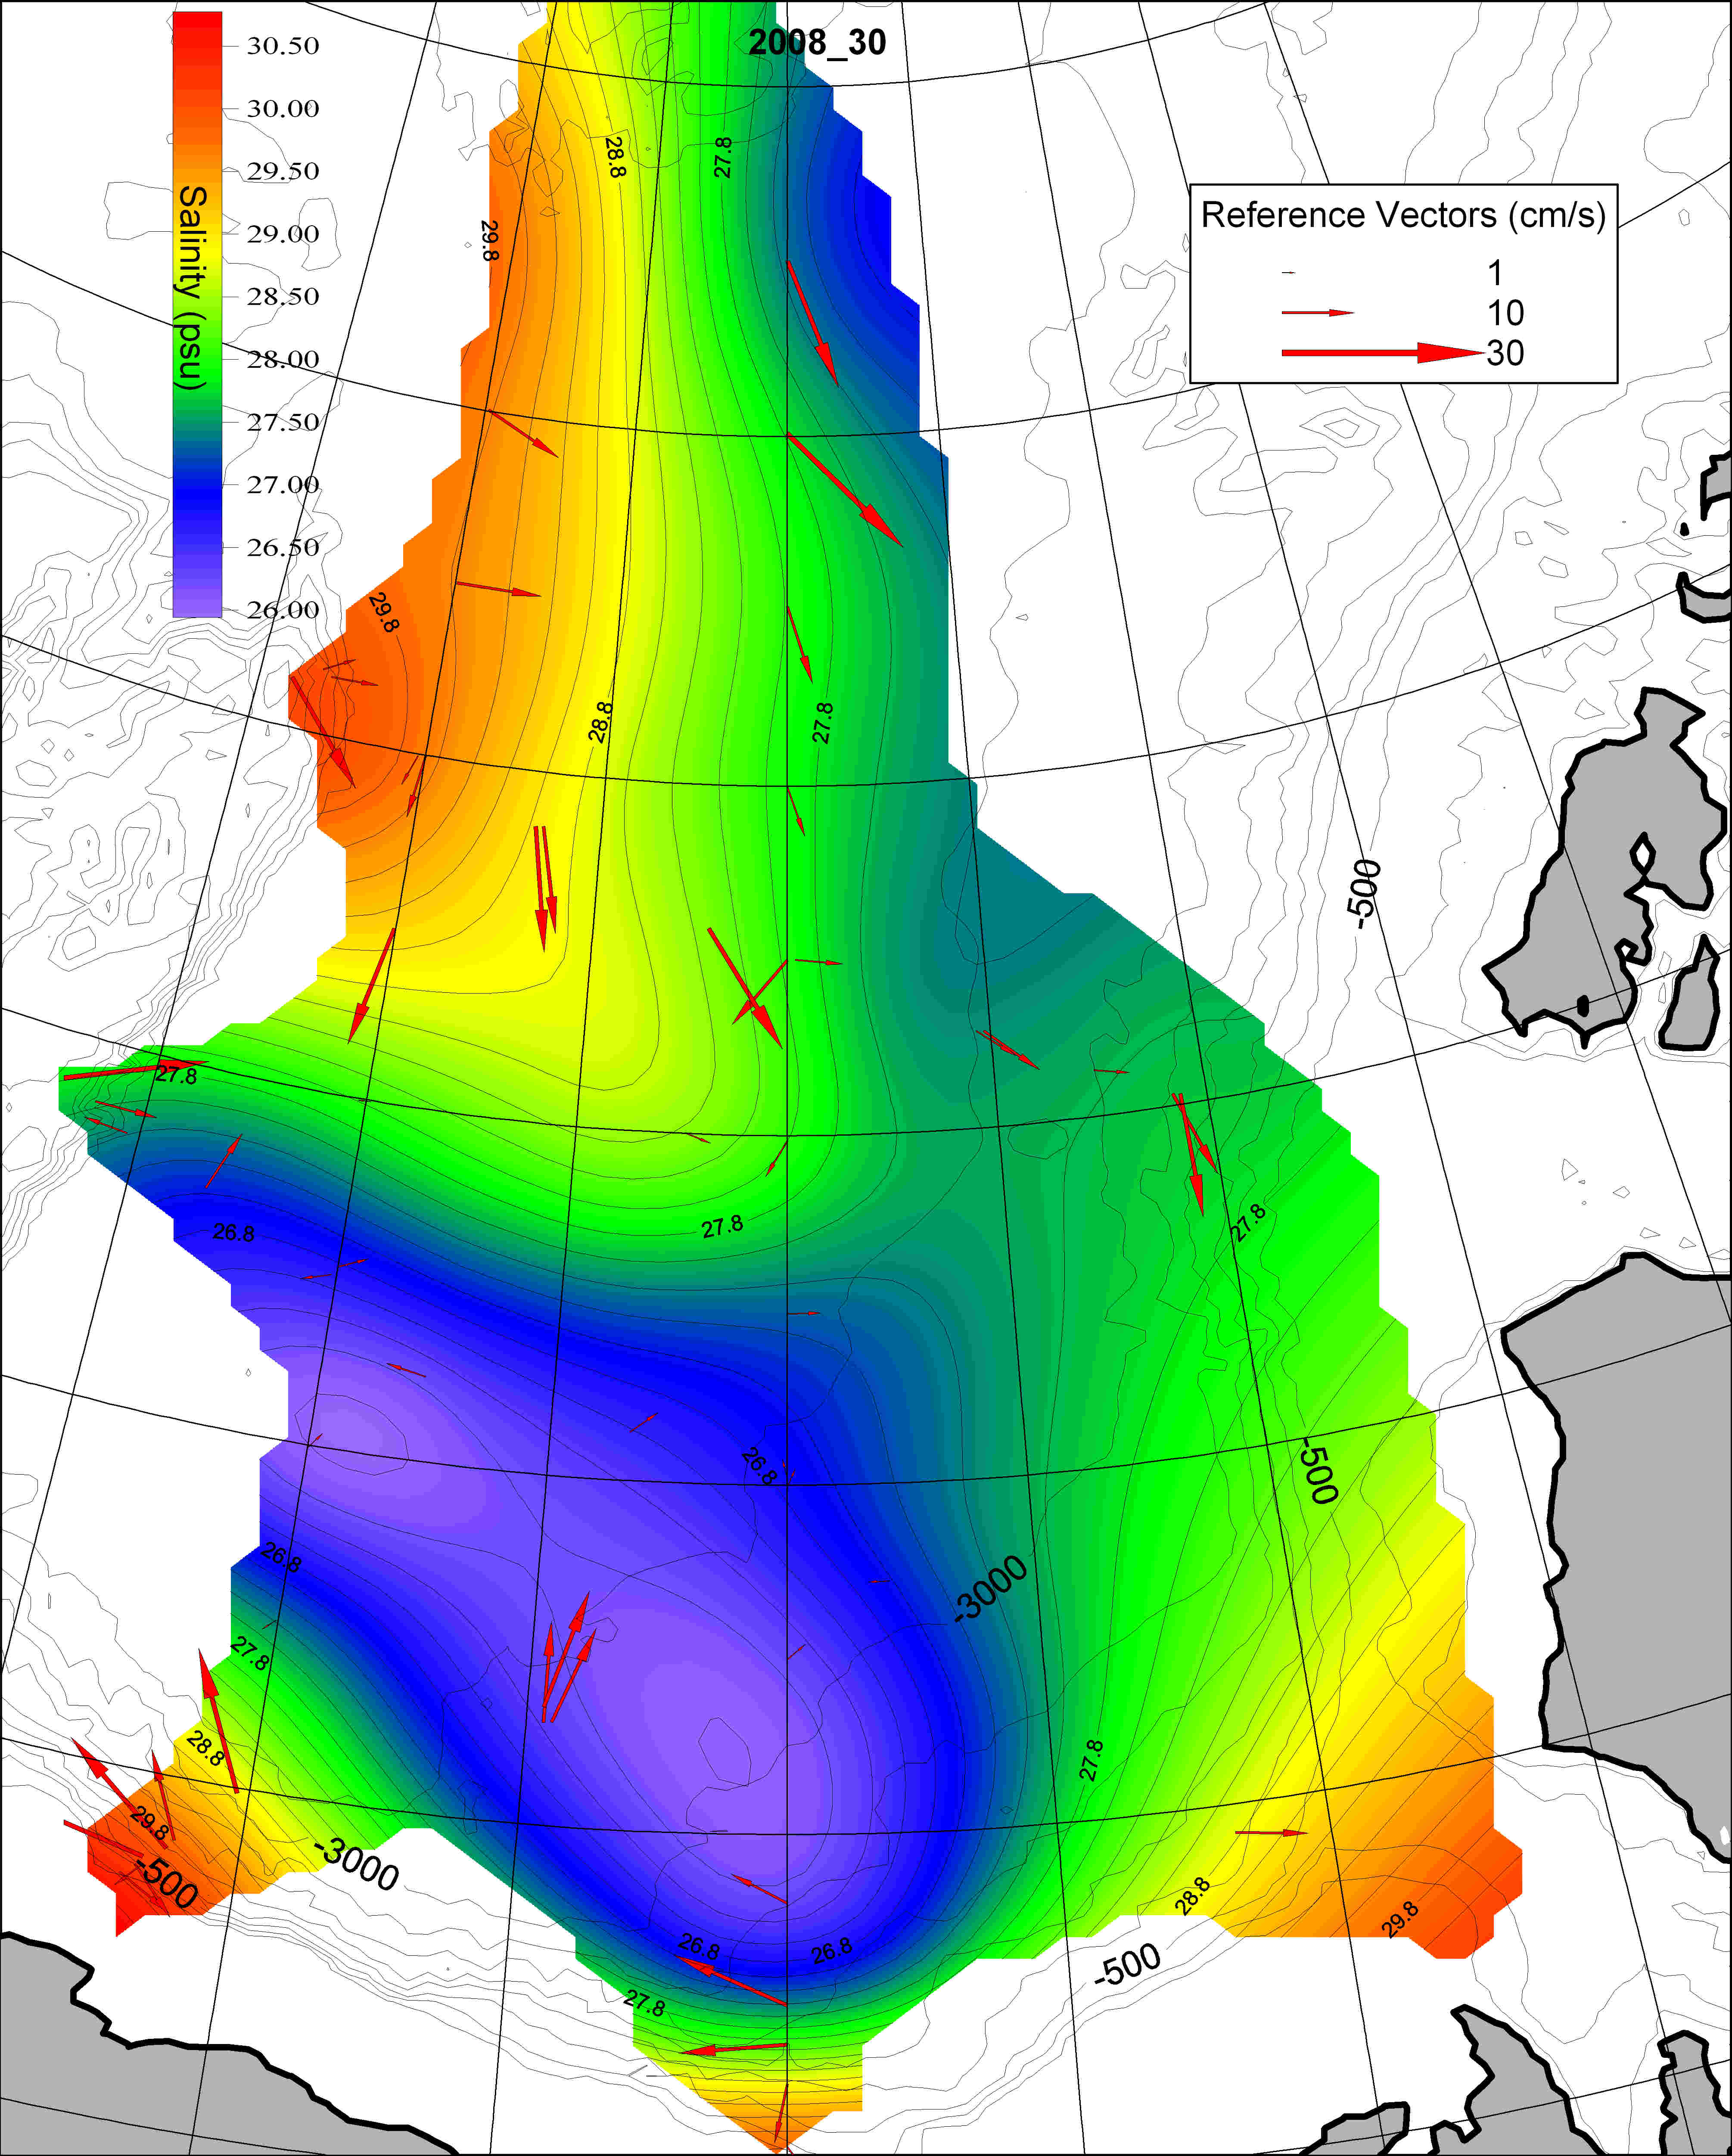

Fig. 6. Salinity and LADCP currents at 20 m.

