LSSL 2008-30 Ice Chemistry
Kristina Brown & Alice Orlich

Ice coring and water sampling was conducted at three different ITP sites during the LSSL 2008-30 cruise. These sites were chosen in combination with the 2008-30 Soot Sampling (Kristina Brown), Sea Ice Floe Mapping (Alice Orlich), and Ice Tethered Profiling (WHOI) programs. ITP 23, 25, & 26, provided sites that were both easily accessible to the coring team and allowed enough time for both ice coring and ice auguring programs to take place. Sea ice core locations were chosen based on ice thickness measurements taking during the ice auguring program (Alice Orlich).

At each station location, sea ice cores were collected to obtain a profile of temperature and salinity and samples for assessing chemical characteristics of the ice floe. Sea ice cores collected for temperature profiles were measured on site, with holes drilled at 10cm intervals down the core for a measurement of floe in situ temperature. Following this, cores were cut up into 10cm pieces to be melted on the ship for salinity analyses. After temperature profiles were completed, one or two more cores were obtained to asses changes in sea ice chemistry at various depth intervals in the floe (effectively top, middle, & bottom). Chemistry cores were cut up on site in 2x10cm pieces at each depth interval and pieces were partitioned into air-tight tedlar bags. Tedlar bags were then evacuated of outside air using a hand pump, and taken back to the ship to be melted in the back Lab B. In total 5 cores were collected for temperature and salinity profile measurements, and 7 cores were collected for chemical parameter sampling back on the ship. Once ice core sections were melted on the ship, samples of the homogenized melt were taken for del13C-DIC, Alkalinity, Salinity, del18O, and nutrients. 24 individual core sections were sampled for chemical parameters from the 7 cores obtained.

After cores were removed from the bore hole, a submersible aquarium pump was lowered to 1.5m below the surface to attempt to extract water from the ice/water interface. Samples were collected at 4 of the 7 chemistry core sites and included del13C-DIC, Alkalinity, Salinity, del18O, Ba, Chla, del13C-POC and nutrients.

Ice Camp Swiss Cheese (ITP-25) provided an opportunity to try and collect brine from varying depth intervals in the ice floe. Brine holes were drilled out with the corer to 1m and 2m at site 1, covered, and let to sit for the duration of the time on the floe. Unexpected traffic at this site, as well as freezing of the holes due to low temperatures, meant that brine collection was conducted at only the 1m deep brine hole. Samples were collected for del13C-DIC, Alkalinity, & Salinity.

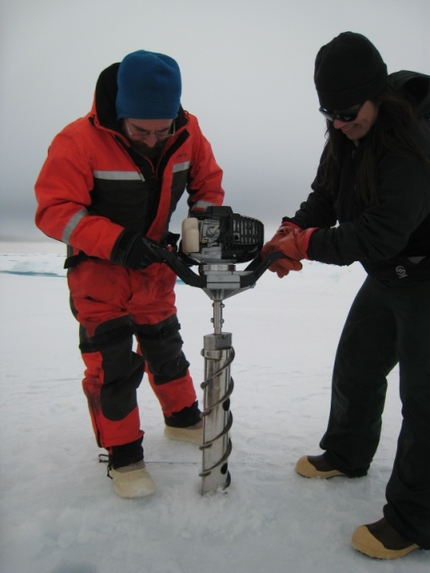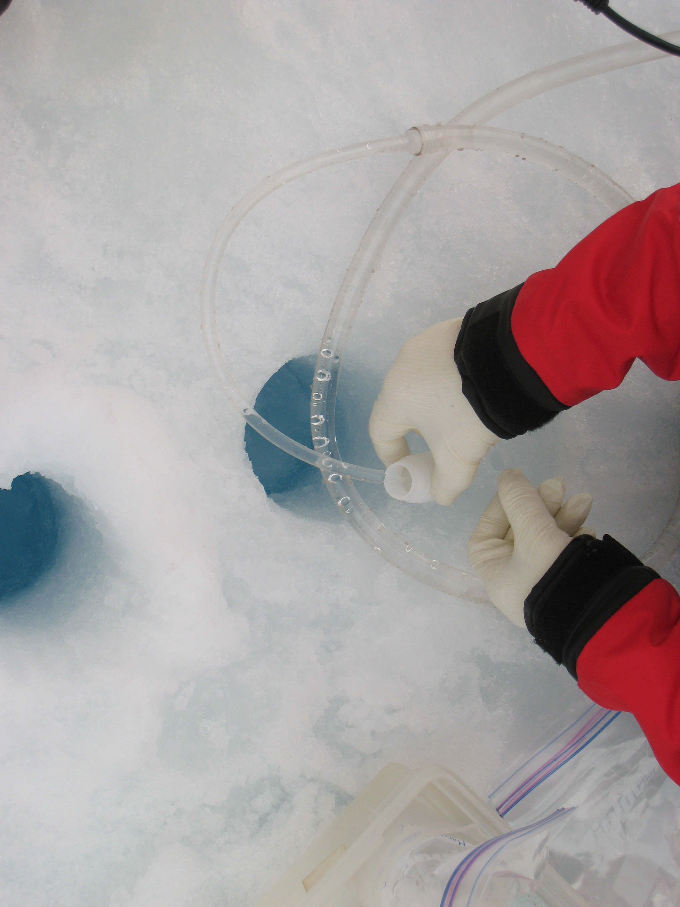
Figure 1 - Coring Operations at Ice Camp Moonscape (Mike Dempsey & Alice Orlich)
Figure 2 - Ice/Water Interface Pumping Operations at Ice Camp Moonscape (Nes Sutherland)

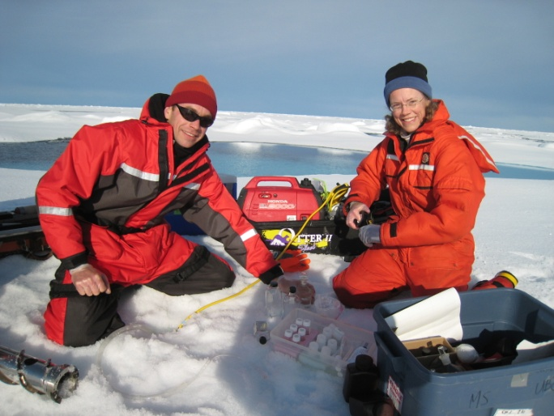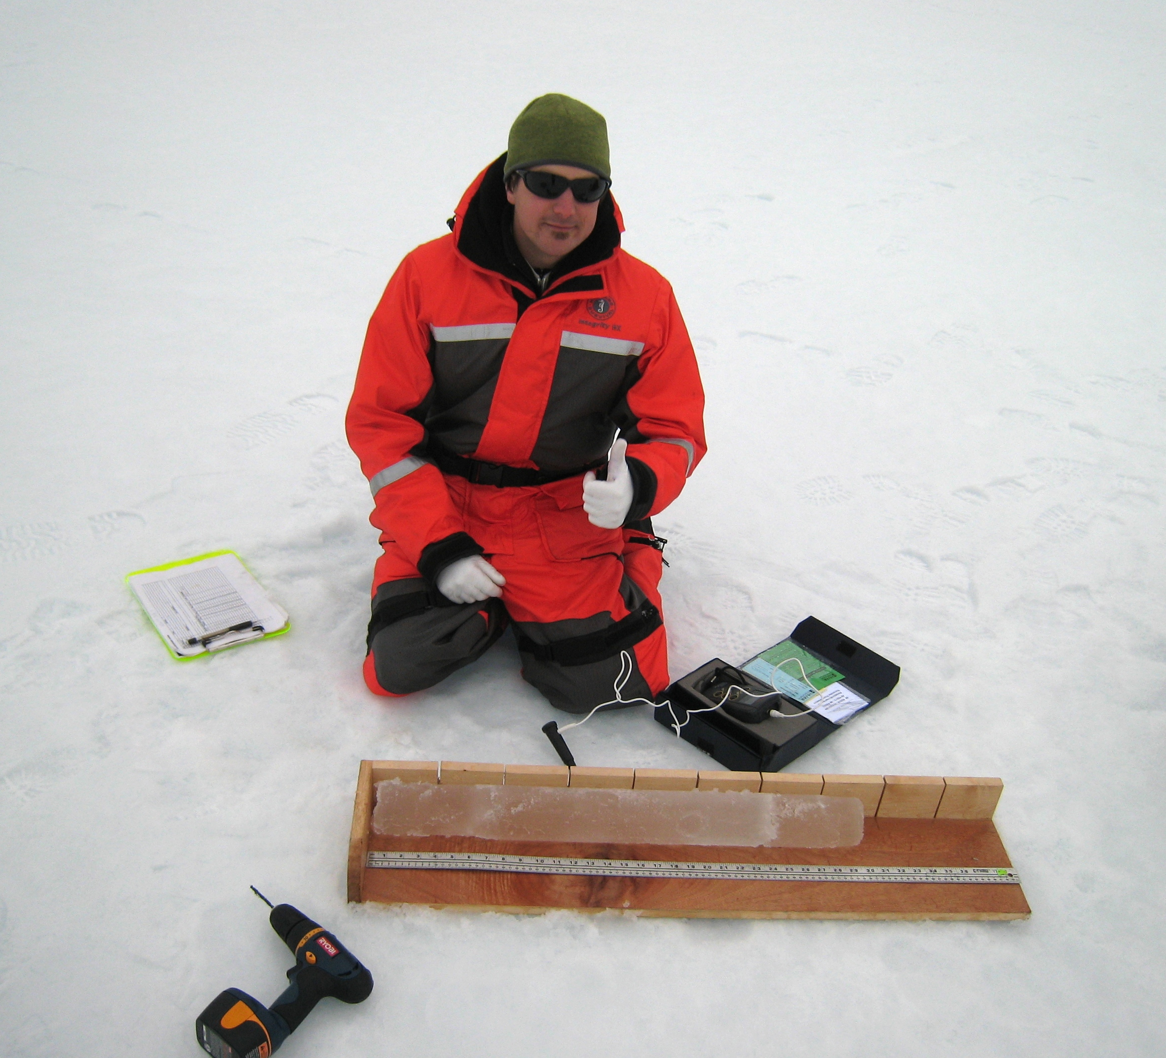
Figure 3 - Pumping Operations at Ice Camp Last Chance (Brian Hunt & Sarah Zimmermann)
Figure 4 - Ice Core Temperature Profiles at Ice Camp Moonscape (Kenny Scozzafava)

