Ice Observations
Alice Orlich

Many thanks to Kristina Brown, Nes Sutherland, Brian Hunt, Mike Dempsey, Kenny Scozzafava, Edmand Fok, Melissa Hennekes, Kelly Young, Hugh Maclean, Will Burt, Gerty Ward, Marie-Claude Bouchard, and Sarah Zimmermann, for assistance in collecting ice data. The hourly ice observations and field program was lead by Alice Orlich, directed by Jennifer Hutchings of IARC/UAF. Data and insight was shared by the ship’s ice observer, Marie-Claude and her organization and patience was greatly appreciated. We would especially like to thank Captain McNeill and the crew of the Louis S. St. Laurent for making these ice observations and sampling excursions possible.

Ice observations recording during the Louis S. St. Laurent 2008-30 cruise will provide detailed information for the interpretation of satellite imagery of the ice pack. Our objective was to identify the major sea ice zones in the Beaufort Sea and determine the types and state of ice in these zones. This information, as well as the 2007-20 cruise data will be used to support a joint drifting-buoy, RADARSAT SAR, field and modeling campaign to investigate sea ice dynamics in the Beaufort Sea during winter 2006 to spring 2008. The project, “Sea ice tide-inertial interaction: Observations and Modeling” is funded by the National Science Foundation, with PIs Jenny Hutchings and Bill Hibler. The observations from this cruise will also support a field project “Detailed investigation of the dynamic component of the sea ice mass balance” which occurred during spring 2007, with PIs Jenny Hutchings, Jackie Richter-Menge and Cathy Geiger. We anticipate that the observations will be useful for investigating the evolution of the ice cover over the last three years when used in conjunction with satellite and buoy data.

The cruise occurred in August, providing a snapshot of ice conditions at the end of the 2008 melt season. Throughout the cruise we experienced melt conditions, with only rarely witnessing frozen meltponds or new ice on the coldest of nights. This season’s cruise occurred closer to the summer’s schedule of the 2006, and therefore relatively earlier than the 2007 cruise dates. This should be considered when forecasting ice concentration and thickness in the areas visited because almost another month of melt conditions is to be expected.

Observations from Bridge: Methodology
Every hour, while the ship was steaming and light conditions allowed, an observation of ice conditions was recorded. Each observation was made from the bridge, and photos were taken from the monkey island to document ice regions. Although the goal was to cover continuous 24-hour periods, observations were reduced because only one observer was available, long periods of time were spent on station with little change in the icescape, and many days at the beginning and end of the trip were ice free. These results are available on request from Jennifer Hutchings.

A combination of ASPECT (Worby & Alison 1999), Standard Russian and Canadian Ice Service codes were used to describe ice conditions. The codes are described in detail below. During each observation period we estimated the total ice coverage within 3km of the ship (when visibility allowed), the types of ice present and the state of open water. For each ice type we estimate the coverage of that type, thickness, flow type, topography, sediment coverage, algae presence, snow type, snow thickness and stage of melt. There was space for detailed observations of three ice types (primary, secondary and tertiary) in the log sheets. We also recorded the codes for any other types of ice present that was at lower concentration than the three main types. We recorded basic meteorological phenomena of cloud coverage and type, visibility and precipitation.

Time
UTC Time was noted. Ship time was set to mountain time (UTC – 6 hours).

Ice Concentration
Ice concentration was estimated in tenths. Partial concentration of each type was estimate as the fractional coverage of the entire observation area (ice and water) in tenths.

Open Water
0 No openings
1 Small cracks
2 very narrow breaks <50m
3 Narrow breaks, 50-200m
4 Wide breaks, 200-500m
5 Very wide breaks, >500m
6 Leads
7 Polynya
8 Water broken only by scattered floes
9 Open sea

Snow and Ice Thickness
A 1.5m pole, painted with 10cm segments, was attached to the railing on the port side of level 500 on the ship. This pole could be viewed from the rear window on the bridge, and was used for gauging ice thickness as the ship overturned pieces of broken ice. The accuracy of each individual thickness measurement is +/- 10cm. It should be noted that the ship does not overturn the thicker pieces of ice fully, so this method can not be used to accurately gauge ice thicknesses greater than about 2m. We found that the ship also did not overturn ice that was 20-50cm, when steaming through 10/10 ice. As the navigator would prefer to steam in open water and thinner/more rotten ice, the thickness measurements will have bias in ice concentrations that are reduced.

Ice Type
10 Frazil
12 Grease
20 Nilas
30 Pancakes
40 Young Grey Ice 0.1-0.15m
50 Young Grey-White Ice 0.15-0.3m
60 First year <0.7m
70 First year 0.7-1.2m
80 First year >1.2m
65 First year, unknown thickness
75 Second year
85 Multiyear
90 Brash

Floe Size
1 Pancakes
2 New sheet ice
3 Brash / Broken Ice
4 Cake ice <20m
5 Small floes 20-100m
6 Medium floes 100-500m
7 Large floes 500-2000
8 Vast floes >2000m
9 Bergy Floes

Topography
Ridges and hummocks indicate the age and dynamic history of sea ice. We estimated topography of each ice type using ASPECT codes. These were chosen as they allow an areal coverage and ridge sail height to be noted. We found that the level of detail required by the coding of areal coverage and average sail height was greater than the eye could gauge. Hence, the areal coverage and sail height values should be used with caution. It would be best to rearrange the data into larger bins reflecting <30%, 30%-60% and >60% coverage. The sail height was difficult to estimate when spatial variability was high, and should only be used in a qualitative sense.

100 Level Ice
200 Rafted Pancakes
300 Cemented Pancakes
400 Finger Rafting
5xy New, unconsolidated ridges (no snow)
6xy New ridges filled with snow or a snow cover
7xy Consolidated ridges, no weathering
8xy Older, weathered ridges
x values:
areal coverage
0 0-10%
1 10-20%
2 20-30%
3 30-40%
4 40-50%
5 50-60%
6 60-70%
7 70-80%
8 80-90%
90 90-100%

y values:
average sail height
1 0.5m
2 1.0m
3 1.5m
4 2.0m
5 3.0m
6 4.0m
7 5.0m
Sediment
Areal coverage of sediment on the surface of each ice type was estimated

0 ice is clean
1 spots on few floes
2 patches > 20m
3 >1/3 ice covered s dirty

Ice Algae
As ice is overturned by ship, ice algae can either be seen in the bottom portion of the ice, or strands of algae are overturned with the ice.

0 no algae
1 <30% overturned ice has algae
2 30-60% has algae
3 >60% has algae
Snow Type
0 No snow observation
1 No snow, no ice or brash
2 Cold new snow, <1day old
3 Cold old snow
4 Cold wind-packed snow
5 New melting snow (wet new snow)
6 Old melting snow
7 Glaze
8 Melt slush
9 Melt ponds
10 Saturated snow
11 Sastrugi

No snow fall was observed during cruise. All ice was at advanced stage of melt (4 or 5) with melt slush and draining melt ponds. At our core sites we found the slush to be between 20 and 30cm thick.

Stage of Melt

Stage of melt coding is highly variable between observation systems. Hutchings choose to work with the Russian coding system, as this is the system she is most familiar with. The stage of melt has to be considered separately for each ice type, as younger and older ice melt are characterized by differing surface conditions.

Young Ice (incl. young first year ice)
0 No melt
1,2 Surface darkened, snow melt single thaw holes
3,4 Greatly disrupted surface thaw holes everywhere
5 Level ice completely melted. Only deeply seated in water remains, ridges still found.

First Year Ice
0 No melt (or pack freezing, young ice forming over thawholes)
1 Some puddles on surface. Ice braccia desctruction begun.
2 Surface darkened, snow partially melted. Big puddles, some melt ponds.
3 Melt ponds everywhere, some thaw holes. Ice is stage of drying, ice colour whitening.
4 Greatly disrupted ice. Thaw holes everywhere. Disruption of Braccia complete. Underwater ramps on ice cakes.
5 Rotten ice. Greatly melted formless blocks. Dark grey color, greatly watered.
Ocean Colour
Multiyear Ice
0 No melt (or pack freezing, young ice forming over melt ponds/thaw holes)
1 Snow melting on top of hummocks. Melt ponds / patches of wet snow in low places.
2 Some ponding, <40% melt ponds. Snow melting. Places with no snow may occur.
3 Well defined melt ponds everywhere. Connected freshwater output to cracks. Area of melted water on surface is decreased due to output.
4 Ice braccia cracked. Area of melted water on surface is decreased, <30%. Thaw holes.
5 Floes have become cracked and blocks, due to intensive melt. Rotten ice.
The ocean colour is apparent against ice draft and the keels of ridges. We noted whether the colour was dark blue (DB), Turquoise (TQ) or green (G) at the time of observation. Green indicates the presence of surface phytoplankton blooms. It should be noted that the surface water sinks under the fresh melt water in the transition across the ice edge, hence this method can not be used to track blooms further into the ice pack.

Cloud Cover
Visibility
90 < 50m
91 50-200m
92 200-500m
93 500-1000m
94 1-2km
95 2-4km
96 4-10km
97 >10km
-1 not available
Estimated in Octaves

Cloud Type
cu Cumulus
ci Cirrus
st Stratus
sc Strata-cumulus
fog Fog

Weather
We used codes provided by the AVOS system.

Cloud development
00 Clouds not observable/observed
01 Clouds dissolving or becoming less developed
02 State of sky as a whole unchanged
03 Clouds forming or developing

Fog/Precipitation during past hour but not at time of obs
20 Drizzle not freezing or snow grains
21 Rain not freezing or snow grains
22 Snow not freezing or snow grains
23 Rain and snow or ice pellets
24 Drizzle or rain, freezing
25 Showers of rain
26 Showers of snow, or of rain and snow
27 Showers of hail, or of rain and hail
28 Fog in past hour, not at present

Blowing or drifting snow
36 Drifting snow below eye level, slight/moderate
37 Drifting snow below eye level, heavy
38 Blowing snow, above eye level, slight/moderate
39 Blowing snow, above eye level, heavy

Fog/Mist
41 Fog in patches
42 Fog thinning in last hour, sky discernable
43 Fog thinning in last hour, sky not discernable
44 Fog unchanged in last hour, sky discernable
45 Fog unchanged in last hour, sky not discernable
46 Fog beginning/thickening in last hour, sky discernable
47 Fog beginning/thickening in last hour, sky not discernable
48 Fog depositing rime, sky discernable
49 Fog depositing rime, sky not discernable

Precipitation as drizzle
50 Slight drizzle, intermittent
51 Slight drizzle, continuous
52 Moderate drizzle, intermittent
53 Moderate drizzle, continuous
54 Dense drizzle, intermittent
55 Dense drizzle, continuous
56 Freezing drizzle, slight
57 Freezing drizzle, moderate or dense
58 Drizzle and rain, slight
59 Drizzle and rain, moderate or dense

Precipitation as rain, not showers
60 Slight rain, intermittent
61 Slight rain, continuous
62 Moderate rain, intermittent
63 Moderate rain, continuous
64 Heavy rain, intermittent
65 Heavy rain, continuous
66 Freezing rain, slight
67 Freezing rain, moderate or heavy
68 Rain or drizzle and snow, slight
69 Rain or drizzle and snow, moderate/heavy

Frozen precipitation, not showers
70 Slight fall of snow flakes, intermittent
71 Slight fall of snow flakes, continuous
72 Moderate fall of snow flakes, intermittent
73 Moderate fall of snow flakes, continuous
74 Heavy fall of snow flakes, intermittent
75 Heavy fall of snow flakes, continuous
76 Ice prisms, with/without fog
77 Snow grains, with/without fog
78 Isolated star like crystals
79 Ice pellets

Precipitation as showers
80 Slight rain showers
81 Moderate or heavy rain showers
82 Violent rain showers
83 Slight showers of rain and snow
84 Moderate/heavy showers of rain and snow
85 Slight snow showers
86 Moderate or heavy snow showers
87 Slight showers of soft or small hail
88 Moderate/heavy showers of soft/small hail
89 Slight showers of hail
90 Moderate or heavy showers of hail

Comments on Bridge Observing Methodology
As we did not have a continuous ice watch, the observations should not be used alone to estimate ice type coverage on scales smaller than 100km. The ship track and speed will introduce a bias into the type and thickness of ice overturned. Hence, although the sampling of thin and medium first year ice may be reasonable, thicker first year and multiyear ice will be under represented in thickness estimates. Poor visibility affects the area of ice observed, and could compound ship track bias in spatial coverage estimates.
It should also be noted that flat light conditions hinder the estimation of ridge height, quality of photos, and visibility for distance estimations. The majority of the days experienced flat light due to overcast skies and low fog.

We found that the photographic record helped in consistency checking of the bridge ice observations. We placed two webcams on the monkey island to record ice automatically. However, due to poor resolution of the forward facing camera, we continued to take hourly photographs for our consistency checks.

Webcam Imagery
Two cameras were installed on the monkey island. Back on land, we will investigate whether the images from the cameras are useful for mapping ice types and concentration by an ice expert who does not attend the cruise. My inclination is that a lot of information is lost by the cameras, as they can not provide 360º vision, and can not be focused on a variety of ice features as the human eye can.

Camera 1 pointed forward on the port side of the ship, and took an image every 10 minutes. This provided a wide field view of the ice pack the ship was heading into. When ice conditions intensified, the camera was adjusted to capture photos more often. This not only provides more imagery, but allows for more continuous record of change in floe size and ice type.

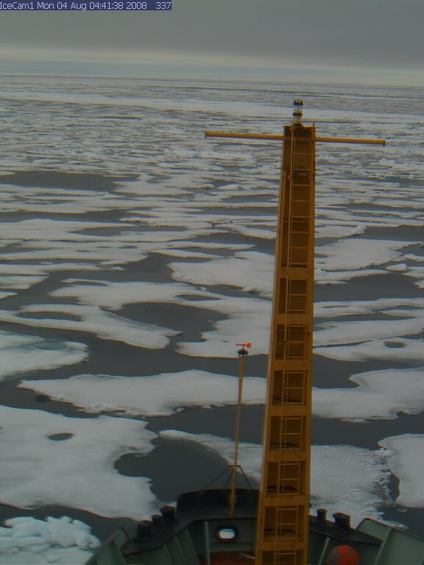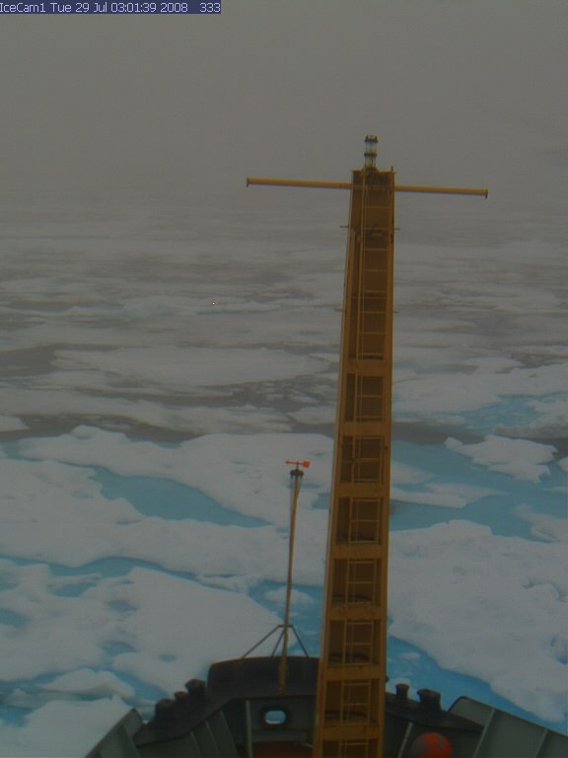

Camera 2 was trained on the “ice thickness pole” to observe overturning ice. In order to get a representative sample of overturned ice, this camera took pictures more often than Camera 1. Both cameras were linked into the NOAA server for image storage. On this cruise Alice Orlich downloaded the images directly to a laptop, external hard drive, and CD-roms. Anyone who is interested in these may contact Jenny.

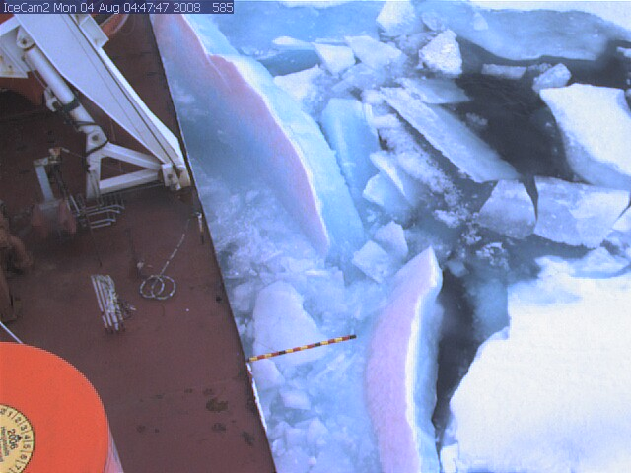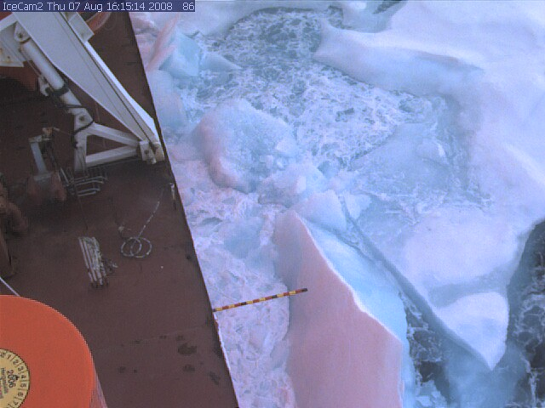

We have not processed the ice thickness data from this camera as it will take considerable time. However, once the data is processed it will give us a much more representative estimate of pack ice thickness than our visual observations from the bridge.

We had a couple of small issues in setting up the camera system. First, the image size needs to be not too large. We found that images over 100 kbytes would become pixilated in file transfer. Second, the netcam cameras do not have a small enough aperture for bright summer time pack ice photos. Hence most images from camera 1 are slightly blurry as they were over exposed. At times, Camera 2 produced bright, near white-out, images due to sun reflecting off fresh snow or the ice pack. The fix to this problem we would like to add a filter on the webcam lenses.

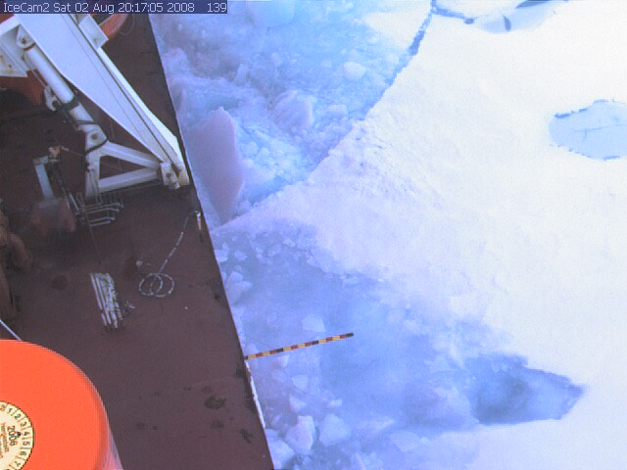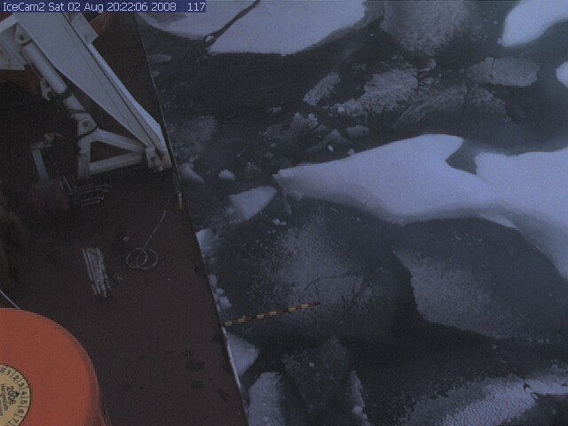

As for the location on the rail of monkey island, the selection was made to be similar to the positions used in 2007. Due to the limited space with appropriate holes for the fasteners, one bolt was used and additional webbing straps held the cameras in place.

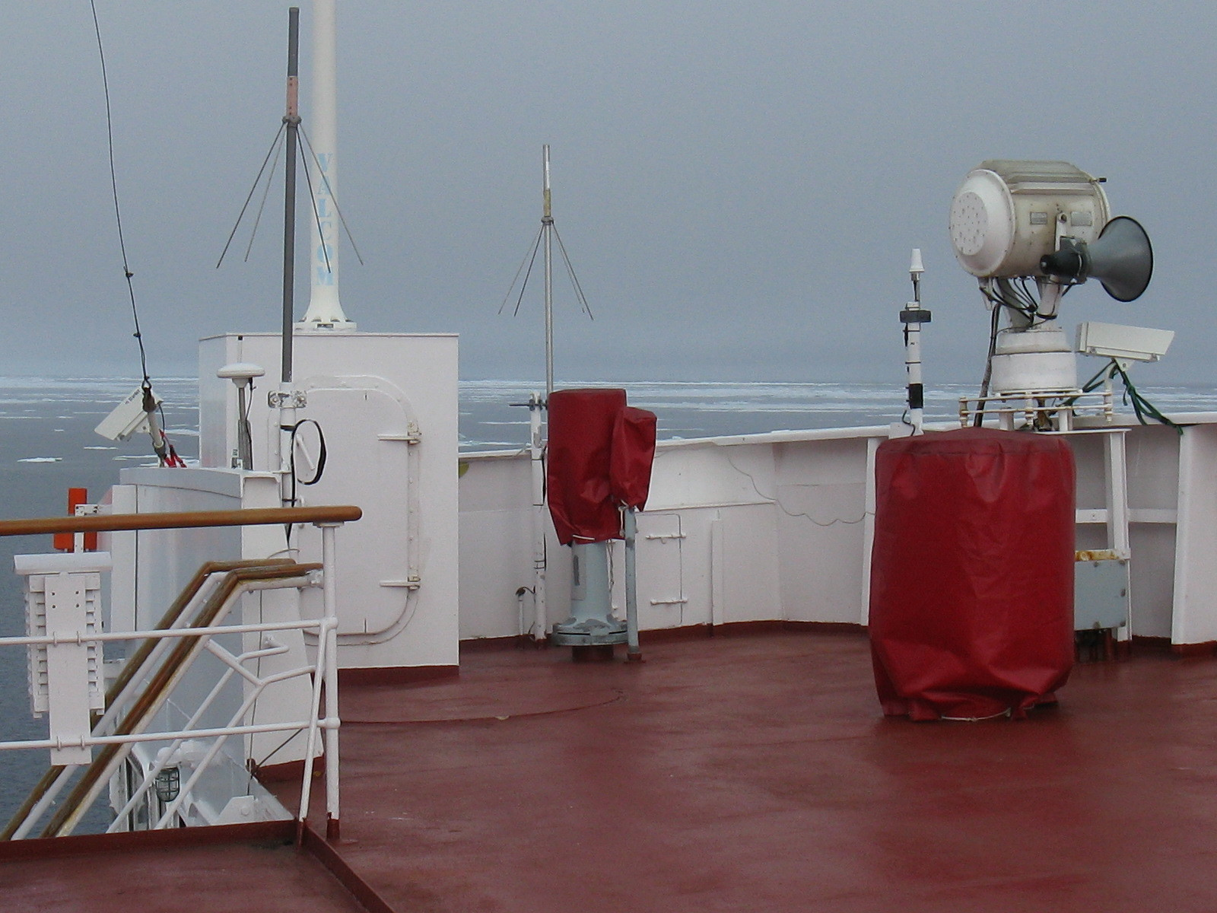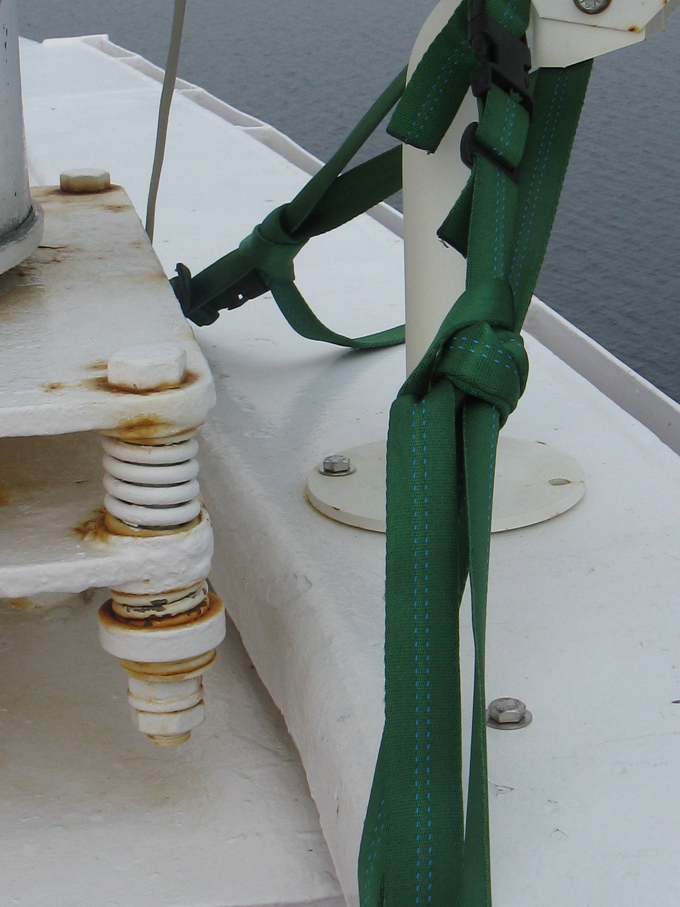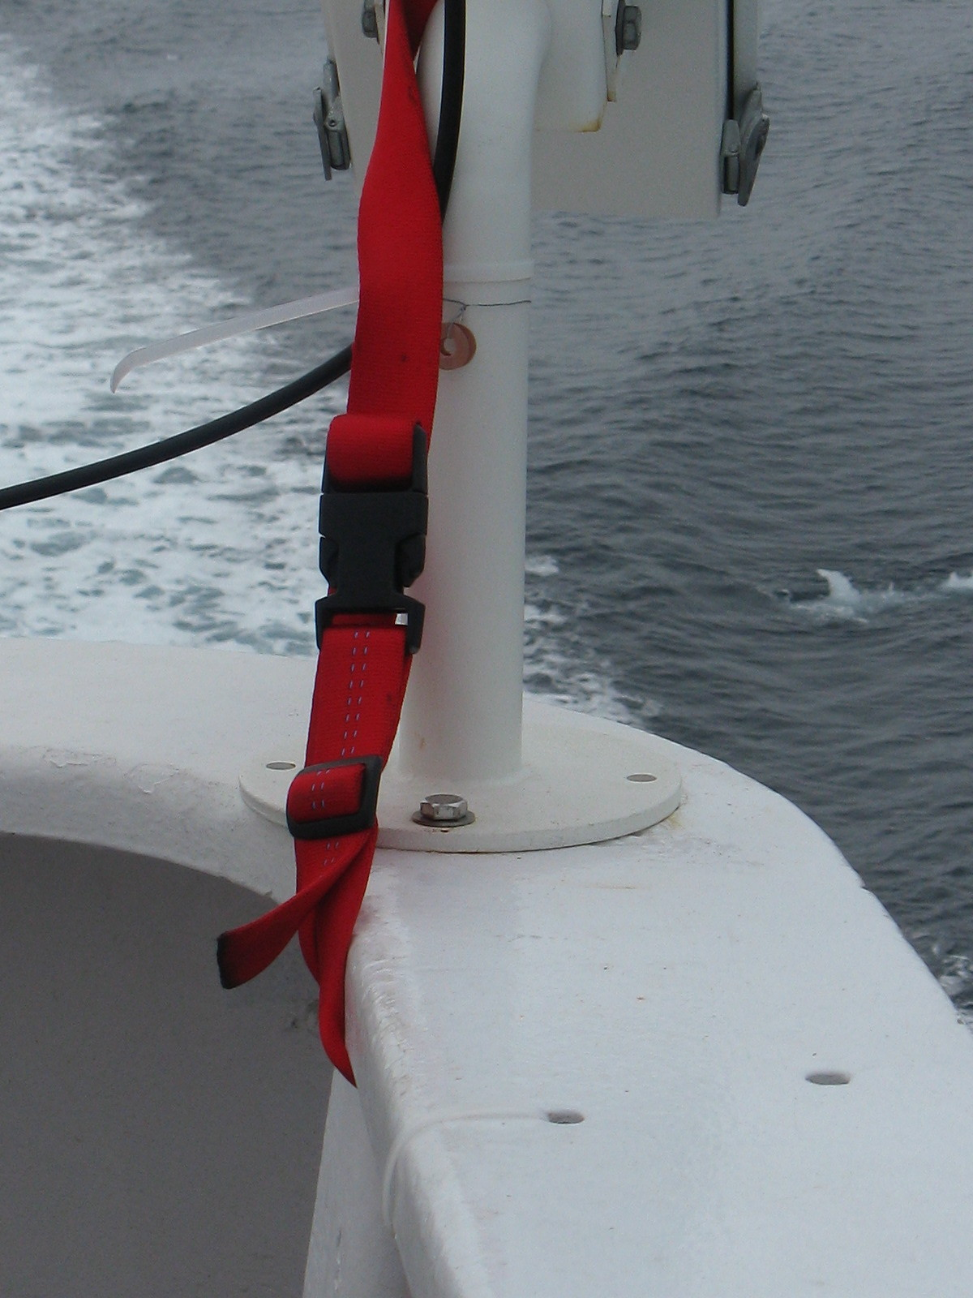
Cameras on rail Cam1 base Cam2 base

Changes in precipitation combined with temperature drops and overcast skies, caused Camera 1 to form ice or other obstructions on the outer window. Monitoring the camera view from a laptop allowed for near-instant removal of ice and maintenance of the quality of photos captured.

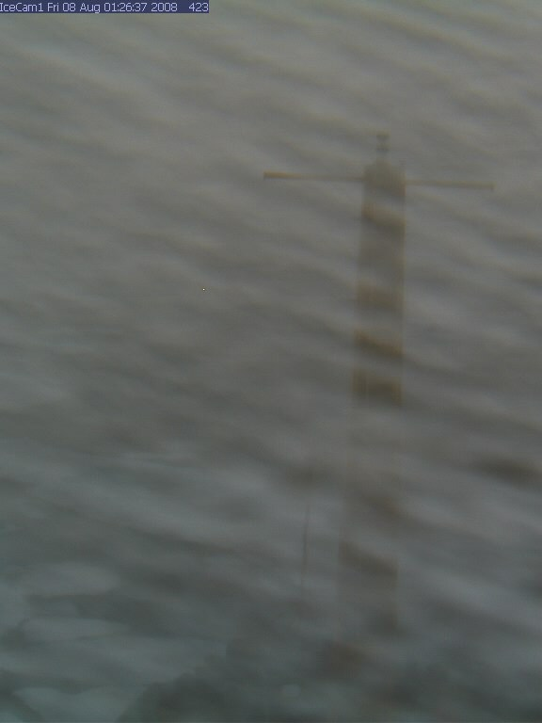

Aerial Ice Observations
At various times during the cruise we had the opportunity to observe the ice cover from helicopter. In flying conditions when visibility was good, and the helicopter could travel at an altitude of 2000 feet, these flights were very helpful in extrapolating ship based observations to the wider field. Although this is the preferred altitude of the ship’s ice observer, low fog sometimes restricted flights to as low as 100’, more often staying at 200’. Compared to last year’s trips, we witnessed greater expanses of open water and small floe sizes. At times, searching for viable sites for buoy deployment required extended flights and multiple test sites due to poor ice availability. During flights, notes were taken of ice coverage, distribution of types and state of melt. Photographs and GPS waypoints were taken as a record of ice conditions.

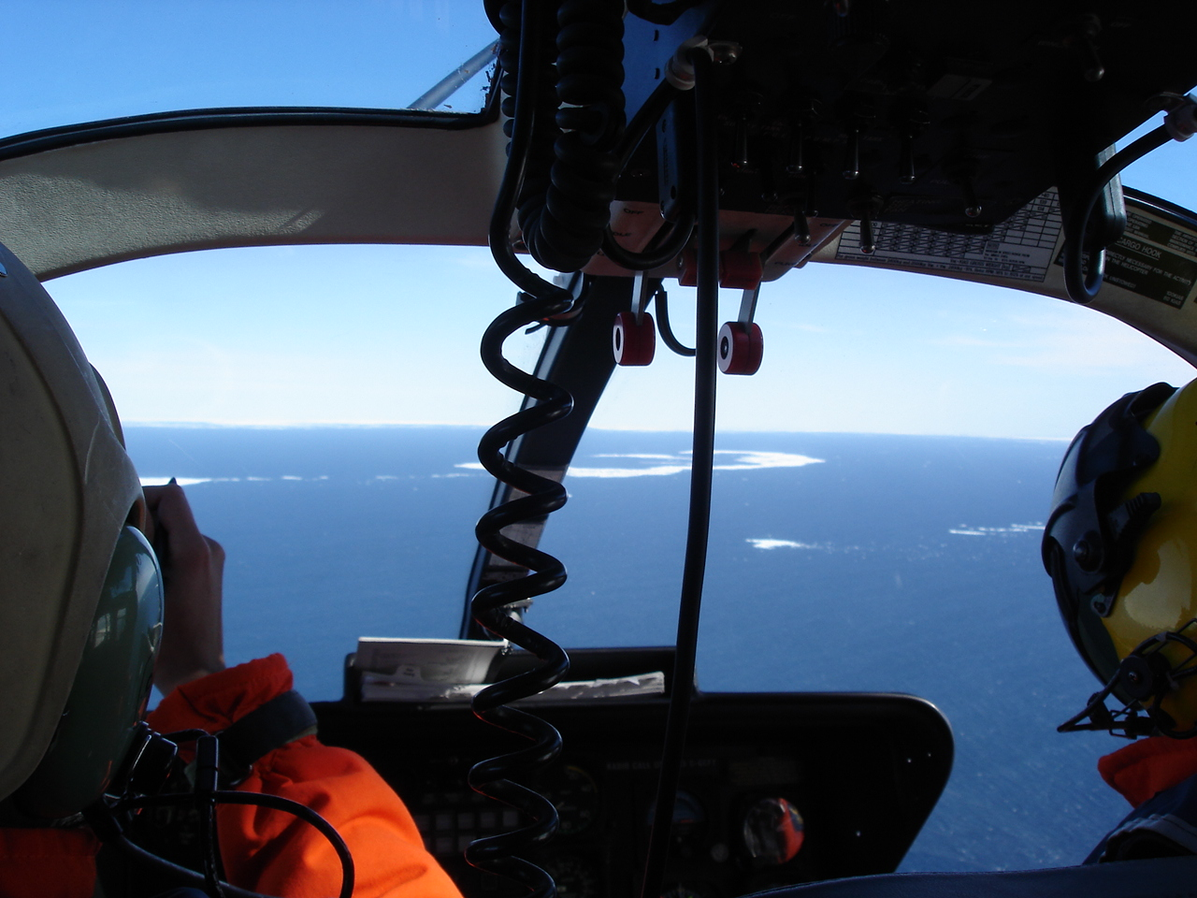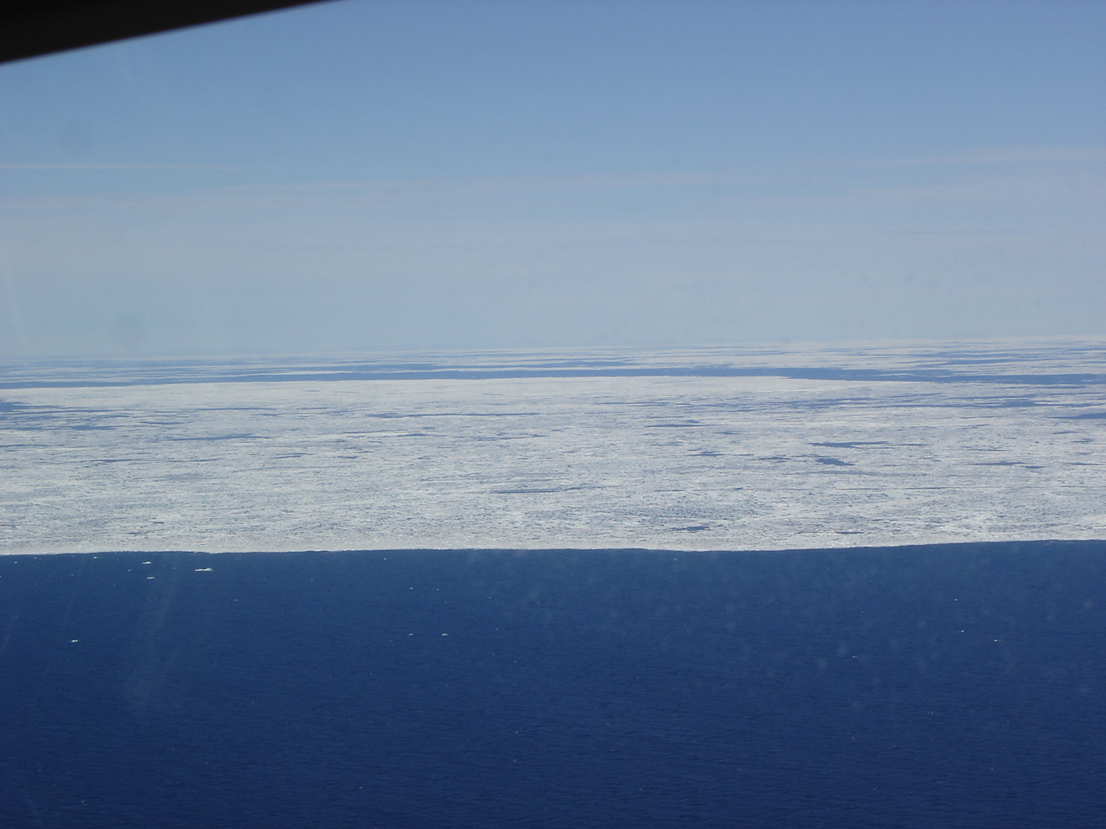
These two images are from the first helicopter recon, on Saturday, 26 July, 2008. The edge of the ice is seen at 74° 21’, 148° 24’ from 1000’.

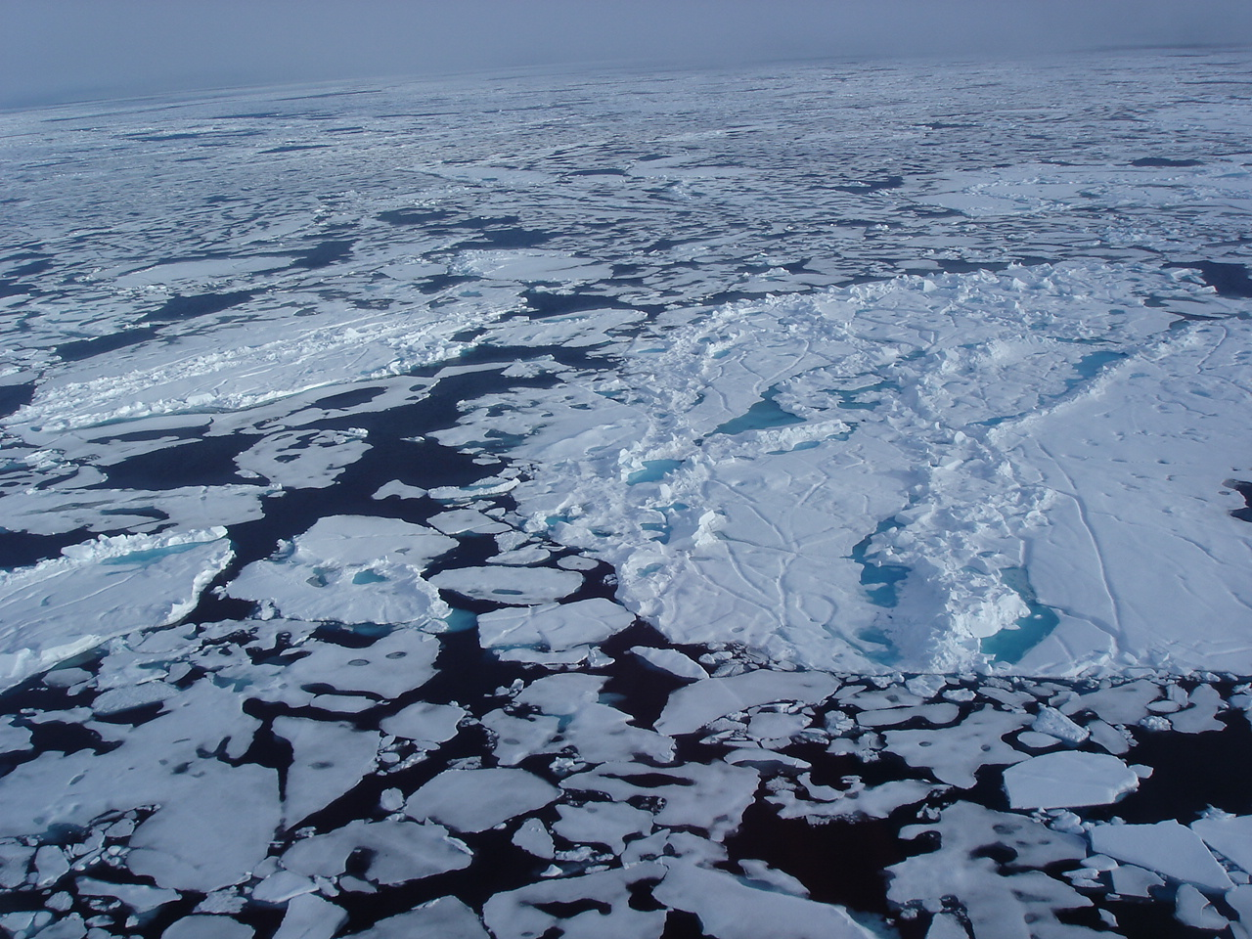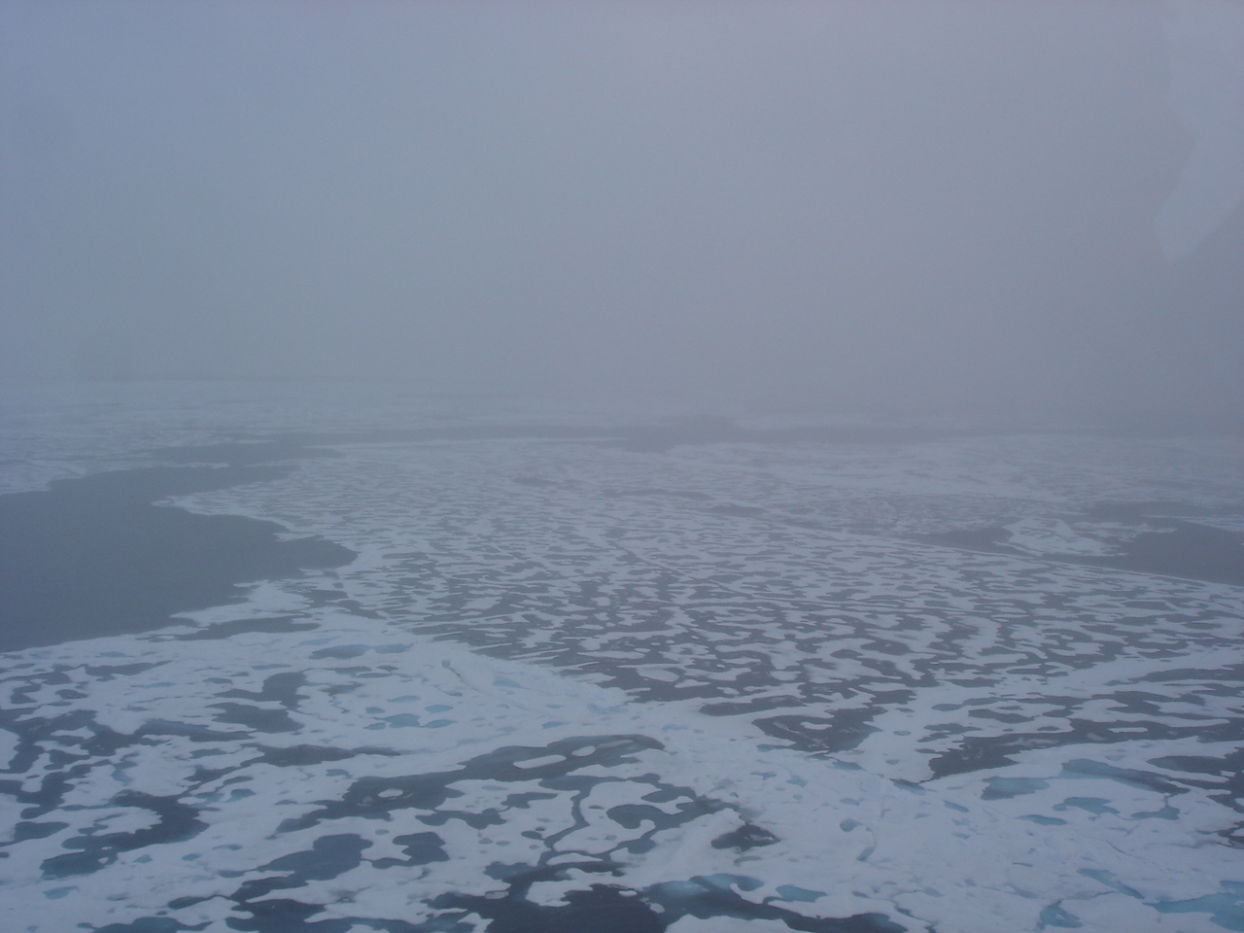
On 30 July, 2008, an ice recon flight was sent to fly the 150° line an overfly stations CB8, CB12, and CB9. Larger flows of multiyear ice with ridging, as on the left, were viewed from 200’. The visibility changed in areas of rotting first year floes with large breaks, as seen on the right from 800’.

During future cruises it would be advantageous to have a camera mounted on the helicopter, pointing downwards with a coincident record of geodetic location and altitude. This could provide a record of ice conditions that could be used to estimate scale of features on the ice and would not take up a seat on the helicopter. The camera which has been used on the Louis helicopter was designed to mount in the cargo hold, and can only be used when there is no load in the hold. This is not an optimal situation for the work we do. It would be better to design a camera that is affixed to the exterior of the helicopter. However, this will require extensive flight testing.

Comments on ice type observations

During the majority of the cruise in the western Beaufort Sea we were traveling through very rotten ice in small, flat floes. These had a smattering of obvious multi-year floes with hummucking and ridges scattered between them. Some first year thick ice had noticeable new ridging with either an unconsolidated surface, or filled with snow or recent snow cover. Much of the ice continued to be rotting first year, perhaps second year, floes with an advanced stage of melt and heavy ponding. Some of the floes had uneven surfaces, suggesting they had experienced a previous melt season. However the majority of this ice type was remarkably flat.

Be aware that the ice type observations in our spread sheets and the Canadian Ice Service charts might be coded wrongly. The CIS charts identify the young ice type as thin to medium thickness first year ice. We described first year by thickness, and considered “old ice” as multi-year type in our observations.

Ice Stations
Transects of ice thickness, snow depth and melt pond shape and orientation can provide additional information about ice conditions that is not possible to gauge with shipboard methods. We had many objectives for ice station work: (1) Snow sampling for black carbon in Arctic snow and ice, (2) Thickness transects with drill holes every 10 meters, (3) Ice core sampling at start, middle, and end of transect line for a study of salinity and multiple chemical analysis, (4) Collect water at ice/water interface for chemical analysis with water pumping/niskin bottles, (5) Ridge thickness study to access sail, keel, and voids in dynamic features, and (6) Collection of dirty ice for sediment transport or algal community characterization

The work conducted on the ice stations was coordinated with Kristina Brown of UBC. Before venturing off the ship, a meeting was organized to discuss the goals, priorities, preferred locations, operations, participant list and sampling plan. The discussion included the Captain, 1st Mate, helicopter pilot, Chief and co-chief scientist, as well as Orlich and Brown. The ice stations were selected by the Captain based on the ship schedule and therefore often occurred on the same floes were buoys were deployed by WHOI or SAMS. The time allotted was adjusted at each location and therefore dictated the type of work performed. On occasion, ice time was extended after the field team was on the floe, and they adjusted their priorities as needed. Typically, Orlich flew out on the first flight to assess the features and potential drill and core sites. This was done in coordination with the needs of the WHOI team and safety concerns. The team consisted of Orlich and Brown, but was able to enlist additional members if many helicopter flights were scheduled, or the time on station was expected to be more than 1.5 hours. Multiple volunteers from the science staff joined the ice sampling team and this increased productivity and allowed for a learning opportunity for researchers with little or no on-ice experience. Data was shared amongst the IARC/UBC, WHOI, and SAMS crews. Maps and GPS waypoints, along with observations and photos will be complied into reports for each station.

Snow sampling for black carbon in Arctic snow and ice
Kristina Brown was asked to collect snow samples at sites on ice floes not polluted by the helicopter or ship operations. In order to facilitate this request, she or a field crew member who landed on the floe during the first trip out would travel upwind and collect samples according to the experiment design. The snow depth was measured, scooped into plastic bags, and recorded. The samples were kept frozen and later stored in the ship’s freezer. Participating in this experiment allowed for cross-institution cooperation and collaboration of snow and ice studies.

Thickness transects with drill holes
When offered an opportunity to have ice time, however brief, the primary sampling gear that was used was the 2” auger system. The choice was made to always acquire floe thickness data based on either transects of the greatest possible length across flat ice, or across ridges, and if those features were unavailable, random sites or smaller transects. The efficiency of the system allows for relatively minimal space in the helicopter, quick results, and simple operation. Many trips were offered with the understanding that the time on ice was to be limited and that readiness was immediate. Thickness transects are the quickest way to profile a floe.

Ice core sampling for a study of salinity and multiple chemical analyses
When time allowed, ice cores were extracted from the drill-hole transect lines at the beginning (0m distance), middle, and end of the line. The initial core at each distance was taken for temperature and salinity, where temperatures of the core were take on site at increments of 10 cm, starting at 5cm deep, and salinity was later found after 10 cm core pieces were melted back aboard the ship. The pieces were measured starting at the top of the core, thus providing a temperature at the center of each slice. The 10cm pieces were measured in three thicknesses with a caliper for consistency, and then averaged to use in calculating the volume, and ultimately, density.

A second group of cores were collected for use in Brown’s chemical analysis of the ice at different depths. Select pieces were stored in tedlar bags with excess air removed, melted on the ship and later analyzed for del 13C-DIC, alkalinity, salinity, del18O, and nutrients.

Water collection at ice/water interface for chemical analysis
After core collections were completed, a submersible aquarium pump was used to collect water from near the ice/water interface. The samples were analyzed for the aforementioned constituents as well as Ba, Chla, and del 13C-POC. The practice could be well-coordinated with two field personnel managing it while a second team travelled on to begin another core site.

Ridge thickness study
Where ridges were transected a floe, ridge thickness studies were planned. By transecting the ridge perpendicularly, a drill-hole line can be used to access sail, keel, and voids in the dynamic feature. There was only one floe in which this brief study was conducted. Given the relation to melt ponds bordering the ridgeline, the transect line travelled over the spine of the ridge for a distance of 70m.
Collection of dirty ice
Dirty ice includes any samples that may be helpful to determine sediment transport or algal community occupation. During the 2007-20 cruise, ice with sediment or algae was collected wherever found. Some sites were easy to access by Zodiac boatcraft, and yielded ice and water samples that could be collected by reaching out of the boat. No boat trips were offered this season. One floe utilized for a buoy deployment had sediment and was collected for student David Griffith from WHOI/MIT.

Additional notes
Because the ice sampling program is regarded as a “science of opportunity” by the trip schedulers, it is important to plan multiple goals for ice work that have reasonable tasks and elements of flexibility incorporated into the research design. By having those goals presented and discussed early in the trip, all interested and affected parties were able to anticipate the field operations when the opportunities arose. The obvious disadvantage to this system is that consistency in field data is uncertain, and mixed data collections result. However, at this point in ship-based sea ice observations, it is accepted and appreciated that any opportunity to collect in-situ data using any method is instrumental in contributing to groundtruthing satellite interpretation, modeling, and future on-going ice observation and sampling programs. We would like to thank IOS, WHOI, and the Canadian Coast Guard for their collective effort in helping us make progress in this objective.

