CABOS 2008 mooring deployment report
Mike Dempsey
22 July 2008

The Canadian Basin Observation System (CABOS) mooring has been deployed by on Institute of Ocean Sciences (IOS) Arctic cruises on behalf of the University of Alaska Fairbanks International Arctic Research Center since 2003 every year except 2007. The location of the mooring has varied due to ice conditions but has been continuously placed to monitor the flow of Atlantic water around the south east slope of the Canada Basin. The mooring is part of a string of moorings deployed by IARC to observe the movement of Atlantic water through the Arctic and measure the heat flux to upper waters. The Nansen/Amundsen Basin Observation System (NABOS) consists of a series of McLane Moored Profiler and conventional moorings located around the self break of the Laptev Sea. The CABOS mooring provides complementary data for this array.
Table 1. 2008 Operations, CABOS mooring
Investigator | Recovery | Recovery | Recovery | Deployment | Deployment | Deployment
 | Depth (m) | Location | Time (UTC) | Depth (m) | Location | Time (UTC)
UAF/IARC |  |  |  | 1114 | 71° 49.702’N | 22 July 2008
I. Polyakov |  |  |  |  | 131° 46.591’W. | 1525 (UTC)

Chronology

Deployment
MMP s/n 11494 set up parameters

ID M| Mooring ID = 008

Start Z| Scheduled start = 07/23/2008 00:00:00

Schedule I| Profile start interval = 001 00:00:00 [DDD HH:MM:SS]
R| Reference date/time = 08/01/2005 00:00:00
B| Burst Interval = Disabled
N| Profiles per burst = Disabled
P| Paired profiles Disabled
F| Profiles / file set = 1

Stops S| Shallow pressure = 50.0 [dbar]
D| Deep pressure = 1110.0 [dbar]
H| Shallow error = 60.0 [dbar]
E| Deep error = 40.0 [dbar]
T| Profile time limit = 01:28:20 [HH:MM:SS]
C| Stop check interval = 5 [sec]
L| Fluorometer = Disabled
O| OBS Turbidity = Disabled

RTC: 07/22/2008 03:30:50 WDC: 07/22/2008 03:30:50 11.4 Vb 0 mA

Sensor warm-up will begin at 07/22/2008 23:58:00
Initial dive to bottom stop will begin at 07/23/2008 00:00:00.

System is ready to deploy.

Sample SBE37 Microcat setup

SBE37SM-RS232 3.0b SERIAL NO. 6015 22 Jul 2008 03:21:15
vMain = 9.07, vLith = 2.88
samplenumber = 0, free = 559240
not logging, stop command
sample interval = 900 seconds
data format = converted engineering
transmit real-time = no
sync mode = no
pump installed = no
S>startnow
<!--start logging at = 22 Jul 2008 03:36:36, sample interval = 900 seconds-->
S>ds
SBE37SM-RS232 3.0b SERIAL NO. 6015 22 Jul 2008 03:21:38
vMain = 9.05, vLith = 2.88
samplenumber = 0, free = 559240
logging
sample interval = 900 seconds
data format = converted engineering
transmit real-time = no
sync mode = no
pump installed = no
S>

22/07/2008
All times UTC
Conditions : 1 to 2 tenths old ice. Wind 346°T at 10 kts. Light fog and fog bow

1405 Releases, bottom glass spheres and anchor ready to sling into position.
1415 Hook up Nilspin on winch through Gifford block in A frame.
1504 MMP s/n 11494 lowered into water on bottom bumper.
1554- SBE37 Microcat lowered into water.
1555 Mooring suspended from pelican hook on 1” nylon rope trough A frame.
1525 Mooring released. GPS position on bridge 71 49.681’N 131 46.575’W. Corrections made for draught and sound speed (calculated from that morning’s rosette cast) give corrected sounder depth of 1114 m (sound velocity 1457ms-1).
1530-. Enable command 376617 sent to release 28388. SR 1119 m
1531 – Use MCAL 1.04 to do survey of CABOS release position. Conduct 30 point survey covering 270° arc around mooring. Surveyed position 71 49.702’N 131 46.591’W.
1625- Complete survey
1630- Ping top transponder (Interogate 11.0 kHz Reply 14.0 kHz) SR 489-496 m
1631 Send disable command 376637to acoustic release s/n 28388. Acknowledgement received and no further replies.
1605- Move ship off station.

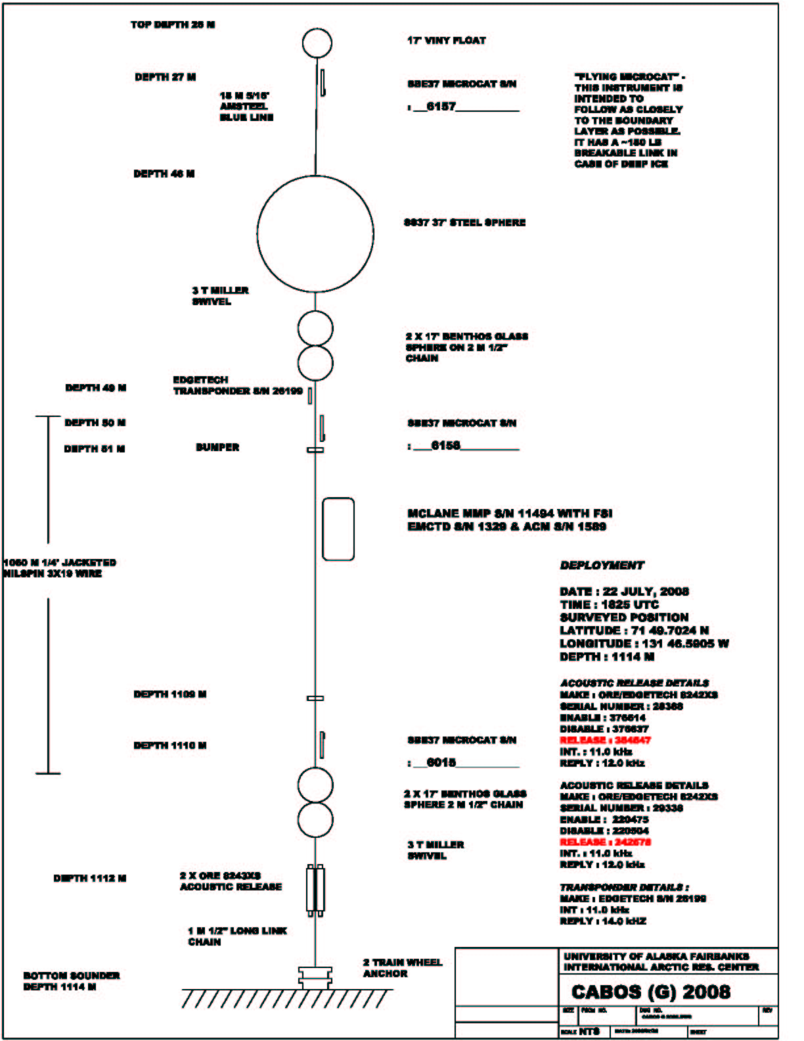

The deployment of the CABOS 2008 mooring was accomplished quickly with the help of many others. The assistance of a trained and motivated deck crew was much appreciated. Also the station keeping of the ship during recovery and deployment was excellent. Many thanks also to Will Ostrom, Jim Dunn and Rick Krishfield of WHOI for their help and the use of their Lebus dual capstan traction winch.

