Bongo Net Report – Louis St. Laurent, Voyage 2008-30

17/7/2008 to 21/8/2008

Participants:
Brian Hunt (University of British Columbia)
Kelly Young (University of Victoria)

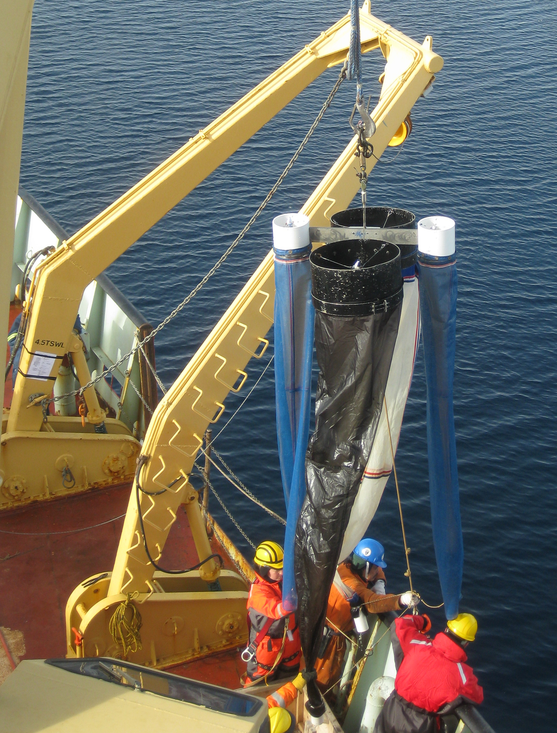

A total of 74 Bongo net hauls were completed during 2008-30, at 37 of 57 oceanographic stations. The Bongo used comprised 4 nets, two 50cm hoops and two 15cm hoops. The large hoops were harnessed with a 236 µm and 150 µm mesh, while the two smaller hoops were harnessed with 53 µm mesh. On arrival on the ship the larger hoops had both been harnessed with 236µm nets by Glenn Cooper, and one of these was switched to a 150 µm net.

Each net had its own flowmeter. The 53 µm and 236 µm nets were harnessed with MF-315 flowmeters, and the 150 µm nets with a TSK mechanical flowmeter. Glenn Cooper had communicated having inconsistent readings with the MF-315 flowmeters. These MF-315 flowmeters were given a basic service by B. Hunt on arrival on the ship, involving cleaning and greasing the propeller axels. One of the MF-315 flowmeters had a permanent malfunction and so was removed from the net configuration, leaving only three operational flowmeters. One of the 53 µm nets was therefore used without a flowmeter for the duration of the voyage and volume filtered was assumed to be the same as that for the second 53 µm net. Problems with inconsistent readings were encountered periodically with the remaining MF-315 flowmeters throughout the voyage.

The net was operated using the starboard A-frame near the bow of the ship. With the winch in low gear for adequate speed control, the net was lowered to the desired depth at ~ 0.5 m.s⁻¹ and raised at the maximum speed possible at this gear ratio (~ 0.8 m.s⁻¹). The hauling speed was higher to increase the catching efficiency of larger more mobile mesozooplankton species, and was consistent throughout the voyage. Once on deck the nets were washed down using a fire hose connected to the on deck sea-water line. This water line was not permanently open and it was necessary to request it be turned on prior to net deployment. It was important to run the water some minutes prior to washing the nets as it was invariably rusty in the beginning. It is required that the hose be left running once the line has been opened in order to prevent pressure build up and freezing when the air temperature was less than zero.

Routine sampling involved conducting two vertical hauls to 100m depth. The 53 µm net samples were combined for each cast leaving a total of 6 samples at these stations. Zooplankton preservation aimed to provide samples suitable for taxonomic / population / biogeographic studies (Formalin), DNA analysis (ethanol), and biomass estimation. The latter was intended to be performed by dry mass estimation after salt removal using ammonium formate. A pre-requisite for this was pre-weighed pans for drying the zooplankton in, however, these were not provided. Consequently, samples for biomass estimation were transferred to petri-dishes and frozen in the -80ºC freezer. This may not be ideal for biomass estimation, but does enable more to be done with the samples than just bulk biomass estimation e.g. stable isotope analyses. The breakdown of sample preservation at a typical two net station was as follows:

Cast 1 (100m):
236 µm into formalin
150 µm into formalin
both 53 µm combined to single formalin sample

Cast 2 (100m):
236 µm ethanol
150 µm frozen
both 53 µm combined ethanol (optional if ethanol is in short supply)

Single net hauls were completed at the following stations: CB10a, CB11b, NW2, CB19, CB22, CB27, CB29, CB31b, and CABOS (second occupation of site on 19/8/08).
In the case of CB10a to CB22 this was due to logistical problems. A hydraulic fluid leak in the A-frame meant that net tows from CB10a to CB22 had to be completed with the forward crane until the mooring work had been completed. This required four crew members and so nets were reduced to only day time tows (8am to 6pm), and also initially limited sampling to only one cast per station.
Single net hauls at CB27 to CABOS were due to insufficient zooplankton jars (including an additional extra 20 jars obtained from the galley) towards the end of the voyage. Since the priority stations had been completed by this stage the focus was put on spatial coverage rather than preservation of zooplankton for all potential analyses. The 236 µm samples were preserved in ethanol to enable both DNA and taxonomic analyses, the 150 µm sample frozen or preserved in formalin, and the 50 µm sample preserved in formalin.

Short term temporal sampling duplicates were obtained at three stations which were occupied for 12 hours or more, and this will provide some data on diel variability. At CB4 and CB21 double bongo net hauls were completed at night and during the day, while at CB9 single Bongo net hauls were completed at night and during the day.

Mesopelagic net hauls were completed at the same three stations where these temporal duplicates were obtained. At each of CB4 and CB9 additional single net hauls were completed to 500m and 1000m, while at CB21 an additional single net haul was made to 1000m.

At five stations individual zooplankton were selected, representative of the dominant species in the community, and frozen individually in cryotubes at -80ºC. IN combinations with the extensive POM collections, these specimens will be used for stable isotope analysis of the food web structure and carbon flow in the study area.

