**LSSL 2008-30 CTD Data**

**Sarah Zimmermann**

**DRAFT**

**V2017-11-29**

**V2017-12-18 Made clarification in CTD Conductivity calibration table.**

**File was corrupted May 2009 so am piecing together new file from 2007 and what had been saved from 2008 in other files.**

CTD Calibration for Cruise ID 2008-30

Contents

[CTD Calibration for Cruise ID 2008-30 1](#_Toc500231121)

[CTD Pressure Calibration 1](#_Toc500231122)

[CTD Temperature Calibration 2](#_Toc500231123)

[Water Samples for Calibration 6](#_Toc500231124)

[CTD Conductivity and Salinity Calibration 6](#_Toc500231125)

[CTD Oxygen 14](#_Toc500231126)

[CTD Transmission 20](#_Toc500231127)

[CTD Fluorescence 22](#_Toc500231128)

[Data Spike Removal 26](#_Toc500231129)

[Determination of CTD Data at Bottle Depths 26](#_Toc500231130)

[CTD File Preparation 28](#_Toc500231131)

[Bottle File Preparation 28](#_Toc500231132)

[Appendix: 28](#_Toc500231133)

[LIST OF INTERPOLATIONS 28](#_Toc500231134)

[Appendix 30](#_Toc500231135)

# For Data Report

## Processing Notes

Cruise: 2008-30

Agency: Ocean Sciences Division, DFO

Location: Arctic Ocean

Project: Joint Ocean Ice Study (JOIS)

Chief Scientist: Sarah Zimmermann, IOS

Platform: CCGS Louis S. St-Laurent

Date: 17 July to 21 August, 2008

Processed by: Sarah Zimmermann

Date of Processing: 4 Jun 2009

Number of original HEX files: 73 Number of CTD files: 73

Number of bottle casts: 72

## CTD DATA ACQUISITION, PROCESSING AND VALIDATION

* + 1. Overview/Highlights

A Seabird SBE9 s/n 0724 was used for the entire cruise with s/n 0756 in reserve as a spare. The CTD was mounted on an ice-strengthened rosette frame configured with a 24- position SBE-32 pylon with 10L Niskin bottles fitted with internal stainless steel springs. The data were collected real-time using the SBE 11+ deck unit and computer running Seasave V7 acquisition software. The CTD was set up with two temperature sensors, two conductivity sensors, a dissolved oxygen sensor, a chlorophyll fluorometer, two transmissometers, a CDOM fluorometer, and altimeter. In addition, two internally recording LADCPs were mounted initially, with one looking up and one looking down. Problems were encountered with water ingress on both units and for half of the cruise only the downward looking unit was installed

Performance

Data acquisition

There were no communication errors between computer and deck unit as seen in 2007. There were however a couple of s/w and full system crashes during casts. In all instances the crash was an isolated event.

Connectors

New wet-pluggable cables were used on the sensors with no failures.

Niskins

Two 2 RDI LADCPs were mounted on the rosette in 2008. Unfortunately, the upward looking unit was mounted directly above bottle 1 and provided a partial shadow to bottles 24 and to a lesser extent 23. Since bottle 1 is closed at the bottom, it is effectively flushed from below, and should show no effect on flow. Bottles 23 and 24 did however appear from the data to be flushing poorly and an alternative “up-down-up” triggering method was used later in the cruise to correct this.

Niskin spigot o-rings replaced with Silicon rubber (less sticky when cold)

Oxygen Sensors

Problems were seen with the SBE43 oxygen sensors. Initially intermittent drop outs and full scale voltage events appeared to be cable related but were later assessed to be associated with the two sensors. Two sensors, including one bought new in 2007 (and failed in 2007 & repaired prior to cruise) failed during the cruise.

CDOM fluorometer

A new Wetlabs CDOM fluorometer was used in 2008. The unit is 6000 m depth rated and was left on for all casts. The initial factory calibration was used and seems to follow well other associated sensors (transmissometer, fluorometer, DO, temperature and conductivity) to measure likely CDOM concentration. Only the raw voltage is reported and calibration will be done using the water sample values from Celine Guegen.

.

* + 1. CTD Accuracy, Calibration and Sensor List

Table . CTD Accuracy, Calibration and Sensor List

**CTD**

|  |  |  |  |  |  |
| --- | --- | --- | --- | --- | --- |
| **CTD#** | **Make** | **Model** | **Serial#** | **Used with Rosette?** | **Casts Used** |
| 724 | SeaBird | 911+ | 724 | Yes | All |

|  |  |  |  |  |  |  |  |  |
| --- | --- | --- | --- | --- | --- | --- | --- | --- |
|  | **Calibration and Accuracy Information CTD** | | | | | | |  |
| **Sensor** | | | **Accuracy** | **Pre-Cruise** | | **Post Cruise** | | **Comment** |
| **Name** | | **S/N** |  | **Date** | **Location** | **Date** | **Location** |  |
| **Pressure Sensor** | | 90559 | 1dbar | 11 Mar 2008 | SeaBird Lab |  |  | Surface bias orrection of +0.9dbar |
| **Temperature, SBE3plus** | | 4322 | +/- 0.001C | 9 Jan 2008 | SeaBird Lab | 11 Feb 2009 | SeaBird Lab | Pre-cruise calibration used |
| **Conductivity,**  **SBE4C** | | 2809 |  | 28 Dec 2007 | SeaBird Lab | 10 Feb 2009 | SeaBird Lab | Calibrated to water samples |
| **Salinity from**  **primary temperature and conductivity sensors** | |  | STD (PSU) with water samples:  0.303 above 300m,  0.003 below 300m,  0.217 all samples. |  |  |  |  |  |
| **Pump,**  SBE5T | | NA |  |  |  |  |  |  |
| **Secondary Temp., SBE3plus** | | 4239 | +/- 0.001C | 3 Jan 2008 | SeaBird Lab | 11 Feb 2009 | SeaBird Lab | Pre-cruise calibration used |
| **Secondary Cond., SBE4C** | | 2810 |  | 4 Jan 2008 | SeaBird Lab | 10 Feb 2009 | SeaBird Lab | Calibrated to water samples |
| **Secondary Pump,** SBE5T | | NA |  |  |  |  |  |  |

|  |  |  |  |  |  |  |  |
| --- | --- | --- | --- | --- | --- | --- | --- |
| **Calibration and Accuracy Information, External Sensors** | | | | | | | |
| **Sensor** | | **Accuracy** | **Pre-Cruise** | | **Post Cruise** | | **Comment** |
| **Name** | **S/N** |  | **Date** | **Location** | **Date** | **Location** |  |
| SBE 43 Dissolved Oxygen sensor | 0435 | See below | 25 Mar 2008 | SeaBird Lab | 17 Sep 2008 | SeaBird Lab | On Primary pump;  Casts 1 to 5 |
| SBE 43 Dissolved Oxygen sensor | 1115 | See below | 08 Apr 2008 | SeaBird Lab | na |  | On Primary pump;  Casts 6 to 22 |
| SBE 43 Dissolved Oxygen sensor | 0398 | See below | 13 Mar 2008 | SeaBird Lab | na |  | On Primary pump;  Casts 23 to 73 |
| Dissolved Oxygen |  | STD (ml/l) with water samples  0.13 above 300m,  0.02 below 300m,  0.10 for all samples |  |  |  |  | Calibrated to water samples |
| Datasoncis Altimeter, Benthos | PSA-916D, 1161 |  | 31 Mar 2005 | Benthos |  |  |  |
| Seapoint Fluorometer (Chl-a) | SCF |  |  |  |  |  | On Secondary Pump; |
| Wetlabs Transmissometer | C-Star  CST-662DR |  | 26 May 2008 | IOS 2 pt in-air calibration |  |  | Casts 1 to 34 Primary  Casts 35 to 73 Secondary |
| Wetlabs Transmissometer | C-Star  CST-993DR |  | 9 Jun 2008 | IOS 2 pt in-air calibration |  |  | Casts 1 to 5 Secondary  Casts 35 to 73 Primary |
| WETLabs ECO CDOM | 1076 |  | 11 Jun 2006 | WETLabs |  |  | Not calibrated to water samples |

**Deck Units**

|  |  |  |  |  |
| --- | --- | --- | --- | --- |
| *Type* | *make* | *model* | *serial* | *comment* |
| Deck Unit | Seabird | 11plus | 680 |  |
| Deck Unit | Seabird | 11plus | 649 |  |

**Rosette Pylons**

|  |  |  |  |  |
| --- | --- | --- | --- | --- |
| *Type* | *make* | *model* | *serial* | *comment* |
| Water Sampler Carousel | Seabird | 32 | **498** |  |
| Water Sampler Carousel | Seabird | 32 | **452** |  |

Seabird specifications on sensors:

**SBE 3plus temperature sensor**

Range -5.0 to +35 °C

Resolution 0.0003 °C at 24 samples per second

Initial Accuracy2 ± 0.001 °C

Response Time3 [sec.] 0.065 ± 0.010 (1.0 m/s water velocity)

Self-heating Error < 0.5 sec. to within 0.001 °C

**SBE4c conductivity sensor**

Measurement Range 0.0 to 7.0 Siemens/meter (S/m)

Settling Time 0.7 seconds to within 0.0001 S/m

Initial Accuracy 0.0003 S/m

Stability 0.0003 S/m/month

Time Response 0.060 seconds (pumped)

**Digiquartz pressure sensor**

Measurement Range Pressure 0 to 6800m (10,000 psi)

Accuracy 0.018% of full scale

Resolution (at 24 Hz) Pressure 0.001% of full scale

Time Response Pressure 0.015 second

* + 1. Acquisition and Processing Steps

Acquisition:

On deck, the transmissometer and CDOM sensor windows were sprayed with deionized water and wiped with a lens cloth (Kimwipe) prior to each deployment. The CTD/Rosette was lowered to 10 m and the pumps turned on. This soak cools the sensors to ambient sea water temperature and removes bubbles from the sensors. After 3 minutes the package was brought up to just below the surface to begin a clean cast, and lowered at 30m/min to 300m, then at 60m/min to within 10m of the bottom. Routinely, the winch was switched from low to high gear and vice versa at 900m to make operation smoother. Niskin bottles were normally closed during the upcast without a stop to avoid the unpredictable wake effects. During a “calibration cast” and some shorter high volume casts, the rosette was yo-yo’d to mechanically flush the bottle, meaning it was stopped for 30sec, lowered 1 m, raised 2 m, lowered 1 m and stopped again for 30 seconds before bottle closure. The instrumented sheave (Brook Ocean Technology) provided a read out to the winch operator, CTD operator, main lab and bridge, allowing all to monitor cable out, wire angle, tension and CTD depth.

The configuration file changed during the cruise with multiple oxygen sensors and transmissometers and troubleshooting requiring the re-positioning of sensors to CTD channels.

Initial configuration:

Ch0 = dissolved oxygen

Ch1 = altimeter

Ch2 = chlorophyll fluorometer

Ch3 = transmissometer

CH4 = transmissometer

CH5 = free

Ch6 = CDOM fluorometer

Ch7 = free

Prior to the cruise, the SBE3plus temperature, SBE4c conductivity and SBE43 oxygen sensors were calibration by the factories. The CDOM fluorometer was new this year. In addition, other sensors were checked for functionality and the plumbing tubing replaced and checked for functionality.

The CTD data were collected real-time using the SBE 11+ deck unit and computer running Seasave V7 acquisition software. The ship’s GPS position was added to each data file via the NMEA interface. Upon completion of the station, the data were copied to new directories for sharing and storage.

Processing:

Seabird’s Windows-based processing software, SBEDataProcessing v7.17a, was used to produce 1db averaged downcast and upcast profiles. The standard processing step as suggested by Seabird for the SBE9+ data were applied:

Data Conversion

Data were converted from raw hex to ascii format, skipping over the surface soak scans specified for each station.

Align CTD

Data were aligned by advancing variables relative to pressure based on time.

Oxygen voltage 8 seconds

Fluorometer 3 seconds

Note that conductivity data (primary and secondary) were already advanced 0.073 seconds by the deck unit during acquisition.

Wild Edit

Data spikes were removed from all the variables using the criteria of 10 standard deviations for pass1, 20 standard deviations for pass 2 and 100 scans per block.

Cell Thermal Mass

A correction for the thermal mass of the conductivity sensor was applied using the suggested values of 0.03 and 7.0 for alpha and 1/beta terms respectively.

Filter

Data were filtered with low pass filter of 0.030 seconds for Conductivity

Data were filtered with a low pass filter 0.150 seconds for Pressure and Depth.

Loop Edit

Pressure reversals were removed by identifying all data with velocities below 0m/s.

Derive

Oxygen was derived. Oxygen used 1 second averaging of doc/dt and a fixed lag of 8 seconds however oxygen data are recalculated during the calibration step.

Bin Average

Data are averaged into 1 dbar bins.

Derive

Calculated properties and salinity were derived.

Split

The files are separated between down and upcast profiles.

Final processing was completed using Matlab-based routines to calibrate, plot and remove spikes in the data. The conductivity sensors were calibrated to the salinity of deep water samples. The calibrated conductivity was then used to determine a standard bottle depth offset due to closing bottles ‘on-the-fly’ through comparisons with salinities from shallow water samples. Using the corrected bottle depths, the downcast oxygen sensor data were calibrated with the bottle oxygen data. Data were plotted station by station to identify density inversions in the downcast. Inversions were replaced with linearly interpolated primary temperature and conductivity sensor data, and the derived properties (salinity, density, theta) recalculated. The interpolations are listed in the appendix. The cdom fluorometer, transmissometers, and altimeter data are unprocessed beyond using the factory provided calibration. See the table on ***Calibration and Accuracy Information, External Sensors*** for the calibration dates.

# CTD Pressure Calibration

Stated SBE911 Pressure Accuracy: 0.015% of full scale (6800m) is 1m. Results suggest this is appropriate for this data set.

From July 2003 to July 2007, there had been no pressure bias of note with this CTD since its pressure calibration received Oct 29th 2002. In July and Aug, 2007 the pressure bias at the surface (0db) drifted from 0.3db to 0.5db with a cruise average of 0.48db and STD of 0.78db. The pressure sensor was recalibrated March 11th 2008, receiving a correction of -1.3db to the surface pressure bias. Surface data during this summer’s cruise show this to be too large of an adjustment. Using the new calibration, the on deck pressure bias was -0.86db with a STD of 0.15, meaning the CTD calibration is very similar to last year’s readings (0.5db with -1.3db correction gives a reading of -0.8db compared to the -0.9db seen this year). A pressure bias of +0.9db was applied to the data. The figure below shows the surface pressure (on deck) after applying the correction of 0.9db.

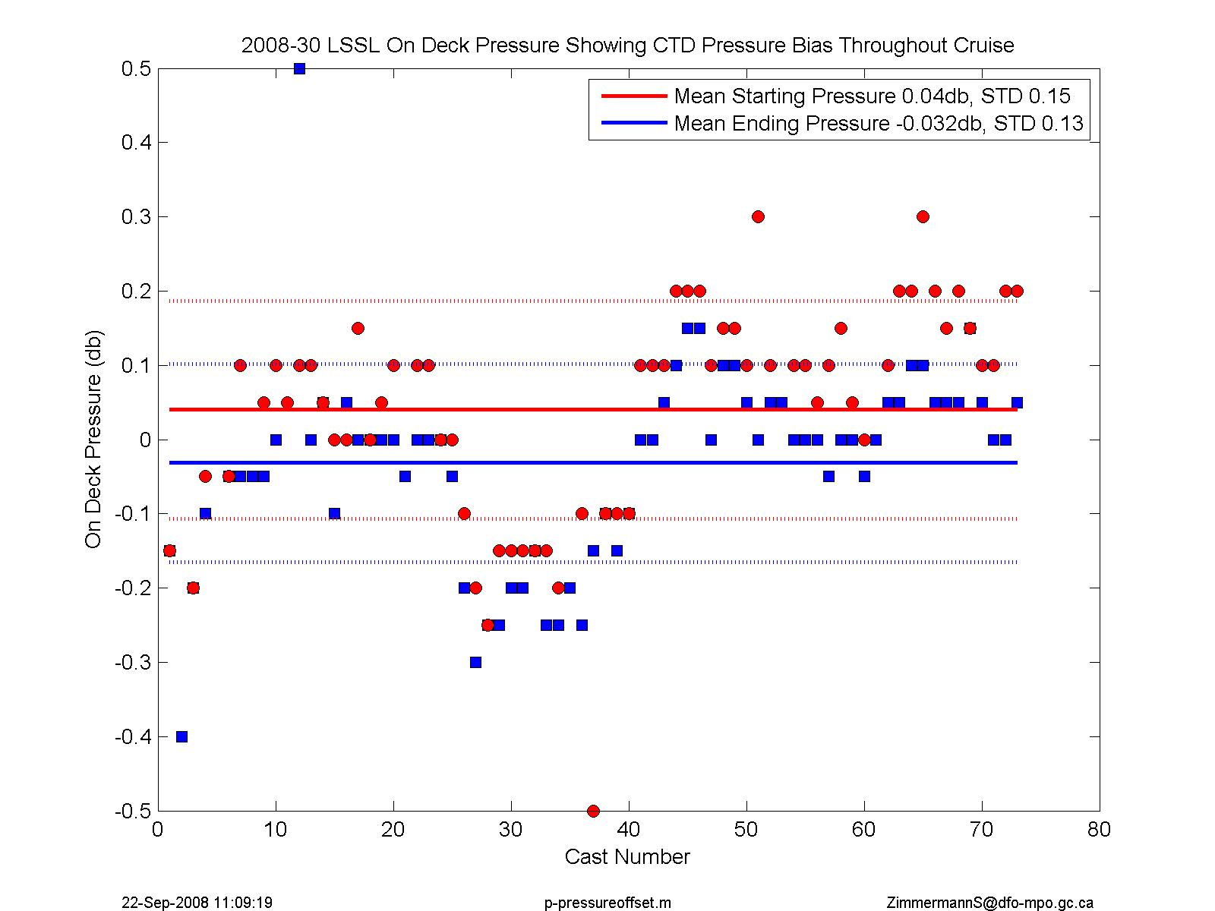

Figure . In-air pressure reading throughout the cruise after applying the correction of +0.9db pressure offset.

# CTD Temperature Calibration

Stated SBE911 Temperature Accuracy: 0.001degC

Results suggest this is appropriate for this data set. Dual sensor comparisons show the sensors are in agreement and have been stable throughout the cruise.

Laboratory calibrations and dual sensor comparisons show temperature has been stable through the cruise and no corrections are needed for the primary or secondary temperature, besides interpolation over spikes. Pre-cruise calibration coefficients are kept.

*Laboratory Calibration*

Apr09: The pre and post-cruise laboratory calibrations were performed by Seabird Inc. They show the sensors continue to have a very stable response with minimal drift. Over the twelve month period between pre and post-cruise calibrations, the primary and secondary sensors changed by less than +0.0004ºC over the full calibration range of interest (-1 to 30ºC). The pre-cruise calibrations are used for the temperature sensors.

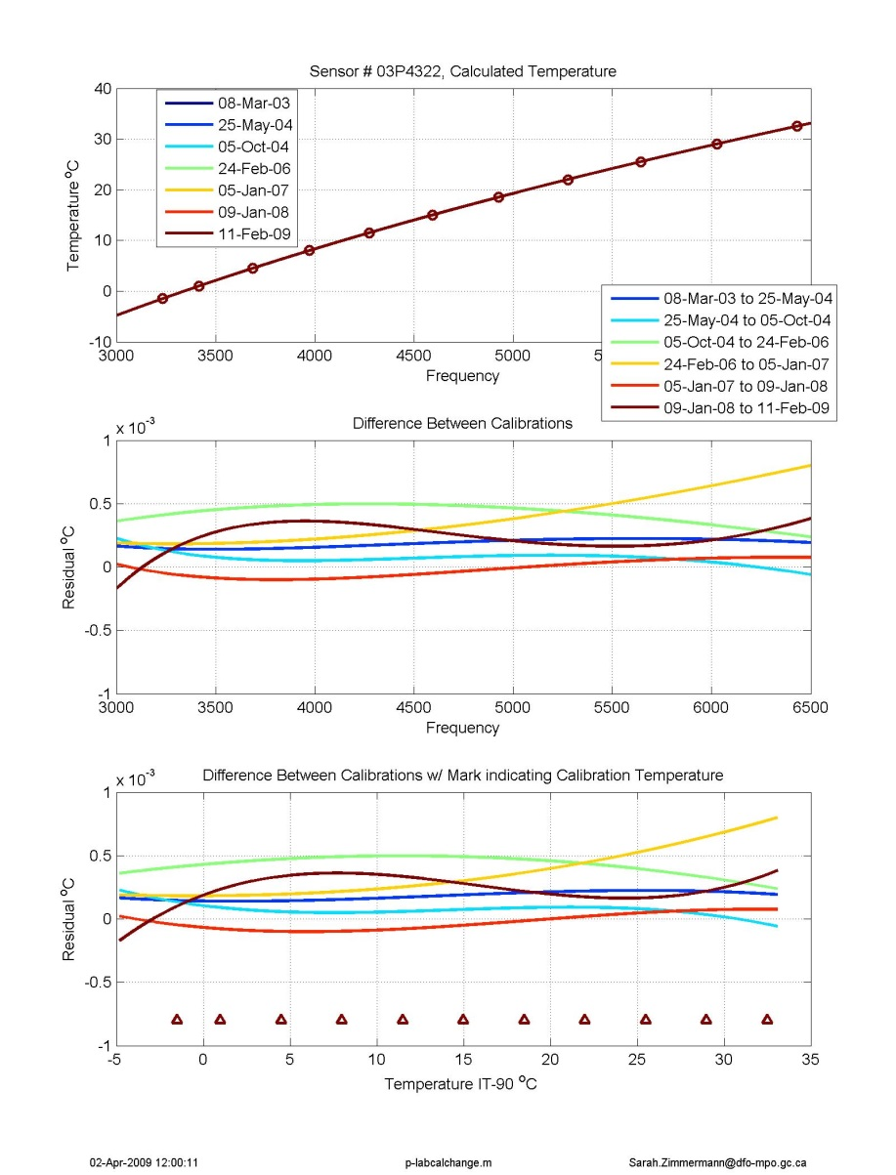

Figure . Lab calibration of primary temperature sensor # 4322. The brown shows the calibration change for this cruise.

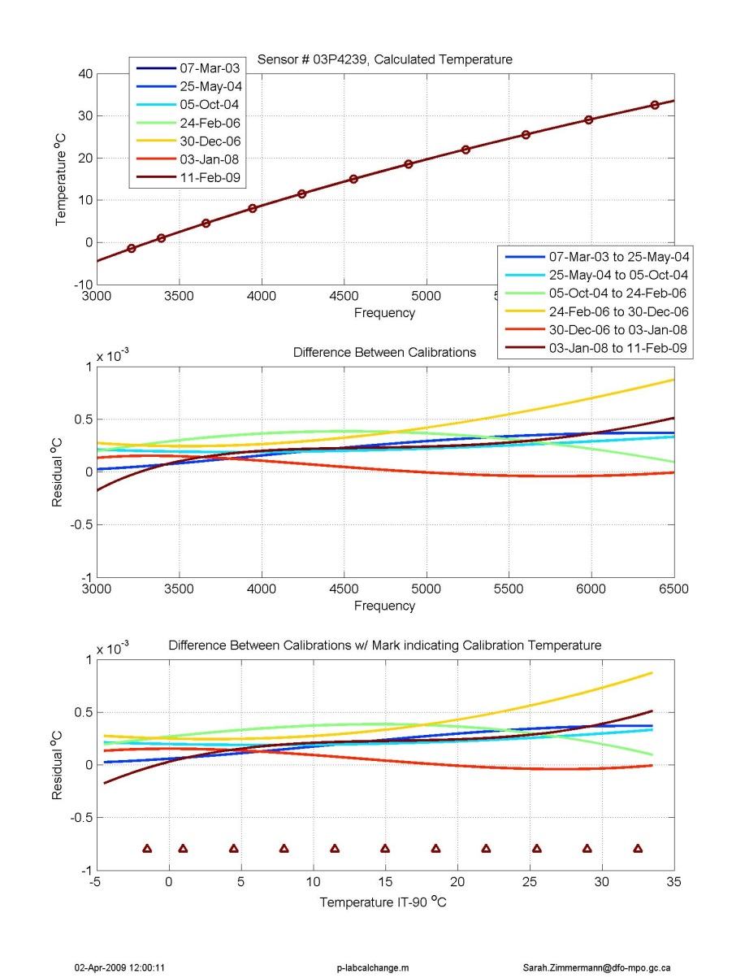

Figure . Lab calibration of secondary temperature sensor # 4239. The brown line shows the calibration change for this cruise.

*Dual Sensor Comparison*

Matlab file:

***p\_ctd\_delta\_sensors\_general.m*** plot the difference between the CTD’s dual sensors.

Comparisons between the primary and secondary sensors in the station data show very little difference in the deep water throughout the cruise (-0.0002°C offset below 1000db with standard deviation of 0.0001°C between casts where secondary is warmer than primary temperature). At warmer temperatures, between 300 and 500db, the difference is slightly larger, with a mean offset of -0.0005°C. In the coldest temperatures, between 0 and 200db, the secondary temperature tends to lag the primary as well as not reach the same extremes as the primary. This may be due to the configuration of the plumbing system.

Figures are at:

G:\Sorted\2008-30\DATA\ctd\CTDproc\DualSensors

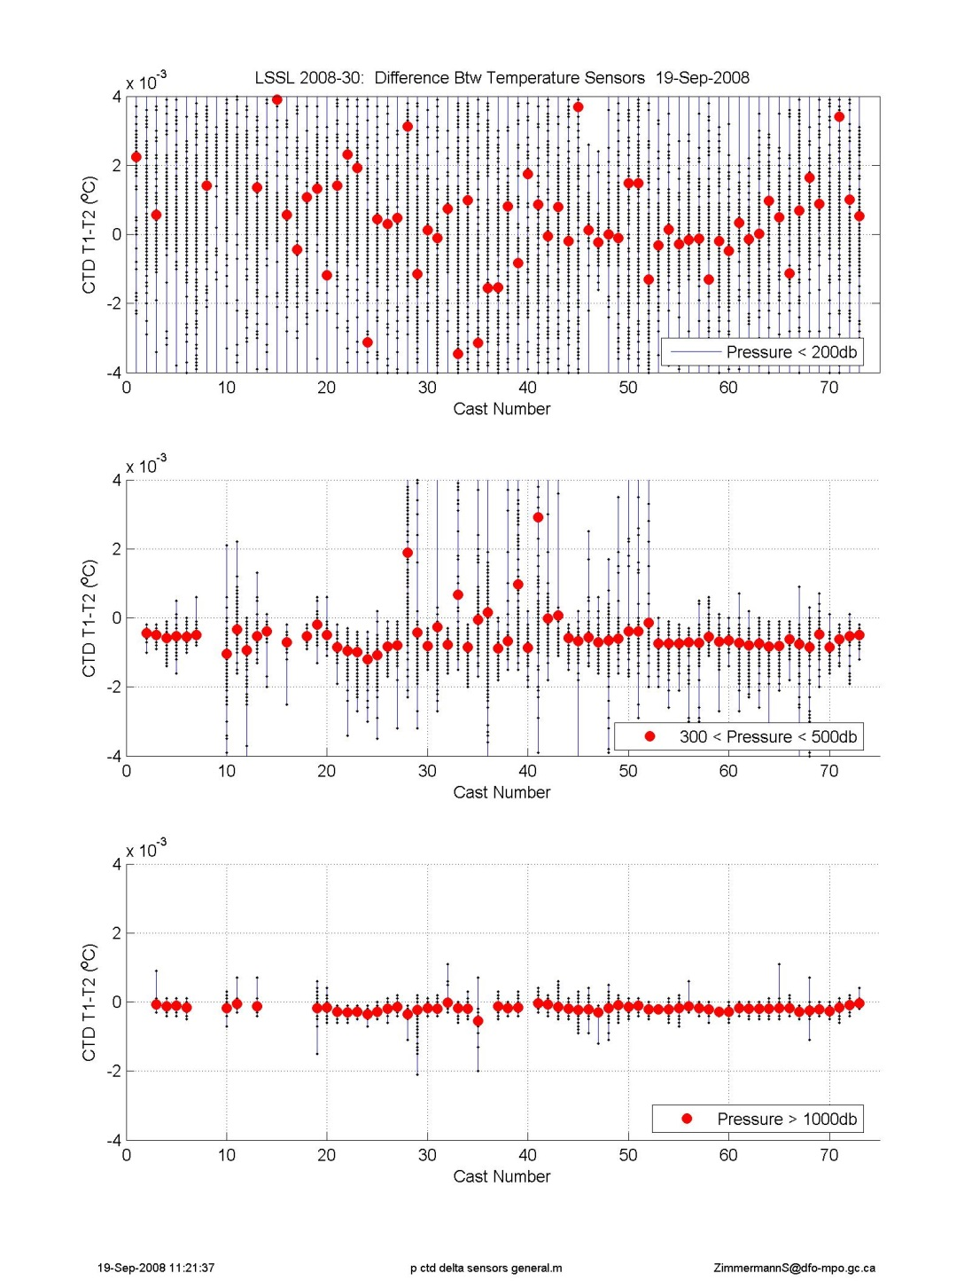

Figure . Difference between primary and secondary temperature per cast, divided into three depth regions.

# Water Samples for Calibration

A number of bottles were taken using the mechanical mixing method where the rosette was stopped for 30seconds, raised up 1m, down 2m, up 1m to its original starting place, another 30 seconds wait and then the Niskin was closed. This method is a substitute for the normal bottle flushing that occurs when a ship rocks in the open ocean during the standard 30second wait before a bottle closer. These ‘calibration’ bottles will be used in conjunction with the deep low gradient water for conductivity and oxygen calibration. Bottle closing method is indicated in the chemistry spreadsheet in a column titled ‘Trip Method’ where the options are: ‘UN’ for upcast with no stop; ‘US’ for upcast with 30second stop; and ‘USM’ for upcast with the mechanical mixing method.

# CTD Conductivity and Salinity Calibration

Conductivity was calibrated using lab calibrations, dual sensor comparisons and water samples. For both primary and secondary conductivity sensors, pre-cruise laboratory calibrations were used and were further adjusted after comparison to water samples. Water samples showed a drift in the CTD values over time therefore the CTD data were calibrated in three groups of casts.

Calibration applied using: ***cal\_salt\_200830.m, out\_finish\_data\_200830\_options\_v20170306.m (wsopt=4)***

|  |  |  |  |  |  |  |  |
| --- | --- | --- | --- | --- | --- | --- | --- |
| **Apply to Casts** | **Cast Groups for Fit Calculation** | **Primary (sn 2809)** | | | **Secondary (sn 2810)** | | |
|  |  | Offset | STD | Obs | Offset | STD | Obs |
| 1-43 | 10-44 | -0.0013 | 0.0010 | 85 of 112 | 0.0016 | 0.0005 | 72 of 112 |
| 44-53 | 44-53 | -0.0007 | 0.0008 | 41 of 65 | 0.0020\* | 0.0008 | 40 of 65 |
|  |  |  |  |  | However, +0.0018 was applied as it was a better match for the deep water | | |
| 54-73 | 53-73 | -0.0004 | 0.0006 | 65 of 89 | 0.0021 | 0.0006 | 65 of 89 |

Table . Comparison of final CTD salinity values and water wamples. Mean and STD of residuals (CTD-WS) for salinity. All QC flagged salinity samples removed.

|  |  |  |  |  |  |  |
| --- | --- | --- | --- | --- | --- | --- |
|  | **Primary** | **Primary** | **Primary** | **Secondary** | **Secondary** | **Secondary** |
| **Pressure Range (db)** | **STD** | **Mean**  **(CTD-WS)** | **Number of Observations** | **STD** | **Mean**  **(CTD-WS)** | **Number of Observations** |
| 0 to 300 | 0.3027 | -0.0633 | 681 | 0.3862 | -0.0630 | 681 |
| 300 to 5000 | 0.0029 | -0.0002 | 672 | 0.0025 | -0.0002 | 672 |
| 2000 to 5000 | 0.0014 | -0.0001 | 148 | 0.0013 | -0.0001 | 148 |
| Full | 0.2170 | -0.0320 | 1353 | 0.2757 | -0.0318 | 1353 |

Laboratory Results

Pre and post-cruise laboratory calibrations were performed by Seabird Inc. They show that the primary sensor has changed, while the secondary has remained fairly stable. Over the twelve month period between calibrations, the primary sensor, sn#2809 changed between +/- 0.002 mS/cm over the range of interest (19 to 32 mS/cm). Because the change is negative for values greater than 25mS/cm (generaly everything deeper than 100db), it means data (conductivity and salinity) calculated with the pre-cruise calibration after the sensor changed should be too high. The secondary sensor sn#2810 changed by less than 0.001 mS/cm over the same range.

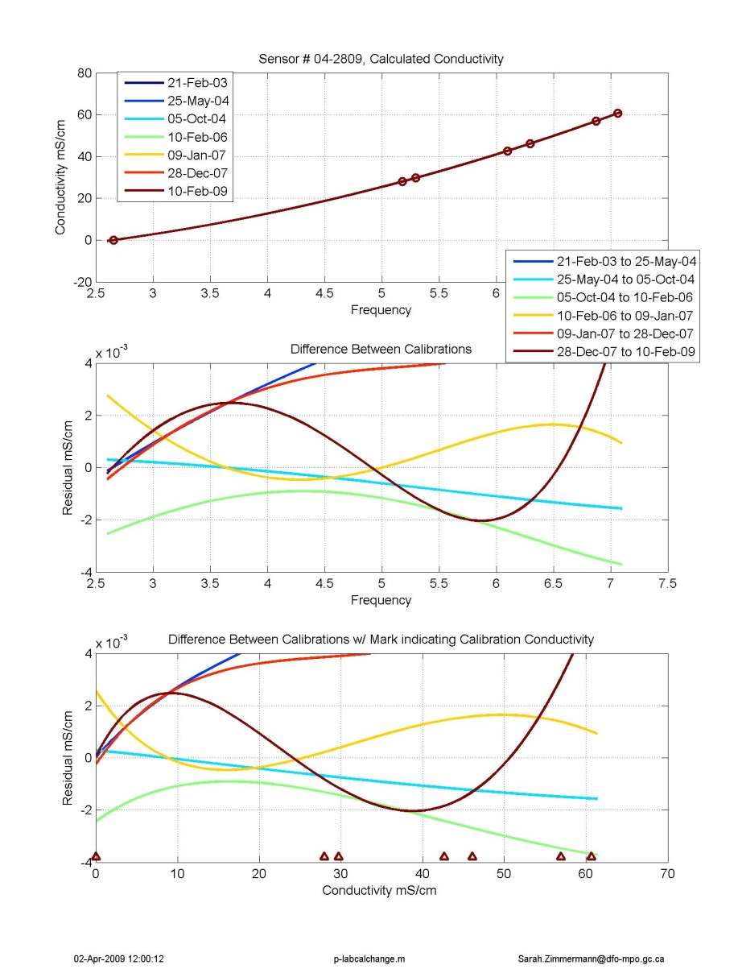

Figure . Lab calibration of primary conductivity # 2809.

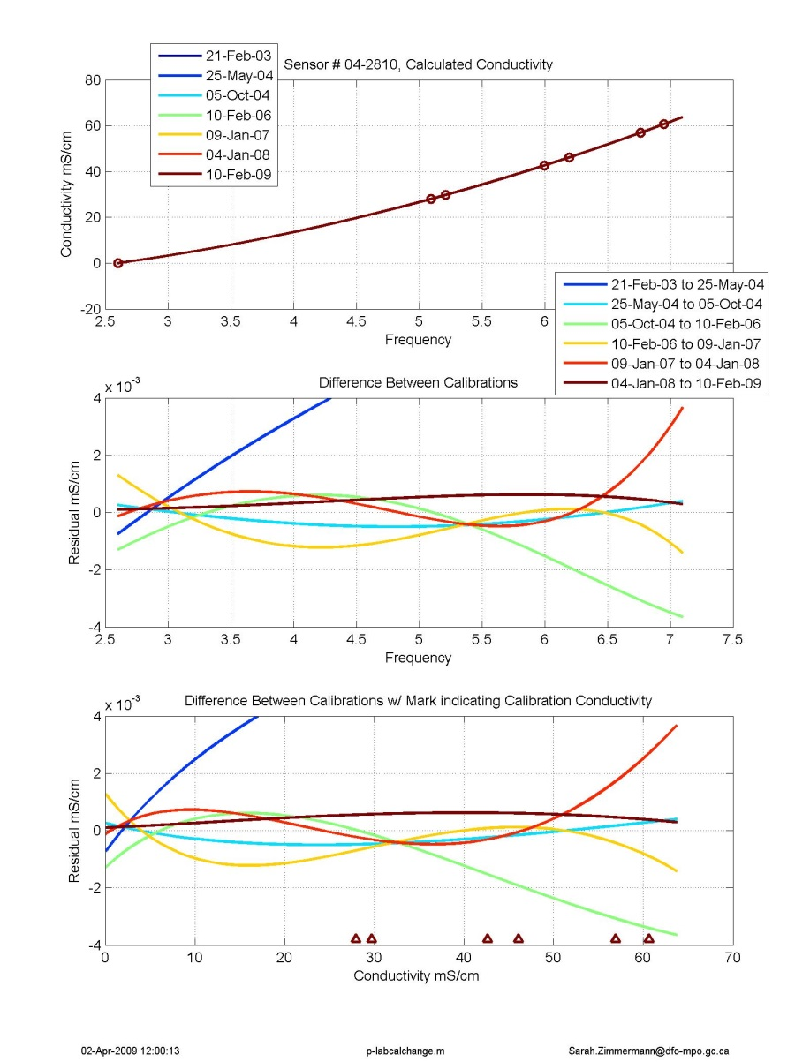

Figure . Lab calibration of secondary conductivity #2810

Dual Sensor Results

Comparisons between the primary and secondary sensors show an offset of approximately +0.001 mS/cm in upper waters (0 to 200dbar), +0.0023mS/cm in the mid-depths (300 to 500dbar) and +0.0022 mS/cm in the deep water (over 1000dbar). Primary conductivity is larger than the secondary conductivity. There is very little change during the cruise, maybe a drift of 0.0003 mS/Cm (where primary is decreasing or secondary is increasing).

In salinity, the difference in conductivity and small difference in temperature become differences of +0.001 in the shallow water , +0.0031 at mid-depths, and +0.0031in the deep water where, in all cases, primary salinity is larger than secondary salinity.

Figures are at:

G:\Sorted\2008-30\DATA\ctd\CTDproc\DualSensors

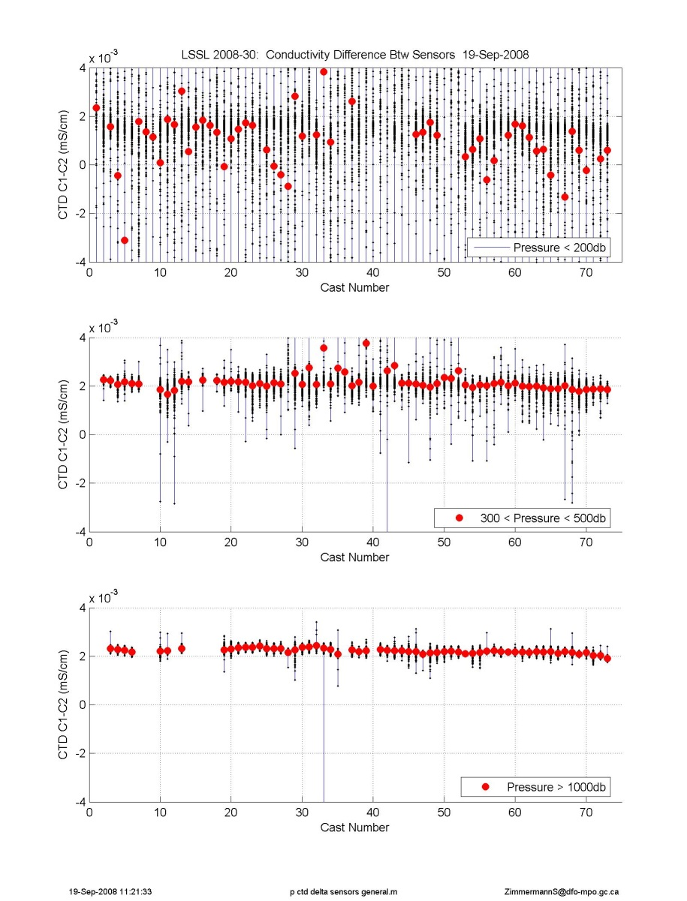

Figure . Difference between primary and secondary conductivity per cast, divided into three depth regions

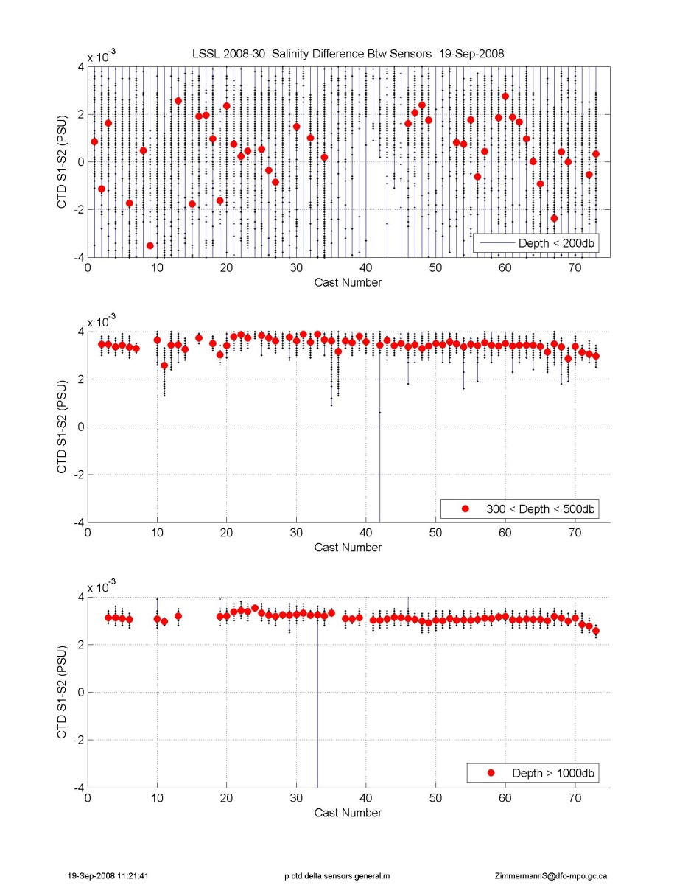

Figure . Difference between primary and secondary salinity per cast, divided into three depth regions

Water Sample Comparison

Bottle salts were collected through the cruise. Of the 73 casts, casts 1 to 70 were analysed on board. An iterative fitting routine was used to find the offset for the bottles closed using the mechanical mixing or below 2000db, using a standard deviation criteria of 2.5 to remove outliers

Predominately the samples were taken on the fly during the up-cast though there were samples taken using the mechanical mixing method in order to have good calibration points in the upper 1000m. For calibration, in addition to the samples collected using the mechanical mixing method, the samples from the deep water below 2000db, water that has very little vertical gradient in salinity (approximately less than 0.005PSU over 200m) were used.

The bottle and calibrated CTD comparisons show a slope or pressure dependence of 0.0005mS/cm difference between 700m and 1000m in both sensors. This was not corrected for.

All data fit as one group:

**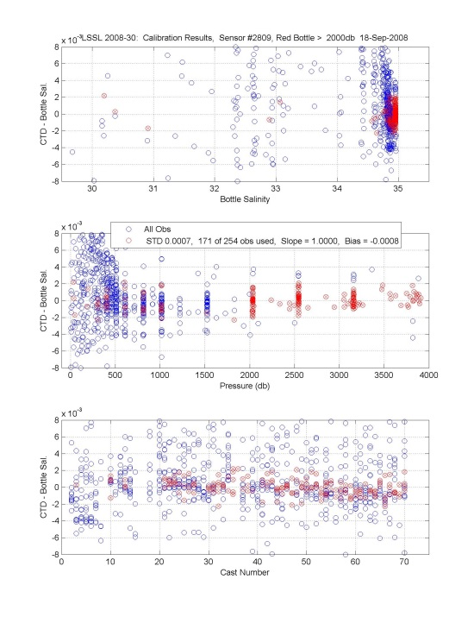**

Figure . Primary CTD calibrated salinity compared to Bottle Salts

**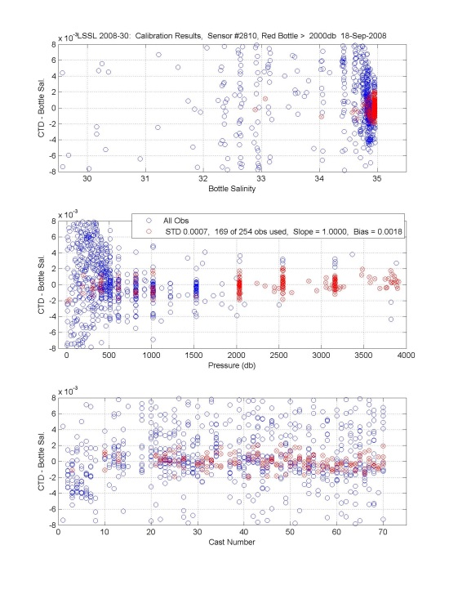**

Figure . Secondary CTD calibrated salinity compared to Bottle Salts

**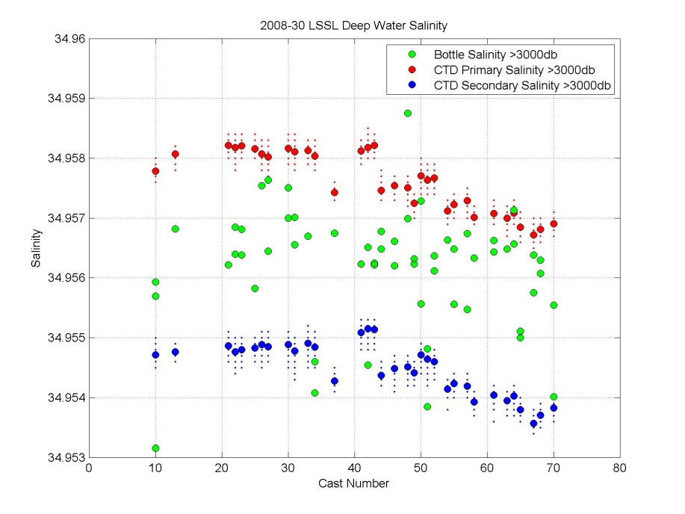**

Figure . Prior to CTD conductivity calibration. Plot shows curious drift in primary and secondary sensors, not reflected in bottle data.

A drift in the CTD values through the cruise was observed. The data were split into three groups and re-calibrated.

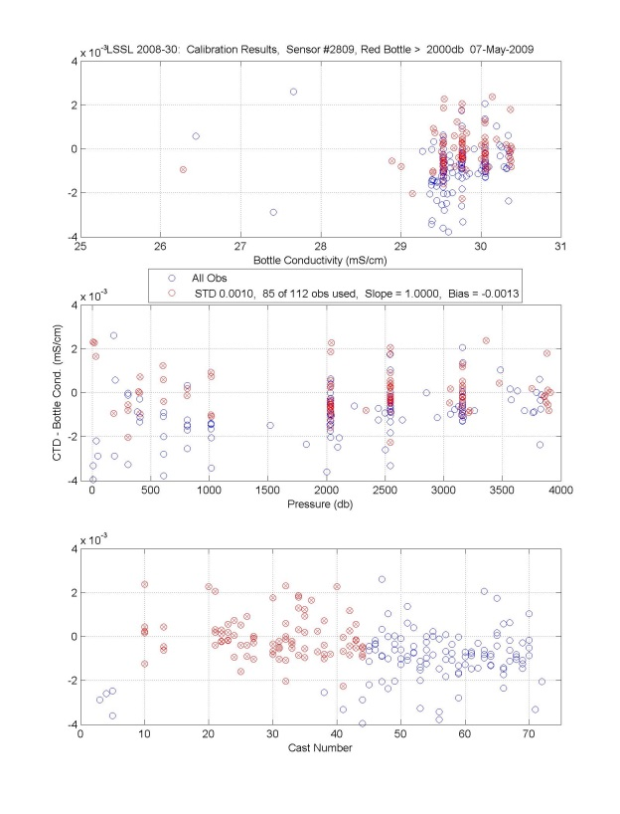

Figure . Casts 1 to 43. Primary CTD calibrated salinity compared to Bottle Salts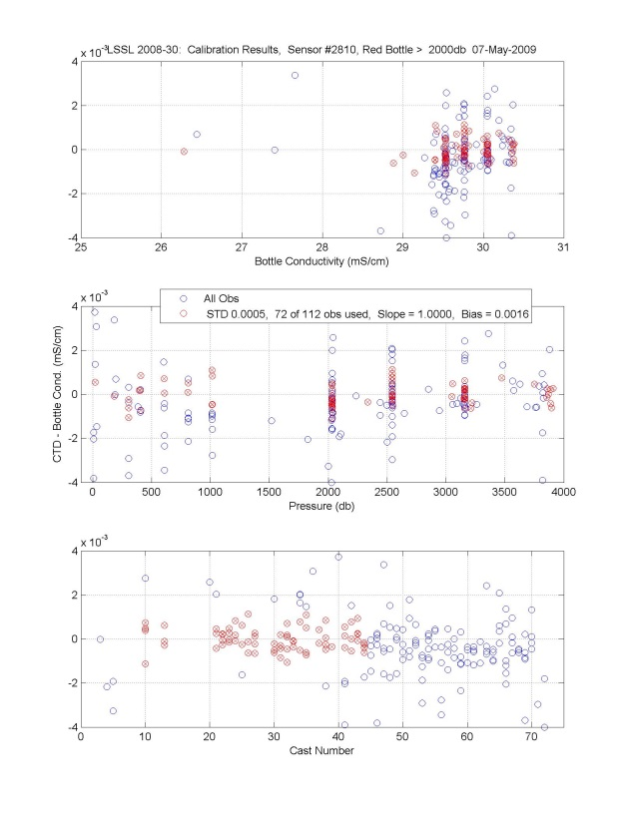

Figure . Casts 1 to 43. Secondary CTD calibrated salinity compared to Bottle Salts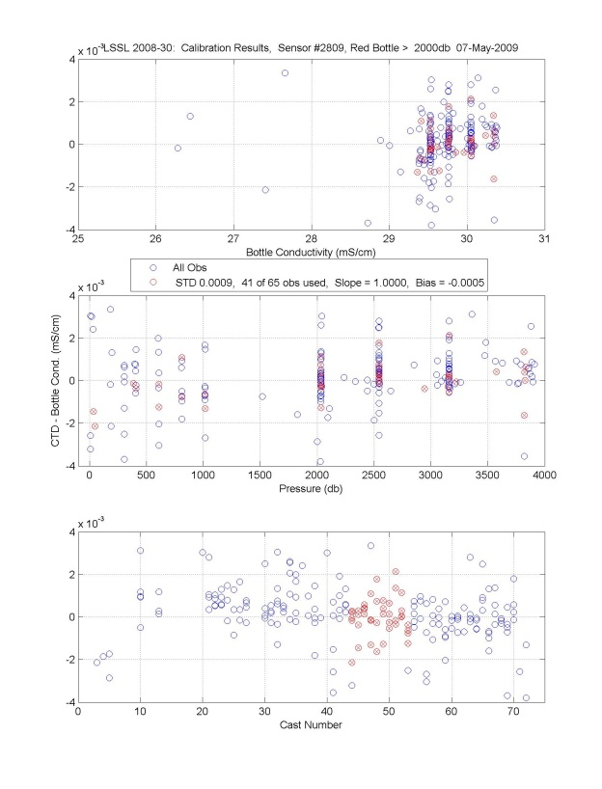Figure . Casts 44 to 53. Primary CTD

calibrated salinity compared to Bottle Salts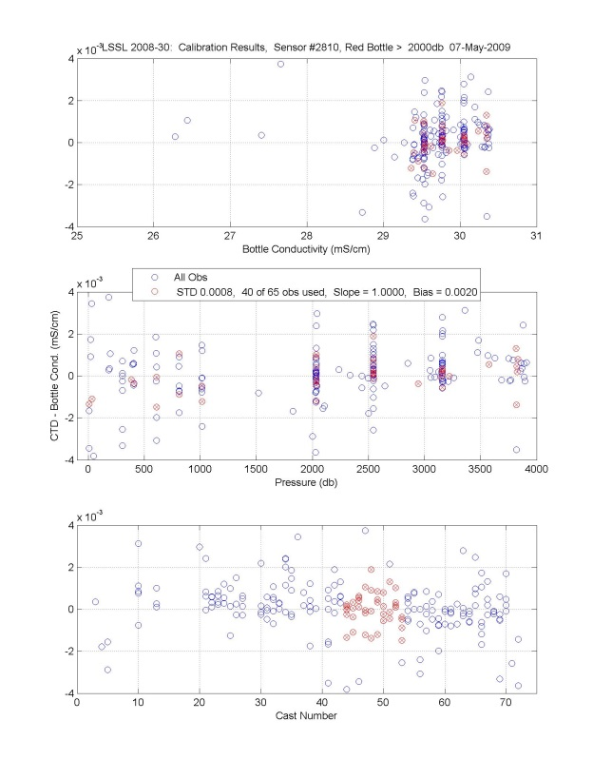Figure . Casts 44 to 53. Secondary CTD

calibrated salinity compared to Bottle Salts

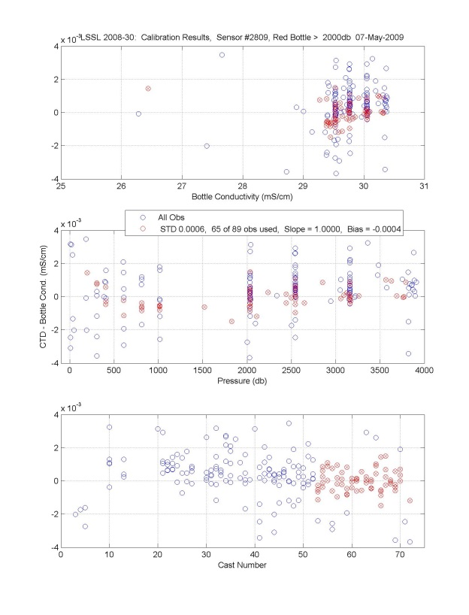Figure . Casts 54 to 73. Primary CTD calibrated salinity compare to

Bottle Salts.

calibrated salinity compared to Bottle Salts.

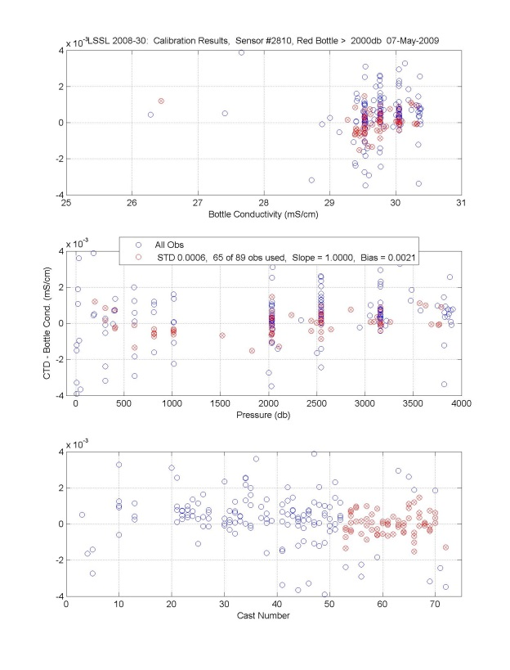Figure . Casts 54 to 73. Secondary CTD calibrated salinity compared to Bottle Salts.

Canada Basin Bottom Water Comparison

Bottles show bottom water salinity in 2008 is 34.9563 with a STD of 0.0008. This is on the fresh side of the mean values that range from 34.9563 to 34.9575.

Table . Deep Bottle Salinity Values (from values deeper than 3000db, and within 34.954 and 34.960) from chemistry files. See *compare\_salt.m*

|  |  |  |  |  |  |  |  |
| --- | --- | --- | --- | --- | --- | --- | --- |
| **Year** | **Cruise** | **Mean Bottle Salinity** | **STD Bottle Salinity** | **Number of Bottle**  **Observations** | **Mean CTD Salinity** | **STD CTD Salinity** | **Number of CTD**  **Observations** |
| 2002 | 2002-23 | 34.9573 | 0.0010 | 9 | 34.9577 | 0.0003 | 16 |
| 2002 | Mirai | 34.9576 | 0.0007 | 17 | 34.9587 | 0.0010 | 25 |
| 2003 | 2003-21 | 34.9564 | 0.0013 | 26 | 34.9571 | 0.0003 | 57 |
| 2004 | 2004-16 | 34.9574 | 0.0008 | 64 | 34.9573 | 0.0002 | 64 |
| 2004 | Mirai | 34.9576 | 0.0004 | 20 | Too high | na | na |
| 2005 | 2005-04 | 34.9563 | 0.0010 | 28 | 34.9568 | 0.0002 | 31 |
| 2005 | Oden | 34.9573 | 0.0012 | 29 | 34.9579 | 0.0004 | 31 |
| 2006 | 2006-18 | 34.9570 | 0.0013 | 33 | 34.9572 | 0.0002 | 40 |
| 2007 | 2007-20 | 34.9570 | 0.0010 | 56 | 34.9577 | 0.0003 | 68 |
| 2008 | 2008-30 | 34.9563 | 0.0009 | 58 |  |  |  |



# 

# CTD Oxygen

Performance

Oxygen Seabird SBE43 sensors had pumped flow and were installed in-line,

following the primary temperature and conductivity sensors. Due to problems with the oxygen sensors, three sensors were used during the cruise. Initially, intermittent drop outs and full scale voltage events appeared to be cable related but were later assessed to be associated with the sensors. Two sensors, including SN#1115 bought new in 2007 (and failed in 2007 & repaired prior to cruise) failed during the cruise.

Casts 1-5: SN 435

Casts 6-22: SN 1115

Casts 23-73: SN 398

(Note this differs from the CNV header, however the list above is correct)

Calibrated CTD oxygen compared to water sample oxygens has a standard deviation of 0.10ml/l over the full depth and 0.02ml/l for bottles deeper than 300m.

Note casts 9, 14 to 17 have no CTD oxygen due to failed sensor.

Calibration

The downcast oxygen data were calibrated to the upcast oxygen water samples, with consideration given to the sensor lag, hysteresis, and water sample quality. Coefficients were primarily found following the Seabird method (Application Note 64-2: http://www.seabird.com/application\_notes/AN64-2.htm). New sets of coefficients were determined for two of the six coefficients (voffset and soc) and applied together with the other post-cruise laboratory calibration coefficients.

Due to the slow response time of the oxygen sensor, prior to the calibration the oxygen voltage was advanced 8 seconds using Seabird "align". The lag of the oxygen voltage was determined by comparing similar oxygen voltage features in the downcast and upcast.

The CTD upcast data were avoided due to the large hysteresis resulting from deep casts at cold temperatures. We have not been using the Seabird depth correction parameters (pressure and temperature dependent lag or hysteresis correction) as the large variable lag applied to the local oxygen gradient creates an artificially large signal in the cold deep water.

The calibration is made using downcast oxygen voltage with upcast temperature and salinity. The downcast oxygen voltage is found by using the bottle trip information, matching the downcast on density for 0 to 600db and pressure below 600db. There will be some error due to the real difference between down and upcast profiles.

The pre-cruise laboratory calibration terms were used, but new SOC and Voffset terms were found using the water sample data following Seabird Application

Note 64 – v2Jun2012 (<http://www.seabird.com/document/an64-2-sbe-43-dissolved-oxygen-sensor-calibration-and-data-corrections> )

**Sensor #435**

**Applied coefficients:**

|  |  |  |  |  |  |  |  |  |  |  |
| --- | --- | --- | --- | --- | --- | --- | --- | --- | --- | --- |
| Casts | d0 | d1 | d2 | a | B | c | e | Soc | Voffset | Lag |
| Pre-Cruise | 1 | 0.000193 | -0.04648 | -1.39E-03 | 1.90E-04 | -4.10E-06 | 0.036 | 0.4171 | -0.4924 | 0 |
| 1-2 |  |  |  |  |  |  |  | 0.4175 | -0.4421 |  |
| 3-5 |  |  |  |  |  |  |  | 0.4040 | -0.3841 |  |

**Sensor #1115**

**Applied coefficients:**

|  |  |  |  |  |  |  |  |  |  |  |
| --- | --- | --- | --- | --- | --- | --- | --- | --- | --- | --- |
| Casts | d0 | d1 | d2 | a | b | c | e | Soc | Voffset | Lag |
| Pre-Cruise | 1 | 0.000193 | -0.04648 | -2.6319E-03 | 1.8739E-04 | -3.6232E-06 | 0.036 | 0.4105 | -0.5056 | 0 |
| 6-19 |  |  |  |  |  |  |  | 0.4118 | -0.4569 |  |
| 20-22 |  |  |  |  |  |  |  | 0.4102 | -0.3950 |  |

**Sensor #398**

**Applied coefficients:**

|  |  |  |  |  |  |  |  |  |  |  |
| --- | --- | --- | --- | --- | --- | --- | --- | --- | --- | --- |
| Casts | d0 | d1 | d2 | a | b | c | e | Soc | Voffset | Lag |
| Pre-Cruise | 1 | 0.000193 | -0.04648 | -1.7301E-03 | 2.2378E-04 | -5.0321E-06 | 0.036 | 0.4120 | -0.5128 | 0 |
| 23-27 |  |  |  |  |  |  |  | 0.4167 | -0.4111 |  |
| 28-38 |  |  |  |  |  |  |  | 0.4223 | -0.4286 |  |
| 39-47 |  |  |  |  |  |  |  | 0.4240 | -0.4338 |  |
| 48-61 |  |  |  |  |  |  |  | 0.4263 | -0.4394 |  |
| 62-73 |  |  |  |  |  |  |  | 0.4234 | -0.4257 |  |

Following this, a correction for the remaining pressure dependent shape in the residuals was applied for each calibration group. A correction profile was made by fitting to the residuals in a particular pressure range and interpolating between ranges to make a smooth correction profile. This correction profile was subtracted from each oxygen profile including the CTD data in the chemistry file.

Casts 1 to 22’s pressure dependent correction is less than +/- 0.1 ml/l except for

Cast 4 and 5 where sensor SN435 was failing.

Cast 4 correction ranged from -0.4 to +0.1ml/l

Cast 5 correction ranged from -0.7 to +0.3ml/l

Casts 9, 14 to 17 needed no correction.

Casts 23 to 73 pressure dependent correction ranged fromr -0.1ml/l at 200m to +0.04ml/l at 1500m. Further corrections ranging from -0.03 to +0.02ml/l for station subgroups.

Table . JOIS program: Mean and STD of residuals (CTD-WS) for oxygen. All flagged oxygen samples removed.

|  |  |  |  |
| --- | --- | --- | --- |
| **Pressure Range (db)** | **STD** | **Mean**  **(CTD-WS)** | **Number of Observations** |
| 0 to 300 | 0.134 | -0.024 | 607 |
| 300 to 4000 | 0.018 | 0.000 | 615 |
| Full | 0.096 | -0.012 | 1222 |

Repeat station

Station CABOS was sampled at the start and end of cruise (Cast #3 and #73). In the deeper waters (500 to 1100dbar) the difference is minimal ~.01ml/l where Cast 73 has lower oxygen than Cast 3 however they have the same value at the bottom. Water samples were only collected at Cast 3 and agree with both casts.

Canada Basin Bottom Water Comparison

The calibrated oxygen are a bit higher than the historic bottom water values of 6.55 ml/l, the 2003 to 2015 average of the JOIS program annual mean of the deep basin stations. Water samples and the fitted CTD oxygen range from 6.56 to 6.59 ml/l.

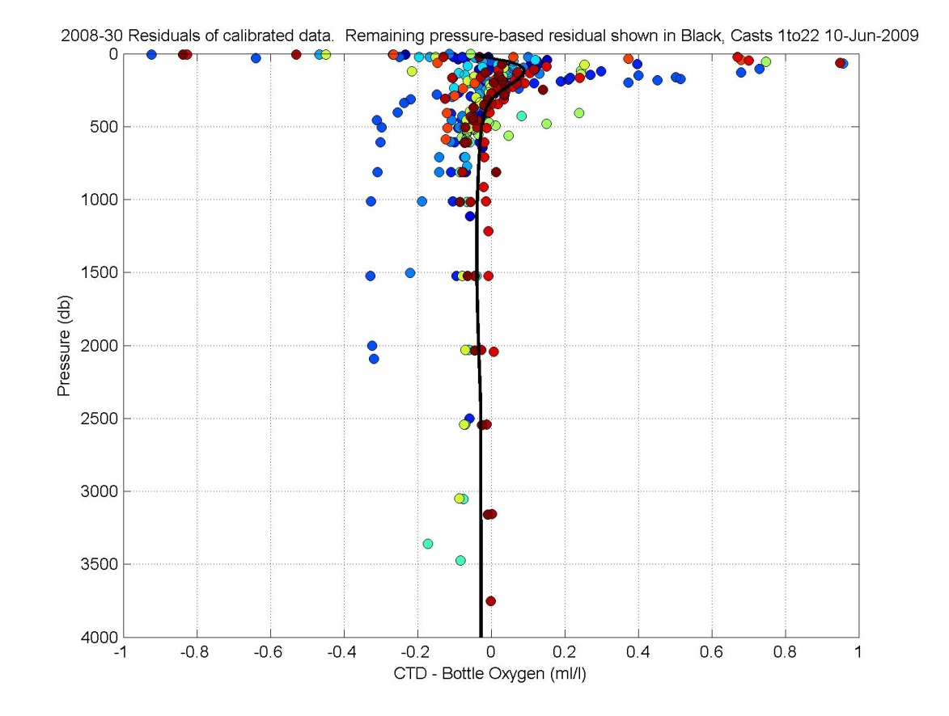

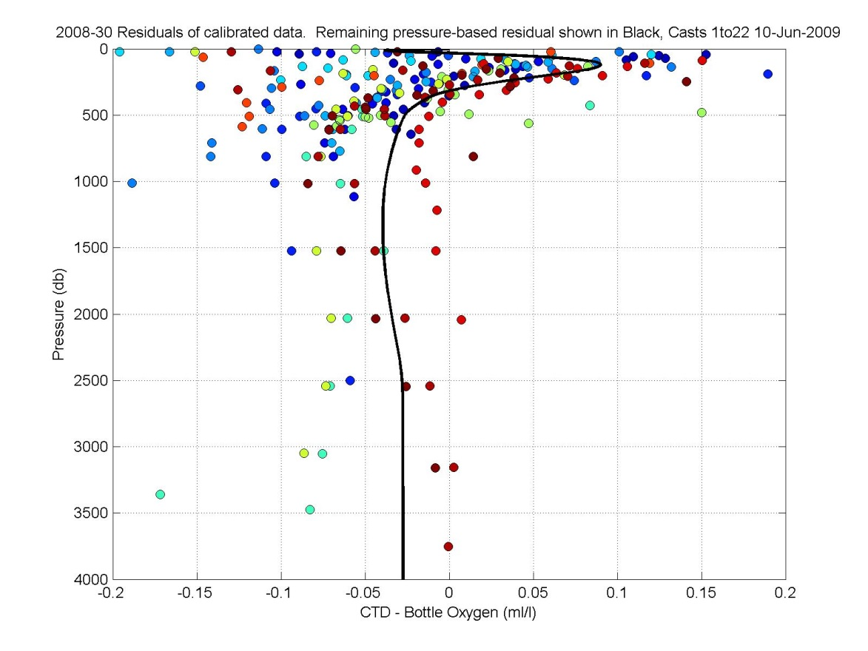

Figure . Casts 1 to 22 Residuals after calibration but before correction for pressure dependent shape. Top plot has larger axis than bottom plot.

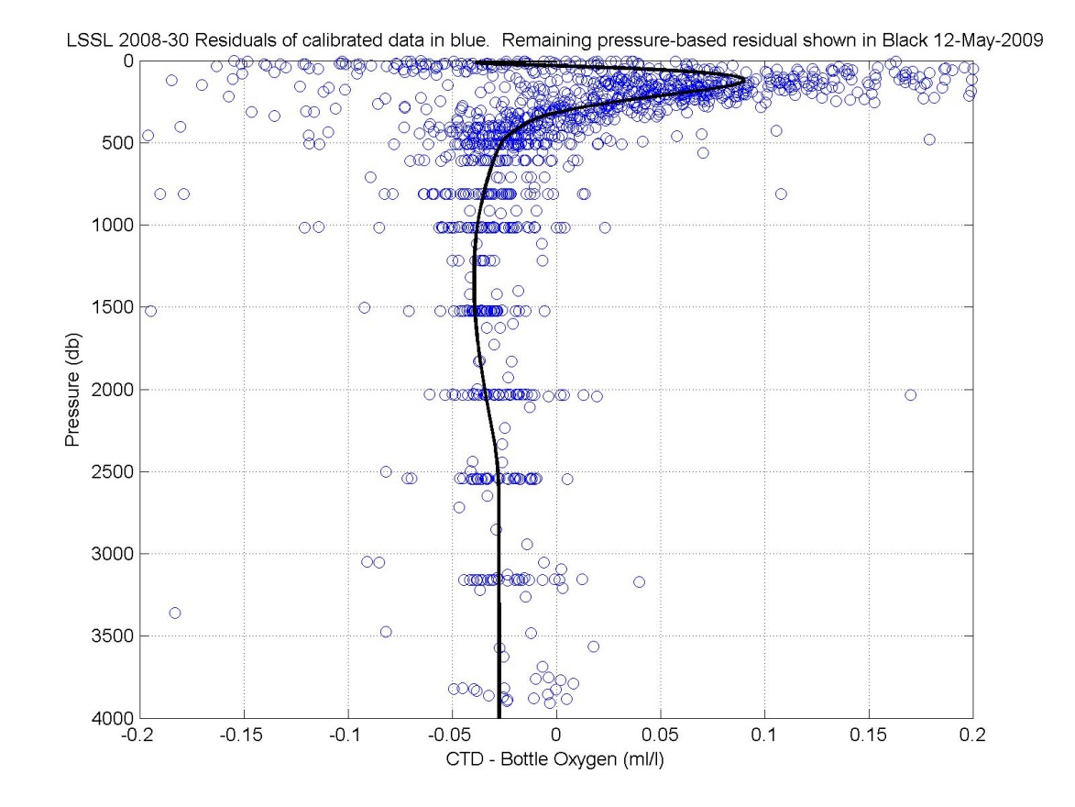

Figure .Casts 23 to 73) Residuals after calibration but before correction for pressure dependent shape. 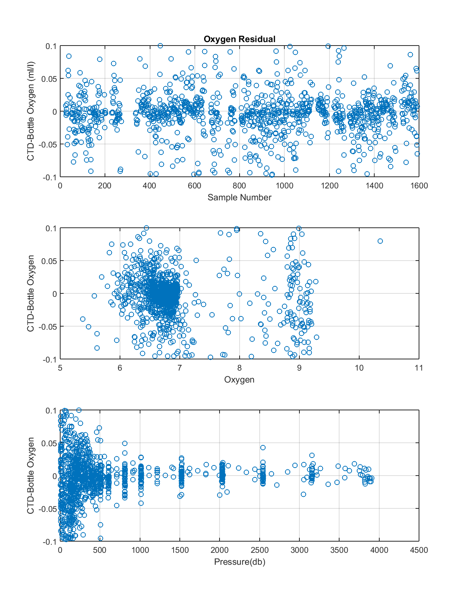

Figure . Mean and STD of Oxygen Residuals (CTD-WS) in ml/l for JOIS program. All flagged oxygen samples removed.

# CTD Transmission

Performance

Two WETLabs CSTAR DR transmissometers, each with an optical path length of 0.25 m, were used, individually and at times simultaneously.

Cast 1, both transmissometers, s/n662 and s/n 993 were installed.

Cast 6, transmissometer s/n993 was removed to make room for a second oxygen sensor.

Cast 35, the second transmissometer was added back on but onto different auxiliary channel.

Sensor 662 appeared to have jumps in values from one group of casts to the next of 0.2 [%]. Sensor 993 had a drift of -0.3 [%] over 38 stations.

In summary:

Casts 1-5, Two Transmissometers, s/n 662 is primary, s/n 993 is secondary

Casts 6-34, One Transmissometer, s/n 662 is primary and column of zeros for secondary

Casts 35-73, Two Transmissometers, s/n 993 is now primary and 662 is secondary

Calibration

The data of the transmissometers were not processed except with nominal coefficients to compute percent transmission.

The windows were wiped with tissue soaked in deionized water prior to each cast as part of the CTD launching routine.

The nominal coefficients used for processing were:

Serial number : CST-662DR; Calibrated on : 26-May-2008

M\* : 18.9650; B\* : -1.0870; Path length : 0.250 m

Note: parameters should have been

M: 19.182, B: -1.099 (so given values are ~1% low)

Serial number : CST-993DR; Calibrated on : 09-Jun-2008

M\* : 19.5125; B\* : -1.1200; Path length : 0.250 m

Note: parameters should have been

M: 19.796, B: -1.136 (so given values are ~1% low)

\*M and B as defined in Seabird Application Note 7 (Seabird, 2008).

Units are either in [%] with pathlength 0.25 m or have been standardized to [%/m] where pathlength 1 m, such that the beam attenuation coefficient remains the same.

G:\Sorted\2008-30\DATA\ctd\CTDproc\Trans-662.tif

Figure . Transmissivity [%], Casts 1 to 34, s/n 662.

G:\Sorted\2008-30\DATA\ctd\CTDproc\Trans-993.tif

Figure . Transmissivity [%], Casts 35 to 73, s/n 993.

G:\Sorted\2008-30\DATA\ctd\CTDproc\Trans-All.tif

Figure . Transmissivity [%], all casts.

# CTD Fluorescence

Performance

Water was pumped past the Seapoint chl-a fluorometer, after passing through the secondary temperature and conductivity sensors to improve the consistency of the reading. The covered housing on the fluorometer prevented accessibility for cleaning during the cruise. A 30x gain cable was used with the fluorometer such that the 0-5 V fluorometer output is linearly converted to 0 - 5 mg/m³. The Seapoint fluorometer minimum detection level is 0.02 mg/m³. Note the fluorometer measures both chlorophyll and phaeopigment.

Calibration

Calibration with bottle data performed using bottle chlorophyll values between 0.025 and 0.6 mg/m3. The number of observations used were 121 out of 177 with a standard deviation of 0.01 in the residuals.

Alignment of -3 seconds used

Coefficients used:  Slope:  1.3324, Bias -0.0174

G:\Sorted\2008-30\DATA\ctd\CTDproc\Calibration_Fluorometer\Range p025 to p6 w 3sec lag\2008-30_All_ctd_cal_fig_5.tif

Figure . CTD Fluorometer calibration.

G:\Sorted\2008-30\DATA\ctd\CTDproc\Calibration_Fluorometer\Range p025 to p6 w 3sec lag\2008-30_All_ctd_cal_fig_3.tif

Figure . CTD Fluorometer calibration results.

G:\Sorted\2008-30\DATA\ctd\CTDproc\Calibration_Fluorometer\Range p025 to p6 w 3sec lag\Profile_1.tif

Figure . Calibrated CTD fluorometer with water sample data.

# CTD CDOM Fluorescence

Performance

This new sensor, WETLabs FLCDRTD s/n1076, which optically measures Colored Dissolved Organic Material was used on all casts. It was calibrated 11 Jun 2006 however only voltage was reported. CDOM water samples will be used to calibrate the voltage by Celine Gueguen, Trent University.

# Data Spike Removal

Data spikes were found in primary temperature and primary conductivity using the density inversion criteria listed below. Linear interpolations were performed on both primary temperature and conductivity if a spike was found in either property. Calculated variables including salinity were re-calculated following the interpolations. Interpolations were also performed for spikes found in oxygen data. All interpolations spanned less than 10 dbar.

Criteria for temperature and salinity spike identification:

0 to 200 m, density inversions over 0.004 kg/m³/m

200 to 600 m, density inversions over 0.001 kg/m³/m

600 m and deeper, density inversions over 0.0005 kg/m³/m

# Determination of CTD Data at Bottle Depths

Because the Niskin bottles were closed on-the-fly, salinity comparisons between water samples and CTD in the upper 300 m were used to determine which CTD data to match with the water samples. Due to bottle flushing lags, the water in the bottles comes from slightly deeper than the depth of the CTD measurement. By applying a standard offset to the CTD data, the data were matched to the water collected in the Niskin.

The appropriate lag was found by comparing 0.2 second averaged CTD data (after applying conductivity calibration) to the bottle data. The comparisons were restricted to the upper 300 m where the vertical salinity gradient is large. Between 100 and 200 db, the vertical salinity gradient is 0.01 to 0.02 PSU/dbar and wire-speeds of 0.5m/sec created temporal salinity gradients of 0.005 to 0.01- PSU/sec. CTD salinities from 0 to 10 seconds prior to bottle closure were compared with the bottle salinities. Casts where the CTD rosette was stopped were excluded.

Using a STD of 2.5 to remove outliers, the bottle and CTD salinities had the smallest mean difference at -1.2 seconds (meaning the CTD data from 1.2 seconds before bottle closure).

There is a skew to the outliers, where bottle salinities tend to be higher than the CTD salinity, indicating bottles are not uniformly flushed and outliers are biased towards water from greater depths. It should be noted that the alternative, stopping the package for a bottle sample, also results in a bias due to the lack of normal ship-rock in ice covered waters that would mechanically flush the bottles. Closing on-the-fly is thought to reduce the size of the bias and produce a more repeatable response than stopping the package for bottle closures.

Table . Results of select CTD time offsets. Calibrated CTD and WS salinities were compared for data within 2.5 STD and 0 to 300 db.

|  |  |  |
| --- | --- | --- |
| **638 observations total** | | |
|  | -0.2 Seconds | Mean = 0.0041 PSU, STD = 0.0097 PSU, 342 obs |
|  | -1.2 Seconds | Mean = -2.5e-5 PSU, STD = 0.0118 PSU, 385 obs |
|  | -2.2 Seconds | Mean = -0.0049 PSU, STD = 0.0157 PSU, 419 obs |
|  | -3.2 Seconds | Mean = -0.0096 PSU, STD = 0.0165 PSU, 404 obs |
|  |  |  |

**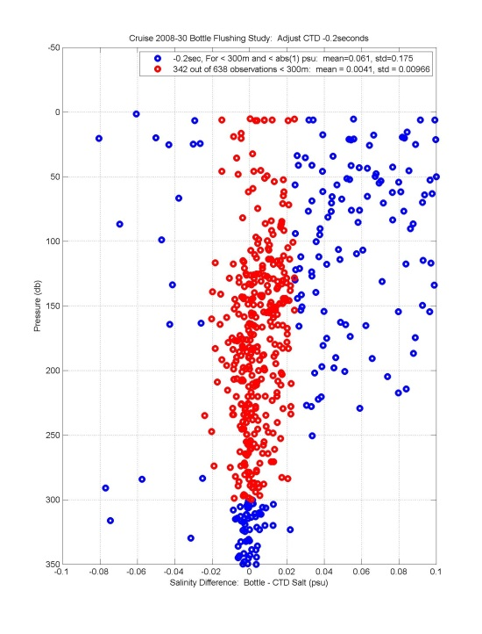 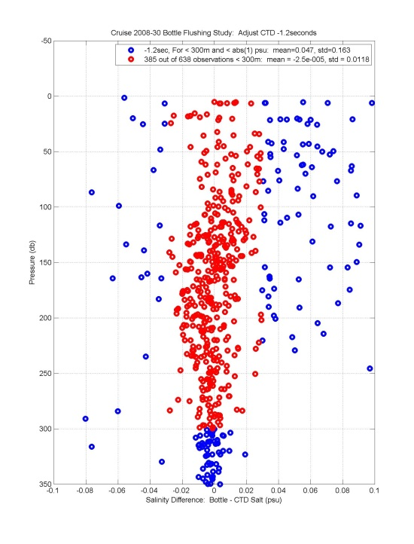**

**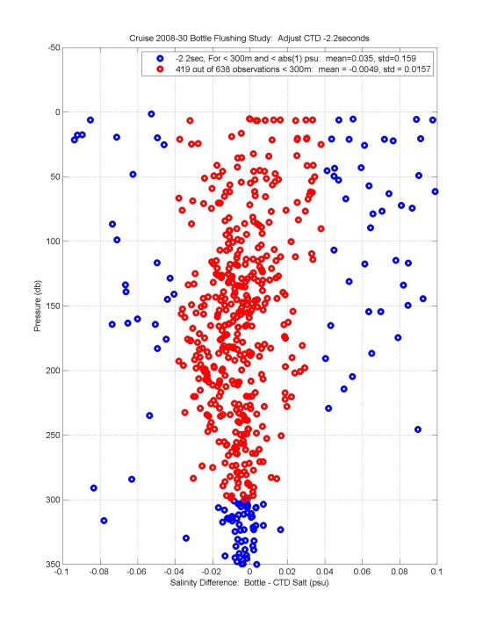 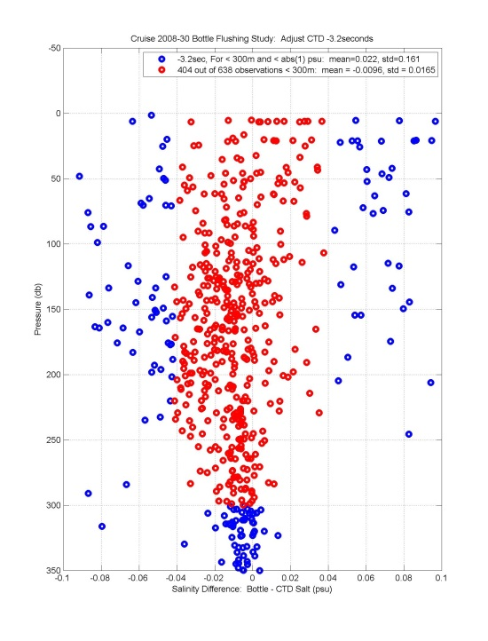**

Figure . Salinity differences after applying a -0.2, -1.2, -2.2 and -3.2 second lag to the CTD data. A lag of -1.2sec was used to process the data.

# CTD File Preparation

File Preparation

The CTD data for down and upcasts are provided in 1-db averaged files (\*.cnv), in Seabird’s text format with one file per cast and separate files for down and up direction. The files contain both processed and unprocessed variables, described below. **The downcast files are the primary data set however the upcast files are provided because of their usefulness for confirming unusual features seen in the downcast.**

Header Processing Notes for Archived Data

CTD Pressure: Lab calibration was adjusted by applying +0.9dbar offset to the bias based on in-air surface readings of the CTD.

CTD Temperature: Pre-cruise lab calibration was used after comparisons with dual sensor and post-cruise calibration information.

CTD Conductivity: Pre-cruise lab calibration adjusted after comparisons with dual sensor, post-cruise calibrations and water sample data. For casts 1 to 43, primary conductivity received offset of -0.0013 mS/cm. For casts 44 to 53, primary was changed by -0.0007 mS/cm. For casts 54 to 73, primary was changed by -0.0004 mS/cm.

CTD Oxygen: Oxygen data are from three SeaBird SBE43 sensors which were installed for casts 1 to 5, 6 to 22 and 23 to 73 respectively. They were installed with pumped flow in-line after the primary temperature and conductivity sensors. A lag of -8 seconds was applied to oxygen voltage in the Seabird processing step Align. Downcast CTD oxygen voltage and upcast temperature and salinity were used to calibrate CTD to water sample oxygen (upcast). The 73 casts required 12 calibration groups. Fitting method followed Seabirds Application Note 64-2 (“SBE 43 Dissolved Oxygen Sensor Calibration and Data Corrections using Winkler Titrations”). A remaining pressure dependent shape in the residual between water sample and CTD oxygen was removed by subtracting a mean curve.  Parts of the mean curve were found by fitting sections of data from discreet pressure ranges.  The parts were then stitched together via spline interpolation to create a full profile mean curve.

CTD Fluorometer: Fluorometer data are from a Seapoint sensor with pumped flow in-line after the secondary temperature and conductivity sensors. Calibration with bottle data performed using bottle chlorophyll values between 0.025 and 0.60 mg/m3. The number of observations used were 121 out of 177 with a standard deviation of 0.01 in the residuals. Coefficients used: Slope: 1.3324, Bias -0.0174. Alignment of -3 seconds was used.

Transmissometer data are unprocessed, using calibration from 26 May 2008 (s/n 662) and 9 Jun 2008 (s/n993).

CTD CDOM Fluorometer data are unprocessed and given as raw voltage.

Altimeter data are unprocessed, using calibration from Mar 2005.

# Bottle File Preparation

Chemistry and CTD Data Assembly

CTD and water sample data were initially combined and posted in a spreadsheet where all data associated with a sample number, consecutive for each niskin and cast were given per row. When two or three properties per sample showed questionable or bad data the sample would be further examined to determine if there was a mistrip or bottle flushing problem. Typically if appeared water in the Niskin was from more than 10m away from intended depth, the Niskin would be flagged bad.

For the IOS Archives, the data have been separated into individual station files.

# Appendix:

## LIST OF INTERPOLATIONS

Table . List of Interpolations.

List of presure values to be interpolated over

Property Key:

(1) Temperature

(2) Conductivity

(3) Temperature and Conductivity

(4) Oxygen

(5) Transmission

(6) Fluoresence

%if starting pressure is less than the first pressure record,

%then replicate from the ending pressure to the first pressure.

%if the ending pressure is deeper than the bottom pressure,

%then replicate the value at the starting pressure to the bottom...

%or if starting and ending pressure are the same

%then start with the record above the listed start.

%otherwise linear interp as usual

Updates:

2009 June 23 - Found spike in final(!) data, Cast 42.

The interpolation has been added below although the fix applied was to

replace primary conductivity and salinity with secondary value.

Station Start (db) End(db) Property

\*\*\*\*\*\*\* \*\*\*\*\*\*\*\*\*\* \*\*\*\*\*\*\*\* \*\*\*\*\*\*\*\*

1 2 4 3

1 6 8 3

1 77 79 3 %replace 78 with 77 for bottom of cast

3 1 3 3

6 611 613 3

7 8 10 3

7 12 14 3

8 4 6 3

8 233 234 3

10 1 3 3

10 3 5 3

10 80 82 3

11 0 2 3 %replace all with 2

11 1014 1016 3 %replace 1015 with 1014

12 1 4 3

14 0 3 3 %replace all with 3

15 2 5 3

16 1 5 3

17 25 27 3

18 0 3 3 %replace all with 3

19 0 3 3 %replace all with 3

20 8 10 3

25 9 11 3

29 21 23 3

29 316 318 3

29 1364 1367 3

31 1 8 3

31 8 11 3

32 8 10 3

33 1833 1835 3

34 4 8 3

35 5 12 3

36 3 5 3

36 9 11 3

36 105 107 3

36 449 452 3

37 12 14 3

38 3 9 3

40 1 4 3

40 7 10 3

40 15 17 3

42 7 12 3

42 32 35 3

42 333 335 3 %replaced C1,S1 with C2,S2 though interp would be fine.

45 0 2 3 %replace all with 2

45 2 7 3

45 20 25 3

46 1 5 3

46 5 8 3

46 9 16 3

46 313 315 3

48 0 7 3 %replace all with 7

48 11 14 3

49 0 2 3 %replace all with 2

49 5 7 3

49 11 15 3

49 17 20 3

49 706 708 3

50 0 4 3 %replace all with 4

51 4 6 3

52 6 15 3

53 7 9 3

54 0 2 3 %replace all with 2

58 2 7 3

58 14 16 3

59 0 3 3 %replace all with 3

60 0 5 3 %replace all with 5

60 9 12 3

60 14 16 3

60 810 812 3

61 1 6 3

61 9 11 3

62 9 14 3

64 6 9 3

64 9 11 3

65 0 2 3 %replace all with 2

67 0 2 3

68 1 7 3 %replace all with 7

71 2 5 3

71 5 8 3

72 2 4 3

72 6 8 3

72 10 12 3

73 1138 1140 3 %replace all with 1138

## Pressure questions

**30 April 2009**

Following a phone call with Jeff from tech support at Seabird:

**Decision is to recalibrate the CTD pressure and see if anything shows up.**

*Could salinity change (fig 1) be due to conductivity cells fouling?*

The change in deep water salinity value is gradual but the offset between the dual sensors is very consistent. It seems surprising the fouling would affect the sensors identically. A gradual fouling might be explained by some contaminant in the protective water/tube put on the T+C pairs after each cast?

*The 2008 pressure calibration was likely done with the CTD mounted vertically though we use the CTD horizontally.*

If the 2008 pressure calibration was down vertically, an offset or somesuch is used to match location of pressure sensor with the T+S sensors? In anycase, it is a slightly different result than when the calibration is with the CTD horizontal and could partially explain why the 2008 calibration overcorrected the data (based on comparisons to on-deck pressure bias (fig 2) from 2007 and 2008).

*Comments from Jeff:*

Pressure drift is normally in one direction and fairly steady. It will also depend on use and depth of casts. The pressure sensor is pretty solid and more likely to fail catastrophically (out of oil, digiquartz problem).

Calibrations every year or every other year are recommended.

On-deck pressure bias is a good way to monitor pressure drift though keep in mind atmospheric pressure can alter reading by +/- 0.1 to 0.2db. They remove 14.7 psi (1atm) from the pressure reading to account for atmospheric component.

(FYI 1 atm is 1013.25mb = 10.1325dbar)

A history sheet can be requested (all calibrations plotted over each other) for any calibration.

**Concern the pressure sensor calibration could be changing calibration mid-cruise**

**Sarah Zimmermann**

**14 April 2009**

CTD 9+ sn 724

Pressure sn 90559

Primary C sn 2809

Secondary C sn 2810

The summer 2008 cruise had a drift in CTD salinity shown in the figure below. The water below 3000db is very uniform over the study area and we expect it, from historical data, to be at a constant value, approximately 34.957. Looking into the cause of the drift, the only suspicion I have is that the pressure sensor’s calibration is changing though I wonder what would make the sensor go unstable. The concern of course is if something is slowly failing, it would be good to chase down now. Below I’ve summarised the dual sensors, lab calibration and water sample data associated with the conductivity. I’ve also appended the complete information regarding the pressure, temperature and salinity calibration if it is of interest.

Please let me know if you have feedback or insight as to what may be causing this drift. I’d be happy to send the data down to you if it would help to have the raw information.

Thanks much,

Sarah

****

Figure . Deep water salinity values prior to CTD conductivity calibration. Plot shows curious drift in primary and secondary sensors, not reflected in bottle data.

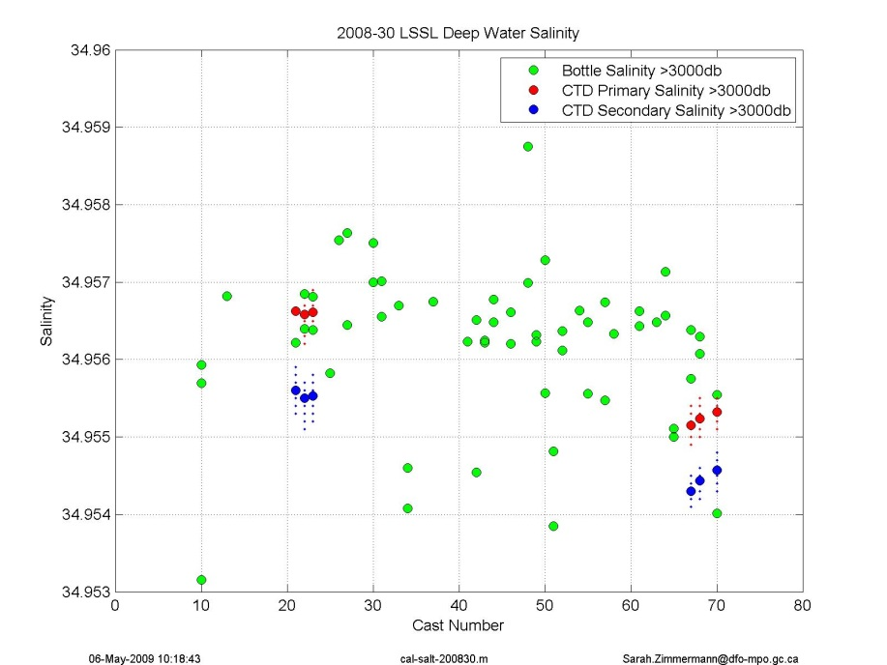

Figure1b. Using post-cruise conductivity lab calibration on primary and secondary sensors for select casts (cal\_salt\_2008.30.m).

Dual sensors show primary and secondary CTD conductivity affected the same way, suggesting a problem not associated with the conductivity cell.

Pumped CTD oxygen does not have a corresponding change at cast 43, suggesting it is not a pump issue.

Water samples show that the sensors agree best with the **post** cruise calibrations, but only for casts 1 to 43, not 44 to 70.

The deep water’s salinity and potential temperature is very uniform from 3100db to the ocean bottom. Recalculating salinity using pressure with an offset of -2db brings casts 44 to 70 into close agreement with cast 1-43.

The pressure sensor has been stable, based on on-deck pressure monitoring from 2003 to July 2007. During the summer 2007 cruise, the on-deck pressure drifted progressively to -0.5db. The CTD was sent for calibration March 2008, receiving new slope and bias terms. The bias was changed by -1.3db from the previous calibration. This was an over correction based on the on-deck pressure reading so using the new calibration, the bias was changed by +0.9db. This correction was appropriate for the entire cruise although there was a small shift in the on-deck reading for casts 26-40 and casts 41-73.



Figure . In-air pressure reading throughout the cruise after applying the correction of +0.9db pressure offset.