LSSL 2008-30
Underway Measurements
Cruise Report

Seawater Loop
The ship’s seawater loop system draws seawater from below the ship’s hull at 9m, to the main lab (“aft lab”). This system allows measurements to be made of the sea surface water without having to stop the ship for sampling. The water is as uncontaminated as possible coming directly from outside of the hull through stainless steel piping without recirculation in a sea-chest. The manifold has been insulated this year to minimize condensation. The rate is controlled for systematic measurements, and allows for continuous autonomous sampling. Measurements were taken by installing sensors in-line, and by diverting water through a manifold to run through various sensors.

Autonomous measurements were made using:
- SBE38: Temperature.
Sensor was installed in-line, approximately 4m from pump at intake. This is the closest measurement to actual sea-temperature.
- SBE21 Seacat Thermosalinograph: Temperature and Conductivity, Fluorescence and CDOM
5 second sample rate, run off the manifold in the main lab
(Fiona McLaughlin, DFO)
- Blue Cooler: Total gas (Gas Tension Device), Oxygen.
15 (?) second sample rate, run off the manifold in the main lab
(Svein Vagle, DFO)
- Black Box: Methane, Oxygen, pCO2.
Hourly sample, run off the manifold in the main lab
(Patricia Ramlal, DFO)

Part of the system, but not attached to the seawater loop:
- SBE48: Temperature was also measured through the hull using a temperature sensor mounted on the ship’s hull, inside, aft of the pump approximately 15m, starboard side.

Discreet Water Samples drawn for analyses on other instruments
- Salinity, Chlorophyll-a, CDOM (Chad Cuss), POM (Brian Hunt), and POC (?)(David Griffith)

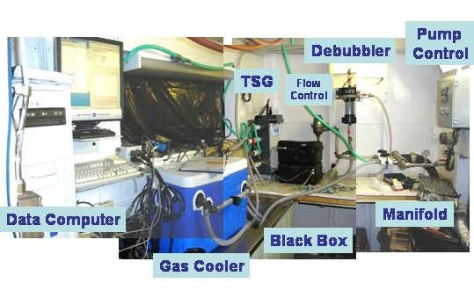
Figure. Seawater loop system providing uncontaminated seawater from 9m depth to the science lab for underway measurements.

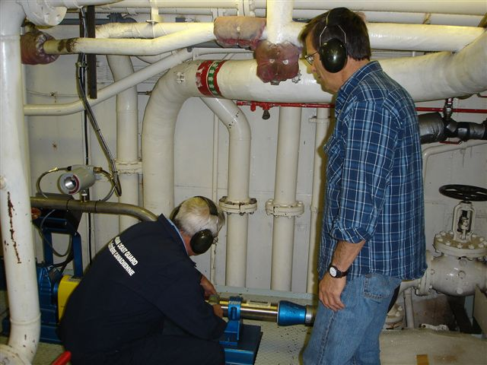
Figure. Pump for seawater loop at intake in engine room.

Some of the instruments were self-contained; others were connected to a single data storage computer. The data storage computer provided a means to pass ship’s GPS for integration into sensor files, to pass the SBE38 data from the engine room to the TSG instrument, and to pass the TSG and SBE48 data to the ship’s data collection system (SCS).

Figure. Underway sea surface salinity.
PAR Data
Photosynthetically available radiation (PAR) was measured continuously. Location was on the hanger top aft of the stack in the most unobstructed spot possible. However, the PAR sensor was never wiped clean….

Ice Cameras
Ice Cameras mounted on above the bridge took pictures every 5 to 30minutes depending on ice conditions. Two cameras were installed, one looking forward, the other looking aft along the side of the ship to observe upturned ice. See the complete report on this system by Alice Orlich.

SCS Data Collection System
The ship uses the Shipboard Computer System (SCS) written by the National Oceanographic and Atmospheric Administration (NOAA), to collect and archive underway measurements. This system takes data arriving via the ship’s network (LAN) in variable formats and time intervals and stores it in a uniform ASCII format that includes a time stamp. Data saved in this format can be easily accessed by other programs or displayed using the SCS software.

The SCS system on a shipboard computer called the “NOAA server” collects:

- Location from the ship’s GPS (GPGGA and GPRMC sentences)
- Heading from the ship’s gyro (HEHDT sentences)
- Depth sounding from the ship’s Knudsen sounder (SDDBT sentences)
- Air temperature, apparent wind speed, apparent and relative wind direction, barometric pressure, relative humidity, and apparent wind gusts from the ship’s AVOS weather data system (AVRTE sentences). SCS derives true wind speed.
- Sea surface temperature, conductivity, salinity and fluorescence from the ship’s SBE 21 and SBE38 thermosalinograph
- Sea surface temperature from the SBE48 hull mounted temperature sensor
- SCS derives speed over ground and course over ground

The RAW files were set to contain a day’s worth of data, restarting around midnight. The ACO and LAB files grew until they were moved out of the datalog/compress directory for archiving.

We were still experiencing some problems this year with the system losing data strings due to communication errors, sensor reconfigurations or sensors having stopped. After removing the SBE48 hull mounted temperature data stream from SCS the system operated more smoothly without hanging. The SCS system required regular checks to confirm data was being collected, requiring stopping and restarting the software to solve the majority of communication problems.

Ship Notes on the Sea Water Plumbing
Engineering Dept

SW SAMPLING SYSTEM FOR THERMAL SALINOGRAPH
ABOARD THE LOUIS S. ST. LAURENT

SEA SUCTION

This consists of a 4” diameter suction fitting fitted flush with the hull. It is located between Frame 179 and Frame 180 and 5’ 3” to Port of the ship’s centerline. The 4” dia. stainless steel suction plate is press fit into the opening and fastened by 4 – ½” stainless steel countersunk screws. The suction plate has a cross pattern across it of 3/8” width yielding 4 quadrants open for suction.

A 4” stainless steel angle globe valve with de-icing connection is directly bolted to the flush fitting at the hull using 8 – 5/8” steel cadmium plated studs on 7 ½” PCD. The valve is fitted with a lazy rod supported by a deck stand at tank top level to allow operation of the valve above the tank top by 10” hand wheel.

PIPING TO PUMP

From the 4” outlet of the valve is a 4” 90⁰ stainless steel elbow connected to a 4” to 2” stainless steel concentric reducer.

Height from the hull plating to the end of the concentric reducer is 1’ 10”.

From concentric reducer, pipe continues vertically via 2” stainless steel, schedule 40 pipe to the tank top. This is a distance of 4 ft..

From the tank top, 2” stainless steel schedule 40 pipe continues 6’ 7” to a 2” – 150# flanged stainless steel ball valve and directly into the 2” Hayward 6036 (CF8M) stainless steel duplex basket strainer c/w changeover cock, 5/32” basket perforations. There is another identical flanged ball valve on the outlet of the strainer.

From the outlet valve, 2” stainless steel schedule 40 piping leads another 6” 5” to a 2” to 3” concentric bushing to a flanged 3” connection on the pump suction.

SW PUMP

The pump is a 3” Moyno Progressive Cavity pump Model #2L6SSQ3SAA, customized seal arrangement, L-frame pump, L6 drive frame. This pump is driven by a geared motor. The pump rated flowrate is 10 GPM. It is composed of a stainless steel rotor and nitrile rubber stator and has a John Crane carbon/ceramic single mechanical seal.

The pump is controlled by a ACTech Model #1450C variable speed controller and gets it’s setpoint from a Honeywell UDC Controller mounted in Lab 426B.

The gearbox is an SEW Eurodrive Type RX67. The motor is an SEW Eurodrive Type RX76DT10044, 5 HP motor.

An Akron Electric (Delta Corporation)VS5100 Flowswitch acts as a drypipe sensor to shut down the pump via the VFD should the duplex basket strainers become clogged with ice.

A pressure transmitter is also fitted in the pipe on the outlet of the pump to provide a pressure alarm signal to the SIMOS system in the Machinery Control Room.

PUMP OUTLET TO LAB 426B

From the pump outlet, 1 ½” sch. 40 stainless steel pipe continues another 12’ to a 1 ½” SS ball valve. From here it continues another 16” via 1 ½” pipe to a 1 ½” “T” where the flow can then be diverted to the SBE 38 via 24” of 1” sch. 40 stainless steel pipe or continue in 1 ½” another 11’ to the 19’ flat of the engine room.(Boiler Flat)

An RTD for measuring temperature is installed just prior to the SBE branch connection.

From the 19’ Flat the 1 ½” pipe continues vertically 16’ 6” to the Incinerator Deck.

From the Incinerator Deck the 1 ½” pipe continues on a 26’ vertical run to the Main Deck.

The same pipe then runs horizontally 85’ along the Main Deck Stbd Alleyway.

From the alleyway to Lab 426B is another 8’ horizontally (athwartships) and 14” vertically.

In Lab 426B, another 6” of 1 1/2'” pipe, then a 1 ½” stainless steel, flanged, ball valve, then a 4’ run of 1 ½” pipe to the 3” pipe manifold.

Manifold has 4 – 1” NPT process connections along it’s length and 1 – 1” threaded process connection at the end to provide a pressure signal from the Honeywell ST 3000 Smart Pressure Transmitter to the Honeywell UDC Controller.

Louis NOAA SCS system, September 2007
Jane Eert

The SCS system on the NOAA server collects data from

-the Ship’s GPS (GPGGA and GPRMC sentences)
-the Ship’s gyro (HEHDT sentences)
-the Knudsen sounder (SDDBT sentences)
-the AVOS weather data system (AVRTE sentences)
-the thermosalinograph, and
-the SBE48 hull mounted temperature sensor.

Variables derived from each sentence are:

GPGGA:
time-UTC, HHMMSS
LAT, dd.ddddd
LONG, ddd.ddddd
Quality, 1=gps 2=dgps
#-of-Sats
HDOP, horizontal dilution of precision

GPRMC:
SOG, Knots
COG, degrees

HEHDT:
Gyro-Heading, Deg

SDDBT:
depth, Meters
quality-flag, None
SoundSpeed, m/s

AVRTE:
time, HHMMSS
date, YYMMDD
apparent-wind-speed, knots
apparent-wind-direction, degrees
relative-wind-direction, degrees
barometric-pressure, mmhg
air-temp, C
relative-humidity, %
apparent-wind-gust, knots

TSG:
SBE21-T, Degrees-C
SBE21-S, PSU
SBE38-T, Degrees-C

SBE48:
Hull-Temp, Degrees-C

As well, the SCS system derives true wind speed based on the AVRTE apparent wind speed and direction and the GPRMC speed over ground and course over ground. Data for each type of sentence is stored in 3 types of files:

RAW: a comma separated file, each record starts with a timestamp, followed by the sentence received at that time.
ACO: a comma separated file, each record starts with a timestamp (year, decimal Julian day, integer Julian day, fractional Julian day) followed by the variables extracted from each record.
LAB: a blank separated file, each record is as for ACO, but decimated in time, so the LAB files are about 1/10th the size of the ACO files.

Setup in 2008: The RAW files were mostly set up to contain a day’s worth of data, restarting around midnight. They are named, for example, GPGGA-Parent_20070821-100257.RAW, and stored in the main SCS datalog directory. The ACO and LAB files grow until they are moved out of the datalog/compress directory for archiving. The files were moved on August 20, so data collected afterward will be in its own set of files. Naming for these files is like GPGGA-Parent.ACO. As well, there are template files, named like GPGGA-Parent.TPL which contain a list of the variables derived for each sentence. Note that the TPL files may be out of date; when the sensor configuration was changed in June and then in July, these TPL files did not get updated (why?). I have modified the ones archived with this document to be correct, but the ones still on the ship are incorrect – use with enlightened caution.

Timestamps: The timestamps generated by SCS are based on the time settings in Windows – SCS assumes that the computer time and time zone are correct and derives UTC from them. Unfortunately, the NOAA server time is automatically set by the ship’s network which incorrectly left the time zone as Atlantic time while the computer was showing local time. I tried to set this properly a couple of times, only to discover some hours later that the computer had reset itself. One of the processing steps is therefore to correct the timestamps in the ACO and LAB files to UTC.

Gaps: There are gaps in the data collection, some of which have been filled by post processing from independent records. The most critical are:

SBE48 – the sentences from this instrument tended to hang the SCS system. The data were logged using hyperterminal and removed from SCS. SCS performed well afterwards.

SDDBT: The sounder depth is recorded but not the sound speed used to calculated the depth.
From July x to July x soundspeed is
From July x to Aug 20 soundspeed is

Processing routines (in IDL):

Check_time,pro, Correct_time.pro – takes the ACO file for the GPGGA-Parent and derives a time series of the difference in time between UTC (from the GPS record) and the SCS timestamp. Check_time writes out this time series to time_corr.csv. Correct_time applies it to all ACO and LAB timestamps, creating files with “_tcor” appended to their base name.

Make_lab_sbe48.pro, Merge_aco_sbe48.pro and Merge_lab_sbe48.pro – takes .txt files captured by hyperterm on the TSG computer and first makes two files (and LAB and an ACO) in the same format and time interval as the SCS files for the SBE48 and then merges the SCS files and new files to get continuous merged ACO and LAB files.
Merge_aco_sounder.pro – takes a file of a time series of sound speed settings and adds this information to records in the SCS SDDBT ACO and LAB files that do not already have it. Also adds the quality flag if not already there – simply 1 if the sounding is not 0, 0 if it is.

Make_tsg_compress.pro – recreates ACO and LAB files for TSG data from RAW files because SCS sensor configuration didn’t capture the “-“ sign infront of SBE38 temperatures.

Make_csv.pro – given a list of file names, desired variables and a time interval, creates a CSV file which has those variables at the given time interval, one record per time. If not data for a given variable is available within half the time interval, its spot is filled with -999.9. Checks to make sure the calculation of true wind speed is based on valid data in the variables required.

