Canada’s Three Oceans (C3O)
March 2010

Carina Gjerdrum¹, Ken Morgan² and Dave Fifield³

¹Canadian Wildlife Service, Environment Canada, 45 Alderney Rd., 6th floor, Dartmouth, NS, Canada, B2Y 2N6, carina.gjerdrum@ec.gc.ca
² Canadian Wildlife Service, Environment Canada, c/o Institute of Ocean Sciences, DFO, 9860 W. Saanich Rd., Sidney, BC, Canada, V8L 4B2
³ Canadian Wildlife Service, Environment Canada, 6 Bruce Street, St. John's, NL, A1N 4T3

Sub-project: The composition, distribution and abundance of marine birds in Canada’s three oceans.

Objectives: (1) characterise the distribution and abundance of marine birds along 12,000 km of ocean track from both coasts to the Arctic Ocean; and (2) identify the associations between the marine bird community and the physical and biological properties of their marine environment.

Methods: Surveys were conducted during the daylight hours while looking forward from the bridge when the vessel was moving, scanning ahead to a 90º angle from either the port or starboard side, limiting observations to a transect band 300 m wide from the beam of the ship. All birds observed within transects were counted and identified as present in the air or on water. At regular intervals throughout the survey, we recorded the ship’s position, time of day, and a number of environmental variables.

Accomplishments and Preliminary Results: Marine bird observers conducted surveys on two sections of the CCG Louis St-Laurent and CCG Sir Wilfrid Laurier deployments in 2008 between Dartmouth, NS and Victoria, BC. The sections included the northbound trips from Dartmouth to Kugluktuk, Nunavut (4 - 18 July), and from Victoria to Kugluktuk (3 Jul - 11 Aug). A total of 5,430 linear km were surveyed over which 62 marine bird species were observed. Through Atlantic Canada and the eastern Arctic, 20 species were encountered, compared with 42 species from Victoria to Kugluktuk. On the eastern section, densities were highest through Davis Strait, Baffin Bay, and near breeding colonies in Lancaster Sound (Figure 1). On the western section, we observed high densities through Unimak Pass and just north of the Aleutian Islands. Birds were also abundant just west of Vancouver Island (Figure 1). Future analyses will characterise seabird abundance throughout the survey area, examine any interannual variation, and identify associations among the birds and the marine ecosystem.

Dartmouth, NS to Kugluktuk, NU
From 4-18 July, we surveyed 1,803 km between Dartmouth and Kugluktuk. We counted 1,054 birds from 6 families (20 species), 28% of which were Northern Fulmars (Fulmarus glacialis). The highest densities of fulmars occurred through Lancaster Sound in the vicinity of breeding colonies. Thick-billed Murres (Uria lomvia) comprised 24% of the observations and were observed primarily through the Davis Strait and near breeding colonies in Lancaster Sound and Barrow Strait. Black-legged Kittiwakes (Rissa tridactyla) (21% of observations) were observed throughout the survey, but were most common through the Davis Strait and near one of their largest breeding colonies at Prince Leopold Island. Dovekies (Alle alle) made up 13% of the observations and were only observed in Baffin Bay. Glaucous Gulls (Larus hyperboreus) were numerous (3% of observations) only in the far northern section of the survey, from Lancaster Sound through to Kugluktuk. Northern Gannets (Morus bassanus), Herring Gulls (L. argentatus), Great Black-backed Gulls (L. marinus), and Common Murres (U. aalga) were only observed in small numbers in the southern part of the survey, through the Cabot Strait and Strait of Belle Isle. Together they accounted for 5% of the sightings. One flock of Red Phalaropes (Phalaropus fulicaria) was sighted near Prince Leopold Island, and migrants from the southern hemisphere (Sooty Shearwater Puffinus griseus and Greater Shearwater P. gravis) were observed in low numbers (1% of observations) and no farther north than the southern Labrador Sea.

Victoria, BC to Kugluktuk, NU
From 3 July – 11 August, we surveyed 3627 km from Victoria to Kugluktuk during which time we counted 8,695 individual birds from 8 families (42 species). The Procellariidae accounted for 79% of all the birds sighted. Most of these were Short-tailed Shearwaters (Puffinus tenuirostris). These were all observed through Unimak Pass and in the Bering Sea. Fork-tailed Storm-Petrels (Oceanodroma furcata) accounted for 23% of the observations and were observed from Victoria through to the Bering Sea. The highest densities were observed just west of Vancouver Island. Leach’s Storm-Petrels (O. leucorhoa) were far less abundant (3% of the observations) and were only observed in the track south of the Aleutian Islands. Northern Fulmars accounted for 10% of the total observations. The highest densities of fulmars were observed in Unimak Pass and in the Bering Sea, but individuals were also seen south of the Kenai Peninsula and as far north as Point Barrow. Other members of the Procellariidae observed include Sooty Shearwaters, Pink-footed Shearwaters (Puffinus creatopus), Mottled Petrels (Pterodroma inexpectata), and Murphy’s Petrels (P. ultima). These were all observed between Vancouver Island and the Aleutian Islands. Only the Mottled Petrel was also observed as far north as the Bering Sea.

Birds from the family Alcidae accounted for 14% of the observations. Thick-billed Murres were the most common (5% of the total observations) and were sighted from St. Matthew Island in the Bering Sea through to MacKenzie Bay in the Beaufort Sea. Least Auklets (Aethia pusilla) and Tufted Puffins (Fratercula cirrhata) were also relatively common (4% and 2% of the observations respectively). Both species were observed near the Aleutian Island chain and in the Bering Sea, but the puffins were also seen south of the Aleutian Islands. Other Alcids observed include Ancient Murrelets (Synthiboramphus antiquus), Horned Puffins (Fratercula corniculata), Crested Auklets (Aethia cristatella), Parakeet Auklets (A. psittacula), Common Murres, Cassin’s Auklets (Ptychoramphus aleuticus), Rhinoceros Auklets (Cerorhinca monocerata), Pigeon Guillemots (Cepphus columba), and Kittlitz’s Murrelets (Cepphus columba). Most of these were observed in the Bering Sea in the vicinity of breeding colonies.

Although 12 species from the family Laridae were observed, they accounted for less than 2% of the total observations. The most common gull was the Black-legged Kittiwake, which was observed in Unimak Pass, through the Bering Strait, and along the north shore of Alaska. Glaucous Gulls (Larus hyperboreus) were also observed along Alaska’s north shore. This area was dominated by local nesters that typically occur in coastal areas, such as King and Common Eiders (Somateria spectabilis and S. mollissima, respectively), Arctic Terns (Sterna paradisea), and Yellow-billed Loons (Gavia adamsii).

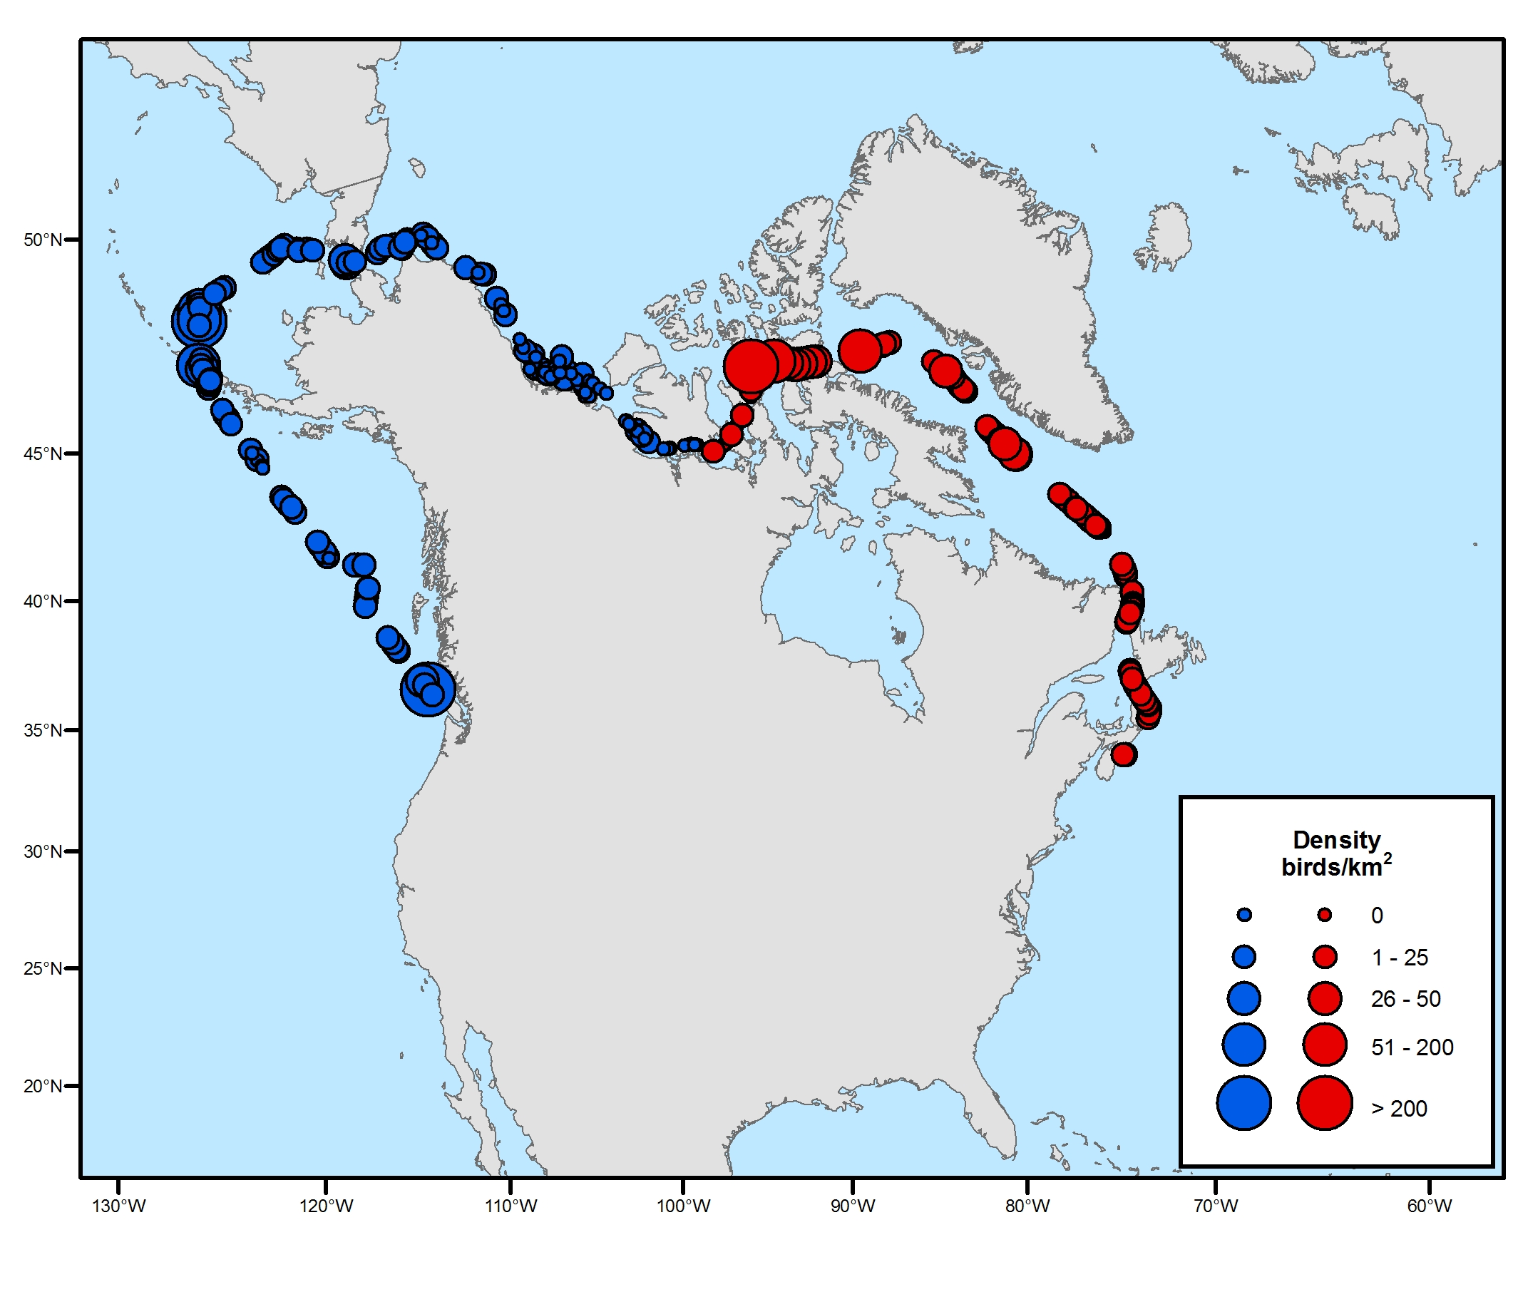
Figure 1. Density of marine birds observed between Dartmouth, NS and Victoria, BC.

