Zooplankton Sampling Report 2007

Helen Drost

Title: Oceanographic Research aboard the CCGS Louis S St-Laurent
Ship: CCGS Louis S St-Laurent
Area: Beaufort Sea / Canada Basin

Fisheries & Oceans Canada IPY program
Program Lead: Fiona McLaughlin
Chief Scientist: Sarah Zimmermann

Methods & Materials:
Two large bongo hoops were fitted with nets with 150μm and 236μm mesh size. A second set of smaller hoops were fitted perpendicular to the large hoops and with nets of finer 53μm mesh. The four nets were fitted with unidirectional flowmeters which measure the amount of water flowing through the hoops. Between cast the nets were stored on the foredeck in a box, built by the ship specifically to accommodate the bongo net.

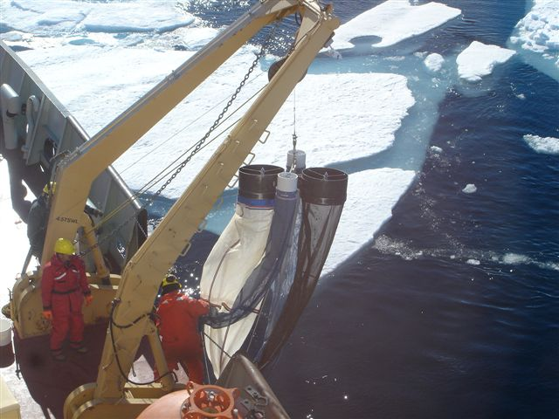
Figure 1. Zooplankton nets
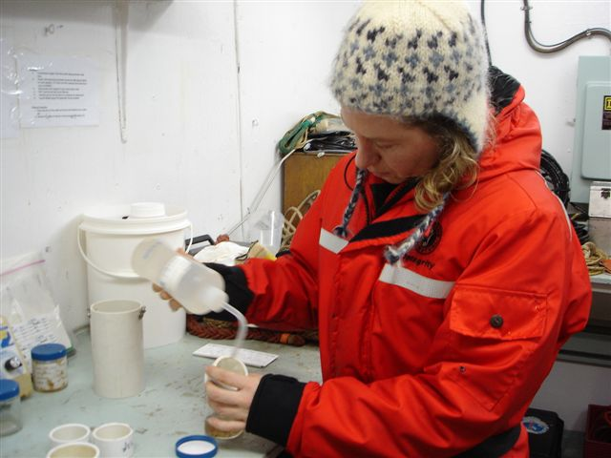

Figure 2. Helen Drost preserves zooplankton samples

Two casts, typically to 100m were performed per station to collect enough samples for identification, DNA analysis and biomass measurements. Samples from the first cast were preserved in formalin with samples from the nets with 53μm-sized mesh combined to form one sample. From the second cast, the samples from the nets with 236μm mesh and combined nets of 53μm mesh were preserved in 95% ethanol. The sample from the net with 150μm mesh was washed with 4% ammonium formate and dried at 50ºC for 24 hours for biomass measurement.

Net Cast Details:
In total 48 casts were performed at 23 stations. Casts were all done to 100m depth, with only one cast to 500m at station CB-15. Locations are depicted in the figure below. All samples were preserved in ethanol or formalin, or dried for dry-weight measurements. The collected samples will be used for identification of zooplankton species, to determine biomass and for genetic (DNA) analysis. All the chemicals used for sample preservation for leg 2 were used. No chemicals were shipped back apart from the ammonium formate waste that was placed in sample jars and returned with zooplankton samples.

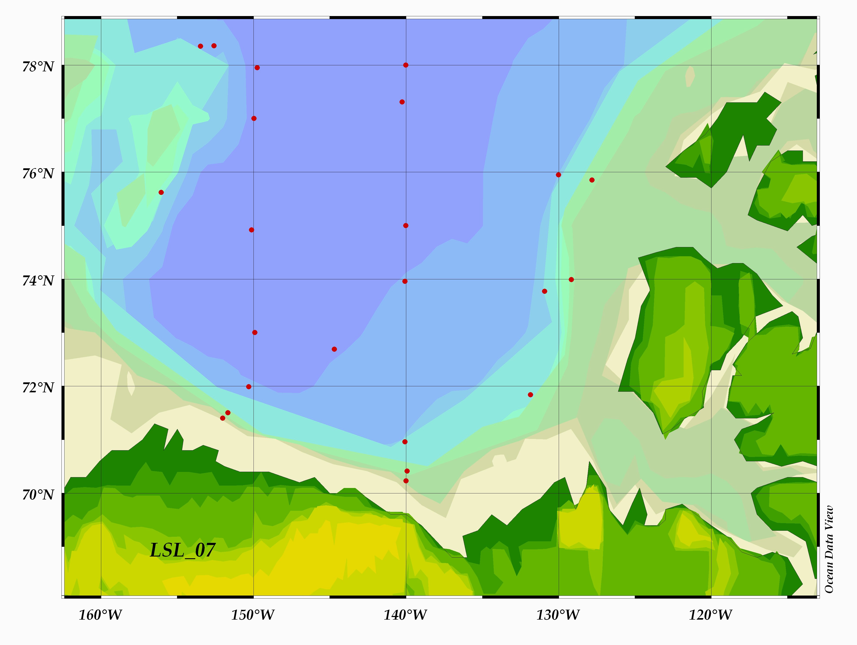
Figure 1. Vertical net haul 2007 stations in the Canadian Basin
Sampling Locations:

Table 1. Sampling locations. Key to net operators are HD (Helen Drost) and HM (Hugh Maclean).
Vertical Net Casts
2007
Net event | Station Name | CTD cast # | Date (UTC) | Time (UTC) | Approx. Max Net Depth (m) | Approx. Water Depth (m) +9 | Biomass Sample | Cast done by | Notes
1 | BI-2 | 7 | 7/30/07 | 4:30 | 100 | 491 |  | HM
2 | BI-2 | 7 | 7/30/07 | 5:00 | 100 | 491 | 6a | HM | Flow meter #4 (53um) broken (see log book
3 | BI_6 | 10 | 7/30/07 | 12:50 | 100 | 2504 |  | HD
4 | BI_6 | 10 | 7/30/07 | 13:03 | 100 | 2504 | 6b | HD | no wash down and 150 codend had a crack in top (replaced it)
5 | CB28b | 16 | 1/08/07 | 10:20 | 100 | 2046 |  | HD
6 | CB28b | 16 | 1/08/07 | 10:35 | 100 | 2046 | 6c | HD
7 | MK-2 | 22 | 2/08/07 | 2:35 | 100 | 524 |  | HM
8 | MK-2 | 22 | 2/08/07 | 2:50 | 100 | 524 | 6f | HM
9 | MK-1 | 23 | 2/08/07 | 6:15 | 100 | 243 |  | HD
10 | MK-1 | 23 | 2/08/07 | 6:30 | 100 | 243 | 3a,3b | HD
11 | BL-2 | 27 | 4/08/07 | 4:53 | 100 | 160 |  | HM
12 | BL-2 | 27 | 4/08/07 | 5:15 | 100 | 160 | 3c, 3d | HM
13 | BL-4 | 29 | 4/08/07 | 10:43 | 100 | 1002 |  | HD
14 | BL-4 | 29 | 4/08/07 | 10:57 | 100 | 1002 | 3e, 3f | HD
15 | BL-8 | 32 | 4/08/07 | 20:16 | 100 | 2995 |  | HM
16 | BL-8 | 32 | 4/08/07 | 20:30 | 100 | 2995 | 4a | HM
17 | CB-2 | 35 | 5/08/07 | 14:30 | 100 | 3745 |  | HD
18 | CB-2 | 35 | 5/08/07 | 14:38 | 100 | 3745 | 4b | HD
19 | CB-4 | 37 | 6/08/07 | 5:00 | 100 | 3829 |  | HM
20 | CB-4 | 37 | 6/08/07 | 5:15 | 100 | 3829 | 4c | HM
21 | RS-4 | 41 | 7/08/07 | 14:42 | 100 | 2349 |  | HD
22 | RS-4 | 41 | 7/08/07 | 15:00 | 100 | 2349 | 4d | HD
23 | CB-8 | 48 | 9/08/07 | 21:45 | 100 | 3828 |  | HM
24 | CB-8 | 48 | 9/08/07 | 22:00 | 100 | 3828 | 4e | HM
25 | CB-9 | 50 | 10/08/07 | 7:30 | 100 | 3829 |  | HD
26 | CB-9 | 50 | 10/08/07 | 7:45 | 100 | 3829 | 4f | HD
27 | RN-6 | 53 | 11/08/07 | 4:35 | 100 | 3517 |  | HM
28 | RN-6 | 53 | 11/08/07 | 4:47 | 100 | 3517 | 2a | HM
29 | CB-10a2 | 55 | 11/08/07 | 12:02 | 100 | 1832 |  | HD
30 | CB-10a2 | 55 | 11/08/07 | 12:40 | 100 | 1832 | 2b | HD
31 | CB-15 | 71 | 15/08/07 | 11:15 | 100 | 3728 |  | HD
32 | CB-15 | 71 | 15/08/07 | 11:30 | 100 | 3728 | 2c | HD
33 | CB-16 | 72 | 16/08/07 | 3:38 | 100 | 3749 |  | HD
34 | CB-16 | 72 | 16/08/07 | 3:50 | 100 | 3749 | 2d | HD
35 | CB-15 | 76 | 18/8/07 | 12:16 | 500 | 3728 |  | HD
36 |  |  |  |  |  |  |  |  | this event number was skipped
37 | PP-4 | 81 | 20/8/07 | 103 | 100 | 1981 |  | HM
38 | PP-4 | 81 | 20/8/07 | 123 | 100 | 1981 |  | HM
39 | PP-4 | 81 | 20/8/07 | 137 | 100 | 1981 | 2e | HM
40 | PP-1 | 84 | 20/8/07 | 1100 | 100 | 438 |  | HD
41 | PP-1 | 84 | 20/8/07 | 1117 | 100 | 438 | 2f | HD
42 | CB-18 | 88 | 21/8/07 | 2037 | 100 | 3621 |  | HM
43 | CB-18 | 88 | 21/8/07 | 2049 | 100 | 3621 | 5a | HM
44 | CB-21 | 91 | 23/8/07 | 643 | 100 | 3490 |  | HD | 15-20 knot wind and stopped at 40meters going up as net was under ship for approx. 2 mins.
45 | CB-21 | 91 | 23/8/07 | 648 | 100 | 3490 | 5b | HD | no angle on 2nd cast - wind dropped.
46 | Stn A. | 99 | 24/8/07 | 1225 | 100 | 3498 |  | HD
47 | Stn A. | 99 | 24/8/07 | 1242 | 100 | 3498 | 5c | HD
48 | CABOS | 107 | 27/8/07 | 412 | 100 | 1167 |  | HM
49 | CABOS | 107 | 27/8/07 | 427 | 100 | 1167 | 5d | HM

Notes:

This year the zooplankton net casts were conducted during leg 1, from Halifax to Kugluktuk (see John Nelson for report). The equipment, at the start of leg 2, was in disarray. Several items were missing, including the new filters and mesh, graduated cylinder for measuring 10%formalin, nylon line and crimper for attaching flow meters, and other misc. items. The nets were torn (repaired with silicone) and only 1of the 4 flow meters worked well throughout leg 2.

Recommendations:
This year the addition of chemicals, to preserve samples, was done under a fume hood. This worked well. It is recommended that zooplankton sample preservation always be done using a fume hood or at least conducted outdoors were there is adequate ventilation.

It is recommended that the sample jars, once full, be stored in a ventilated area or at least an area not frequented by people. To reduce fumes from sample jars electrical tape should be wrapped around lid.

It is recommended that the 4 flow meters are sent for repairs in preparation for next year.

The bongo drum assembly is in need of maintenance. There is a rusted shackle attached to the bongo frame that needs to be removed (see Mike Dempsey for photograph of rusted shackle). Ideally all moving parts on the frame need to be greased prior to deployment next year.

New filters and mesh for filtering samples are required. It took a long time to filter samples on leg 2, especially from the 53µm nets, due to old mesh and small filter diameters. It is recommended that a proper filter set be purchased for next year.

The bongo drum and box were left onboard the LSSL this year. All other equipment was returned to IOS-Pat Bay. A final inventory and repacking was conducted in November 2007.

