4.8 Underway Measurements

Seawater Loop
A seawater loop system, drawing seawater from below the ship’s hull to the main lab (“aft lab”) was installed for the 2007 field season. This system allows measurements to be made of the sea surface water without having to stop the ship for sampling. The water is as uncontaminated as possible coming directly from outside of the hull through stainless steel piping without recirculation in a sea-chest. The flow rate is controlled for systematic measurements, and allows for continuous autonomous sampling. Measurements were taken by installing sensors in-line, and by diverting water through a manifold to run through various sensors.

Autonomous measurements were made using:
- SBE38: Temperature.
Sensor was installed in-line, approximately 4m from pump at intake. This is the closest measurement to actual sea-temperature.
- SBE21 Seacat Thermosalinograph: Temperature and Conductivity.
5 second sample rate, run off the manifold in the main lab
(Fiona McLaughlin, DFO)
- Blue Cooler: Total gas (Gas Tension Device), Oxygen.
15 (?) second sample rate, run off the manifold in the main lab
(Svein Vagle, DFO)
- Black Box: Methane, Oxygen, pCO2.
Hourly sample, run off the manifold in the main lab
(Patricia Ramlal, DFO)

Part of the system, but not attached to the seawater loop:
- SBE48: Temperature was also measured through the hull using a temperature sensor mounted on the ship’s hull, inside, aft of the pump approximately 15m, starboard side.

Discreet Water Samples drawn for analyses on other instruments
- Salinity, Barium, O-18, Alkalinity

Other
- Water was taken from the manifold to the hangertop by approximately 50m of garden hose to support an incubation study requiring sea surface water temperature.

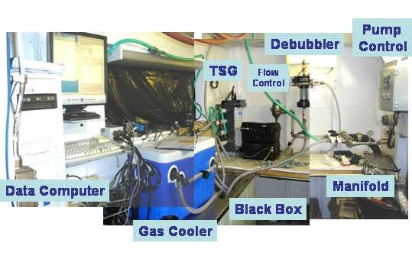
Figure 1. Seawater loop system providing uncontaminated seawater from 9m depth to the science lab for underway measurements.

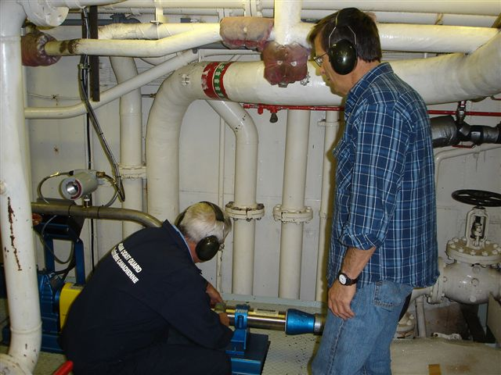
Figure 2. Pump for seawater loop at intake in engine room.

The seawater loop was operational beginning July 16th after the installation of pump, plumbing, manifold, variable flow control that uses feedback between the main lab and the pump, 3 flow control valves, and finally the science instruments. Some of the instruments were self-contained; others were connected to a single data storage computer. The data storage computer provided a means to pass ship’s GPS for integration into sensor files, to pass the SBE38 data from the engine room to the TSG instrument, and to pass the TSG and SBE48 data to the ship’s data collection system (SCS).

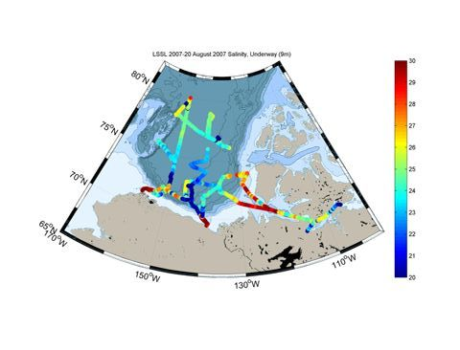
Figure 3. Underway sea surface salinity.

SCS Data Collection System
The ship uses the Shipboard Computer System (SCS) written by the National Oceanographic and Atmospheric Administration (NOAA), to collect and archive underway measurements. This system takes data arriving via the ship’s network (LAN) in variable formats and time intervals and stores it in a uniform ASCII format that includes a time stamp. Data saved in this format can be easily accessed by other programs or displayed using the SCS software.

The SCS system on a shipboard computer called the “NOAA server” collects:

- Location from the ship’s GPS (GPGGA and GPRMC sentences)
- Heading from the ship’s gyro (HEHDT sentences)
- Depth sounding from the ship’s Knudsen sounder (SDDBT sentences)
- Air temperature, apparent wind speed, apparent and relative wind direction, barometric pressure, relative humidity, and apparent wind gusts from the ship’s AVOS weather data system (AVRTE sentences). SCS derives true wind speed.
- Sea surface temperature and salinity from the ship’s SBE 21 and SBE38 thermosalinograph
- Sea surface temperature from the SBE48 hull mounted temperature sensor
- SCS derives speed over ground and course over ground

The RAW files were set to contain a day’s worth of data, restarting around midnight. The ACO and LAB files grew until they wee moved out of the datalog/compress directory for archiving.

We were still experiencing some problems this year with the system losing data strings due to communication errors, sensor reconfigurations or sensors having stopped. The SCS system required regular checks to confirm data was being collected, requiring stopping and restarting the software to solve the majority of communication problems.

