2007-20 Bottle Oxygen Corrections, Post-Cruise
26 May 2008
Updated 25 Feb 2009

The oxygen water sample data collected from the Canada Basin had a 0.2ml/l offset from expected values based on historical data. Following the cruise, the dispensing unit for the potassium iodate standard (the digitrate dispenser) was calibrated and found to be dispensing a lower volume of potassium iodate than expected. This explains partially why the oxygen values were high and the sodium thiosulfate standard volume low. The drift during the cruise however is still unaccounted for.

The data show a starting offset of 0.13 ml/l with a positive drift during the cruise:

1 to 37: Are between 6.68 and 6.70 ml/l.

40 to 47: Deep casts 40 and 47 are slightly higher in the deep water, +0.02 ml/l (6.72 ml/l)

48 to 72: Deep water value increases by another +0.03 (now 6.75 ml/l)
New standard value applied starting with cast 48 (this could account for +0.02 ml/l of the shift).

73 to end: Deep water value increases by +0.02 ml/l (now 6.77 to 6.78 ml/l)

To determine an appropriate correction the deep water is used as the reference value for water sample where the deep water is expected to be between 6.56 and 6.57 ml/l throughout the basin.

The numbers to be used for reprocessing were found:
Using the initial blank and sodium thiosulfate standard for casts 1 to 37 and the deep water reference, a new volume for potassium iodate was determined. This volume was used to reprocess the full data set. All subsequent drifts were corrected by finding a new sodium thiosufate standard volume. The blank was kept the same. When a new batch of potassium iodate was used, the new n number was applied, and a new std was determined.

The calibrated digitrate dispenser volume is larger than the volume determined here however it is within three STD. The calibrated value had mean of 9.91g (9.94ml) with a std of 0.055g. The response was bimodal with the two peaks at roughly 9.82 and 9.94 g (9.85 and 9.71ml). The volume found here based on the deep reference value is 9.81 ml.

Casts | Sodioum Thio Std Volume (ml) | Blank (ml) | Volume of Potassium Iodate Std (ml) | Potassium Iodate Normality | Pre -Correction offset from Reference (ml/l)
1 to 37 | 0.709 | 0.004 | 9.81 | 0.01013126 | 0.13
40 to 47 | 0.710 | 0.004 | 9.81 | 0.01013126 | 0.16
48 to 72 | 0.714 | 0.004 | 9.81 | 0.01013126 | 0.19
73 to 88 | 0.715 | 0.004 | 9.81 | 0.01013126 | 0.21
89 to 107 | 0.715 | 0.004 | 9.81 | 0.0101262 | 0.21

The changes from at-sea values using the new parameters above:
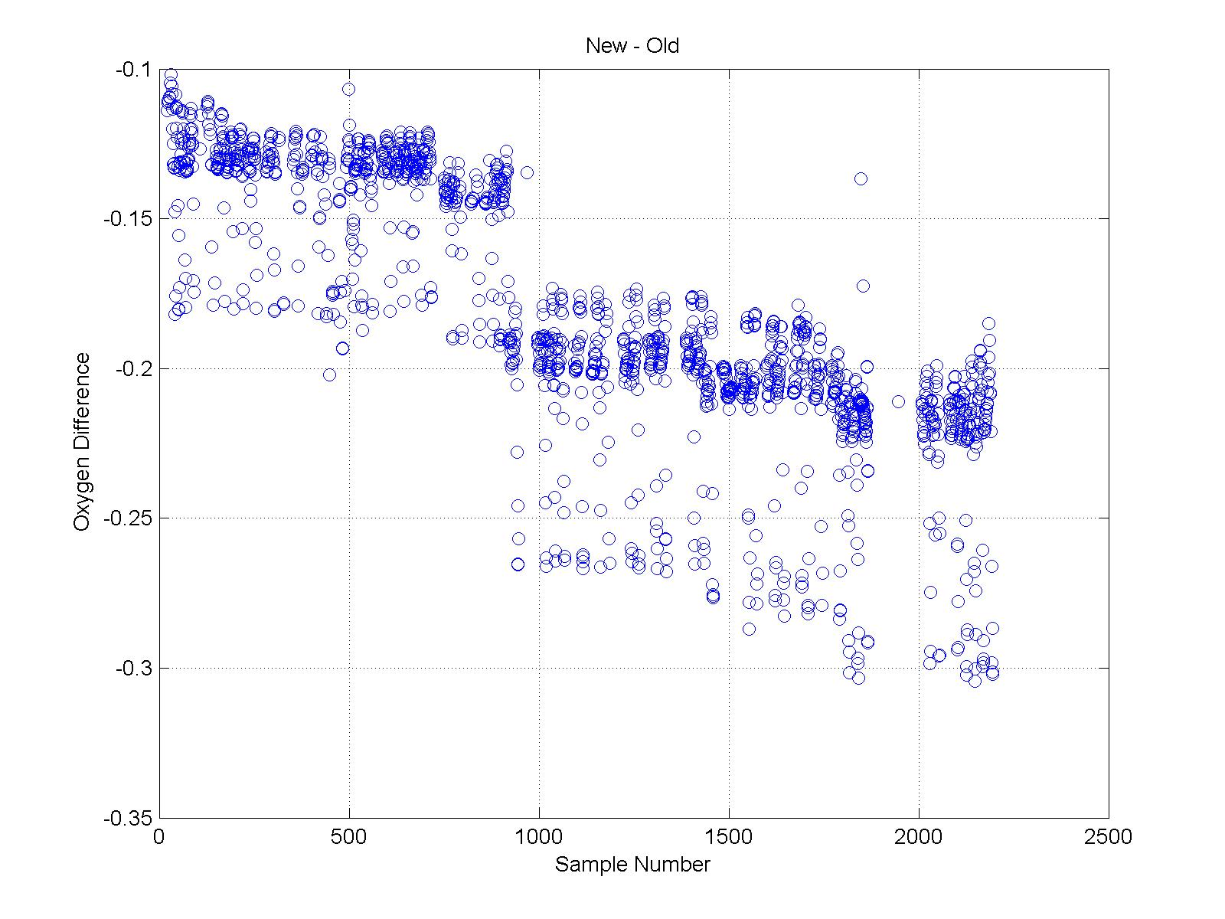
Figure 1. The changes from at-sea to 26May2008 values using the new parameters from the above table.

Data have been written to spreadsheet:
N:\Share\2007\2007-19+20-LSSL\2007-20\Data\Chemistry\oxygen\post_cruise_edits
Post_Cruse_DO_Values_2007-20_26_May_2008.xls
Calculated, spreadsheet output and figure from Matlab program
calculate _from_WS_titrate.m Section 3

25 Feb 2009
New oxygen flask volumes were measured Jan 2009 by Tara Lamothe and Bernard Minkley. Nina Nemcek has determined which flasks have new volumes that should be corrected in the 2007 data (those over 0.2ml different AND with no known reasons for a change in volume such as a change to the stopper etc.). These new volumes were entered into the spreadsheet (Post_Cruse_DO_Values_2007-20_25Feb2009.xls) and new oxygen values calculated using the updated Matlab program called calculate _from_WS_titrate.m Section 3. The data in worksheet "merge format" are ready to be put into the 2007-20 chemistry spreadsheet.

Flask volume information is in: N:\SHARE\CHEMISTRY- Methods and Calibrations\Oxygen\Flask Calibrations\2009_Jan_IOS_flask_volumes24Feb2009.xls Sheet Name: 2007-20

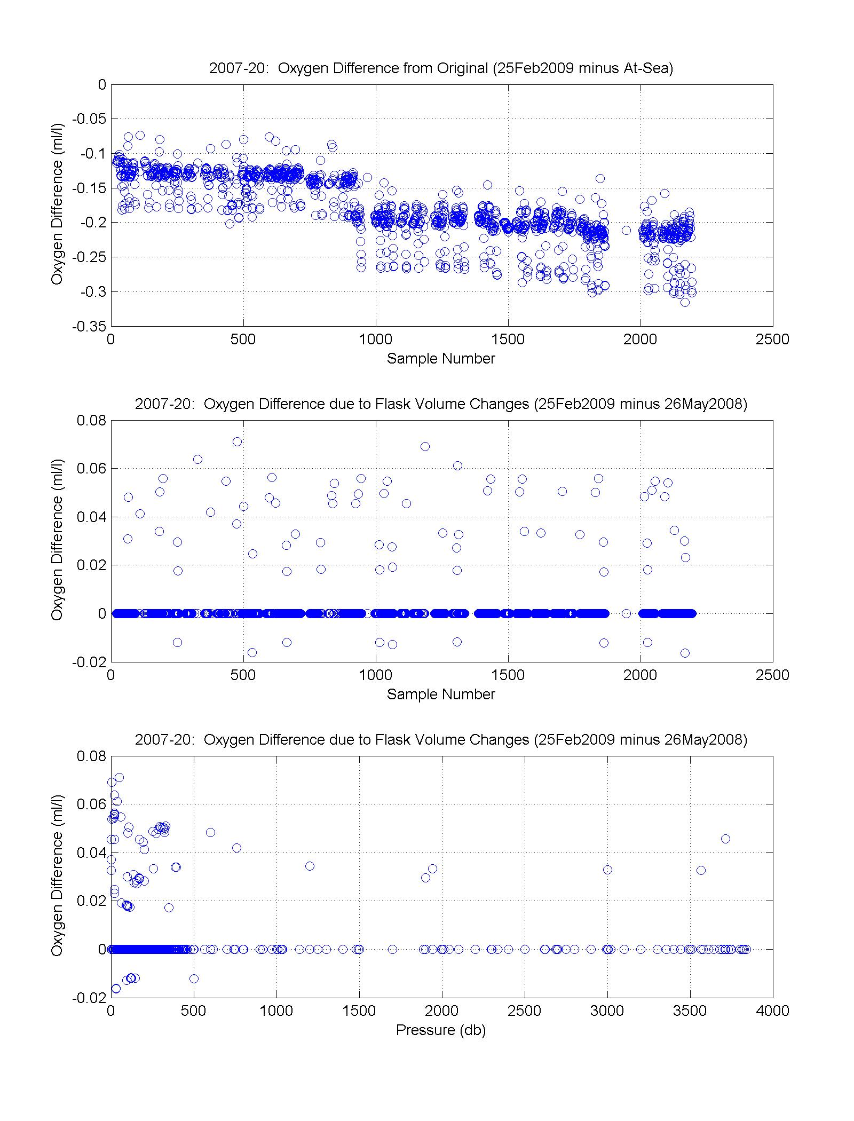
Figure 2. Summary of changes to calculated oxygen. Changes due to new STD volume are between -0.1 to -0.3 ml/l (top figure). Changes due to select new flask volumes are -0.02 to 0.08 ml/l (bottom two figures).

