Dissolved organic carbon and colored dissolved organic matter in the Arctic Ocean
Céline Guéguen, Trent University (celinegueguen@trentu.ca)

Background
Dissolved organic carbon is (DOC) is an important component in global carbon budgets and marine carbon cycling. A portion of the total DOC pool, which absorbs lights in the UV and visible ranges, is referred to chromophoric (or colored) dissolved organic matter (CDOM). Recent studies have shown that CDOM may play an important role in radiative transfer of light in the ocean and remote sensing of primary production. Major sources of CDOM in the ocean are mostly from terrestrially derived humic substances from river runoff, especially in coastal regions, diagenetic processes in shelf sediment and phytoplankton production. In addition to tracing DOC concentrations in the water column, CDOM can be used as a potential tracer in water mass mixing, especially in the Arctic Ocean where there is a large share of global river discharge and terrigenous DOC. However, characteristics of CDOM and its distribution in the Arctic Ocean are poorly understood.

Objectives
1) To characterize the nature and origin of organic matter in the cold halocline
2) To assess the spatial distribution of DOC and CDOM in the Canadian Basin
3) To evaluate the potential of CDOM as water mass tracer (e.g. Pacific Summer Water vs. Atlantic Water) and to better understand the dynamic cycling of organic carbon in the Arctic Ocean
4) To investigate the nature and composition of DOM in multi-year ice in relation with seawater.

Method
680 seawater samples were collected at 12 depths (1000, 800, 500, Tpmax, 34.4, 34.0, 33.1, 32.9, 32.3, Chla, 20, 5) and 61 stations (Figure 1). Briefly, seawater was filtered on a precombusted glass fiber filter (GF/F, Whatman). Aliquots of filtrate were then sampled for DOC and CDOM analysis. DOC samples were immediately frozen whereas CDOM were stored in the dark at 4ºC. DOC concentrations will be measured on a TOC analyzer whereas the optical properties of CDOM will be investigated by absorbance and fluorescence spectroscopy. Three-dimensional fluorescence (3D-EEM) will be performed on selected samples to identify the main fluorophore moieties in relation with water mass origin.
Four ice cores and 12 melt pond waters were collected at 4 ice stations in collaboration with Jenny Hutchings (IARC, UAF). Ice temperature was measured directly on the field every 10 cm. Salinity, nutrients and chlorophyll of melted cores were measured onboard whereas DOC and CDOM will be measured at Trent University. Typical profiles of salinity, nitrate and chlorophyll-a in ice core are shown in Figure1. Ice bottom is characterized by higher salinity, nutrient and chlorophyll-a concentration than the top ice core.

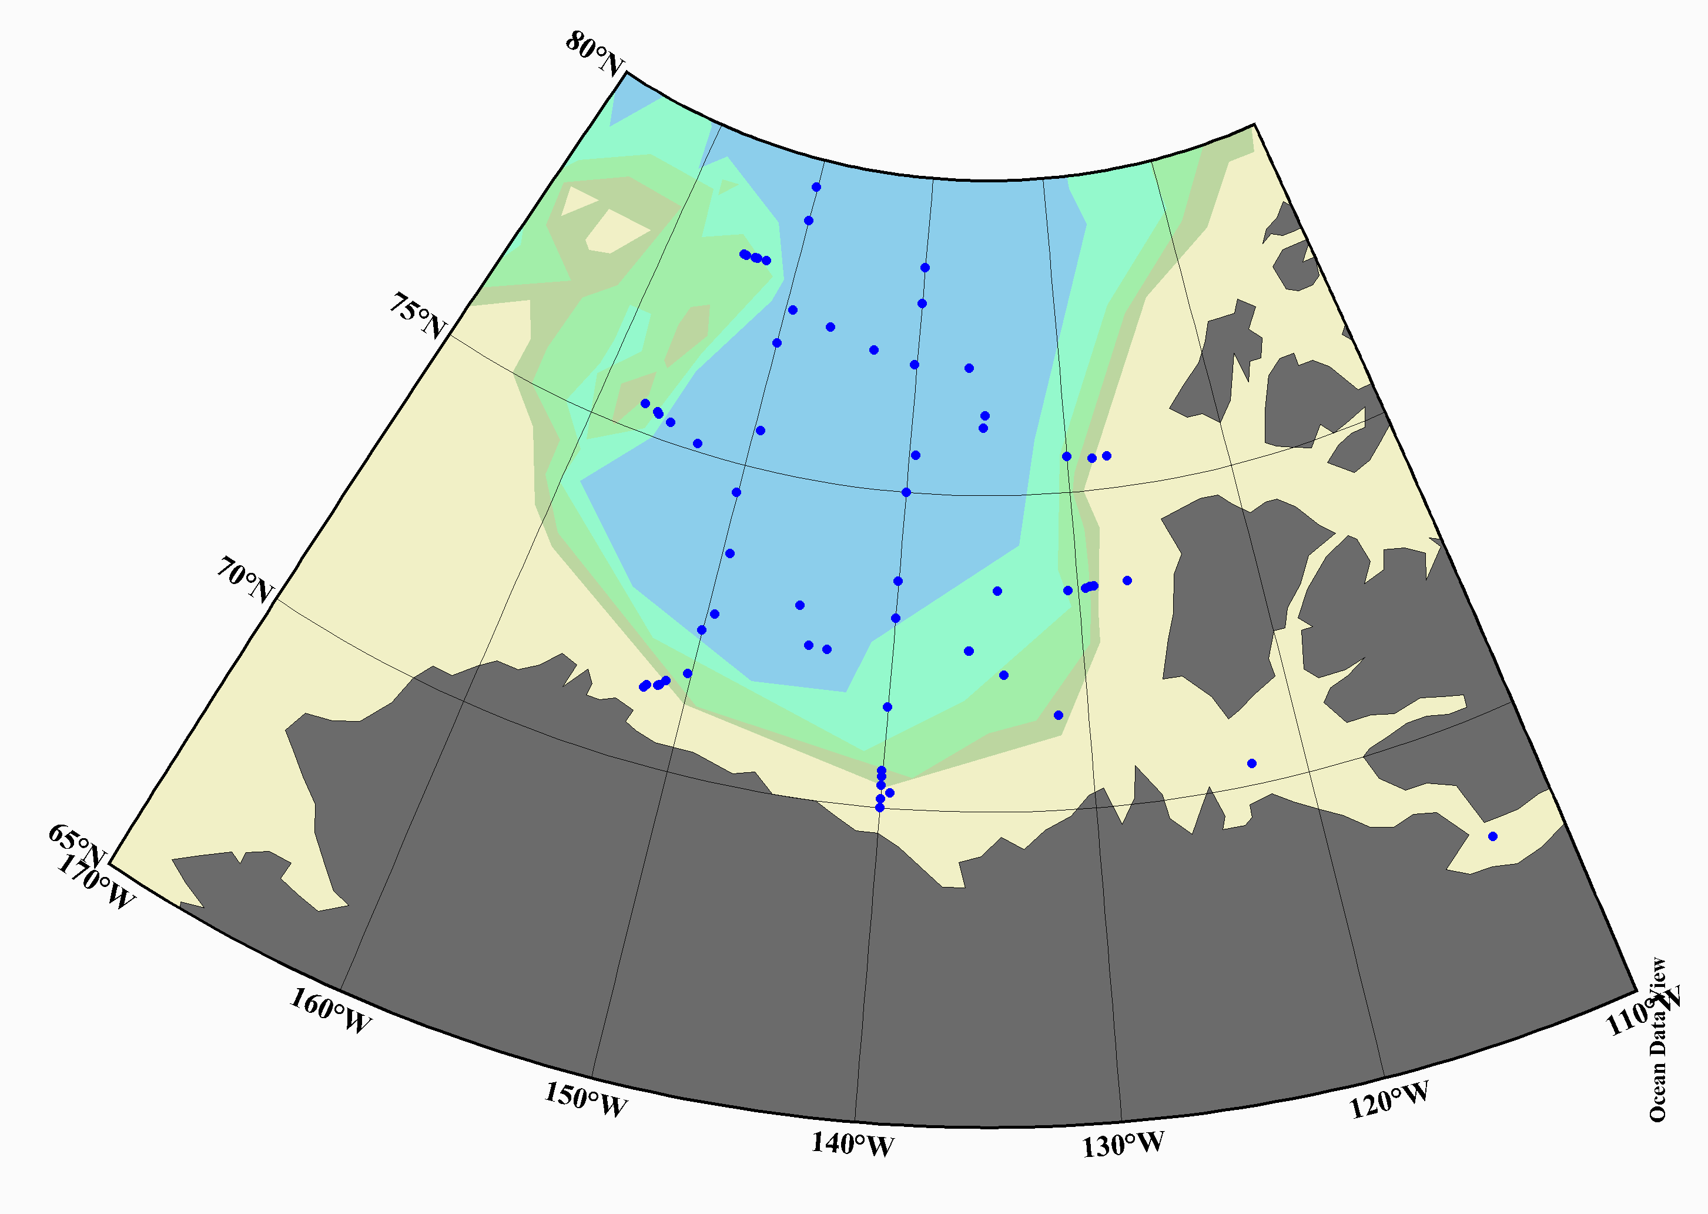
Figure 1: Sampling locations for DOC and CDOM analysis during the CCGS Louis S.St-Laurent (LSSL2007.20).

Figure 2: Salinity, nitrate and chlorophyll-a in multi-year ice core collected in the Canada Basin (78º01N/149º13W)

