Anthropogenic Radionuclide Measurements 2007-20:

Recent investigations have revealed that the Arctic
Ocean is undergoing major changes in contaminant
concentrations and rates of water circulation on time
scales of the order of years (Carmack et al., 1995; 1997;
Morison et al., 1998; Steele and Boyd, 1998). Results
from icebreaker cruises in 1993–1995 in the Western
Arctic Ocean indicate that a major thermohaline disturbance
was underway, characterized by an increase in the
transport and/or temperature of Atlantic water flowing
into the Eurasian Basin and a corresponding increase in
flow past the Lomonosov Ridge into the Canada Basin
(McLaughlin et al., 1996; Carmack et al., 1997; Swift
et al., 1997). This direct intrusion of water from the
North Atlantic along the continental margin of the
Eurasian Basin into the Canada Basin is also carrying
elevated inventories of the radioactive tracers, ¹²⁹I and
¹³⁷Cs, which during the past 30 years have been released
in large quantities from the nuclear fuel reprocessing
plants at Sellafield, UK and La Hague, France, which
discharge into the Irish Sea and English Channel, respectively.
Changes in the reprocessing plant release rates of
¹²⁹I and ¹³⁷Cs are propagated through the Norwegian
and Atlantic Coastal Currents into the marginal seas and
interior of the Arctic Ocean on time scales of 4–5 years
(Livingston, 1988; Smith et al., 1990; Kershaw and
Baxter, 1995) and measurements of these signals can be
used to constrain water circulation time-scales throughout
the Arctic Ocean (Smith et al., 1998).
There are two basic tracer applications of these radionuclides
in the Arctic Ocean: (1) measurements of ¹²⁹I and
¹³⁷Cs, separately provide evidence for Atlantic-origin
water labeled by discharges from European reprocessing
plants; and (2) measurements of ¹²⁹I and ¹³⁷Cs, together
can be used to identify a given year of transport through
the Norwegian Coastal Current (NCC) thereby permitting the determination of a transit time from the NCC to the sampling location (Smith et al., 1998).

Methods:
Samples were collected from 13 stations for ¹²⁹I (1 liter), 8 stations ¹³⁷Cs (40 liters) and 2 stations Pu/AM (80 liters).

¹²⁹I: One liter samples were collected from selected depths (see attached spreadsheet) stored and returned to the laboratory analysis by Accelerator Mass spectrometry. Thirteen stations were sampled and 179 samples were collected.

¹³⁷Cs: Forty liter samples were collected at selected depths and ¹³⁷ Cs was concentrated on 5 gram columns of KCFC coated silica gel. The KCFC was dried and returned to the laboratory for analysis. ¹³⁷ Cs is determined using Gamma Spectrometry with HPGE detectors. Eight stations were sampled and 48 samples were collected.

Pu/Am: Eighty liter samples were collected at selected depths for Pu/Am analysis.
Pu/Am was precipitated from 80 liters with FeCl₃ at pH 8-10. The ppt was transferred to 1 liter nalgene bottles and transported to the laboratory for analysis. The Pu and Am are separated by ion exchange, platted on nickel disks and activities are determined using alpha spectrometry. Two stations were sampled and 14 samples were collected.

Pu/Am Mixing samples.

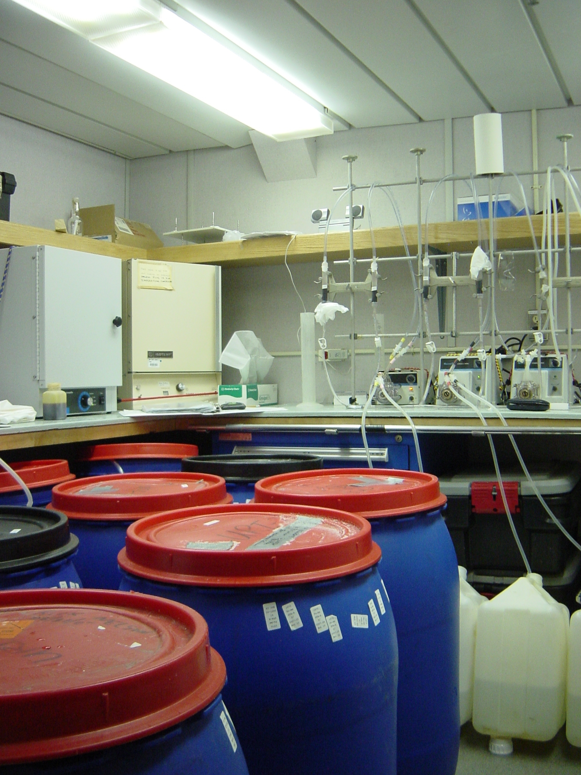

Cs-137 Passing seawater through KCFC columns.

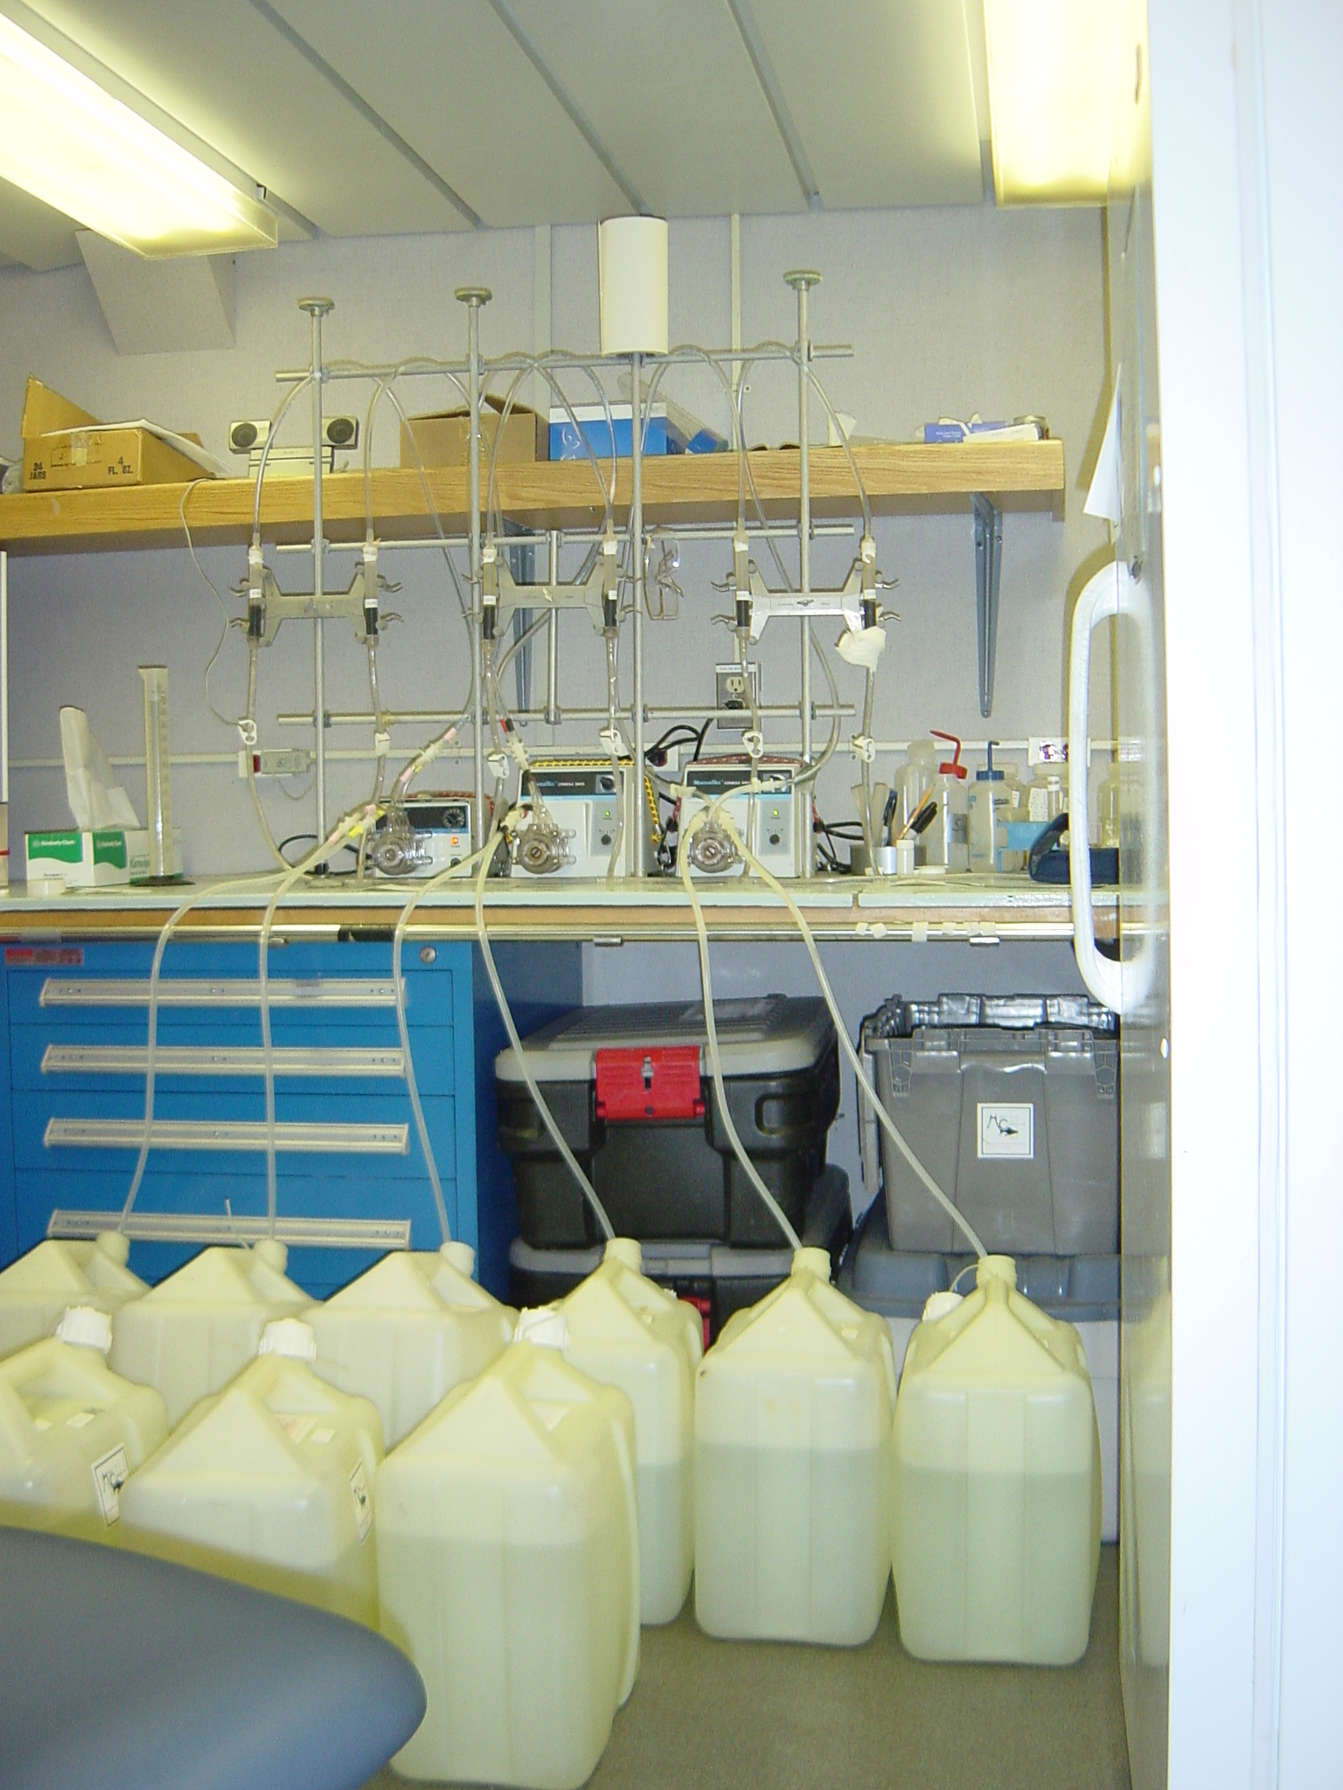

Table 1:List of samples and sample locations:

Louis S St.Laurent 2007-20
Radionuclide | Station | Lat | Long | Depth | Sample # | Radionuclide | Station | Lat | Long | Depth | Sample # | BIO SAMPLE # | VOLUME | Radionuclide | Station | Lat | Long | Depth | Sample # | BIO SAMPLE # | VOLUME
I-129 | MK-3 | 70 34.927 | 140 2.902 | 500 | 353 | Cs-137 |  |  |  |  |  |  |  | Pu/Am | MK-3 | 70 34.541 | 140 0.648 | 800 | 329-326 | 254801
 |  |  |  | 400 | 354 |  |  |  |  |  |  |  |  |  |  |  |  | 600 | 337-334 | 254802
 |  |  |  | 345 | 355 |  |  |  |  |  |  |  |  |  |  |  |  | 400 | 345-351 | 254803
 |  |  |  | 265 | 356 |  |  |  |  |  |  |  |  |  |  |  |  | 200 | 382-389 | 254804
 |  |  |  | 50 | 365 |  |  |  |  |  |  |  |  |  |  |  |  | 5 | 392-399 | 254805
I-129 | CB-9 | 77 56.61 | 149 46.30 | 3100 | 998 | CS-137 | CB-9 | 77 56.400 | 149 48.32 | 1000 | 973-976 | 254806
 |  |  |  | 2500 | 999 |  |  |  |  | 800 | 977-980 | 254807
 |  |  |  | 2000 | 1000 |  |  |  |  | 600 | 981-984 | 254808
 |  |  |  | 1500 | 1001 |  |  |  |  | 400 | 985-988 | 254809
 |  |  |  | 1000 | 976 |  |  |  |  | 300 | 989-992 | 254810
 |  |  |  | 800 | 980 |  |  |  |  | 5 | 993-996 | 254811
 |  |  |  | 600 | 984
 |  |  |  | 500 | 1005
 |  |  |  | 400 | 988
 |  |  |  | 313 | 1007
 |  |  |  | 300 | 992
 |  |  |  | 232 | 1010
 |  |  |  | 195 | 1011
 |  |  |  | 94 | 1016
 |  |  |  | 47 | 1018
 |  |  |  | 5 | 996
I-1219 | CB10-A2 | 78 21.06 | 153 28.12 | 1000 | 1069 | CS-137 | CB-10A2 | 78 20.49 | 153 29.37 | 1000 | 1069-1072 | 254812
 |  |  |  | 800 | 1073 |  |  |  |  | 800 | 1073-1076 | 254813
 |  |  |  | 600 | 1077 |  |  |  |  | 600 | 1077-1080 | 254814
 |  |  |  | 500 | 1100 |  |  |  |  | 400 | 1081-1084 | 254815
 |  |  |  | 430 | 1101 |  |  |  |  | 300 | 1085-1088 | 254816
 |  |  |  | 400 | 1081 |  |  |  |  | 5 | 1089-1092 | 254817
 |  |  |  | 300 | 1085
 |  |  |  | 290 | 1103
 |  |  |  | 221 | 1105
 |  |  |  | 123 | 1111
 |  |  |  | 62 | 1113
 |  |  |  | 5 | 1089
I-129 | CB-12 | 77 42.80 | 146 49.40 | 3100 | 1290 | CS-137 | CB-12 | 77 42 12 | 146 49.40 | 1000 | 1265-1268 | 254818
 |  |  |  | 2500 | 1291 |  |  |  |  | 800 | 1269-1272 | 254819
 |  |  |  | 2000 | 1292 |  |  |  |  | 600 | 1273-1276 | 254820
 |  |  |  | 1500 | 1293 |  |  |  |  | 400 | 1277-1280 | 254821
 |  |  |  | 1000 | 1265 |  |  |  |  | 300 | 1281-1284 | 254822
 |  |  |  | 800 | 1269 |  |  |  |  | 5 | 1285-1288 | 254823
 |  |  |  | 600 | 1273
 |  |  |  | 500 | 1297
 |  |  |  | 400 | 1276
 |  |  |  | 312 | 1299
 |  |  |  | 300 | 1281
 |  |  |  | 192 | 1303
 |  |  |  | 97 | 1308
 |  |  |  | 50 | 1309
 |  |  |  | 5 | 1285
I-129 | CB-15 | 77 02.47 | 140 15.26 | 3100 | 1389 | CS-137 | CB15 | 77 01.94 | 140 14.79 | 1000 | 1364-1367 | 254824
 |  |  |  | 2500 | 1390 |  |  |  |  | 800 | 1368-1371 | 254825
 |  |  |  | 2000 | 1391 |  |  |  |  | 600 | 1372-1375 | 254826
 |  |  |  | 1500 | 1392 |  |  |  |  | 400 | 1376-1379 | 254827
 |  |  |  | 1000 | 1393 |  |  |  |  | 300 | 1380-1383 | 254828
 |  |  |  | 800 | 1394 |  |  |  |  | 5 | 1384-1387 | 254829
 |  |  |  | 600 | 1395
 |  |  |  | 500 | 1396
 |  |  |  | 400 | 1397
 |  |  |  | 305 | 1398
 |  |  |  | 298 | 1399
 |  |  |  | 231 | 1401
 |  |  |  | 188 | 1402
 |  |  |  | 103 | 1407
 |  |  |  | 43 | 1409
 |  |  |  | 5 | 1411
1-129 | CB16N | 78 57.09 | 139 56.552 | 3100 | 1437 | CS-137 | CB16N | 78 57.09 | 139 56.552 | 1000 | 1460-1463 | 254830
 |  |  |  | 2000 | 1439 |  |  |  |  | 800 | 1464-1467 | 254831
 |  |  |  | 1500 | 1440 |  |  |  |  | 600 | 1468-1471 | 254832
 |  |  |  | 1000 | 1463 |  |  |  |  | 400 | 1472-1475 | 254833
 |  |  |  | 800 | 1467 |  |  |  |  | 300 | 1476-1479 | 254834
 |  |  |  | 600 | 1471 |  |  |  |  | 5 | 1480-1483 | 254835
 |  |  |  | 400 | 1475
 |  |  |  | 300 | 1479
 |  |  |  | 260 | 1448
 |  |  |  | 220 | 1449
 |  |  |  | 101 | 1455
 |  |  |  | 5 | 1483
I-129 | PP7 | 76 26.272 | 135 20.286 | 1500 | 1556
 |  |  |  | 1000 | 1557
 |  |  |  | 800 | 1558
 |  |  |  | 600 | 1559
 |  |  |  | 500 | 1560
 |  |  |  | 395 | 1561
 |  |  |  | 301 | 1562
 |  |  |  | 264 | 1564
 |  |  |  | 184 | 1566
 |  |  |  | 106 | 1571
 |  |  |  | 18 | 1574
 |  |  |  | 5 | 1575
I-129 | PP6 |  |  | 3005 | 1600
 |  |  |  | 2500 | 1601
 |  |  |  | 1999 | 1602
 |  |  |  | 1500 | 1603
 |  |  |  | 1000 | 1604
 |  |  |  | 800 | 1605
 |  |  |  | 600 | 1606
 |  |  |  | 500 | 1607
 |  |  |  | 394 | 1608
 |  |  |  | 378 | 1609
 |  |  |  | 296 | 1610
 |  |  |  | 263 | 1611
 |  |  |  | 184 | 1613
 |  |  |  | 104 | 1619
 |  |  |  | 39 | 1621
 |  |  |  | 5 | 1623
I-129 | PP4 | 75 57.200 | 130 0.812 | 1945 | 1624
 |  |  |  | 1500 | 1625
 |  |  |  | 1000 | 1627
 |  |  |  | 800 | 1628
 |  |  |  | 600 | 1629
 |  |  |  | 500 | 1630
 |  |  |  | 394 | 1632
 |  |  |  | 384 | 1633
 |  |  |  | 288 | 1635
 |  |  |  | 249 | 1636
 |  |  |  | 208 | 1637
 |  |  |  | 111 | 1642
 |  |  |  | 56 | 1644
I-129 | CB21 | 73 57.43 | 140 05.97 | 3000 | 1848 | CS-137 | CB21 | 73 58.79 | 140 02.40 | 1000 | DNF
 |  |  |  | 2500 | 1853 |  |  |  |  | 800 | 1867-1870 | 254836
 |  |  |  | 2000 | 1858 |  |  |  |  | 600 | 1871-1874 | 254837
 |  |  |  | 1500 | 1860 |  |  |  |  | 400 | 1875-1878 | 254838
 |  |  |  | 1000 | LOST |  |  |  |  | 300 | 1879-1882 | 254839
 |  |  |  | 800 | 1867 |  |  |  |  | 5 | 1883-1886 | 254840
 |  |  |  | 600 | 1871
 |  |  |  | 500 | 1861
 |  |  |  | 400 | 1875
 |  |  |  | 350 | 1862
 |  |  |  | 300 | 1879
 |  |  |  | 250 | 1863
 |  |  |  | 200 | 1864
 |  |  |  | 100 | 1865
 |  |  |  | 50 | 1866
 |  |  |  | 5 | 1883
I-129 | STN A | 72 41.32 | 144 41.82 | 3000 | 2010 | CS-137 | STN A | 72 41.21 | 144 42.108 | 1000 | 1985-1988 | 254850 |  | PU/AM | STN A | 72 41.236 | 144 42.359 | 3000 | 1913-1920 | 254841
 |  |  |  | 2500 | 2011 |  |  |  |  | 800 | 1989-1992 | 254851 |  |  |  | 74 40.42 | 144 44.88 | 2000 | 1921-1928 | 254842
 |  |  |  | 2000 | 2012 |  |  |  |  | 600 | 1993-1996 | 254852 |  |  |  | 72 40.17 | 144 46.98 | 1500 | 1929-1936 | 254843
 |  |  |  | 1500 | 2013 |  |  |  |  | 400 | 1997-2000 | 254853 |  |  |  |  |  | 1000 | 1937-1944 | 254844
 |  |  |  | 1000 | 2014 |  |  |  |  | 300 | 2001-2004 | 254854 |  |  |  |  |  | 800 | 1945-1952 | 254845
 |  |  |  | 800 | 2015 |  |  |  |  | 5 | 2005-2008 | 254855 |  |  |  |  |  | 600 | 1953-1960 | 254846
 |  |  |  | 600 | 2016 |  |  |  |  |  |  |  |  |  |  |  |  | 400 | 1961-1968 | 254847
 |  |  |  | 500 | 2017 |  |  |  |  |  |  |  |  |  |  |  |  | 200 | 1969-1976 | 254848
 |  |  |  | 452 | 2018 |  |  |  |  |  |  |  |  |  |  |  |  | 5 | 1977-1984 | 254849
 |  |  |  | 357 | 2020
 |  |  |  | 311 | 2021
 |  |  |  | 267 | 2022
 |  |  |  | 201 | 2024
 |  |  |  | 100 | 2028
 |  |  |  | 64 | 2029
 |  |  |  | 5 | 2032
I-129 | STN A-E | 72 38.764 | 143 49.70 | 3000 | 2034
 |  |  |  | 2500 | 2035
 |  |  |  | 2000 | 2036
 |  |  |  | 1500 | 2037
 |  |  |  | 1000 | 2038
 |  |  |  | 800 | 2039
 |  |  |  | 600 | 2040
 |  |  |  | 500 | 2041
 |  |  |  | 442 | 2042
 |  |  |  | 347 | 2043
 |  |  |  | 298 | 2045
 |  |  |  | 264 | 2046
 |  |  |  | 201 | 2048
 |  |  |  | 104 | 2052
 |  |  |  | 75 | 2053
I-129 | STN A-95-CH | 73 0.656 | 145 22.087 | 3000 | 2082 | CS-137 | STN A-95-CH | 73 00.114 | 145 21.164 | 1000 | 2057-2060 | 254856
 |  |  |  | 2500 | 2083 |  |  |  |  | 800 | 2061-2064 | 254857
 |  |  |  | 2000 | 2084 |  |  |  |  | 600 | 2065-2068 | 254858
 |  |  |  | 1500 | 2085 |  |  |  |  | 400 | 2069-2072 | 254859
 |  |  |  | 1000 | 2086 |  |  |  |  | 300 | 2073-2076 | 254860
 |  |  |  | 800 | 2087 |  |  |  |  | 5 | 2077-2080 | 254861
 |  |  |  | 600 | 2088
 |  |  |  | 500 | 2089
 |  |  |  | 406 | 2090
 |  |  |  | 350 | 2091
 |  |  |  | 294 | 2093
 |  |  |  | 257 | 2094
 |  |  |  | 205 | 2096
 |  |  |  | 102 | 2100
 |  |  |  | 61 | 2101
 |  |  |  | 5 | 2104

Appendix 1:

Radionuclide Monitoring Report for Cruise 2007-20:

Radioactive tracers Pu-242 and Am-243 were used in Lab D during Cruise
2007-20 on board the CCGS Louis S. St-Laurent.
Radionuclides were used on two occasions. Five samples were processed on August 2, 2007 at station MK3 and 9 samples were processed at station Stn A on August 24, 2007. Lab D was surveyed on July 27, 2007 before work commenced and at the end of the cruise when radionuclide work was finished on August 29, 2007. Measurements on both occasions showed background levels of radiation with no changes from the beginning till the end of the cruise. Results are presented in Table 2 and sample locations in Figure 1.
The radionuclides were stored in a locked box in Lab D when not in use not in use and will be locked and stored for the trip back.

Table 2:

Radiation Monitoring Report for Lab D:
For sampling locations see fig 1.
Sampling Location | Gamma | Alpha/Beta | Sampling Date
 | Dose Rate (µ Sv/Hr) | Count Rate S-1 | July 27 2007
background | 0.2 | 0.2
Training Room
1 | 0.1 | 0.1
2 | 0.1 | 0.1
3 | 0.1 | 0.1
4 | 0.1 | 0.1
5 | 0.1 | 0.1
Radionuclide | 0.1 | 0.1
storage
background | 0.2 | 0.2 | Aug 29 2007
Training Room
1 | 0.1 | 0.1
2 | 0.1 | 0.2
3 | 0.1 | 0.2
4 | 0.1 | 0.1
5 | 0.1 | 0.1
Radionuclide | 0.1 | 0.1
storage

Figure 1:

