LSSL 2007-20 CB Ammonium

Methods
Ammonium sampling during the LSSL 2007-20 program occurred at shelf stations and productivity stations throughout the Canada Basin. Ammonium concentrations were determined following the procedures outlined by Holmes et al. 1999. Samples of 40.5 (± 0.58) mL of seawater were collected in duplicate from the 10 L niskin bottles collected at each station from a depth of 34.6 psu and shallower, with a zero value sample set taken at ~ 450 - 500 m depth. Samples were then prepared by adding 10.00 mL of working reagent (prepared according to Holmes et al. 1999) and let to sit in the dark for 5-8 hrs at room temperature. After sitting for 5-8 hrs, samples were measured with a TD-700 fluorometer (Turner Designs), in simple mode, with sensitivity calibrated to a 0.5 μM standard (S2), reading sensitivity level 31. Samples with concentrations falling outside of the standard curve range were evaluated again with the instrument calibrated to a 1.0 μM standard (S4), reading a sensitivity level of 28. 376 sample pairs were collected and processed during this cruise along with 17 sets of standards.

Standard sets were run with every station or group of stations and prepared with samples using seawater either collected from the 450 -500 m bottle from the same rosette or from a cubitainer of water collected from deep bottles at the beginning of the BL line and stored in the cold room on the ship. In order to analyze stations that were close together some samples were stored in the oxygen fridge (away from any ammonium based chemicals) for up to 72 hours before adding working reagent. These samples were analyzed in batches with one set of standards and almost always prepared for analysis within 36 hrs of sampling.

Reagents were prepared on board in the main lab fume hood and allowed to sit for at least 24 hrs prior to use. Samples were collected in 50 mL glass test tubes with plastic screw top lids. Glassware was rinsed twice in DMQ water before being soaked in a 10 % HCl bath for at least 4 hrs (usually overnight) and then rinsed again twice in DMQ and allowed to air dry. The plastic screw top test tube lids were cleaned with DMQ water and a 10% HCl rinse before being soaked for >4hrs in DMQ water. Caps were used a maximum of 3 successive batches before being discarded. The acid bath was kept in the main lab fume hood and rinsing was done in the main lab nutrient room, with subsequent air drying done in LAB B.

Standards
Ammonium chloride secondary standards from 2006 and 2007 were run concurrently to test standard solutions between years. In this comparison, the 2007 secondary standard used in analysis was measured against a new batch of secondary standard made from the primary standard used in 2006. As can be seen in Figure 1 below, the 2007 ammonium chloride standard differed little from the 2006 standard.

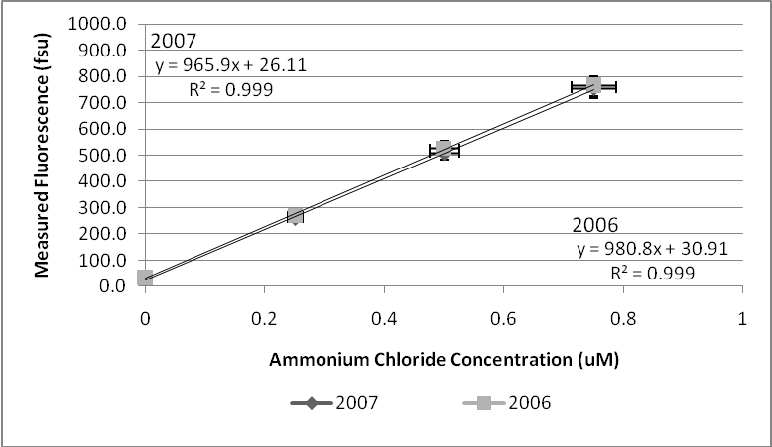
Figure 1. 2007 vs 2006 Ammonium Chloride Secondary Standard.

Reagent Blank
The average reagent blank value (all batches of working reagent) is given below. A test was also done at CB21 using one WR batch (WR 5) to determine the reproducibility of duplicates and the detection limit of the method.

Reagent Blank (Zero Standard): All stations, All working reagents
Average: 46.94 fsu (n=33)
Standard Deviation: 17.38 fsu

10 Blank CB21 Test (500m bottle)
Average: 29.18 fsu (n=10)
Standard Deviation: 5.33 fsu

From the Blank test at CB21 the detection limit for this method for this year should be 16.0 fsu (3 x 5.33 fsu), or around 0.01 μM, compared to a DL of 14.5 fsu in 2006. While the blank test at CB21 gave blank values in line with those found in 2006, the blanks measured throughout the trip were quite different. As was reported in 2006, the blank readings over the course of this cruise made it apparent that fluorometer readings below 30-50 fsu are highly variable, and perhaps the detection limit should be re-evaluated. Samples reading from 30 – 50 fsu would fall around -0.02 (in put as 0.00) to 0.02 uM depending on the WR blank.

An important issue to address with this trip was the difference in the reagent blank between 2006 and 2007. This year the blank was significantly higher (48.94 ± 17.38 fsu) compared to that found in 2006 (17.0 ± 11.1 fsu). While 2007’s reagent blank was higher, it continued to be consistent throughout the cruise, dropping only slightly in the second half.

There are several ways the reagent blank average can be looked at over the course of the trip. Table 1 illustrates the reagent blank evolution over the cruise. Characteristically the initial standard sets reagent blank will be higher due to the equilibration time required for the WR. Sampling got underway rather quickly this trip and therefore only permitted the WR batch 1 to sit for ~2 days before being used, if the initial two standard sets are taken out of the pool of all standard sets for this reason the reagent blank value lowers to 42.22 ± 12.00 fsu.

Table 1. Comparison of Reagent Blank Groupings
Reagent Blank | Average (fsu) | STDEV (fsu) | n
All stations, All WR | 46.94 | 17.38 | 33
All stations w/o first 2 batches | 42.22 | 12.00 | 31
All stations, WR Batches 1-3 | 48.98 | 10.91 | 14
All stations, WR Batches 4-5 | 37.45 | 10.57 | 18

It was observed that the OPA crystals used to make WR during this field season were very difficult to dissolve in the ethanol. In 2006 it seemed that the time limiting factor for making WR was the dissolution of the borate buffer, however this year the OPA crystals took hours to days to dissolve, and because of time constraints, were added to the first 3 batches of WR without full dissolution (only a few crystals left, but still not fully dissolved). It was thought that the non-denatured ethanol was the culprit and a denatured ethanol was tried for WR batch 2, however this substitution did not decrease the time to dissolve the OPA crystals into solution.

For the first 3 batches of WR the OPA solution was allowed to dissolve for as long as 8-10 hrs before being added to the WR solution, as time pressure required that the first 3 batches be made quickly. For the 4th and 5th batches of WR the OPA crystals had a bit more of a chance to dissolve and were able to dissolve completely after being kept in a very warm room (the forward lab housing the Knudsen main computer hub) overnight. This difference in the OPA dissolution in Batches 1-3 and Batches 4 & 5 might explain the drop in reagent blank over the course of the trip (from 48.98 ± 10.91 fsu to 37.45 ± 10.57 fsu), and might give an overall explanation as to why the reagent blank was so high compared to 2006. Impurities in the OPA crystals (i.e. One vial of crystals had a black substance in it that was not there when I packed weighed them out. I did not use this vial. Also, I assumed the crystals were previously desiccated, perhaps this was not the case) might also be an explanation for increased variability in blank & low sample duplicates compared to 2006.

Duplicates
Reproducibility between sample duplicates was usually quite good over the trip, despite the blank (zero samples) values being highly variable.

Calculated Sp values: Sp (all pair sets) = 0.02 uM
Sp (pair sets without flagged data) = 0.01 uM

Results: A brief discussion of trends in the data
In the data collected from 2006 a trend was observed along the BS line with high concentrations of ammonium found along the 33.1 psu layer traveling out off the shelf and into the basin. As described by Nishino et al (2005), this density level signifies the accumulation of cold, dense winter water on the shelf sediments, where ammonium accumulates as organic material decays. As these waters migrate into the basin they carry with them particulate material and ammonium from the sediments they have been interacting with, propagating this dense water signal off of the shelf (Nishino, 2005). While this signal was most prominent in 2006 along the BS Line, the same transect in 2007 showed a much weaker signal in ammonium, corresponding with a reduced transmission peak. Figures 2 & 3 illustrate the Ammonium concentrations found along the BS Line transect along with Temperature, Salinity and Transmission recorded by the CTD.

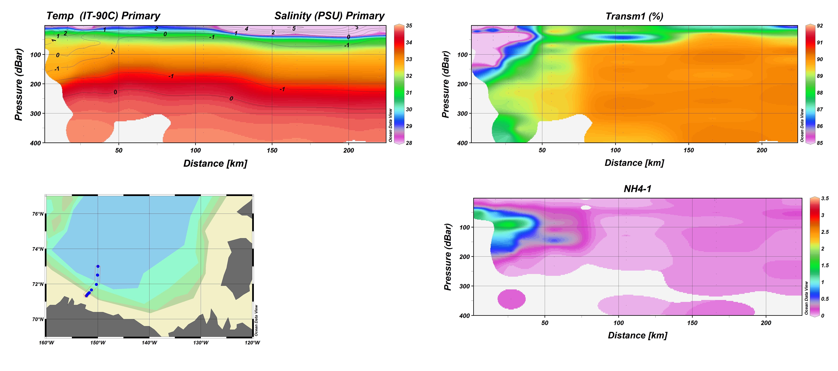
Figure 2. Temperature/Salinity, Transmissivity, and Ammonium along the BS Line, data collected in 2007 aboard the Louis S. St. Laurent 2007-20.

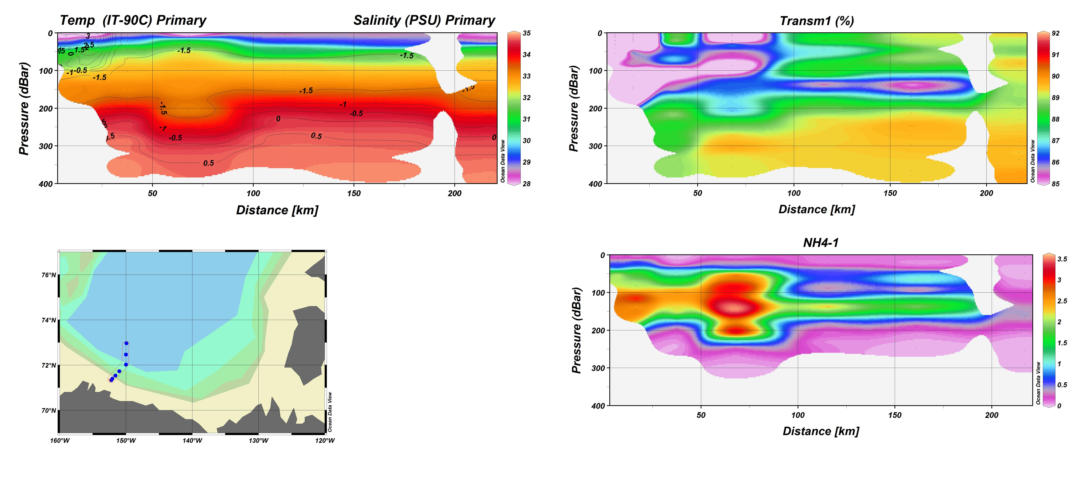

Figure 3. Temperature/Salinity, Transmissivity, and Ammonium along the BS line, data collected in 2006 aboard the Louis S. St. Laurent 2006-18.

