Ice Observations DRAFT
Jennifer Hutchings & Alice Orlich

Many thanks to Steve, Celine Guegen, Helen Drost, Kristina, Luc, Tim, Jenny, Sarah Zimmermann, Mike Dempsey for assistance in collecting ice data. The Ice Pick, Denis, provided much insight and discussion about ice types. We would especially like to thank the captain and crew of the Louis S. St. Laurent for making these ice observations possible.

Ice observations recording during the Louis S. St. Laurent 2007-20 cruise will provide detailed information for the interpretation of satellite imagery of the ice pack. Our objective was to identify the major sea ice zones in the Beaufort Sea and determine the types and state of ice in these zones. This information will be used to support a joint drifting-buoy, RADARSAT SAR, field and modeling campaign to investigate sea ice dynamics in the Beaufort Sea during winter 2006 to spring 2008. The project, “Sea ice tide-inertial interaction: Observations and Modeling” is funded by the National Science Foundation, with PIs Jenny Hutchings and Bill Hibler. The observations from this cruise will also support a field project “Detailed investigation of the dynamic component of the sea ice mass balance” during spring 2007, with PIs Jenny Hutchings, Jackie Richter-Menge and Cathy Geiger. We anticipate that the observations will be useful for investigating the evolution of the ice cover over the last two years when used in conjunction with satellite and buoy data.

The cruise occurred in August, providing a snapshot of ice conditions at the end of the 2007 melt season. Through out the cruise we experienced melt conditions, with grease ice and nilas only forming on clear dry nights. Caution should be taken in comparing the 2007 to 2006 observations, as the 2006 cruise occurred two weeks later in the season and we experienced the beginning of the freeze season at latitudes about 76N.

Observations from Bridge: Methodology
Every hour, while the ship was steaming and light conditions allowed, an observation of ice conditions was recorded. Each observation was made from the bridge, and photos were taken from the monkey island to document ice regions. These are available on request from Jennifer Hutchings.

A combination of ASPECT (Worby & Alison 1999), Standard Russian and Canadian Ice Service codes were used to describe ice conditions. The codes are described in detail below. During each observation period we estimated the total ice coverage within 3km of the ship (when visibility allowed), the types of ice present and the state of open water. For each ice type we estimate the coverage of that type, thickness, flow type, topography, sediment coverage, algae presence, snow type, snow thickness and stage of melt. There was space for detailed observations of three ice types (primary, secondary and tertiary) in the log sheets. We also recorded the codes for any other types of ice present that was at lower concentration than the three main types. We recorded basic meteorological phenomena of cloud coverage and type, visibility and precipitation.

Time
UTC Time was noted. Ship time was set to mountain time (UTC – 6 hours).

Ice Concentration
Ice concentration was estimated in tenths. Partial concentration of each type was estimate as the fractional coverage of the entire observation area (ice and water) in tenths.

Open Water
0 No openings
1 Small cracks
2 very narrow breaks <50m
3 Narrow breaks, 50-200m
4 Wide breaks, 200-500m
5 Very wide breaks, >500m
6 Leads
7 Polynya
8 Water broken only by scattered floes
9 Open sea

Snow and Ice Thickness
A 1.5m pole, painted with 10cm segments, was attached to the railing on the port side of level 500 on the ship. This pole could be viewed from the rear window on the bridge, and was used for gauging ice thickness as the ship overturned pieces of broken ice. The accuracy of each individual thickness measurement is +/- 10cm. It should be noted that the ship does not overturn the thicker pieces of ice fully, so this method can not be used to accurately gauge ice thicknesses greater than about 2m. We found that the ship also did not overturn ice that was 20-50cm, when steaming through 10/10 ice. As the navigator would prefer to steam in open water and thinner/more rotten ice, the thickness measurements will have bias in ice concentrations that are reduced.

Ice Type
10 Frazil
12 Grease
20 Nilas
30 Pancakes
40 Young Grey Ice 0.1-0.15m
50 Young Grey-White Ice 0.15-0.3m
60 First year <0.7m
70 First year 0.7-1.2m
80 First year >1.2m
65 First year, unknown thickness
75 Second year
85 Multiyear
90 Brash

Floe Size
1 Pancakes
2 New sheet ice
3 Brash / Broken Ice
4 Cake ice <20m
5 Small floes 20-100m
6 Medium floes 100-500m
7 Large floes 500-2000
8 Vast floes >2000m
9 Bergy Floes

Topography
Ridges and hummocks indicate the age and dynamic history of sea ice. We estimated topography of each ice type using ASPECT codes. These were chosen as they allow an areal coverage and ridge sail height to be noted. We found that the level of detail required by the coding of areal coverage and average sail height was greater than the eye could gauge. Hence, the areal coverage and sail height values should be used with caution. It would be best to rearrange the data into larger bins reflecting <30%, 30%-60% and >60% coverage. The sail height was difficult to estimate when spatial variability was high, and should only be used in a qualitative sense.

100 Level Ice
200 Rafted Pancakes
300 Cemented Pancakes
400 Finger Rafting
5xy New, unconsolidated ridges (no snow)
6xy New ridges filled with snow or a snow cover
7xy Consolidated ridges, no weathering
8xy Older, weathered ridges
x values:
areal coverage
0 0-10%
1 10-20%
2 20-30%
3 30-40%
4 40-50%
5 50-60%
6 60-70%
7 70-80%
8 80-90%
90 90-100%

y values:
average sail height
1 0.5m
2 1.0m
3 1.5m
4 2.0m
5 3.0m
6 4.0m
7 5.0m
Sediment
Areal coverage of sediment on the surface of each ice type was estimated

0 ice is clean
1 spots on few floes
2 patches > 20m
3 >1/3 ice covered s dirty

Ice Algae
As ice is overturned by ship, ice algae can either be seen in the bottom portion of the ice, or strands of algae are overturned with the ice.

0 no algae
1 <30% overturned ice has algae
2 30-60% has algae
3 >60% has algae
Snow Type
0 No snow observation
1 No snow, no ice or brash
2 Cold new snow, <1day old
3 Cold old snow
4 Cold wind-packed snow
5 New melting snow (wet new snow)
6 Old melting snow
7 Glaze
8 Melt slush
9 Melt ponds
10 Saturated snow
11 Sastrugi

No snow fall was observed during cruise. All ice was at advanced stage of melt (4 or 5) with melt slush and draining melt ponds. At our core sites we found the slush to be between 20 and 30cm thick.

Stage of Melt

Stage of melt coding is highly variable between observation systems. I choose to work with the Russian coding system, as this is the system I am most familiar with. The stage of melt has to be considered separately for each ice type, as younger and older ice melt are characterized by differing surface conditions.

Young Ice (incl. young first year ice)
0 No melt
1,2 Surface darkened, snow melt single thaw holes
3,4 Greatly disrupted surface thaw holes everywhere
5 Level ice completely melted. Only deeply seated in water remains, ridges still found.

First Year Ice
0 No melt (or pack freezing, young ice forming over thawholes)
1 Some puddles on surface. Ice braccia desctruction begun.
2 Surface darkened, snow partially melted. Big puddles, some melt ponds.
3 Melt ponds everywhere, some thaw holes. Ice is stage of drying, ice colour whitening.
4 Greatly disrupted ice. Thaw holes everywhere. Disruption of Braccia complete. Underwater ramps on ice cakes.
5 Rotten ice. Greatly melted formless blocks. Dark grey color, greatly watered.
Multiyear Ice
0 No melt (or pack freezing, young ice forming over melt ponds/thaw holes)
1 Snow melting on top of hummocks. Melt ponds / patches of wet snow in low places.
2 Some ponding, <40% melt ponds. Snow melting. Places with no snow may occur.
3 Well defined melt ponds everywhere. Connected freshwater output to cracks. Area of melted water on surface is decreased due to output.
4 Ice braccia cracked. Area of melted water on surface is decreased, <30%. Thaw holes.
5 Floes have become cracked and blocks, due to intensive melt. Rotten ice.

Ocean Colour
The ocean colour is apparent against ice draft and the keels of ridges. We noted whether the colour was blue, Turquoise (Tq) or green at the time of observation. Green indicates the presence of surface phytoplankton blooms. It should be noted that the surface water sinks under the fresh melt water in the transition across the ice edge, hence this method can not be used to track blooms further into the ice pack.

Cloud Cover
Visibility
90 < 50m
91 50-200m
92 200-500m
93 500-1000m
94 1-2km
95 2-4km
96 4-10km
97 >10km
-1 not available
Estimated in Octaves

Cloud Type
cu Cumulus
ci Cirrus
st Stratus
sc Strata-cumulus
fog Fog
Weather
We used codes provided by the AVOS system.

Cloud development
00 Clouds not observable/observed
01 Clouds dissolving or becoming less developed
02 State of sky as a whole unchanged
03 Clouds forming or developing

Fog/Precipitation during past hour but not at time of obs
20 Drizzle not freezing or snow grains
21 Rain not freezing or snow grains
22 Snow not freezing or snow grains
23 Rain and snow or ice pellets
24 Drizzle or rain, freezing
25 Showers of rain
26 Showers of snow, or of rain and snow
27 Showers of hail, or of rain and hail
28 Fog in past hour, not at present

Blowing or drifting snow
36 Drifting snow below eye level, slight/moderate
37 Drifting snow below eye level, heavy
38 Blowing snow, above eye level, slight/moderate
39 Blowing snow, above eye level, heavy

Fog/Mist
41 Fog in patches
42 Fog thinning in last hour, sky discernable
43 Fog thinning in last hour, sky not discernable
44 Fog unchanged in last hour, sky discernable
45 Fog unchanged in last hour, sky not discernable
46 Fog beginning/thickening in last hour, sky discernable
47 Fog beginning/thickening in last hour, sky not discernable
48 Fog depositing rime, sky discernable
49 Fog depositing rime, sky not discernable

Precipitation as drizzle
50 Slight drizzle, intermittent
51 Slight drizzle, continuous
52 Moderate drizzle, intermittent
53 Moderate drizzle, continuous
54 Dense drizzle, intermittent
55 Dense drizzle, continuous
56 Freezing drizzle, slight
57 Freezing drizzle, moderate or dense
58 Drizzle and rain, slight
59 Drizzle and rain, moderate or dense

Precipitation as rain, not showers
60 Slight rain, intermittent
61 Slight rain, continuous
62 Moderate rain, intermittent
63 Moderate rain, continuous
64 Heavy rain, intermittent
65 Heavy rain, continuous
66 Freezing rain, slight
67 Freezing rain, moderate or heavy
68 Rain or drizzle and snow, slight
69 Rain or drizzle and snow, moderate/heavy

Frozen precipitation, not showers
70 Slight fall of snow flakes, intermittent
71 Slight fall of snow flakes, continuous
72 Moderate fall of snow flakes, intermittent
73 Moderate fall of snow flakes, continuous
74 Heavy fall of snow flakes, intermittent
75 Heavy fall of snow flakes, continuous
76 Ice prisms, with/without fog
77 Snow grains, with/without fog
78 Isolated star like crystals
79 Ice pellets

Precipitation as showers
80 Slight rain showers
81 Moderate or heavy rain showers
82 Violent rain showers
83 Slight showers of rain and snow
84 Moderate/heavy showers of rain and snow
85 Slight snow showers
86 Moderate or heavy snow showers
87 Slight showers of soft or small hail
88 Moderate/heavy showers of soft/small hail
89 Slight showers of hail
90 Moderate or heavy showers of hail

Comments on Bridge Observing Methodology
As we did not have a continuous ice watch, the observations should not be used alone to estimate ice type coverage on scales smaller than 100km. The ship track and speed will introduce a bias into the type and thickness of ice overturned. Hence, although the sampling of thin and medium first year ice may be reasonable, thicker first year and multiyear ice will be under represented in thickness estimates. Poor visibility affects the area of ice observed, and could compound ship track bias in spatial coverage estimates.
It should also be noted that flat light conditions hinder the estimation of ridge height.

We found that the photographic record helped in consistency checking of the bridge ice observations. We placed two webcams on the monkey island to record ice automatically. However, due to poor resolution of the forward facing camara, we continued to take hourly photographs for our consistency checks.

Webcam Imagery
Two cameras were installed on the monkey island. Back on land, we will investigate whether the images from the cameras are useful for mapping ice types and concentration by an ice expert who does not attend the cruise. My inclination is that a lot of information is lost by the cameras, as they can not provide 360º vision, and can not be focused on a variety of ice features as the human eye can.

Camera 1 pointed forward on the port side of the ship, and took an image every 10 minutes. This provided a wide field view of the ice pack the ship was heading into. The second camera was trained on the “ice thickness pole” to observed overturning ice. In order to get a representative sample of overturned ice, this camera took pictures every 10 seconds. Both cameras were linked into the ship’s local area network (LAN), and images can be stored on any computer on this LAN that is running an FTP server. The NOAA server will be used in future for image storage. On this cruise Jenny Hutchings downloaded the images directly to my laptop. Anyone who is interested in these may contact Jenny.

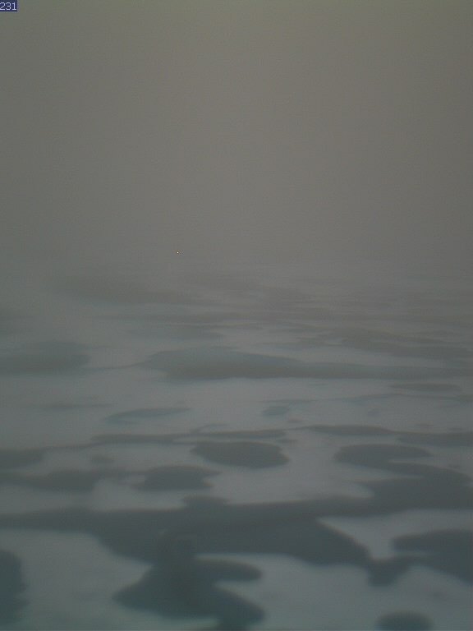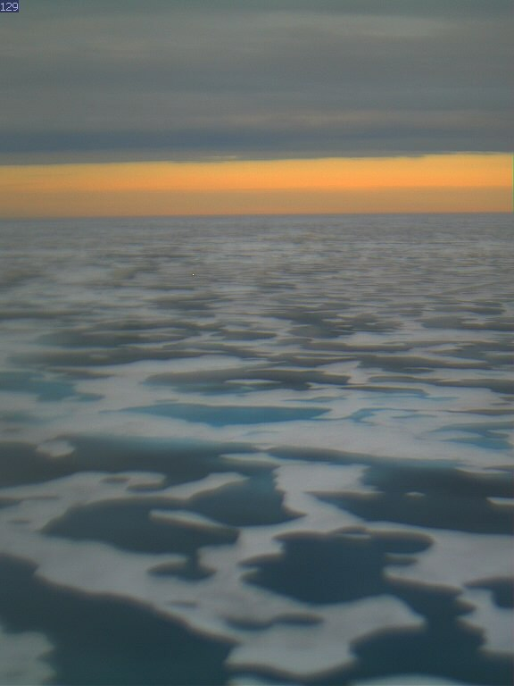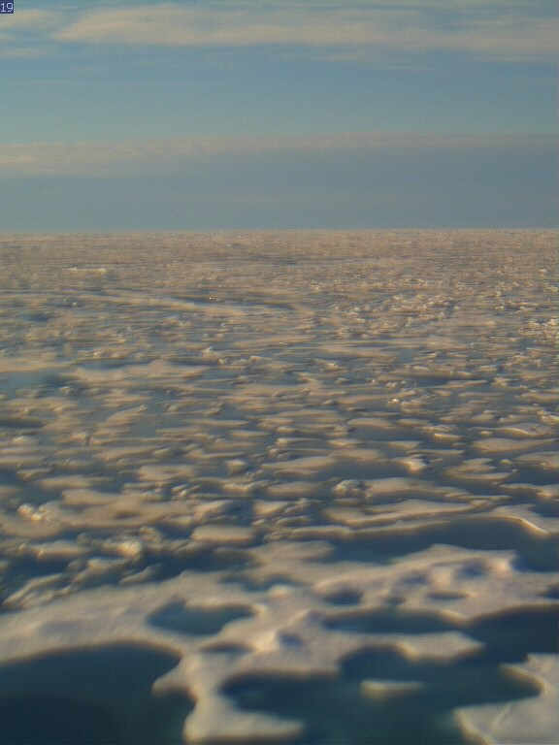
Camera 1 images from August 13th (left) 11:42 UTC, (middle) 12:32 UTC (right) 16:32 UTC. Notice how differing light conditions affect quality of image.

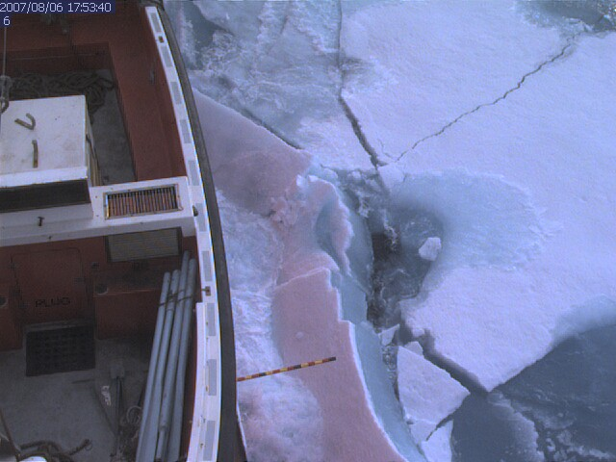

Example of an image from camera 2. We have not processed the ice thickness data from this camera as it will take considerable time. However, once the data is processed it will give us a much more representative estimate of pack ice thickness than our visual observations from the bridge.

We had a couple of small issues in setting up the camera system. First, the image size needs to be not too large, as the ships LAN can not support large file transfer. We found that images over 100 kbytes would become pixilated in file transfer. Second the netcam cameras do not have a small enough aperture for bright summer time pack ice photos. Hence most images from camera 1 are slightly blurry as they were over exposed. The fix to this problem would be a filter on the webcam lens.

Description of Ice Zones
Bringing together the suite of bridge observations taken during the cruise, preliminary maps of the main zones of ice in the Beaufort Sea during late summer 2007 are presented.

Physical Ice Properties
The following 3 figures need to be replaced with this years data.
Most prevalent sea ice types
Sea ice concentration
Figure 1:
First year ice yellow
Multi-year ice red
Mode of sea ice thickness
Figure 2:
10-40% blue
50-70% green
70-90% yellow
>90% red

Phytoplankton Blooms

Ice Algae Patches

Aerial Ice Observations
At various times during the cruise we had the opportunity to observe the ice cover from helicopter. In flying conditions when visibility was good, and the helicopter could travel at an altitude of 2000 feet, these flights were very helpful in extrapolating ship based observations to the wider field. During flights, notes were taken of ice coverage, distribution of types and state of melt. Photographs were taken as a record of ice conditions.

July 30th

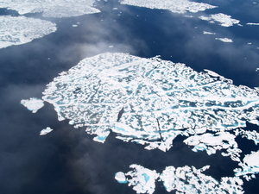
Multi-year ice at 73 30N 135W. Photograph was taken from 1600 feet elevation. The ice pack was unusually loose near to Banks Island, and consisted mainly of these vast floes, some of which were more than 20 miles diameter.

July 31st
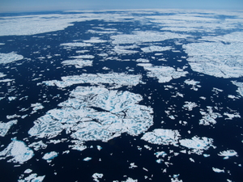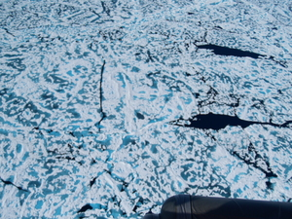
Vast, degrading multi-year ice floes at 71 30N 140W (left photograph, taken at 5000 feet). The photograph on the right was is from 2000 feet at 71 45N 140 02W.

August 5th
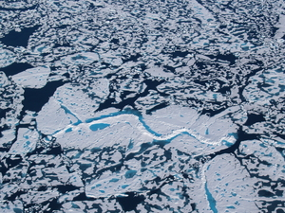
Example of ice pack between 74N and 75N at 150W.

August 6th
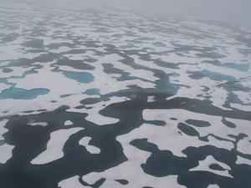
Fog hindered regional visualization. This photograph was taken in the vicinity of 75N 150W.

August 13th
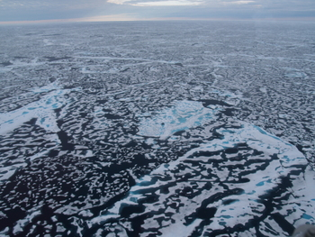
Ice pack at 78N 150W. Three types of ice existed: multi-year ice (about 2/10, which consisted mostly of rotten ridge remnants), younger ice (about 7/10, and appeared to be young multi-year, perhaps second year ice), and less than 1/10 bergy floes (see bottom left corner of photograph, where the bergy floes might be first year ice remnants).

August 18th
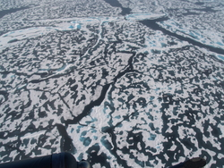
Pack ice at 76 56N 139 25W. This ice had very similar character to the ice observed in the west at 78N 140W. It appears that there is a continuous zone of young rotten multi-year ice in much of the northern Beaufort Sea. Only when we travel east to 133W do we exit this zone.

August 20th
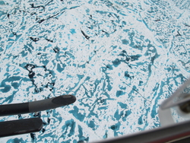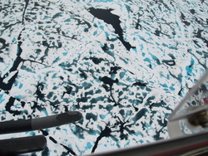

The photograph on the left shows typical multi-year ice in the vicinity of 75 40N 133W. Ten miles to the west of this multi-year ice the ice in the right photograph was predominant. Note that the ice to the west was more watered, show more advanced melt and was quite rotten. This was the vicinity of a clear boundary between ice types in RADARSat imagery. Both photographs where taken from 2000 feet elevation, and the regional ice concentration was 6/10 in both ice zones.

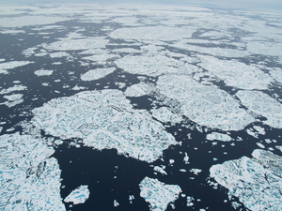
View of ‘eastern’ ice zone from 4000 feet.

August 21st
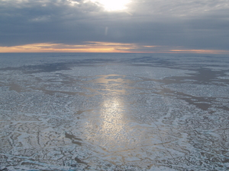
Ice pack at 75 38N 139 54W. The flight proceeded south-west, and quickly entered less concentrated ice. This was the start of the transition towards the southern ice edge.
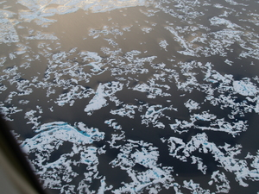
Pack, 6/10 concentration at 75 31N 139 56W.
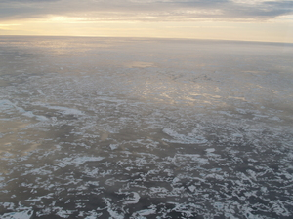
Ice at 75N 140W. Between the location of this photograph and the photograph above ice varied in cover between 4/10 and 6/10.

During future cruises it would be advantageous to have a camera mounted on the helicopter, pointing downwards with a coincident record of geodetic location and altitude. This could provide a record of ice conditions that could be used to estimate scale of features on the ice and would not take up a seat on the helicopter. The camera which has been used on the Louis helicopter was designed to mount in the cargo hold, and can only be used when there is no load in the hold. This is not an optimal situation for the work we do. It would be better to design a camera that is affixed to the exterior of the helicopter. However, this will require extensive flight testing.

Comments on ice type observations: A note of caution

During the majority of the cruise in the western Beaufort Sea we were traveling through very rotten ice in small flat floes. These had a smattering of obvious multi-year floes with hummucking and ridges scattered between them. In these regions we were confused as to whether the predominant ice type was first year, second year or very young multi-year ice. The melt ponding patterns and rotten character of the ice underside did not match with my experience of how first year ice looks at an advanced stage of melt. Some of the floes had uneven surfaces, suggesting they had experienced a previous melt season. However the majority of this ice type was remarkably flat. Occasionally we saw old ridges attached to ice that looked like the predominant type.

Unfortunately we did not acquire sufficient samples of the younger ice for salinity analysis. In order to type this ice it would have been useful to have several cores from it. We did not feel confident coring on this ice, which was in a very advanced stage of decay, even at 78N. To identify the age of the ice we plan to use the 2006 LSSL observations with buoy drift and deformation estimates. We should be able to map the transport of each region of ice throughout the winter of 2006/2007 and summer 2007.

Be aware that the ice type observations in our spread sheets and the Canadian Ice Service charts might be coded wrongly. The CIS charts identify the young ice type as thin to medium thinkness first year ice. We wavered between first year and second year type in our observations.

Ice Stations
Transects of ice thickness, snow depth and melt pond depth can provide additional information about ice conditions that is not possible to gauge with shipboard methods. Ice cores were taken to provide temperature and salinity profiles through the ice. We had two objectives for ice station work: (1) to determine the mean level ice thickness and variability at point locations during the cruise, and (2) to investigate surface melt conditions and to provide information about the progress of this summers melt. An important component of our ice station work was to compliment the deployment of a cluster of three ice drifting buoys that will monitor ice deformation (the IARC GPS drifters) around an Ice Mass Balance Buoy (in collaboration with Cold Regions Research and Engineering Laboratory and Woods Hole Institute) that will monitor the thermodynamic evolution of the multi-year ice in the center of the buoys array.

Table 1: Measurements and samples at each ice stations.
Ice Station | Date | Latitude | Longitude | # Cores | # thickness | Thickness transects | Melt Pond Depths | Other Samples
1 | 9-Aug | 74 40 | 151 21 | 1 | 8 | 1 | no | none
2 | 11-Aug | 78 21 | 154 02 | 2 | 7 | 1 | no | melt pond temp
3 | 13-Aug | 78 11 | 150 05 | 2 | 20 | 1 | yes | Celine: Melt pond
4 | 16-Aug | 78 56 | 139 58 | 2 | 11 | 2 | yes | Celine: Melt pond
5 | 17-Aug | 78 30 | 139 29 | 1 | 30 | 4 | yes | Biota

Ice Cores
August 9th: 74 40N 151 21W ITP recovery site.

One core was taken for T/S

August 11th: 78 21N 154 02W ITP deployment site

Core 1 taken for T/S. Unfortunately salinity samples of the top 230cm were contaminated by rust.
Core 2 taken by Celine and Steve for DOC and POC analysis

August 13th: 78 11N 150 05W ITP, IMB, flux buoy, IARC GPS deployment

Could not extract all of Core 1. Only temperatures were recorded for the part of the core we managed to extract.
Core 2 was taken for DOC analysis, though 10cm temperatures were recorded.

August 16th: 78 56N 139 58W ITP, IMB, flux buoy deployment

Core 1 taken for DOC analysis. Core 2 for T/S.

August 17th: 78 30N 139 29W ITP recovery site

One core taken for DOC analysis

Ice Thickness Measurements

August 9th

Distance (m) | Depth (cm) | freeboard(cm)
0 | 193
5 | 233
10 | 225 | 33
15 | 215 | 30
20 | 200 | 26
25 | 232 | 22
30 | 236 | 36
35 | 230 | 24
Mean | 220.5 | 28.5
Std.dev. | 16.2 | 5.4

August 11th

Distance (m) | Depth (cm) | freeboard(cm)
10 | 323 | 34
15 | 304 | 32
20 | 352 | 33
25 | 355 | 34
30 | 382 | 28
35 | 324 | 34
40 | 342 | 33
Mean | 340.3 | 32.3
Std.dev. | 25.7 | 2.3

August 13th

Distance (m) | Depth (cm) | freeboard(cm)
0 | 282 | 57
5 | 139 | 41
10 | 77 | 22
15 | 244 | 36
20 | 229 | 26
25 | 180 | 28
30 | 214 | 24
35 | 287 | 22
40 | 201 | 24
45 | 187 | 34
50 | 185 | 27
55 | 198 | 23
60 | 209 | 24
65 | 360 | 31
70 | 395 | 31
75 | 203
80 | 169 | 42
86 | 199 | 45
Mean | 219.9 | 31.6
Std. dev | 74.5 | 9.8
Site A (hummock) | 343 | 77
Site B (hummock peak) | ~550

August 16th
Two ice thickness transects were made, orthogonal to each other. The first transect ran parallel to a recent ridge, 40m from the ridge. The second transect ran perpendicular to the ridge, starting a few meters from the ridge.

Distance (m) | Depth (cm) | freeboard(cm)
0 | 286 | 36
10 | 324 | 43
20 | 333 | 46
30 | 288 | 44
40 | 291 | 47
50 | 301 | 35
0 | 205 | 24
10 | 346 | 26
20 | 322 | 32
30 | 324 | 37
37 | 333 | 46
Mean | 301.3 | 33.3
Std.dev. | 43.9 | 8.0

August 17th

A grid of ice thickness measurements was made. The grid consisted of three transects placed 10m apart, drill holes then being made every 10m along each transect. We ensured the transects ran parallel to each other by triangulating the first two drill hold positions to the adjacent transect with a 14.14m line and 10m line. Transects were sighted down a 100m survey tape.

X Distance (m) | Y Distance (m) | Depth (cm) | freeboard(cm) | melt pond depth (cm)
0 | 0 | 201 | 28
10 | 0 | 208 | 23
20 | 0 | 219 | 18
30 | 0 | 233 | 24
40 | 0 | 242 | 31
50 | 0 | 169 | 40 | 14
60 | 0 | 225 | 45 | 11
0 | 10 | 280 | 42
10 | 10 | 352 | 34
20 | 10 | 230 | 28
30 | 10 | 247 | 32
40 | 10 | 244 | 33
50 | 10 | 208 | 32
60 | 10 | 279 | 42
0 | 20 | 249 | 28
10 | 20 | 218 | 9
20 | 20 | 215 | 19
30 | 20 | 268 | 41
50 | 20 | 132 | 53 | 27
60 | 20 | 270 | 41
70 | 20 | 225 | 39
 | Mean | 234.0 | 32.5
 | Std.dev. | 44.3 | 10.4

A ridge ran roughly parallel to the three transect lines, about 15m from these. We place a transect line down the peak of the ridge. The ridge was found to be shallow, with large freeboard, but no evidence of voids. It was a heavily ablated ridge, probably over 2 years old.
Distance (m) | Ridge Depth (cm) | freeboard(cm)
0 | 312 | 83
10 | 371 | 100
20 | 276 | 36
30 | 287 | 78
40 | 252 | 49
50 | 194 | 16
60 | 257 | 47
70 | 331 | 90
80 | 376 | 79
Mean | 295.1 | 64.2
Std.dev. | 59.0 | 28.2
‘The Hump’  Ridge peak | 441 | 158

As the ship left the ice station, it broke the ice floe in a location centered on our transect grid. Ice thicknesses of blocks overturned were recorded from the bridge (1.5m, 2m, 1.2m). We also saw many smaller blokes of lower thickness that originated from the melt ponds on the floe. The ship had no trouble breaking the ice floe, treating it just like other multi-year floes that had been broken in the region.

Melt Pond Depth Measurements

On August 13 we estimated the depth of melt ponds from which we collected water samples for Celine. On August 16th and 17th melt pond depth transects were performed. We measured depth along several ponds every meter of the ponds length.

August 13th
Pond A: 10cm
Pond B: 10cm
Pond C: 19cm

August 16th

Depth of melt ponds A through H in cm, at given distances along pond. Note pond A was a connected system of ponds. Mean depth of all ponds measured was 9cm.
Distance (m) | A | B | C | D | E | F | G | H
1 | 9 | 7 | 5 | 20 | 7 | 7 | 6 | 13
2 | 8 | 3 |  | 10 | 8 | 12 |  | 15
3 | 12 | 7 |  | 10 | 6 | 11 |  | 17
4 | 22 | 2 |  | 9 | 5 | 9 |  | 14
5 | 27 | 3 |  | 7 | 0 |  |  | 0
6 | 20 |  |  |  | 3 |  |  | 9
7 | 14 |  |  |  | 2 |  |  | 14
8 | 13 |  |  |  | 5 |  |  | 7
9 | 20 |  |  |  | 0 |  |  | 0
10 | 24 |  |  |  | 8 |  |  | 0
11 | 14 |  |  |  | 15 |  |  | 15
12 | 5 |  |  |  | 18 |  |  | 14
13 | 7 |  |  |  | 26 |  |  | 9
14 | 10 |  |  |  | 35 |  |  | 15
15 | 10 |  |  |  |  |  |  | 9
16 | 12
17 | 14
18 | 8
19 | 9
20 | 10
21 | 14
22 | 16
23 | 17
24 | 16
25 | 8
26 | 22
27 | 21
28 | 23
29 | 23
30 | 22
31 | 21
32 | 23
33 | 20
34 | 21
35 | 12
Mean | 16 | 4 |  | 11 | 10 | 10 |  | 10

August 17th

Depth of melt ponds A through F in cm, at given distances along pond. The second columns for ponds C and F contain measurements taken from the center of these ponds. The mean depth of all ponds measured was 21cm.
distance (m) | A | B | C | C | D | E | F | F
1 | 24 | 7 | 10 |  | 7 | 22 | 9
2 | 22 | 6 | 11 | 39 | 22 |  | 20 | 37
3 | 18 | 3 | 10 | 40 |  |  | 9 | 18
4 | 12 | 3 | 12 | 42 |  |  | 11 | 17
5 | 20 | 9 | 14 | 40 |  |  | 14 | 21
6 | 22 | 10 | 20 | 41 |  |  | 26 | 19
7 | 19 |  | 23 | 41 |  |  | 17 | 20
8 | 22 |  | 21 | 42 |  |  | 14 | 20
9 | 22 |  | 24 | 38 |  |  | 12 | 16
10 | 24 |  | 23
11 | 33 |  | 24
12 | 23 |  | 25
13 | 24 |  | 24
14 | 22 |  | 25
15 | 26 |  | 28
16 | 22 |  | 27
17 |  |  | 29
18 |  |  | 32
19 |  |  | 36
20 |  |  | 33
21 |  |  | 36
22 |  |  | 38
23 |  |  | 39
24 |  |  | 41
25 |  |  | 40
Mean | 22 | 6 | 26 | 40 | 15 | 22 | 15 | 21

Sampling Dirty Ice

During the two legs between (76 09N, 133 03W), (75 49N, 127 08W) and (75 42N, 133 18W) dirty ice was recorded during each observation period. Arial estimates of the amount of ice affected were 1/10 during the helicopter flight on August 20th. We collected samples from two dirty ice floes on August 20th at 75 46N, 129 51W using the ship’s zodiac.

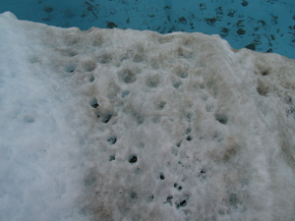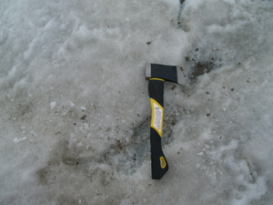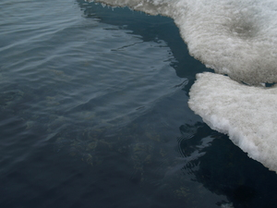

First floe:
Samples:
1) Collected blocks of ice from keel underwater, approximately 2ft deep.
2) Mud from surface of floe. The mud was in "puddles" about 4inches in diameter
3) Surface ice

Second floe:
Samples:
1) Surface ice from edge of floe
2) Surface ice from center of floe. Alice and Alfie got off boat onto ice.

GPS Buoy Deployment

The deployment of a GPS buoy ice deformation array was successfully completed. This buoy array will monitor pack ice strain rate of a 10mile square region which includes autonomous buoy site with Ice Mass Balance Buoy. The three IARC GPS drifters provide GPS position with 10 minute frequency.

On August 13th, 3 ice drifting GPS buoys were deployed in a 10 mile side square with an Ice Tethered Profiler, Ice Mass Balance Buoy and Heat Flux Buoy joint site comprising one corner of the square. The region of deployment, around 78N 150W, was covered with greater than 90% multi-year and young multi-year ice. All ice in the region was in an advanced stage of melt. In fact, there were relatively few multi-year floes without thaw holes to choose for deployment sites.

All buoys were placed on the most substantial multiyear floes we could find within one mile of the planned deployment location. It took 1 1/2 hours to deploy the array, roughly ½ hour per buoy. We spent 15-25 minutes on the ice at each buoy site, drilling two holes to measure ice thickness and anchor the buoy.

Table 1: Deployment locations of buoys in deformation array, with depth and freeboard of holes drilled to anchor each buoy.
Buoy ARGOS ID | Relative location | latitude | longitude | depth (cm) | freeboard (cm)
53538 | North West | 78 10.363 | 149 59.603 | 356 | 40
 |  |  |  | >400
IMB/ITP | South East | 77 59.99 | 149 08.761 | 235 | 42
 |  |  |  | 239 | 44
53537 | North East | 78 10.527 | 149 10.428 | 287 | 31
 |  |  |  | 270 | 28
53526 | South West | 77 58.380 | 150 00.883 | 271 | 47
 |  |  |  | 268 | 46

