IOS Winches used on board CCGS Louis S St-Laurent July-August 2007 and anticipated request for 2008
S Zimmermann
10 Dec 2007

The IOS Winch shop supplied the LSSL with two winches for the summer field season:

- 30 HP hydraulic power pack, power control box and remote control. Runs at 600V. Control box has 2.8m cable to connect to ship's power.
- SWANN Winch 410 s/n 1433 with 3140m of 3/16" steel wire with hardeye termination and 4m hoses to connect to power pack.
- Capstan Winch Model 390 S/N 1333 (Wire on winch not intended for use)
- Block and counter for hydro wire
- Spare Block (A20) and counter (ODC, s/n A20) for .316 CTD wire

Wire:
During set up in Halifax, insufficient information on the hydro-wire required us to send a section of wire out for a wire destruction test. Although the wire on the Capstan Winch had not been requested and was not intended for use we decided to have this wire tested as well. The tests were completed at Hercules SLR Inc the day before we sailed. Due to the mate’s strict reading of the wire-use requirements, Hercules SLR Inc was also required to come to the ship to perform the reterminations on both wires. Although fully booked, Hercules SLR made the time to perform the tests and reterminations in time for our sailing. The cost was approximately $250.

The hydro-wire winch was supplied with 3/16th steel wire. The insufficient documentation consisted of a photocopy of the metal tag that came with the wire spool. I believe the tag listed breaking strength of 3900 pounds and no date. The destruction test had a peak load of 3090 pounds before breaking. The wire was to be used for bongo nets, van veen and smith-mac grabs to 1000m and for lowering pumps to 3000m. The use had been planned assuming 3900 pound breaking strength.

HydroWinch:
Spooling problems were encountered throughout the 3000m casts requiring many adjustments of the diamond track to re-sync the spooling. Mike Dempsey can speak better to this as to weather this could have been caused by misalignment of the winch to the A-frame.

Past chaffing of the wire on the winch was pointed out mid-cruise. Its not clear when (what season?) this happened or if this is a problem. Pictures attached for documentation.

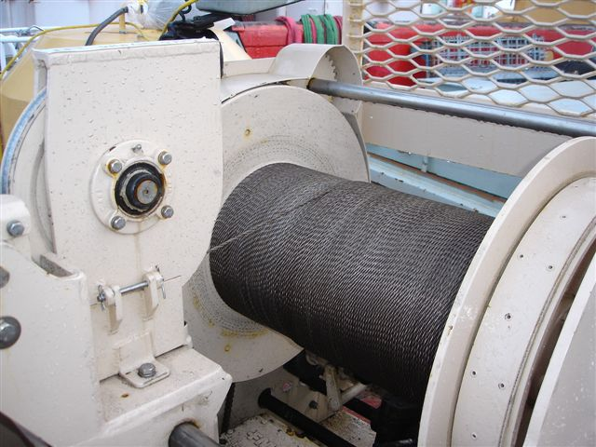
Figure 1. Hydro-wire Winch

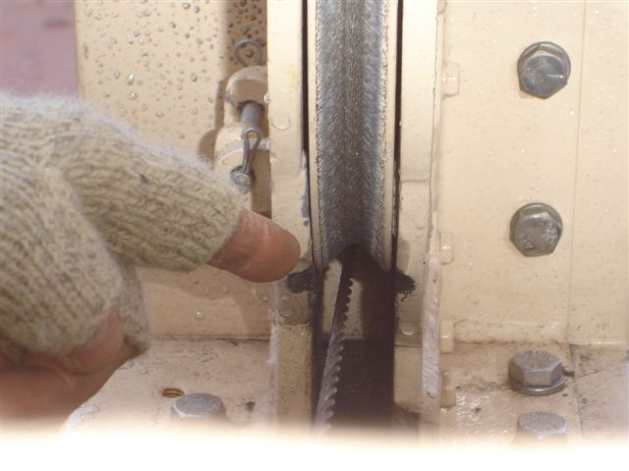
Figure 2. Chafing on edges

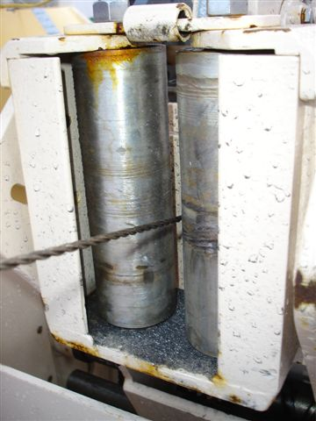
Figure 3. Chafing also on rollers

Request for 2008 LSSL

We require all documentation, tests and certifications for the equipment sent from IOS to the LSSL to comply with CG and ship safety regulations.

Not yet confirmed, but currently we anticipate the activities/needs below.

Desire working ratio of 1/5th the wire breaking strength and operating speeds of 60m/min.

Approximate dates: June 10 to Dec 10, 2008.

- Mooring recovery and redeployment (Shallow moorings of 110 and 10m length) – Capstan winch like ‘Blacky’ would be suitable.
- Dragging capability for the above moorings.
- Up to 8 pumps , total 730 pounds (91 lb each), to be lowered to 3800m
- Box- core work to ~ 4000m
- Bongo Nets to 500m
- Block to match wire on winch
- Counter on winch
- Cable between control unit and power pack needs to be long enough to reach across deck – length used in 2005-2007 still appropriate (10m?).
- Spare block with counter for .316 wire to replace ship’s existing CTD block if needed. Block with ‘cheek modification’ used from 2005-2007 would be ideal.

