Cruise report – Beaufort Gyre 2007
Luc Rainville, WHOI*
Email: lrainville@whoi.edu
Phone: 508-289-3321

Deep Canada Basin:
My main objective on this cruise was to deploy instruments on 2 of the 4 moorings of the Beaufort Gyre Exploration Project to study the variability of the deep Canada Basin. This is an IPY project that Dr. Mary-Louise Timmermans and I have funded through the Office of Polar Programs at the National Science Foundation.
We deployed an additional McLane Moored Profiler (MMP) on the deep portion of WHOI Mooring-A. The deep portion of Mooring D (is instrumented with 12 RBR TR-1050 temperature sensors, 2 RBR XR-420 Conductivity-Temperature (CT) sensors, 2 RBR XR-420 Conductivity-Temperature-Pressure (CTD) sensors, 1 SBE Microcat, and 2 Aanderaa RCM-11 Current Meters. The deployments were successful and we are looking forward to seeing the data next year.
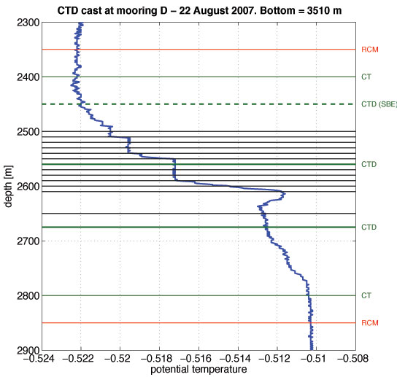
CTD profile (blue) at CB-21, the site where WHOI Mooring D is deployed. The depths where the different instruments we added are indicated by horizontal lines. Black lines are T sensors, green are CT or CTD sensors, and red are current meters.
Aerosol optical depth measurements:
During the cruise, I made aerosol optical depth measurements for Alexander Smirnov (Goddard Earth Sciences and Technology Center, University of Maryland, Baltimore County, asmirnov@aeronet.gsfc.nasa.gov). Dr. Smirnov provided me with a hand-held sunphotometer (Microtops II) that was used to acquire 152 solar scans. This instrument is specifically designed to measure columnar optical depth and water vapor content. To obtain the time and position of the measurements, the sunphotometer was connected to a hand-held GPS. The measurements were made only when the sun disk was completely free of clouds or fog.
Those measurements are important for several reasons: lack of knowledge on aerosol optical properties over the oceans; satellite remote sensing validation needs them; global aerosol transport models need the data; radiative forcing computations. We expect very little or no aerosol in the Arctic, but this is the first time direct measurements were taken from the Arctic Ocean. Filling the data gaps is the major point. Verifying the satellite aerosol estimates in the Arctic is crucial. These measurements will be important for comparison in the future.
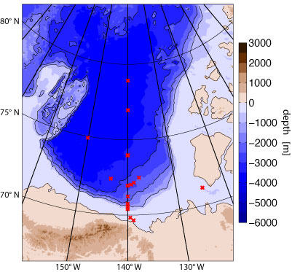 | 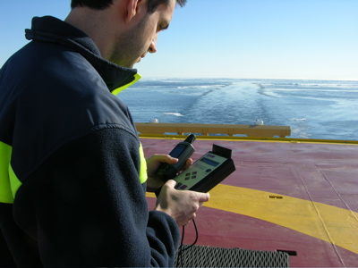
Map of the locations (red dots) of the aerosol optical depth measurements taken during the 2007 cruise. | Luc Rainville taking the aerosol measurements with the Microtops connected to the GPS unit.

Upper Ocean CTD casts with SBE19+:
During the cruise, Jennifer Jackson (UBC) and I led a side program in which 70 CTD profiles of the upper ocean were recorded using a small SBE19+ from the zodiac, the ship, and the ice. These measurements are described in more details by Jen and in a document left with the data.

