CTD Report

CCGS Louis S St-Laurent

IOS Cruise Number 2007-20
29 August 2007
Sarah Zimmermann

To be Continued:

The primary CTD system used on board was a Seabird SBE9+ CTD configured with a 24- position SBE-32 pylon and ice-strengthened rosette frame with 10L Niskin bottles fitted with internal stainless steel springs. The data were collected real-time using the SBE 11+ deckunit and computer running Seasave Win32 V 5.37d acquisition software. The CTD was set up with two temperature sensors, two conductivity sensors, two oxygen sensors, fluorometer, transmissometer, altimeter, a bottom contact switch and surface reference PAR. Early on during the cruise the secondary oxygen failed and was replaced by a secondary transmissometer. Casts shallower than 1000m typically also had a nitrate and PAR sensors.

A second CTD, SBE19+, used for casts from the zodiac. The internally recording SBE19+ CTD is configured with pumped temperature and conductivity. No water samples were taken during these casts.

During a typical deployment:
The transmissometer(s) windows and nitrate sensor window were wiped with deionized water soaked kimwipe or q-tip prior to each deployment. The PAR sensor was wiped periodically.
The package was lowered to 5m, taking a PAR measurement just below the surface if required. The pumps were turned on the system soaked for 3 minutes. The package was then brought up to just below the surface to begin a clean cast, and lowered to the 300m at 30m/m then increase speed to 60m/m. The casts were typically to the bottom. Niskin bottles were closed during the upcast without a stop. The instrumented sheave (Brook Ocean Technology) readouts to the winch operator, CTD operator and bridge allowed all three to monitor cable out, wire angle and CTD depth.

Improvements to the CTD system this year:
- The wire on the winch was adjusted so that it now lays correctly on the drum removing the wrapping problem experienced in 2006.
- A new CTD operation room. Due to the degradation of the existing CTD lab container, a new container lab was built to specifications for a functional space that opens (door and windows) to the work area. After the electrical wiring, GPS and LAN were in place this has proved to be a very nice lab space.
- All the auxillary channels were changed to wet-pluggable connectors from the normal impulse dry-plug connectors.

Data/Performance notes:

The SBE9+ CTD overall performance was good. Editing and calibration have not yet been done, but the data will likely meet or exceed the SBE9+ performance specifications given by Seabird. Header information of position, station name, depth have not been quality controlled yet. Salinity, oxygen, nitrate and chlorophyll-a were all sampled from the water and can be used to calibrate the sensors.

Problems were seen intermittently with Secondary Conductivity, Secondary Oxygen, bottom contact switch, perhaps due to cable problems. Conductivity reads 990 mS/cm and Oxygen values are all above 10ml/l.

PAR sensor had problems with leaking connector early in the program. The leak was at the PAR bulkhead cable interface (troublesome dry-plug connectors). The connectors as much as possible and reconnected. Effort was made to replace the PAR bulkhead connector with a wet-pluggle version (the sensor was opened up) but nothing was available in the right size. A week or so into the cruise the PAR bulkhead connector leaked again and the bulkhead connector pin burned through. Mike Dempsey had brought out a spare and replaced cable and bulkhead connector.

The Surface PAR sensor was located above the hanger near the incubation tanks. Comparisons with Ian Wrohan’s surface PAR will be possible.

The nitrate sensor required battery change once during the cruise. This was done before the sensor ran out of power so should not be noticed in the data.

Communication errors between computer and deck unit appear to be the fault of the com1 and com2 of the computer. Computer swapped out.

Photos:

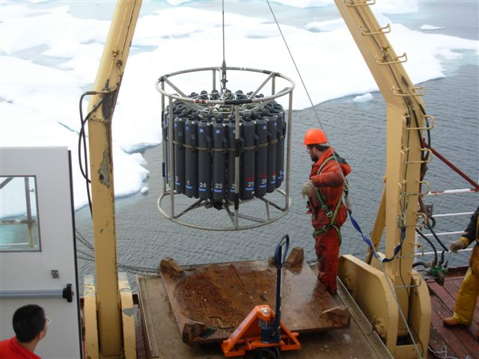

Figure 1. The 24-bottle rosette with the SBE9+ CTD is deployed by Mike Dempsey.

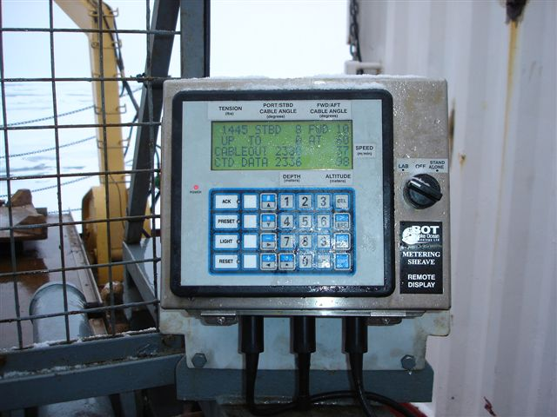

Figure 2. Integrated sheave and CTD display for winch operator.

