Table of Contents – Appendix
List of Tables – Appendix 2
1. SCIENCE PARTICIPANTS 3
2. LOCATION OF SCIENCE STATIONS 5
3. CTD SETUP SPECIFICATIONS 16
4. CTD CAST NOTES AND LIST OF INTERPOLATIONS 16
5. INDIVDUAL STATION PLOTS 17
Bacteria 17
6. PROPERTY PLOTS 36
7. SECTION PLOTS 38
8. Moorings 39
9. Ice Observations 43

List of Tables – Appendix
Table 1. Onboard Science Team 3
Table 2. Principal Investigators on Shore 4
Table 3. Affiliation Abbreviation 4
Table 4. CTD/Rosette Casts 5
Table 5. XCTD Casts 7
Table 6. XBT Casts 10
Table 7. XCP Casts 11
Table 8. Zooplankton Casts 12
Table 9. Vertical net casts 2007 - sampling locations. Key to net operators are HD (Helen Drost) and HM (Hugh Maclean). 13
Table 10. Large volume pump casts 15
Table 11. Comments on CTD Casts 16
Table 12. List of linear interpolations made to downcast CTD data. 16
Table 13. List of linear interpolations made to upcast CTD data. 16
Table 14. Property legend for the following individual station plots. 17
Table 15. Cast list within each group. 36

SCIENCE PARTICIPANTS
Table 1. Onboard Science Team
Person | Affiliation | Role
Sarah Zimmermann | DFO | Chief Scientist
Jane Eert | DFO | Co-Chief Scientist / CTD
Linda White | DFO | Nutrient Analysis
Kristina Brown | DFO | Ammonium Analysis
Michael Dempsey | DFO | Chief Technician /CTD
Mary Steel | DFO | Oxygen Analysis
Hugh Maclean | DFO | CTD
Helen Drost | DFO | Zooplankton/ CTD
Jennifer Jackson | UBC | POC Analysis
Céline Guéguen | Trent University | CDOM Analysis
Timothy Kane | DFO | CTD
Emile Didierjean | ULaval | Microbial DNA+RNA
Karen Scarcella | ULaval | Microbial DNA+RNA
Ian Wrohan | UVIC | Phytoplankton Filtration + Productivity Studies
Rick Nelson | DFO | Isotope Analysis
Motoyo Itoh | JAMSTEC | CTD/ XCTD
Richard Krishfield | WHOI | Moorings and Buoys
Kris Newhall | WHOI | Moorings and Buoys
Luc Rainville | WHOI | Moorings and Buoys
Steven Manganini | WHOI | Moorings and Buoys
Jim Dunne | WHOI | Moorings and Buoys
Jennifer Hutchings | IARC | Ice Observation
Alice Orlich | IARC | Ice Observation
Toshio Nagashima | ABC, Japan TV | Media
Yuko Mukahira | ABC, Japan TV | Media
Masakazu Nagata | ABC, Japan TV | Media

Table 2. Principal Investigators on Shore
Name | Affiliation | Program
Fiona McLaughlin | DFO | CTD and chemistry
Eddy Carmack | DFO | CTD and chemistry
Andrey Proshutinsky | WHOI | WHOI moorings
Koji Shimada | JAMSTEC | XCTD
Chris Guay | OSU | Barium samples
Bill Li | DFO | Bacteria samples
John Smith | DFO | Cs-137, I-129, Pu/Am samples
Russ Hopcroft | UAF | Zooplankton net tows
John Nelson | UVic/DFO | Zooplankton net tows
Igor Polyakov | IARC | CABOS mooring
Connie Lovejoy | ULaval | Microbial RNA/DNA samples
Diana Varela | UVic | Productivity samples

Table 3. Affiliation Abbreviation
ABC | Asahi Broadcasting Company
DFO | Department of Fisheries and Oceans, Canada
IARC | International Arctic Research Center, Alaska
JAMSTEC | Japan Agency for Marine-Earth Science Technology, Japan
OSU | Oregon State University, OR
UAF | University of Alaska Fairbanks, Alaska
UBC | University of British Columbia, BC
UVic | University of Victoria, BC
WHOI | Woods Hole Oceanographic Institution, Massachusetts

LOCATION OF SCIENCE STATIONS
Locations of CTD/Rosette, XCTD, XBT, XCP, zooplankton vertical net hauls and large volume pump casts are listed in the tables below.

Table 4. CTD/Rosette Casts
CTD Cast | Station | Latitude (N) | Longitude (W) | Cast Start Time (UTC) | Water Depth (+9m) | Water Depth (m) | Cast Depth (m) | Sample Numbers
1 | AG5 | 70.547 | 122.903 | 2007/07/28 14:16 | 634 | 643 | 150 | 1-20
2 | AG5 | 70.546 | 122.888 | 2007/07/28 15:47 | 614 | 623 | 618 | 21-43
3 | BI-1 | 73.858 | 127.345 | 2007/07/29 10:56 | 188 | 197 | 189+5 | 44-53
4 | BI-3 | 73.812 | 129.591 | 2007/07/29 16:49 | 1007 | 1016 | 1011+15 | 54-70
5 | BI-4 | 73.777 | 129.973 | 2007/07/29 19:51 | 1537 | 1546 | 1487+10m | 71-91
6 | BI-5 | 73.797 | 130.434 | 2007/07/29 23:00 | 2000 | 2009 | 2008+9m | 92-104
7 | BI-2 | 73.851 | 129.174 | 2007/07/30 02:50 | 490 | 499 | 491 dbar | 105-126
8 | BI-2 | 73.834 | 129.171 | 2007/07/30 05:19 | 485 | 494 | 232
9 | BI-2 | 73.824 | 129.197 | 2007/07/30 07:13 | 511 | 520 | 232 | 127-149
10 | BI-6 | 73.757 | 130.938 | 2007/07/30 12:02 | 2499 | 2508 | 2496+7 | 150-173
11 | BI-7 | 73.681 | 134.813 | 2007/07/31 00:31 | 3036 | 3045 | 2995+10m | 174-197
12 | CB23a | 72.897 | 136.009 | 2007/07/31 08:38 | 2729 | 2738 | 2742+7m | 198-221
13 | CB29 | 71.992 | 140.039 | 2007/07/31 21:09 | 2675 | 2684 |  | 222-233
14 | CB29 | 71.990 | 140.048 | 2007/07/31 22:13 | 2675 | 2684 |  | 234-257
15 | CB28b | 70.965 | 140.032 | 2007/08/01 08:51 | 2033 | 2042 | 653 | 258-280
16 | CB28b | 70.965 | 140.089 | 2007/08/01 11:06 | 2038 | 2047 | 2039+6 | 281-304
17 | MK-4 | 70.814 | 140.053 | 2007/08/01 15:25 | 1527 | 1536 | 1487+7m | 305-328
18 | MK-3 | 70.576 | 140.010 | 2007/08/01 18:42 | 753 | 762 | 815+9m | 329-352
19 | MK-3 | 70.577 | 140.033 | 2007/08/01 20:16 | 814 | 823
20 | MK-3 | 70.582 | 140.048 | 2007/08/01 21:10 | 861 | 870 |  | 353-376
21 | MK-3 | 70.572 | 140.000 | 2007/08/01 23:15 | 780 | 789 |  | 377-329
22 | MK-2 | 70.401 | 139.973 | 2007/08/02 01:25 | 500 | 509 |  | 400-423
23 | MK-1 | 70.230 | 140.002 | 2007/08/02 05:29 | 242 | 251 |  | 424-446
24 | CB28aa | 70.003 | 140.009 | 2007/08/02 08:36 | 49 | 58 | 53 | 447-451
25 | BL-1 | 71.326 | 152.218 | 2007/08/04 03:41 | unknown |  | 51 | 456-461
26 | BL-2 | 71.400 | 152.031 | 2007/08/04 04:43 | 144 | 153 | 146+9m | 462-473
27 | BL-2 | 71.401 | 152.040 | 2007/08/04 05:39 | 153 | 162 | 149 | 474-492
28 | BL-3 | 71.465 | 151.798 | 2007/08/04 07:27 | 557 | 566 | 567+10 | 493-515
29 | BL-4 | 71.502 | 151.657 | 2007/08/04 10:19 | 992 | 1001 | 1000+9 | 516-538
30 | BL-6 | 71.657 | 151.232 | 2007/08/04 13:11 | 2010 | 2019 | 2000+11 | 539-562
31 | BL-8 | 71.965 | 150.230 | 2007/08/04 17:37 | 2986 | 2995 | 2992+9 | 563-585
32 | BL-8 | 71.984 | 150.307 | 2007/08/04 19:50 | 2986 | 2995 |  | 586-609
33 | CB-2a | 72.499 | 150.044 | 2007/08/05 00:55 | 3681 | 3690 | 80 | 610-621
34 | CB-2a | 72.510 | 150.071 | 2007/08/05 02:12 | 3682 | 3691 |  | 622-645
35 | CB-2 | 72.998 | 149.979 | 2007/08/05 07:42 | 3736 | 3745 | 3737+10 | 646-669
36 | CB-3 | 73.985 | 149.976 | 2007/08/05 16:56 | 3815 | 3824 | 3815+19 | 670-693
37 | CB-4 | 74.924 | 150.133 | 2007/08/06 04:25 | 3818 | 3818 |  | 694-717
38 | CB-4 | 74.920 | 150.147 | 2007/08/06 09:05 | 3822 | 3831 | 76 | 718-729
39 | CB-4 | 74.918 | 150.158 | 2007/08/06 10:09 | 3819 | 3828 | 800 | 730-750
40 | RS-6 | 75.513 | 155.268 | 2007/08/07 08:16 | 3839 | 3848 | 3830 | 751-773
41 | RS-4 | 75.615 | 156.057 | 2007/08/07 13:32 | 2354 | 2363 | 2330 | 775-79
42 | RS-1 | 75.747 | 157.097 | 2007/08/07 17:26 | 979 | 988 | 304 | 799-821
43 | RS-1 | 75.747 | 157.097 | 2007/08/07 17:26 | 983 | 992 | 971 | 822-844
44 | RS-2 | 75.665 | 156.299 | 2007/08/07 23:31 | 1452 | 1461 | 1000 | 845-856
45 | RS-2 | 75.666 | 156.302 | 2007/08/08 01:02 | 1452 | 1461 | 1406 | 857-880
46 | CB-5 | 75.200 | 156.288 | 2007/08/08 01:02 | 3838 | 3847 | 1001 | 881-898
47 | CB-7 | 75.985 | 149.958 | 2007/08/09 09:31 | 3820 | 3829 | 3819 | 899-922
48 | CB-8 | 76.999 | 150.001 | 2007/08/09 18:23 | 3819 | 3828 | 3816 | 923-946
49 | CB-9 | 77.933 | 149.832 | 2007/08/10 04:00 | 3816 | 3825 | 5 | 947-950
50 | CB-9 | 77.935 | 149.827 | 2007/08/10 04:14 | 3816 | 3825 | 800 | 951-972
51 | CB-9 | 77.940 | 149.807 | 2007/08/10 05:53 | 3817 | 3826 | 1000 | 973-996
52 | CB-9 | 77.943 | 149.772 | 2007/08/10 07:20 | 3816 | 3825 | 3813 | 997-1020
53 | RN-6 | 78.354 | 152.615 | 2007/08/11 04:03 | 3513 | 3522 | 3446 | 1021-1044
54 | RN-4 | 78.343 | 153.130 | 2007/08/11 08:20 | 2564 | 2573 | 2614 | 1045-1068
55 | CB-10a2 | 78.341 | 153.490 | 2007/08/11 11:58 | 1840 | 1849 | 1000 | 1069-1092
56 | CB-10a2 | 78.351 | 153.469 | 2007/08/11 13:47 | 1912 | 1921 | 1880 | 1093-1116
57 | CB-10a | 78.322 | 154.044 | 2007/08/11 17:09 | 1014 | 1023 | 1000 | 1117-1139
58 | CB-10a | 78.329 | 154.012 | 2007/08/11 19:35 | 1051 | 1060 | 1037 | 1140-1163
59 | CB10aa | 78.337 | 154.323 | 2007/08/11 21:43 | 915 | 924 | 917 | 1164-1186
60 | CB11b | 79.989 | 150.012 | 2007/08/12 14:13 | 3811 | 3820 | 107 | 1187-1198
61 | CB11b | 79.992 | 149.990 | 2007/08/12 15:24 | 3811 | 3820 | 1001 | 1199-1221
62 | CB11b | 79.915 | 150.153 | 2007/08/12 20:28 | 3813 | 3822 | 3801 | 1222-1245
63 | CB11 | 78.999 | 150.031 | 2007/08/13 07:04 | 3822 | 3831 | 1000 | 1246-1264
64 | CB9a | 78.038 | 149.240 | 2007/08/14 00:53 | 3817 | 3826 | 1000 | 1265-1288
65 | CB-12 | 77.705 | 146.806 | 2007/08/14 06:44 | 3806 | 3815 | 3803 | 1289-1312
66 | CB-12 | 77.713 | 146.823 | 2007/08/14 08:06 | 3807 | 3816 | 3771 | 1313-1336
67 | CB-13 | 77.307 | 143.239 | 2007/08/14 16:28 | 3779 | 3788 | 5 | 1337-1341
68 | CB-15 | 76.998 | 140.186 | 2007/08/15 01:36 | 3725 | 3734 | 1000 | 1342-1363
69 | CB-15 | 76.999 | 140.187 | 2007/08/15 01:52 | 3725 | 3734 | 1001 | 1364-1387
70 | CB-15 | 77.033 | 140.247 | 2007/08/15 08:31 | 3728 | 3737 | 3722 | 1388-1411
71 | CB-15 | 77.041 | 140.254 | 2007/08/15 09:55 | 3728 | 3737 | 3742 | 1412-1435
72 | CB-16 | 77.994 | 140.016 | 2007/08/16 02:52 | 3747 | 3756 | 3742 | 1412-1435
72 | CB-16 | 77.998 | 140.023 | 2007/08/16 04:10 | 3747 | 3756 | 3742 | 1412-1435
73 | CB-16N | 78.952 | 139.942 | 2007/08/16 13:00 | 3763 | 3772 | 3761 | 1436-1459
74 | CB-16N | 78.938 | 139.950 | 2007/08/16 20:29 | 3763 | 3772 | 1000 | 1460-1483
75 | TK-1 | 78.734 | 138.904 | 2007/08/17 02:35 | 3749 | 3758 | 3747 | 1484-1507
76 | CB-15 | 76.968 | 140.074 | 2007/08/18 12:49 | 3717 | 3726 |  | 1508-1531
77 | LS-28 | 77.012 | 136.514 | 2007/08/19 02:05 | 3605 | 3614 | 3630 | 1532-1555
78 | PP-7 | 76.438 | 135.338 | 2007/08/19 10:42 | 3543 | 3552 | 1502 | 1556-1575
79 | PP-6.5 | 76.259 | 133.883 | 2007/08/19 14:06 | 3333 | 3342 | 5 | 1576-1599
80 | PP-6 | 76.123 | 132.482 | 2007/08/19 17:16 | 3030 | 3039 | 3015 | 1600-1623
81 | PP-4 | 75.953 | 130.013 | 2007/08/20 00:02 | 1980 | 1989 | 1956 | 1624-1647
82 | PP-2 | 75.845 | 128.642 | 2007/08/20 05:22 | 996 | 1005 | 999 | 1648-1670
83 | PP-2 | 75.837 | 128.708 | 2007/08/20 07:22 | 1020 | 1029 | 1025 | 1671-1693
84 | PP-1 | 75.846 | 127.793 | 2007/08/20 10:39 | 420 | 429 | 436 | 1694-1710
85 | CB-17 | 75.992 | 139.980 | 2007/08/21 09:17 | 3704 | 3704 | 301 | 1711-1722
86 | CB-17 | 75.984 | 139.986 | 2007/08/21 10:58 | 3688 | 3688 | 3686 | 1723-1746
87 | CB-17.5 | 75.650 | 139.717 | 2007/08/21 15:34 | 3693 | 3702 | 5 | 1747-1770
88 | CB-18 | 75.001 | 140.004 | 2007/08/21 19:58 | 3621 | 3630 | 3616 | 1771-1794
89 | CB-19W | 74.504 | 144.977 | 2007/08/22 06:57 | 3731 | 3740 | 3729 | 1795-1818
90 | CB-21 | 73.974 | 140.062 | 2007/08/22 22:32 | About |  | 3494 | 1819-1842
91 | CB-21 | 73.956 | 140.101 | 2007/08/23 06:12 | 3490 | 3499 | 3483 | 1843-1866
92 | CB-21 | 73.981 | 140.036 | 2007/08/23 11:24 | 3506 | 3515 | 1000 | 1867-1886
93 | CB-21 | 73.966 | 140.093 | 2007/08/23 13:02 | 3492 | 3501 | 5 | 1887-1890
94 | CB-21 | 73.967 | 140.088 | 2007/08/23 13:21 | 3493 | 3502 | 1000 | 1891-1912
95 | STA-A | 72.687 | 144.706 | 2007/08/24 05:35 | 3498 | 3507 | 3000 | 1913-1936
96 | STA-A | 72.674 | 144.747 | 2007/08/24 08:00 | 3498 | 3507 | 1000 | 1937-1960
97 | STA-A | 72.670 | 144.783 | 2007/08/24 09:08 | 3456 | 3465 | 401 | 1961-1984
98 | STA-A | 72.687 | 144.701 | 2007/08/24 10:46 | 3463 | 3472 | 1000 | 1985-2008
99 | STA-A | 72.688 | 144.697 | 2007/08/24 12:05 | 3463 | 3472 | 3458 | 2009-2032
100 | STA-A-E | 72.646 | 143.828 | 2007/08/24 16:26 | 3426 | 3435 | 3408 | 2033-2056
101 | STN-A95-CH | 73.000 | 145.351 | 2007/08/26 15:43 | 3561 | 3570 | 1000 | 2057-2080
102 | STN-A95-CH | 73.011 | 145.368 | 2007/08/26 17:13 | 3567 | 3576 | 3562 | 2081-2104
103 | CB-27 | 73.000 | 139.993 | 2007/08/27 03:42 | 3211 | 3220 | 3203 | 2105-2128
104 | CB-23a | 72.905 | 136.001 | 2007/08/27 11:38 | 2757 | 2766 | 1200 | 2129-2150
105 | CB-31b | 72.271 | 134.297 | 2007/08/27 18:08 |  |  | 1201 | 2151-2171
106 | CABOS | 71.831 | 131.798 | 2007/08/28 02:41 | 1111 | 1111 | 1000
107 | CABOS | 71.834 | 131.836 | 2007/08/28 03:46 | 1152 | 1161 | 1141 | 2172-2195

Table 5. XCTD Casts
XCTD Cast | Time (UTC) |  |  |  | Latitude (°N) |  | Longitude (°W) |  | Water Depth (m)
23 | 2007 | 7 | 29 | 05:35 | 73 | 01.13 | 129 | 08.55 | 645
24 | 2007 | 7 | 29 | 06:34 | 73 | 11.61 | 128 | 44.74 | 480
25 | 2007 | 7 | 29 | 08:36 | 73 | 32.37 | 127 | 53.68 | 197
26 | 2007 | 7 | 29 | 13:01 | 73 | 50.56 | 128 | 13.15 | 331
27 | 2007 | 7 | 30 | 16:01 | 73 | 45.35 | 132 | 27.11 | 2809*
28 | 2007 | 7 | 30 | 19:30 | 73 | 45.25 | 133 | 29.13
29 | 2007 | 7 | 31 | 05:37 | 73 | 20.23 | 135 | 22.17
30 | 2007 | 7 | 31 | 13:12 | 72 | 35.26 | 137 | 14.71 | 2604
31 | 2007 | 7 | 31 | 16:03 | 72 | 17.82 | 138 | 33.27 | 2585
32 | 2007 | 8 | 01 | 03:29 | 71 | 36.73 | 140 | 00.82 | 2490
33 | 2007 | 8 | 01 | 05:50 | 71 | 17.51 | 139 | 59.95 | 2294*
34 | 2007 | 8 | 01 | 14:21 | 70 | 45.29 | 140 | 00.58 | 1470
35 | 2007 | 8 | 02 | 11:35 | 70 | 25.99 | 140 | 52.86 | 443
36 | 2007 | 8 | 02 | 12:19 | 70 | 34.11 | 141 | 07.03 | 775
37 | 2007 | 8 | 02 | 13:43 | 70 | 50.63 | 141 | 35.97 | 2200
38 | 2007 | 8 | 02 | 15:24 | 71 | 01.49 | 142 | 37.63 | 2105
39 | 2007 | 8 | 02 | 17:48 | 71 | 28.79 | 143 | 42.58 | 3037
40 | 2007 | 8 | 02 | 19:28 | 71 | 28.08 | 144 | 57.12 | 2983
41 | 2007 | 8 | 02 | 20:59 | 71 | 31.25 | 146 | 08.72 | 3004
42 | 2007 | 8 | 02 | 22:31 | 71 | 37.34 | 147 | 19.74 | 2942
43 | 2007 | 8 | 03 | 00:21 | 71 | 45.69 | 148 | 36.03 | 2916
44 | 2007 | 8 | 03 | 01:57 | 71 | 54.52 | 149 | 50.30 | 2973
45 | 2007 | 8 | 03 | 04:26 | 72 | 09.81 | 151 | 42.80 | 2975
46 | 2007 | 8 | 03 | 05:39 | 71 | 56.36 | 152 | 18.51 | 2050
47 | 2007 | 8 | 03 | 06:40 | 71 | 47.22 | 152 | 45.41 | 1200
48 | 2007 | 8 | 03 | 06:57 | 71 | 45.05 | 152 | 51.36 | 800
49 | 2007 | 8 | 03 | 07:21 | 71 | 41.00 | 152 | 58.38 | 171
50 | 2007 | 8 | 03 | 07:49 | 71 | 38.28 | 153 | 09.13 | 67
51 | 2007 | 8 | 04 | 06:55 | 71 | 26.65 | 151 | 53.23 | 250
52 | 2007 | 8 | 04 | 12:21 | 71 | 33.97 | 151 | 28.09 | 1460
53 | 2007 | 8 | 04 | 17:36 | 71 | 48.66 | 150 | 48.15 | 2543
54 | 2007 | 8 | 05 | 13:29 | 73 | 29.24 | 150 | 04.63
55 | 2007 | 8 | 05 | 00:00 | 74 | 29.13 | 151 | 23.51
56 | 2007 | 8 | 06 | 22:42 | 74 | 45.05 | 150 | 08.80
57 | 2007 | 8 | 06 | 01:24 | 74 | 59.72 | 151 | 23.51
58 | NA
59 | 2007 | 8 | 07 | 04:53 | 75 | 20.14 | 154 | 22.40
60 | 2007 | 8 | 07 | 19:19 | 75 | 47.00 | 157 | 30.31
61 | 2007 | 8 | 08 | 02:51 | 75 | 38.01 | 156 | 07.82 | 2076
62 | 2007 | 8 | 08 | 04:04 | 75 | 34.76 | 155 | 56.06 | 3000
63 | 2007 | 8 | 09 | 07:01 | 75 | 30.18 | 149 | 59.26 | 3831
64 | 2007 | 8 | 09 | 15:12 | 76 | 29.87 | 149 | 57.39 | 3832
65 | 2007 | 8 | 10 | 01:05 | 77 | 29.21 | 149 | 57.39
66 | 2007 | 8 | 11 | 01:08 | 78 | 9.593 | 151 | 04.84
67 | 2007 | 8 | 11 | 07:48 | 78 | 20.84 | 153 | 02.25 | 2900
68 | 2007 | 8 | 11 | 10:56 | 78 | 20.84 | 153 | 46.56 | 2361
69 | 2007 | 8 | 11 | 16:10 | 78 | 20.93 | 153 | 46.56
70 | 2007 | 8 | 12 | 00:22 | 78 | 28.42 | 153 | 45.25 | 1964
71 | NA
72 | 2007 | 8 | 12 | 01:57 | 78 | 37.77 | 153 | 24.08 | 3294
73 | 2007 | 8 | 12 | 04:18 | 78 | 57.76 | 152 | 36.54 | 3632
74 | 2007 | 8 | 12 | 07:36 | 79 | 19.08 | 151 | 35.54 | 3830
75 | 2007 | 8 | 12 | 07:36 | 79 | 19.74 | 151 | 35.33 | 3830
76 | 2007 | 8 | 12 | 10:00 | 79 | 39.41 | 150 | 54.59 | 3820
77 | 2007 | 8 | 13 | 02:37 | 79 | 30.01 | 150 | 05.24 | 3826
78 | 2007 | 8 | 13 | 04:59 | 79 | 16.67 | 150 | 02.61 | 3828
79 | 2007 | 8 | 13 | 10:34 | 78 | 40.45 | 150 | 02.66 | 3832
80 | 2007 | 8 | 13 | 13:04 | 78 | 20.71 | 150 | 02.77 | 3827
81 | 2007 | 8 | 14 | 04:12 | 77 | 54.14 | 148 | 19.00 | 3826
82 | 2007 | 8 | 14 | 13:41 | 77 | 28.75 | 145 | 02.88 | 3802
83 | 2007 | 8 | 14 | 22:50 | 77 | 09.13 | 141 | 38.58
84 | 2007 | 8 | 15 | 22:53 | 77 | 30.24 | 140 | 00.68
85 | 2007 | 8 | 16 | 08:51 | 78 | 29.02 | 140 | 01.01 | 3771
86 | 2007 | 8 | 17 | 21:25 | 76 | 49.48 | 138 | 15.38
87 | 2007 | 8 | 19 | 07:01 | 76 | 42.46 | 135 | 52.92 | 3614
88 | 2007 | 8 | 19 | 14:24 | 76 | 31.64 | 136 | 28.64 | 3430
89 | 2007 | 8 | 19 | 22:10 | 76 | 01.00 | 132 | 02.00 | 2535
90 | 2007 | 8 | 20 | 03:30 | 75 | 50.48 | 129 | 21.10 | 1506
91 | 2007 | 8 | 20 | 09:42 | 75 | 49.08 | 128 | 15.73 | 548
92 | 2007 | 8 | 20 | 17:42 | 75 | 38.26 | 130 | 16.54 | 1881
93 | 2007 | 8 | 20 | 18:16 | 75 | 38.06 | 130 | 40.94 | 2111
94 | 2007 | 8 | 20 | 20:06 | 75 | 35.02 | 131 | 31.32 | 2557
95 | 2007 | 8 | 20 | 22:44 | 75 | 42.15 | 132 | 38.82 | 3006
96 | 2007 | 8 | 21 | 00:20 | 75 | 42.35 | 133 | 18.87 | 3183
97 | 2007 | 8 | 21 | 01:06 | 75 | 45.52 | 134 | 16.82 | 3379
98 | 2007 | 8 | 21 | 02:19 | 75 | 47.81 | 135 | 06.07 | 3459
99 | 2007 | 8 | 21 | 04:16 | 75 | 53.32 | 136 | 40.25 | 3577
100 | 2007 | 8 | 21 | 06:25 | 75 | 54.91 | 138 | 12.75 | 3638
101 | 2007 | 8 | 21 | 16:42 | 75 | 30.74 | 139 | 49.38 | 3693
102 | 2007 | 8 | 22 | 01:22 | 74 | 52.97 | 141 | 40.30
103 | 2007 | 8 | 22 | 04:05 | 74 | 43.38 | 143 | 23.59
104 | 2007 | 8 | 22 | 12:09 | 74 | 18.34 | 143 | 22.74 | 3704
105 | 2007 | 8 | 22 | 14:55 | 74 | 10.42 | 141 | 42.55 | 3645
106 | 2007 | 8 | 23 | 21:41 | 73 | 37.90 | 141 | 10.80
107 | 2007 | 8 | 24 | 00:04 | 73 | 17.13 | 142 | 12.90 | 3526
108 | 2007 | 8 | 24 | 02:23 | 72 | 56.81 | 143 | 20.25 | 3453
109 | 2007 | 8 | 24 | 16:14 | 72 | 38.78 | 143 | 49.97 | 3427
110 | 2007 | 8 | 24 | 20:39 | 72 | 09.47 | 143 | 21.93 | 3221
111 | 2007 | 8 | 24 | 23:32 | 71 | 40.81 | 143 | 13.14
112 | 2007 | 8 | 25 | 02:40 | 70 | 58.66 | 142 | 33.60 | 1897
113 | 2007 | 8 | 25 | 04:03 | 70 | 50.36 | 141 | 37.50 | 1980
114 | 2007 | 8 | 25 | 05:05 | 70 | 37.90 | 141 | 06.22 | 1052
115 | 2007 | 8 | 25 | 23:38 | 70 | 25.67 | 140 | 00.43 | 550
116 | 2007 | 8 | 26 | 01:49 | 70 | 56.79 | 140 | 00.21 | 2018
117 | 2007 | 8 | 26 | 11:26 | 71 | 58.76 | 145 | 17.96 | 3340
118 | 2007 | 8 | 27 | 01:39 | 73 | 02.61 | 138 | 04.91 | 3387
119 | 2007 | 8 | 27 | 08:15 | 72 | 56.67 | 138 | 04.91 | 2878
120 | 2007 | 8 | 27 | 16:22 | 72 | 18.27 | 135 | 12.00
121 | 2007 | 8 | 27 | 21:23 | 72 | 00.74 | 132 | 48.60
122 | 2007 | 8 | 28 | 06:39 | 71 | 35.35 | 131 | 05.90 | 605
123 | 2007 | 8 | 28 | 07:18 | 71 | 27.90 | 130 | 44.69 | 267
* data error below 500m

Table 6. XBT Casts
XBT Cast | Time (UTC) |  |  |  | Latitude (°N) |  | Longitude (°W) |  | Water Depth (m) | Comment
50 | 2007 | 8 | 01 | 3:40 | 71 | 36.73 | 140 | 00.82 | 2480 | bad data
51 | 2007 | 8 | 01 | 3:40 | 71 | 36.73 | 140 | 00.82 | 2480 | bad data
52 | 2007 | 8 | 01 | 3:47 | 71 | 36.73 | 140 | 00.82 | 2480 | bad data
53 | 2007 | 8 | 01 | 3:48 | 71 | 36.73 | 140 | 00.82 | 2480
54 | 2007 | 8 | 01 | 5:50 | 70 | 55.44 | 140 | 10.36 | 1861 | failed 500m
55 | 2007 | 8 | 01 | 13:25 | 70 | 39.48 | 140 | 00.81 | 1297 | bad data
56 | 2007 | 8 | 01 | 17:39 | 70 | 38.97 | 140 | 00.98 | 1297
NA
58 | 2007 | 8 | 02 | 0:39 | 70 | 28.29 | 139 | 59.94 | 650
59 | 2007 | 8 | 02 | 4:40 | 70 | 18.94 | 139 | 59.98 | 450 | bad data
60 | 2007 | 8 | 02 | 4:47 | 70 | 18.94 | 139 | 59.98 | 450 | failed 500m
NA
62 | 2007 | 8 | 02 | 7:05 | 70 | 08.56 | 140 | 00.47 | 110
NA
64 | 2007 | 8 | 02 | 7:05 | 70 | 08.56 | 140 | 00.47 | 110
NA
66 | 2007 | 8 | 02 | 7:33 | 70 | 05.23 | 140 | 00.34 | 80
67 | 2007 | 8 | 02 | 7:36 | 70 | 05.23 | 140 | 00.34 | 80
NA
69 | 2007 | 8 | 24 | 14:47 | 72 | 41.56 | 144 | 35.42 |  | failed 150m
70 | 2007 | 8 | 24 | 14:59 | 72 | 40.80 | 144 | 29.00 |  | failed 300m
71 | 2007 | 8 | 24 | 15:09 | 72 | 40.79 | 144 | 23.04 |  | failed 200m
72 | 2007 | 8 | 24 | 15:28 | 72 | 40.32 | 144 | 11.33 |  | failed 150m
73 | 2007 | 8 | 24 | 15:43 | 72 | 39.69 | 144 | 02.60 |  | failed 300m
74 | 2007 | 8 | 24 | 16:20 | 72 | 38.77 | 143 | 49.76
75 | 2007 | 8 | 25 | 07:13 | 70 | 09.56 | 139 | 59.93
76 | 2007 | 8 | 25 | 21:57 | 70 | 10.20 | 140 | 00.00 | 58
77 | 2007 | 8 | 25 | 22:01 | 70 | 16.80 | 140 | 00.00 | 58
78 | 2007 | 8 | 25 | 22:50 | 70 | 13.80 | 140 | 00.00 | 270
79 | 2007 | 8 | 25 | 23:10 | 70 | 14.92 | 140 | 00.13 | 300
80 | 2007 | 8 | 26 | 00:17 | 70 | 34.36 | 140 | 00.39 | 771
81 | 2007 | 8 | 26 | 01:00 | 70 | 44.88 | 140 | 00.08 | 1479
82 | 2007 | 8 | 26 | 20:29 | 73 | 01.92 | 144 | 52.05
83 | 2007 | 8 | 26 | 21:51 | 73 | 05.30 | 144 | 07.87
84 | 2007 | 8 | 26 | 21:56 | 73 | 05.27 | 144 | 04.57 | 1675
85 | 2007 | 8 | 26 | 23:00 | 73 | 00.45 | 143 | 28.64
NA
87 | 2007 | 8 | 27 | 07:30 | 71 | 24.87 | 130 | 39.96 | 377
88 | 2007 | 8 | 27 | 07:46 | 71 | 23.71 | 130 | 32.23 | 84

Table 7. XCP Casts
XCP Event No. | Time (UTC) | Latitude (°N) |  | Longitude (°W) |  | Bottom Depth (m) | Comment
CP-1 | 2007/07/29 21:20 | 73 | 46.777 | 129 | 59.294 | 1976 | Serial #07011002; from ship; FAILED
CP-2 | 2007/08/01 16:03 | 70 | 48.889 | 140 | 4.46 | 1528 | Serial #07011008; from FRC
CP-3 | 2007/08/04 06:32 | 71 | 24.54 | 152 | 2.659 | 174 | Serial #07011005; from ship; slip-line caught
CP-4 | 2007/08/04 11:58 | 71 | 33.071 | 151 | 28.9 | 1453 | Serial #07011009; from ship
CP-5 | 2007/08/04 22:09 | 72 | 0.089 | 150 | 21.725 | 3052 | Serial #07021003; from ship
CP-6 | 2007/08/05 19:02 | 73 | 59.504 | 150 | 1.911 | 3827 | Serial #07031002; from FRC
CP-7 | 2007/08/07 23:39 | 75 | 39.97 | 156 | 17.859 | 1448 | Serial #07031004; from FRC
CP-8 | 2007/08/13 21:13 | 78 | 1.313 | 149 | 12.067 | 3825 | Serial #07031006; from ice
CP-9 | 2007/08/16 21:05 | 78 | 55.841 | 139 | 58.603 | 3772 | Serial #07031007; from ice
CP-10 | 2007/08/20 15:15 | 75 | 45.978 | 129 | 51.981 | 1680 | Serial #07031024; from FRC

Table 8. Zooplankton Casts
Net event | Station Name | CTD Cast No. | Date (UTC) | Time (UTC) | Approx Max Net Depth (m) | Approx Water Depth (m) | Biomass Sample | Cast done by | Notes
1 | BI-2 | 7 | 7/30/2007 | 4:30 | 100 | 500 |  | HM
2 | BI-2 | 7 | 7/30/2007 | 5:00 | 100 | 500 | 6a | HM | Flow meter #4 (53um) broken (see log book)
3 | BI-6 | 10 | 7/30/2007 | 12:50 | 100 | 2513 |  | HD
4 | BI-6 | 10 | 7/30/2007 | 13:03 | 100 | 2513 | 6b | HD | no wash down and 150 µm codend had a crack in top (replaced it)
5 | CB28b | 16 | 1/8/2007 | 10:20 | 100 | 2055 |  | HD
6 | CB28b | 16 | 1/8/2007 | 10:35 | 100 | 2055 | 6c | HD
7 | MK-2 | 22 | 2/8/2007 | 2:35 | 100 | 533 |  | HM
8 | MK-2 | 22 | 2/8/2007 | 2:50 | 100 | 533 | 6f | HM
9 | MK-1 | 23 | 2/8/2007 | 6:15 | 100 | 252 |  | HD
10 | MK-1 | 23 | 2/8/2007 | 6:30 | 100 | 252 | 3a,3b | HD
11 | BL-2 | 27 | 4/8/2007 | 4:53 | 100 | 169 |  | HM
12 | BL-2 | 27 | 4/8/2007 | 5:15 | 100 | 169 | 3c, 3d | HM
13 | BL-4 | 29 | 4/8/2007 | 10:43 | 100 | 1011 |  | HD
14 | BL-4 | 29 | 4/8/2007 | 10:57 | 100 | 1011 | 3e, 3f | HD
15 | BL-8 | 32 | 4/8/2007 | 20:16 | 100 | 3004 |  | HM
16 | BL-8 | 32 | 4/8/2007 | 20:30 | 100 | 3004 | 4a | HM
17 | CB-2 | 35 | 5/8/2007 | 14:30 | 100 | 3754 |  | HD
18 | CB-2 | 35 | 5/8/2007 | 14:38 | 100 | 3754 | 4b | HD
19 | CB-4 | 37 | 6/8/2007 | 5:00 | 100 | 3838 |  | HM
20 | CB-4 | 37 | 6/8/2007 | 5:15 | 100 | 3838 | 4c | HM
21 | RS-4 | 41 | 7/8/2007 | 14:42 | 100 | 2358 |  | HD
22 | RS-4 | 41 | 7/8/2007 | 15:00 | 100 | 2358 | 4d | HD
23 | CB-8 | 48 | 9/8/2007 | 21:45 | 100 | 3837 |  | HM
24 | CB-8 | 48 | 9/8/2007 | 22:00 | 100 | 3837 | 4e | HM
25 | CB-9 | 50 | 10/8/2007 | 7:30 | 100 | 3838 |  | HD
26 | CB-9 | 50 | 10/8/2007 | 7:45 | 100 | 3838 | 4f | HD
27 | RN-6 | 53 | 11/8/2007 | 4:35 | 100 | 3526 |  | HM
28 | RN-6 | 53 | 11/8/2007 | 4:47 | 100 | 3526 | 2a | HM
29 | CB-10a2 | 55 | 11/8/2007 | 12:02 | 100 | 1841 |  | HD
30 | CB-10a2 | 55 | 11/8/2007 | 12:40 | 100 | 1841 | 2b | HD
31 | CB-15 | 71 | 15/08/07 | 11:15 | 100 | 3737 |  | HD
32 | CB-15 | 71 | 15/08/07 | 11:30 | 100 | 3737 | 2c | HD
33 | CB-16 | 72 | 16/08/07 | 3:38 | 100 | 3758 |  | HD
34 | CB-16 | 72 | 16/08/07 | 3:50 | 100 | 3758 | 2d | HD
35 | CB-15 | 76 | 18/8/07 | 12:16 | 500 | 3737 |  | HD
36 |  |  |  |  |  | 9 |  |  | this event number was skipped
37 | PP-4 | 81 | 20/8/07 | 103 | 100 | 1990 |  | HM
38 | PP-4 | 81 | 20/8/07 | 123 | 100 | 1990 |  | HM
39 | PP-4 | 81 | 20/8/07 | 137 | 100 | 1990 | 2e | HM
40 | PP-1 | 84 | 20/8/07 | 1100 | 100 | 447 |  | HD
41 | PP-1 | 84 | 20/8/07 | 1117 | 100 | 447 | 2f | HD
42 | CB-18 | 88 | 21/8/07 | 2037 | 100 | 3630 |  | HM
43 | CB-18 | 88 | 21/8/07 | 2049 | 100 | 3630 | 5a | HM
44 | CB-21 | 91 | 23/8/07 | 643 | 100 | 3499 |  | HD | 15-20 knot wind and stopped at 40meters going up as net was under ship for ~ 2 mins
45 | CB-21 | 91 | 23/8/07 | 648 | 100 | 3499 | 5b | HD | no angle on 2nd cast - wind dropped
46 | Stn A | 99 | 24/8/07 | 1225 | 100 | 3507 |  | HD
47 | Stn A | 99 | 24/8/07 | 1242 | 100 | 3507 | 5c | HD
48 | CABOS | 107 | 27/8/07 | 412 | 100 | 1176 |  | HM
49 | CABOS | 107 | 27/8/07 | 427 | 100 | 1176 | 5d | HM

Table 9. Vertical net casts 2007 - sampling locations. Key to net operators are HD (Helen Drost) and HM (Hugh Maclean).
Net event | Station Name | CTD cast # | Date (UTC) | Time (UTC) | Approx. Max Net Depth (m) | Approx. Water Depth (m) +9 | Biomass Sample | Cast done by | Notes
1 | BI-2 | 7 | 7/30/07 | 4:30 | 100 | 491 |  | HM
2 | BI-2 | 7 | 7/30/07 | 5:00 | 100 | 491 | 6a | HM | Flow meter #4 (53um) broken (see log book
3 | BI_6 | 10 | 7/30/07 | 12:50 | 100 | 2504 |  | HD
4 | BI_6 | 10 | 7/30/07 | 13:03 | 100 | 2504 | 6b | HD | no wash down and 150 codend had a crack in top (replaced it)
5 | CB28b | 16 | 1/08/07 | 10:20 | 100 | 2046 |  | HD
6 | CB28b | 16 | 1/08/07 | 10:35 | 100 | 2046 | 6c | HD
7 | MK-2 | 22 | 2/08/07 | 2:35 | 100 | 524 |  | HM
8 | MK-2 | 22 | 2/08/07 | 2:50 | 100 | 524 | 6f | HM
9 | MK-1 | 23 | 2/08/07 | 6:15 | 100 | 243 |  | HD
10 | MK-1 | 23 | 2/08/07 | 6:30 | 100 | 243 | 3a,3b | HD
11 | BL-2 | 27 | 4/08/07 | 4:53 | 100 | 160 |  | HM
12 | BL-2 | 27 | 4/08/07 | 5:15 | 100 | 160 | 3c, 3d | HM
13 | BL-4 | 29 | 4/08/07 | 10:43 | 100 | 1002 |  | HD
14 | BL-4 | 29 | 4/08/07 | 10:57 | 100 | 1002 | 3e, 3f | HD
15 | BL-8 | 32 | 4/08/07 | 20:16 | 100 | 2995 |  | HM
16 | BL-8 | 32 | 4/08/07 | 20:30 | 100 | 2995 | 4a | HM
17 | CB-2 | 35 | 5/08/07 | 14:30 | 100 | 3745 |  | HD
18 | CB-2 | 35 | 5/08/07 | 14:38 | 100 | 3745 | 4b | HD
19 | CB-4 | 37 | 6/08/07 | 5:00 | 100 | 3829 |  | HM
20 | CB-4 | 37 | 6/08/07 | 5:15 | 100 | 3829 | 4c | HM
21 | RS-4 | 41 | 7/08/07 | 14:42 | 100 | 2349 |  | HD
22 | RS-4 | 41 | 7/08/07 | 15:00 | 100 | 2349 | 4d | HD
23 | CB-8 | 48 | 9/08/07 | 21:45 | 100 | 3828 |  | HM
24 | CB-8 | 48 | 9/08/07 | 22:00 | 100 | 3828 | 4e | HM
25 | CB-9 | 50 | 10/08/07 | 7:30 | 100 | 3829 |  | HD
26 | CB-9 | 50 | 10/08/07 | 7:45 | 100 | 3829 | 4f | HD
27 | RN-6 | 53 | 11/08/07 | 4:35 | 100 | 3517 |  | HM
28 | RN-6 | 53 | 11/08/07 | 4:47 | 100 | 3517 | 2a | HM
29 | CB-10a2 | 55 | 11/08/07 | 12:02 | 100 | 1832 |  | HD
30 | CB-10a2 | 55 | 11/08/07 | 12:40 | 100 | 1832 | 2b | HD
31 | CB-15 | 71 | 15/08/07 | 11:15 | 100 | 3728 |  | HD
32 | CB-15 | 71 | 15/08/07 | 11:30 | 100 | 3728 | 2c | HD
33 | CB-16 | 72 | 16/08/07 | 3:38 | 100 | 3749 |  | HD
34 | CB-16 | 72 | 16/08/07 | 3:50 | 100 | 3749 | 2d | HD
35 | CB-15 | 76 | 18/8/07 | 12:16 | 500 | 3728 |  | HD
36 |  |  |  |  |  |  |  |  | this event number was skipped
37 | PP-4 | 81 | 20/8/07 | 103 | 100 | 1981 |  | HM
38 | PP-4 | 81 | 20/8/07 | 123 | 100 | 1981 |  | HM
39 | PP-4 | 81 | 20/8/07 | 137 | 100 | 1981 | 2e | HM
40 | PP-1 | 84 | 20/8/07 | 1100 | 100 | 438 |  | HD
41 | PP-1 | 84 | 20/8/07 | 1117 | 100 | 438 | 2f | HD
42 | CB-18 | 88 | 21/8/07 | 2037 | 100 | 3621 |  | HM
43 | CB-18 | 88 | 21/8/07 | 2049 | 100 | 3621 | 5a | HM
44 | CB-21 | 91 | 23/8/07 | 643 | 100 | 3490 |  | HD | 15-20 knot wind and stopped at 40meters going up as net was under ship for approx. 2 mins.
45 | CB-21 | 91 | 23/8/07 | 648 | 100 | 3490 | 5b | HD | no angle on 2nd cast - wind dropped.
46 | Stn A. | 99 | 24/8/07 | 1225 | 100 | 3498 |  | HD
47 | Stn A. | 99 | 24/8/07 | 1242 | 100 | 3498 | 5c | HD
48 | CABOS | 107 | 27/8/07 | 412 | 100 | 1167 |  | HM
49 | CABOS | 107 | 27/8/07 | 427 | 100 | 1167 | 5d | HM
Table 10. Large volume pump casts
LVP Cast # | LVP Location ID | LVP Date | LVP LAT (°N) | LVP LON (°W) | Filter Type (142 mm) | LVP Depth | Volume (gal) | Note
1 | BGFE-A | 06/08/2007 | 74° 55.22 | 150° 08.83 | GFF | 2000 | 104.7 | ok
1 | BGFE-A | 06/08/2007 | 74° 55.22 | 150° 08.83 | Versapore (0.4 µm) | 1980 | 70.8 | ok
2 | BGFE-B | 10/08/2007 | 77° 56.61 | 149° 46.30 | GFF | 2000 | 111.3 | ok
2 | BGFE-B | 10/08/2007 | 77° 56.61 | 149° 46.30 | Versapore (0.4 µm) | 1980 | 90.0 | ok
3 | BGFE-C | 15/08/2007 | 77° 02.47 | 140° 15.26 | GFF | 2920 | 208.0 | ok
3 | BGFE-C | 15/08/2007 | 77° 02.47 | 140° 15.26 | Versapore (0.4 µm) | 2900 | 165.5 | ok
3 | BGFE-C | 15/08/2007 | 77° 02.47 | 140° 15.26 | GFF | 1900 | 211.2 | ok
3 | BGFE-C | 15/08/2007 | 77° 02.47 | 140° 15.26 | Versapore (0.4 µm) | 1880 | 129.7 | ok
4 | BGFE-C | 18/08/2007 | 76° 58.06 | 140° 04.03 | GFF | 1020 | 224.0 | ok
4 | BGFE-C | 18/08/2007 | 76° 58.06 | 140° 04.03 | Versapore (0.4 µm) | 1000 | 143.5 | ok
4 | BGFE-C | 18/08/2007 | 76° 58.06 | 140° 04.03 | GFF | 520 | 81.0 | 2 GFF filters
4 | BGFE-C | 18/08/2007 | 76° 58.06 | 140° 04.03 | Versapore (0.4 µm) | 500 | 103.7 | ok
5 | BGFE-D | 22/08/2007 | 73° 58.523 | 140° 03.685 | GFF | 2920 | 212.5 | ok
5 | BGFE-D | 22/08/2007 | 73° 58.523 | 140° 03.685 | Versapore (0.4 µm) | 2900 | 160.5 | ok
5 | BGFE-D | 22/08/2007 | 73° 58.523 | 140° 03.685 | GFF | 1900 | 67.0 | sudden pressure release
5 | BGFE-D | 22/08/2007 | 73° 58.523 | 140° 03.685 | Versapore (0.4 µm) | 1880 | 128.0 | ok
6 | BGFE-D | 23/08/2007 | 73° 57.43 | 140° 05.97 | GFF | 1020 | 202.0 | ok
6 | BGFE-D | 23/08/2007 | 73° 57.43 | 140° 05.97 | Versapore (0.4 µm) | 1000 | 168.0 | ok
6 | BGFE-D | 23/08/2007 | 73° 57.43 | 140° 05.97 | GFF | 520 | 22.0 | sudden pressure release
6 | BGFE-D | 23/08/2007 | 73° 57.43 | 140° 05.97 | Versapore (0.4 µm) | 500 | 121.0 | ok

CTD SETUP SPECIFICATIONS
The two CTD systems onboard are described with relevant laboratory calibration dates. Only the primary system was used.

Primary CTD SBE9plus s/n 0724

Backup CTD SBE9plus s/n 0756

Heights and Dimensions:

CTD CAST NOTES AND LIST OF INTERPOLATIONS

Table 11. Comments on CTD Casts
Cast # | Station Name | Comments

Table 12. List of linear interpolations made to downcast CTD data.
Cast | Start (db) | Stop (db) | Interval (db) | Property

Table 13. List of linear interpolations made to upcast CTD data.
Cast | Start (db) | Stop (db) | Interval (db) | Property

INDIVDUAL STATION PLOTS
The following section contains data plots for each CTD cast taken on the 20XX-XX cruise. CTD and chemistry data are plotted in eight figures per cast with primarily CTD properties on the even pages and chemistry properties on the odd pages.
Axis changes occur between casts 1 to 15, and 16 to 50. Salinity, oxygen and transmission ranges are larger for casts 1 to 15.

Table 14. Property legend for the following individual station plots.
Salinity (PSU), CTD
Theta (°C)
Silicate (mmol/m³)
Nitrate and Nitrite (mmol/m³)
Orthophosphate (mmol/m³)
Oxygen (mL/L), CTD
O¹⁸ (‰)
Transmissometer (%)
Salinity (PSU), Bottle
Fluorescence & Chl a (mg/m³)
Alkalinity (µmol/kg)
CFC 12 (nmol/m3)
CFC 11 (nmol/m3)
Barium (µmol/m³)
Silicate (mmol/m³)
Oxygen (mL/L), bottle

Bacteria

PROPERTY PLOTS
The data have been divided into three groups, geographically. The first two groups: casts from the Canada Basin west of 145°W and casts east of 145°W have been colored by latitude with the blue indicating south and red to the north. The figures are ordered by property with the west group shown on the left facing page and the east group on the right facing page. The third group, casts from the Canadian Arctic Archipelago, has been colored by longitude with blue indicating east and red indicating west.

The plotted parameters:
SZ to confirm:
CTD:
- Theta (potential temperature)
- Salinity
- Transmission
- Fluorescence and Chlorophyll-a
- Dissolved Oxygen

Chemistry:
- Salinity
- CFC 12
- CFC 11
- Silicate
- Phosphate
- Nitrate
- Dissolved Oxygen
- Barium
- O¹⁸
- Alkalinity FW

For each parameter the data are plotted:
- A profile from 0 to 400 m
- A profile from 0 to 4000 m
- Against CTD salinity from 25.5 to 35.5 PSU
- Against CTD salinity from 34 to 35 PSU

Table 15. Cast list within each group.
Group 1: West of 145°W |  | Group 2: East of 145°W |  |  | Group 3: Canadian Archipelago
Cast | Station |  | Cast | Station |  | Cast | Station

Casts in the Canada Basin
[INSERT FIGURE – CASTS IN CANADA BASIN]
The Canada Basin is divided into two groups, the east side and the west side. The division line at 145°W is drawn in black. Plotted colors are the same as used in the figures below. Colors refer to latitude (°N) and are labeled in color bar.
[INSERT STATION PLOTS HERE]

SECTION PLOTS

MOORINGS

BGOS Mooring Diagrams for 2007 Deployment (Moorings A, B, C and D) and the CABOS mooring recovery diagram are shown below:

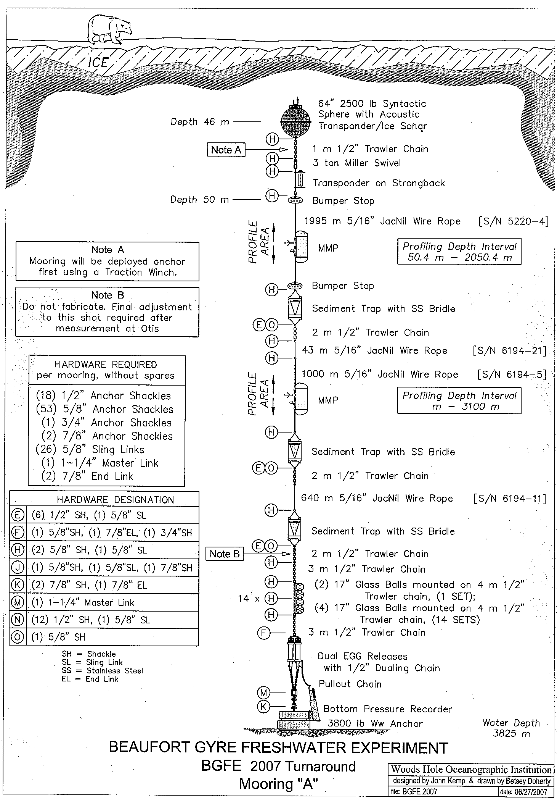

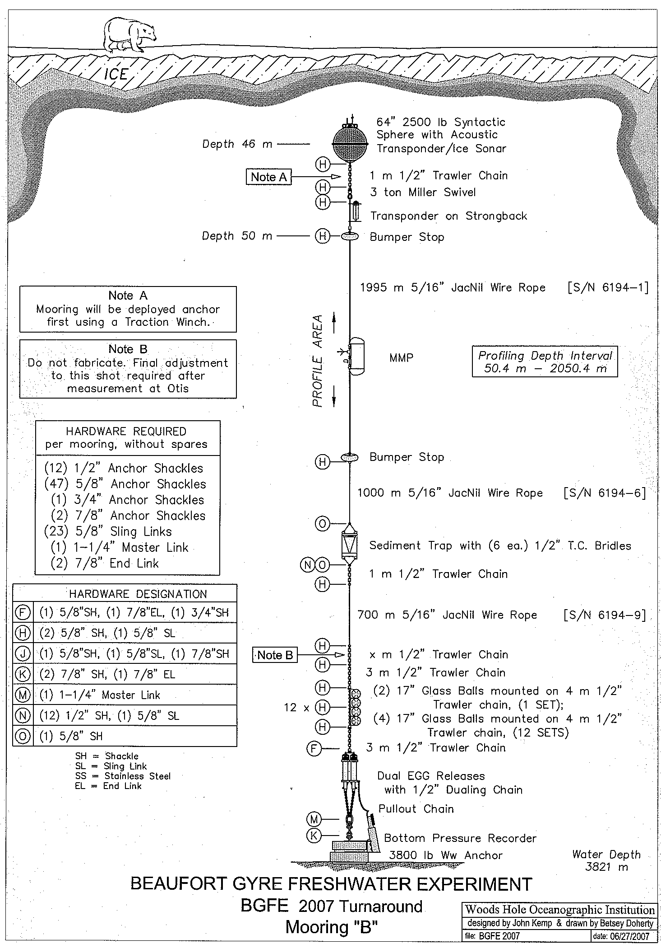

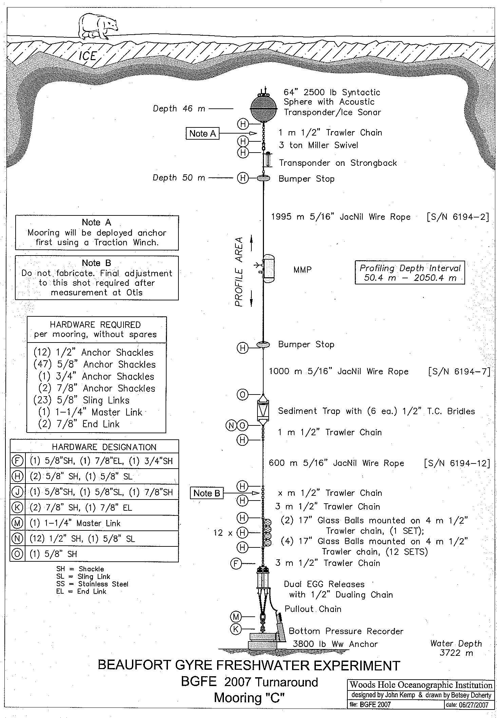

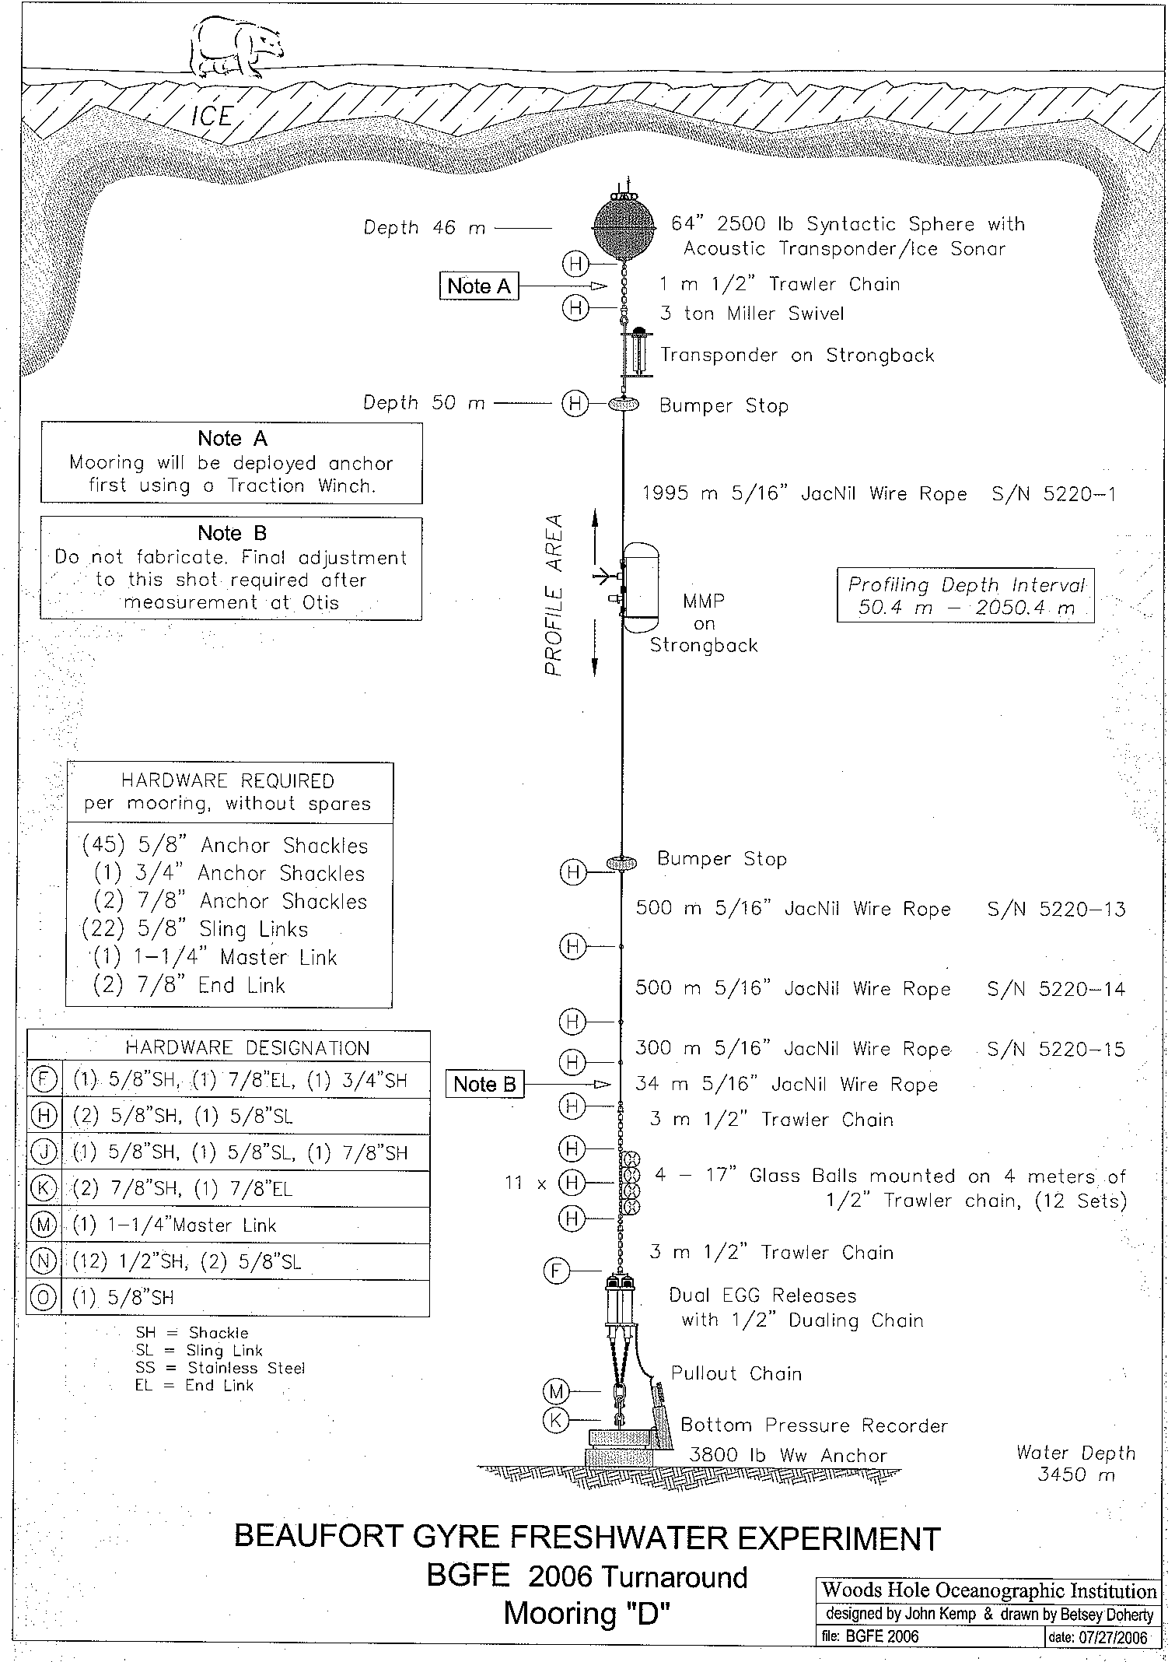

CABOS Recovered Mooring:

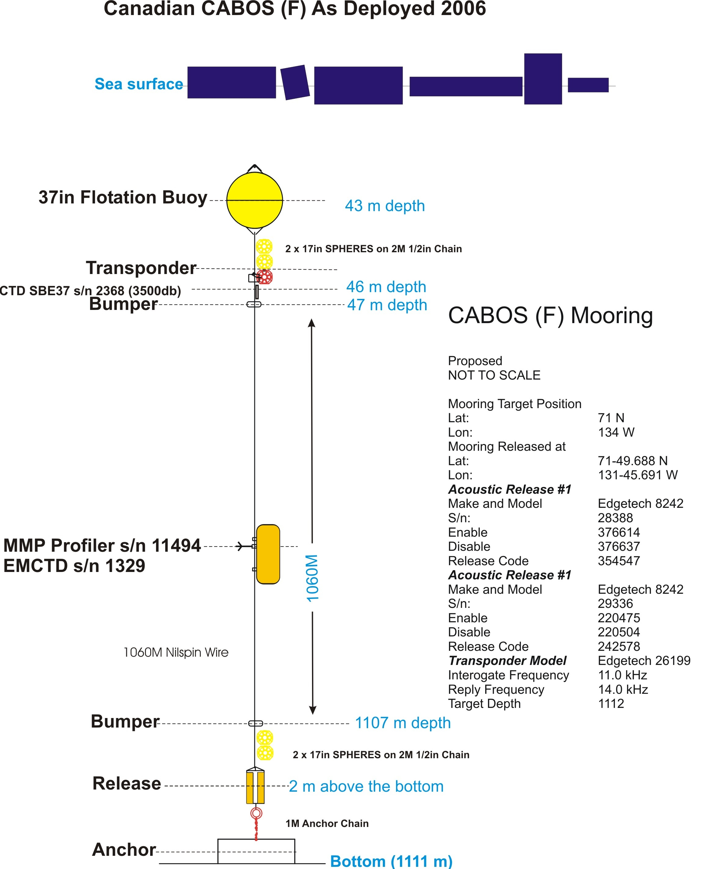

ICE OBSERVATIONS
See below for independent ice observation report by Jennifer Hutchings (IARC).

