CTD Report
C3O
CCGS Louis S St-Laurent
IOS Cruise Number 2007-19
25 July 2007
Sarah Zimmermann

The primary CTD system used on board was a Seabird SBE9+ CTD configured with a 24- position SBE-32 pylon and ice-strengthened rosette frame with 10L Niskin bottles fitted with internal stainless steel springs. The data were collected real-time using the SBE 11+ deckunit and computer running Seasave Win32 V 5.37d acquisition software. The CTD was set up with two temperature sensors, two conductivity sensors, two oxygen sensors, fluorometer, transmissometer, altimeter, a bottom contact switch and surface reference PAR. On casts shallower than 1000m, there were also nitrate and PAR sensors.

A second CTD used for casts from the helicopter was an internally recording SBE19+ CTD configured with pumped temperature and conductivity. No water samples were taken during these casts.

During a typical deployment:
The transmissometer(s) windows and nitrate sensor window were wiped with deionized water soaked kimwipe or q-tip prior to each deployment. The PAR sensor was wiped periodically.
The package was lowered to 5m, taking a PAR measurement just below the surface if required. The pumps were turned on the system soaked for 3 minutes. The package was then brought up to just below the surface to begin a clean cast, and lowered to the requested depth at 60m/m. The casts were typically to the bottom or 1000m whichever was shallower. Full depth casts (over 1000m) were performed near the Ocean Station Bravo site and along the Baffin Bay section. Niskin bottles were closed during the upcast after waiting 30seconds at each trip depth.
The instrumented sheave (Brook Ocean Technology) readouts to the winch operator, CTD operator and bridge allowed all three to monitor cable out, wire angle and CTD depth.

Improvements to the CTD system this year:
- The wire on the winch was adjusted so that it now lays correctly on the drum removing the wrapping problem experienced in 2006.
- A new CTD operation room. Due to the degradation of the existing CTD lab container, a new container lab was built to specifications for a functional space that opens (door and windows) to the work area. After the electrical wiring, GPS and LAN were in place this has proved to be a very nice lab space.
- All the auxillary channels were changed to wet-pluggable connectors from the normal impulse dry-plug connectors.

Data/Performance notes:

The SBE9+ CTD overall performance was good. Editing and calibration have not yet been done, but the data will likely meet or exceed the SBE9+ performance specifications given by Seabird. Header information of position, station name, depth have not been quality controlled yet. Salinity, oxygen, nitrate and chlorophyll-a were all sampled from the water and can be used to calibrate the sensors.

Problems were seen intermittently with Secondary Conductivity and Secondary Oxygen perhaps due to cable problems. Conductivity reads 990 mS/cm and Oxygen values are all above 10ml/l. The primary sensors appear to have worked well throughout.

PAR sensor had problems with leaking connector early in the program. The leak was at the PAR bulkhead cable interface (troublesome dry-plug connectors). The connectors as much as possible and reconnected. The PAR performed well following this. Effort was made to replace the PAR bulkhead connector with a wet-pluggle version (the sensor was opened up) but nothing was available in the right size.

The SPAR sensor was not put in its final location up above the hanger near the incubation tanks until a few days into the program. The first few days the SPAR was placed near the CTD deployment area where it could have been in shaded by the lab container (however the days were cloudy).

The nitrate sensor required battery change once during the cruise. This was done before the sensor ran out of power so should not be noticed in the data.

Four Niskin bottles broke due to implosion of Niskin #2 at depth. It appears the lanyard broke, closing the bottle before it went very deep.

Photos:

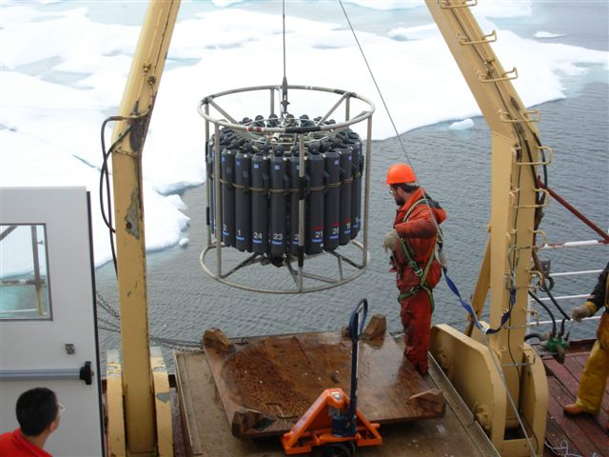
Figure 1. The 24-bottle rosette with the SBE9+ CTD is deployed by Mike Dempsey.

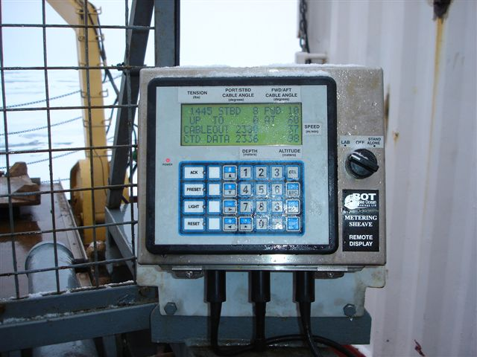
Figure 2. Integrated sheave and CTD display for winch operator.

