PACIFIC REGION CCG VESSEL -POST CRUISE REPORT

NAME OF SHIP/PLATFORM: John P Tully

DATE: FROM: 14 August 2007 TO: 1 September 2007

SCIENCE CRUISE NUMBER: 2007-15 SHIP’S PATROL NUMBER: 07-05

CHIEF SCIENTIST[S]: Marie Robert

SCIENTIFIC PERSONNEL:

Female | Male
Janet Barwell-Clarke | Michael Arychuk
Victoria Fabry (CSU San Marcos) | Michael Bentley
Tansey Hall (CSU San Marcos) | Bill Crawford
Maria Kavanaugh (OSU) | Marty Davelaar
Anissa Merzouk (UBC) | David Nicholson (UW)
Wendy Richardson | Robert O’Brien (Southampton)
Marie Robert | Johan Schijf (U. Maryland (UMCES))
Christina Wood (Southampton)
Jody Wright (UBC)
Marnie Jo Zirbel (OSU)

AREAS OF OPERATION: North East Pacific.

CRUISE TRACK:
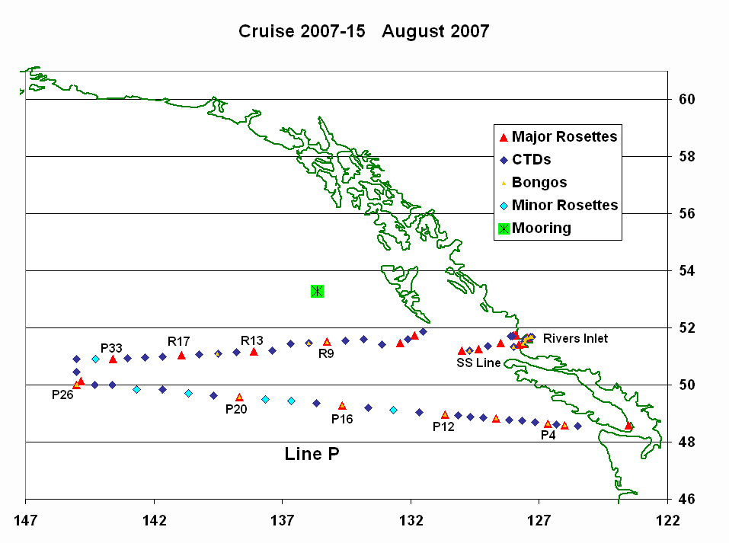
INTRODUCTION/PROGRAM BACKGROUND: Line P is a long standing program which surveys a 1400 km long section 3 times annually. Data have been collected along this line since 1956 and shows evidence of the impact of climate variability on ocean productivity. It is the only Canadian long time-series that allows scientists to monitor climate changes in the Pacific Ocean. It is also the best opportunity for other programs (e.g. Universities) to do research in the Pacific since the Line P data give them background as well as current water properties. In addition, it is the best occasion for other projects (e.g. CWS) to access offshore waters.

CRUISE OBJECTIVE/OBJECTIVES: Repeat hydrography sections, deploy one mooring.

DAYS ALLOCATED: 19 DAYS OF OPERATION: 18

DAYS LOST DUE TO WEATHER: None. No station cancelled.

RESULTS:

- The Line P survey was successful. No casts were cancelled due to weather.
- All of Line R, Line SS, Rivers Inlet, and Koeye River Line were sampled as well.
- One mooring was deployed as Bowie Seamount.
- The samples collected include:
- Underway: T, S, fluorescence, pCO₂, acoustic sounder, ADCP, size fractioned pigment analysis, pulse-amplitude modulated (PAM) fluorometry (to quantify the electron transport rate and approximate photosynthesis) and continuous measurements of surface adsorption and light attenuation with a Wetlabs AC-S, water vapour, N₂, O₂, Ar, CO₂, DMS.
- Discrete (casts): T, S, fluorescence, oxygen, transmissivity, irradiance.
- Water: oxygen, salinity, nutrients, chlorophyll, HPLC, DIC, Alk, C13, DMS, DMSP, ONAR (Oxygen, Nitrogen, ARgon), Iron, Bacterial genomic, CO₂, CH₄, N₂O, dissolution of aragonitic pteropod shells.
- Zooplankton and pteropod shells using vertical and oblique net hauls.
M. Robert: Temperature, Salinity and Sigma-t data

In June 2007 the surface waters along Line P were colder than usual along the whole line, with anomalies ranging between 1 and 2 °C. In August the ‘coastal’ surface waters (up to ~ P11) were slightly warmer than usual, but along the rest of Line P the waters just below the surface (10 to 110 m) were still colder than the long term average (1956 to 1991) by up to 2.5°C.

Anissa Merzouk and Jody Wright, UBC

Objective:
Establish surface and depth distributions of the climate active gases nitrous oxide (N2O), methane (CH4), carbon dioxide (CO2) and dimethylsulfide (DMS), and describe the taxonomy and genetic makeup of the
bacterial communities involved in the cycling of these gases along Line P.

Sampling plan:
Measure dissolved nitrogen (N2), oxygen (O2), CO2, argon (Ar) and DMS continuously at the surface using a membrane inlet mass spectrometer (MIMS).

At 11 surface stations along Line P, filter large volumes (20 L) of seawater to create DNA and RNA genomic libraries of the bacterial communities and identify bacterial genes involved in sulfur and DMS cycling.

At the 5 major stations, 1) measure the bacterial abundance and the concentration of greenhouse gases (CO2, CH4 and N2O) along a 12 depths vertical profile, 2) filter 1L seawater samples at 12 depths for high resolution bacterial DNA and RNA extraction and sequencing; and 3) filter large volumes (20 L) of seawater at 4 depths across the oxygen minimum zone (OMZ) to create genomic libraries of the bacterial communities.

Comments:
Overall, the cruise went really well for our team. All stations were visited and sampled according to our plan. Very high levels of DMS were measured in surface waters from P12 to PAPA. Such high concentrations have
not been observed at Line P since 2002 and this feature made this cruise very exciting.

The main problem we encountered during the cruise was the presence of bubbles in the ship's seawater intake, which caused a high level of noise in the signal and a loss of sensitivity for the underway gas measurements.
The engineers solved the problem, which they attributed to fouling (by algae, mussels?) of the pump or pipes. Cleaning the ship's seawater intake system prior to the August Line P cruise may be a good idea in future
years to avoid similar problems.

We wish to thank the Tully crew for their assistance and excellent work throughout the cruise, and particularly for solving the 'bubble problem'. Thanks to Marie Robert and the scientists onboard for their help on deck and in the lab, and for making this cruise such a fun experience.

Dissolution kinectics of aragonitic pteropod shells (V. Fabry, J. Schijf, T. Hall)

We tested a prototype experimental cell that was designed to be pressurized and temperature-controlled for pH measurements under in situ conditions. As a newly developed device, the unit worked under some conditions, but not others. The information we gained on this cruise will inform the next generation of experimental cells for this project. In addition, we took water samples from 100-1200 meters for dissolved inorganic carbon and total alkalinity analysis at two stations: P26 (Station P) and P20. We took additional seawater samples and collected pteropod shells from plankton tows and will ship these samples for dissolution experiments in the shore laboratory. In plankton tows, we collected three species of euthecosomatous pteropods, and may have extended the known latitudinal range of one of them. The Line P stations are of critical importance to our project because of the shallow depth of the aragonite saturation horizon and because of the ancillary measurements made by IOS scientists. We will complete our data analysis back onshore. We greatly appreciate the opportunity to participate in this cruise. The crew, officers and other scientists onboard were extremely helpful in making this cruise a successful one for us.

Carbon Cycles in the North Pacific—Progress Report for Tully Cruise 2007-15

Non-IOS Scientists/Engineers involved in this project on this cruise:
Maria Kavanaugh, Oregon State University
David Nicholson, University of Washington
Marnie Jo Zirbel, Oregon State University

The North Pacific Carbon Cycle Science Program is a U.S. - Canadian collaboration involving scientists at the University of Washington and NOAA’s Pacific Marine Environmental Laboratory (PMEL) in Seattle, Oregon State University in Corvallis and the Institute of Ocean Sciences (IOS) in Sidney, B.C. The goals of the project are to understand the processes controlling the flux of carbon between the atmosphere and ocean in the North Pacific. Several activities were carried out in support of the North Pacific Carbon Cycle Science Program during the August Station P cruise (2007-15). These included the deployment of a Seaglider in the vicinity of Station Papa, as well as a number of ship based chemical and biological measurements.
GLIDER: The Seaglider is an autonomous platform that measures temperature, salinity and dissolved oxygen in the upper 1000 meters. Seaglider measurements can be used to calculate net biological oxygen production, which is proportional to carbon export. The initial Seaglider deployment was planned to span from August until the February Station P cruise. The Seaglider was deployed at 1130 on 22 August 2007 near Station P. The deployment operation was successful. The biggest difficulty was establishing acoustic communication with the Seaglider. Two transducers were brought along. The Ixsea TT801 transducer was intermittently successful in receiving the return signal at distances up to 4 km from the Seaglider. No communication was established using the older TT201 unit. Transducers were both deployed over the starboard side at depths ranging from 15 to 5 meters below the surface. Unfortunately two days after deployment during the fourth dive the Seaglider failed to resurface and is presumed lost.
CHEMISTRY: To support the mooring efforts at Station Papa, water samples were taken during the cruise for oxygen, nitrogen and argon (ONAR) analysis. Samples were taken near the surface for major stations on Line P and for a deep cast at Station P. In addition, ONAR, Alkalinity and DIC samples were taken in the upper 30 meters at the mooring site to calibrate mooring sensors that were deployed during the February Line P cruise.
BIOLOGY: In order to characterize the spatiotemporal variability in phytoplankton structure, abundance, physiology, and productivity, discrete measurements of pigments (HPLC and phycoerythrin), particulate carbon and nitrogen, functional absorbance, and flow cytometry were collected and 14C productivity experiments (photosynthesis vs. irradiance curves) were conducted at the following stations: P19, P20, P22, P26 (Papa), PMEL mooring site, P49, R19, R16, and R 9. At several of these stations, experiments were conducted and aforementioned characteristics quantified with water from two depths: 5 m and 30m (approximate depth of chlorophyll maximum). While at Station Papa, at the suite was collected at three different times of the day (7am, noon, and 7pm). Spatial variability in the surface layer was quantified using water from the ships flow through system while underway (4.5 meters at dawn, mid morning, early afternoon, and post-dusk). The PAM instrument used in the previous Line P cruise was unavailable; a Walz XE PAM was brought as a substitute. Unfortunately, the sensitivity of this instrument was not suitable for outside of coastal waters and therefore PAM measurements were not collected in tandem with 14 C Pvs E experiments as hoped.
An ac-s instrument (Wetlabs- Philomath Oregon USA) was installed in the ships flow through system in order to obtain a continuous record of absorption and light attenuation in the surface layer. Continuous measurements of photosynthetically active radiation were collected using a 2 pi PAR sensor (IOS, LiCOR) that was installed on a gimbled mast on the aft deck to minimize shading from the ship. After calibration, the ac-s and PAR sensor data will be compared with MODIS ocean color derived products. The figure below shows uncalibrated chlorophyll concentrations derived from the ac-s for Line P during the most recent cruise (2007-15).

We greatly appreciate the hard work and skill of Tully crew for their ability to perform difficult mooring-deployment tasks in the unruly seas of the North Pacific. Special thanks goes to Chief Scientist Marie Robert for her skill in organizing and carrying out these cruises, to Janet Barwell-Clarke for facilitating the isotope work, and to Angelica Pena for providing the PAR sensor. We are also grateful for the excellent work of the oceanographers on the Station P Program staff at IOS, including Marty Davelaar and Bill Crawford for providing sage guidance during watches, and Melanie Quenneville and Darren Tuele for lab and logistical support.

Figure 1. Ac-s derived chlorophyll (micrograms m⁻³) for Line P (August 2007). The values here represent chlorophyll concentrations derived in the manner of Shifrin [1988] from uncalibrated absorbances. While the structure near the coast is robust to instrument drift, the gradual greening toward Station Papa may not be and therefore should be interpreted with caution.

Bill Crawford on Line-P cruise 2007-15, August 2007.

Thanks to officers and crew of CCGS JP Tully who all helped me so much.

We passed through a Haida eddy from north to south with ER60 multi-frequency and ADCP Doppler sounders on, and then from west to east with sounders on and Rosette stations along R-Line. (The eddy centre was near 51° 30.90' N, 135° 14.91'W, close to station R9). Sounders revealed fewer scatterers in the top 50 metres of the eddy, suggesting fewer zooplankton. Satellite imagery for July and early August 2007 indicated less chlorophyll in the middle of this eddy than in surrounding waters, an indication of fewer phytoplankton in the eddy. I suspect waters surrounding the eddy were coastal waters recently carried offshore with higher coastal iron concentrations and phytoplankton. Phytoplankton in surface waters of the eddy may have consumed all the iron at ocean surface earlier.

Radioisotope Use:

Some work was done with radioisotopes (¹⁴C) by the University of Oregon personnel. The lab was cleaned and decommissioned as soon as their work was completed. Measurements on background radioactivity were made at the beginning of the cruise, after one, and after two weeks or work, using wipe-tests and the scintillation counter. Copies of the decommission lab report and other related paperwork were handed to the first officer on board the Tully as well as to the IOS RSO.

PROBLEMS [SCIENTIFIC GEAR AND OPERATIONS]:

During the last Line P cruise (June 2007) we had problems with the CTD signal. Both sensors (Temperature and Salinity, primary and secondary) were drifting between pressures of about 1000 and 2000 dbar. A report was sent to Seabird, but we didn’t hear anything back before leaving on this cruise. At the beginning of this cruise, the problem appeared again. An email was sent to Seabird right away, and we learnt that the pump cable was the problem. Hopefully it will become standard practice for the people in charge of the CTD to write down the serial number of the pumps in the logbook, as well as identifying all the cable (with maybe a date of first use).

There were lots of bubbles in the loop system (see Anissa Merzouk and Jody Wright’s report). Not only was it affecting the UBC instrumentation and data, it was also affecting the Oregon State University data and the IOS thermosalinograph. As well as bubbles, we also found some pieces of shells in the instruments. Thanks to the engineers for looking into this problem.

The thermosalinograph constantly seems to have problems with salinity/conductivity values. There are huge jumps in the signal, as well as slower drifts. Another problem is the very significant difference in temperature between the intake sensor and the lab sensor. Hopefully this can be looked into and solved by the IOS CTD technicians.

Some salinity bottles loaded on the ship for use during the cruise were not properly rinsed; big salt crystals were found at the bottom of the bottles.

The metal line holding the weights under the rosette broke. It would be good practice to leave some spare wire on the ship in case this happens again.

Due to a lack of storage space at IOS, we usually ask outside groups to ship their gear at the last possible moment. As a consequence of this, many boxes of gear arrived on the ship only hours prior of departure, and one box did not arrive at all. Storage space has to be found at IOS for two purposes: to be able to receive gear going on a cruise long enough in advance, and to store equipment between cruises when the participants will be on the ship again on the following Line P cruise.

SUCCESSES [SCIENTIFIC]:

Last February one of the science tables in the lab collapsed. Following this incident the Water Properties Group ordered new metal tables. We used one of these tables during the June Line P cruise, and all three of them were used in this cruise. They are really stable and solid, and with the sheet of plywood on top it makes it easy to lash things on it. These tables were a good choice.

We had many teams from outside of British Columbia on this cruise: two people from Oregon State University in Corvallis, one person from University of Washington in Seattle, one person from University of Maryland Center for Environmental
Science, and two people from California State University San Marcos. Despite the distance, the planning and preparation of the cruise went really well. Thanks to everyone for starting the preparations months in advance so that almost no last minute surprises were encountered.

The crew successfully deployed a mooring at Bowie Seamount for Svein Vagle.

It was wonderful for me to finally have two people standing a regular (12-hour) CTD watch, and to be able to concentrate on doing the Chief Scientist tasks only without having to stand a regular watch. Also, trying to have all major stations during day time when more people are available to sample worked really well. Thanks to all. Marie Robert.

PROBLEMS [SHIP’S EQUIPMENT/OPERATIONS/PLATFORM SUITABILITY]:

We had some problems with the spooling of the bongo winch during the deep cast.

SUCCESSES [SHIP]:

Special thanks to the galley crew for dealing so well with so many scientists.

DELAYS [OTHER THAN WEATHER]:

0.5 day lost to receive lub oil for engine room. 0.5 day lost to fuelling.

SAFETY CONCERNS:

None.

HAZARDOUS OCCURRENCES:

None.

EVENT LOG:
DATE OPERATIONS

Tuesday 14 Aug: Start loading at IOS.
Wednesday 15 Aug: Saanich Inlet cast. Leave Pat Bay.
Thursday 16 Aug: Start Line P.
Wednesday 22 Aug: Station P day. Deploy Seaglider.
Thursday 23 Aug: Start Line R.
Saturday 25 Aug: Deploy mooring at Bowie Seamount.
Tuesday 28 Aug: Start Line SS.
Wednesday 29 Aug: Rivers Inlet and Hakai Passage stations.
Thursday 30 Aug: Fueling in Port Hardy.
Friday 31 Aug: Offloading at IOS.

SUMMARY/FINAL COMMENTS:

- Many thanks to the whole crew of the Tully for all their help in making this cruise such a success. Special thanks to Captain Quaye; it was a pleasure working with you!

