PACIFIC REGION CCG VESSEL -POST CRUISE REPORT

NAME OF SHIP/PLATFORM: John P Tully

DATE: FROM: 19 June 2007 TO: 3 July 2007

SCIENCE CRUISE NUMBER: 2007-14 SHIP’S PATROL NUMBER: 07-04

CHIEF SCIENTIST[S]: Marie Robert

SCIENTIFIC PERSONNEL:

Female | Male
Valerie Forsland | Michael Bentley (CWS)
Wendy Richardson | Marty Davelaar
Marie Robert | Yiming Luo (UBC)
 | Doug Moore
 | Akash Sastri
 | Doug Yelland

AREAS OF OPERATION: North East Pacific.

CRUISE TRACK:
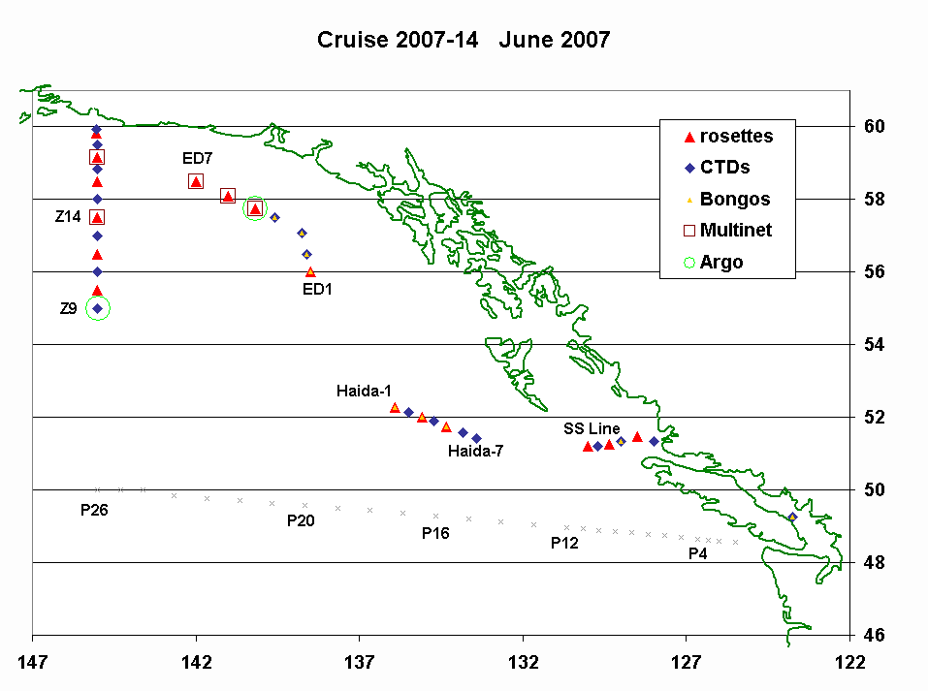
INTRODUCTION/PROGRAM BACKGROUND: Line P is a long-standing program which surveys a 1400 km long section 3 times annually. Data have been collected along this line since 1956 and show evidence of the impact of climate variability on ocean productivity. It is the only Canadian long time-series that allows scientists to monitor climate changes in the Pacific Ocean. It is also the best opportunity for other programs (e.g. Universities) to do research in the Pacific since the Line P data give them background as well as current water properties. In addition, it is the best occasion for other projects (e.g. CWS) to access offshore waters.

On this occasion we added a survey along Line-Z which is a N/S section passing through Ocean Station Papa. This was executed from 47°N to the coast of Alaska. The purpose of this was to use a trans-Pacific section (P1) to be completed this summer along latitude 47°N by Japanese scientists on board their research vessel Mirai. The combination of our surveys with the Japanese surveys forms a contribution to SAGE (the Sub-Arctic Gyre Experiment) and will allow observation of heat, salt and mass transfers through closed ocean regions bounded by P1, Line-P and Line-Z aiding our understanding of ocean processes controlling seasonal climate change.

CRUISE OBJECTIVE/OBJECTIVES: Survey a hydrography section (Line Z) and deploy 2 Argo floats.

DAYS ALLOCATED: 14 DAYS OF OPERATION: 13

DAYS LOST DUE TO WEATHER: None. One multinet cast cancelled.

RESULTS:

- Since a good portion of Line Z was surveyed during the previous cruise, we had time to sample all stations of Line Z to the bottom.
- In addition, we sampled 2 Sitka eddies and one Haida eddy.
- The samples collected include:
- Underway: T, S, fluorescence, pCO₂, acoustic sounder, ADCP.
- Discrete (casts): T, S, fluorescence, oxygen, transmissivity.
- Water: oxygen, salinity, nutrients, chlorophyll.
- Zooplankton using vertical net hauls (Bongo and Multinet).

Doug Yelland - MultiNet Zooplankton Sampling

Since acquiring the MultiNet sampler, we now have the ability to do discrete layer sampling of zooplankton down to a depth of 3000m. On this cruise we sampled several stations in an attempt to target Stage 5 copepods at their overwintering depth. One station was situated near a Continuous Plankton Recorder track to try to give an independent comparison of sorts for that instrument. Also mounted on the MultiNet is a two-frequency Side-Scan Sonar (100 and 400 kHz), being tested for eventual deployment on Argo floats. This sounder worked well at 100kHz, with appropriate data processing I believe useful data is being collected. I’m not so sure about the 400 kHz channel at this point however. The ability to collect high-frequency acoustic data at depth (to 1000m at this point) will greatly enhance our profiling capability, particularly when paired with a sampling tool such as the MultiNet. Several small issues still remain to be resolved with the sounder but it is looking very promising.

Doug Yelland - Shipboard acoustics and Eddy sampling

The EK60 multi-frequency sounder has again shown it’s value on this cruise. A large amount of data was and preliminary processing gives all indications that it will prove very interesting. During passes through several large eddies (two Sitka and at least one Haida eddy) changes in scatterer depth distribution and intensity were seen both within the eddies and between them. Strong diurnal migrations were seen down to several hundred metres depth.

ADCP current plots were especially interesting this trip (see below for an example), showing the strong rotational aspect of the eddies. The instrument also proved useful in locating the centre of the eddies, not always reliably determined using satellite altimetry alone. Further processing to remove unreliable data when on station, tides, and other effects will give a good idea of the extent of the eddies and their rotational speed, and therefore the volume transport associated with them.

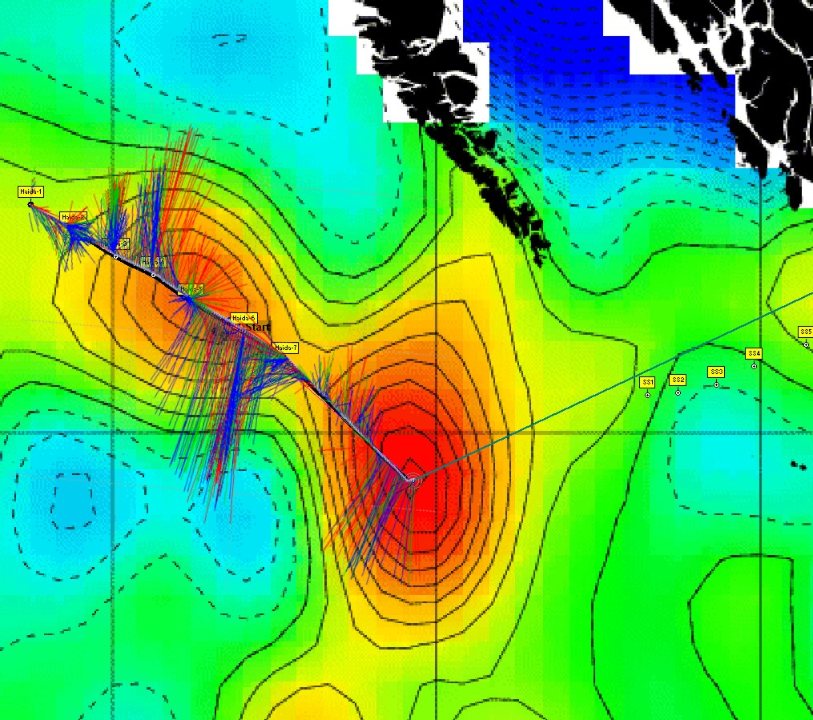

Radioisotope Use:

No radioisotopes were used during this cruise.

PROBLEMS [SCIENTIFIC GEAR AND OPERATIONS]:

The Portasal could not be used on board because it was very unstable again. It will be interesting, after the swap between the actual ship’s office and the data room, to see if it is really movement and temperature that are causing the problems of if the Portasal is really not working.

The 7-conductor wire on the Hawboldt winch, used to do multinets, is extremely greasy again. The thick black grease gets on everything and ends up being carried through the entire ship. Fortunately the main (CTD) winch did not have that problem.

SUCCESSES [SCIENTIFIC]:

Last February one of the science tables in the lab collapsed. Following this incident the Water Properties Group ordered new metal tables. One of these was delivered just on time to be used during the cruise. It is really stable and solid, and with the sheet of plywood on top it makes it easy to lash things on it. These tables were a good choice.

PROBLEMS [SHIP’S EQUIPMENT/OPERATIONS/PLATFORM SUITABILITY]:

There was an important air leak in the heave-compensation gear.

SUCCESSES [SHIP]:

Special thanks to Captain Noon for good weather information every morning. Thanks as well to Shane Lovelace, the second officer, for changing the waypoints a million times without complaining!

DELAYS [OTHER THAN WEATHER]:

None.

SAFETY CONCERNS:

None.

HAZARDOUS OCCURRENCES:

None.

EVENT LOG:

DATE OPERATIONS

Tuesday 19 June: Leave Prince Rupert.
Thursday 21 June: Start first (Sitka) eddy survey.
Saturday 23 June: Start north end of Line Z.
Monday 25 June: Complete Line Z, start heading east.
Wednesday 27 June: Start second (Haida) eddy study.
Saturday 29 June: Arrive at Pat Bay.
Monday 1 July: Offload IOS gear.
Tuesday 2 July: Offload NOAA, UBC, and UVic gear.

SUMMARY/FINAL COMMENTS:

- Many thanks to the whole crew of the Tully for all their help in making this cruise such a success.
- Special thanks to Paddy Murphy for making the right phone calls at the last minute so that we could enter US waters, since no Request for US Clearance had been filled-in prior to the cruise.

