EXPEDITION PLAN AND ITINERARY

DEPARTMENT: DFO, Ocean Sciences and Productivity Division

MISSION NO: 2007-14 CCG PATROL NO: 07-04

MISSION AREA: Line Z

MISSION OBJECTIVE: Repeat hydrography section, deploy Argo floats.

SHIP: John P. Tully

DATE, FROM: 19 June 2007 (Prince-Rupert) TO: 3 July 2007 (Pat Bay)

SENIOR SCIENTIST: Marie Robert

SCIENTIFIC PERSONNEL: 9 berths required
Female | Male
Valerie Forsland (IOS) | Marty Davelaar (IOS)
Wendy Richardson (IOS) | Michael Bentley (CWS)
Marie Robert (IOS) | Doug Moore (IOS)
 | Akash Sastri (UVic)
 | Doug Yelland (IOS)
 | Luo Yiming (UBC)

SHIP EQUIPMENT REQUIRED: depth sounder, sea water supply to lab and heli-deck, heave compensator, tugger winch.

DECK MACHINERY REQUIRED:

Note: The details are on the deck plan, at the end. Same deck plan as previous cruise.

OTHER EQUIPMENT TO BE LOADED: None.

ANTICIPATED LOADING TIME: One day for crew change in Prince-Rupert.

DANGEROUS CHEMICALS:
[INCLUDING MATERIAL SAFETY DATA SHEETS AND WHMIS LABELS]
Separate list to follow, to be handed to the Chief Officer before departure.
No radioisotopes will be used.

Station List:

Station | Latitude  deg min N |  | Longitude  deg min W |  | Bottom Depth m |  | Sampling
Z21 |  | 60 05.00 |  | 145 00.00 |  | 172 |  | CTD
Z20 |  | 59 50.00 |  | 145 00.00 |  | 140 |  | Rosette
Z19 |  | 59 30.00 |  | 145 00.00 |  | 1010 |  | CTD
Z18 |  | 59 10.00 |  | 145 00.00 |  | 4071 |  | Rosette
Z17 |  | 58 50.00 |  | 145 00.00 |  | 3905 |  | CTD
Z16 |  | 58 30.00 |  | 145 00.00 |  | 3989 |  | Rosette
Z15 |  | 58 00.00 |  | 145 00.00 |  | 3874 |  | CTD,
Z14 |  | 57 30.00 |  | 145 00.00 |  | 3962 |  | Rosette
Z13 |  | 57 00.00 |  | 145 00.00 |  | 3839 |  | CTD
Z12 |  | 56 30.00 |  | 145 00.00 |  | 3859 |  | Rosette
Z11 |  | 56 00.00 |  | 145 00.00 |  | 3902 |  | CTD
Z10 |  | 55 30.00 |  | 145 00.00 |  | 4007 |  | Rosette
Z9 |  | 55 00.00 |  | 145 00.00 |  | 4106 |  | CTD, Argo
Z8 |  | 54 27.00 |  | 145 00.00 |  | 4123 |  | Rosette
Z7 |  | 54 00.00 |  | 145 00.00 |  | 4039 |  | CTD
Z6 |  | 53 33.00 |  | 145 00.00 |  | 4067 |  | Rosette
Z5 |  | 53 06.00 |  | 145 00.00 |  | 4095 |  | CTD
Z4 |  | 52 39.00 |  | 145 00.00 |  | 4073 |  | Rosette
Z3 |  | 52 12.00 |  | 145 00.00 |  | 4090 |  | CTD
Z2 |  | 51 47.50 |  | 145 00.00 |  | 3850 |  | Rosette
Z1 |  | 51 21.00 |  | 145 00.00 |  | 4175 |  | CTD
P32 |  | 50 54.0 |  | 145 00.0 |  | 4267 |  | Rosette
P41 |  | 50 27.0 |  | 145 00.0 |  | 4268 |  | CTD
P26 |  | 50 00.0 |  | 145 00.0 |  | 4250 |  | Rosette
S1 |  | 49 30.0 |  | 145 00.0 |  | ? |  | CTD
S2 |  | 49 00.0 |  | 145 00.0 |  | ? |  | Rosette
S3 |  | 48 30.0 |  | 145 00.0 |  | ? |  | CTD
S4 |  | 48 00.0 |  | 145 00.0 |  | ? |  | Rosette
S5 |  | 47 30.0 |  | 145 00.0 |  | ? |  | CTD
P1E93 |  | 47 00.0 |  | 144 40.20 |  | 4685 |  | Rosette

Note: Some of these stations will have been done during the previous cruise, 2007-13. The position of the remaining stations might be modified so that the whole line can be covered in the time left.

Itinerary

June 19 Crew change in Prince Rupert..
June 22 Start Line Z at Z21
June 28 Start heading back to Pat Bay
July 2 Arrive Pat Bay and offload

Cruise track
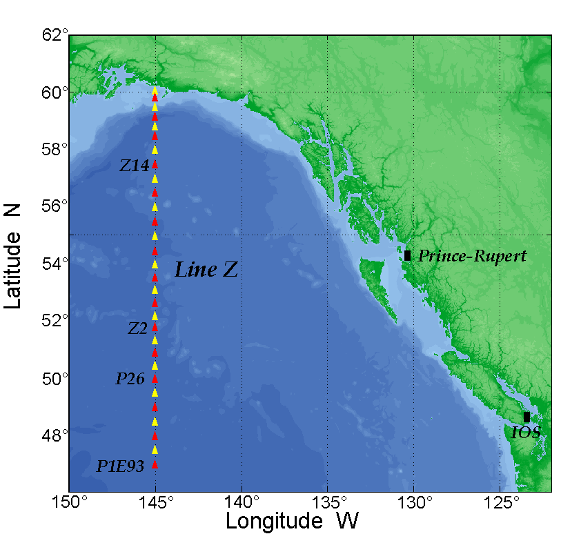

CCGS John P. Tully
Deck Lay Out: M. Robert,
Station P Cruise
Cruise ID: 2007-13 – 2007-14
Date: May 29 – July 3, 2007
A: | Not Required
B: | Hydro Winch 310 #1082 c/w 4730m X 5/32” X 3x19 wire
C: | Work Winch 331 #1231 c/w 2395m X ½” X 3x19 Drag Wire
D: | Work Winch 589 #515c/w  2910 m X 5x16” X 3x19 wire
E: | CTD Winch #17027c/w 5800m  X .322” X 3cdr cable
F: | CTD Winch #17026 c/w 3280m  X .322” X 7cdr cable
G: | Not Required
H: | Not Required
I: | U-Vic MVP winch
J: | Not Required
K: | Capstan Required
L: | Heave Compensator Required
Crane |  | Required
Aft A-Frame |  | Required
Stbd. A-Frame |  | Not Required
20' Container |  | Required
Comments:
- NOAA PMEL Surface Flux mooring will require a 12m^2 deck area pre-deployment and may use the Capstan.
- Please also load, 2 Osco 20” CTD blocks, and an Omron counter for each winch.
- The Heave Compensator and Tully Tugger operational c/w spares are required. (Ship's Engineers, please)
- Trace-Metal sheave and rollers needed for breeze-way hydro winch 310 #1082

